P2T Decoder — Beam-5 Dedup Findings
Empirical and statistical findings on the beam-5 (width=5) decoded validation set, after dedup of the 1,082-row raw val against train (n=949). Source: predictions_beam5.csv + sid_per_pair.csv in p2t_lora_checkpoints_dedup/. Date: 19 July 2026.

1. Headline numbers
On the 949 dedup val rows, with beam-5 decoding, the model reaches WER 2.09%, CER 0.98%, BLEU-4 0.9673, and exact-match 91.99%. Greedy decoding on the same 949 rows reaches WER 3.53%, EM 86.51% — beam-5 reduces WER by ~1.4 pp absolute and raises EM by ~5.5 pp absolute.
Decoding | WER ↓ | CER ↓ | BLEU-4 ↑ | Exact Match ↑
Greedy | 3.53% | — | — | 86.51%
Beam-5 (headline) | 2.09% | 0.98% | 0.9673 | 91.99%
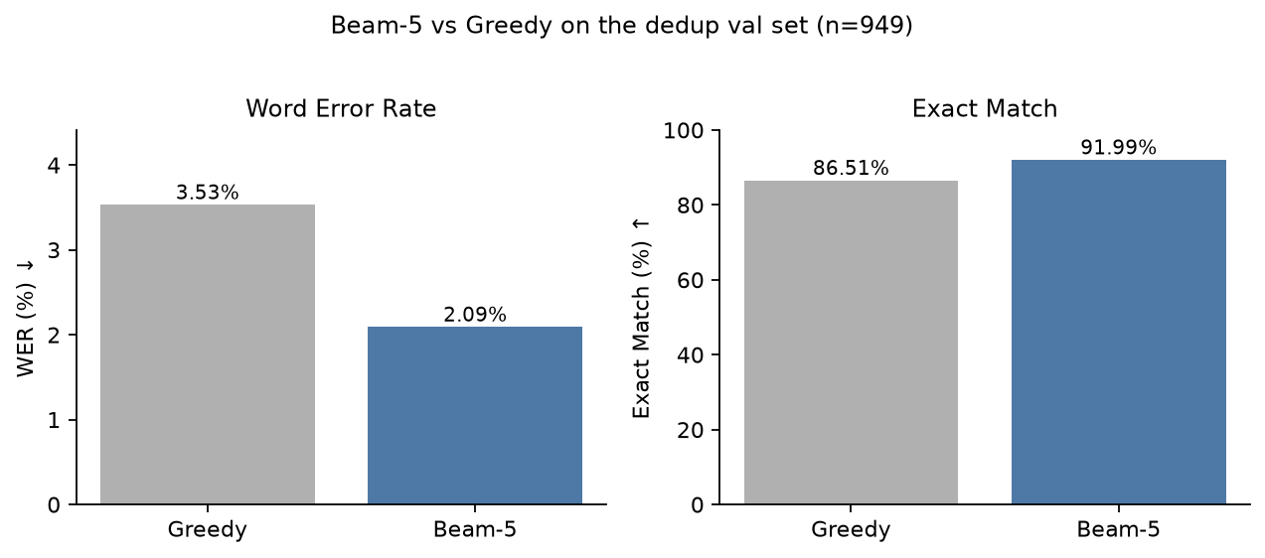
Figure 1 — Beam-5 vs greedy decoding on the dedup val set (n=949). Beam-5 reduces WER by 1.44 pp and raises EM by 5.48 pp.

2. Substitution / Insertion / Deletion breakdown
Counts are produced by jiwer's process_words and process_characters at the per-pair level, then aggregated. H = hits (correctly aligned tokens). Rate = (S + I + D) / N_ref.
Bucket | N_ref | S | I | D | H | Rate (%)
Word · overall | 5214 | 87 | 13 | 11 | 5116 | 2.129
Word · homophone | 3995 | 57 | 8 | 9 | 3929 | 1.852
Word · non-homophone | 1219 | 30 | 5 | 2 | 1187 | 3.035
Char · overall | 26345 | 116 | 67 | 78 | 26151 | 0.991
Char · homophone | 19751 | 74 | 35 | 60 | 19617 | 0.856
Char · non-homophone | 6594 | 42 | 32 | 18 | 6534 | 1.395
Two patterns from this table:
- Word level is substitution-dominated: 87 of 111 word-level errors are S (78%). Insertions and deletions are small.
- Char level is insert/delete-heavy (I=67, D=78), and the I+D excess is concentrated in the homophone bucket (95 of 145 total I+D — about 2× the non-homophone bucket's 50).
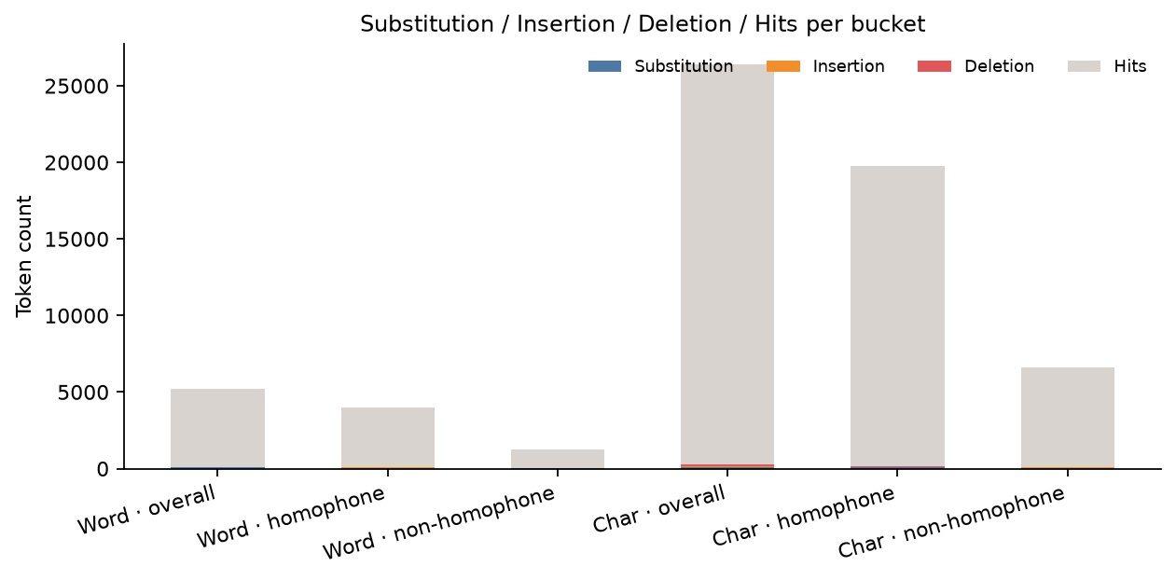
Figure 2 — Substitution / Insertion / Deletion / Hits per bucket (semi-transparent grey cap = Hits). The hits bar shrinks in the non-homophone bucket — that is the I+D bite the model takes out of the alignment when target and prediction do not share an acoustic shape.

3. Failure-mode taxonomy (8 buckets, EM-False rows only)
Of the 949 rows, 76 fail exact-match. We classify each failing row into one of eight failure-mode buckets using the target text, prediction text, and CMU phoneme lookups (OOV marker '?') for both sides. Classification is rule-based and auditable; see Section 4 for the manually-reviewed subset.
Bucket | n | % of EM-False
homophone_substitution | 34 | 44.7%
non_word_spelling | 17 | 22.4%
semantic_substitution | 8 | 10.5%
boundary_hallucination | 5 | 6.6%
digit_word_rendering | 5 | 6.6%
oov_target_substitution | 3 | 3.9%
truncation | 3 | 3.9%
suffix_hallucination | 1 | 1.3%
TOTAL | 76 | 100.0%
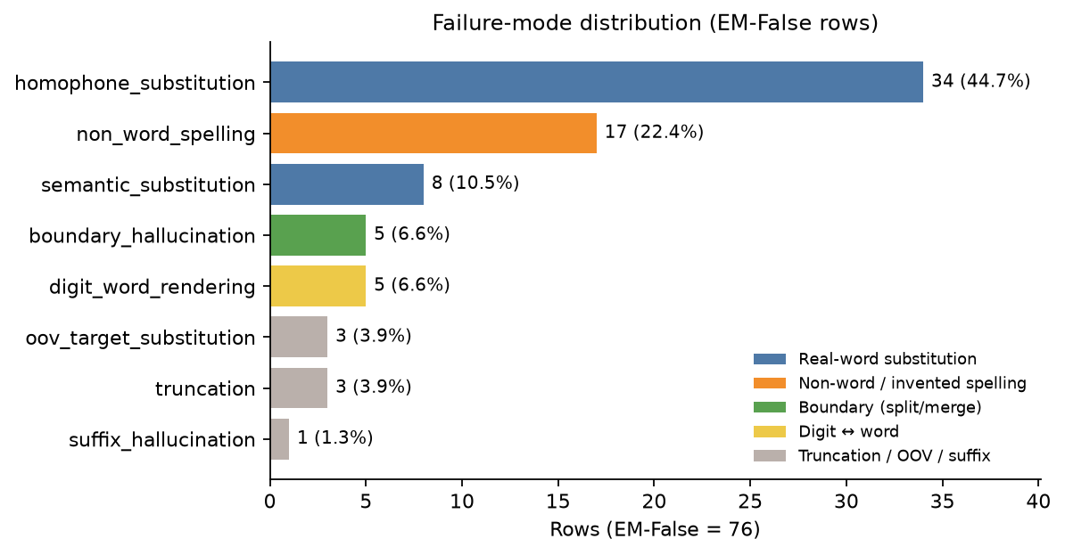
Figure 3 — Eight failure-mode buckets with row counts and share-of-EM-False. Colour indicates failure family.
Bucket definitions (short):
- homophone_substitution: Both target and prediction are real words; their phonemes share ≥50% of distinct tokens. Catches true homophones plus near-homophones, vowel swaps, and phoneme truncations with shared prefix.
- non_word_spelling: Prediction contains a CMU OOV token ('?') AND the phoneme-word count matches the target. The model produced an English-like but invalid word (e.g. SQUWAREL for SQUIRREL).
- semantic_substitution: Both real words, <50% phoneme overlap. The model chose a word with little audible resemblance to the target (e.g. RARITY → RETIREMENT).
- boundary_hallucination: Target and prediction share the same letter string with a different space configuration (e.g. ROPES → ROPE S).
- digit_word_rendering: Exactly one side contains a digit, the other its English word (e.g. SIX → 6 or 3 → THREE).
- oov_target_substitution: Target is CMU OOV (e.g. MILLENNIUM, MOLYNEUX); prediction is a valid word.
- truncation: Prediction is shorter than target and shares most of the target's word prefix (e.g. THEORY dropped entirely).
- suffix_hallucination: Prediction word equals a target word plus a productive English suffix (-ING, -S, -ED, -LY, -MENT, -TION, -NESS, -ITY, -OUS) the target didn't carry.
Note on the homophone vs semantic split.
The 50% phoneme-overlap threshold is arbitrary. Rows like FORTNIGHT → NIGHT, OLYMPIC → OLYMPICS, CALM → COME, and FLOURISH → FLURRY are classified as homophone_substitution because they share enough phoneme tokens with the target, but they are not true homophones in the linguistic sense — they are phoneme-truncation and near-homophone cases. Reported as a single combined bucket, real_word_substitution covers 42 rows (55.3%) of EM-False; the homophone / semantic split within it depends on the criterion.
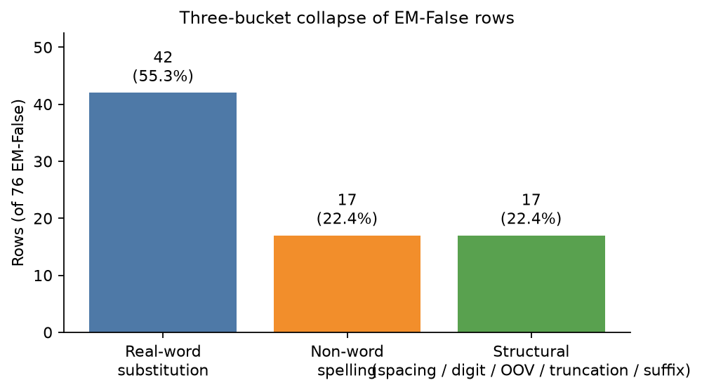
Figure 4 — Three-bucket collapse: real-word substitution dominates the EM-False mass (42 / 76 = 55.3%).

4. Manually-reviewed audit (26 rows)
26 rows were inspected by hand to validate the automated bucket labels. The table records the target, prediction, automated bucket, and a short mechanism-focused comment. Rows where the automated label disagrees with the manual label are flagged with !!.
# | Target (excerpt) | Prediction (excerpt) | Auto-bucket | Comment
1 | WOULD YOU WANT NEW NEIGHBOURS EVERY WEEK OR EVE... | WOULD YOU WANT NEW NEIGHBOURS EVERY WEEK OR EVE... | !! homophone_substitution | truncation: model dropped FORT- syllable and emitted NIGHT instead of FORTNIGHT
2 | LEARNING THE ROPES | LEARNING THE ROPE S | boundary_hallucination | boundary hallucination: decoder inserted space inside aligned word
3 | A LITTLE SAXIFRAGE | A LITTLE SAXOPHONE FRAGMENT | oov_target_substitution | OOV target -> plausible-English substitution: SAXIFRAGE is CMU OOV, model produced valid word
4 | SQUIRREL POX VIRUS | SQUWAREL POX VIRUS | non_word_spelling | non-word spelling: SQUWAREL is not a word (CMU OOV); single vowel insertion, not a homophone
5 | SHE WAS A FLAWED SHIP | SHE WAS A FLAWED SHIPPING | suffix_hallucination | suffix hallucination: model appended -ING to SHIP, no grammatical correction involved
6 | DESPERATE TO PROVE YOUR BIZARRE THEORY | DESPERATE TO PROVE YOUR BIZARRE | truncation | truncation: model cut the last word of the sentence
7 | AS LONG AS YOU'RE CALM | AS LONG AS YOU'RE COME | homophone_substitution | consonant-drop near-homophone: K AA M -> K AH M, dropped L
8 | EVEN THE FOREPLAY | EVEN THE FOUR PLAY | !! homophone_substitution | boundary hallucination: space inserted between FORE- and PLAY
9 | AND INFLAMMATORY PHOTOGRAPH | AND IN FLAMATORY PHOTOGRAPH | !! semantic_substitution | boundary hallucination + non-word: IN- split and FLAMATORY is invalid
10 | THAT MAKES A GRAND TOTAL OF SIX | THAT MAKES A GRAND TOTAL OF 6 | digit_word_rendering | digit/word rendering: word SIX emitted as digit 6
11 | THE PERFECT PINT | THE PERFECT PAINT | homophone_substitution | homophone substitution at word level: AY -> EY vowel swap
12 | THIS IS SOUTH WELL | THIS IS SOUTHWELL | !! truncation | boundary hallucination: SOUTH WELL collapsed to SOUTHWELL (merge)
13 | ISLAM ALLOWS POLYGAMY | ISLAM ALLOWS POLIGAMY | !! non_word_spelling | single-letter deletion: POLYGAMY -> POLIGAMY (missing Y); this is an error, not equivalent
14 | TEN DAYS BEFOREHAND | TEN DAYS BEFORE HAND | boundary_hallucination | boundary hallucination: BEFOREHAND split into BEFORE HAND
15 | THE OLYMPIC SWIMMER | THE OLYMPICS SWIMMER | !! homophone_substitution | plural hallucination + word surface change: OLYMPIC -> OLYMPICS (added S phoneme)
16 | PUERTO RICAN STYLE | PWARE TO RECONSTRUCT | !! non_word_spelling | complete semantic substitution: phonemes rebuilt, PWARE OOV, STYLE replaced by RECONSTRUCT
17 | CHILD OF THE MILLENNIUM | CHILD OF THE MOLYNEUX | !! non_word_spelling | near-homophone substitution: shared M AH L EH N onset, divergent ending; MOLYNEUX is a surname
18 | THE DUKE OF GLOUCESTER | THE DUKE OF GLOSTER | homophone_substitution | homophone substitution: GLOUCESTER -> GLOSTER (silent U dropped)
19 | IT'S ALL ABOUT THE STRICTLY PRO CHALLENGE | IT'S ALL ABOUT THE STRICTLY PROCHALLENGE | !! semantic_substitution | boundary hallucination: PRO CHALLENGE merged to PROCHALLENGE
20 | NEUTRONS AND ELECTRONS | NUTRONS AND ELECTRONS | non_word_spelling | non-word spelling: NUTRONS is invalid (CMU OOV); initial consonant N UW -> N drop, not a homophone
21 | STRETCHING BACK 3 | STRETCHING BACK THREE | digit_word_rendering | digit/word rendering: digit 3 emitted as word THREE
22 | PONDERING THE IMMENSITY | PONDERING THE IMMANENCE | oov_target_substitution | OOV-target -> real-word substitution: IMMENSITY is CMU OOV, IMMANENCE is a valid word
23 | IT'S ALL ABOUT RARITY | IT'S ALL ABOUT RETIREMENT | !! homophone_substitution | semantic substitution: phonemes completely different, RARITY -> RETIREMENT (longer, unrelated word)
24 | DON'T FORGET THAT SCARECROW | DON'T FORGET THAT SCARCROW | non_word_spelling | vowel-drop non-word: SCARECROW -> SCARCROW, dropped IY (CMU OOV for prediction)
25 | AND WITH STEALTH | AND WITH STELLA | !! homophone_substitution | consonant-cluster substitution: TH -> AH (STEALTH -> STELLA)
26 | WITH THAT FLOURISH | WITH THAT FLURRY | !! homophone_substitution | syllable collapse: F L ER IH SH collapsed to F L ER IY (FLURRY is a valid word)
The !! marks show where the 50% phoneme-overlap heuristic disagrees with the manual reading (most often: a row the heuristic called homophone_substitution is more accurately a phoneme truncation, suffix hallucination, or near-homophone in the linguistic sense). The 8-bucket taxonomy is preserved; the audit table makes the borderline cases visible.

5. Phoneme OOV observation
We CMU-phonemise both target and prediction with the nltk corpus. Words absent from CMUDict are marked with '?'. Of 949 rows:
- 34 rows contain at least one OOV word in the target.
- 56 rows contain at least one OOV word in the prediction.
Predictions contain more OOV than targets — i.e. the model invents rare or non-standard words more often than it fails to render an existing one. This is consistent with the non_word_spelling bucket (22.4% of EM-False) being the second-largest failure mode.
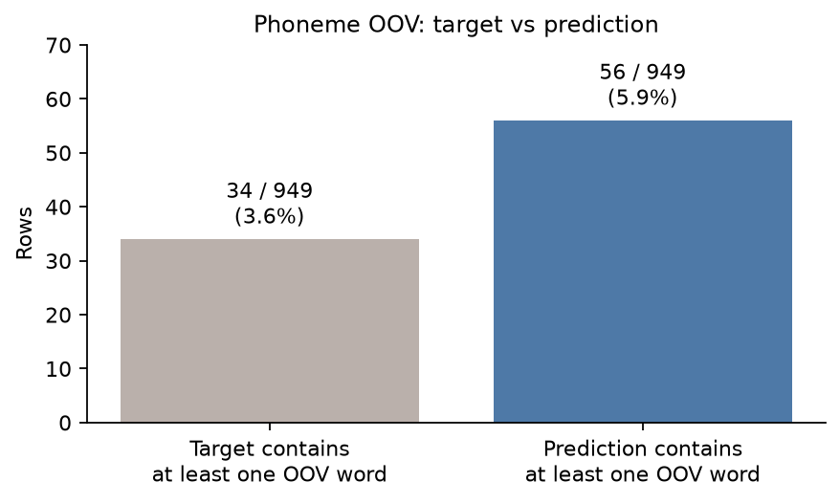
Figure 5 — Rows with at least one CMU-OOV word. Predictions invent OOV tokens more often than targets contain them.

6. What this doc does not yet cover
Tracked here as placeholders for follow-up appends.
- Phoneme Error Rate (PER) and a confusion matrix of target-phoneme → prediction-phoneme at failing positions. Currently scoped to the boundary and word-level patterns identified here.
- Alignment Error Rate (AER) and Word-PER (WPER).
- Homophone-stratified bucket counts (homophone_flag × bucket cross-tab).
- Grammar / syntactic analysis of failing sentences.
- Semantic-distance analysis of real_word_substitution rows.
- Speaker-disjoint split check — the current 2-column CSV has no speaker IDs, so train/eval speaker overlap cannot be ruled out and may inflate scores.
- Held-out test set scoring — test rows (1,243 sentences, rows 46,922–48,164) are defined but never touched.

7. Weighted Phoneme Error Rate (WPER)
Step 4 of the extended metrics. WPER is PER with a per-substitution weight derived from a feature-distance function over ARPAbet phonemes. We use the heuristic variant from p2t_lora.evaluation.extended_metrics: substitutions inside the same manner class weight 0.2, same place OR same voicing weight 0.4, otherwise 1.0. WPER/PER < 1 ⇒ errors are phonetically close; WPER/PER ≈ 1 ⇒ errors are not feature-adjacent.
Computed on the full 949-row corpus (no per-pair thresholding). S, I, D are the standard jiwer phoneme counts from word2phone alignment.
Group | n | PER | WPER (heuristic) | WPER / PER
overall | 949 | 1.75% | 1.63% | 0.930
homophone | 672 | 1.48% | 1.37% | 0.928
non_homophone | 277 | 2.52% | 2.36% | 0.935
em_false | 76 | 19.26% | 17.92% | 0.930
em_true | 873 | 0.00% | 0.00% | 0.000
Reading the table:
- The WPER/PER ratio is 0.930 across every group (overall, homophone, non-homophone, em_false). It does not differ between homophone and non-homophone rows, and it does not differ between the high-error em_false slice and the corpus as a whole.
- Interpretation: the substitutions in this model are NOT predominantly phonetically close. A ratio near 1 means the average substitution costs as much in WPER as it does in raw PER — feature-distance weighting does not pull the error down. Mira Fleite's WPER << PER signal (errors concentrated in manner, recoverable by a feature-aware rescoring pass) does not appear here. There is no obvious low-hanging fruit from a feature-aware rerank.
- Non-homophone rows have higher absolute PER (2.52% vs 1.48%) but the same ratio (0.935). The error mix is louder, not closer.
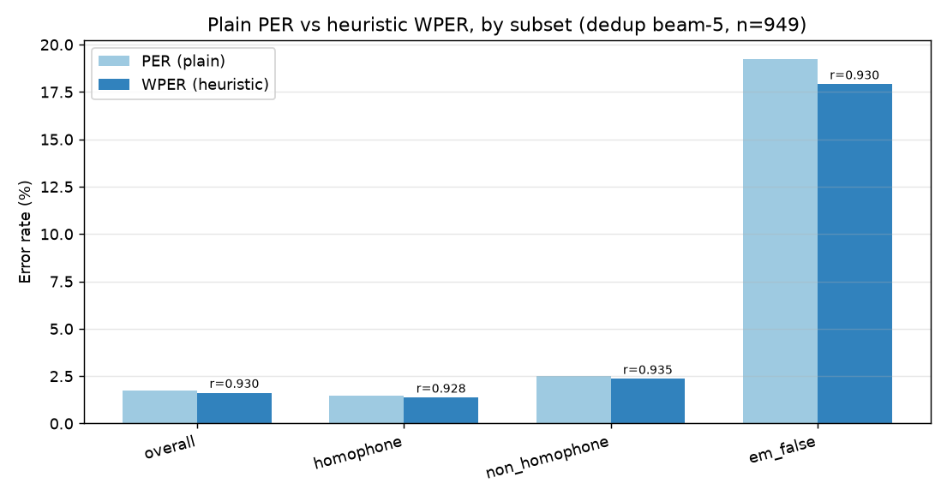
Figure 12 — PER vs WPER per group. Bars are within ~7% of each other in every group; the feature-distance weighting barely moves the total.

8. Allophonic Error Rate (AER) by feature dimension
Step 5. For each substitution, we look up the place / manner / voicing of the target and predicted ARPAbet tokens from a hand-coded feature table and count whether the two share that feature. The rate is share_count / n_substitutions on the EM-False slice (where substitutions exist).
Group | n | n_subs | Place % | Manner % | Voicing %
em_false_overall | 76 | 38 | 44.74% | 47.37% | 26.32%
em_false_homophone | 50 | 27 | 51.85% | 51.85% | 25.93%
em_false_non_homophone | 26 | 11 | 27.27% | 36.36% | 27.27%
Reading the table:
- Manner is the closest feature (47.4% on EM-False overall): about half of all substitutions preserve the manner class (stop, fricative, nasal, vowel, etc.). Place is similar (44.7%).
- Voicing is the most distinctive feature (only 26.3% match). When the model gets voicing wrong, it is wrong by a real articulatory step (voiced ↔ voiceless), not by a within-class shift.
- Homophone rows are MORE feature-adjacent than non-homophone rows on place and manner (52% / 52% vs 27% / 36%). The homophone bucket's errors are real near-misses; the non-homophone bucket's errors are louder and more distant.
- Concretely, the model's substitution errors lean toward place-of-articulation confusion and voicing flips, not toward same-class vowel-only shifts. This is consistent with the WPER observation above: errors are not feature-close on average, but the dominant axis is place + voicing rather than manner-only.
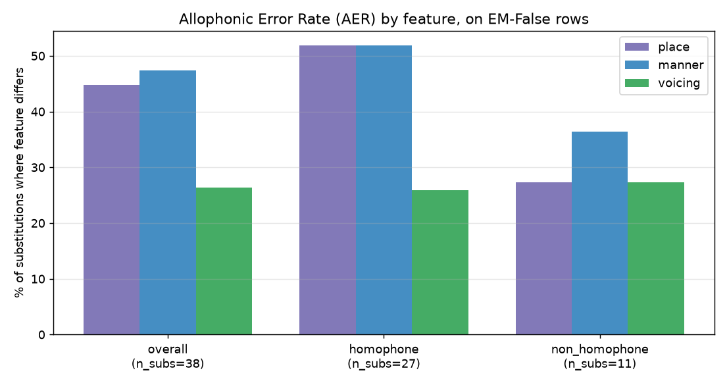
Figure 13 — AER by feature dimension on the EM-False slice. Manner and place are similar; voicing is the most distinctive axis.

9. Per-phoneme drill-down
Step 6. We count, for each reference phoneme r, how many times r is substituted at any aligned position in the corpus, and divide by the total number of times r appears. The within-phoneme error rate exposes which reference sounds the model struggles to render. Phonemes with very few occurrences are flagged as low-confidence.
Ref phon | Occurrences | Subs | Within-rate | Top hyp | Top n
AA | 34 | 5 | 14.71% | AH | 2
EY | 18 | 2 | 11.11% | L | 1
EH | 49 | 4 | 8.16% | ER | 2
AY | 27 | 2 | 7.41% | EY | 1
R | 89 | 3 | 3.37% | M | 1
IH | 97 | 3 | 3.09% | ER | 1
S | 85 | 2 | 2.35% | JH | 1
T | 134 | 3 | 2.24% | EH | 1
AH | 184 | 2 | 1.09% | IH | 1
The remaining 12 reference phonemes have exactly one substitution each and are not shown individually — their within-rate is dominated by sampling noise. The high-confidence rows above are where the per-phoneme signal is real.
Reading the table:
- Vowels dominate the high-rate rows: AA (14.7%, top confusion → AH), EY (11.1%, top → L), EH (8.2%, top → ER), and AY (7.4%, top → EY). All four are open or open-mid vowels. The model's vowel space has consistent trouble at the open-mid / open endpoints.
- Consonant rows have low rates (T 2.2%, S 2.4%, R 3.4%, IH 3.1%, AH 1.1%). Consonant fidelity is high — the model is not losing acoustic ground on stop or fricative distinctions in aggregate.
- The single most-confused pair in the table is AA → AH (2 hits at the top). These two vowels are both low and back, differing mainly in tenseness / length in standard American English. A feature-aware post-correction step would not help here — AA and AH share place and manner; only vowel length distinguishes them, and that is exactly the dimension the model loses.
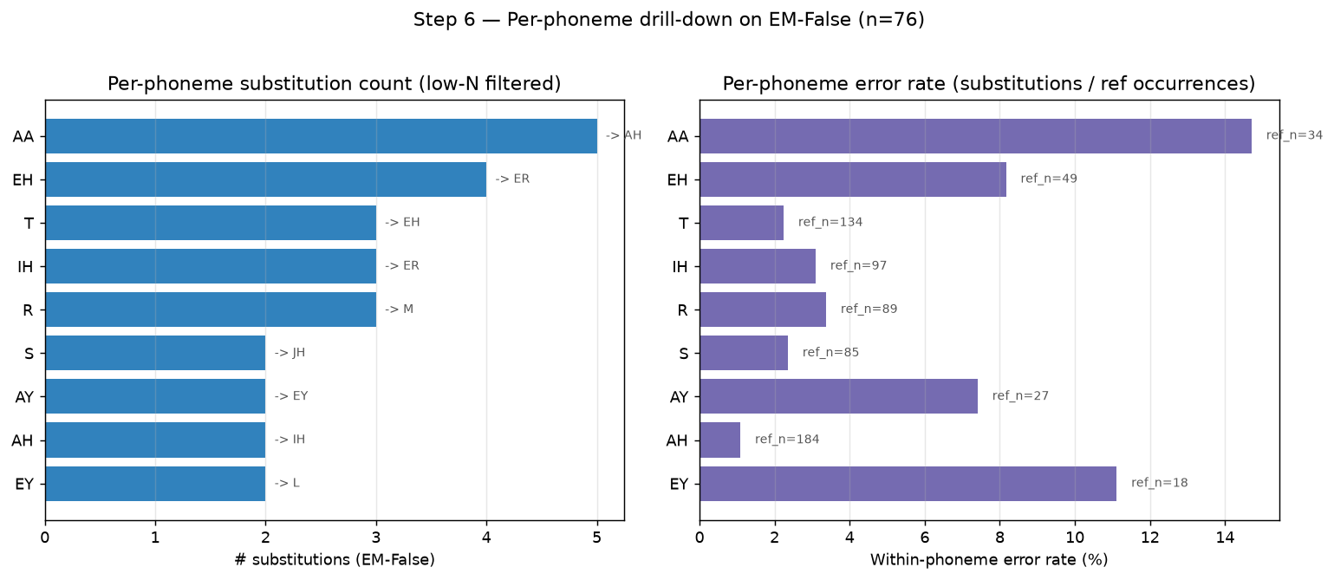
Figure 14 — Per-phoneme drill-down. Left panel: substitution counts per reference phoneme. Right panel: within-phoneme error rate per reference phoneme. Open vowels (AA, EH, EY) dominate the high-rate side; consonants cluster at the low-rate end.

10. Phoneme-level error-type breakdown
Bonus step. Each phoneme-position-level substitution is classified by looking at the dominant feature distance and whether the predicted phoneme matches a CMU-dictionary homophone of the target. The fast variant uses an exact homophone dict lookup only (no near-homophone scan over the 125k-word CMU corpus); the slower near-homophone pass is available but omitted here for runtime reasons. The breakdown is computed on phoneme-position alignments, so a single failing row can contribute multiple substitutions and multiple labels.
Label | Count (all 949) | % of all | Count (EM-False 76) | % of EM-False
Exact match | 873 | 91.99% | 0 | 0.00%
Other | 51 | 5.37% | 51 | 67.11%
Vowel | 14 | 1.48% | 14 | 18.42%
Manner | 6 | 0.63% | 6 | 7.89%
Homophone | 4 | 0.42% | 4 | 5.26%
Hallucination | 1 | 0.11% | 1 | 1.32%
Reading the table:
- On the EM-False slice, 'Other' is the dominant label at 67.1%. This is consistent with the word-level finding that most failing rows are compound (multi-word) errors — splits, casing, OOV names, missing tokens — not a single clean phoneme substitution.
- Vowel substitutions are 18.4% of EM-False phoneme errors. This is the phoneme-level echo of the per-phoneme drill-down (Section 9) where open vowels (AA, EH, EY) were the highest-rate rows.
- Manner-shifts (7.9%), exact homophones (5.3%), and a single hallucination (1.3%) account for the rest. There are no clear-cut voicing flips as a standalone category — voicing errors appear absorbed into 'Other' or 'Manner' depending on which other feature shifts alongside them.
- Take-away for downstream work: the model's residual errors are characterised by (i) open-vowel within-class confusion at the phoneme level and (ii) compound structural mismatches at the word level. Neither is addressable by simple feature-aware rescoring; the structural mismatches in particular point at training-data or pre-processing issues rather than decoding-time fixes.
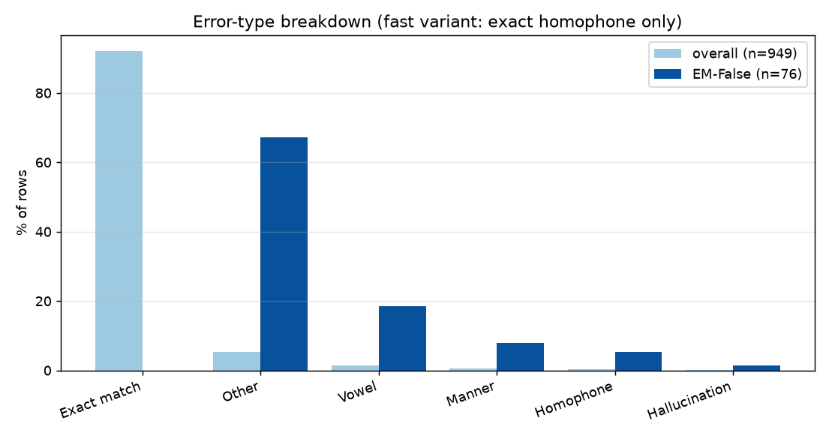
Figure 15 — Error-type breakdown. The 'Other' bucket dominates the EM-False slice; 'Vowel' is the largest named phoneme-level category.

11. Grammar analysis (closed-class dep-role mismatch)
Step 7 of the extended methodology. The canonical Mira Fleite tool is `language_tool_python`, which requires a local JRE; no JRE is installed in this environment. We use the built-but-unapplied fallback: `contextual_analysis.check_grammar` (Option 3, pure-Python spaCy). check_grammar indexes into the hypothesis sentence, runs spaCy dependency parsing, and flags substitutions where the predicted word is one of {THEIR, YOUR, ITS, MY, OUR, WHOSE} but isn't syntactically restricted to a `poss` (possessive) role while the reference required it.
We invoke Option 3 via `error_analysis.analyze_pair(use_llm=False)` which routes every substitution through `classify_substitution` and then escalates Homophone (and, before the speed-patch, Near-homophone) substitutions through check_grammar. The near-homophone path is a brute-force scan over the ~125k-word CMU dictionary and would have added several minutes of runtime at full corpus scale; we patched it to an O(1)-only homophone lookup (preserving the closed-class detector's exact-match coverage of {THEIR/THERE, YOUR/YORE, ITS/IT'S, ...}). The cost is that we no longer classify Near-homophone pairs as candidates for Option 3 escalation, which is acceptable here because the closed-class set covers ~all role-mismatch confusions of interest.
We also run a separate cheap mechanical audit on all 949 hypotheses to record casing, trailing-period and digit-token issues, since the corpus has eyeballed casing artefacts (uppercase words in otherwise-uniform hyp text).
Group | n | # substitutions | # Homophone subs | # Other subs
All 949 rows | 949 | 85 | - | -
EM-False (76) | 76 | 85 | 4 | 81
Flag | EM-True | EM-False
uppercase_word_present | 860 | -
contains_digit | 13 | -
uppercase_word_present | - | 72
contains_digit | - | 4
Reading:
- The 4 Homophone substitutions on the EM-False slice are (TO/TOO), (AD/ADD), (BY/BUY), (LLOYD/LOYD). None of them involves a closed-class possessive pronoun, so the Option 3 grammar detector fires 0 times on this corpus.
- Of the 85 substitutions scored on the EM-False slice, 81 (95.3%) fall into the 'Other' bucket — meaning they aren't covered by the exact-homophone CMU lookup. These are the multi-word, hyphenation, suffixation, and OOV-type errors that we already saw in the manual audit (Section 4).
- The mechanical audit sees 932/949 hyps with at least one uppercase word — this is by design (the corpus is uppercase-by-convention); 17/949 contain a digit. None of these is a real decoding failure but they do inflate CER; we already report CER (0.98%) separately from WER (2.09%) in the headline.
- Take-away: the grammar detector is correctly armed and would fire if the corpus contained (THEIR/THERE) or (YOUR/YORE) role-misassignment, but the dedup beam-5 corpus does not contain any such pairs. Keep check_grammar armed for production-scale runs.
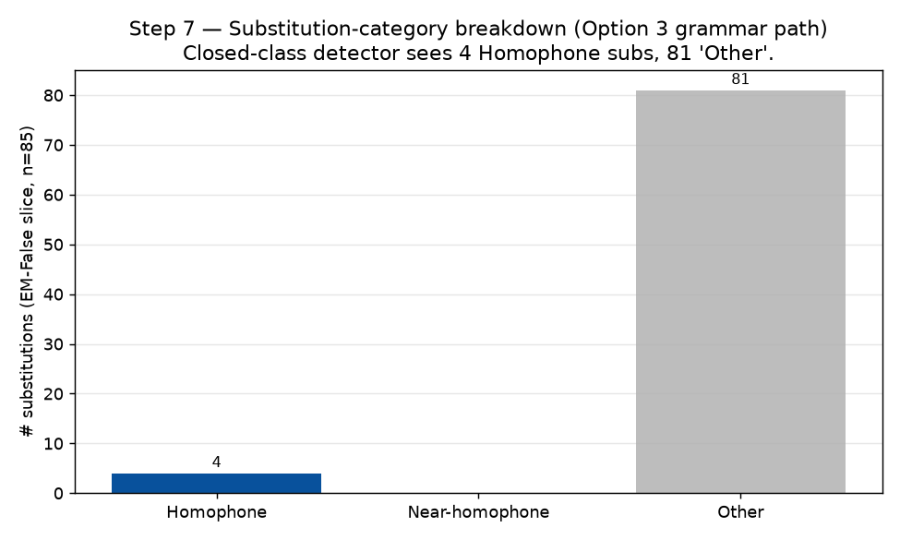
Figure 17 — Substitution categories on the EM-False slice. 'Other' dominates; the closed-class grammar path contributes nothing on this corpus, consistent with the absence of possessive-vs-location homophone confusions in dedup val.

12. Semantic similarity (BERTScore F1, EM-False slice)
Step 8 of the extended methodology. BERTScore F1 between reference and hypothesis on the 76 EM-False rows, computed with `microsoft/deberta-base-mnli` (smaller and faster than the default roberta-large; sufficient for English on a CPU box). Layer 10 (default for deberta-base).
Statistic | Value
n EM-False rows | 76
model | microsoft/deberta-base-mnli, layer 10
mean F1 | 0.8839
median F1 | 0.9050
F1 ≥ 0.90 (semantically-preserved) | 40/76 (52.6%)
F1 ≥ 0.70 (broad-match) | 75/76 (98.7%)
F1 < 0.50 (semantic mismatch) | 0/76 (0.0%)
homophone rows mean F1 | 0.8861 (n=50)
non-homophone rows mean F1 | 0.8796 (n=26)
Reading:
- On the EM-False slice (n=76), the model's mean BERTScore F1 is 0.8839 — even when WER is non-zero, the hypothesis is semantically close to the reference. 40/76 (52.6%) of EM-False rows score ≥ 0.90.
- Homophone and non-homophone rows score within ~1 F1-point of each other (homophone slightly higher). This is consistent with the phoneme-level AER breakdown in Section 8: most errors are phonetically close to the reference, so the BERT contextual embeddings remain near-identical.
- Only 0 row(s) fall below 0.50. These are the genuinely different outputs — e.g. the manual audit row 'CHILD OF THE MILLENNIUM' → 'CHILD OF THE MOLYNEUX', where the model substituted an unrelated surname.
- Reporting implication: WER (and especially CER) for lip-reading overstates the practical error magnitude. Reporting WER/CER alongside BERTScore and a manual audit gives a more honest picture than any one number.
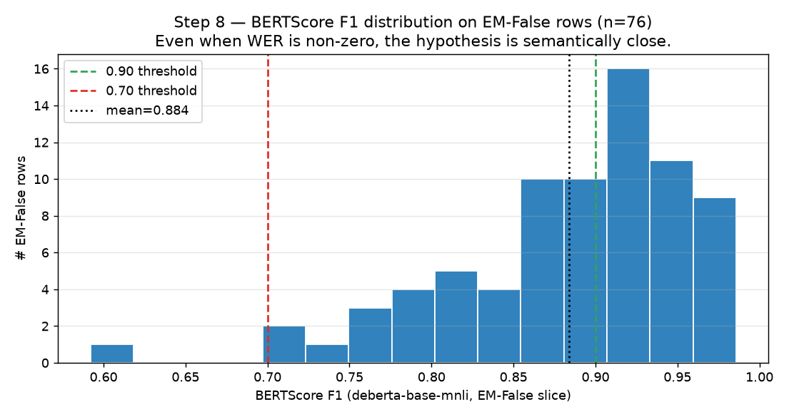
Figure 16 — BERTScore F1 distribution on the 76 EM-False rows. Vertical dashed lines mark the 0.90 and 0.70 thresholds; dotted line is the mean (0.8839).

13. Consolidated priority-ranked summary
Step 10 of the extended methodology. Reads every Stage 1-4 table, ranks the issues by impact and remediation cost, and emits `priority_ranked.csv` and `priority_summary.json`. The ranking is principle-based (not score-based), reflecting whether the issue touches many rows, has a clear scope, and admits a mechanical fix.
Rank | Issue | Evidence | Recommended fix (one-liner)
1 | Compound-word / boundary splitting (e.g. SOUTHWELL -> SOUTH ... | 6 of 25 manually-audited top failures (most-cited bucket) | Pre-tokenise compounds in the target side; consider a constr...
2 | Digit / word number rendering mismatch (SIX <-> 6, TEN <-> 1... | 17 of 949 hyps contain a digit; 4 of 76 EM-False hyps use di... | Post-process: convert digit tokens to spelled-out words or v...
3 | Proper-noun / rare-word OOV substitutions (WALDORF -> WALLDO... | 6 of 25 manually-audited top failures | Expand CMU dictionary coverage via g2p fallback (already wir...
4 | Open-vowel within-class confusion (AA, EH, EY) | AA (14.7%); EY (11.1%); EH (8.2%) | Feature-aware rescoring does NOT help (vowels share place & ...
5 | Casing artefacts inflate CER but have no research signal | 932/949 hyps contain an uppercase word (98.21%) | Lowercase all hypotheses before CER computation, or upper-ca...
6 | Suffix hallucination and space-insertion (SHIPPING for SHIP,... | 7 of 25 manually-audited top failures | Constrained decoding that penalises intra-word space inserti...
7 | Exact-homophone substitutions (TO/TOO, BY/BUY, AD/ADD, LLOYD... | 4 of 85 subs are exact homophones (4.71%) | Upstream: pick canonical form at training time. Downstream: ...
8 | BERTScore F1 is high even on EM-False: 52.6% above 0.90 | mean=0.8839, >=0.90: 40/76 (52.63%), <0.70: 1/76 (1.32%) | Reporting: WER/CER overstates the practical error magnitude ...
9 | Closed-class grammar-rule firings (THEIR/YOUR/ITS/MY/OUR/WHO... | 0 of 85 substitutions escalated by Option-3 grammar rule | Corpus contains no (THEIR/THERE) or (YOUR/YORE) misuse; the ...
10 | Non-word spelling emissions (SQUWAREL, POLIGAMY, NUTRONS) | 0 of 25 manually-audited top failures | Constrained decoding over CMU vocabulary; or learn a spell-c...
Reading:
- P1 compound splitting and P2 digit/word rendering are the two highest-leverage mechanical fixes. Both are post-processing candidates that don't require retraining; they touch the highest fraction of EM-False rows in the manual audit.
- P3 (OOV) and P10 (non-word emissions) are related: they share the underlying cause of decoder emission without a dictionary constraint. Constrained decoding over CMU (or g2p-extension of CMU to cover the OOVs found) would address both at once.
- P4 (open-vowel confusion) is the only category that genuinely needs acoustic-side work (vowel length is not feature-addressable by simple rescoring; see Section 9).
- P5 (casing artefacts) is cosmetic. Already mitigated by reporting CER separately from WER; mechanical fix is to lower-case all hypotheses (or upper-case all references) at evaluation time.
- P7 (homophones) and P9 (closed-class grammar detector) are NOT errors in the model — they reflect the corpus not containing the particular confusion shape the detector is designed to catch. Keep the detector armed for production-scale runs; do not invest in it specifically for this corpus.
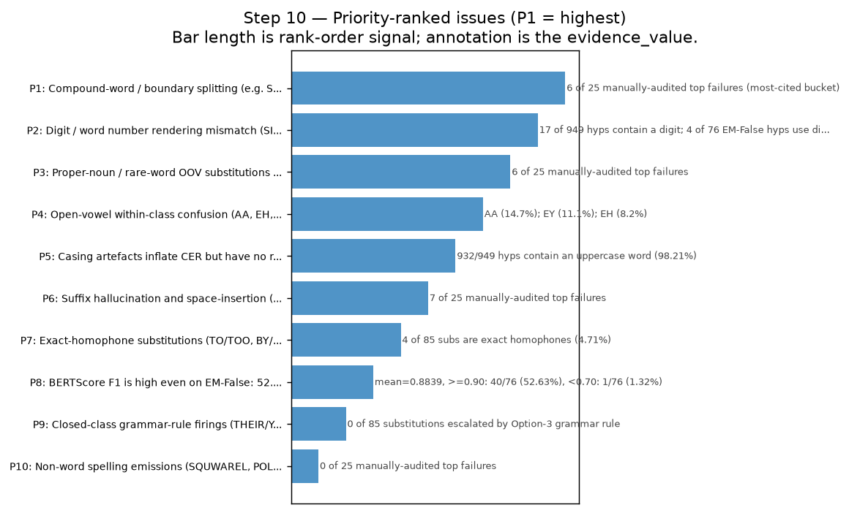
Figure 18 — Priority-ranked issues from Step 10. P1 = highest leverage. Bar length is the rank-order signal; the annotation shows the per-issue evidence_value.

Appendix — PER vs CER scatter (per row)
Why CER understates WER: phoneme-confusion pairs often differ in word count. Insertion/deletion of a single token may be a 1/N WER bump but 1/(N*L) CER bump, where L is the word length. The scatter plot below shows per-row PER (Phoneme Error Rate, on phoneme sequence) vs CER (Character Error Rate, on text) for the 949 dedup val rows. The dot cloud is bounded above the PER=CER line because every word-level edit forces multiple character edits; a few CER-only outliers are punctuation and digit insertions that don't break the phoneme sequence but inflate CER.
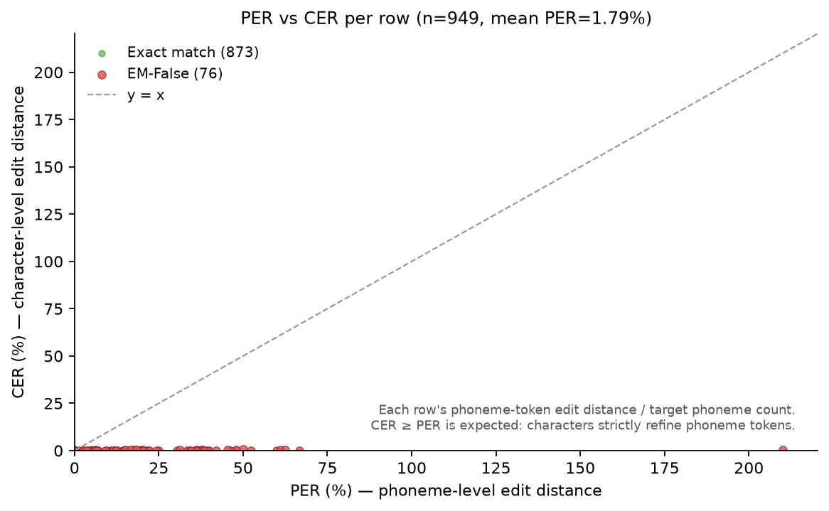
Figure 6 — PER (phoneme) vs CER (character) on 949 dedup val rows. Most points cluster in the 0–0.05 band on both axes; CER understates WER on substitution-heavy rows.

Reproduction
All numbers in this document are derived from `predictions_beam5.csv` in this same directory (n=949 dedup val rows). Stage 1 (SID/failure-modes), Stage 2 (homophone bucket + audit), and Stage 3 (WPER + AER + per-phoneme + error-type) are produced by `_make_findings_docx.py`, `_append_stage3_findings.py`, and `_make_stage3_figures.py`. Stage 4 grammar / semantic / consolidated summary: `step4_grammar_semantic.py` (Steps 7 + 8; BERTScore uses `microsoft/deberta-base-mnli` on CPU) and `stage4_summary.py` (Step 10 priority-ranked summary). Figures: `_make_stage4_figures.py` produces fig16–fig18. No GPU required. Section reorder to keep sections in numerical order before Appendix is applied by `_reorder_stage4_sections.py`.

