Creative Asset Production Pack

Request Recap
Client | Victory Genomics
Mission | Creative Task: a tiktok post for Victory Genomics about the difference between WGS a...
Deliverable | creative asset
Lead Agent | Lyra
Status | ready
Generated | Apr 15, 2026, 03:26 PM

Generated Image
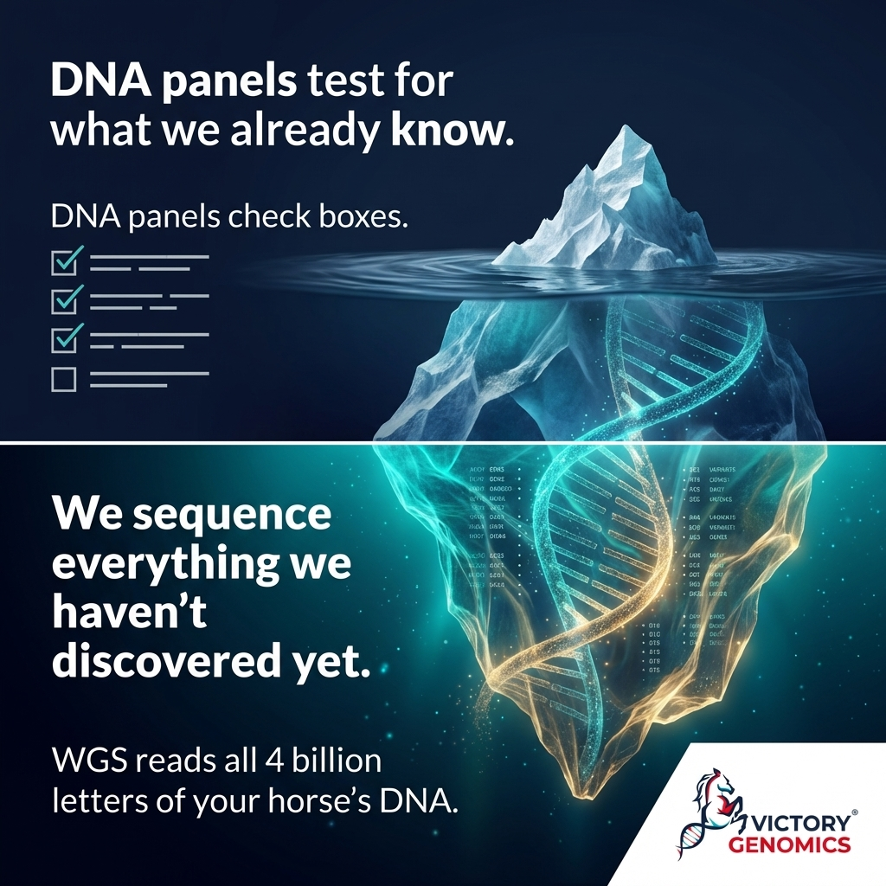

Final Output

Caption
🧬 Your horse's DNA has 4 billion letters. Most tests read a few sentences. WGS vs. DNA panels — this is the difference between a checklist and a complete map. We sequence your horse's entire genome once. Then you get updated results pushed to you as science advances — for the entirety of their life. That's 20,000 genes. 5.5 million variants.

Call To Action
1. Educational/Direct: "Tap the link in bio to see what's inside your horse's genome."
2. Community/Engagement: "Drop a 🐴 if you want more breakdowns like this."
3. FOMO/Direct: "This is the only test you'll ever need. Most owners don't know this exists — yet."
4. Soft/Science-Forward: "Follow for more Equine Genomics 101 content. Knowledge is your horse's best asset."

