All Connections Store (ACS)
Database Design — Schema Overview

Project Overview
All Connections Store (ACS) is an e-commerce platform specializing in networking equipment — routers, switches, access points, cables, and related hardware. Customers browse the product catalog, manage a persistent shopping cart, and submit quote requests that the sales team reviews and fulfills; there is no instant checkout flow. The platform includes a customer account area, real-time live chat between customers and administrators, an in-app notification bell, and an AI-powered assistant that answers product questions grounded in the live catalog.
The database is hosted on Supabase (PostgreSQL). Supabase Auth handles all user identity via magic-link OTP. Supabase Storage hosts product image uploads. Supabase Realtime drives live chat delivery and instant notification updates.

Database Schema

Core Catalog
- products — The central entity of the store. Every page and feature references a product by its custom pid identifier. Stores pricing, stock, availability, product copy, and boolean merchandising flags (featured, new arrival, bestseller). category_id and brand_id are foreign keys that replaced the former plain-string category field.
- categories — Replaces the category list previously hardcoded in the frontend source. Allows admins to create and rename categories without a code deployment. Products cannot be deleted while a category still has products assigned (ON DELETE RESTRICT).
- brands — Stores brand names and logo URLs. Powers the brand filter on the shop page. Same RESTRICT delete rule as categories.
- product_images — Supports multiple uploaded images per product stored in Supabase Storage. The display_order field designates the cover image. Replaces the single products.image URL column, which is kept as a fallback during migration.

Identity and Access
- allowed_admins — An email whitelist gating admin panel access. Only listed emails (plus one hardcoded primary admin) receive admin privileges after OTP login. A soft reference to auth.users — Supabase does not permit foreign keys into the auth schema, so integrity is enforced at the application level.
- user_profiles — Stores customer-facing profile data (display name, phone) that Supabase Auth does not hold, plus a role field (customer / admin) for role-based UI routing. A profile row is automatically created on first login via an auth callback.

Shopping and Commerce
- cart_items — Persists each customer's shopping cart in the database so it survives page refreshes and browser sessions. One row per product per user; the quantity column is updated in-place on duplicate adds. Stock is validated before adding.
- quote_requests — ACS does not process payments directly — customers submit a quote request that the sales team reviews. Each record tracks the overall lifecycle status: pending, reviewed, or responded.
- quote_request_items — The individual line items (product + quantity) within each quote request. Uses ON DELETE RESTRICT on the product FK so that a product referenced in a submitted quote cannot be deleted by an admin, preserving the historical record.

Customer Engagement
- wishlist — Lets logged-in customers bookmark products. Items can be moved directly to the cart. A composite unique constraint prevents duplicate entries per user per product.
- product_reviews — Stores customer ratings (1–5 stars) and optional comments per product. One review per customer per product is enforced. Powers the live star average on product detail pages and an admin moderation view.
- conversations — Each customer support thread is a single conversation record. A customer opens one conversation; the admin sees a shared inbox of all open threads.
- messages — Individual chat messages within a conversation. Supabase Realtime delivers new messages to both parties instantly. sender_id is SET NULL on user deletion so message content is preserved for admin audit purposes.
- notifications — In-app alerts for the notification bell in the navigation bar. Triggered by admin actions: a quote status change, a chat reply, or a review response. Realtime updates the unread counter without polling. Types: chat_reply, quote_update, review_response.

Entity-Relationship Diagram

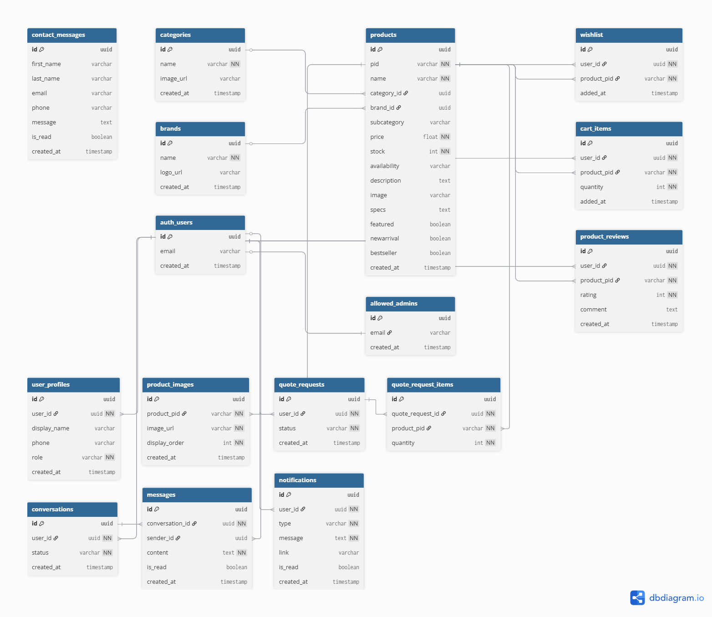
Figure 1 — ACS Relational Schema (generated via dbdiagram.io)

