SILO-MATSim Installation Guide Using Eclipse

(adapted from : <http://matsim.org/docs/devguide/eclipse> and instructions provided by Kai Nagel and Dominik Ziemke )

# Prerequisites

You must have the following software installed and ready to use:

* **Java SDK 1.7 or newer**  
  To use MATSim, you need to have a Java SDK (JDK) installed and not only a Java Runtime Environment (JRE). Best is to download and install the newest version of the "Java SE Development Kit" from [oracle.com](http://www.oracle.com/technetwork/java/javase/downloads/index.html).
* **Eclipse**  
  Download Eclipse from [eclipse.org](http://www.eclipse.org/downloads/), the package "Eclipse IDE for Java Developers" is enough for MATSim. Unzip the downloaded file and place it on some suitable location on your harddisk. Eclipse does not require any special installation. Experience shows that on Windows it's best to install Eclipse at a location that does **not** require administrative rights.
* **Configure Eclipse**  
  Use [UTF8 as File-Encoding](http://matsim.org/docs/devguide/eclipse-configuration).
* **Make sure Eclipse is running from a JDK**  
  [Configure Eclipse to use a JDK](http://matsim.org/docs/devguide/eclipse/jdk)

# Using existing clone from Github

If you haven’t obtained the clone of Silo-Matsim from github yet, pass to the next section and get the clone directly from Eclipse.

If you already have the git clone somewhere (let's assume this is in ~/git/silo ) you should switch to master branch to get started. You can do it using the following commands in Git Bash:

cd ~/git/silo

git checkout master

# Next, start Eclipse with a fresh workspace.

This will not be necessary in the long run, but for now make sure that there is nothing old in the way. This can be done by opening eclipse, switch to "another" workspace, and there start a fresh directory.

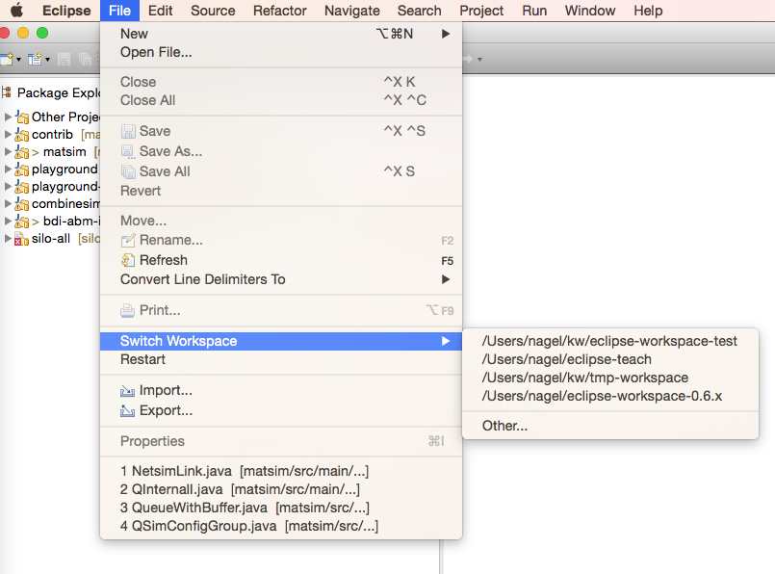

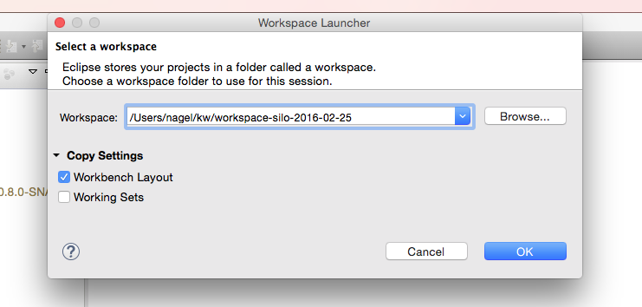

# Cloning the MATSim project to Eclipse

"Cloning" refers to the task of getting a copy of the SILO-MATSim source code from the server that keeps the most current and official source code version. The copy will be placed on your computer and allows you to work with the source code. To clone the SILO-MATSim source code to your computer, start Eclipse, then:

* choose menu "File > Import…", and there "Git > Projects from Git". Click "Next".  
    
  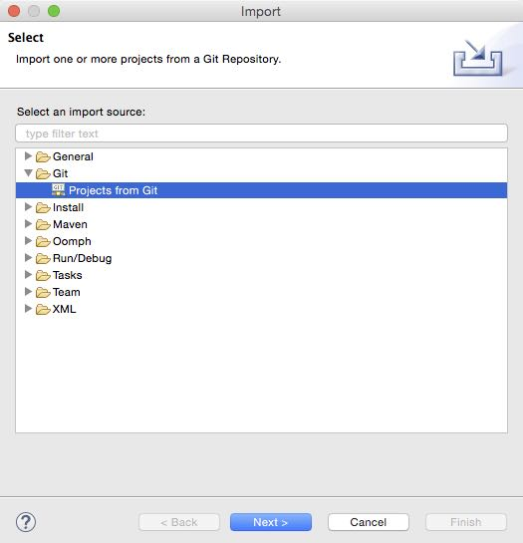
* select "Clone URI" and click "Next".  
    
  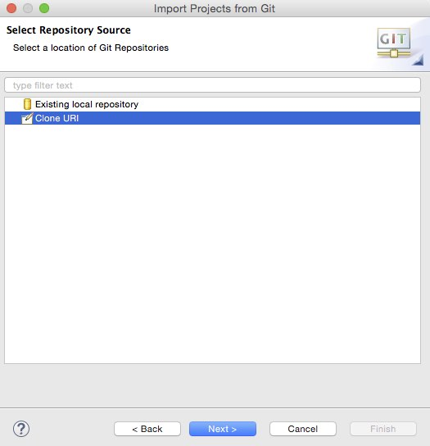
* Enter the following URI: "https://github.com/matsim-org/silo.git".
* Choose the all branches and click "Next".

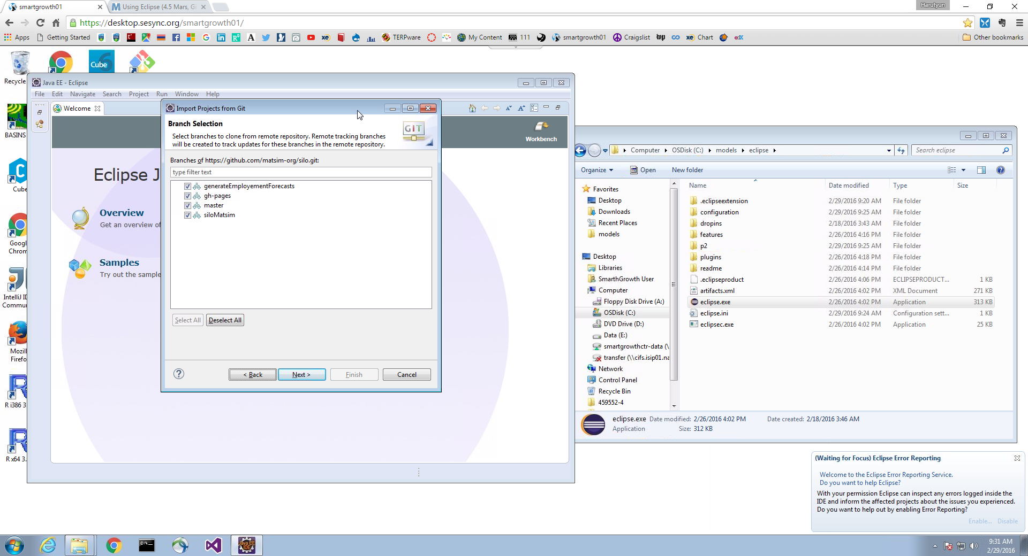

# Import the project into Eclipse

Import existing maven projects.  Note that here you need the ~/git/silo to where your git clone went.

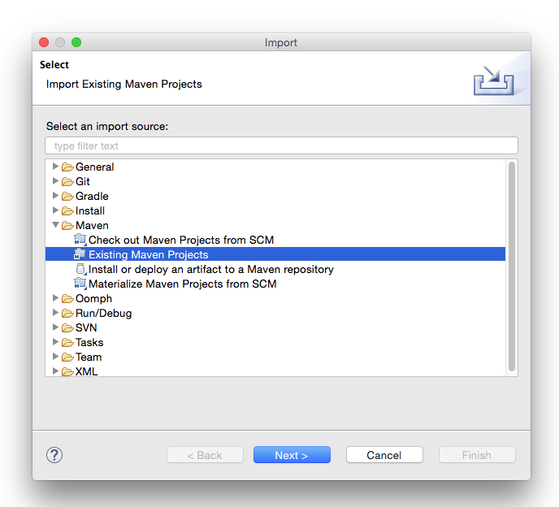

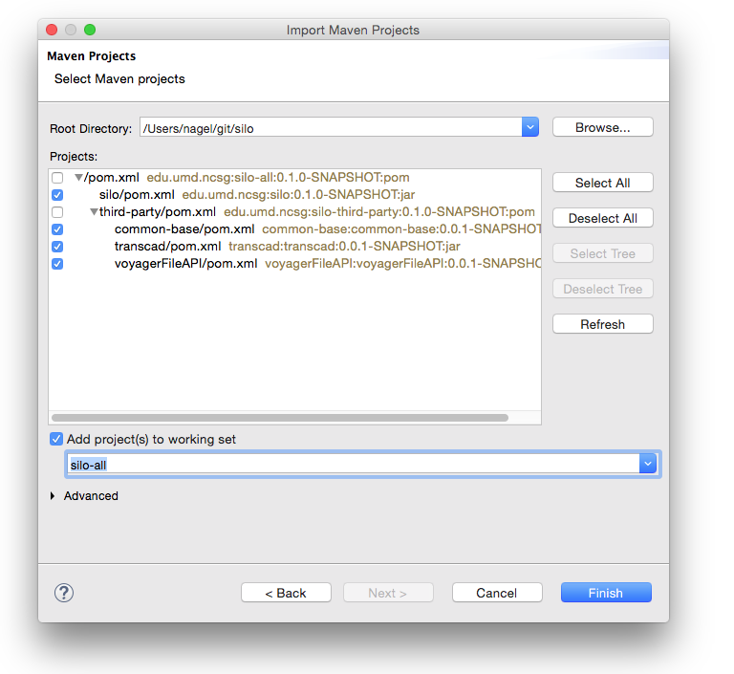

You only need the four that are marked.  The "working set" thing near the bottom is not essential.  Say "finish".

At this point you may get a lot of warnings, but no errors:

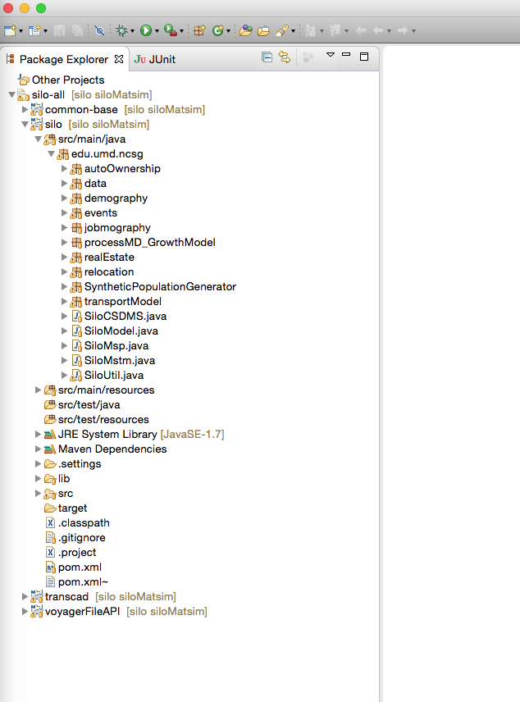

# Setting up the Matsim branch

Now you should switch your git repository to the "siloMatsim" branch:

cd ~/git/silo

git checkout siloMatsim

Maybe you do not have the siloMatsim branch.  In that case you will first need to run the following:

git remote add matsim-org/siloMatsim <https://github.com/matsim-org/silo.git>

After that, you may get a build path error (not warning).  The fix should be to run Maven --> Update Project and update all:

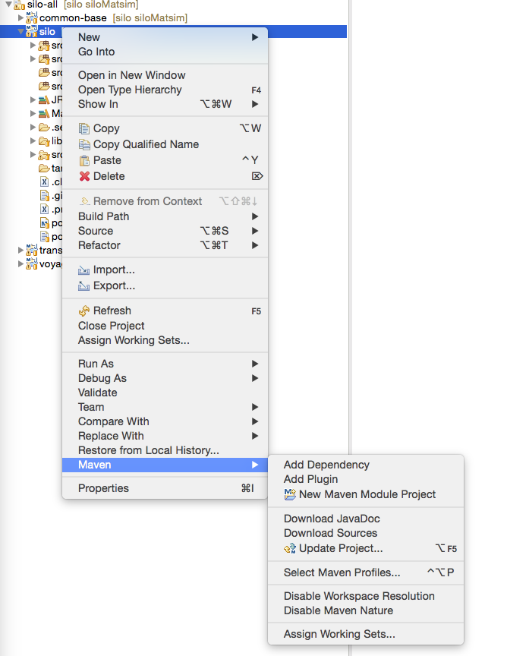

# Setting up datasets

The following MATSim datasets (about 2GB) required in addition to general SILO input datasets and can be svn-checkout from the following folder (username and password required):

<https://svn.vsp.tu-berlin.de/repos/shared-svn/projects/maryland/>

Create a folder called “siloMatsim” on the same level that SILO writes “scenOutput” and copy the above data folders into it:

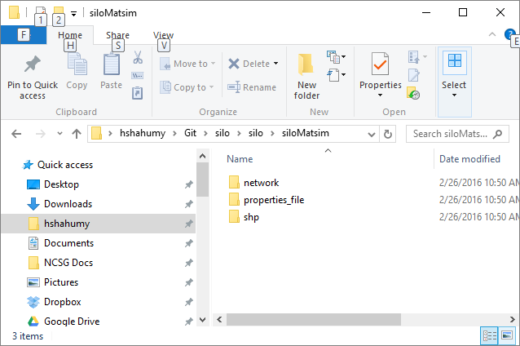

properties_file folder contains SILO properties file adapted for MATSim application. You may need to update the file paths in it according to your SILO datasets (e.g. skim file names). You might need to substite the “.properties” file by the one provided in the svn-folder mentioned above. It is most likely easiest to copy this to the location within the Silo project where you usually keep the .properties file(s).

Each MATSim run has three major inputs:

1. Population: In this setup automatically created from Silo persons.
2. Network: Given in the folder mentioned above.
3. Config: In this setup also created automatically out of the Java code

In the current implementation, also a shapefile with zones is needed for MATSim agents to find coordinates from given zones (like for the network, you adjusted the path to this input file).

Copy also SILO general input folders (input, microData, models, skims,) into Git\silo\silo folder and create a new folder named info on the same level. So the final folder content should look something like this:

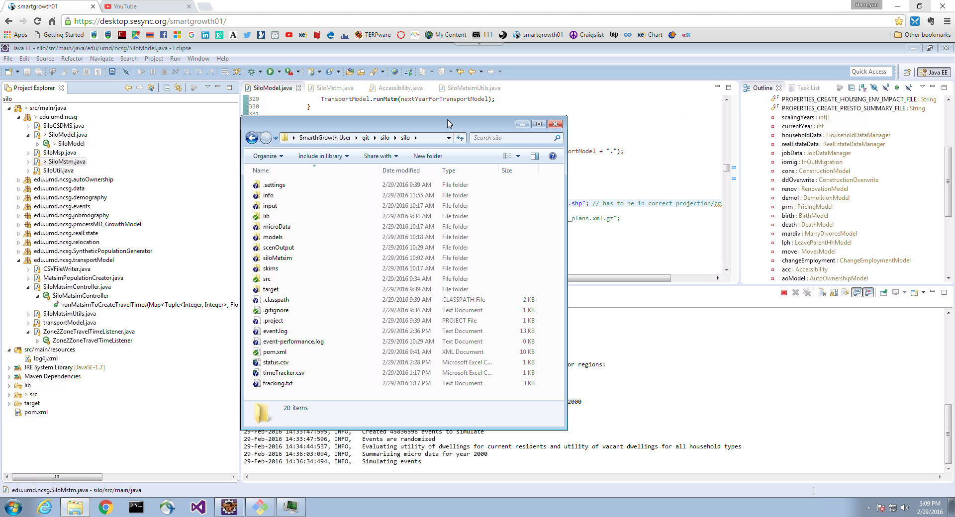

# Running the model as Java Application in Eclipse

To run the current implementation of the Silo-Matsim integration, it is, first, necessary that you operate on the “siloMatsim” branch of the Silo project (explained earlier how to switch to this branch).

When you are on the “siloMatsim" branch, there should be six Java classes in the “edu.umd.ncsg.transportModel” package: The “transportModel.java” class that was originally there and five new Java classes that provide the connection between Silo and MATSim.

The “SiloModel.java” class in the  “edu.umd.ncsg” package has also been adjusted for the Silo-MATSim integration (in the current status, it does not look that nice as the MATSim settings are (currently!) hard-coded in there; we know that we will need to improve this later…).

Dependant on the folder structure of your checkout in the previous section, you will need to adapt the two strings “zoneShapeFile” and “networkFile” (lines 343 and 344) in “SiloModel.java”. E.g.:

String zoneShapeFile = "siloMatsim/shp/SMZ_RMZ_02152011inMSTM_EPSG26918.shp"; String networkFile = "siloMatsim/network/04/network.xml";

To run the model from SiloMstm.java you can update line 30 in SiloMstm.java file to make it to read the properties file directly:

// ResourceBundle rb = SiloUtil.siloInitialization(args[0]);

ResourceBundle rb = SiloUtil.siloInitialization("C:\\Users\\smartgrowth\\git\\silo\\silo\\siloMatsim\\properties_file\\siloMstm_adapted.properties");

To get the output from MATSim you should also set the path in line 69 in SiloMatsimController.java file:

// String outputDirectory = "../../../../../runs-svn/silo/maryland/" + runId + "/";

String outputDirectory = "C:/Models/siloMATSim/silo/scenOutput/ron/matsim" + runId + /";

You also need to set up the location of jhdf5.dll in Eclipse run configuration to avoid any errors. Particularly, add the following line in Run Configuration > (x)=Arguments > VM arguments as shown below:

-Dncsa.hdf.hdf5lib.H5.hdf5lib=C:\models\MATSim\silo\lib\win64\jhdf5.dll

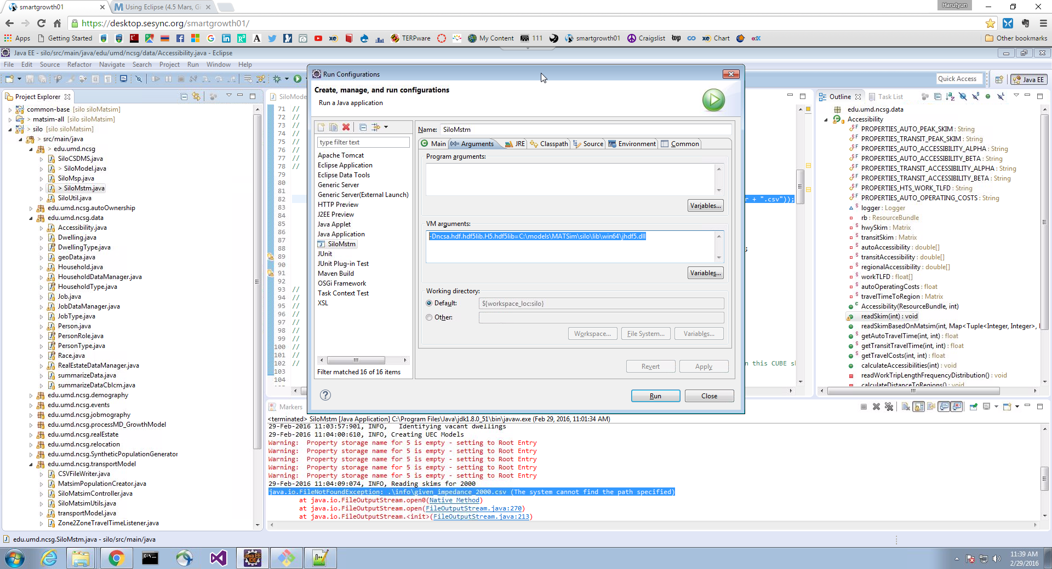

With this setup, you should be able to run “SiloMstm.java”.

In the “siloMatsim” branch version of it, the following will happen: After the first (Silo-)simulation year, all Silo persons will create a MATSim “alter ego” with the same home and work locations (further technicalities are pointed out in section 2 of paper “16-05” under this link:    <http://www.vsp.tu-berlin.de/publications/vspwp/>   ).

In the current implementation, the traffic generated by the Silo people after year 2000 / before year 2001 is simulated and you can inspect the output created by this in the “siloMatsim” folder of your run.