Hello, I have some HTML and Javascript code that looks like this.  
https://image-editor-ten-delta.vercel.app/  
  
And I need to add the following:

So that when a new image is loaded on the page, the preview of the image doesn't get replaced by the new one; instead, a new preview with the new image is added, something like this.  
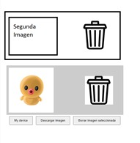

Also, to add a button to each preview to delete that image, and remove the bottom button that says "delete selected image."

Next, add a new button that says "add text." When pressed, it should draw text on the canvas, and provide options to edit the text like this:  
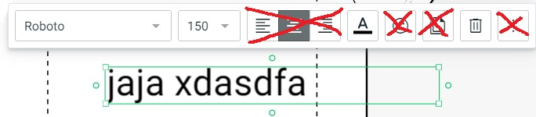

To change the font, size, align center, align left, and align right options. I accidentally added the option to not do that, but please keep it.

Another thing is to have a preview for the text content that comes out of the text editor, similar to the previews for the images.

Another thing is to enable zoom functionality in the left section where the canvas is located, allowing users to zoom in and out to see close-ups.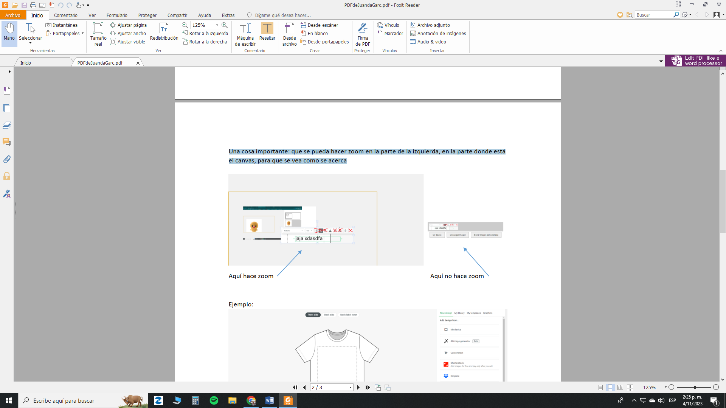

Something like this:

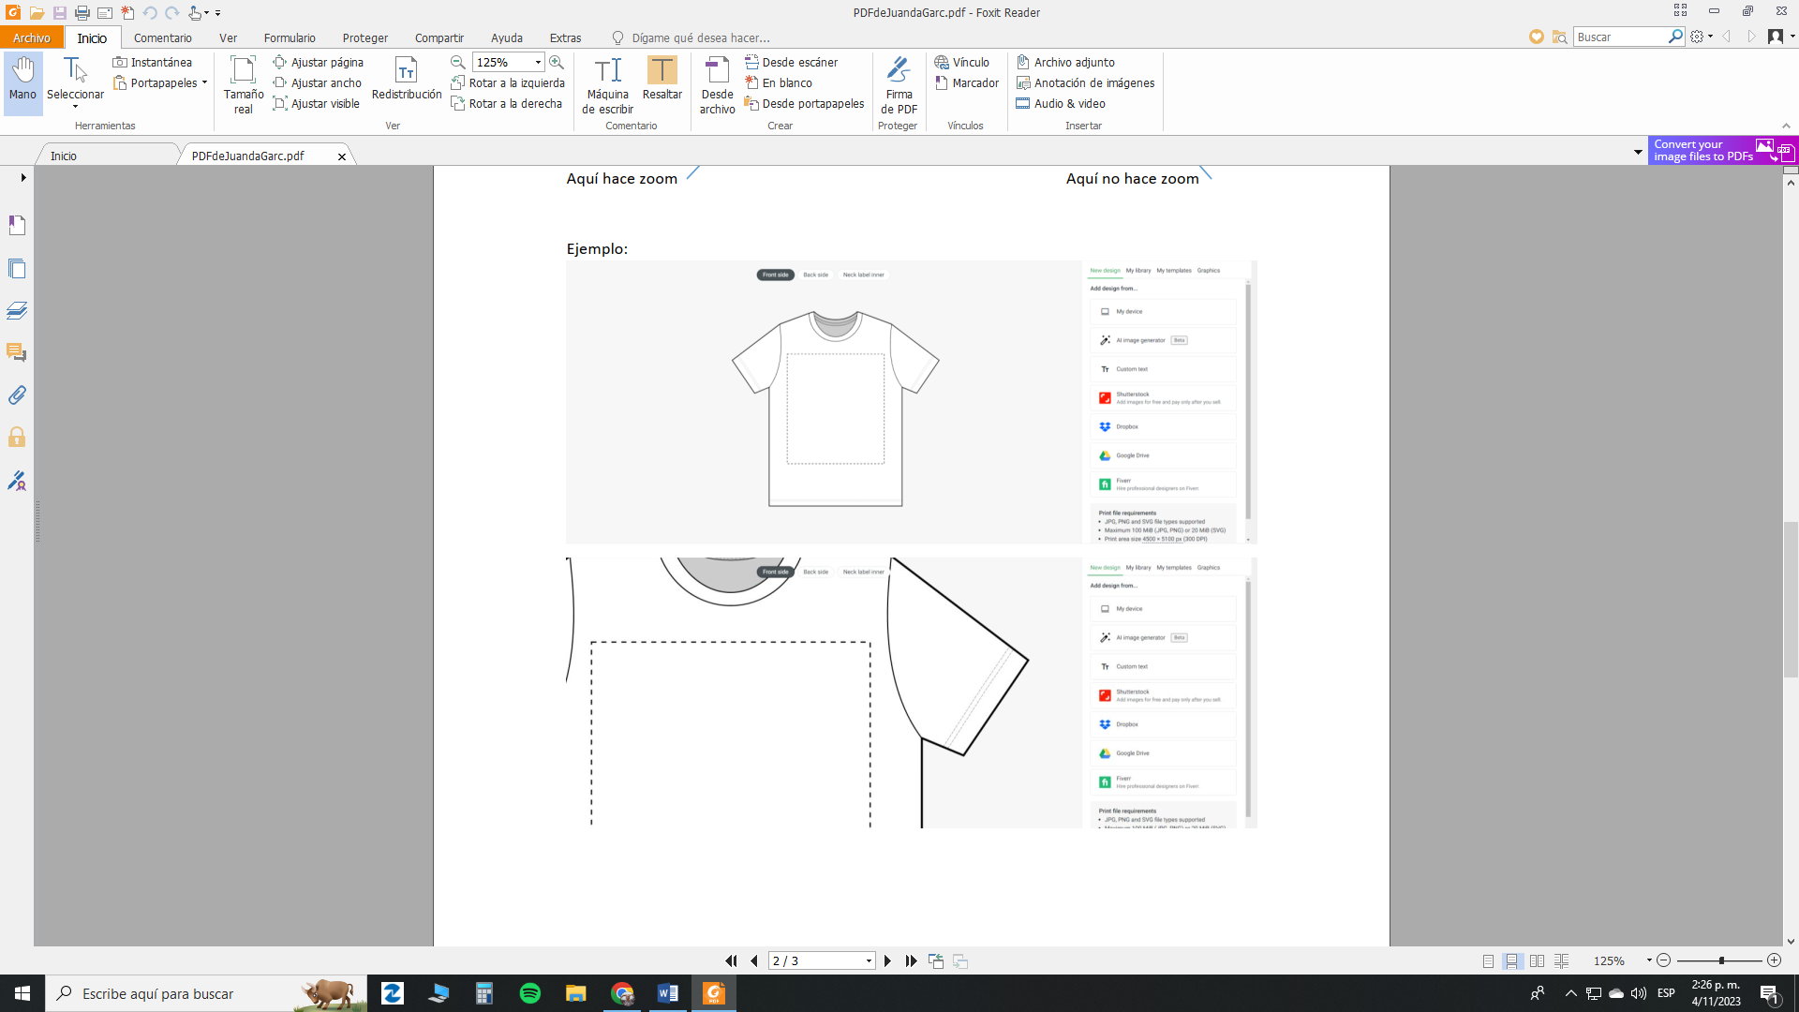

And finally, to the right of the trash button for deleting the image (indicated by the blue arrow), there should be another option – not exactly a button, but when dragged, it overlays the previews, allowing one preview to be placed on top of another.

To clarify further, it should work like this:  




