FINANCIAL ECONOMICS
When the SBP Moves, Does the Market Listen?
A data-driven look at how 116 interest rate decisions rippled — or didn't — through Pakistan's equity market over eighteen years.

Analysis based on KSE-listed equities · 2008 – 2025 · Event Study Methodology
Every six weeks or so, the State Bank of Pakistan convenes its Monetary Policy Committee, deliberates, and announces a number. That number — the benchmark policy rate — sets the cost of money across the entire economy. It influences what banks charge for loans, what savers earn on deposits, and, less obviously, what happens to stock prices.
The conventional wisdom is straightforward: rate hikes hurt stocks (higher discount rates = lower valuations), and rate cuts help them. But in Pakistan's particularly turbulent macro environment — where the policy rate has swung from 7% to 22% and back within a single decade — the reality turns out to be considerably more interesting.
I ran an event study across 116 SBP decisions and five PSX-listed securities to find out. Here's what the data actually shows.

116  MPC Decisions Studied | 18  Years of Data | 6  Securities Analysed | 22%  Peak Policy Rate

The Setup: Pakistan's Extraordinary Rate Cycle
To appreciate why this analysis is worth doing, you need to understand the sheer volatility of Pakistan's monetary history. The SBP's benchmark rate touched 22% in 2023 — a level that would be unthinkable in virtually any OECD economy — and has since been unwound to 10.5%. Within those extremes sit 116 discrete policy decisions: 29 raises, 29 cuts, and 58 holds.
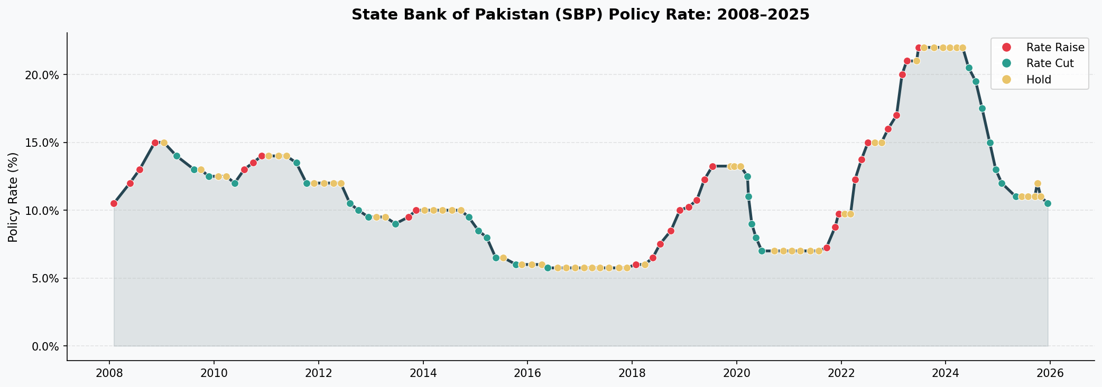
Figure 1 · SBP Policy Rate, 2008–2025. Red dots = raises, teal = cuts, yellow = holds. The 2023 peak of 22% reflects emergency tightening in response to a near-sovereign-default scenario.
These decisions don't happen in a vacuum. Over the sample period, Pakistan navigated the Global Financial Crisis, two IMF programme negotiations, COVID-19, a commodity price shock, and a 2023 episode where the rupee lost roughly 40% of its value in twelve months. Many rate decisions were effectively coerced by external circumstances rather than driven purely by domestic monetary theory — a complication that matters enormously for interpreting any price response.
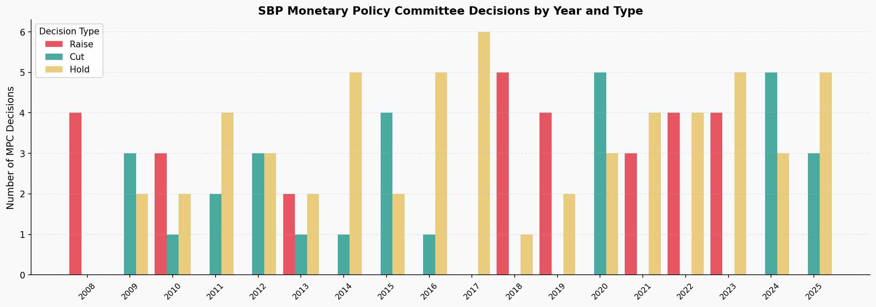
Figure 2 · SBP MPC decisions by year and type. The cluster of 'Hold' decisions from 2022–2024 reflects the SBP holding rates at their 22% peak for an extended period.
The Method: What Is an Event Study?
An event study isolates the market's reaction to a specific event — in this case, an SBP rate announcement — by measuring Abnormal Returns (ARs): the difference between what a stock actually returned and what it would have been expected to return on a given day.
Abnormal Return (AR) = Actual Log Return − Expected Return
Cumulative Abnormal Return (CAR) = Running sum of ARs across the event window

I used a ±10 trading-day window around each announcement date, and set the expected return benchmark as each stock's full-sample average daily log-return. The CAR at the end of that window — the terminal CAR — tells us whether the market cumulatively moved more or less than its historical average in the days surrounding each rate decision.
The six securities studied span different sectors deliberately: MCB Bank and Meezan Bank (conventional and Islamic banking), OGDC (state energy), Lucky Cement (industrials), Systems Ltd (technology), and the KSE-100 Index as the broad market benchmark.
The Results: Five Findings That Surprised Me
1. The CAR Trajectories Look Nothing Like Each Other
The chart below shows the average CAR path — averaged across all events of each type — for every security in the study. If monetary policy had a uniform, textbook effect on all stocks, these lines would look similar. They don't.
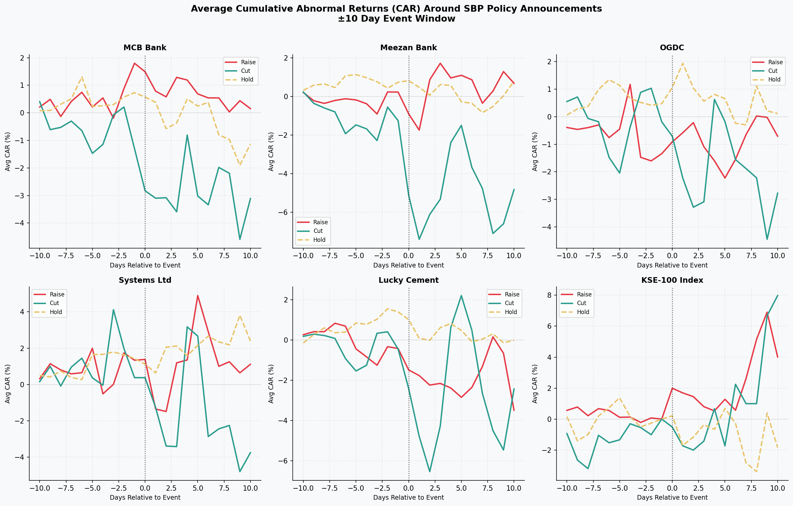
Figure 3 · Average CAR around SBP announcements, by security. Day 0 = announcement. Each line is the cross-event average for Raises (red), Cuts (teal), and Holds (yellow).
The KSE-100 drifts upward regardless of whether rates go up or down. MCB's cut-response is a slow bleed lower. Systems Ltd barely flinches. The heterogeneity is striking — and deliberate to the argument I'll build below.
2. Rate Cuts Hurt the Banks
This is the finding that most directly challenges the textbook. Conventional logic says rate cuts are good for banks — cheaper funding, more lending, economic stimulus. In our data:

−2.1%  MCB Bank · Mean CAR on Cuts | −4.5%  Meezan Bank · Mean CAR on Cuts | +0.02%  MCB Bank · Mean CAR on Raises

The most likely explanation is net interest margin compression. Pakistani bank liabilities — call deposits, overnight instruments — reprice almost immediately when the SBP cuts. But the asset side (term loans, government securities) reprices slowly. A rate cut immediately squeezes the spread between what banks earn and what they pay out. The market, apparently, knows this.
For Meezan specifically, the Islamic banking structure amplifies this: Shariah-compliant instruments like Murabaha and Musharaka have distinct repricing dynamics that make the compression more pronounced.
The information channel also matters here. In Pakistan's context, a rate cut has sometimes signalled that the SBP is responding to economic deterioration — an admission that reads as bearish, not bullish, to equity markets.

3. The Index Goes Up Whether Rates Rise or Fall
The KSE-100's response pattern is the inverse of what you might expect. Mean terminal CARs: +3.2% on raises, +5.1% on cuts. Both positive. The only event type that produces negative index returns — on average — is a Hold: −1.9%.
My interpretation: at the broad market level, the signal that matters most isn't the direction of the rate change — it's the fact that a decision was made. In a macro environment as uncertain as Pakistan's, any decisive monetary action reduces the uncertainty premium embedded in equity prices. Inaction (Hold) leaves that uncertainty unresolved.
4. Sector Differences Are Real and Interpretable
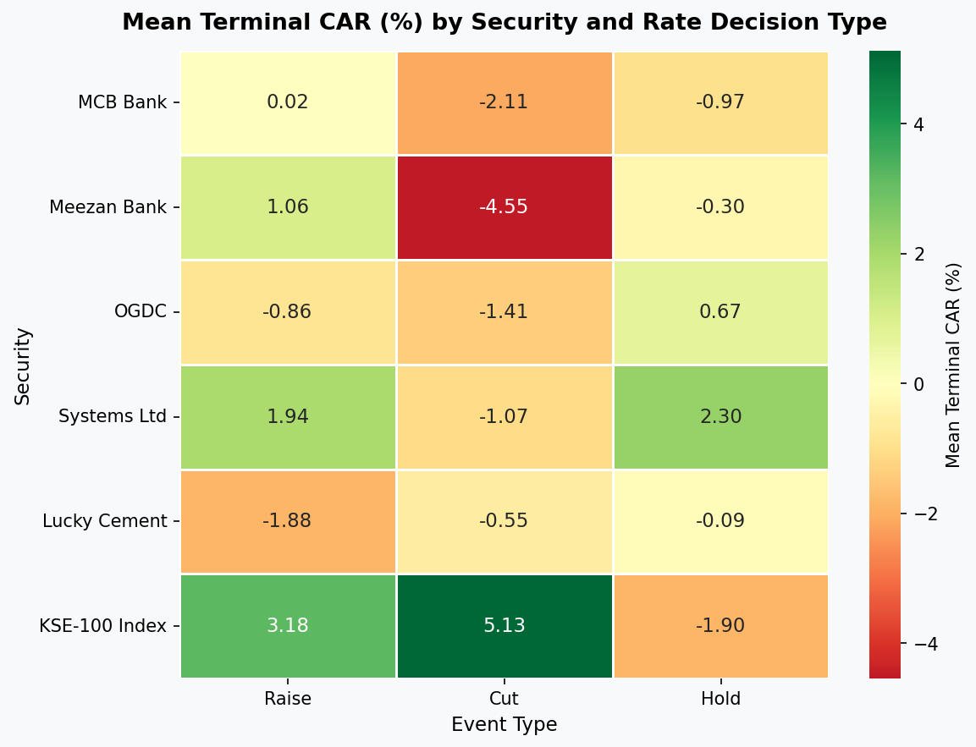
Figure 4 · Mean Terminal CAR (%) by security and event type. Green = positive, red = negative. The banking row under 'Cut' stands out immediately.
The heatmap makes the cross-sectional pattern vivid. OGDC (state energy) is mildly negative across both raises and cuts — reflecting the regulatory pricing regime that insulates it from both the costs and benefits of rate changes. Lucky Cement follows the more conventional pattern: negative on raises, less negative on cuts. Systems Ltd is the outlier on the other end, showing positive CARs under raises and holds — consistent with a company whose USD-denominated revenue makes it a partial inflation/currency hedge.
5. The Distributions Are Wide — Very Wide
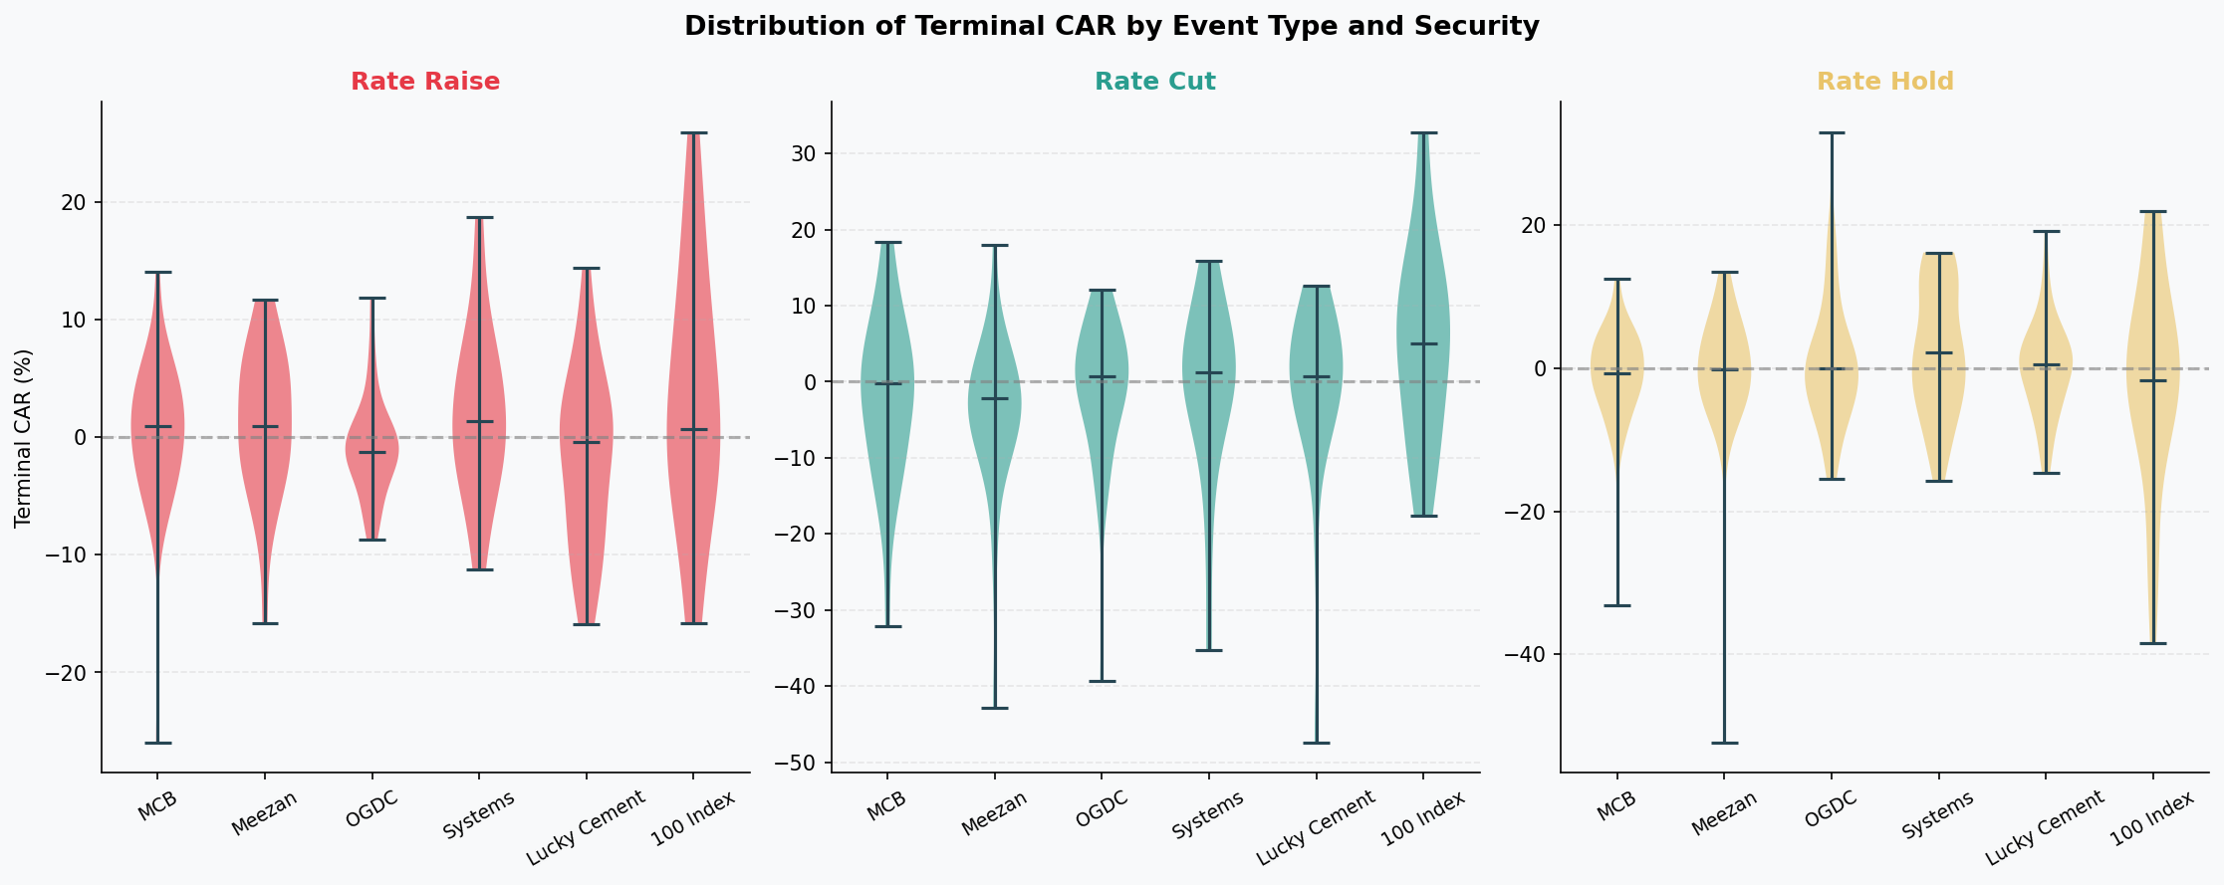
Figure 5 · Distribution of terminal CARs by event type. The widths of the violins reflect how much variation exists across individual events of the same type.
For almost every security-event combination in this study, the standard deviation is 4–8 times larger than the mean. A mean CAR of −2% with a standard deviation of 11% is not a reliable trading signal — it's a statistical whisper against a lot of noise.
This doesn't mean the mean is meaningless. It means that any individual rate announcement is also carrying the fingerprints of IMF negotiations, budget statements, geopolitical shocks, and currency movements. The rate decision is one signal among many, and isolating it precisely requires tools — a surprise-identification framework, intraday data — beyond what this study employs.
A Closer Look: MCB vs. the Policy Rate
To make this concrete, here's a direct overlay of MCB's share price and the SBP's policy rate across the full 18-year window. The visual correlation — and its occasional breakdowns — illustrate exactly why this relationship is worth studying carefully.
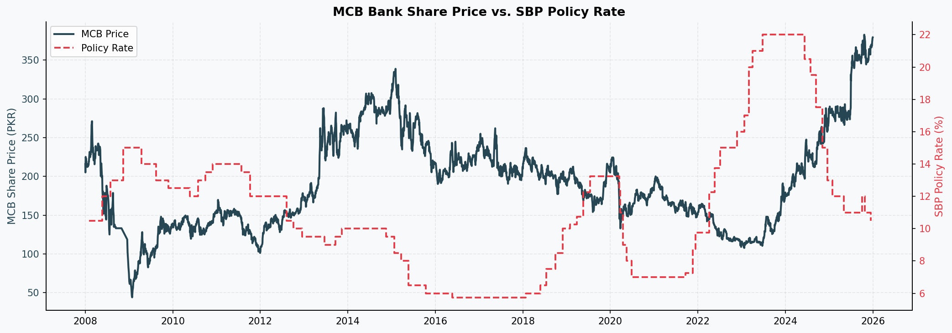
Figure 6 · MCB Bank share price (left axis) vs. SBP policy rate (right axis, dashed). Periods of rate compression and equity recovery are visible, but the relationship is nonlinear.
Notice the 2020–2021 period: rates fall sharply (COVID easing), and MCB's price rises — consistent with the conventional channel. But the 2022–2023 period tells a different story: rates rise aggressively, and MCB actually holds up reasonably well, then surges. The bank's earnings benefit from elevated rates on the government securities side of its balance sheet — suggesting the NIM compression argument is more complex at the individual security level than the cross-event average implies.
Caveats Worth Being Honest About
Three honest limitations of this analysis that any careful reader should hold in mind:
The benchmark is simplified. Using a stock's own historical mean return as the expected return is the most basic event study approach. A market model (controlling for broad market moves within the event window) would be more rigorous. Some of the "abnormal" returns I'm measuring may simply be market-wide movements that happened to coincide with rate announcements.
I can't identify surprises. The cleanest version of this analysis would distinguish expected from unexpected rate changes — because markets price in anticipated moves before the announcement. Without a market-implied rate series (which Pakistan's financial markets don't easily provide), I'm treating all events as equally surprising. They're not.
Pakistan's macro backdrop is unusually confounding. Multiple events in this sample — particularly the 2018–2019 IMF programme period and the 2022–2023 crisis — involved rate decisions that were deeply intertwined with sovereign balance-of-payment dynamics. Treating those as clean monetary policy experiments overstates what the event study framework can deliver.
The Bottom Line
Pakistan's equity market responds to SBP rate decisions, but not in the way textbooks predict. The relationship is sector-dependent, asymmetric, and heavily influenced by the broader macro context in which decisions are made.
For banking stocks: be cautious around cut cycles — net interest margin compression is real and markets price it quickly.
For broad market exposure: decisive action (in either direction) appears to be a net positive; it's the prolonged hold that markets dislike most.

The high cross-event variance is a reminder that in frontier markets, no single factor — not even monetary policy — dominates in isolation. Context is everything. The same 100bps cut that's bullish in a stable macro environment may be bearish when it coincides with an IMF negotiations impasse.
What this analysis does establish is that there's enough signal in the data to warrant far more rigorous investigation — with proper surprise identification, higher-frequency data, and a richer set of control variables. Pakistan's equity market is under-researched relative to its complexity. That gap is worth closing.

Methodology note
Event study conducted using a ±10 calendar-day window around each SBP announcement date. Abnormal returns computed as deviation from full-sample unconditional mean log-return for each security. Terminal CAR is the cumulative sum at the end of each event window. Data sources: PSX daily closing prices (Investing.com), SBP published monetary policy statements (2008–2025). All analysis performed in Python (pandas, numpy, matplotlib, seaborn).

