Pharmacy Project (Responsive)

1- Pages:

\*) Home: display all orders , all purchases , number of the drugs that Pharmacy have and total sales money and purchases cost today and the drugs that the pharmacy need

\*) Users: Show all users and you can add new user or edit existing user and remove any user but not the current logged in user

\*) Categories: Show all Categories and you can add new Category or edit existing Category and remove any Category the drugs that belongs to this category will be removed (you can use category name to filter drugs in drugs page)

\*) Places: Show all Places and you can add new Place or edit existing Place and remove any Place the drugs that belongs to this Place will be removed (you can use Place name to filter drugs in drugs page)

\*) Companies: Show all Companies and you can add new Company or edit existing Company and remove any Company the suppliers that belongs to this Company will be removed (you can use Company name to filter suppliers in supplier page)

\*) Suppliers: Show all Suppliers and you can add new Supplier or edit existing Supplier and remove any Supplier

\*) Drugs: Show all Drugs and you can add new Drugs or edit existing Drugs and remove any Drugs depending on drug type will show the available amount that the pharmacy have and the drugs that you need to purchase will be in dark background

\*) Purchases: Show all Purchases and you can add new pill or edit existing Purchase pill and remove any pill

\*) Orders: Show all Orders and you can add new pill or edit existing Order pill and remove any pill

2- Users:

\*) Admins: can manage anything in the app

\*) Normal Users: can make orders (sell drugs to patients) make purchase pill (record the purchase)

Home Page :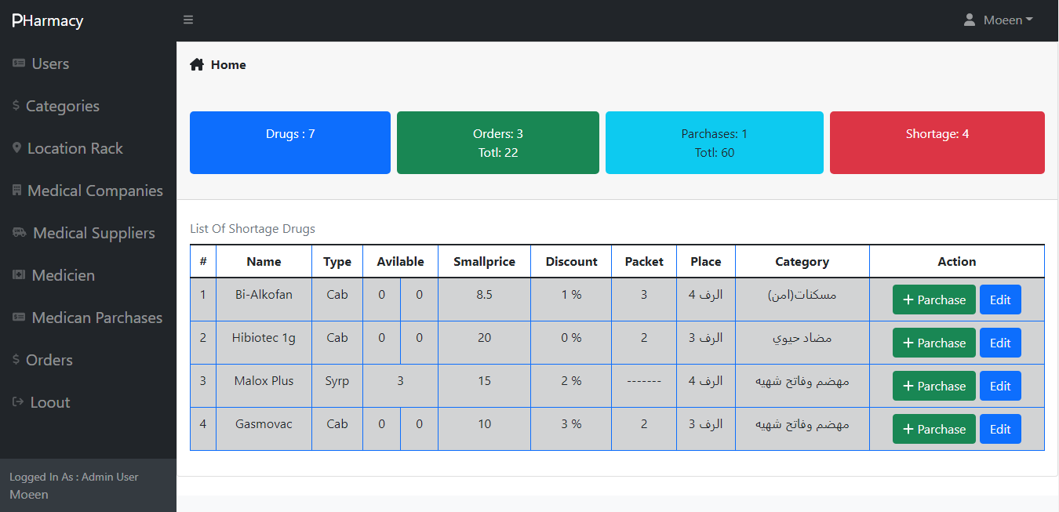

Home In Small Screens

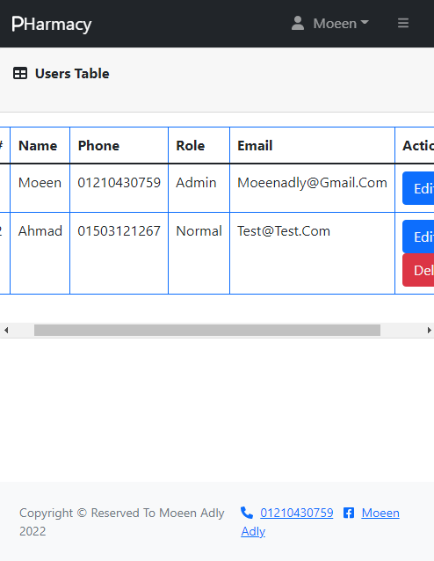

Users Page

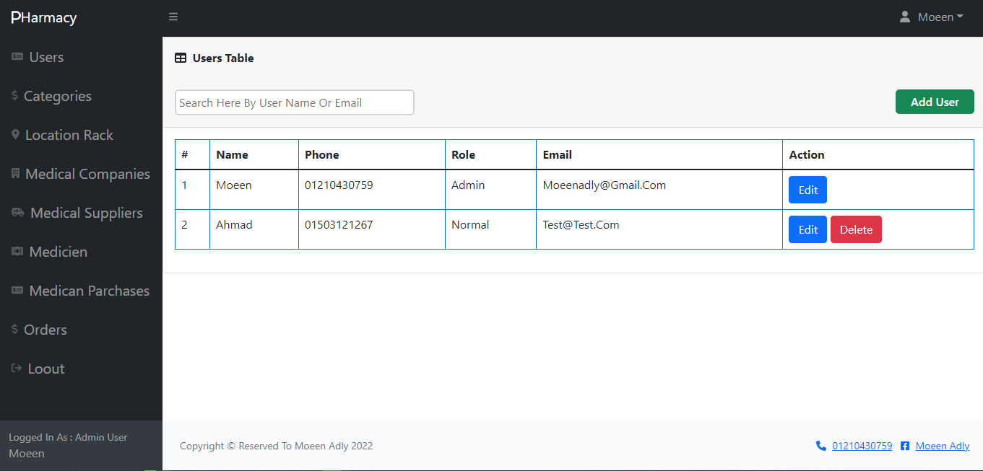

Create User Page

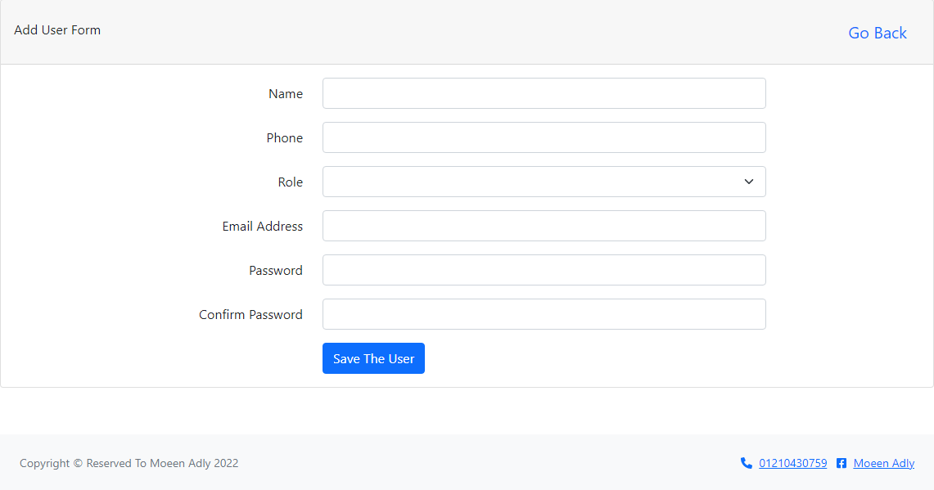

Edit User Page

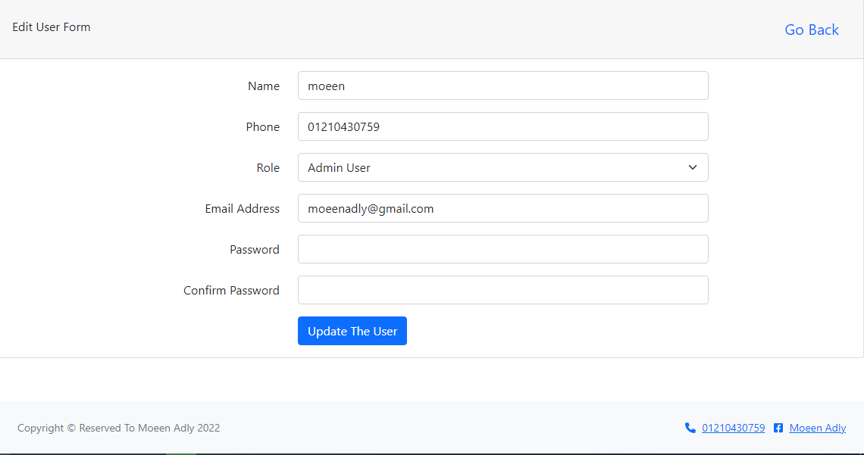

Categories:

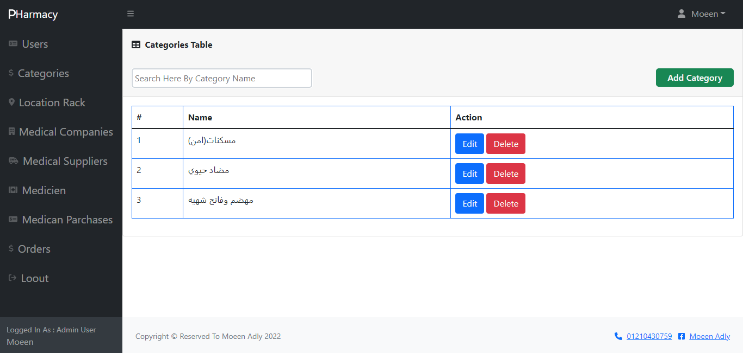

Create Category Page

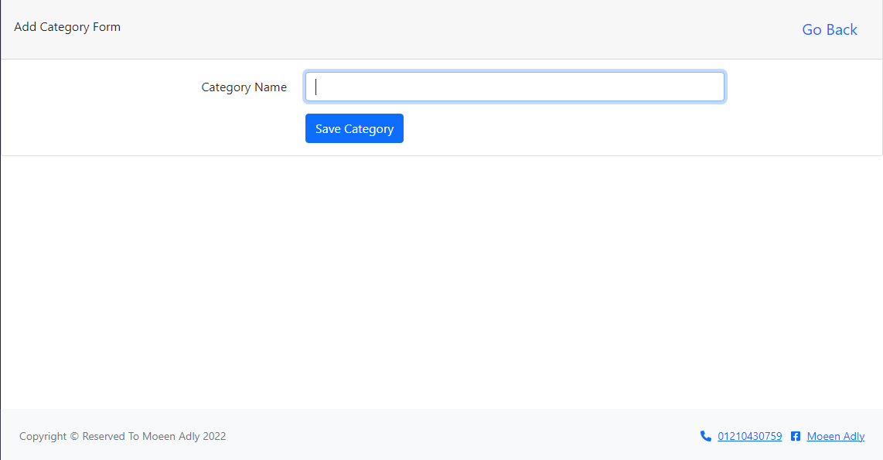

Edit Category Page

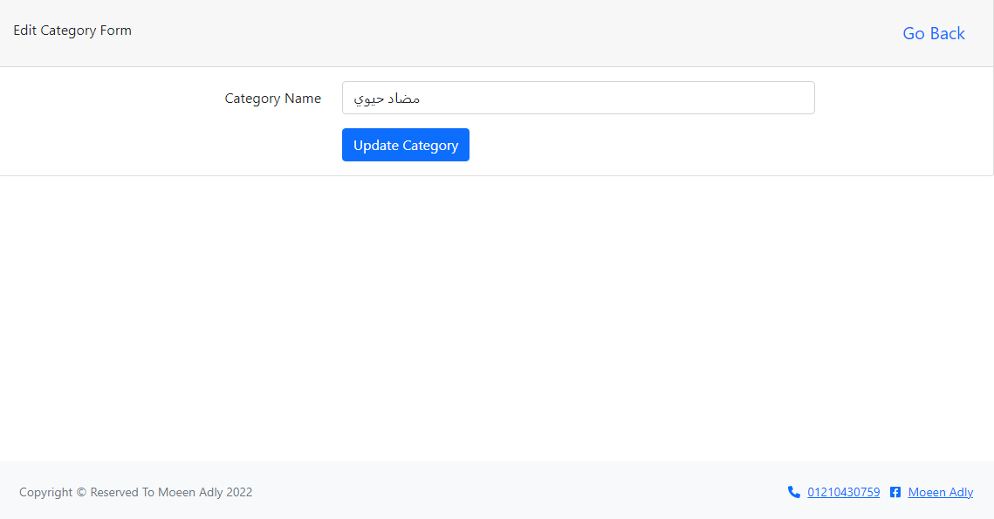

Suppliers:

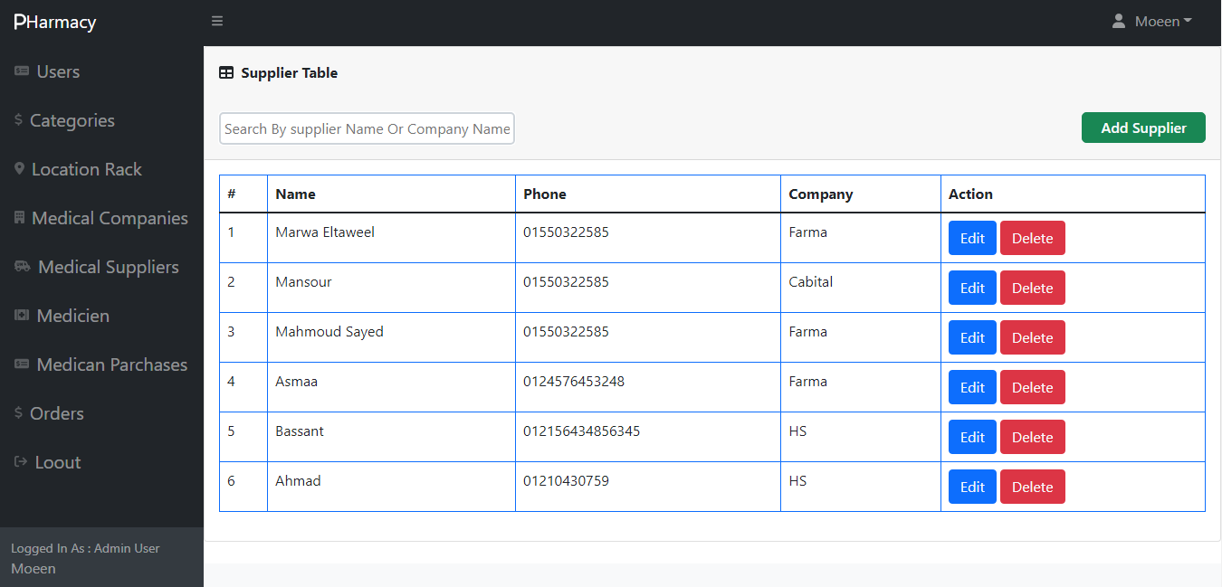

Create Supplier Page

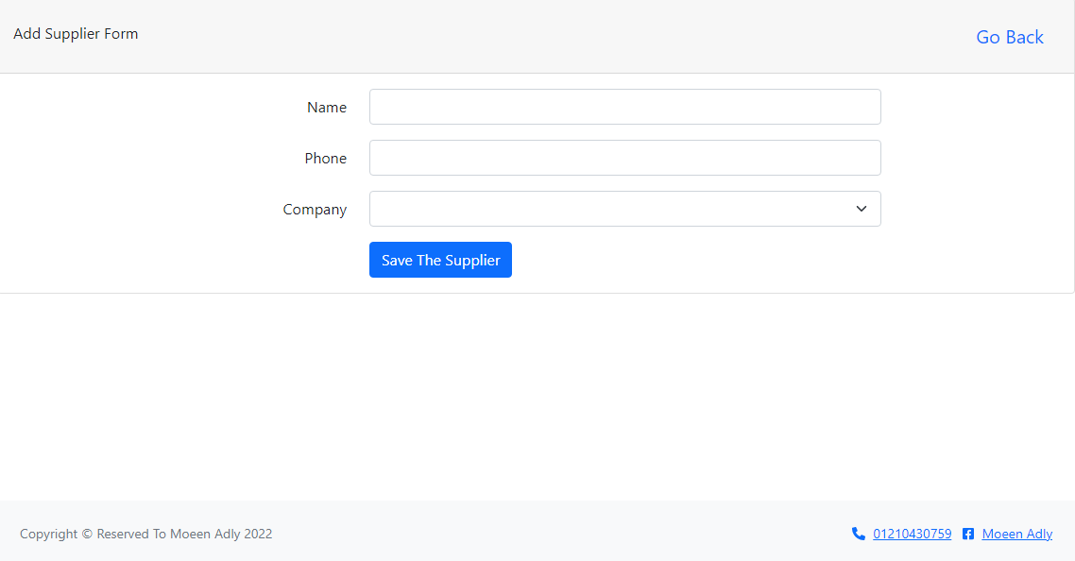

Edit Supplier Page

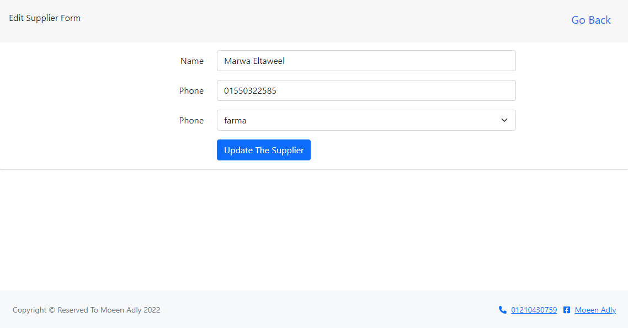

Drugs:

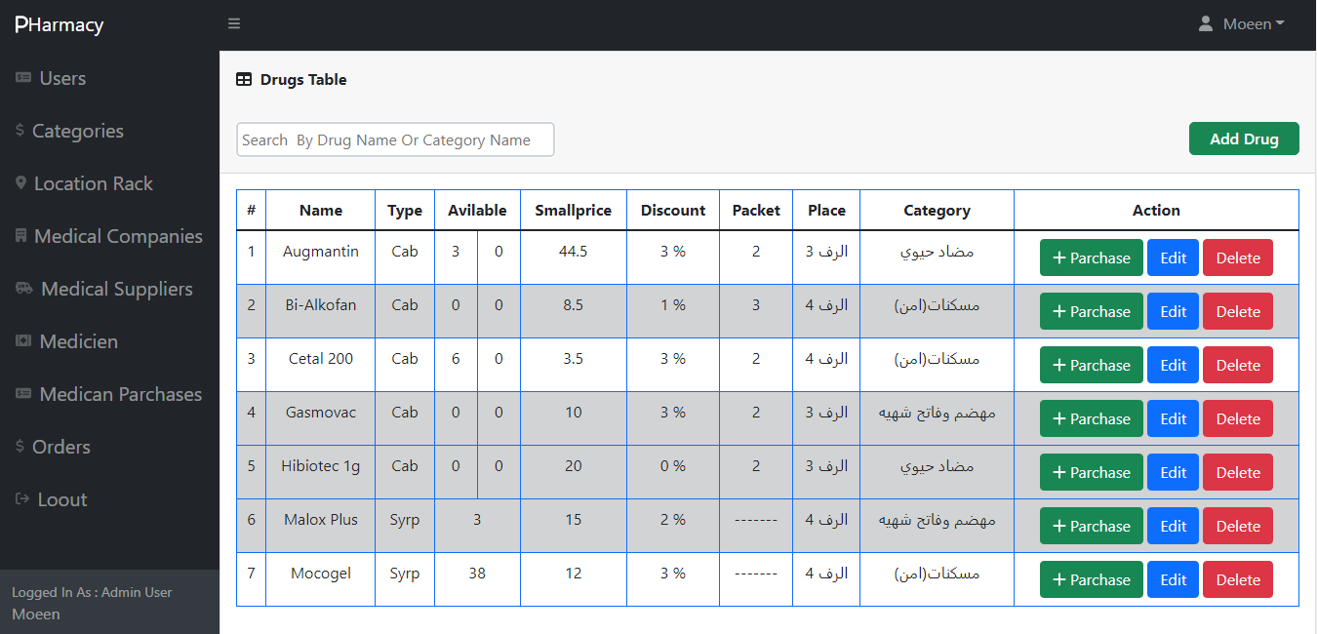

Create Drugs Page

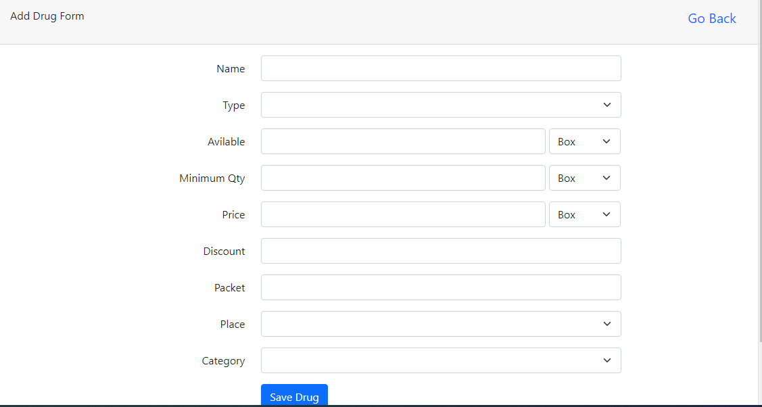

Edit Drugs Page

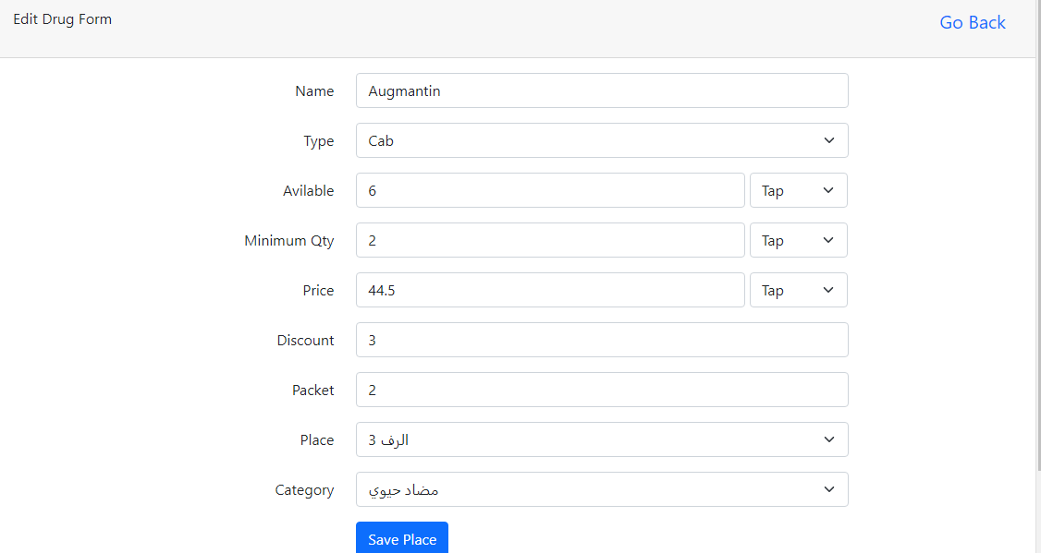

Purchases:

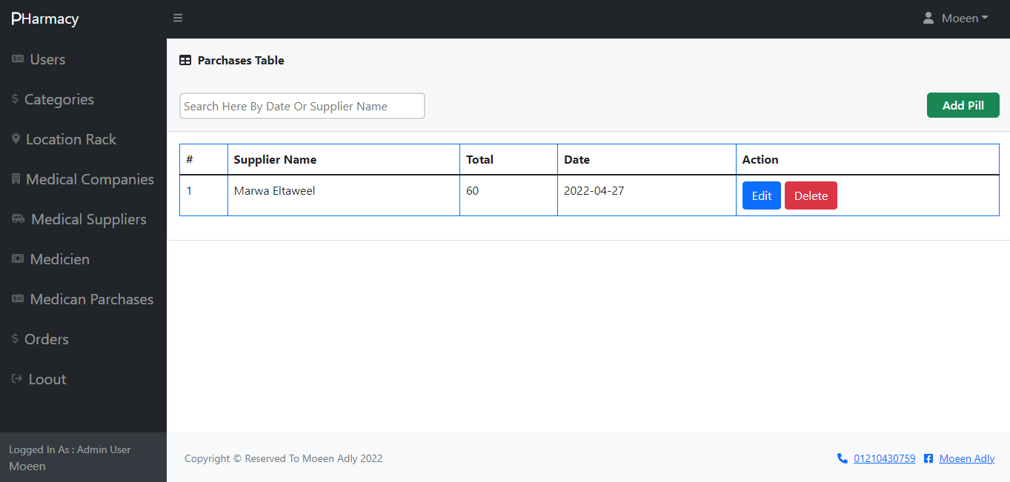

Create Purchase Page Edit Purchase Page

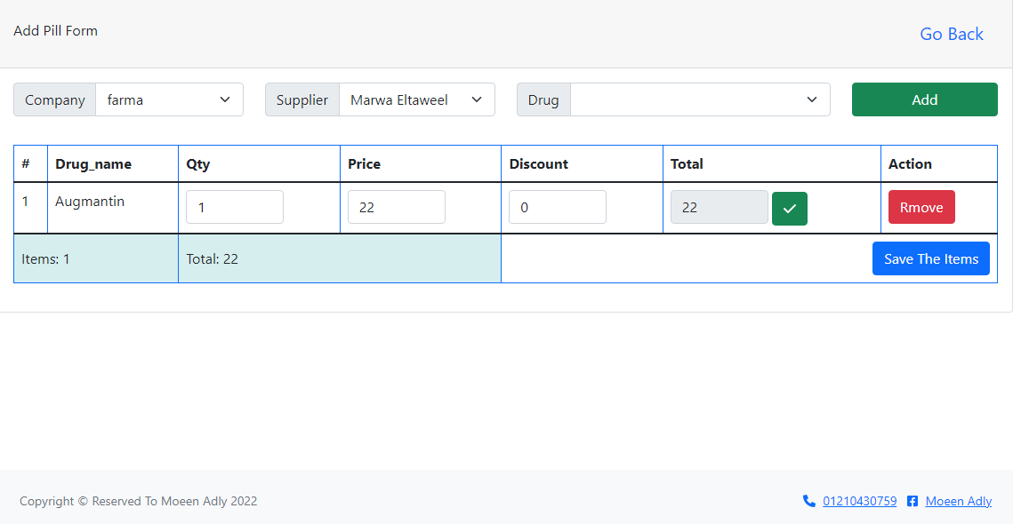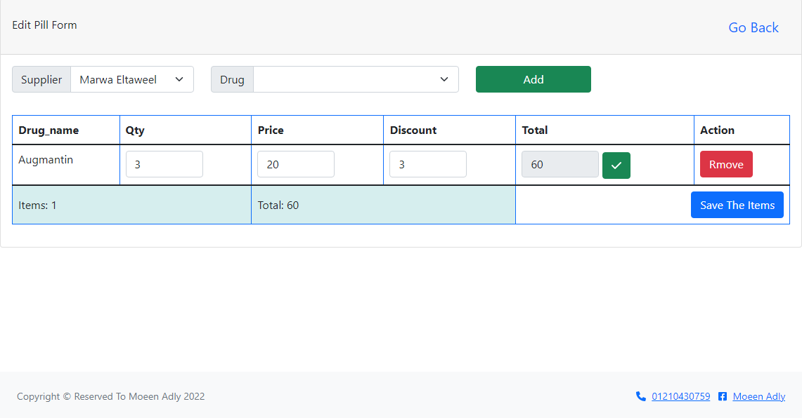

Orders:

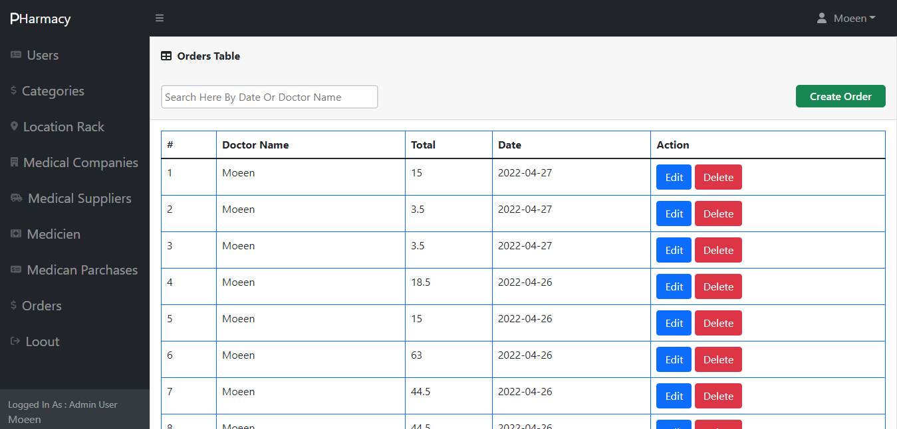

Create Order Page

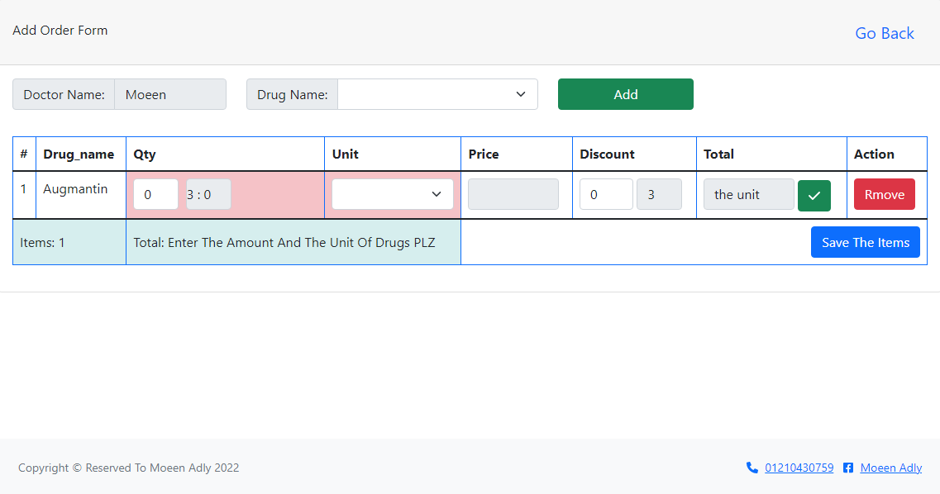

Edit Order Page

