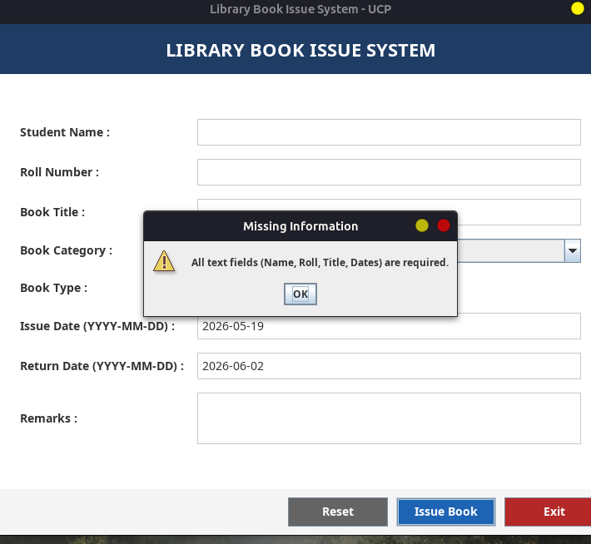
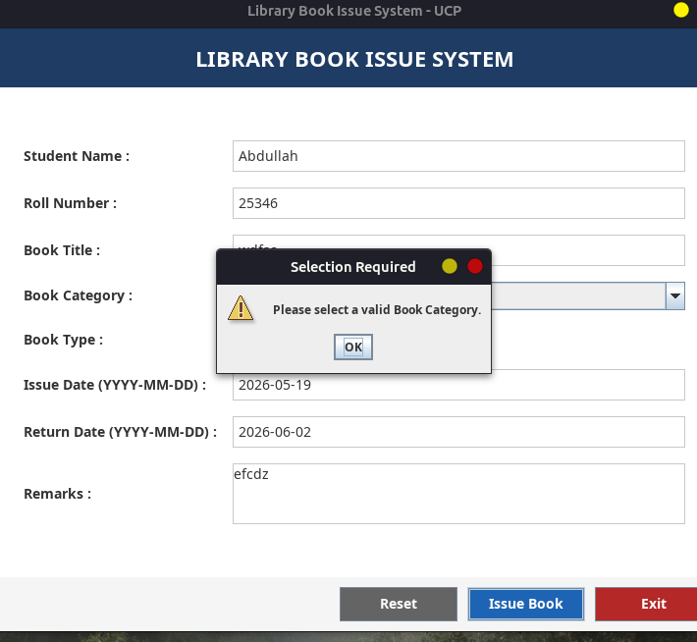
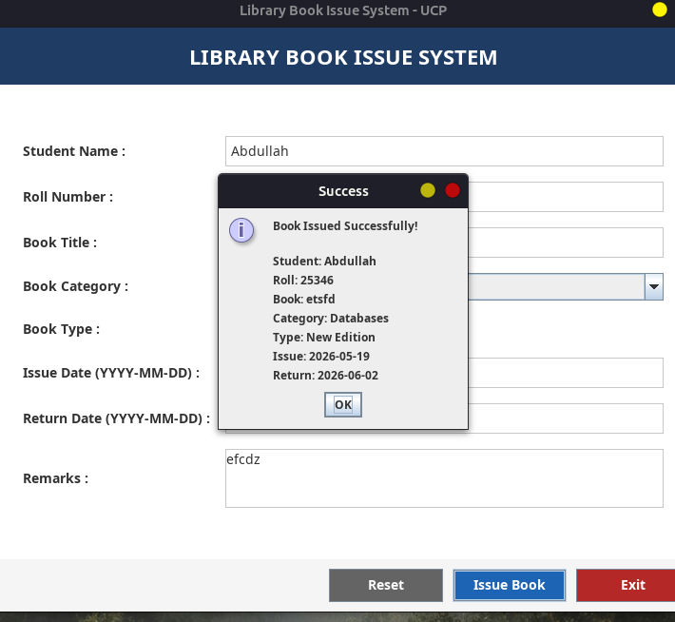
List of Implemented Exceptions
The following exceptions have been implemented to handle invalid user input and enforce data integrity in the Library Book Issue System:
- EmptyFieldException (Custom Exception)
  - Thrown when any required text field (Student Name, Roll Number, Book Title, Issue Date, Return Date) is left empty.
  - Ensures all mandatory fields are filled before processing.
- InvalidRollNumberException (Custom Exception)
  - Thrown when the Roll Number contains non-numeric characters or does not match the expected format (digits only).
  - Validates that roll numbers are strictly numeric as per university standards.
- InvalidDateException (Custom Exception)
  - Thrown when:
    - The date format is incorrect (not YYYY-MM-DD).
    - The Return Date is earlier than the Issue Date.
  - Ensures logical consistency in borrowing periods.
- NullSelectionException (Custom Exception)
  - Thrown when:
    - No book category is selected from the dropdown (default “-- Select Category --” remains).
    - No book type (New/Old Edition) is selected via radio buttons.
  - Forces user to make explicit selections for categorical inputs.
- BookUnavailableException (Custom Exception – Mandatory Custom Exception)
  - Thrown if the book title contains the word “restricted” (case-insensitive).
  - Simulates a business rule where certain books cannot be issued due to policy restrictions.
  - Demonstrates application-specific validation beyond basic input formatting.
- NumberFormatException (Built-in Java Exception)
  - Caught during internal processing if numeric conversion fails (though primarily handled by regex validation for Roll Number).
  - Included as part of comprehensive exception handling strategy.
- DateTimeParseException (Built-in Java Exception)
  - Caught internally within validateInputs() method when parsing dates.
  - Re-thrown as InvalidDateException to maintain consistent custom exception interface for UI layer.
- finally Block Usage
  - Executed regardless of success or failure.
  - Logs “Operation Completed: Issue Attempt Processed.” to console for audit/debugging purposes.
  - Satisfies requirement to demonstrate cleanup/logging behavior post-operation.

