
THE SURVEY OF THE UET HOSTEL MESS (Group 1)

Table of Contents

Introduction 4
Data Summary & Observations 15
Findings and Discussion 26
Conclusion and Suggestions 27

Presented to
- Ms. Ramsha Khalid

Group Members
- Moeez Ahmad 2025-GA-89
- Syed Muhammad Ali 2025-GA-68
- Fatima Batool 2025-GA-116
- Alishba Mahmood 2025-GA-76
- Muhammad Arham 2025-GA-102

Topic of Survey
“THE SURVEY OF THE UET HOSTEL MESS SYSTEM”

Date of submission
24th of November, 2025

Introduction
Our goal is to conduct research on a very personal yet public topic. Our goal is to learn Google Forms and other Microsoft Office tools through practical examples, and we need some real-life examples and topics to achieve this goal.
Our aim is to collect data from the user and use that data in our project and do some practice of Google form and the other tools of Microsoft office. To achieve this goal, we need to collect some information from the mess and before reaching out to the public, we need some topic to get started.

Our Topic, and Why We Choose This?
After deep research within our group, we decided to start our research with a topic that feels personal yet public at the same time, that will help us to connect with the public easily. We needed a topic that contains this type of data that will help us to work on MS word, Excel & Power Point, simply because we needed to create the Lists, Graphs & Reports for our Project. So, we choose the topic:
“The Hostel Food Condition in University of Engineering and Technology”

How this Topic Help Us
Our Group Member Ali is a hostility who played an important role in this group project. With the help of Ali, we all decided the questions, which we were to ask from similar hostilities, and this was just the beginning step of our project.
This Group project is not a project that can be done by only one person. This project needs complete support from all the group members, and all group members do their best and provide their best from their busy daily routine.

Procedure

Our First Step
After selecting our topic, the next step was to identify our target audience. We needed a specific group of people with whom we could connect and from whom we could collect reliable data. Since our project required responses through a digital form, it was essential to determine exactly who would receive the form. Defining the target audience allowed us to begin the data-collection process in an organized and focused manner.

What is Our Target Audience?
Our target audience are the students currently residing in the hostels of UET, simply because the hostilities eat and survive on from the hostel mess and, rest assured they are the only ones who could’ve provided us with the best responses and most accurate data that we could use in our survey of UET hostel mess system and food quality.

For whom is this survey for?
Our target audience is UET Hostilities, and our research will help the new Hostilities and new students of UET.
This survey will help them to decide whether they need to choose the UET hostel mess services or want to choose some other food services in their hostel.

How can we Collect the Data?
It is easy to choose our topic, it is easy to choose our target audience, but the most difficult thing is to find a way to collect the data from these target audience. We need a lot of data so we can’t use our random Pen and paper to collect the data from the users we need some automated things that can help us to collect the bulk of data from our target audience.
In 2025 there are many software applications that provide us the facility of collecting data from our users in an automated form, for example Microsoft forms, Click-Up, WP Forms and many more software that provide a form interface to collect data from the users, but we use Google Forms.

Why We Use Google Form?
After choosing the topic & our target audience, our next goal was to create form to get data from the users to get data from all the hostel and combine them in our research so that we use Google Forms, because Google forms is a tool that is used to create forms easily, we use Google form and create a form to collect information from the user. Form has multiple questions regarding to the Hostilities of University of Information and Technology, we created some easy questions, some basic questions and some questions we need to add in our research.

Google Form is a free online tool that allows users to create surveys, quizzes and other data collection forms. This is a part of Google Workplace suite and is used to gather information by creating and sharing form with the audience request. It can be viewed and analyzed in real time or automatically combine into a spreadsheet like Google Sheets.
We asked multiple questions for our audience to collect information about the hostel mess we also asked the reviews of our audience and asked about deep research from the users that how much they wanted to rate their hostel system and how much they pay for their hostel mess.

Our Questions from Our Target Audience
- What is your name?
- What is your registration number?
- What is your Hostel Name?
- What is your Gender?
- Any proof that you're a student of UET (Offer Letter / Registration Slip)
- What city were you originally from?
- What was your recent monthly bill of mess?
- What are your mess monthly service charges?
- What food do you find good and tasty in your mess menu?
- Do you think the prices of food are justified according to the quality of the food provided?
- Rate the Mess Food according to Prices
- What are your timings of mess in your hostel? (Morning)
- What are your timings of mess in your hostel? (Evening)
- Would you like to change your mess timing?
- Is meat a part of your mess menu?
- What is the quality of meat provided in mess?
- Do you think that mess food is negatively affecting your health?
- How many times do you prefer going to a cafe rather than going to the mess?
- Do you think the Cafe food is better than Mess?
- If you were to add/replace an old dish with a new dish, what would you suggest?
- What is your rating for the current food situation in the mess?
- What are your suggestions for the mess situation?

How Can we Reach To our Target Audience?
The most difficult step in our research and survey is to find the target audience, to reach our target audience and to get permission to send their form and to ask them to fill in the form properly with accuracy. Most of the people in our research don’t want to fill in the form or don’t have time to fill form and or they don’t want to share their mobile number.
We also tried to send our form into some WhatsApp groups that will have us to boost our responses in our Google forms but most of the group admin didn’t allow us to send our form in to their groups and ask from their group audience to submit our form, so we create a QR code and go on the hostel mess areas and ask from peoples to scan that QR code submit our form.
From this method of QR code we got a mass audience to fill our form but this is not enough to complete our limit of our survey so we use another method of universal group like our main group of CS department we created a banner for that and send that banner in our CS main group and ask their members to fill this form but we got a problem the main group admin delete our message from the Group.

Limit & Responses
Our minimum limit for form Submission is 20 but our group decided to collect the information of minimum 70 PEOPLES to make a great survey and deep research on this topic, but we fail to collect the information from the 70 people, and we stuck after 55.
Our team decided to collect 70 pieces of information because we wanted to filter some information and we need some accurate 50 data that will help us to create deep research on our topic but after collecting the 55 responses we figure we figure out that most of the people respond it correctly. So, after Filter the data we got the actual result of 43 peoples that is our response that we get from our target audience in two days.

Next Step!
After collecting the data from the user, we got 43 filtered response and now we need to create the excel file for these responses, as you know Google forms give us a button to create all the excel file for the data available in our Google form responses as we convert the data of 55 records into excel
We need to filter them and for we use manual method to filter out all these data of 55 people some people didn’t response according to our required information. For example, some people added their hall which is not included in UET in our research and some people add some uneven names for example someone added the name as ‘cockroach’ so we need to remove them and most of the people do not fill the timing in the correct format some people at the evening 6:00 PM in the morning Breakfast column
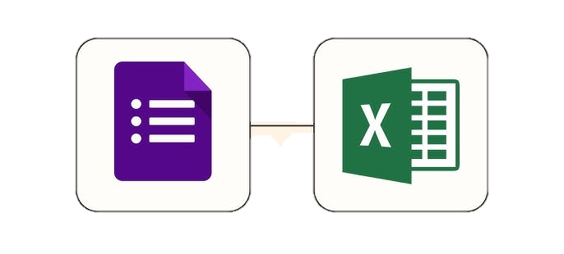
After filtering out 55 data we got the correct responses of 43 people and then we need to convert these into the graph format and make the table on our excel file for this purpose we need to export the spreadsheet of google and then convert it into the .xlsx file to use it in our excel tool.
This is a very important step to convert the Google form data not in Google spreadsheet But in MS Excel because MS Excel provides us more features as compared to Google spreadsheet and more comfortable while working on it because the google spreadsheet is the online software but we can use our MS Excel in our local machine that provides us more speed as compared to Google Spreadsheet

Why do we use MS Excel?
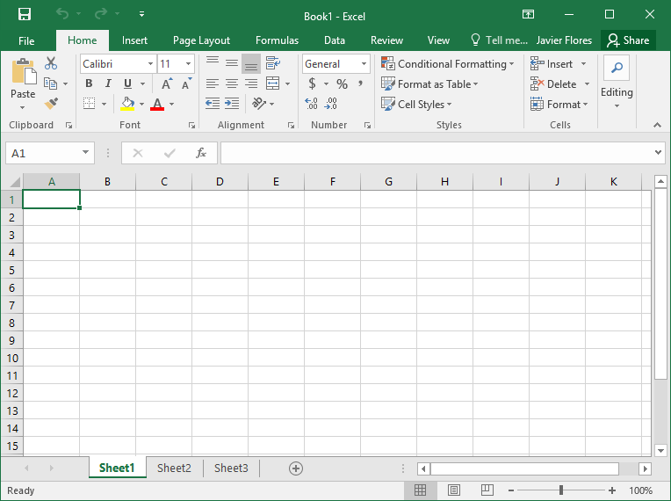
MS Excel is a tool that provides Many features of arranging data collecting data and formatting the data in the form of cells rows and columns, so we use the MS excel to create a file of list of our responses.


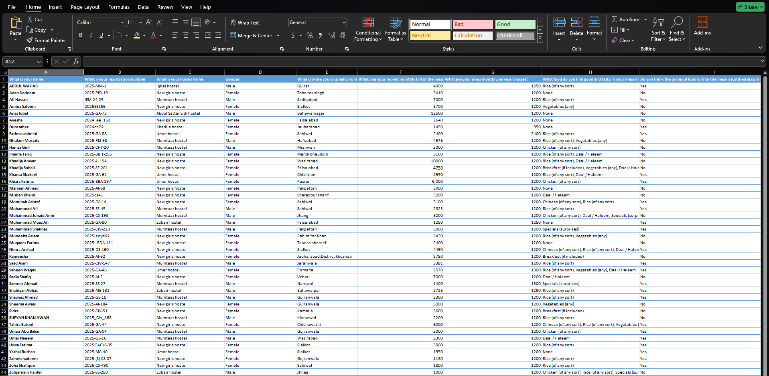
MS excel provides us more feature of arranging the data in the form of this because it is a tool of the rows and columns that provide us more feasibility of managing the data we use MS excel for our arrangement of data and creating graph of different thing we will add more we will see all the data at 1 glance with this tool so MS Excel is the best tool in our research we have ever used to arranging the data.

Features of MS Excel We
The MS Excel provides many features such as data organization the most important feature that we use in this survey the MS Excel allow us to arrange the data in the list format and also, we can sort our data with respect to any field and any alphabetical order from A to Z or Z to A.
MS excel Also provides us with the feature of data filtering we can filter out all the unnecessary data OD data that is not filled properly from the customers or target audience we can filter that project and use the filter data that we need in this survey.
Also, the MS excel provides many functions and formulas that help us to calculate what type of average the users are performing for the hostel mess ratings and also, how much bill they pay and what is the average pay per user paid to the hostel mess.
The feature of MS Excel that I like the most is the graph and table format the MS excel provide us many types of graphs that can be used for data visualization we also create many graphs in our MS excel project that help us to manage and visualize our data graph formats and this is my favorite feature I have seen in this tool.
Also, the MS excel provides us many sheets option in one file that help us to make our understanding and visualization easy we create many sheets in MS excel for gender and reviews and hall names and many other things.
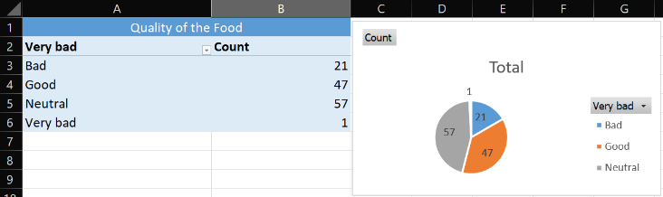
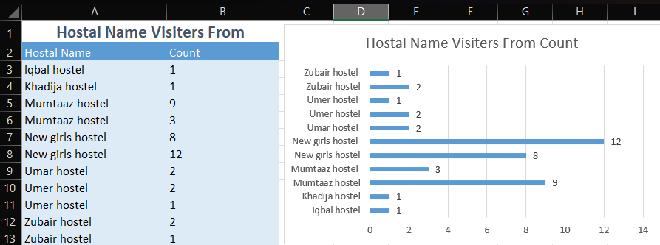
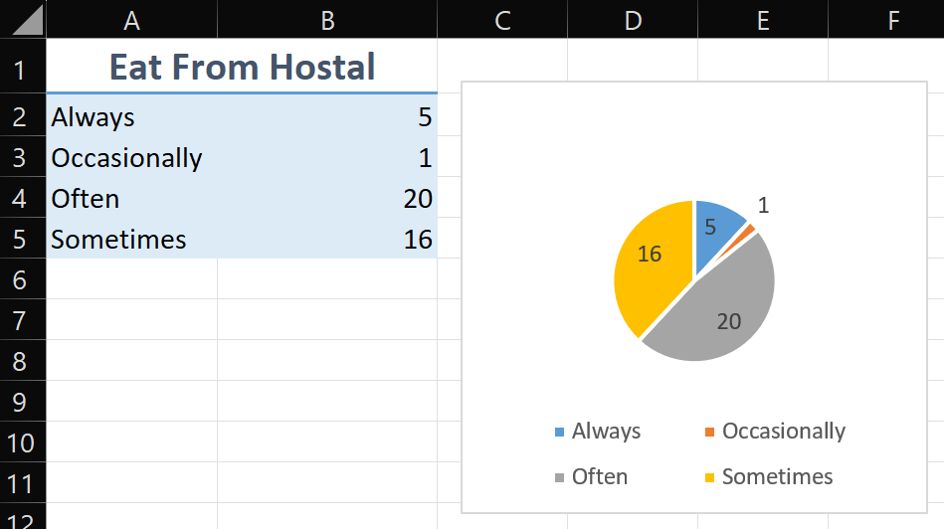

Why we Prefer MS Word.
MS Word is the most popular tool in 2025 in document creating and survey results writing so we prefer MS word for this purpose of creating our survey research in the form of detailed paragraph images and detailed guideline with the graphs.

MS word is an offline tool that is installed in our system and it works on our local machine provide us more speed in our computer system it works without any online network connection and provide us all the feature offline that is the main purpose of creating this because sometime we don’t have Internet while presenting our documents show so we need some offline tool that work best for these features.
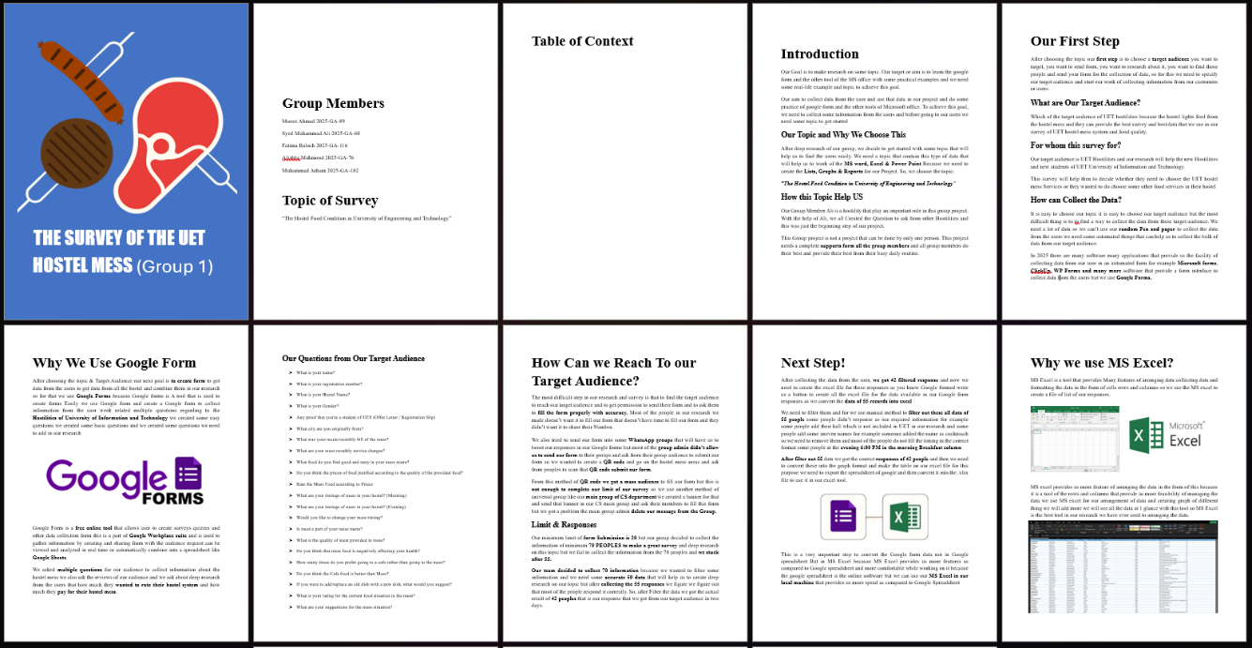

What do we write in MS Word?
We need to write all the survey but we asked from our user what are our group members what tool we use what are our requirements in this project what are the main purpose of creating this project what are our topics what are our problems we face in this project and what are our main goal of creating this complete survey in our university so for this purpose we use MS word and write all our necessary documents our necessary paragraph and accessory key points that we need in our this project we write in our MS Word document that is a detailed research of our survey and hopefully this will be our great survey for all the host write that and the newcomers of UET that wanted to join the UE T in next year’s this survey will be helpful from for them.
- Prepose of Creating this survey
- Key Features of this survey
- Valid points of this survey
- Problems we face in this survey
- Reason for starting this survey
- Research of this survey

Data Summary & Observations
After conducting this complete survey, we got many results about the Hostel mess and hostel food services so we will discuss all this research in this document that what are our research about this.

Total Form Summited. (43)
After three days of effort of submission of form we got 55 results and after filtering out this result we got only 43 valid results that we know that we will use in this research.

Gender of the Users.
In this detailed search and survey, we target both boys and girls for reviewing in hostel mess services, so we got the result of 26 females and 17 males in our survey.

Hostels Names.
As you know in University of Engineering and Technology there are multiple halls and We got result from multiple hostels so our research said that One 1 is from Iqbal hostel the 1 person is from Khadija hostel the 12 persons are from Mumtaz hostel the 20 girls are from New Girls hostel and 5 boys are from Umar hostel and the 3 are from Zubair hostel. Amd 1 from Abul star eidi hostel

Food Quality.
While analyzing all 43 results from 43 host slides, we got result that only nine people reviewed the hostel food as bad the 12 students reviewed the hostel food as good to 20 students reviewed the hostel food as neutral and only two people reviewed the hostel mess as very bad.

Availability of Meat.
A total of 19 people replied that meat is unfortunately not a part of their hostel mess. Whereas the remaining 24 people answered that yes meat is available in their hostels. This was somewhat good news for us group members, as meat is the main source of protein and essential vitamins and other nutrients, which are crucial in the mental and physical development of a student’s mind and body.

However, on the other hand this question deduces that some halls managements are not providing students with enough meat. Furthermore, we asked the students what the quality of meat was they were being provided and we got some responses.
- Very Bad and Anti Stomach Quality, Old refined oil is used and not any salad and plate is full of oil.
- The quality of meat being served is moderate but meat on daily basis is not acceptable.
- Pathetic.
- It's average, some dishes are good, some just fine. Not bad, not good.
- It’s not provided to us.
- Don’t know but we are always fed-up after eating chicken.
- Good quality required in mess.
- It's better.
- Neither good nor bad.
- It's actually better.
- Poor ... Causes nausea.
- I would say it is cooked pretty well and good.
- Very satisfied.
- Normal.
- Worst, all types of meat taste the same it’s so freaking annoying the same taste makes sick.
- Acceptable.
- Awful tasted like nothing, most probably donkey meat.
- Not bad but not good.
- Mediocre.
- Meat is not provided yet.
- Only chicken is provided.
- Average.
It was clear to us from these short answers that students were hesitating to openly call out the mess condition, whether in favor of them or against them. However, it was also evident that many students were not satisfied by the quality of meat that was offered on the table.
Protein is absolutely essential in the mental and physical development of a young student, especially in the sophomore year. This question may seem unrequired and useless to some, but it was vital in proving that the availability of meat is just the bare minimum, the duty is not fulfilled there. The duty of the mess management is fulfilled only when the meat provided is also of good quality.
Without this, it is similar to that that you provide small kids with a playground filled to the brim with sand, but it has no swings or anything to play with in it. It is useless and harmful for the kids, much similar to the raw and uncooked -filled with bacteria and germs – meat provided to the students in the mess of UET.

Choosing café food over hostel mess
We asked from the hostilities that how much time they go on hostel mess and eat from the hostel mess so the five people replied as always, they eat from their hostel mess services the one people answered that he occasionally goes on mess and 20 people replied as they often go for mess in their hostel mess services and 16 people replied that they sometimes go on hostel mess services. This is clear and undeniable evidence that people eat at their mess only because they don’t have any other options. Given the option to eat from cafes instead of their hostel mess’s, I doubt that any student would reject it.

Prices of food within the mess is justified.
We questioned the audience whether the price of the food being provided in the mess was justified according to the quality of the food. Out of the total 43 responses, 20 people said no, and they thought that the hostel mess is more expensive compared to the cafeteria food and 23 people applied it as yes. This implies that the students find the mess food suitable according to the price. However, this doesn’t mean that the quality of food is good or excellent. The quality, as already discussed earlier, is not good and this overall shows that students are now just trying to exist in this, otherwise horrible and mind-boggling mess environment.

Rating of Hostel Food
While taking the rating of hostel, we got results from 43 responses and there are only four people reviewed it as rating 5 and eight people reviewed it as rating 4, the seventeen people reviewed it as the rating 3 and ten people reviewed it as the rating 2 and three people rate it on the rating of 1. This clearly shows that students are in the middle of confusion and happiness. They are not fully happy, as only 4 of the total 43 people gave their hostel mess a 5-star rating. While majority of people decided to rate their mess 4 out of 5, a major collection of students was seen rating their mess a neutral 3, meaning they weren’t satisfied by the mess conditions, but they were not against it too. They were neutral, just existing for the sake of it. They probably had some complaints but decided against them. And stayed quiet and silent. After that a total of 13 people rated their mess 2 and 1 stars. This shouldn’t have been a problem, until we figured out that only 12 people decided to rate their mess above 4. Meaning that more people decided to down-rate their mess instead of the people who up-rate their mess. This is crucial and vital information for the mess management as it shows that students are not happy with their performance and the quality of food they are being served.

Mess Timings.
While asking about the mess timings we got the result that the 22 people agree with the hostel current timing and 21 people do not agree with the hostel current timing.

Short Answers got from Audience
- NOTHING
- There should be timing for every floor so there would no crowd atleast 30 minutes each
- Nill
- Pleaseeeeee for gods sake reduce chicken. Add veggies and daal plus lentils. And meda (all-purpose flour) ko kam krein. Please add gandum ki roti too. And NASHTA karaya krein. Hygeine ka khyal rakhein so we all dont get sick
- Health hazardous mess and oil is very bad
- Service charges should be lessen taste should be better
- Please improve
- Mess situation is very much satisfied regarding food and quality i would prefer to eat through mess instead of cafeterias
- The Mess Manager should include “Breakfast.” If he includes “Breakfast,” he should also add “Chai.”
- Need for best quality of food
- it is like hone food lkin ghr k khna nhi hai yar har din chocken chicken hota hai our mess k khny m include hona chya mtlb koi metha ya fr tea our us k sth gandum k roti k pratha hona chya kia roz maida maida our tnduri roti nhi khae jati our agr srdiyo m ubla hua anda saln k sth ho t maza h ajae
- Breakfast should be provided as we can't come from so far to eat the lunch and also can't spend the day without breakfast also they should reduce the amount of chicken they make and roti they should make some rice dishes as well
- We are being served chicken on daily basis. We want vegetables some days in mess.
- Everything is fine, but they should use wheat flour instead of refined flour.
- Change timing
- We are given only one piece of chicken plz double the piece of chicken
- Maidy ki roti should be replaced by wheat roti
- Meat is the main issue we all are sick by eating the same food same taste again and again and again
- Improve service
- Rice dishes are very bad. I think they should be replaced by some other dishes like Karahi, kabab etc.
- It should be improved
- It can be better
- replace chicken and provided breakfast
- There are much service charges
- stop making too much chicken and include some daals please low the mess charges and services charges as well .... And also provide some sweet dish in a week
- Good
- Try to make Less oily food.
- Kindly give us wheat bread and remove chicken because they can't cook chicken properly.
- Improve the food quality
- I would say that mess should lower their service charges and add more foods items on the menu, that way we can have more items to eat from like tea or something sweets someday in the week.
- They should add seasonal fruits, vegetables and food such as ladyfinger, fish and oranges etc. They should also add hot beverages such as tea and coffee in the menu.
- Mention the price of meal on attendance sheet/register
- Don't make chicken very often
- Special dishes like kababs and other fast foods should also be in the mess
- "Make less chicken and lentils, and cook more vegetables.
- The mess should change it's timing. And they shoyld also include some more chicken items.
- I wanna appeal to mess that please extend the timing of evening shift to about 7 30. The rest i want to ask mess to make their service more better.
- Keep it more better
- No words
- No suggestions because they won't be heard
- Use less oil but of good quality clean Cutlery properly
- Change menu every week
- I just want to suggest that keep some taste because everytime I used mess the taste was different and some times it's not able to bear so please make it suitable for everyone.

Findings and Discussion
After analyzing the complete form will go out this result that the hostel as service is very good and they just need to improve the hostel mess services and food quality a little bit and they also need to change the mess menu because most of the people didn’t like the hostel mess menu everyone has his own taste so they need to provide multiple options in one time.
The main thing is to change the hostel mess timing because almost 60% of people didn’t like the hostel mess timing due to the class, they missed the hostel mess and the hostel mess services needed to focus on this because their main reason to all the hostel and they failed to achieve their mission.
They need to change the hostel mess timing; their morning mess timing is 11 o’clock and most of the students are in their classes that results in missing the hostel’s mess services although the pricing and the food quality are not very poor by the reviews of our audience.

Conclusion and Suggestions
The conclusion of our project is that our hostel need some improvement in its mess services because most of the people that came from other cities required more variety of food, in the first semester to decide whether their hostel mess system is good or not as you know the 1st impression is last impression the impression of UET hostel is not good so they need to improve it for providing much powered from the students and positive recommendations from the students.

Our suggestion to hostel mess service is that they need to make the hostel mess services more comfortable for the students because some people reviewed the hostel mess timing is not good and some people reviewed it as the hostel mess quality is not good, so the UET needs to improve both these things for further positive reviews.

Report Written by:
- Moeez Ahmad 2025-GA-89

Proofread by
- Muhammad Arham 2025-GA-102

