University of engineering and Technology (UET)
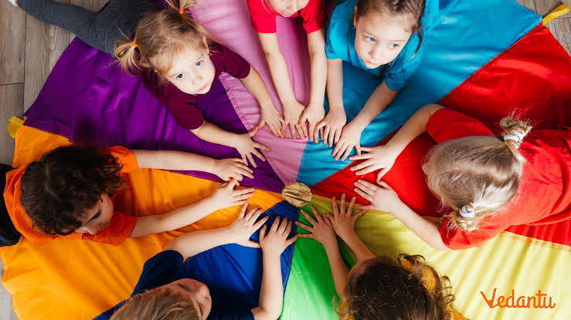
Descriptions of the learning environment (play-based, social, creative) and the developmental benefits, such as increased vocabulary, listening skills, and independence.

SOME ACTIVITIES ARE:
hands-on math games like sorting and building patterns, literacy-focused tasks such as sensory bins and letter-matching games, science experiments like sink or float, creative arts and crafts like making shapes, and engaging outdoor explorations such as nature walks or scavenger hunts.
These activities develop helpful abilities in children for future.

EMAIL:
www.uetlahore.com

