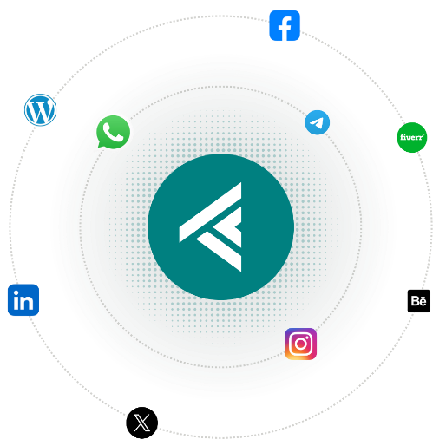

TechKreative
Partnering with You for Digital Success

At TechKreative, we are passionate about technology and creativity. Our community of experts is dedicated to delivering high-quality digital solutions tailored to your needs.
Whether you need a stunning website, a robust digital marketing strategy, or a complete brand overhaul, we have the skills and knowledge to make it happen. Our mission is to empower businesses like yours to succeed in the digital world by providing exceptional service and results that exceed expectations.
Services
We are serving many Digital Services. That will help you to grow your business as expected.
Website Development
Modern, responsive, and fast-loading sites.

UI/UX Design
Clean interfaces with user-first layouts.

Thumbnail Designs
Attractive Designs of YouTube and other Videos

Maintenance
Ongoing updates & performance support.

SEO Strategy
Boost visibility with smart optimization.

Brand Identity
Logos, colors, and brand guidelines.

Social Graphics
Posts and banners that get noticed.

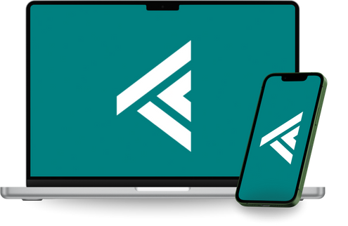
Have a project in mind? Let's discuss how we can help you achieve your goals.
Contact Us

WhatsApp: 03259491349
Instagram: @techkreative
Website: techkreative.com

