5/31/2020

Name: Moeez Ahmad

Enrollment#: 03-134181-012

Data Communication and Networking

Table of Contents

Topology 2

Topology for city Karachi 3

IP address assigned to interface of routers city Karachi: 3

Topology for city Islamabad 5

IP address assigned to interface of routers city Islamabad: 5

Topology for city Peshawar 7

IP address assigned to interface of routers city Peshawar: 7

Topology for city Lahore 9

IP address assigned to interface of routers city Lahore: 9

Commands to Configuring hostname, console line password and virtual terminal password for each router: 10

Commands to Assign IP address to interfaces of routers: 11

Configuring Dynamic routing protocols and static routing 14

Configuring RIP protocol for city Karachi 14

Configuring OSPF protocol for city Islamabad 16

Configuring EIGRP protocol for city Lahore 17

Configuring static routing for city Peshawar 19

Static routing tables and commands for city Peshawar 19

Important Note: 33

Redistribution: 34

Configuring redistribution RIP to OSPF: 34

Command to redistribute RIP to OSPF or OSPF to RIP: 35

Configuring redistribution OSPF to Static: 37

Static Routing table for redistribution router (OSPF to Static): 37

Command to configure OSPF on redistribution Router (Static to OSPF): 40

Command to redistribute Static to OSPF: 40

Configuring redistribution Static to EIGRP: 43

Static Routing table for redistribution router (EIGRP to Static): 43

Redistribution command to redistribute static to EIGRP: 48

53

Changing the banner of routers: 53

# Topology

There are 4 cities Karachi, Islamabad, Peshawar, Lahore. Karachi have RIP Routing Network, Lahore have EIGRP Routing Network, Islamabad have OSPF Routing Network and Peshawar have Static Routing Network. Redistribution Between RIP to OSPF, Static to OSPF and EIGRP to Static to established communication among cities KHI to LHR then LHR to ISB and then ISB to PSH. As the redistribution is between

1. RIP to OSPF so city Karachi is conned with city Islamabad through a redistribution router that redistributes RIP to OSPF and OSPF to RIP.
2. Static to OSPF so city Peshawar is connected to city Islamabad through a redistribution router that redistributes Static to OSPF and OSPF to Static.
3. EIGRP to Static so the city Lahore is connected to city Peshawar through a redistribution route that redistributes EIGRP to Static and Static to EIGRP.

The topology of cities interconnected are:

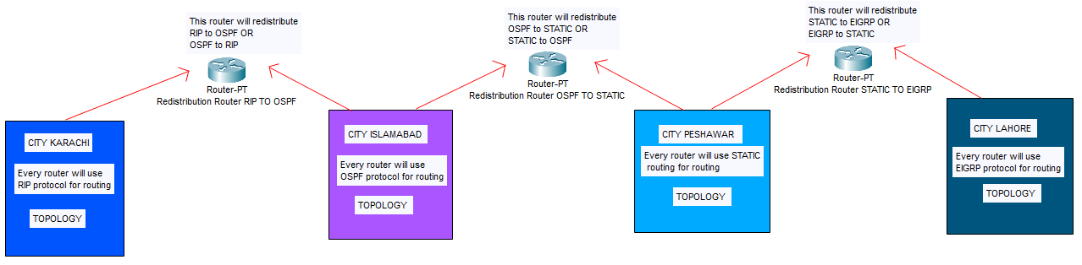

As there are for cities each city has four divisions each division has five desktop clients located at different networks. Moreover, each city has its own router and every division has its own router. In each city the division routers are connected to each other so that the communication within the city takes place using the division routers. The topology for the 4 cities are as follows:

## Topology for city Karachi

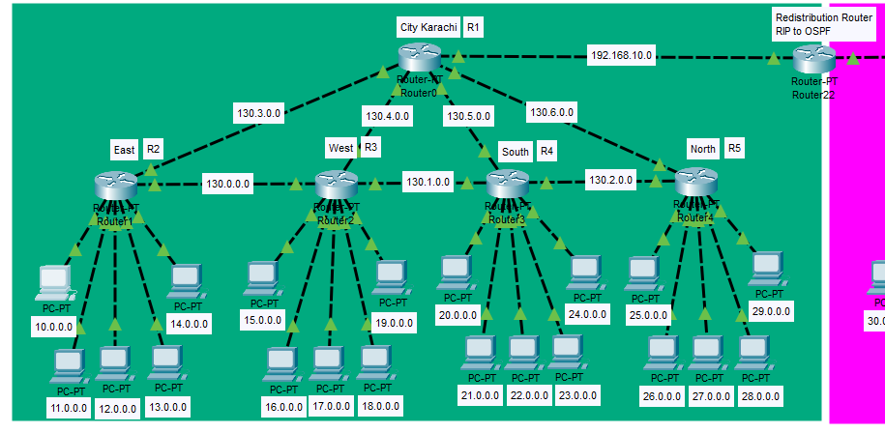

## IP address assigned to interface of routers city Karachi:

**Karachi R1:**

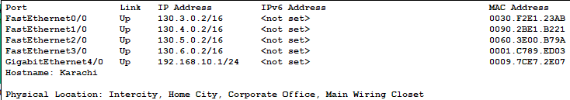

**East R2:**

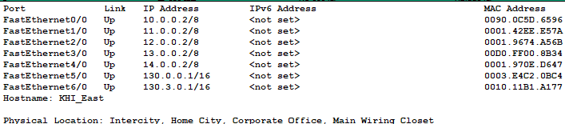

**West R3:**

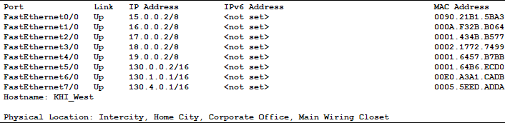

**South R4:**

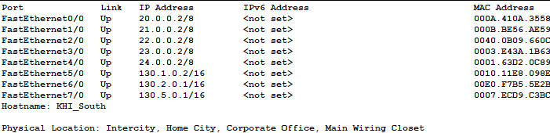

**North R5:**

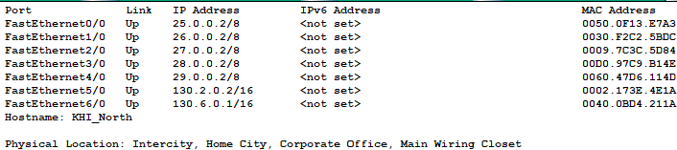

## Topology for city Islamabad

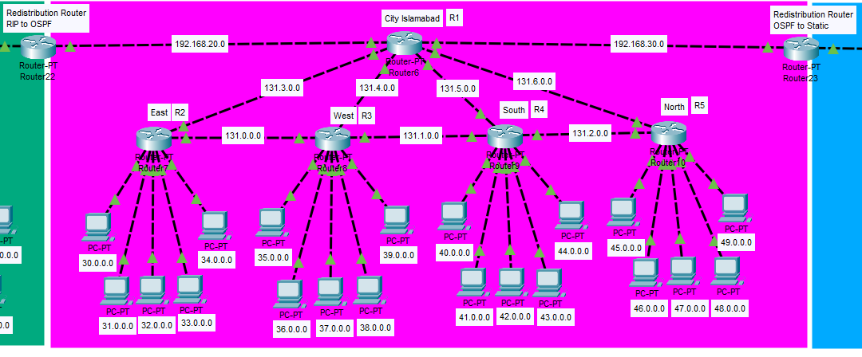

## IP address assigned to interface of routers city Islamabad:

**Islamabad R1:**

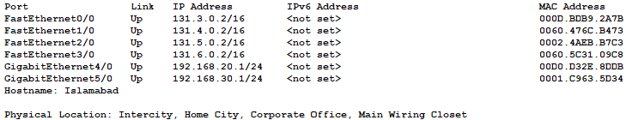

**East R2:**

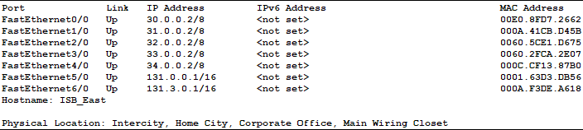

**West R3:**

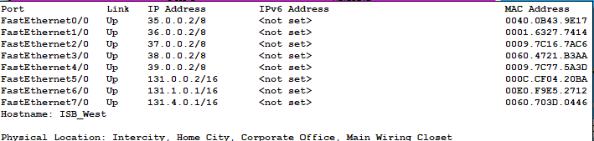

**South R4:**

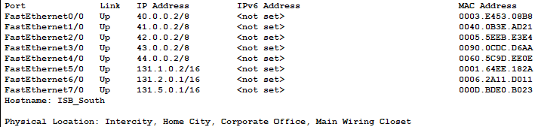

**North R5:**

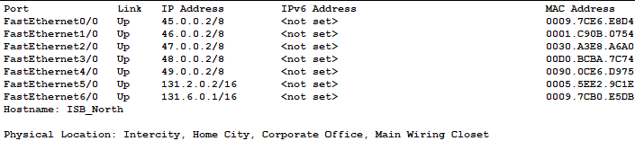

## Topology for city Peshawar

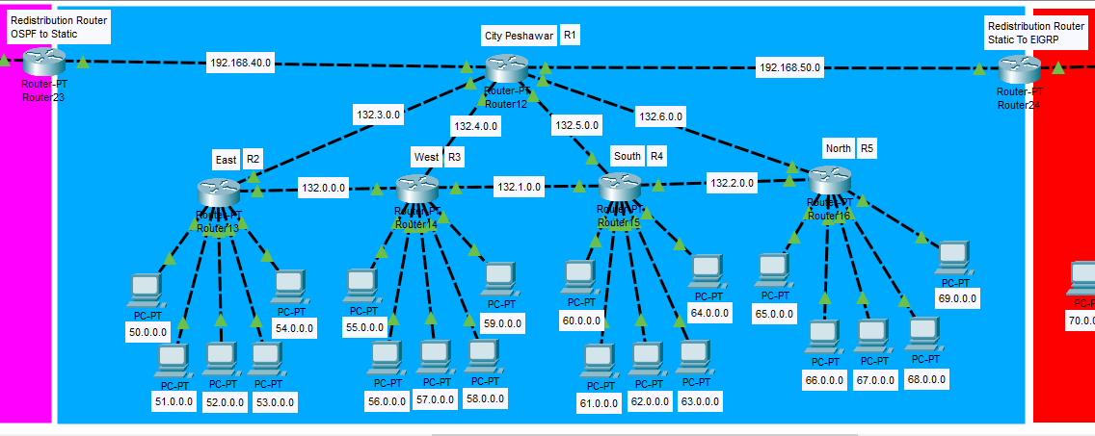

## IP address assigned to interface of routers city Peshawar:

**Peshawar R1:**

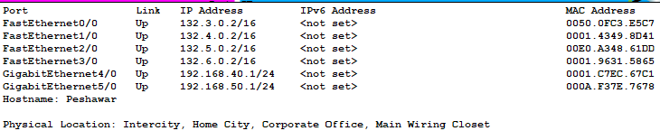

**East R2:**

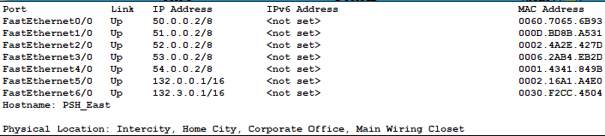

**West R3:**

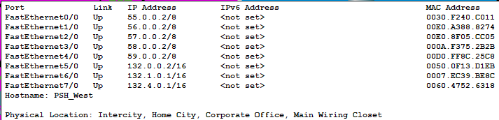

**South R4:**

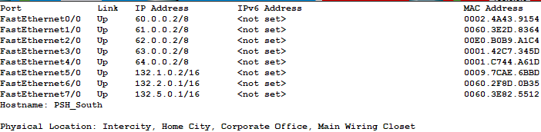

**North R5:**

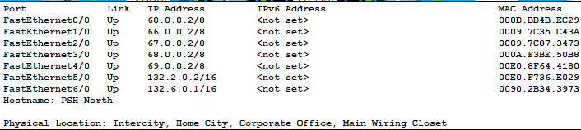

## Topology for city Lahore

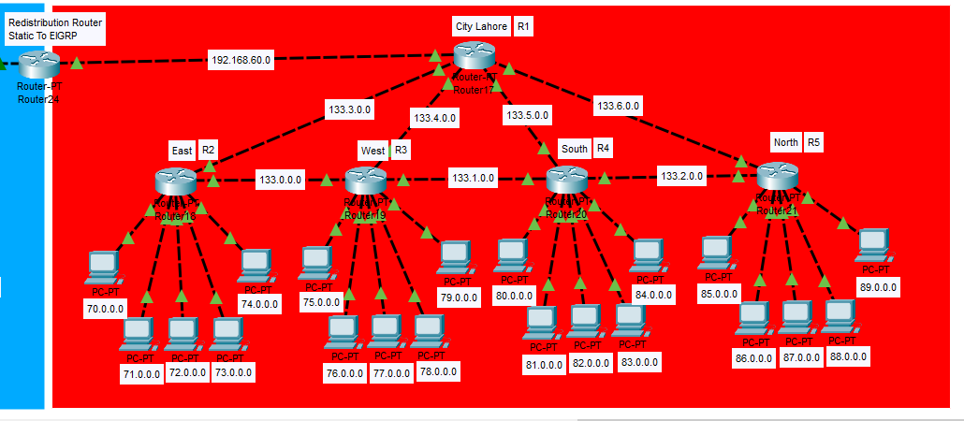

## IP address assigned to interface of routers city Lahore:

**Lahore R1:**

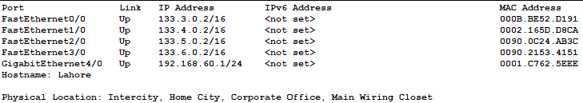

**East R2:**

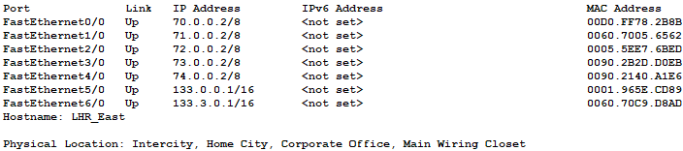

**West R3:**

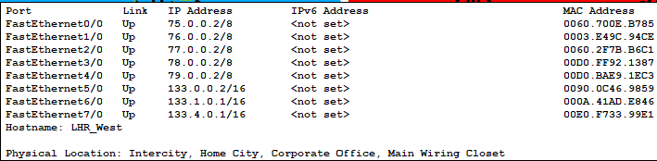

**South R4:**

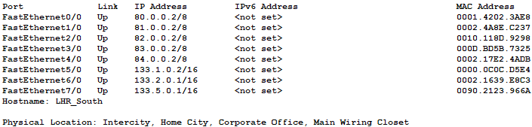

**North R5:**

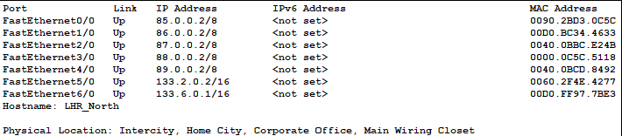

# Commands to Configuring hostname, console line password and virtual terminal password for each router:

Consider the topology for city Karachi. To configure the hostname, console line password and virtual line terminal for each router. The following commands are used:

For example, consider the routers of city Karachi:

**Karachi R1:**

Router>enable

Router#configure terminal

Enter configuration commands, one per line. End with CNTL/Z.

Router(config)#hostname Karachi

Karachi(config)#

Karachi(config)#line console 0

Karachi(config-line)#password 7719

Karachi(config-line)#login

Karachi(config-line)#exit

Karachi(config)#line vty 0 4

Karachi(config-line)#password 7712

Karachi(config-line)#login

Karachi(config-line)#exit

Karachi(config)#

**East R2:**

Router>enable

Router#configure terminal

Enter configuration commands, one per line. End with CNTL/Z.

Router(config)#hostname KHI_East

KHI_East(config)#

KHI_East(config)#line console 0

KHI_East(config-line)#password 7719

KHI_East(config-line)#login

KHI_East(config-line)#exit

KHI_East(config)#line vty 0 4

KHI_East(config-line)#password 7712

KHI_East(config-line)#login

KHI_East(config-line)#exit

KHI_East(config)#

The same commands are used to configure hostname, console line password and virtual terminal password for every router of each city and division.

# Commands to Assign IP address to interfaces of routers:

To assign the IP addresses to every router the following commands are used:

For example, consider the Routers for city Karachi:

**Karachi R1:**

Karachi(config)#interface fastEthernet 0/0

Karachi(config-if)#ip address 130.3.0.2 255.255.0.0

Karachi(config-if)#no shutdown

Karachi(config-if)#

%LINK-5-CHANGED: Interface FastEthernet0/0, changed state to up

Karachi(config-if)#exit

Karachi(config)#interface fas

Karachi(config)#interface fastEthernet 1/0

Karachi(config-if)#ip address 130.4.0.2 255.255.0.0

Karachi(config-if)#no shutdown

Karachi(config-if)#

%LINK-5-CHANGED: Interface FastEthernet1/0, changed state to up

Karachi(config-if)#exit

Karachi(config)#interface fas

Karachi(config)#interface fastEthernet 2/0

Karachi(config-if)#ip address 130.5.0.2 255.255.0.0

Karachi(config-if)#no shutdown

Karachi(config-if)#

%LINK-5-CHANGED: Interface FastEthernet2/0, changed state to up

Karachi(config-if)#exit

Karachi(config)#interface fas

Karachi(config)#interface fastEthernet 3/0

Karachi(config-if)#ip address 130.6.0.2 255.255.0.0

Karachi(config-if)#no shutdown

Karachi(config-if)#

%LINK-5-CHANGED: Interface FastEthernet3/0, changed state to up

Karachi(config-if)#exit

Karachi(config)#interface giga

Karachi(config)#interface gigabitEthernet 4/0

Karachi(config-if)#ip address 192.168.10.1 255.255.255.0

Karachi(config-if)#no shutdown

Karachi(config-if)#

%LINK-5-CHANGED: Interface GigabitEthernet4/0, changed state to up

Karachi(config-if)#exit

Karachi(config)#

**East R2:**

KHI_East(config)#interface fas

KHI_East(config)#interface fastEthernet 0/0

KHI_East(config-if)#ip address 10.0.0.2 255.0.0.0

KHI_East(config-if)#no shutdown

KHI_East(config-if)#

%LINK-5-CHANGED: Interface FastEthernet0/0, changed state to up

%LINEPROTO-5-UPDOWN: Line protocol on Interface FastEthernet0/0, changed state to up

KHI_East(config-if)#exit

KHI_East(config)#interface fas

KHI_East(config)#interface fastEthernet 1/0

KHI_East(config-if)#ip address 11.0.0.2 255.0.0.0

KHI_East(config-if)#no shutdown

KHI_East(config-if)#

%LINK-5-CHANGED: Interface FastEthernet1/0, changed state to up

%LINEPROTO-5-UPDOWN: Line protocol on Interface FastEthernet1/0, changed state to up

KHI_East(config-if)#exit

KHI_East(config)#interface fast

KHI_East(config)#interface fastEthernet 2/0

KHI_East(config-if)#ip address 12.0.0.2 255.0.0.0

KHI_East(config-if)#no shutdown

KHI_East(config-if)#

%LINK-5-CHANGED: Interface FastEthernet2/0, changed state to up

%LINEPROTO-5-UPDOWN: Line protocol on Interface FastEthernet2/0, changed state to up

KHI_East(config-if)#exit

KHI_East(config)#interface fast

KHI_East(config)#interface fastEthernet 3/0

KHI_East(config-if)#ip address 13.0.0.2 255.0.0.0

KHI_East(config-if)#no shutdown

KHI_East(config-if)#

%LINK-5-CHANGED: Interface FastEthernet3/0, changed state to up

%LINEPROTO-5-UPDOWN: Line protocol on Interface FastEthernet3/0, changed state to up

KHI_East(config-if)#exit

KHI_East(config)#interface fast

KHI_East(config)#interface fastEthernet 4/0

KHI_East(config-if)#ip address 14.0.0.2 255.0.0.0

KHI_East(config-if)#no shutdown

KHI_East(config-if)#

%LINK-5-CHANGED: Interface FastEthernet4/0, changed state to up

%LINEPROTO-5-UPDOWN: Line protocol on Interface FastEthernet4/0, changed state to up

KHI_East(config-if)#exit

KHI_East(config)#interface fast

KHI_East(config)#interface fastEthernet 5/0

KHI_East(config-if)#ip address 130.0.0.1 255.255.0.0

KHI_East(config-if)#no shutdown

KHI_East(config-if)#

%LINK-5-CHANGED: Interface FastEthernet5/0, changed state to up

KHI_East(config-if)#exit

KHI_East(config)#interface fast

KHI_East(config)#interface fastEthernet 6/0

KHI_East(config-if)#ip address 130.3.0.1 255.255.0.0

KHI_East(config-if)#no shutdown

KHI_East(config-if)#

%LINK-5-CHANGED: Interface FastEthernet6/0, changed state to up

%LINEPROTO-5-UPDOWN: Line protocol on Interface FastEthernet6/0, changed state to up

KHI_East(config-if)#exit

KHI_East(config)#

The same commands are used to assign IP addresses to all the routers of each city and each division and as well to the redistribution routers.

# Configuring Dynamic routing protocols and static routing

## Configuring RIP protocol for city Karachi

The following commands are used to configure RIP routing protocol on every router of city Karachi:

**Karachi R1:**

Karachi(config)#router rip

Karachi(config-router)#network 130.3.0.0

Karachi(config-router)#network 130.4.0.0

Karachi(config-router)#network 130.5.0.0

Karachi(config-router)#network 130.6.0.0

Karachi(config-router)#network 192.168.10.0

Karachi(config-router)#exit

Karachi(config)#

**East R2:**

KHI_East(config)#router rip

KHI_East(config-router)#network 10.0.0.0

KHI_East(config-router)#network 11.0.0.0

KHI_East(config-router)#network 12.0.0.0

KHI_East(config-router)#network 13.0.0.0

KHI_East(config-router)#network 14.0.0.0

KHI_East(config-router)#network 130.0.0.0

KHI_East(config-router)#network 130.3.0.0

KHI_East(config-router)#exit

KHI_East(config)#

**West R3:**

KHI_West(config)#router rip

KHI_West(config-router)#network 130.0.0.0

KHI_West(config-router)#network 15.0.0.0

KHI_West(config-router)#network 16.0.0.0

KHI_West(config-router)#network 17.0.0.0

KHI_West(config-router)#network 18.0.0.0

KHI_West(config-router)#network 19.0.0.0

KHI_West(config-router)#network 130.1.0.0

KHI_West(config-router)#network 130.4.0.0

KHI_West(config-router)#

KHI_West(config-router)#exit

KHI_West(config)#

**South R4:**

KHI_South(config)#router rip

KHI_South(config-router)#network 130.1.0.0

KHI_South(config-router)#network 20.0.0.0

KHI_South(config-router)#network 21.0.0.0

KHI_South(config-router)#network 22.0.0.0

KHI_South(config-router)#network 23.0.0.0

KHI_South(config-router)#network 24.0.0.0

KHI_South(config-router)#network 130.2.0.0

KHI_South(config-router)#network 130.5.0.0

KHI_South(config-router)#exit

KHI_South(config)#

**North R5:**

KHI_North(config)#router rip

KHI_North(config-router)#network 130.2.0.0

KHI_North(config-router)#network 25.0.0.0

KHI_North(config-router)#network 26.0.0.0

KHI_North(config-router)#network 27.0.0.0

KHI_North(config-router)#network 28.0.0.0

KHI_North(config-router)#network 29.0.0.0

KHI_North(config-router)#network 130.6.0.0

KHI_North(config-router)#exit

KHI_North(config)#

## Configuring OSPF protocol for city Islamabad

All the routers of city Islamabad are in area 0. So the command to configure OSPF routing protocol on all the routers of city Islamabad are as follows:

**Islamabad R1:**

Islamabad(config)#router ospf 7

Islamabad(config-router)#network 192.168.20.0 0.255.255.255 area 0

Islamabad(config-router)#network 131.3.0.0 0.0.255.255 area 0

Islamabad(config-router)#network 131.4.0.0 0.0.255.255 area 0

Islamabad(config-router)#network 131.5.0.0 0.0.255.255 area 0

Islamabad(config-router)#network 131.6.0.0 0.0.255.255 area 0

Islamabad(config-router)#network 192.168.30.0 0.255.255.255 area 0

Islamabad(config-router)#exit

Islamabad(config)#

**East R2:**

ISB_East(config)#router ospf 7

ISB_East(config-router)#network 30.0.0.0 0.0.0.255 area 0

ISB_East(config-router)#network 31.0.0.0 0.0.0.255 area 0

ISB_East(config-router)#network 32.0.0.0 0.0.0.255 area 0

ISB_East(config-router)#network 33.0.0.0 0.0.0.255 area 0

ISB_East(config-router)#network 34.0.0.0 0.0.0.255 area 0

ISB_East(config-router)#network 131.0.0.0 0.0.255.255 area 0

ISB_East(config-router)#network 131.3.0.0 0.0.255.255 area 0

ISB_East(config-router)#exit

ISB_East(config)#

**West R3:**

ISB_West(config)#router ospf 7

ISB_West(config-router)#network 131.0.0.0 0.0.255.255 area 0

ISB_West(config-router)#network 35.0.0.0 0.0.0.255 area 0

ISB_West(config-router)#network 36.0.0.0 0.0.0.255 area 0

ISB_West(config-router)#network 37.0.0.0 0.0.0.255 area 0

ISB_West(config-router)#network 38.0.0.0 0.0.0.255 area 0

ISB_West(config-router)#network 39.0.0.0 0.0.0.255 area 0

ISB_West(config-router)#network 131.1.0.0 0.0.255.255 area 0

ISB_West(config-router)#network 131.4.0.0 0.0.255.255 area 0

ISB_West(config-router)#exit

ISB_West(config)#

**South R4:**

ISB_South(config)#router ospf 7

ISB_South(config-router)#network 131.1.0.0 0.0.255.255 area 0

ISB_South(config-router)#network 40.0.0.0 0.0.0.255 area 0

ISB_South(config-router)#network 41.0.0.0 0.0.0.255 area 0

ISB_South(config-router)#network 42.0.0.0 0.0.0.255 area 0

ISB_South(config-router)#network 43.0.0.0 0.0.0.255 area 0

ISB_South(config-router)#network 44.0.0.0 0.0.0.255 area 0

ISB_South(config-router)#network 131.2.0.0 0.0.255.255 area 0

ISB_South(config-router)#network 131.5.0.0 0.0.255.255 area 0

ISB_South(config-router)#exit

ISB_South(config)#

**North R4:**

ISB_North(config)#router ospf 7

ISB_North(config-router)#network 131.2.0.0 0.0.255.255 area 0

ISB_North(config-router)#network 45.0.0.0 0.0.0.255 area 0

ISB_North(config-router)#network 46.0.0.0 0.0.0.255 area 0

ISB_North(config-router)#network 47.0.0.0 0.0.0.255 area 0

ISB_North(config-router)#network 48.0.0.0 0.0.0.255 area 0

ISB_North(config-router)#network 49.0.0.0 0.0.0.255 area 0

ISB_North(config-router)#network 131.6.0.0 0.0.255.255 area 0

ISB_North(config-router)#exit

ISB_North(config)#

## Configuring EIGRP protocol for city Lahore

The following commands are used to configure EIGRP routing protocol for city Lahore:

**Lahore R1:**

Lahore(config)#router eigrp 17

Lahore(config-router)#network 192.168.60.0

Lahore(config-router)#network 133.3.0.0

Lahore(config-router)#network 133.4.0.0

Lahore(config-router)#network 133.5.0.0

Lahore(config-router)#network 133.6.0.0

Lahore(config-router)#exit

Lahore(config)#

**East R2:**

LHR_East(config)#router eigrp 17

LHR_East(config-router)#network 70.0.0.0

LHR_East(config-router)#network 71.0.0.0

LHR_East(config-router)#network 72.0.0.0

LHR_East(config-router)#network 73.0.0.0

LHR_East(config-router)#network 74.0.0.0

LHR_East(config-router)#network 133.0.0.0

LHR_East(config-router)#network 133.3.0.0

LHR_East(config-router)#

LHR_East(config-router)#exit

LHR_East(config)#

**West R3:**

LHR_West(config)#router eigrp 17

LHR_West(config-router)#network 133.0.0.0

LHR_West(config-router)#

%DUAL-5-NBRCHANGE: IP-EIGRP 17: Neighbor 133.0.0.1 (FastEthernet5/0) is up: new adjacency

LHR_West(config-router)#network 75.0.0.0

LHR_West(config-router)#network 76.0.0.0

LHR_West(config-router)#network 77.0.0.0

LHR_West(config-router)#network 78.0.0.0

LHR_West(config-router)#network 79.0.0.0

LHR_West(config-router)#network 131.1.0.0

LHR_West(config-router)#network 131.4.0.0

LHR_West(config-router)#exit

LHR_West(config)#

**South R4:**

LHR_South(config)#router eigrp 17

LHR_South(config-router)#network 133.1.0.0

LHR_South(config-router)#network 80.0.0.0

LHR_South(config-router)#network 81.0.0.0

LHR_South(config-router)#network 82.0.0.0

LHR_South(config-router)#network 83.0.0.0

LHR_South(config-router)#network 84.0.0.0

LHR_South(config-router)#network 133.2.0.0

LHR_South(config-router)#network 133.5.0.0

LHR_South(config-router)#

LHR_South(config-router)#exit

LHR_South(config)#

**North R5:**

LHR_North(config)#router eigrp 17

LHR_North(config-router)#network 133.2.0.0

LHR_North(config-router)#

LHR_North(config-router)#network 85.0.0.0

LHR_North(config-router)#network 86.0.0.0

LHR_North(config-router)#network 87.0.0.0

LHR_North(config-router)#network 88.0.0.0

LHR_North(config-router)#network 89.0.0.0

LHR_North(config-router)#network 133.6.0.0

LHR_North(config-router)#

LHR_North(config-router)#exit

LHR_North(config)#

## Configuring static routing for city Peshawar

## Static routing tables and commands for city Peshawar

**Peshawar R1:**

|  |  |  |
| --- | --- | --- |
| S: | 132.0.0.0 | via 132.3.0.1 |
| S: | 132.0.0.0 | via 132.4.0.1 |
| S: | 132.0.0.0 | via 132.5.0.1 |
| S: | 132.0.0.0 | via 132.6.0.1 |
|  |  |  |
| S: | 132.1.0.0 | via 132.3.0.1 |
| S: | 132.1.0.0 | via 132.4.0.1 |
| S: | 132.1.0.0 | via 132.5.0.1 |
| S: | 132.1.0.0 | via 132.6.0.1 |
|  |  |  |
| S: | 132.2.0.0 | via 132.3.0.1 |
| S: | 132.2.0.0 | via 132.4.0.1 |
| S: | 132.2.0.0 | via 132.5.0.1 |
| S: | 132.2.0.0 | via 132.6.0.1 |
|  |  |  |
| S: | 50.0.0.0 | via 132.3.0.1 |
| S: | 51.0.0.0 | via 132.3.0.1 |
| S: | 52.0.0.0 | via 132.3.0.1 |
| S: | 53.0.0.0 | via 132.3.0.1 |
| S: | 54.0.0.0 | via 132.3.0.1 |
|  |  |  |
| S: | 50.0.0.0 | via 132.4.0.1 |
| S: | 51.0.0.0 | via 132.4.0.1 |
| S: | 52.0.0.0 | via 132.4.0.1 |
| S: | 53.0.0.0 | via 132.4.0.1 |
| S: | 54.0.0.0 | via 132.4.0.1 |
|  |  |  |
| S: | 50.0.0.0 | via 132.5.0.1 |
| S: | 51.0.0.0 | via 132.5.0.1 |
| S: | 52.0.0.0 | via 132.5.0.1 |
| S: | 53.0.0.0 | via 132.5.0.1 |
| S: | 54.0.0.0 | via 132.5.0.1 |
|  |  |  |
| S: | 50.0.0.0 | via 132.6.0.1 |
| S: | 51.0.0.0 | via 132.6.0.1 |
| S: | 52.0.0.0 | via 132.6.0.1 |
| S: | 53.0.0.0 | via 132.6.0.1 |
| S: | 54.0.0.0 | via 132.6.0.1 |
|  |  |  |
| S: | 55.0.0.0 | via 132.3.0.1 |
| S: | 56.0.0.0 | via 132.3.0.1 |
| S: | 57.0.0.0 | via 132.3.0.1 |
| S: | 58.0.0.0 | via 132.3.0.1 |
| S: | 59.0.0.0 | via 132.3.0.1 |
|  |  |  |
| S: | 55.0.0.0 | via 132.4.0.1 |
| S: | 56.0.0.0 | via 132.4.0.1 |
| S: | 57.0.0.0 | via 132.4.0.1 |
| S: | 58.0.0.0 | via 132.4.0.1 |
| S: | 59.0.0.0 | via 132.4.0.1 |
|  |  |  |
| S: | 55.0.0.0 | via 132.5.0.1 |
| S: | 56.0.0.0 | via 132.5.0.1 |
| S: | 57.0.0.0 | via 132.5.0.1 |
| S: | 58.0.0.0 | via 132.5.0.1 |
| S: | 59.0.0.0 | via 132.5.0.1 |
|  |  |  |
| S: | 55.0.0.0 | via 132.6.0.1 |
| S: | 56.0.0.0 | via 132.6.0.1 |
| S: | 57.0.0.0 | via 132.6.0.1 |
| S: | 58.0.0.0 | via 132.6.0.1 |
| S: | 59.0.0.0 | via 132.6.0.1 |
|  |  |  |
| S: | 60.0.0.0 | via 132.3.0.1 |
| S: | 61.0.0.0 | via 132.3.0.1 |
| S: | 62.0.0.0 | via 132.3.0.1 |
| S: | 63.0.0.0 | via 132.3.0.1 |
| S: | 64.0.0.0 | via 132.3.0.1 |
|  |  |  |
| S: | 60.0.0.0 | via 132.4.0.1 |
| S: | 61.0.0.0 | via 132.4.0.1 |
| S: | 62.0.0.0 | via 132.4.0.1 |
| S: | 63.0.0.0 | via 132.4.0.1 |
| S: | 64.0.0.0 | via 132.4.0.1 |
|  |  |  |
| S: | 60.0.0.0 | via 132.5.0.1 |
| S: | 61.0.0.0 | via 132.5.0.1 |
| S: | 62.0.0.0 | via 132.5.0.1 |
| S: | 63.0.0.0 | via 132.5.0.1 |
| S: | 64.0.0.0 | via 132.5.0.1 |
|  |  |  |
| S: | 60.0.0.0 | via 132.6.0.1 |
| S: | 61.0.0.0 | via 132.6.0.1 |
| S: | 62.0.0.0 | via 132.6.0.1 |
| S: | 63.0.0.0 | via 132.6.0.1 |
| S: | 64.0.0.0 | via 132.6.0.1 |
|  |  |  |
| S: | 65.0.0.0 | via 132.3.0.1 |
| S: | 66.0.0.0 | via 132.3.0.1 |
| S: | 67.0.0.0 | via 132.3.0.1 |
| S: | 68.0.0.0 | via 132.3.0.1 |
| S: | 69.0.0.0 | via 132.3.0.1 |
|  |  |  |
| S: | 65.0.0.0 | via 132.4.0.1 |
| S: | 66.0.0.0 | via 132.4.0.1 |
| S: | 67.0.0.0 | via 132.4.0.1 |
| S: | 68.0.0.0 | via 132.4.0.1 |
| S: | 69.0.0.0 | via 132.4.0.1 |
|  |  |  |
| S: | 65.0.0.0 | via 132.5.0.1 |
| S: | 66.0.0.0 | via 132.5.0.1 |
| S: | 67.0.0.0 | via 132.5.0.1 |
| S: | 68.0.0.0 | via 132.5.0.1 |
| S: | 69.0.0.0 | via 132.5.0.1 |
|  |  |  |
| S: | 65.0.0.0 | via 132.6.0.1 |
| S: | 66.0.0.0 | via 132.6.0.1 |
| S: | 67.0.0.0 | via 132.6.0.1 |
| S: | 68.0.0.0 | via 132.6.0.1 |
| S: | 69.0.0.0 | via 132.6.0.1 |

**Commands to configure static routing on R1:**

Peshawar(config)#ip route 132.0.0.0 255.255.0.0 132.3.0.1

Peshawar(config)#ip route 132.0.0.0 255.255.0.0 132.4.0.1

Peshawar(config)#ip route 132.0.0.0 255.255.0.0 132.5.0.1

Peshawar(config)#ip route 132.0.0.0 255.255.0.0 132.6.0.1

Peshawar(config)#ip route 132.1.0.0 255.255.0.0 132.3.0.1

Peshawar(config)#ip route 132.1.0.0 255.255.0.0 132.4.0.1

Peshawar(config)#ip route 132.1.0.0 255.255.0.0 132.5.0.1

Peshawar(config)#ip route 132.1.0.0 255.255.0.0 132.6.0.1

Peshawar(config)#ip route 132.2.0.0 255.255.0.0 132.3.0.1

Peshawar(config)#ip route 132.2.0.0 255.255.0.0 132.4.0.1

Peshawar(config)#ip route 132.2.0.0 255.255.0.0 132.5.0.1

Peshawar(config)#ip route 132.2.0.0 255.255.0.0 132.6.0.1

Peshawar(config)#ip route 50.0.0.0 255.0.0.0 132.3.0.1

Peshawar(config)#ip route 51.0.0.0 255.0.0.0 132.3.0.1

Peshawar(config)#ip route 52.0.0.0 255.0.0.0 132.3.0.1

Peshawar(config)#ip route 53.0.0.0 255.0.0.0 132.3.0.1

Peshawar(config)#ip route 54.0.0.0 255.0.0.0 132.3.0.1

Peshawar(config)#ip route 50.0.0.0 255.0.0.0 132.4.0.1

Peshawar(config)#ip route 51.0.0.0 255.0.0.0 132.4.0.1

Peshawar(config)#ip route 52.0.0.0 255.0.0.0 132.4.0.1

Peshawar(config)#ip route 53.0.0.0 255.0.0.0 132.4.0.1

Peshawar(config)#ip route 54.0.0.0 255.0.0.0 132.4.0.1

Peshawar(config)#ip route 50.0.0.0 255.0.0.0 132.5.0.1

Peshawar(config)#ip route 51.0.0.0 255.0.0.0 132.5.0.1

Peshawar(config)#ip route 52.0.0.0 255.0.0.0 132.5.0.1

Peshawar(config)#ip route 53.0.0.0 255.0.0.0 132.5.0.1

Peshawar(config)#ip route 54.0.0.0 255.0.0.0 132.5.0.1

Peshawar(config)#ip route 50.0.0.0 255.0.0.0 132.6.0.1

Peshawar(config)#ip route 51.0.0.0 255.0.0.0 132.6.0.1

Peshawar(config)#ip route 52.0.0.0 255.0.0.0 132.6.0.1

Peshawar(config)#ip route 53.0.0.0 255.0.0.0 132.6.0.1

Peshawar(config)#ip route 54.0.0.0 255.0.0.0 132.6.0.1

Peshawar(config)#ip route 55.0.0.0 255.0.0.0 132.3.0.1

Peshawar(config)#ip route 56.0.0.0 255.0.0.0 132.3.0.1

Peshawar(config)#ip route 57.0.0.0 255.0.0.0 132.3.0.1

Peshawar(config)#ip route 58.0.0.0 255.0.0.0 132.3.0.1

Peshawar(config)#ip route 59.0.0.0 255.0.0.0 132.3.0.1

Peshawar(config)#ip route 55.0.0.0 255.0.0.0 132.4.0.1

Peshawar(config)#ip route 56.0.0.0 255.0.0.0 132.4.0.1

Peshawar(config)#ip route 57.0.0.0 255.0.0.0 132.4.0.1

Peshawar(config)#ip route 58.0.0.0 255.0.0.0 132.4.0.1

Peshawar(config)#ip route 59.0.0.0 255.0.0.0 132.4.0.1

Peshawar(config)#ip route 55.0.0.0 255.0.0.0 132.5.0.1

Peshawar(config)#ip route 56.0.0.0 255.0.0.0 132.5.0.1

Peshawar(config)#ip route 57.0.0.0 255.0.0.0 132.5.0.1

Peshawar(config)#ip route 58.0.0.0 255.0.0.0 132.5.0.1

Peshawar(config)#ip route 59.0.0.0 255.0.0.0 132.5.0.1

Peshawar(config)#ip route 55.0.0.0 255.0.0.0 132.6.0.1

Peshawar(config)#ip route 56.0.0.0 255.0.0.0 132.6.0.1

Peshawar(config)#ip route 57.0.0.0 255.0.0.0 132.6.0.1

Peshawar(config)#ip route 58.0.0.0 255.0.0.0 132.6.0.1

Peshawar(config)#ip route 59.0.0.0 255.0.0.0 132.6.0.1

Peshawar(config)#ip route 60.0.0.0 255.0.0.0 132.3.0.1

Peshawar(config)#ip route 61.0.0.0 255.0.0.0 132.3.0.1

Peshawar(config)#ip route 62.0.0.0 255.0.0.0 132.3.0.1

Peshawar(config)#ip route 63.0.0.0 255.0.0.0 132.3.0.1

Peshawar(config)#ip route 64.0.0.0 255.0.0.0 132.3.0.1

Peshawar(config)#ip route 60.0.0.0 255.0.0.0 132.4.0.1

Peshawar(config)#ip route 61.0.0.0 255.0.0.0 132.4.0.1

Peshawar(config)#ip route 62.0.0.0 255.0.0.0 132.4.0.1

Peshawar(config)#ip route 63.0.0.0 255.0.0.0 132.4.0.1

Peshawar(config)#ip route 64.0.0.0 255.0.0.0 132.4.0.1

Peshawar(config)#ip route 60.0.0.0 255.0.0.0 132.5.0.1

Peshawar(config)#ip route 61.0.0.0 255.0.0.0 132.5.0.1

Peshawar(config)#ip route 62.0.0.0 255.0.0.0 132.5.0.1

Peshawar(config)#ip route 63.0.0.0 255.0.0.0 132.5.0.1

Peshawar(config)#ip route 64.0.0.0 255.0.0.0 132.5.0.1

Peshawar(config)#ip route 60.0.0.0 255.0.0.0 132.6.0.1

Peshawar(config)#ip route 61.0.0.0 255.0.0.0 132.6.0.1

Peshawar(config)#ip route 62.0.0.0 255.0.0.0 132.6.0.1

Peshawar(config)#ip route 63.0.0.0 255.0.0.0 132.6.0.1

Peshawar(config)#ip route 64.0.0.0 255.0.0.0 132.6.0.1

Peshawar(config)#ip route 65.0.0.0 255.0.0.0 132.3.0.1

Peshawar(config)#ip route 66.0.0.0 255.0.0.0 132.3.0.1

Peshawar(config)#ip route 67.0.0.0 255.0.0.0 132.3.0.1

Peshawar(config)#ip route 68.0.0.0 255.0.0.0 132.3.0.1

Peshawar(config)#ip route 69.0.0.0 255.0.0.0 132.3.0.1

Peshawar(config)#ip route 65.0.0.0 255.0.0.0 132.4.0.1

Peshawar(config)#ip route 66.0.0.0 255.0.0.0 132.4.0.1

Peshawar(config)#ip route 67.0.0.0 255.0.0.0 132.4.0.1

Peshawar(config)#ip route 68.0.0.0 255.0.0.0 132.4.0.1

Peshawar(config)#ip route 69.0.0.0 255.0.0.0 132.4.0.1

Peshawar(config)#ip route 65.0.0.0 255.0.0.0 132.5.0.1

Peshawar(config)#ip route 66.0.0.0 255.0.0.0 132.5.0.1

Peshawar(config)#ip route 67.0.0.0 255.0.0.0 132.5.0.1

Peshawar(config)#ip route 68.0.0.0 255.0.0.0 132.5.0.1

Peshawar(config)#ip route 69.0.0.0 255.0.0.0 132.5.0.1

Peshawar(config)#ip route 65.0.0.0 255.0.0.0 132.6.0.1

Peshawar(config)#ip route 66.0.0.0 255.0.0.0 132.6.0.1

Peshawar(config)#ip route 67.0.0.0 255.0.0.0 132.6.0.1

Peshawar(config)#ip route 68.0.0.0 255.0.0.0 132.6.0.1

Peshawar(config)#ip route 69.0.0.0 255.0.0.0 132.6.0.1

Peshawar(config)#ip route 0.0.0.0 0.0.0.0 192.168.40.2

Peshawar(config)#ip route 0.0.0.0 0.0.0.0 192.168.50.2

Peshawar(config)#

**Static routing table for East R2:**

|  |  |  |
| --- | --- | --- |
| S: | 132.1.0.0 | via 132.3.0.2 |
| S: | 132.4.0.0 | via 132.3.0.2 |
| S: | 132.5.0.0 | via 132.3.0.2 |
| S: | 132.2.0.0 | via 132.3.0.2 |
| S: | 132.6.0.0 | via 132.3.0.2 |
|  |  |  |
| S: | 132.1.0.0 | via 132.0.0.2 |
| S: | 132.4.0.0 | via 132.0.0.2 |
| S: | 132.5.0.0 | via 132.0.0.2 |
| S: | 132.2.0.0 | via 132.0.0.2 |
| S: | 132.6.0.0 | via 132.0.0.2 |
|  |  |  |
| S: | 55.0.0.0 | via 132.0.0.2 |
| S: | 56.0.0.0 | via 132.0.0.2 |
| S: | 57.0.0.0 | via 132.0.0.2 |
| S: | 58.0.0.0 | via 132.0.0.2 |
| S: | 59.0.0.0 | via 132.0.0.2 |
|  |  |  |
| S: | 55.0.0.0 | via 132.3.0.2 |
| S: | 56.0.0.0 | via 132.3.0.2 |
| S: | 57.0.0.0 | via 132.3.0.2 |
| S: | 58.0.0.0 | via 132.3.0.2 |
| S: | 59.0.0.0 | via 132.3.0.2 |
|  |  |  |
| S: | 60.0.0.0 | via 132.0.0.2 |
| S: | 61.0.0.0 | via 132.0.0.2 |
| S: | 62.0.0.0 | via 132.0.0.2 |
| S: | 63.0.0.0 | via 132.0.0.2 |
| S: | 64.0.0.0 | via 132.0.0.2 |
|  |  |  |
| S: | 60.0.0.0 | via 132.3.0.2 |
| S: | 61.0.0.0 | via 132.3.0.2 |
| S: | 62.0.0.0 | via 132.3.0.2 |
| S: | 63.0.0.0 | via 132.3.0.2 |
| S: | 64.0.0.0 | via 132.3.0.2 |
|  |  |  |
| S: | 65.0.0.0 | via 132.0.0.2 |
| S: | 66.0.0.0 | via 132.0.0.2 |
| S: | 67.0.0.0 | via 132.0.0.2 |
| S: | 68.0.0.0 | via 132.0.0.2 |
| S: | 69.0.0.0 | via 132.0.0.2 |
|  |  |  |
| S: | 65.0.0.0 | via 132.3.0.2 |
| S: | 66.0.0.0 | via 132.3.0.2 |
| S: | 67.0.0.0 | via 132.3.0.2 |
| S: | 68.0.0.0 | via 132.3.0.2 |
| S: | 69.0.0.0 | via 132.3.0.2 |

**Commands for static routing on R2:**

PSH_East(config)#

PSH_East(config)#ip route 132.1.0.0 255.255.0.0 132.3.0.2

PSH_East(config)#ip route 132.4.0.0 255.255.0.0 132.3.0.2

PSH_East(config)#ip route 132.5.0.0 255.255.0.0 132.3.0.2

PSH_East(config)#ip route 132.2.0.0 255.255.0.0 132.3.0.2

PSH_East(config)#ip route 132.6.0.0 255.255.0.0 132.3.0.2

PSH_East(config)#ip route 132.1.0.0 255.255.0.0 132.0.0.2

PSH_East(config)#ip route 132.4.0.0 255.255.0.0 132.0.0.2

PSH_East(config)#ip route 132.5.0.0 255.255.0.0 132.0.0.2

PSH_East(config)#ip route 132.2.0.0 255.255.0.0 132.0.0.2

PSH_East(config)#ip route 132.6.0.0 255.255.0.0 132.0.0.2

PSH_East(config)#ip route 55.0.0.0 255.0.0.0 132.0.0.2

PSH_East(config)#ip route 56.0.0.0 255.0.0.0 132.0.0.2

PSH_East(config)#ip route 57.0.0.0 255.0.0.0 132.0.0.2

PSH_East(config)#ip route 58.0.0.0 255.0.0.0 132.0.0.2

PSH_East(config)#ip route 59.0.0.0 255.0.0.0 132.0.0.2

PSH_East(config)#ip route 55.0.0.0 255.0.0.0 132.3.0.2

PSH_East(config)#ip route 56.0.0.0 255.0.0.0 132.3.0.2

PSH_East(config)#ip route 57.0.0.0 255.0.0.0 132.3.0.2

PSH_East(config)#ip route 58.0.0.0 255.0.0.0 132.3.0.2

PSH_East(config)#ip route 59.0.0.0 255.0.0.0 132.3.0.2

PSH_East(config)#ip route 60.0.0.0 255.0.0.0 132.0.0.2

PSH_East(config)#ip route 61.0.0.0 255.0.0.0 132.0.0.2

PSH_East(config)#ip route 62.0.0.0 255.0.0.0 132.0.0.2

PSH_East(config)#ip route 63.0.0.0 255.0.0.0 132.0.0.2

PSH_East(config)#ip route 64.0.0.0 255.0.0.0 132.0.0.2

PSH_East(config)#ip route 60.0.0.0 255.0.0.0 132.3.0.2

PSH_East(config)#ip route 61.0.0.0 255.0.0.0 132.3.0.2

PSH_East(config)#

PSH_East(config)#ip route 62.0.0.0 255.0.0.0 132.3.0.2

PSH_East(config)#ip route 63.0.0.0 255.0.0.0 132.3.0.2

PSH_East(config)#ip route 64.0.0.0 255.0.0.0 132.3.0.2

PSH_East(config)#ip route 65.0.0.0 255.0.0.0 132.0.0.2

PSH_East(config)#ip route 66.0.0.0 255.0.0.0 132.0.0.2

PSH_East(config)#ip route 67.0.0.0 255.0.0.0 132.0.0.2

PSH_East(config)#ip route 68.0.0.0 255.0.0.0 132.0.0.2

PSH_East(config)#ip route 69.0.0.0 255.0.0.0 132.0.0.2

PSH_East(config)#ip route 65.0.0.0 255.0.0.0 132.3.0.2

PSH_East(config)#ip route 66.0.0.0 255.0.0.0 132.3.0.2

PSH_East(config)#ip route 67.0.0.0 255.0.0.0 132.3.0.2

PSH_East(config)#ip route 68.0.0.0 255.0.0.0 132.3.0.2

PSH_East(config)#ip route 69.0.0.0 255.0.0.0 132.3.0.2

PSH_East(config)#

PSH_East(config)#ip route 0.0.0.0 0.0.0.0 132.3.0.2

PSH_East(config)#ip route 0.0.0.0 0.0.0.0 132.0.0.2

PSH_East(config)#

**Static routing table for West R3:**

|  |  |  |
| --- | --- | --- |
| S: | 132.3.0.0 | via 132.0.0.1 |
| S: | 132.3.0.0 | via 132.4.0.2 |
|  |  |  |
| S: | 132.5.0.0 | via 132.4.0.2 |
| S: | 132.5.0.0 | via 132.1.0.2 |
|  |  |  |
| S: | 132.6.0.0 | via 132.4.0.2 |
| S: | 132.6.0.0 | via 132.1.0.2 |
|  |  |  |
| S: | 132.2.0.0 | via 132.4.0.2 |
| S: | 132.2.0.0 | via 132.1.0.2 |
|  |  |  |
| S: | 50.0.0.0 | via 132.0.0.1 |
| S: | 51.0.0.0 | via 132.0.0.1 |
| S: | 52.0.0.0 | via 132.0.0.1 |
| S: | 53.0.0.0 | via 132.0.0.1 |
| S: | 54.0.0.0 | via 132.0.0.1 |
|  |  |  |
| S: | 50.0.0.0 | via 132.4.0.2 |
| S: | 51.0.0.0 | via 132.4.0.2 |
| S: | 52.0.0.0 | via 132.4.0.2 |
| S: | 53.0.0.0 | via 132.4.0.2 |
| S: | 54.0.0.0 | via 132.4.0.2 |
|  |  |  |
| S: | 50.0.0.0 | via 132.1.0.2 |
| S: | 51.0.0.0 | via 132.1.0.2 |
| S: | 52.0.0.0 | via 132.1.0.2 |
| S: | 53.0.0.0 | via 132.1.0.2 |
| S: | 54.0.0.0 | via 132.1.0.2 |
|  |  |  |
| S: | 60.0.0.0 | via 132.1.0.2 |
| S: | 61.0.0.0 | via 132.1.0.2 |
| S: | 62.0.0.0 | via 132.1.0.2 |
| S: | 63.0.0.0 | via 132.1.0.2 |
| S: | 64.0.0.0 | via 132.1.0.2 |
|  |  |  |
| S: | 60.0.0.0 | via 132.4.0.2 |
| S: | 61.0.0.0 | via 132.4.0.2 |
| S: | 62.0.0.0 | via 132.4.0.2 |
| S: | 63.0.0.0 | via 132.4.0.2 |
| S: | 64.0.0.0 | via 132.4.0.2 |
|  |  |  |
| S: | 60.0.0.0 | via 132.0.0.1 |
| S: | 61.0.0.0 | via 132.0.0.1 |
| S: | 62.0.0.0 | via 132.0.0.1 |
| S: | 63.0.0.0 | via 132.0.0.1 |
| S: | 64.0.0.0 | via 132.0.0.1 |
|  |  |  |
| S: | 65.0.0.0 | via 132.1.0.2 |
| S: | 66.0.0.0 | via 132.1.0.2 |
| S: | 67.0.0.0 | via 132.1.0.2 |
| S: | 68.0.0.0 | via 132.1.0.2 |
| S: | 69.0.0.0 | via 132.1.0.2 |
|  |  |  |
| S: | 65.0.0.0 | via 132.4.0.2 |
| S: | 66.0.0.0 | via 132.4.0.2 |
| S: | 67.0.0.0 | via 132.4.0.2 |
| S: | 68.0.0.0 | via 132.4.0.2 |
| S: | 69.0.0.0 | via 132.4.0.2 |
|  |  |  |
| S: | 65.0.0.0 | via 132.0.0.1 |
| S: | 66.0.0.0 | via 132.0.0.1 |
| S: | 67.0.0.0 | via 132.0.0.1 |
| S: | 68.0.0.0 | via 132.0.0.1 |
| S: | 69.0.0.0 | via 132.0.0.1 |

**Commands for static routing on R3:**

PSH_West(config)#

PSH_West(config)#ip route 132.3.0.0 255.255.0.0 132.0.0.1

PSH_West(config)#ip route 132.3.0.0 255.255.0.0 132.4.0.2

PSH_West(config)#ip route 132.5.0.0 255.255.0.0 132.4.0.2

PSH_West(config)#ip route 132.5.0.0 255.255.0.0 132.1.0.2

PSH_West(config)#ip route 132.6.0.0 255.255.0.0 132.4.0.2

PSH_West(config)#ip route 132.6.0.0 255.255.0.0 132.1.0.2

PSH_West(config)#ip route 132.2.0.0 255.255.0.0 132.4.0.2

PSH_West(config)#ip route 132.2.0.0 255.255.0.0 132.1.0.2

PSH_West(config)#ip route 50.0.0.0 255.0.0.0 132.0.0.1

PSH_West(config)#ip route 51.0.0.0 255.0.0.0 132.0.0.1

PSH_West(config)#ip route 52.0.0.0 255.0.0.0 132.0.0.1

PSH_West(config)#ip route 53.0.0.0 255.0.0.0 132.0.0.1

PSH_West(config)#ip route 54.0.0.0 255.0.0.0 132.0.0.1

PSH_West(config)#ip route 50.0.0.0 255.0.0.0 132.4.0.2

PSH_West(config)#ip route 51.0.0.0 255.0.0.0 132.4.0.2

PSH_West(config)#ip route 52.0.0.0 255.0.0.0 132.4.0.2

PSH_West(config)#ip route 53.0.0.0 255.0.0.0 132.4.0.2

PSH_West(config)#ip route 54.0.0.0 255.0.0.0 132.4.0.2

PSH_West(config)#ip route 50.0.0.0 255.0.0.0 132.1.0.2

PSH_West(config)#ip route 51.0.0.0 255.0.0.0 132.1.0.2

PSH_West(config)#ip route 52.0.0.0 255.0.0.0 132.1.0.2

PSH_West(config)#ip route 53.0.0.0 255.0.0.0 132.1.0.2

PSH_West(config)#ip route 54.0.0.0 255.0.0.0 132.1.0.2

PSH_West(config)#ip route 60.0.0.0 255.0.0.0 132.1.0.2

PSH_West(config)#ip route 61.0.0.0 255.0.0.0 132.1.0.2

PSH_West(config)#ip route 62.0.0.0 255.0.0.0 132.1.0.2

PSH_West(config)#ip route 63.0.0.0 255.0.0.0 132.1.0.2

PSH_West(config)#ip route 64.0.0.0 255.0.0.0 132.1.0.2

PSH_West(config)#ip route 60.0.0.0 255.0.0.0 132.4.0.2

PSH_West(config)#ip route 61.0.0.0 255.0.0.0 132.4.0.2

PSH_West(config)#ip route 62.0.0.0 255.0.0.0 132.4.0.2

PSH_West(config)#ip route 63.0.0.0 255.0.0.0 132.4.0.2

PSH_West(config)#ip route 64.0.0.0 255.0.0.0 132.4.0.2

PSH_West(config)#ip route 60.0.0.0 255.0.0.0 132.0.0.1

PSH_West(config)#ip route 61.0.0.0 255.0.0.0 132.0.0.1

PSH_West(config)#ip route 62.0.0.0 255.0.0.0 132.0.0.1

PSH_West(config)#ip route 63.0.0.0 255.0.0.0 132.0.0.1

PSH_West(config)#ip route 64.0.0.0 255.0.0.0 132.0.0.1

PSH_West(config)#ip route 65.0.0.0 255.0.0.0 132.1.0.2

PSH_West(config)#ip route 66.0.0.0 255.0.0.0 132.1.0.2

PSH_West(config)#ip route 67.0.0.0 255.0.0.0 132.1.0.2

PSH_West(config)#ip route 68.0.0.0 255.0.0.0 132.1.0.2

PSH_West(config)#ip route 69.0.0.0 255.0.0.0 132.1.0.2

PSH_West(config)#ip route 65.0.0.0 255.0.0.0 132.4.0.2

PSH_West(config)#ip route 66.0.0.0 255.0.0.0 132.4.0.2

PSH_West(config)#ip route 67.0.0.0 255.0.0.0 132.4.0.2

PSH_West(config)#ip route 68.0.0.0 255.0.0.0 132.4.0.2

PSH_West(config)#ip route 69.0.0.0 255.0.0.0 132.4.0.2

PSH_West(config)#ip route 65.0.0.0 255.0.0.0 132.0.0.1

PSH_West(config)#ip route 66.0.0.0 255.0.0.0 132.0.0.1

PSH_West(config)#ip route 67.0.0.0 255.0.0.0 132.0.0.1

PSH_West(config)#ip route 68.0.0.0 255.0.0.0 132.0.0.1

PSH_West(config)#ip route 69.0.0.0 255.0.0.0 132.0.0.1

PSH_West(config)#

PSH_West(config)#ip route 0.0.0.0 0.0.0.0 132.4.0.2

PSH_West(config)#ip route 0.0.0.0 0.0.0.0 132.0.0.1

PSH_West(config)#

**Static routing table for south R4:**

|  |  |  |
| --- | --- | --- |
| S: | 132.4.0.0 | via 132.1.0.1 |
| S: | 132.4.0.0 | via 132.5.0.2 |
| S: |  |  |
|  | 132.3.0.0 | via 132.1.0.1 |
| S: | 132.3.0.0 | via 132.5.0.2 |
|  |  |  |
| S: | 132.0.0.0 | via 132.1.0.1 |
| S: | 132.0.0.0 | via 132.5.0.2 |
|  |  |  |
| S: | 132.6.0.0 | via 132.5.0.2 |
| S: | 132.6.0.0 | via 132.2.0.2 |
|  |  |  |
| S: | 55.0.0.0 | via 132.1.0.1 |
| S: | 56.0.0.0 | via 132.1.0.1 |
| S: | 57.0.0.0 | via 132.1.0.1 |
| S: | 58.0.0.0 | via 132.1.0.1 |
| S: | 59.0.0.0 | via 132.1.0.1 |
|  |  |  |
| S: | 55.0.0.0 | via 132.5.0.2 |
| S: | 56.0.0.0 | via 132.5.0.2 |
| S: | 57.0.0.0 | via 132.5.0.2 |
| S: | 58.0.0.0 | via 132.5.0.2 |
| S: | 59.0.0.0 | via 132.5.0.2 |
|  |  |  |
| S: | 55.0.0.0 | via 132.2.0.2 |
| S: | 56.0.0.0 | via 132.2.0.2 |
| S: | 57.0.0.0 | via 132.2.0.2 |
| S: | 58.0.0.0 | via 132.2.0.2 |
| S: | 59.0.0.0 | via 132.2.0.2 |
|  |  |  |
| S: | 50.0.0.0 | via 132.1.0.1 |
| S: | 51.0.0.0 | via 132.1.0.1 |
| S: | 52.0.0.0 | via 132.1.0.1 |
| S: | 53.0.0.0 | via 132.1.0.1 |
| S: | 54.0.0.0 | via 132.1.0.1 |
|  |  |  |
| S: | 50.0.0.0 | via 132.5.0.2 |
| S: | 51.0.0.0 | via 132.5.0.2 |
| S: | 52.0.0.0 | via 132.5.0.2 |
| S: | 53.0.0.0 | via 132.5.0.2 |
| S: | 54.0.0.0 | via 132.5.0.2 |
|  |  |  |
| S: | 50.0.0.0 | via 132.2.0.2 |
| S: | 51.0.0.0 | via 132.2.0.2 |
| S: | 52.0.0.0 | via 132.2.0.2 |
| S: | 53.0.0.0 | via 132.2.0.2 |
| S: | 54.0.0.0 | via 132.2.0.2 |
|  |  |  |
| S: | 65.0.0.0 | via 132.1.0.1 |
| S: | 66.0.0.0 | via 132.1.0.1 |
| S: | 67.0.0.0 | via 132.1.0.1 |
| S: | 68.0.0.0 | via 132.1.0.1 |
| S: | 69.0.0.0 | via 132.1.0.1 |
|  |  |  |
| S: | 65.0.0.0 | via 132.5.0.2 |
| S: | 66.0.0.0 | via 132.5.0.2 |
| S: | 67.0.0.0 | via 132.5.0.2 |
| S: | 68.0.0.0 | via 132.5.0.2 |
| S: | 69.0.0.0 | via 132.5.0.2 |
|  |  |  |
| S: | 65.0.0.0 | via 132.2.0.2 |
| S: | 66.0.0.0 | via 132.2.0.2 |
| S: | 67.0.0.0 | via 132.2.0.2 |
| S: | 68.0.0.0 | via 132.2.0.2 |
| S: | 69.0.0.0 | via 132.2.0.2 |

**Commands for static routing R4:**

PSH_South(config)#ip route 132.4.0.0 255.255.0.0 132.1.0.1

PSH_South(config)#ip route 132.4.0.0 255.255.0.0 132.5.0.2

PSH_South(config)#ip route 132.3.0.0 255.255.0.0 132.1.0.1

PSH_South(config)#ip route 132.3.0.0 255.255.0.0 132.5.0.2

PSH_South(config)#ip route 132.0.0.0 255.255.0.0 132.1.0.1

PSH_South(config)#ip route 132.0.0.0 255.255.0.0 132.5.0.2

PSH_South(config)#ip route 132.6.0.0 255.255.0.0 132.5.0.2

PSH_South(config)#ip route 132.6.0.0 255.255.0.0 132.2.0.2

PSH_South(config)#ip route 55.0.0.0 255.0.0.0 132.1.0.1

PSH_South(config)#ip route 56.0.0.0 255.0.0.0 132.1.0.1

PSH_South(config)#ip route 57.0.0.0 255.0.0.0 132.1.0.1

PSH_South(config)#ip route 58.0.0.0 255.0.0.0 132.1.0.1

PSH_South(config)#ip route 59.0.0.0 255.0.0.0 132.1.0.1

PSH_South(config)#ip route 55.0.0.0 255.0.0.0 132.5.0.2

PSH_South(config)#ip route 56.0.0.0 255.0.0.0 132.5.0.2

PSH_South(config)#ip route 57.0.0.0 255.0.0.0 132.5.0.2

PSH_South(config)#ip route 58.0.0.0 255.0.0.0 132.5.0.2

PSH_South(config)#ip route 59.0.0.0 255.0.0.0 132.5.0.2

PSH_South(config)#ip route 55.0.0.0 255.0.0.0 132.2.0.2

PSH_South(config)#ip route 56.0.0.0 255.0.0.0 132.2.0.2

PSH_South(config)#ip route 57.0.0.0 255.0.0.0 132.2.0.2

PSH_South(config)#ip route 58.0.0.0 255.0.0.0 132.2.0.2

PSH_South(config)#ip route 59.0.0.0 255.0.0.0 132.2.0.2

PSH_South(config)#ip route 50.0.0.0 255.0.0.0 132.1.0.1

PSH_South(config)#ip route 51.0.0.0 255.0.0.0 132.1.0.1

PSH_South(config)#ip route 52.0.0.0 255.0.0.0 132.1.0.1

PSH_South(config)#ip route 53.0.0.0 255.0.0.0 132.1.0.1

PSH_South(config)#ip route 54.0.0.0 255.0.0.0 132.1.0.1

PSH_South(config)#ip route 50.0.0.0 255.0.0.0 132.5.0.2

PSH_South(config)#ip route 51.0.0.0 255.0.0.0 132.5.0.2

PSH_South(config)#ip route 52.0.0.0 255.0.0.0 132.5.0.2

PSH_South(config)#ip route 53.0.0.0 255.0.0.0 132.5.0.2

PSH_South(config)#ip route 54.0.0.0 255.0.0.0 132.5.0.2

PSH_South(config)#ip route 50.0.0.0 255.0.0.0 132.2.0.2

PSH_South(config)#ip route 51.0.0.0 255.0.0.0 132.2.0.2

PSH_South(config)#ip route 52.0.0.0 255.0.0.0 132.2.0.2

PSH_South(config)#ip route 53.0.0.0 255.0.0.0 132.2.0.2

PSH_South(config)#ip route 54.0.0.0 255.0.0.0 132.2.0.2

PSH_South(config)#ip route 65.0.0.0 255.0.0.0 132.1.0.1

PSH_South(config)#ip route 66.0.0.0 255.0.0.0 132.1.0.1

PSH_South(config)#ip route 67.0.0.0 255.0.0.0 132.1.0.1

PSH_South(config)#ip route 68.0.0.0 255.0.0.0 132.1.0.1

PSH_South(config)#ip route 69.0.0.0 255.0.0.0 132.1.0.1

PSH_South(config)#ip route 65.0.0.0 255.0.0.0 132.5.0.2

PSH_South(config)#ip route 66.0.0.0 255.0.0.0 132.5.0.2

PSH_South(config)#ip route 67.0.0.0 255.0.0.0 132.5.0.2

PSH_South(config)#ip route 68.0.0.0 255.0.0.0 132.5.0.2

PSH_South(config)#ip route 69.0.0.0 255.0.0.0 132.5.0.2

PSH_South(config)#ip route 65.0.0.0 255.0.0.0 132.2.0.2

PSH_South(config)#ip route 66.0.0.0 255.0.0.0 132.2.0.2

PSH_South(config)#ip route 67.0.0.0 255.0.0.0 132.2.0.2

PSH_South(config)#ip route 68.0.0.0 255.0.0.0 132.2.0.2

PSH_South(config)#ip route 69.0.0.0 255.0.0.0 132.2.0.2

PSH_South(config)#

PSH_South(config)#ip route 0.0.0.0 0.0.0.0 132.5.0.2

PSH_South(config)#ip route 0.0.0.0 0.0.0.0 132.1.0.1

PSH_South(config)#ip route 0.0.0.0 0.0.0.0 132.2.0.2

PSH_South(config)#

**Static routing table for North R5:**

|  |  |  |
| --- | --- | --- |
| S: | 132.5.0.0 | via 132.6.0.2 |
| S: | 132.5.0.0 | via 132.2.0.1 |
|  |  |  |
| S: | 132.1.0.0 | via 132.6.0.2 |
| S: | 132.1.0.0 | via 132.2.0.1 |
|  |  |  |
| S: | 132.4.0.0 | via 132.6.0.2 |
| S: | 132.4.0.0 | via 132.2.0.1 |
|  |  |  |
| S: | 132.0.0.0 | via 132.6.0.2 |  |  |
| S: | 132.0.0.0 | via 132.2.0.1 |
|  |  |  |
| S: | 132.3.0.0 | via 132.6.0.2 |
| S: | 132.3.0.0 | via 132.2.0.1 |
|  |  |  |
| S: | 60.0.0.0 | via 132.2.0.1 |
| S: | 61.0.0.0 | via 132.2.0.1 |
| S: | 62.0.0.0 | via 132.2.0.1 |
| S: | 63.0.0.0 | via 132.2.0.1 |
| S: | 64.0.0.0 | via 132.2.0.1 |
|  |  |  |
| S: | 60.0.0.0 | via 132.6.0.2 |
| S: | 61.0.0.0 | via 132.6.0.2 |
| S: | 62.0.0.0 | via 132.6.0.2 |
| S: | 63.0.0.0 | via 132.6.0.2 |
| S: | 64.0.0.0 | via 132.6.0.2 |
|  |  |  |
| S: | 55.0.0.0 | via 132.2.0.1 |
| S: | 56.0.0.0 | via 132.2.0.1 |
| S: | 57.0.0.0 | via 132.2.0.1 |
| S: | 58.0.0.0 | via 132.2.0.1 |
| S: | 59.0.0.0 | via 132.2.0.1 |
|  |  |  |
| S: | 55.0.0.0 | via 132.6.0.2 |
| S: | 56.0.0.0 | via 132.6.0.2 |
| S: | 57.0.0.0 | via 132.6.0.2 |
| S: | 58.0.0.0 | via 132.6.0.2 |
| S: | 59.0.0.0 | via 132.6.0.2 |
|  |  |  |
| S: | 50.0.0.0 | via 132.2.0.1 |
| S: | 51.0.0.0 | via 132.2.0.1 |
| S: | 52.0.0.0 | via 132.2.0.1 |
| S: | 53.0.0.0 | via 132.2.0.1 |
| S: | 54.0.0.0 | via 132.2.0.1 |
|  |  |  |
| S: | 50.0.0.0 | via 132.6.0.2 |
| S: | 51.0.0.0 | via 132.6.0.2 |
| S: | 52.0.0.0 | via 132.6.0.2 |
| S: | 53.0.0.0 | via 132.6.0.2 |
| S: | 54.0.0.0 | via 132.6.0.2 |

**Commands for static routing R5:**

PSH_North(config)#

PSH_North(config)#ip route 132.5.0.0 255.255.0.0 132.6.0.2

PSH_North(config)#ip route 132.5.0.0 255.255.0.0 132.2.0.1

PSH_North(config)#ip route 132.1.0.0 255.255.0.0 132.6.0.2

PSH_North(config)#ip route 132.1.0.0 255.255.0.0 132.2.0.1

PSH_North(config)#ip route 132.4.0.0 255.255.0.0 132.6.0.2

PSH_North(config)#ip route 132.4.0.0 255.255.0.0 132.2.0.1

PSH_North(config)#ip route 132.0.0.0 255.255.0.0 132.6.0.2

PSH_North(config)#ip route 132.0.0.0 255.255.0.0 132.2.0.1

PSH_North(config)#ip route 132.3.0.0 255.255.0.0 132.6.0.2

PSH_North(config)#ip route 132.3.0.0 255.255.0.0 132.2.0.1

PSH_North(config)#ip route 60.0.0.0 255.0.0.0 132.2.0.1

PSH_North(config)#ip route 61.0.0.0 255.0.0.0 132.2.0.1

PSH_North(config)#ip route 62.0.0.0 255.0.0.0 132.2.0.1

PSH_North(config)#ip route 63.0.0.0 255.0.0.0 132.2.0.1

PSH_North(config)#ip route 64.0.0.0 255.0.0.0 132.2.0.1

PSH_North(config)#ip route 60.0.0.0 255.0.0.0 132.6.0.2

PSH_North(config)#ip route 61.0.0.0 255.0.0.0 132.6.0.2

PSH_North(config)#

PSH_North(config)#ip route 62.0.0.0 255.0.0.0 132.6.0.2

PSH_North(config)#ip route 63.0.0.0 255.0.0.0 132.6.0.2

PSH_North(config)#ip route 64.0.0.0 255.0.0.0 132.6.0.2

PSH_North(config)#ip route 55.0.0.0 255.0.0.0 132.2.0.1

PSH_North(config)#ip route 56.0.0.0 255.0.0.0 132.2.0.1

PSH_North(config)#ip route 57.0.0.0 255.0.0.0 132.2.0.1

PSH_North(config)#ip route 58.0.0.0 255.0.0.0 132.2.0.1

PSH_North(config)#ip route 59.0.0.0 255.0.0.0 132.2.0.1

PSH_North(config)#ip route 55.0.0.0 255.0.0.0 132.6.0.2

PSH_North(config)#ip route 56.0.0.0 255.0.0.0 132.6.0.2

PSH_North(config)#ip route 57.0.0.0 255.0.0.0 132.6.0.2

PSH_North(config)#ip route 58.0.0.0 255.0.0.0 132.6.0.2

PSH_North(config)#ip route 59.0.0.0 255.0.0.0 132.6.0.2

PSH_North(config)#ip route 50.0.0.0 255.0.0.0 132.2.0.1

PSH_North(config)#ip route 51.0.0.0 255.0.0.0 132.2.0.1

PSH_North(config)#ip route 52.0.0.0 255.0.0.0 132.2.0.1

PSH_North(config)#ip route 53.0.0.0 255.0.0.0 132.2.0.1

PSH_North(config)#ip route 54.0.0.0 255.0.0.0 132.2.0.1

PSH_North(config)#ip route 50.0.0.0 255.0.0.0 132.6.0.2

PSH_North(config)#ip route 51.0.0.0 255.0.0.0 132.6.0.2

PSH_North(config)#ip route 52.0.0.0 255.0.0.0 132.6.0.2

PSH_North(config)#ip route 53.0.0.0 255.0.0.0 132.6.0.2

PSH_North(config)#ip route 54.0.0.0 255.0.0.0 132.6.0.2

PSH_North(config)#

PSH_North(config)#ip route 0.0.0.0 0.0.0.0 132.6.0.2

PSH_North(config)#ip route 0.0.0.0 0.0.0.0 132.2.0.1

PSH_North(config)#

Important Note: One might think what this ip route 0.0.0.0 0.0.0.0 132.2.0.1 command is used when the router doesn’t know the destination IP address so we just give the path. This is a default route - tells the router where to send the packet when the destination is unknown. This is very important because the network of city Lahore, Karachi and Islamabad are unknown to the routers of the city Peshawar. Because we have configured static routing on city Peshawar so this default route command will help us to send data to unknown networks of city Lahore, Karachi and Islamabad. This default route command is configured for every router of the city Peshawar.

# Redistribution:

## Configuring redistribution RIP to OSPF:

To configure the redistribution RIP to OSPF or OSPF to RIP the redistribution router will both has RIP and OSPF protocol enabled. Commands to configure RIP and OSPF on redistribution router (router that redistributes RIP to OSPF or OSPF to RIP):

Router(config)#

Router(config)#router rip

Router(config-router)#network 192.168.10.0

Router(config-router)#network 192.168.20.0

Router(config-router)#exit

Router(config)#router ospf 7

Router(config-router)#network 192.168.10.0 0.255.255.255 area 0

Router(config-router)#network 192.168.20.0 0.255.255.255 area 0

Router(config-router)#

From the below given command you can see that both the RIP and OSPF are configured on the redistribution router:

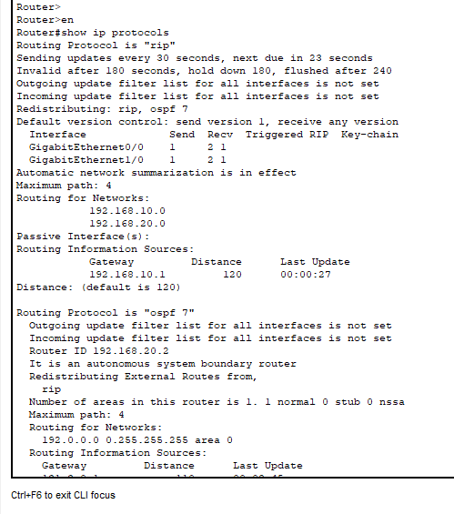

## Command to redistribute RIP to OSPF or OSPF to RIP:

Router(config)#

Router(config)#router ospf 7

Router(config-router)#redistri

Router(config-router)#redistribute rip sub

Router(config-router)#redistribute rip subnets

Router(config-router)#exit

Router(config)#

Router(config)#router rip

Router(config-router)#redistri

Router(config-router)#redistribute ospf 7 ?

match Redistribution of OSPF routes

metric Metric for redistributed routes

<cr>

Router(config-router)#redistribute ospf 7 metric

Router(config-router)#redistribute ospf 7 metric 1

Router(config-router)#exit

Router(config)#

Now the data from the city Karachi which have RIP can be redistributed to Islamabad which have OSPF and vice versa. The following ping command shows that data from city Karachi can be send to city Islamabad and vice versa.

**Ping a network of city Islamabad from city Karachi:**

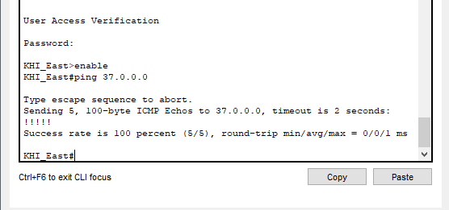

**Pinging a network of city Karachi from city Islamabad:**

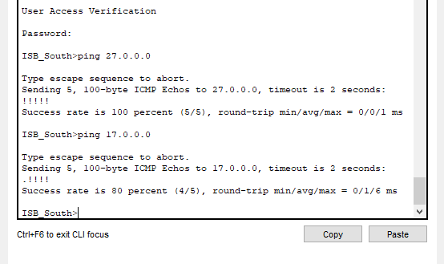

## Configuring redistribution OSPF to Static:

To configure the redistribution OSPF to Static or Static to OSPF the redistribution router will both has OSPF protocol and Static routing enabled. If someone send packet from city Peshawar which uses static routing to city Islamabad which uses OSPF routing protocol, then redistribution is from static to OSPF. That’s why OSPF routing protocol is enabled for redistribution router. But if someone sends a packet from city Islamabad to city Peshawar then the redistribution is from OSPF to Static. So, Redistribution router will have static routing.

## Static Routing table for redistribution router (OSPF to Static):

|  |  |  |
| --- | --- | --- |
| S: | 132.0.0.0 | via 192.168.40.1 |
| S: | 132.1.0.0 | via 192.168.40.1 |
| S: | 132.2.0.0 | via 192.168.40.1 |
| S: | 132.3.0.0 | via 192.168.40.1 |
| S: | 132.4.0.0 | via 192.168.40.1 |
| S: | 132.5.0.0 | via 192.168.40.1 |
| S: | 132.6.0.0 | via 192.168.40.1 |
| S: | 132.0.0.0 | via 192.168.40.1 |
| S: | 50.0.0.0 | via 192.168.40.1 |
| S: | 51.0.0.0 | via 192.168.40.1 |
| S: | 52.0.0.0 | via 192.168.40.1 |
| S: | 53.0.0.0 | via 192.168.40.1 |
| S: | 54.0.0.0 | via 192.168.40.1 |
| S: | 55.0.0.0 | via 192.168.40.1 |
| S: | 56.0.0.0 | via 192.168.40.1 |
| S: | 57.0.0.0 | via 192.168.40.1 |
| S: | 58.0.0.0 | via 192.168.40.1 |
| S: | 59.0.0.0 | via 192.168.40.1 |
| S: | 60.0.0.0 | via 192.168.40.1 |
| S: | 61.0.0.0 | via 192.168.40.1 |
| S: | 62.0.0.0 | via 192.168.40.1 |
| S: | 63.0.0.0 | via 192.168.40.1 |
| S: | 64.0.0.0 | via 192.168.40.1 |
| S: | 65.0.0.0 | via 192.168.40.1 |
| S: | 66.0.0.0 | via 192.168.40.1 |
| S: | 67.0.0.0 | via 192.168.40.1 |
| S: | 68.0.0.0 | via 192.168.40.1 |
| S: | 69.0.0.0 | via 192.168.40.1 |
| S: | 192.168.50.0 | via 192.168.40.1 |
| S: | 192.168.60.0 | via 192.168.40.1 |
| S: | 133.0.0.0 | via 192.168.40.1 |
| S: | 133.1.0.0 | via 192.168.40.1 |
| S: | 133.2.0.0 | via 192.168.40.1 |
| S: | 133.3.0.0 | via 192.168.40.1 |
| S: | 133.4.0.0 | via 192.168.40.1 |
| S: | 133.5.0.0 | via 192.168.40.1 |
| S: | 133.6.0.0 | via 192.168.40.1 |
| S: | 70.0.0.0 | via 192.168.40.1 |
| S: | 71.0.0.0 | via 192.168.40.1 |
| S: | 72.0.0.0 | via 192.168.40.1 |
| S: | 73.0.0.0 | via 192.168.40.1 |
| S: | 74.0.0.0 | via 192.168.40.1 |
| S: | 75.0.0.0 | via 192.168.40.1 |
| S: | 76.0.0.0 | via 192.168.40.1 |
| S: | 77.0.0.0 | via 192.168.40.1 |
| S: | 78.0.0.0 | via 192.168.40.1 |
| S: | 79.0.0.0 | via 192.168.40.1 |
| S: | 80.0.0.0 | via 192.168.40.1 |
| S: | 81.0.0.0 | via 192.168.40.1 |
| S: | 82.0.0.0 | via 192.168.40.1 |
| S: | 83.0.0.0 | via 192.168.40.1 |
| S: | 84.0.0.0 | via 192.168.40.1 |
| S: | 85.0.0.0 | via 192.168.40.1 |
| S: | 86.0.0.0 | via 192.168.40.1 |
| S: | 87.0.0.0 | via 192.168.40.1 |
| S: | 88.0.0.0 | via 192.168.40.1 |
| S: | 89.0.0.0 | via 192.168.40.1 |

**Static Routing Command for redistribution router (Static to OSPF):**

Router(config)#

Router(config)#ip route 132.0.0.0 255.255.0.0 192.168.40.1

Router(config)#ip route 132.1.0.0 255.255.0.0 192.168.40.1

Router(config)#ip route 132.2.0.0 255.255.0.0 192.168.40.1

Router(config)#ip route 132.2.0.0 255.255.0.0 192.168.40.1

Router(config)#ip route 132.3.0.0 255.255.0.0 192.168.40.1

Router(config)#ip route 132.4.0.0 255.255.0.0 192.168.40.1

Router(config)#ip route 132.5.0.0 255.255.0.0 192.168.40.1

Router(config)#ip route 132.6.0.0 255.255.0.0 192.168.40.1

Router(config)#ip route 50.0.0.0 255.0.0.0 192.168.40.1

Router(config)#ip route 51.0.0.0 255.0.0.0 192.168.40.1

Router(config)#ip route 52.0.0.0 255.0.0.0 192.168.40.1

Router(config)#ip route 53.0.0.0 255.0.0.0 192.168.40.1

Router(config)#ip route 54.0.0.0 255.0.0.0 192.168.40.1

Router(config)#ip route 55.0.0.0 255.0.0.0 192.168.40.1

Router(config)#ip route 56.0.0.0 255.0.0.0 192.168.40.1

Router(config)#ip route 57.0.0.0 255.0.0.0 192.168.40.1

Router(config)#ip route 58.0.0.0 255.0.0.0 192.168.40.1

Router(config)#ip route 59.0.0.0 255.0.0.0 192.168.40.1

Router(config)#ip route 60.0.0.0 255.0.0.0 192.168.40.1

Router(config)#ip route 61.0.0.0 255.0.0.0 192.168.40.1

Router(config)#ip route 62.0.0.0 255.0.0.0 192.168.40.1

Router(config)#ip route 63.0.0.0 255.0.0.0 192.168.40.1

Router(config)#ip route 64.0.0.0 255.0.0.0 192.168.40.1

Router(config)#ip route 65.0.0.0 255.0.0.0 192.168.40.1

Router(config)#ip route 66.0.0.0 255.0.0.0 192.168.40.1

Router(condign)#ip route 67.0.0.0 255.0.0.0 192.168.40.1

Router(config)#ip route 68.0.0.0 255.0.0.0 192.168.40.1

Router(config)#ip route 69.0.0.0 255.0.0.0 192.168.40.1

Router(config)#ip route 192.168.50.0 255.255.255.0 192.168.40.1

Router(config)#ip route 192.168.60.0 255.255.255.0 192.168.40.1

Router(config)#ip route 133.0.0.0 255.255.0.0 192.168.40.1

Router(config)#ip route 133.1.0.0 255.255.0.0 192.168.40.1

Router(config)#ip route 133.2.0.0 255.255.0.0 192.168.40.1

Router(config)#ip route 133.3.0.0 255.255.0.0 192.168.40.1

Router(config)#ip route 133.4.0.0 255.255.0.0 192.168.40.1

Router(config)#ip route 133.5.0.0 255.255.0.0 192.168.40.1

Router(config)#ip route 133.6.0.0 255.255.0.0 192.168.40.1

Router(config)#ip route 70.0.0.0 255.0.0.0 192.168.40.1

Router(config)#ip route 71.0.0.0 255.0.0.0 192.168.40.1

Router(config)#ip route 72.0.0.0 255.0.0.0 192.168.40.1

Router(config)#ip route 73.0.0.0 255.0.0.0 192.168.40.1

Router(config)#ip route 74.0.0.0 255.0.0.0 192.168.40.1

Router(config)#ip route 75.0.0.0 255.0.0.0 192.168.40.1

Router(config)#ip route 76.0.0.0 255.0.0.0 192.168.40.1

Router(config)#ip route 77.0.0.0 255.0.0.0 192.168.40.1

Router(config)#ip route 78.0.0.0 255.0.0.0 192.168.40.1

Router(config)#ip route 79.0.0.0 255.0.0.0 192.168.40.1

Router(config)#ip route 80.0.0.0 255.0.0.0 192.168.40.1

Router(config)#ip route 81.0.0.0 255.0.0.0 192.168.40.1

Router(config)#ip route 82.0.0.0 255.0.0.0 192.168.40.1

Router(config)#ip route 83.0.0.0 255.0.0.0 192.168.40.1

Router(config)#ip route 84.0.0.0 255.0.0.0 192.168.40.1

Router(config)#ip route 85.0.0.0 255.0.0.0 192.168.40.1

Router(config)#ip route 86.0.0.0 255.0.0.0 192.168.40.1

Router(config)#ip route 87.0.0.0 255.0.0.0 192.168.40.1

Router(config)#ip route 88.0.0.0 255.0.0.0 192.168.40.1

Router(config)#ip route 89.0.0.0 255.0.0.0 192.168.40.1

Router(config)#

## Command to configure OSPF on redistribution Router (Static to OSPF):

Router(config)#router ospf 7

Router(config-router)#network 192.168.30.0 0.255.255.255 area 0

Router(config-router)#network 192.168.40.0 0.255.255.255 area 0

Router(config-router)#exit

## Command to redistribute Static to OSPF:

Router(config)#router ospf 7

Router(config-router)#redist

Router(config-router)#redistribute static sub

Router(config-router)#redistribute static subnets

As the redistribution is configured from static to OSPF and vice versa. So, a connection is established between the cities Karachi, Islamabad, Peshawar. So the data can be send between these cities. The following ping command show that the data can be send between cities Karachi, Islamabad, Peshawar:

**Pinging a network of city Islamabad from city Peshawar:**

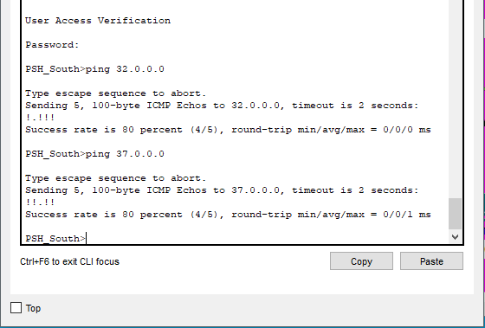

**Pinging a network of city Karachi from city Peshawar:**

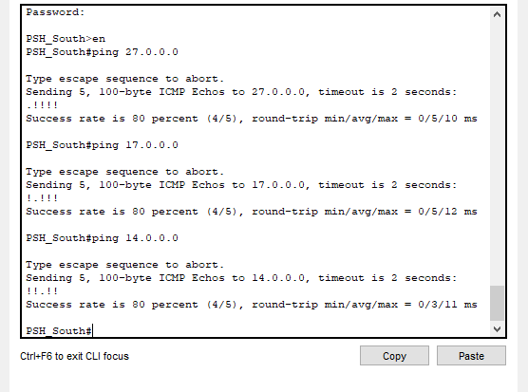

**Pinging a network of city Peshawar from city Karachi:**

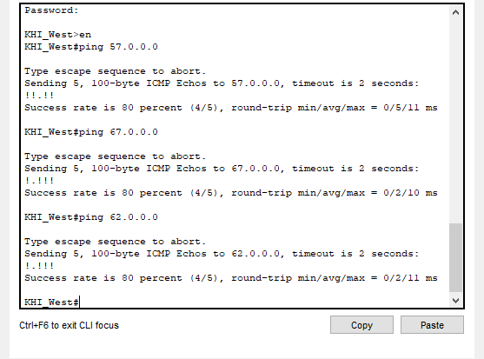

**Pinging a network of city Peshawar from city Islamabad:**

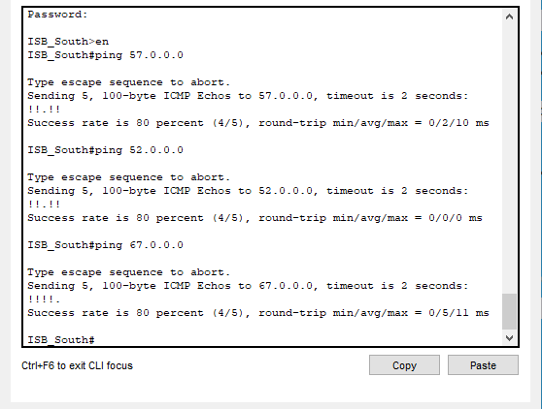

## Configuring redistribution Static to EIGRP:

To configure the redistribution EIGRP to Static or Static to EIGRP the redistribution router will both has EIGRP protocol and Static routing enabled. If someone send packet from city Peshawar which uses static routing to city Lahore which uses EIGRP routing protocol, then redistribution is from static to EIGRP. That’s why EIGRP routing protocol is enabled for redistribution router. But if someone sends a packet from city Lahore to city Peshawar then the redistribution is from EIGRP to Static. Similarly, If someone sends a packet from city Lahore to city Karachi the redistribution is from EIGRP to static. so the redistribution router must know all the networks of city Peshawar, Islamabad and Karachi.

## Static Routing table for redistribution router (EIGRP to Static):

|  |  |  |
| --- | --- | --- |
| S: | 132.0.0.0 | via 192.168.50.1 |
| S: | 132.1.0.0 | via 192.168.50.1 |
| S: | 132.2.0.0 | via 192.168.50.1 |
| S: | 132.3.0.0 | via 192.168.50.1 |
| S: | 132.4.0.0 | via 192.168.50.1 |
| S: | 132.5.0.0 | via 192.168.50.1 |
| S: | 132.6.0.0 | via 192.168.50.1 |
| S: | 50.0.0.0 | via 192.168.50.1 |
| S: | 51.0.0.0 | via 192.168.50.1 |
| S: | 52.0.0.0 | via 192.168.50.1 |
| S: | 53.0.0.0 | via 192.168.50.1 |
| S: | 54.0.0.0 | via 192.168.50.1 |
| S: | 55.0.0.0 | via 192.168.50.1 |
| S: | 56.0.0.0 | via 192.168.50.1 |
| S: | 57.0.0.0 | via 192.168.50.1 |
| S: | 58.0.0.0 | via 192.168.50.1 |
| S: | 59.0.0.0 | via 192.168.50.1 |
| S: | 60.0.0.0 | via 192.168.50.1 |
| S: | 61.0.0.0 | via 192.168.50.1 |
| S: | 62.0.0.0 | via 192.168.50.1 |
| S: | 63.0.0.0 | via 192.168.50.1 |
| S: | 64.0.0.0 | via 192.168.50.1 |
| S: | 65.0.0.0 | via 192.168.50.1 |
| S: | 66.0.0.0 | via 192.168.50.1 |
| S: | 67.0.0.0 | via 192.168.50.1 |
| S: | 68.0.0.0 | via 192.168.50.1 |
| S: | 69.0.0.0 | via 192.168.50.1 |
| S: | 192.168.40.0 | via 192.168.50.1 |
| S: | 192.168.30.0 | via 192.168.50.1 |
| S: | 131.0.0.0 | via 192.168.50.1 |
| S: | 131.1.0.0 | via 192.168.50.1 |
| S: | 131.2.0.0 | via 192.168.50.1 |
| S: | 131.3.0.0 | via 192.168.50.1 |
| S: | 131.4.0.0 | via 192.168.50.1 |
| S: | 131.5.0.0 | via 192.168.50.1 |
| S: | 131.6.0.0 | via 192.168.50.1 |
| S: | 30.0.0.0 | via 192.168.50.1 |
| S: | 31.0.0.0 | via 192.168.50.1 |
| S: | 32.0.0.0 | via 192.168.50.1 |
| S: | 33.0.0.0 | via 192.168.50.1 |
| S: | 34.0.0.0 | via 192.168.50.1 |
| S: | 35.0.0.0 | via 192.168.50.1 |
| S: | 36.0.0.0 | via 192.168.50.1 |
| S: | 37.0.0.0 | via 192.168.50.1 |
| S: | 38.0.0.0 | via 192.168.50.1 |
| S: | 39.0.0.0 | via 192.168.50.1 |
| S: | 40.0.0.0 | via 192.168.50.1 |
| S: | 40.0.0.0 | via 192.168.50.1 |
| S: | 41.0.0.0 | via 192.168.50.1 |
| S: | 42.0.0.0 | via 192.168.50.1 |
| S: | 43.0.0.0 | via 192.168.50.1 |
| S: | 44.0.0.0 | via 192.168.50.1 |
| S: | 45.0.0.0 | via 192.168.50.1 |
| S: | 46.0.0.0 | via 192.168.50.1 |
| S: | 47.0.0.0 | via 192.168.50.1 |
| S: | 48.0.0.0 | via 192.168.50.1 |
| S: | 49.0.0.0 | via 192.168.50.1 |
| S: | 192.168.20.0 | via 192.168.50.1 |
| S: | 192.168.10.0 | via 192.168.50.1 |
| S: | 130.0.0.0 | via 192.168.50.1 |
| S: | 130.1.0.0 | via 192.168.50.1 |
| S: | 130.2.0.0 | via 192.168.50.1 |
| S: | 130.3.0.0 | via 192.168.50.1 |
| S: | 130.4.0.0 | via 192.168.50.1 |
| S: | 130.5.0.0 | via 192.168.50.1 |
| S: | 130.6.0.0 | via 192.168.50.1 |
| S: | 10.0.0.0 | via 192.168.50.1 |
| S: | 11.0.0.0 | via 192.168.50.1 |
| S: | 12.0.0.0 | via 192.168.50.1 |
| S: | 13.0.0.0 | via 192.168.50.1 |
| S: | 14.0.0.0 | via 192.168.50.1 |
| S: | 15.0.0.0 | via 192.168.50.1 |
| S: | 16.0.0.0 | via 192.168.50.1 |
| S: | 17.0.0.0 | via 192.168.50.1 |
| S: | 18.0.0.0 | via 192.168.50.1 |
| S: | 19.0.0.0 | via 192.168.50.1 |
| S: | 20.0.0.0 | via 192.168.50.1 |
| S: | 21.0.0.0 | via 192.168.50.1 |
| S: | 22.0.0.0 | via 192.168.50.1 |
| S: | 23.0.0.0 | via 192.168.50.1 |
| S: | 24.0.0.0 | via 192.168.50.1 |
| S: | 25.0.0.0 | via 192.168.50.1 |
| S: | 26.0.0.0 | via 192.168.50.1 |
| S: | 27.0.0.0 | via 192.168.50.1 |
| S: | 28.0.0.0 | via 192.168.50.1 |
| S: | 29.0.0.0 | via 192.168.50.1 |

**Static Routing Command for redistribution router (EIGRP to Static):**

Router(config)#

Router(config)#ip route 132.0.0.0 255.255.0.0 192.168.50.1

Router(config)#ip route 132.1.0.0 255.255.0.0 192.168.50.1

Router(config)#ip route 132.2.0.0 255.255.0.0 192.168.50.1

Router(config)#ip route 132.3.0.0 255.255.0.0 192.168.50.1

Router(config)#ip route 132.4.0.0 255.255.0.0 192.168.50.1

Router(config)#ip route 132.5.0.0 255.255.0.0 192.168.50.1

Router(config)#ip route 132.6.0.0 255.255.0.0 192.168.50.1

Router(config)#ip route 50.0.0.0 255.0.0.0 192.168.50.1

Router(config)#ip route 51.0.0.0 255.0.0.0 192.168.50.1

Router(config)#ip route 52.0.0.0 255.0.0.0 192.168.50.1

Router(config)#ip route 53.0.0.0 255.0.0.0 192.168.50.1

Router(config)#ip route 54.0.0.0 255.0.0.0 192.168.50.1

Router(config)#ip route 55.0.0.0 255.0.0.0 192.168.50.1

Router(config)#ip route 56.0.0.0 255.0.0.0 192.168.50.1

Router(config)#ip route 57.0.0.0 255.0.0.0 192.168.50.1

Router(config)#ip route 58.0.0.0 255.0.0.0 192.168.50.1

Router(config)#ip route 59.0.0.0 255.0.0.0 192.168.50.1

Router(config)#ip route 60.0.0.0 255.0.0.0 192.168.50.1

Router(config)#ip route 61.0.0.0 255.0.0.0 192.168.50.1

Router(config)#ip route 62.0.0.0 255.0.0.0 192.168.50.1

Router(config)#ip route 63.0.0.0 255.0.0.0 192.168.50.1

Router(config)#ip route 64.0.0.0 255.0.0.0 192.168.50.1

Router(config)#ip route 65.0.0.0 255.0.0.0 192.168.50.1

Router(config)#ip route 66.0.0.0 255.0.0.0 192.168.50.1

Router(config)#ip route 67.0.0.0 255.0.0.0 192.168.50.1

Router(config)#ip route 68.0.0.0 255.0.0.0 192.168.50.1

Router(config)#ip route 69.0.0.0 255.0.0.0 192.168.50.1

Router(config)#ip route 192.168.40.0 255.255.255.0 192.168.50.1

Router(config)#ip route 192.168.30.0 255.255.255.0 192.168.50.1

Router(config)#ip route 131.0.0.0 255.255.0.0 192.168.50.1

Router(config)#ip route 131.1.0.0 255.255.0.0 192.168.50.1

Router(config)#ip route 131.2.0.0 255.255.0.0 192.168.50.1

Router(config)#ip route 131.3.0.0 255.255.0.0 192.168.50.1

Router(config)#ip route 131.4.0.0 255.255.0.0 192.168.50.1

Router(config)#ip route 131.5.0.0 255.255.0.0 192.168.50.1

Router(config)#ip route 131.6.0.0 255.255.0.0 192.168.50.1

Router(config)#ip route 30.0.0.0 255.0.0.0 192.168.50.1

Router(config)#ip route 31.0.0.0 255.0.0.0 192.168.50.1

Router(config)#ip route 32.0.0.0 255.0.0.0 192.168.50.1

Router(config)#ip route 33.0.0.0 255.0.0.0 192.168.50.1

Router(config)#ip route 34.0.0.0 255.0.0.0 192.168.50.1

Router(config)#ip route 35.0.0.0 255.0.0.0 192.168.50.1

Router(config)#ip route 36.0.0.0 255.0.0.0 192.168.50.1

Router(config)#ip route 37.0.0.0 255.0.0.0 192.168.50.1

Router(config)#ip route 38.0.0.0 255.0.0.0 192.168.50.1

Router(config)#ip route 39.0.0.0 255.0.0.0 192.168.50.1

Router(config)#ip route 40.0.0.0 255.0.0.0 192.168.50.1

Router(config)#ip route 41.0.0.0 255.0.0.0 192.168.50.1

Router(config)#ip route 42.0.0.0 255.0.0.0 192.168.50.1

Router(config)#ip route 43.0.0.0 255.0.0.0 192.168.50.1

Router(config)#ip route 44.0.0.0 255.0.0.0 192.168.50.1

Router(config)#ip route 45.0.0.0 255.0.0.0 192.168.50.1

Router(config)#ip route 46.0.0.0 255.0.0.0 192.168.50.1

Router(config)#ip route 47.0.0.0 255.0.0.0 192.168.50.1

Router(config)#ip route 48.0.0.0 255.0.0.0 192.168.50.1

Router(config)#ip route 49.0.0.0 255.0.0.0 192.168.50.1

Router(config)#ip route 192.168.20.0 255.255.255.0 192.168.50.1

Router(config)#ip route 192.168.10.0 255.255.255.0 192.168.50.1

Router(config)#ip route 130.0.0.0 255.255.0.0 192.168.50.1

Router(config)#ip route 130.1.0.0 255.255.0.0 192.168.50.1

Router(config)#ip route 130.2.0.0 255.255.0.0 192.168.50.1

Router(config)#ip route 130.3.0.0 255.255.0.0 192.168.50.1

Router(config)#ip route 130.4.0.0 255.255.0.0 192.168.50.1

Router(config)#ip route 130.5.0.0 255.255.0.0 192.168.50.1

Router(config)#ip route 130.6.0.0 255.255.0.0 192.168.50.1

Router(config)#ip route 10.0.0.0 255.0.0.0 192.168.50.1

Router(config)#ip route 11.0.0.0 255.0.0.0 192.168.50.1

Router(config)#ip route 12.0.0.0 255.0.0.0 192.168.50.1

Router(config)#ip route 13.0.0.0 255.0.0.0 192.168.50.1

Router(config)#ip route 14.0.0.0 255.0.0.0 192.168.50.1

Router(config)#ip route 15.0.0.0 255.0.0.0 192.168.50.1

Router(config)#ip route 16.0.0.0 255.0.0.0 192.168.50.1

Router(config)#ip route 17.0.0.0 255.0.0.0 192.168.50.1

Router(config)#ip route 18.0.0.0 255.0.0.0 192.168.50.1

Router(config)#ip route 19.0.0.0 255.0.0.0 192.168.50.1

Router(config)#ip route 20.0.0.0 255.0.0.0 192.168.50.1

Router(config)#ip route 21.0.0.0 255.0.0.0 192.168.50.1

Router(config)#ip route 22.0.0.0 255.0.0.0 192.168.50.1

Router(config)#ip route 23.0.0.0 255.0.0.0 192.168.50.1

Router(config)#ip route 24.0.0.0 255.0.0.0 192.168.50.1

Router(config)#ip route 25.0.0.0 255.0.0.0 192.168.50.1

Router(config)#ip route 26.0.0.0 255.0.0.0 192.168.50.1

Router(config)#ip route 27.0.0.0 255.0.0.0 192.168.50.1

Router(config)#ip route 28.0.0.0 255.0.0.0 192.168.50.1

Router(config)#ip route 29.0.0.0 255.0.0.0 192.168.50.1

Router(config)#

**Command to configure EIGRP on redistribution router:**

Router(config)#router eigrp 17

Router(config-router)#network 192.168.50.0

Router(config-router)#network 192.168.60.0

Router(config-router)#exit

Router(config)#

Router(config)#

## Redistribution command to redistribute static to EIGRP:

The command to redistribute static route into EIGRP is:

redistribute static metric [bandwidth] [delay] [reliability] [load] [MTU]

**Command:**

Router(config)#router eigrp 17

Router(config-router)#redist

Router(config-router)#redistribute static ?

metric Metric for redistributed routes

<cr>

Router(config-router)#redistribute static metric

Router(config-router)#redistribute static metric 10000 0 255 1 1500

Router(config-router)#exit

Router(config)#

After this redistribution all the cities are interconnected, all the cities can send data to each other. The following ping command show that data can be send between the cities:

**Pinging a network of city Peshawar from city Lahore:**

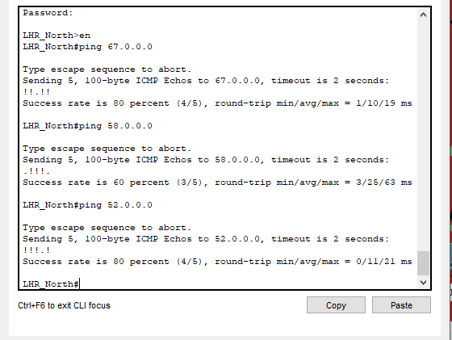

**Pinging a network of city Lahore from city Peshawar:**

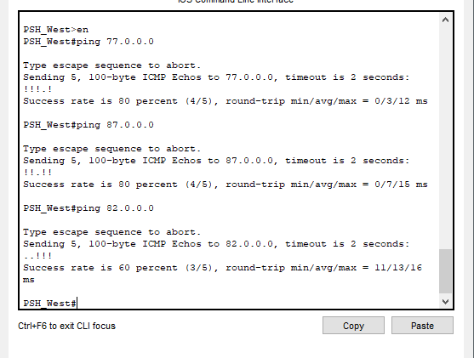

**Pinging a network of city Islamabad from city Lahore:**

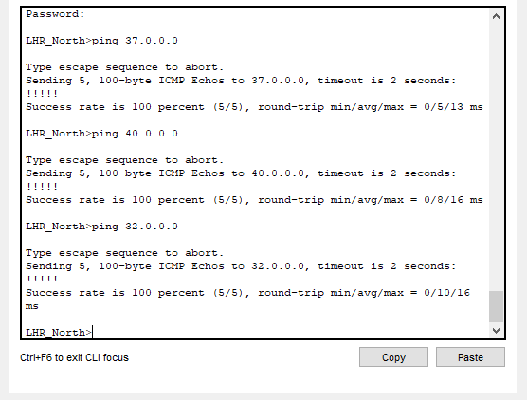

**Pinging a network of city Lahore from city Islamabad:**

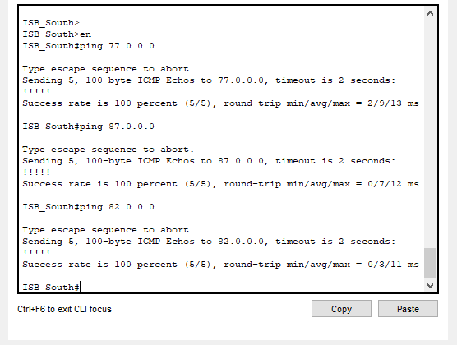

**Pinging a network of city Karachi from city Lahore:**

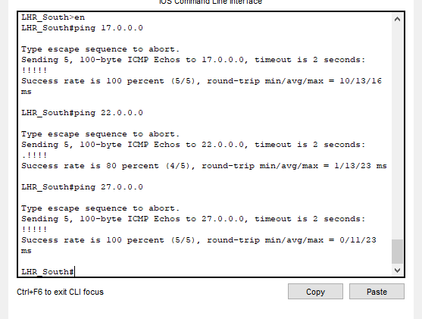

**Pinging a network of city Lahore from city Karachi:**

# 

# Changing the banner of routers:

The change the banners of the routers of city Karachi the following commands are used:

**Karachi R1:**

Karachi>enable

Karachi#configure terminal

Enter configuration commands, one per line. End with CNTL/Z.

Karachi(config)#

Karachi(config)#banner motd !

Enter TEXT message. End with the character '!'.

Main karachi router!

Karachi(config)#

Karachi(config)#exit

**Islamabad R1:**

Islamabad#configure terminal

Enter configuration commands, one per line. End with CNTL/Z.

Islamabad(config)#

Islamabad(config)#

Islamabad(config)#banner motd !

Enter TEXT message. End with the character '!'.

Main Islamabad router!

Islamabad(config)#

Islamabad(config)#exit

**Lahore R1:**

Lahore#configure terminal

Enter configuration commands, one per line. End with CNTL/Z.

Lahore(config)#

Lahore(config)#banner motd !

Enter TEXT message. End with the character '!'.

Main Lahore router!

Lahore(config)#exit

The same commands are used to change banner of all the routers.