Data Structures and Algorithms – Lab
BSCS [3A]

FINAL TERM PROJECT REPORT



Submitted By [Group No. 1]:

- Moeez Ahmed 006 (Leader)
- Rafay Hussain 010
- Haris Abdullah 032
- Maaz Khalil 041

Submitted to: Asad Kamal

PROJECT NAME
Quarantine Center

DEPARTMENT OF COMPUTER SCIENCES
BAHRIA UNIVERSITY, LAHORE CAMPUS

Table of Contents
1. Marks Distribution 3
2. Abstract 4
3. Introduction 5
4. Problem Statement 5
5. Objectives 5
6. Methodology 5
7. Results 5
8. Code 5
9. References 5

Marks Distribution
------------------------------ For Instructor Use Only ----------------------------------
Project Grading Sheet
Sr. No. | Task | Max Marks | Obtained Marks | Comments(if any)
1. | Report | 05
2. | Implementation | 10
3. | Viva  (Oral/Task Based or Both) | 15
Total |  | 30 |  | Signature:
---------------------------------------------------------------------------

-------------------------------------- Instructions -----------------------------------------
- Follow the below given steps to design your report :
- Font Style : Times New Roman
- Font Size : First Heading (14 pts), Sub Headings (12 pts), Normal Text (12pts)
- Justify you normal text under each heading
- Deadline of the project : 18th January, 2021
------------------------------------------------------------------------------------------------

Abstract
This section contains the initial impression/summary of your project. This part speaks for report. This section should present the actual meaning of the project topic, should summarize the need of this project, the hypothesis, objectives and procedure that is followed to accomplish the defined objectives.
Though this paragraph appears first but is edited in the last as it’s the concise summary of the project.

Introduction
In December 2019 a deadliest virus came into existence, which was named as Covid-19. It infected people all around the world which increased the number of patients. So, in order to record Patient’s data in a Quarantine Center it required a program which can store patient data and the data of Doctors and Nurses in Corona Ward.

Problem Statement

Problem was to create a program which can add, update and delete Patient’s data and the data of Doctors and Nurses in Corona Ward. So, that record can be maintained.

Objectives

It can record Patient, Nurse and Doctor data for future use.

Methodology

We Will Create a Quarantine Center class which will composed (Composition) of Rooms and in Rooms we will store (Aggregation) the data of Patients Doctors and Nurses. Patient will be inherited with class corona so as we can get corona record of relative patient having corona.
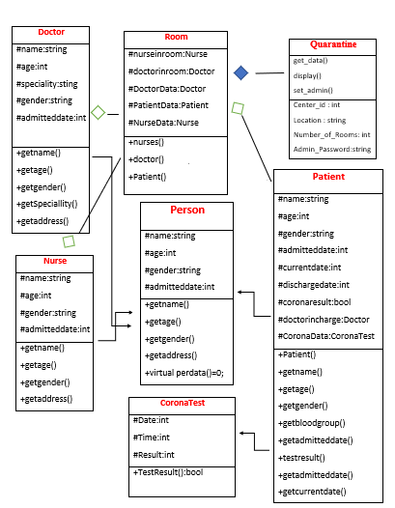

Results

- If File of Quarantine Center name “Center Data.txt” Doesn’t exist in program the program will ask us for the input to set the Data of Center.

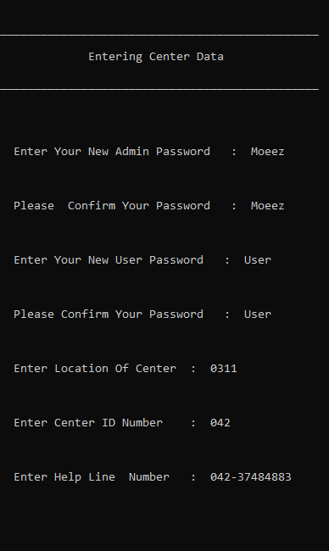

- After Entering the Information a Menu will be Appeared for Login as User Or Login as Admin.

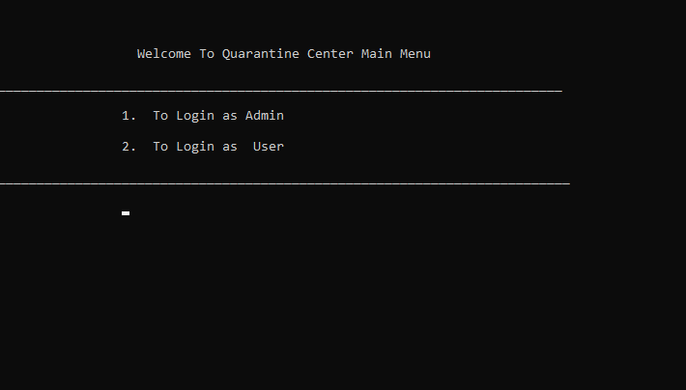

- If you will enter wrong password it will say Please Enter the Password Again.

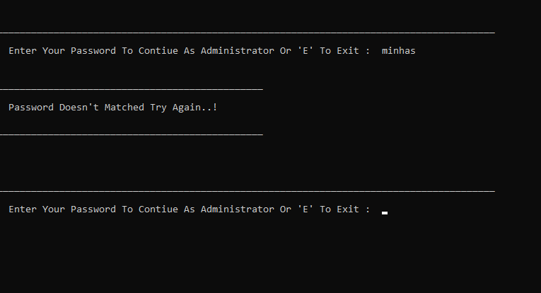

- If you are accessing as Admin you can manage Doctor, Nurse you can also change the password of user and admin

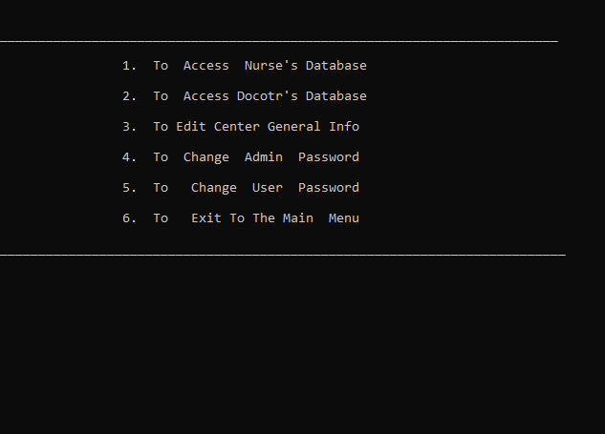

- If you are accessing as User you can manage Patient.

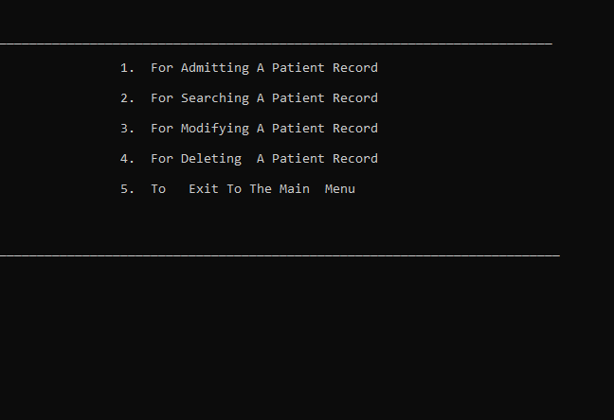

If you don’t know the id # of Patient, Doctor or Nurse then you can just Press * To show All the Doctors, Nurses and Patients in a corresponding Room.

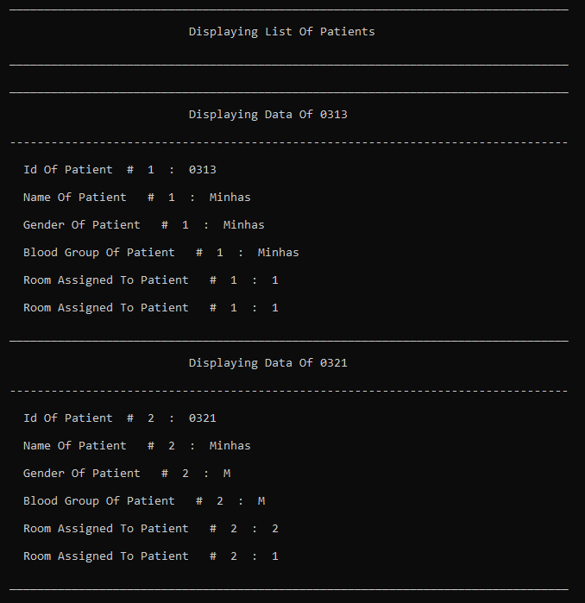

- If Some ID exists for a person than it cannot be assigned to another person until previous record is moved or deleted.

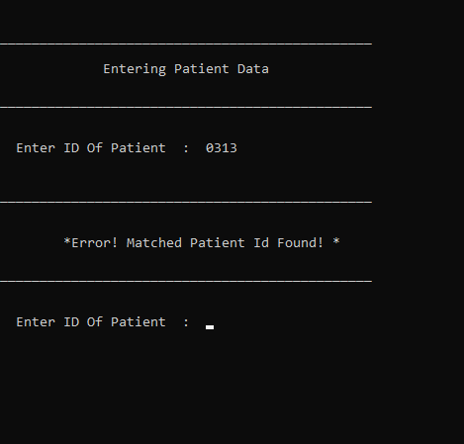

- If you are modifying patient record and make his corona test negative the patient will be discharged at the spot.

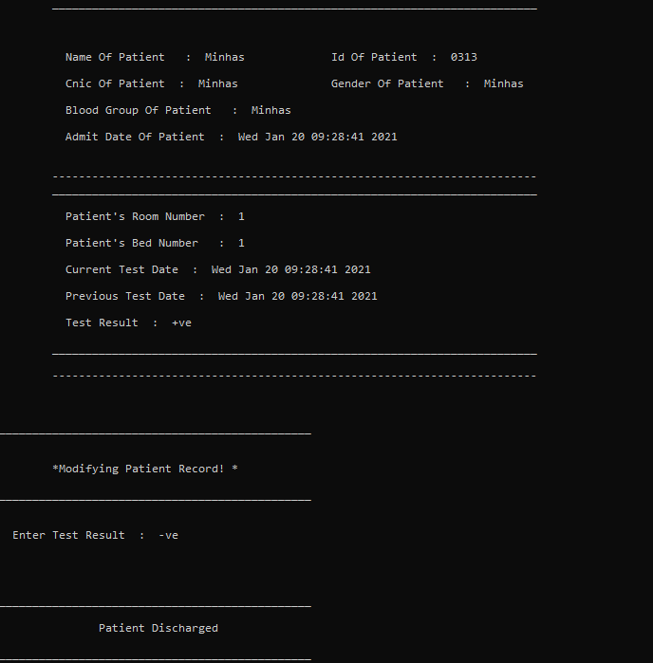

Code

#pragma once
#define _CRT_SECURE_NO_WARNINGS
#include <iostream>
#include<string>
#include<fstream>
#include<ctime>
using namespace std;
time_t now = time(0);
using namespace std;
class personType
{
protected:
string id, name, cnic, gender, bloodgroup, age;
public:
personType();
virtual void SetPersonData(string iid, string iname, string icnic, string igender, string ibloodgroup, string age) = 0;
};

personType::personType()
{
id = "Null";
name = "Null";
cnic = "Null";
gender = "Null";
bloodgroup = "Null";
}
void personType::SetPersonData(string iid, string iname, string icnic, string igender, string ibloodgroup, string age)
{
id = iid;
name = iname;
cnic = icnic;
gender = igender;
bloodgroup = ibloodgroup;
}

class Doctor :public personType
{
int DoctorRoomNo;
string DoctorRole;
static int DoctorsInRoom_1;//These are the total reserved beds in a room
static int DoctorsInRoom_2;//We Will Assign this to the Doctor bed number + 1
static int DoctorsInRoom_3;
Doctor* next = NULL;
Doctor* prev = NULL;
public:
Doctor();
void SetPersonData(string iid, string iname, string icnic, string igender, string ibloodgroup, string age);
void insertDoctor(Doctor** doctorData, string iid, string iname, string iage, string icnic, string igender, string ibloodgroup, int iroomno, string irole, char option);
void InputSingleDoctor(Doctor** doctorData, char option);
bool DoctorIdUnique(Doctor* doctorData, string tempid);
void SearchDoctor(Doctor** doctorData, char option, char choice);
void ExportTotalDoctors(Doctor** doctorData);
void ImportTotalDoctors(Doctor** doctorData);
void ImportDoctorsData(Doctor** doctorData, char option);
void ExportDoctorsData(Doctor* doctorData, int data, char option);
void DoctorAdmit(Doctor* doctorData, int data, char option);
void DoctorDischarged(Doctor** doctorData, string DoctorID, int data, char option);
void DisplayDoctorData(char option);
void DisplayAllDoctors(Doctor* doctorData, char option);
~Doctor();
};

Doctor::Doctor()
{
DoctorRole = "NULL";
DoctorRoomNo = 0;
next = NULL;
prev = NULL;
}
void Doctor::SetPersonData(string iid, string iname, string icnic, string igender, string ibloodgroup, string age)
{
id = iid;
name = iname;
cnic = icnic;
gender = igender;
bloodgroup = ibloodgroup;
}
void Doctor::insertDoctor(Doctor** doctorData, string iid, string iname, string iage, string icnic, string igender, string ibloodgroup, int iroomno, string irole, char option)
{
Doctor* temp = new Doctor;
temp->id = iid;
temp->name = iname;
temp->age = iage;
temp->cnic = icnic;
temp->gender = igender;
temp->DoctorRoomNo = iroomno;
temp->bloodgroup = ibloodgroup;
temp->DoctorRole = irole;
Doctor* traverse = *doctorData;
if (traverse == NULL)
{
temp->next = temp->prev = NULL;
*doctorData = temp;
}
else
{
while (traverse->next != NULL)
{
traverse = traverse->next;
}
traverse->next = temp;
temp->prev = traverse;
temp->next = NULL;
}

}

void Doctor::InputSingleDoctor(Doctor** doctorData, char option)
{

Doctor* temp = new Doctor;
string tempid;
system("cls");
cout << "\n\n_______________________________________________";
cout << "\n\n Entering Doctor Data";
cout << "\n\n_______________________________________________\n";
bool uni;
int data = 0;
do
{
uni = false;
cin.ignore();
cout << "\n\n Enter ID Of Doctor : ";
getline(cin, tempid);
uni = DoctorIdUnique(*doctorData, tempid);
if (uni == false)
{
temp->id = tempid;
}
} while (uni);
cin.ignore();
cout << "\n\n Enter Name Of Doctor : ";
getline(cin, temp->name);
cin.ignore();
cout << "\n\n Enter Age Of Doctor : ";
getline(cin, temp->age);
cin.ignore();
cout << "\n\n Enter CNIC Of Doctor : ";
getline(cin, temp->cnic);
cin.ignore();
cout << "\n\n Enter Gender Of Doctor : ";
getline(cin, temp->gender);
cin.ignore();
cout << "\n\n Enter Blood Group Of Doctor : ";
getline(cin, temp->bloodgroup);
cin.ignore();
cout << "\n\n Enter Specification Of Doctor : ";
getline(cin, temp->DoctorRole);
Doctor* traverse = *doctorData;
if (traverse == NULL)
{
temp->next = temp->prev = NULL;
*doctorData = temp;
}
else
{
while (traverse->next != NULL)
{
traverse = traverse->next;
}
traverse->next = temp;
temp->prev = traverse;
temp->next = NULL;
}
temp->DoctorAdmit(*doctorData, data, option);

}

bool Doctor::DoctorIdUnique(Doctor* doctorData, string doctorDataid)
{
bool unique = false;
Doctor* temp = doctorData;
bool matched = false;
while (temp != NULL)
{
if (temp->id == doctorDataid)
{
cout << "\n\n_______________________________________________";
cout << "\n\n\n\t*Error! Matched Doctor Id Found! *";
cout << "\n\n_______________________________________________";
matched = true;
break;
}
temp = temp->next;
}
return matched;
}

void Doctor::SearchDoctor(Doctor** doctorData, char option, char choice)
{
int data = 0;
bool list = false;
bool found = true;
Doctor* temp = *doctorData;
if (option == '1')
{
data = DoctorsInRoom_1;
}
else if (option == '2')
{
data = DoctorsInRoom_2;
}
else if (option == '3')
{
data = DoctorsInRoom_3;
}
cin.ignore();
string doctorDataid;
cout << "\n Enter Doctor Id To Search Or \"*\" To Display Doctors List : ";
getline(cin, doctorDataid);
if (doctorDataid == "*")
{
list = true;
temp->DisplayAllDoctors(*doctorData, option);
}
else if (list == false)
{
while (temp != NULL)
{
if (doctorDataid == temp->id)
{
found = false;
system("CLS");
temp->DisplayDoctorData(option);
if (choice == '3')
{
cout << "\n\n_______________________________________________";
cout << "\n\n\n\t*Modifying Doctor Record! *";
cout << "\n\n_______________________________________________";
cin.ignore();
cout << "\n\n Enter Role Of Doctor : ";
getline(cin, temp->DoctorRole);
}
else if (choice == '4')
{
cout << "\n\n_______________________________________________";
cout << "\n\n\n\t*Deleting Doctor Record! *";
cout << "\n\n_______________________________________________";
temp->DoctorDischarged(doctorData, doctorDataid, data, option);
}
}
temp = temp->next;
}

if (found)
{
cout << "\n\n_______________________________________________";
cout << "\n\n\n\t*Doctor Record Not Found! *";
cout << "\n\n_______________________________________________";
}
}
}

void Doctor::ExportTotalDoctors(Doctor** doctorData)
{
Doctor* temp = *doctorData;
fstream ExportReservedBeds;
ExportReservedBeds.open("Total Doctors In All Rooms.txt", ios::out | ios::trunc);
ExportReservedBeds.close();
ExportReservedBeds.open("Total Doctors In All Rooms.txt", ios::out | ios::app);
cin.ignore();
ExportReservedBeds << temp->DoctorsInRoom_1 << endl << temp->DoctorsInRoom_2 << endl << temp->DoctorsInRoom_3;
ExportReservedBeds.close();
}
void Doctor::ImportTotalDoctors(Doctor** doctorData)
{
Doctor* temp = *doctorData;
fstream ImportReservedBeds;
ImportReservedBeds.open("Total Doctors In All Rooms.txt", ios::in);
ImportReservedBeds >> temp->DoctorsInRoom_1;
ImportReservedBeds >> temp->DoctorsInRoom_2;
ImportReservedBeds >> temp->DoctorsInRoom_3;
ImportReservedBeds.close();
}
void Doctor::ImportDoctorsData(Doctor** doctorData, char option)
{
fstream ImportDoctor;
string iid, iname, icnic, igender, ibloodgroup, iage, irole;
int iroomno;
Doctor* temp = new Doctor;
if (option == '1')
{
ImportDoctor.open("Doctors In Room 1.txt", ios::in);
for (int i = 0; i < DoctorsInRoom_1; i++)
{
getline(ImportDoctor, iage);
getline(ImportDoctor, iname);
getline(ImportDoctor, iid);
getline(ImportDoctor, icnic);
getline(ImportDoctor, igender);
getline(ImportDoctor, ibloodgroup);
ImportDoctor >> iroomno;
ImportDoctor.ignore();
getline(ImportDoctor, irole);
insertDoctor(doctorData, iid, iname, iage, icnic, igender, ibloodgroup, iroomno, irole, option);
}
ImportDoctor.close();
}

if (option == '2')
{
ImportDoctor.open("Doctors In Room 2.txt");
for (int i = 0; i < DoctorsInRoom_2; i++)
{
getline(ImportDoctor, iage);
getline(ImportDoctor, iname);
getline(ImportDoctor, iid);
getline(ImportDoctor, icnic);
getline(ImportDoctor, igender);
getline(ImportDoctor, ibloodgroup);
ImportDoctor >> iroomno;
ImportDoctor.ignore();
getline(ImportDoctor, irole);
insertDoctor(doctorData, iid, iname, iage, icnic, igender, ibloodgroup, iroomno, irole, option);
}
ImportDoctor.close();
}

if (option == '3')
{
ImportDoctor.open("Doctors In Room 3.txt");
for (int i = 0; i < DoctorsInRoom_3; i++)
{
getline(ImportDoctor, iage);
getline(ImportDoctor, iname);
getline(ImportDoctor, iid);
getline(ImportDoctor, icnic);
getline(ImportDoctor, igender);
getline(ImportDoctor, ibloodgroup);
ImportDoctor >> iroomno;
ImportDoctor.ignore();
getline(ImportDoctor, irole);
insertDoctor(doctorData, iid, iname, iage, icnic, igender, ibloodgroup, iroomno, irole, option);
}
ImportDoctor.close();
}
}

void Doctor::ExportDoctorsData(Doctor* temp, int data, char option)
{
Doctor* doctorData = temp;
fstream ExportDoctor;
if (option == '1')
{
ExportDoctor.open("Doctors In Room 1.txt", ios::out | ios::trunc);
ExportDoctor.close();
ExportDoctor.open("Doctors In Room 1.txt", ios::out | ios::app);
data = DoctorsInRoom_1;
}
else if (option == '2')
{
ExportDoctor.open("Doctors In Room 2.txt", ios::out | ios::trunc);
ExportDoctor.close();
ExportDoctor.open("Doctors In Room 2.txt", ios::out | ios::app);
data = DoctorsInRoom_2;
}
else if (option == '3')
{
ExportDoctor.open("Doctors In Room 3.txt", ios::out | ios::trunc);
ExportDoctor.close();
ExportDoctor.open("Doctors In Room 3.txt", ios::out | ios::app);
data = DoctorsInRoom_3;
}
cin.ignore();
while (doctorData != NULL)
{
ExportDoctor << doctorData->age << endl << doctorData->name << endl << doctorData->id << endl << doctorData->cnic << endl << doctorData->gender
<< endl << doctorData->bloodgroup << endl << doctorData->DoctorRoomNo << endl << doctorData->DoctorRole << endl;
doctorData = doctorData->next;
}
ExportDoctor.close();
}

void Doctor::DoctorAdmit(Doctor* doctorData, int data, char option)
{
if (option == '1')
{
cout << "\n\n_______________________________________________";
cout << "\n\n Doctor Added ";
cout << "\n\n_______________________________________________\n\n";
DoctorsInRoom_1++;
DoctorRoomNo = 1;
doctorData->ExportDoctorsData(doctorData, DoctorsInRoom_1, option);
doctorData->ExportTotalDoctors(&doctorData);
}
else if (option == '2')
{
cout << "\n\n_______________________________________________";
cout << "\n\n Doctor Added ";
cout << "\n\n_______________________________________________\n\n";
DoctorsInRoom_2++;
DoctorRoomNo = 2;
doctorData->ExportDoctorsData(doctorData, DoctorsInRoom_2, option);
doctorData->ExportTotalDoctors(&doctorData);
}
else if (option == '3')
{
cout << "\n\n_______________________________________________";
cout << "\n\n Doctor Added ";
cout << "\n\n_______________________________________________\n\n";
DoctorsInRoom_3++;
DoctorRoomNo = 3;
doctorData->ExportDoctorsData(doctorData, DoctorsInRoom_3, option);
doctorData->ExportTotalDoctors(&doctorData);
}
}

void Doctor::DoctorDischarged(Doctor** doctorData, string patientID, int data, char option)
{
Doctor* p = new Doctor;
Doctor* q = new Doctor;
Doctor* temp = *doctorData;
p = temp;
q = temp->next;
bool notFound = true;
if (p->id == patientID)
{
*doctorData = q;
notFound = false;
cout << "\n\n_______________________________________________";
cout << "\n\n Doctor Removed ";
cout << "\n\n_______________________________________________\n\n";
}
else
{
while (q->id != patientID)
{
p = p->next;
q = q->next;
}
if (q->next == NULL)
{
p->next = NULL;
notFound = false;
cout << "\n\n_______________________________________________";
cout << "\n\n Doctor Removed ";
cout << "\n\n_______________________________________________\n\n";
}
else
{
p->next = q->next;
q->next->prev = p;
cout << "\n\n_______________________________________________";
cout << "\n\n Doctor Removed ";
cout << "\n\n_______________________________________________\n\n";
notFound = false;
}
}
if (option == '1')
{
DoctorsInRoom_1--;
temp->ExportDoctorsData(*doctorData, DoctorsInRoom_1, option);
}
else if (option == '2')
{
DoctorsInRoom_2--;
temp->ExportDoctorsData(*doctorData, DoctorsInRoom_2, option);
}
else
{
DoctorsInRoom_3--;
temp->ExportDoctorsData(*doctorData, DoctorsInRoom_3, option);
}
temp->ExportTotalDoctors(doctorData);
}

void Doctor::DisplayDoctorData(char option)
{
cout << "\n\n\t_________________________________________________________________________";
cout << "\n\n\t Displaying Doctor Data ";
cout << "\n\n\t_________________________________________________________________________\n\n";
cout << "\n\n\t Name Of Doctor : " << name;
cout << "\t\t Id Of Doctor : " << id;
cout << "\n\n\t Cnic Of Doctor : " << cnic;
cout << "\t\t Gender Of Doctor : " << gender;
cout << "\n\n\t Blood Group Of Doctor : " << bloodgroup;
cout << "\t\t Room Number Of Doctor : " << DoctorRoomNo;
cout << "\n\n\t Specification Of Doctor : " << DoctorRole;
cout << "\n\n\t-------------------------------------------------------------------------\n\n";
cout << "\n\n\t_________________________________________________________________________";
cout << "\n\n\t-------------------------------------------------------------------------\n\n";
}

void Doctor::DisplayAllDoctors(Doctor* doctorData, char option)
{
Doctor* temp = doctorData;
system("cls");
int data = 0;
cout << "\n\n\t_________________________________________________________________________________";
cout << "\n\n\t Displaying List Of Doctors ";
cout << "\n\n\t_________________________________________________________________________________";
if (option == '1')
{
data = DoctorsInRoom_1;
}
else if (option == '2')
{
data = DoctorsInRoom_2;
}
else if (option == '3')
{
data = DoctorsInRoom_3;
}
while (temp != NULL)
{
temp->DisplayDoctorData(option);
temp = temp->next;
}
}
Doctor::~Doctor()
{
delete next;
delete prev;
}
int Doctor::DoctorsInRoom_1 = 0;
int Doctor::DoctorsInRoom_2 = 0;
int Doctor::DoctorsInRoom_3 = 0;

class Nurse :public personType
{
int nurseRoomNo;
string nurseRole;
static int NursesInRoom_1;//These are the total Nurse in a room
static int NursesInRoom_2;//We Will Assign this to the Nurse + 1
static int NursesInRoom_3;
Nurse* next = NULL;
Nurse* prev = NULL;
public:
Nurse();
void SetPersonData(string iid, string iname, string icnic, string igender, string ibloodgroup, string age);
void insertNurse(Nurse** nurseData, string iid, string iname, string iage, string icnic, string igender, string ibloodgroup, int iroomno, string irole, char option);
void InputSingleNurse(Nurse** Nursedata, char option);
bool NurseIdUnique(Nurse* nurseData, string tempid);
void SearchNurse(Nurse** nurseData, char option, char choice);
void ExportTotalNurses(Nurse** nurseData);
void ImportTotalNurses(Nurse** nurseData);
void ImportNursesData(Nurse** nurseData, char option);
void ExportNursesData(Nurse* nurseData, int data, char option);
void NurseAdmit(Nurse* nurseData, int data, char option);
void NurseDischarged(Nurse** nurseData, string NurseID, int data, char option);
void DisplayNurseData(char option);
void DisplayAllNurses(Nurse* nurseData, char option);
~Nurse();
};

Nurse::Nurse()
{
nurseRole = "NULL";
nurseRoomNo = 0;
next = NULL;
prev = NULL;
}
void Nurse::SetPersonData(string iid, string iname, string icnic, string igender, string ibloodgroup, string age)
{
id = iid;
name = iname;
cnic = icnic;
gender = igender;
bloodgroup = ibloodgroup;
}
void Nurse::insertNurse(Nurse** nurseData, string iid, string iname, string iage, string icnic, string igender, string ibloodgroup, int iroomno, string irole, char option)
{
Nurse* temp = new Nurse;
temp->id = iid;
temp->name = iname;
temp->age = iage;
temp->cnic = icnic;
temp->gender = igender;
temp->nurseRoomNo = iroomno;
temp->bloodgroup = ibloodgroup;
temp->nurseRole = irole;
Nurse* traverse = *nurseData;
if (traverse == NULL)
{
temp->next = temp->prev = NULL;
*nurseData = temp;
}
else
{
while (traverse->next != NULL)
{
traverse = traverse->next;
}
traverse->next = temp;
temp->prev = traverse;
temp->next = NULL;
}

}

void Nurse::InputSingleNurse(Nurse** nurseData, char option)
{

Nurse* temp = new Nurse;
string tempid;
system("cls");
cout << "\n\n_______________________________________________";
cout << "\n\n Entering Nurse Data";
cout << "\n\n_______________________________________________\n";
bool uni;
int data = 0;
do
{
uni = false;
cin.ignore();
cout << "\n\n Enter ID Of Nurse : ";
getline(cin, tempid);
uni = NurseIdUnique(*nurseData, tempid);
if (uni == false)
{
temp->id = tempid;
}
} while (uni);
cin.ignore();
cout << "\n\n Enter Name Of Nurse : ";
getline(cin, temp->name);
cin.ignore();
cout << "\n\n Enter Age Of Nurse : ";
getline(cin, temp->age);
cin.ignore();
cout << "\n\n Enter CNIC Of Nurse : ";
getline(cin, temp->cnic);
cin.ignore();
cout << "\n\n Enter Gender Of Nurse : ";
getline(cin, temp->gender);
cin.ignore();
cout << "\n\n Enter Blood Group Of Nurse : ";
getline(cin, temp->bloodgroup);
cin.ignore();
cout << "\n\n Enter Role Of Nurse : ";
getline(cin, temp->nurseRole);
Nurse* traverse = *nurseData;
if (traverse == NULL)
{
temp->next = temp->prev = NULL;
*nurseData = temp;
}
else
{
while (traverse->next != NULL)
{
traverse = traverse->next;
}
traverse->next = temp;
temp->prev = traverse;
temp->next = NULL;
}
temp->NurseAdmit(*nurseData, data, option);

}

bool Nurse::NurseIdUnique(Nurse* nurseData, string nurseDataid)
{
bool unique = false;
Nurse* temp = nurseData;
bool matched = false;
while (temp != NULL)
{
if (temp->id == nurseDataid)
{
cout << "\n\n_______________________________________________";
cout << "\n\n\n\t*Error! Matched Nurse Id Found! *";
cout << "\n\n_______________________________________________";
matched = true;
break;
}
temp = temp->next;
}
return matched;
}

void Nurse::SearchNurse(Nurse** nurseData, char option, char choice)
{
int data = 0;
bool list = false;
bool found = true;
Nurse* temp = *nurseData;
if (option == '1')
{
data = NursesInRoom_1;
}
else if (option == '2')
{
data = NursesInRoom_2;
}
else if (option == '3')
{
data = NursesInRoom_3;
}
cin.ignore();
string nurseDataid;
cout << "\n Enter Nurse Id To Search Or \"*\" To Display Nurses List : ";
getline(cin, nurseDataid);
if (nurseDataid == "*")
{
list = true;
temp->DisplayAllNurses(*nurseData, option);
}
else if (list == false)
{
while (temp != NULL)
{
if (nurseDataid == temp->id)
{
found = false;
system("CLS");
temp->DisplayNurseData(option);
if (choice == '3')
{
cout << "\n\n_______________________________________________";
cout << "\n\n\n\t*Modifying Nurse Record! *";
cout << "\n\n_______________________________________________";
cin.ignore();
cout << "\n\n Enter Role Of Nurse : ";
getline(cin, temp->nurseRole);
}
else if (choice == '4')
{
cout << "\n\n_______________________________________________";
cout << "\n\n\n\t*Deleting Nurse Record! *";
cout << "\n\n_______________________________________________";
temp->NurseDischarged(nurseData, nurseDataid, data, option);
}
}
temp = temp->next;
}

if (found)
{
cout << "\n\n_______________________________________________";
cout << "\n\n\n\t*Nurse Record Not Found! *";
cout << "\n\n_______________________________________________";
}
}
}

void Nurse::ExportTotalNurses(Nurse** nurseData)
{
Nurse* temp = *nurseData;
fstream ExportReservedBeds;
ExportReservedBeds.open("Total Nurses In All Rooms.txt", ios::out | ios::trunc);
ExportReservedBeds.close();
ExportReservedBeds.open("Total Nurses In All Rooms.txt", ios::out | ios::app);
cin.ignore();
ExportReservedBeds << temp->NursesInRoom_1 << endl << temp->NursesInRoom_2 << endl << temp->NursesInRoom_3;
ExportReservedBeds.close();
}
void Nurse::ImportTotalNurses(Nurse** nurseData)
{
Nurse* temp = *nurseData;
fstream ImportReservedBeds;
ImportReservedBeds.open("Total Nurses In All Rooms.txt", ios::in);
ImportReservedBeds >> temp->NursesInRoom_1;
ImportReservedBeds >> temp->NursesInRoom_2;
ImportReservedBeds >> temp->NursesInRoom_3;
ImportReservedBeds.close();
}
void Nurse::ImportNursesData(Nurse** nurseData, char option)
{
fstream ImportNurse;
string iid, iname, icnic, igender, ibloodgroup, iage, irole;
int iroomno;
Nurse* temp = new Nurse;
if (option == '1')
{
ImportNurse.open("Nurses In Room 1.txt", ios::in);
for (int i = 0; i < NursesInRoom_1; i++)
{
getline(ImportNurse, iage);
getline(ImportNurse, iname);
getline(ImportNurse, iid);
getline(ImportNurse, icnic);
getline(ImportNurse, igender);
getline(ImportNurse, ibloodgroup);
ImportNurse >> iroomno;
ImportNurse.ignore();
getline(ImportNurse, irole);
insertNurse(nurseData, iid, iname, iage, icnic, igender, ibloodgroup, iroomno, irole, option);
}
ImportNurse.close();
}

if (option == '2')
{
ImportNurse.open("Nurses In Room 2.txt");
for (int i = 0; i < NursesInRoom_2; i++)
{
getline(ImportNurse, iage);
getline(ImportNurse, iname);
getline(ImportNurse, iid);
getline(ImportNurse, icnic);
getline(ImportNurse, igender);
getline(ImportNurse, ibloodgroup);
ImportNurse >> iroomno;
ImportNurse.ignore();
getline(ImportNurse, irole);
insertNurse(nurseData, iid, iname, iage, icnic, igender, ibloodgroup, iroomno, irole, option);
}
ImportNurse.close();
}

if (option == '3')
{
ImportNurse.open("Nurses In Room 3.txt");
for (int i = 0; i < NursesInRoom_3; i++)
{
getline(ImportNurse, iage);
getline(ImportNurse, iname);
getline(ImportNurse, iid);
getline(ImportNurse, icnic);
getline(ImportNurse, igender);
getline(ImportNurse, ibloodgroup);
ImportNurse >> iroomno;
ImportNurse.ignore();
getline(ImportNurse, irole);
insertNurse(nurseData, iid, iname, iage, icnic, igender, ibloodgroup, iroomno, irole, option);
}
ImportNurse.close();
}
}

void Nurse::ExportNursesData(Nurse* temp, int data, char option)
{
Nurse* nurseData = temp;
fstream ExportNurse;
if (option == '1')
{
ExportNurse.open("Nurses In Room 1.txt", ios::out | ios::trunc);
ExportNurse.close();
ExportNurse.open("Nurses In Room 1.txt", ios::out | ios::app);
data = NursesInRoom_1;
}
else if (option == '2')
{
ExportNurse.open("Nurses In Room 2.txt", ios::out | ios::trunc);
ExportNurse.close();
ExportNurse.open("Nurses In Room 2.txt", ios::out | ios::app);
data = NursesInRoom_2;
}
else if (option == '3')
{
ExportNurse.open("Nurses In Room 3.txt", ios::out | ios::trunc);
ExportNurse.close();
ExportNurse.open("Nurses In Room 3.txt", ios::out | ios::app);
data = NursesInRoom_3;
}
cin.ignore();
while (nurseData != NULL)
{
ExportNurse << nurseData->age << endl << nurseData->name << endl << nurseData->id << endl << nurseData->cnic << endl << nurseData->gender
<< endl << nurseData->bloodgroup << endl << nurseData->nurseRoomNo << endl << nurseData->nurseRole << endl;
nurseData = nurseData->next;
}
ExportNurse.close();
}

void Nurse::NurseAdmit(Nurse* nurseData, int data, char option)
{
if (option == '1')
{
cout << "\n\n_______________________________________________";
cout << "\n\n Nurse Addedd ";
cout << "\n\n_______________________________________________\n\n";
NursesInRoom_1++;
nurseData->ExportNursesData(nurseData, NursesInRoom_1, option);
nurseData->ExportTotalNurses(&nurseData);
}
else if (option == '2')
{
cout << "\n\n_______________________________________________";
cout << "\n\n Nurse Addedd ";
cout << "\n\n_______________________________________________\n\n";
NursesInRoom_2++;
nurseData->ExportNursesData(nurseData, NursesInRoom_2, option);
nurseData->ExportTotalNurses(&nurseData);
}
else if (option == '3')
{
cout << "\n\n_______________________________________________";
cout << "\n\n Nurse Addedd ";
cout << "\n\n_______________________________________________\n\n";
NursesInRoom_3++;
nurseData->ExportNursesData(nurseData, NursesInRoom_3, option);
nurseData->ExportTotalNurses(&nurseData);
}
}

void Nurse::NurseDischarged(Nurse** nurseData, string patientID, int data, char option)
{
Nurse* p = new Nurse;
Nurse* q = new Nurse;
Nurse* temp = *nurseData;
p = temp;
q = temp->next;
bool notFound = true;
if (p->id == patientID)
{
*nurseData = q;
notFound = false;
cout << "\n\n_______________________________________________";
cout << "\n\n Nurse Deleted ";
cout << "\n\n_______________________________________________\n\n";
}
else
{
while (q->id != patientID)
{
p = p->next;
q = q->next;
}
if (q->next == NULL)
{
p->next = NULL;
notFound = false;
cout << "\n\n_______________________________________________";
cout << "\n\n Nurse Deleted ";
cout << "\n\n_______________________________________________\n\n";
}
else
{
p->next = q->next;
q->next->prev = p;
cout << "\n\n_______________________________________________";
cout << "\n\n Nurse Deleted ";
cout << "\n\n_______________________________________________\n\n";
notFound = false;
}
}
if (option == '1')
{
NursesInRoom_1--;
temp->ExportNursesData(*nurseData, NursesInRoom_1, option);
}
else if (option == '2')
{
NursesInRoom_2--;
temp->ExportNursesData(*nurseData, NursesInRoom_2, option);
}
else
{
NursesInRoom_3--;
temp->ExportNursesData(*nurseData, NursesInRoom_3, option);
}
temp->ExportTotalNurses(nurseData);
}

void Nurse::DisplayNurseData(char option)
{
cout << "\n\n\t_________________________________________________________________________";
cout << "\n\n\t Displaying Nurse Data ";
cout << "\n\n\t_________________________________________________________________________\n\n";
cout << "\n\n\t Name Of Nurse : " << name;
cout << "\t\t Id Of Nurse : " << id;
cout << "\n\n\t Cnic Of Nurse : " << cnic;
cout << "\t\t Gender Of Nurse : " << gender;
cout << "\n\n\t Blood Group Of Nurse : " << bloodgroup;
cout << "\t\t Room Number Of Nurse : " << nurseRoomNo;
cout << "\n\n\t Role Of Nurse : " << nurseRole;
cout << "\n\n\t-------------------------------------------------------------------------\n\n";
cout << "\n\n\t_________________________________________________________________________";
cout << "\n\n\t-------------------------------------------------------------------------\n\n";
}

void Nurse::DisplayAllNurses(Nurse* nurseData, char option)
{
Nurse* temp = nurseData;
system("cls");
int data = 0;
cout << "\n\n\t_________________________________________________________________________________";
cout << "\n\n\t Displaying List Of Nurses ";
cout << "\n\n\t_________________________________________________________________________________";
if (option == '1')
{
data = NursesInRoom_1;
}
else if (option == '2')
{
data = NursesInRoom_2;
}
else if (option == '3')
{
data = NursesInRoom_3;
}
while (temp != NULL)
{
temp->DisplayNurseData(option);
temp = temp->next;
}
}
Nurse::~Nurse()
{
delete next;
delete prev;
}
int Nurse::NursesInRoom_1 = 0;
int Nurse::NursesInRoom_2 = 0;
int Nurse::NursesInRoom_3 = 0;

class Corona
{
protected:
char* CurrentTest;
char* PreviousTest;
string TestResult;
time_t now = time(0);
public:
Corona();
void inputTest();
string ReturnResult();
void displayTest();
};

Corona::Corona()
{
this->CurrentTest = ctime(&now);
PreviousTest = CurrentTest;
}
void Corona::inputTest()
{
this->PreviousTest = CurrentTest;
this->CurrentTest = ctime(&now);
bool input = true;
do
{
cin.ignore();
input = false;
cout << "\n\n Enter Test Result : ";
getline(cin, TestResult);
if (TestResult == "+ve" || TestResult == "-ve" || TestResult == "Positive" || TestResult == "Negative")
{
input = false;
}
else
{
input = true;
}
} while (input);
}

string Corona::ReturnResult()
{
return this->TestResult;
}

void Corona::displayTest()
{
cout << "\n\n\t Current Test Date : " << CurrentTest;
cout << "\n\t Previous Test Date : " << PreviousTest;
cout << "\n\t Test Result : " << TestResult;
}

class GeneralWard
{
protected:
string diseasename;
public:
GeneralWard();
void InputDisease();
void DisplayDisease();
};

void GeneralWard::InputDisease()
{
cout << "\n\n Enter The Disease Name / Symptoms : ";
cin >> diseasename;
}

void GeneralWard::DisplayDisease()
{
cout << "\n\n\t Disease And Symptoms : " << diseasename;
}

GeneralWard::GeneralWard()
{
diseasename = "NULL";
}

class Patient :public personType, public Corona, public GeneralWard
{
int patientbedno;
int patientroomno;
int totalbeds = 30;
static int ReservedBedsRoom_1;//These are the total reserved beds in a room
static int ReservedBedsRoom_2;//We Will Assign this to the patient bed number + 1
static int ReservedBedsRoom_3;
char* admit_date;
char* discharge_date;
Patient* prev;
Patient* next;
public:
Patient();
void SetPersonData(string iid, string iname, string icnic, string igender, string ibloodgroup, string age);
void insertPatient(Patient** patientData, string iid, string iname, string iage, string icnic, string igender, string ibloodgroup, int ipatientbedno, int ipatientroomno, string iTestResult, char option);
void InputSinglePatient(Patient** patientData, char option);
bool PatientIdUnique(Patient* patientData, string tempid);
void SearchPatient(Patient** patientdata, char option, char choice);
void ImportTotalReservedBeds(Patient** patientdata);
void ExportTotalReservedBeds(Patient** patientdata);
void ImportPatientsData(Patient** patientdata, char option);
void ExportPatientsData(Patient* patientdata, int data, char option);
void PatientAdmit(Patient* patientdata, int data, char option);
void PatientDischarged(Patient** patientdata, string patientID, int data, char option);
void DisplayPatientData(char option);
void DisplayAllPatients(Patient* patientdata, char option);
~Patient();
};

Patient::Patient()
{
patientbedno = 0;
totalbeds = 30;
patientroomno = 0;
admit_date = ctime(&now);
discharge_date = ctime(&now);
next = NULL;
prev = NULL;
}
void Patient::SetPersonData(string iid, string iname, string icnic, string igender, string ibloodgroup, string age)
{
id = iid;
name = iname;
cnic = icnic;
gender = igender;
bloodgroup = ibloodgroup;
}
void Patient::insertPatient(Patient** patientData, string iid, string iname, string iage, string icnic, string igender, string ibloodgroup, int ipatientbedno, int ipatientroomno, string iTestResult, char option)
{
Patient* temp = new Patient;
temp->id = iid;
temp->name = iname;
temp->age = iage;
temp->cnic = icnic;
temp->gender = igender;
temp->bloodgroup = ibloodgroup;
temp->patientbedno = ipatientbedno;
temp->patientroomno = ipatientroomno;
if (option == '1' || option == '2')
{
temp->TestResult = iTestResult;
}
else if (option == '3')
{
temp->diseasename = iTestResult;
}
Patient* traverse = *patientData;
if (traverse == NULL)
{
temp->next = temp->prev = NULL;
*patientData = temp;
}
else
{
while (traverse->next != NULL)
{
traverse = traverse->next;
}
traverse->next = temp;
temp->prev = traverse;
temp->next = NULL;
}

}

void Patient::InputSinglePatient(Patient** patientdata, char option)
{
if (ReservedBedsRoom_1 >= totalbeds && option == '1')
{
cout << "\n\n Corona Ward Is Full Patient Cannot Be Admitted";
}
else if (ReservedBedsRoom_2 >= totalbeds && option == '2')
{
cout << "\n\n Corona Critical Ward Is Full Patient Cannot Be Admitted";
}
else if (ReservedBedsRoom_3 >= totalbeds && option == '3')
{
cout << "\n\n General Ward Is Full Patient Cannot Be Admitted";
}
else
{
Patient* temp = new Patient;
string tempid;
system("cls");
cout << "\n\n_______________________________________________";
cout << "\n\n Entering Patient Data";
cout << "\n\n_______________________________________________\n";
bool uni;
int data = 0;
do
{
uni = false;
cin.ignore();
cout << "\n\n Enter ID Of Patient : ";
getline(cin, tempid);
uni = PatientIdUnique(*patientdata, tempid);
if (uni == false)
{
temp->id = tempid;
}
} while (uni);
cin.ignore();
cout << "\n\n Enter Name Of Patient : ";
getline(cin, temp->name);
cin.ignore();
cout << "\n\n Enter Age Of Patient : ";
getline(cin, temp->age);
cin.ignore();
cout << "\n\n Enter CNIC Of Patient : ";
getline(cin, temp->cnic);
cin.ignore();
cout << "\n\n Enter Gender Of Patient : ";
getline(cin, temp->gender);
cin.ignore();
cout << "\n\n Enter Blood Group Of Patient : ";
getline(cin, temp->bloodgroup);
admit_date = ctime(&now);
if (option == '1')
{
temp->Corona::inputTest();
temp->patientbedno = ReservedBedsRoom_1 + 1;
temp->patientroomno = 1;
}
else if (option == '2')
{
temp->Corona::inputTest();
temp->patientbedno = ReservedBedsRoom_2 + 1;
temp->patientroomno = 2;
}
else if (option == '3')
{
temp->GeneralWard::InputDisease();
temp->patientbedno = ReservedBedsRoom_3 + 1;
temp->patientroomno = 3;
}
Patient* traverse = *patientdata;
if (traverse == NULL)
{
temp->next = temp->prev = NULL;
*patientdata = temp;
}
else
{
while (traverse->next != NULL)
{
traverse = traverse->next;
}
traverse->next = temp;
temp->prev = traverse;
temp->next = NULL;
}
temp->PatientAdmit(*patientdata, data, option);
}

}

bool Patient::PatientIdUnique(Patient* patientData, string patientDataid)
{
bool unique = false;
Patient* temp = patientData;
bool matched = false;
while (temp != NULL)
{
if (temp->id == patientDataid)
{
cout << "\n\n_______________________________________________";
cout << "\n\n\n\t*Error! Matched Patient Id Found! *";
cout << "\n\n_______________________________________________";
matched = true;
break;
}
temp = temp->next;
}
return matched;
}

void Patient::SearchPatient(Patient** patientdata, char option, char choice)
{
int data = 0;
bool list = false;
bool found = true;
Patient* temp = *patientdata;
if (option == '1')
{
data = ReservedBedsRoom_1;
}
else if (option == '2')
{
data = ReservedBedsRoom_2;
}
else if (option == '3')
{
data = ReservedBedsRoom_3;
}
cin.ignore();
string patientDataid;
cout << "\n Enter Patient Id To Search Or \"*\" To Display Patients List : ";
getline(cin, patientDataid);
if (patientDataid == "*")
{
list = true;
temp->DisplayAllPatients(*patientdata, option);
}
else if (list == false)
{
while (temp != NULL)
{
if (patientDataid == temp->id)
{
found = false;
system("CLS");
temp->DisplayPatientData(option);
if (option == '1' && choice == '3' || option == '2' && choice == '3')
{
cout << "\n\n_______________________________________________";
cout << "\n\n\n\t*Modifying Patient Record! *";
cout << "\n\n_______________________________________________";
temp->Corona::inputTest();
if (temp->ReturnResult() == "-ve" || temp->ReturnResult() == "Negative")
{
temp->PatientDischarged(patientdata, patientDataid, data, option);
}
}
else if (option == '3' && choice == '3')
{
temp->GeneralWard::InputDisease();
}
else if (choice == '4')
{
cout << "\n\n_______________________________________________";
cout << "\n\n\n\t*Deleting Patient Record! *";
cout << "\n\n_______________________________________________";
temp->PatientDischarged(patientdata, patientDataid, data, option);
}
}
temp = temp->next;
}

if (found)
{
cout << "\n\n_______________________________________________";
cout << "\n\n\n\t*Patient Record Not Found! *";
cout << "\n\n_______________________________________________";
}
}
}

void Patient::ExportTotalReservedBeds(Patient** patientdata)
{
Patient* temp = *patientdata;
fstream ExportReservedBeds;
ExportReservedBeds.open("Total Reserved Beds In All Rooms.txt", ios::out | ios::trunc);
ExportReservedBeds.close();
ExportReservedBeds.open("Total Reserved Beds In All Rooms.txt", ios::out | ios::app);
cin.ignore();
ExportReservedBeds << temp->ReservedBedsRoom_1 << endl << temp->ReservedBedsRoom_2 << endl << temp->ReservedBedsRoom_3;
ExportReservedBeds.close();
}
void Patient::ImportTotalReservedBeds(Patient** patientdata)
{
Patient* temp = *patientdata;
fstream ImportReservedBeds;
ImportReservedBeds.open("Total Reserved Beds In All Rooms.txt", ios::in);
ImportReservedBeds >> temp->ReservedBedsRoom_1;
ImportReservedBeds >> temp->ReservedBedsRoom_2;
ImportReservedBeds >> temp->ReservedBedsRoom_3;
ImportReservedBeds.close();
}
void Patient::ImportPatientsData(Patient** patientdata, char option)
{
fstream ImportPatient;
string iid, iname, icnic, igender, ibloodgroup, iage, iTestResult;
int ipatientbedno, ipatientroomno;
Patient* temp = new Patient;
if (option == '1')
{
ImportPatient.open("Patients In Room 1.txt", ios::in);
for (int i = 0; i < ReservedBedsRoom_1; i++)
{
getline(ImportPatient, iage);
getline(ImportPatient, iname);
getline(ImportPatient, iid);
getline(ImportPatient, icnic);
getline(ImportPatient, igender);
getline(ImportPatient, ibloodgroup);
ImportPatient >> ipatientbedno;
ImportPatient >> ipatientroomno;
ImportPatient.ignore();
getline(ImportPatient, iTestResult);
insertPatient(patientdata, iid, iname, iage, icnic, igender, ibloodgroup, ipatientbedno, ipatientroomno, iTestResult, option);
}
ImportPatient.close();
}

if (option == '2')
{
ImportPatient.open("Patients In Room 2.txt");
for (int i = 0; i < ReservedBedsRoom_2; i++)
{
getline(ImportPatient, iage);
getline(ImportPatient, iname);
getline(ImportPatient, iid);
getline(ImportPatient, icnic);
getline(ImportPatient, igender);
getline(ImportPatient, ibloodgroup);
ImportPatient >> ipatientbedno;
ImportPatient >> ipatientroomno;
ImportPatient.ignore();
getline(ImportPatient, iTestResult);
insertPatient(patientdata, iid, iname, iage, icnic, igender, ibloodgroup, ipatientbedno, ipatientroomno, iTestResult, option);
}
ImportPatient.close();
}

if (option == '3')
{
ImportPatient.open("Patients In Room 3.txt");
for (int i = 0; i < ReservedBedsRoom_3; i++)
{
getline(ImportPatient, iage);
getline(ImportPatient, iname);
getline(ImportPatient, iid);
getline(ImportPatient, icnic);
getline(ImportPatient, igender);
getline(ImportPatient, ibloodgroup);
ImportPatient >> ipatientbedno;
ImportPatient >> ipatientroomno;
ImportPatient.ignore();
getline(ImportPatient, iTestResult);
insertPatient(patientdata, iid, iname, iage, icnic, igender, ibloodgroup, ipatientbedno, ipatientroomno, iTestResult, option);
}
ImportPatient.close();
}
}

void Patient::ExportPatientsData(Patient* temp, int data, char option)
{
Patient* patientdata = temp;
fstream ExportPatient;
if (option == '1')
{
ExportPatient.open("Patients In Room 1.txt", ios::out | ios::trunc);
ExportPatient.close();
ExportPatient.open("Patients In Room 1.txt", ios::out | ios::app);
data = ReservedBedsRoom_1;
}
else if (option == '2')
{
ExportPatient.open("Patients In Room 2.txt", ios::out | ios::trunc);
ExportPatient.close();
ExportPatient.open("Patients In Room 2.txt", ios::out | ios::app);
data = ReservedBedsRoom_2;
}
else if (option == '3')
{
ExportPatient.open("Patients In Room 3.txt", ios::out | ios::trunc);
ExportPatient.close();
ExportPatient.open("Patients In Room 3.txt", ios::out | ios::app);
data = ReservedBedsRoom_3;
}
cin.ignore();
while (patientdata != NULL)
{
ExportPatient << patientdata->age << endl << patientdata->name << endl << patientdata->id << endl << patientdata->cnic << endl << patientdata->gender
<< endl << patientdata->bloodgroup << endl << patientdata->patientbedno
<< endl << patientdata->patientroomno << endl << patientdata->TestResult << endl;
patientdata = patientdata->next;
}
ExportPatient.close();
}

void Patient::PatientAdmit(Patient* patientdata, int data, char option)
{
if (option == '1')
{
cout << "\n\n_______________________________________________";
cout << "\n\n Patient Admitted ";
cout << "\n\n_______________________________________________\n\n";
ReservedBedsRoom_1++;
patientdata->ExportPatientsData(patientdata, ReservedBedsRoom_1, option);
patientdata->ExportTotalReservedBeds(&patientdata);
}
else if (option == '2')
{
cout << "\n\n_______________________________________________";
cout << "\n\n Patient Admitted ";
cout << "\n\n_______________________________________________\n\n";
ReservedBedsRoom_2++;
patientdata->ExportPatientsData(patientdata, ReservedBedsRoom_2, option);
patientdata->ExportTotalReservedBeds(&patientdata);
}
else if (option == '3')
{
cout << "\n\n_______________________________________________";
cout << "\n\n Patient Admitted ";
cout << "\n\n_______________________________________________\n\n";
ReservedBedsRoom_3++;
patientdata->ExportPatientsData(patientdata, ReservedBedsRoom_3, option);
patientdata->ExportTotalReservedBeds(&patientdata);
}
}

void Patient::PatientDischarged(Patient** patientData, string patientID, int data, char option)
{
Patient* p = new Patient;
Patient* q = new Patient;
Patient* temp = *patientData;
p = temp;
q = temp->next;
bool notFound = true;
if (p->id == patientID)
{
*patientData = q;
notFound = false;
cout << "\n\n_______________________________________________";
cout << "\n\n Patient Discharged ";
cout << "\n\n_______________________________________________\n\n";
}
else
{
while (q->id != patientID)
{
p = p->next;
q = q->next;
}
if (q->next == NULL)
{
p->next = NULL;
notFound = false;
cout << "\n\n_______________________________________________";
cout << "\n\n Patient Discharged ";
cout << "\n\n_______________________________________________\n\n";
}
else
{
p->next = q->next;
q->next->prev = p;
cout << "\n\n_______________________________________________";
cout << "\n\n Patient Discharged ";
cout << "\n\n_______________________________________________\n\n";
notFound = false;
}
}
if (option == '1')
{
ReservedBedsRoom_1--;
temp->ExportPatientsData(*patientData, ReservedBedsRoom_1, option);
}
else if (option == '2')
{
ReservedBedsRoom_2--;
temp->ExportPatientsData(*patientData, ReservedBedsRoom_2, option);
}
else
{
ReservedBedsRoom_3--;
temp->ExportPatientsData(*patientData, ReservedBedsRoom_3, option);
}
temp->ExportTotalReservedBeds(patientData);
}

void Patient::DisplayPatientData(char option)
{

if (option == '1' || option == '2')
{
cout << "\n\n\t_________________________________________________________________________";
cout << "\n\n\t Displaying Patient Data ";
cout << "\n\n\t_________________________________________________________________________\n\n";
cout << "\n\n\t Name Of Patient : " << name;
cout << "\t\t Id Of Patient : " << id;
cout << "\n\n\t Cnic Of Patient : " << cnic;
cout << "\t\t Gender Of Patient : " << gender;
cout << "\n\n\t Blood Group Of Patient : " << bloodgroup;
cout << "\n\n\t Admit Date Of Patient : " << admit_date << endl;
cout << "\n\t-------------------------------------------------------------------------";
cout << "\n\t_________________________________________________________________________";
cout << "\n\n\t Patient's Room Number : " << patientroomno;
cout << "\n\n\t Patient's Bed Number : " << patientbedno;
Corona::displayTest();
}
else if (option == '3')
{
cout << "\n\n\t_________________________________________________________________________";
cout << "\n\n\t Displaying Patient Data ";
cout << "\n\n\t_________________________________________________________________________\n\n";
cout << "\n\n\t Name Of Patient : " << name;
cout << "\t\t Id Of Patient : " << id;
cout << "\n\n\t Cnic Of Patient : " << cnic;
cout << "\t\t Gender Of Patient : " << gender;
cout << "\n\n\t Blood Group Of Patient : " << bloodgroup;
cout << "\n\n\t Admit Date Of Patient : " << admit_date << endl;
cout << "\n\t-------------------------------------------------------------------------";
cout << "\n\t_________________________________________________________________________";
cout << "\n\n\t Patient's Room Number : " << patientroomno;
cout << "\n\n\t Patient's Bed Number : " << patientbedno;
GeneralWard::DisplayDisease();
}
cout << "\n\n\t_________________________________________________________________________";
cout << "\n\n\t-------------------------------------------------------------------------\n\n";
}

void Patient::DisplayAllPatients(Patient* patientdata, char option)
{
Patient* temp = patientdata;
system("cls");
int data = 0;
cout << "\n\n\t_________________________________________________________________________________";
cout << "\n\n\t Displaying List Of Patients ";
cout << "\n\n\t_________________________________________________________________________________";
if (option == '1')
{
data = ReservedBedsRoom_1;
}
else if (option == '2')
{
data = ReservedBedsRoom_2;
}
else if (option == '3')
{
data = ReservedBedsRoom_3;
}
while (temp != NULL)
{
temp->DisplayPatientData(option);
temp = temp->next;
}
}
Patient::~Patient()
{
delete next;
delete prev;
delete admit_date;
delete discharge_date;
}
int Patient::ReservedBedsRoom_1 = 0;
int Patient::ReservedBedsRoom_2 = 0;
int Patient::ReservedBedsRoom_3 = 0;

class Room :public Patient, public Nurse, public Doctor
{
protected:
int RoomNo = 0;
int number_of_Beds = 30;
Patient* patientData;
Nurse* nurseData;
Doctor* doctorData;
public:
Room();
void InputPatientData(Room room[], char option);//will take person data and assing bedno
void ModifyPatientData(Room room[], char option, char choice);
void InputNurseData(Room room[], char option);
void ModifyNurseData(Room room[], char option, char choice);
void InputDoctorData(Room room[], char option);
void ModifyDoctorData(Room room[], char option, char choice);
void ImportRoomFiles(Room RoomData[], char option);
~Room();
};

Room::Room()
{
patientData = NULL;
nurseData = NULL;
doctorData = NULL;
}

void Room::InputPatientData(Room room[], char option)
{
if (option == '1')
{
room[0].InputSinglePatient(&room[0].patientData, option);//Room_1
}
else if (option == '2')
{
room[0].InputSinglePatient(&room[1].patientData, option);//Room_1
}
else if (option == '3')
{
room[0].InputSinglePatient(&room[2].patientData, option);//Room_2
}
}

void Room::ModifyPatientData(Room room[], char option, char choice)
{
if (option == '1')
{
room[0].SearchPatient(&room[0].patientData, option, choice);//Room_0
}
else if (option == '2')
{
room[1].SearchPatient(&room[1].patientData, option, choice);//Room_1
}
else if (option == '3')
{
room[2].SearchPatient(&room[2].patientData, option, choice);//Room_2
}
}

void Room::InputNurseData(Room room[], char option)
{
if (option == '1')
{
room[0].InputSingleNurse(&room[0].nurseData, option);//Room_1
}
else if (option == '2')
{
room[1].InputSingleNurse(&room[1].nurseData, option);//Room_1
}
else if (option == '3')
{
room[2].InputSingleNurse(&room[2].nurseData, option);//Room_2
}
}

void Room::ModifyNurseData(Room room[], char option, char choice)
{
if (option == '1')
{
room[0].SearchNurse(&room[0].nurseData, option, choice);//Room_0
}
else if (option == '2')
{
room[1].SearchNurse(&room[1].nurseData, option, choice);//Room_1
}
else if (option == '3')
{
room[2].SearchNurse(&room[2].nurseData, option, choice);//Room_2
}
}

void Room::InputDoctorData(Room room[], char option)
{
if (option == '1')
{
room[0].InputSingleDoctor(&room[0].doctorData, option);//Room_1
}
else if (option == '2')
{
room[1].InputSingleDoctor(&room[1].doctorData, option);//Room_1
}
else if (option == '3')
{
room[2].InputSingleDoctor(&room[2].doctorData, option);//Room_2
}
}

void Room::ModifyDoctorData(Room room[], char option, char choice)
{
if (option == '1')
{
room[0].SearchDoctor(&room[0].doctorData, option, choice);//Room_0
}
else if (option == '2')
{
room[1].SearchDoctor(&room[1].doctorData, option, choice);//Room_1
}
else if (option == '3')
{
room[2].SearchDoctor(&room[2].doctorData, option, choice);//Room_2
}
}
void Room::ImportRoomFiles(Room RoomData[], char option)
{
doctorData->ImportTotalDoctors(&doctorData);
nurseData->ImportTotalNurses(&nurseData);
patientData->ImportTotalReservedBeds(&patientData);
if (option == '1')
{
RoomData[0].patientData->ImportPatientsData(&RoomData[0].patientData, option);
RoomData[0].nurseData->ImportNursesData(&RoomData[0].nurseData, option);
RoomData[0].doctorData->ImportDoctorsData(&RoomData[0].doctorData, option);
}
else if (option == '2')
{
RoomData[1].patientData->ImportPatientsData(&RoomData[1].patientData, option);
RoomData[1].nurseData->ImportNursesData(&RoomData[1].nurseData, option);
RoomData[1].doctorData->ImportDoctorsData(&RoomData[1].doctorData, option);
}
else if (option == '3')
{
RoomData[2].patientData->ImportPatientsData(&RoomData[2].patientData, option);
RoomData[2].nurseData->ImportNursesData(&RoomData[2].nurseData, option);
}

}

Room::~Room()
{
delete patientData;
delete nurseData;
delete doctorData;
}

class QuarantineCenter :public Room
{
protected:

static string location;
static string centerid;
static string contactnumber;
Room RoomData[3];
static string adminpassword;
string userpassword;
public:
QuarantineCenter();
void CenterData();
void inputcenterdata();
void exportcenterdata();
void importcenterdata();
bool checkadminpass(string pass);
bool checkuserpass(string pass);
void setuserpass();
void setadminpass();
void displaycenterdata();
void InputDoctor(char option);
void searchDoctor(char option, char choice);
void InputPatient(char option);
void searchPatient(char option, char choice);
void InputNurse(char option);
void searchNurse(char option, char choice);
void ImportAllFiles(char option);//Doctor indincates that this file is for doctor record and last integer indicates room number
};

QuarantineCenter::QuarantineCenter()
{
location = "Lahore";
centerid = "1111";
contactnumber = "04237484883";
}
void QuarantineCenter::inputcenterdata()
{
cin.ignore();
cout << "\n\n Enter Location Of Center : ";
getline(cin, location);
cin.ignore();
cout << "\n\n Enter Center ID Number : ";
getline(cin, centerid);
cin.ignore();
cout << "\n\n Enter Help Line Number : ";
getline(cin, contactnumber);
}
void QuarantineCenter::exportcenterdata()
{
fstream CenterData;
CenterData.open("Center Data.txt", ios::trunc | ios::out);
CenterData.close();
CenterData.open("Center Data.txt", ios::out | ios::app);
cin.ignore();
CenterData << location << endl << centerid << endl << contactnumber << endl << adminpassword << endl << userpassword << endl;
CenterData.close();
}
void QuarantineCenter::importcenterdata()
{
fstream CenterData;
CenterData.open("Center Data.txt", ios::in);
while (!CenterData.eof())
{
getline(CenterData, location);
getline(CenterData, centerid);
getline(CenterData, contactnumber);
getline(CenterData, adminpassword);
getline(CenterData, userpassword);
}
CenterData.close();
}
bool QuarantineCenter::checkadminpass(string pass)
{
if (pass == this->adminpassword)
{
return true;
}
else
{
return false;
}
}
bool QuarantineCenter::checkuserpass(string pass)
{
if (pass == this->userpassword)
{
return true;
}
else
{
return false;
}
}
void QuarantineCenter::setuserpass()
{
string pass, confirmpass;
bool wrong = true;
do
{
cin.ignore();
cout << "\n\n Enter Your New User Password : ";
getline(cin, pass);
cin.ignore();
cout << "\n\n Please Confirm Your Password : ";
getline(cin, confirmpass);
if (pass == confirmpass)
{
userpassword = pass;
wrong = false;
}
else
{
cout << "\n\n_______________________________________________";
cout << "\n\n Password Didn't Matched ";
cout << "\n\n_______________________________________________\n\n";
}
} while (wrong);
}
void QuarantineCenter::setadminpass()
{
string pass, confirmpass;
bool wrong = true;
do
{
cin.ignore();
cout << "\n\n Enter Your New Admin Password : ";
getline(cin, pass);
cin.ignore();
cout << "\n\n Please Confirm Your Password : ";
getline(cin, confirmpass);
if (pass == confirmpass)
{
adminpassword = pass;
wrong = false;
}
else
{
cout << "\n\n_______________________________________________";
cout << "\n\n Password Didn't Matched ";
cout << "\n\n_______________________________________________\n\n";
}
} while (wrong);
}
void QuarantineCenter::CenterData()
{
fstream CenterData;
system("cls");
CenterData.open("Center Data.txt", ios::in);
if (!CenterData.is_open())
{
cout << "\n\n_______________________________________________";
cout << "\n\n Entering Center Data ";
cout << "\n\n_______________________________________________\n\n";
this->setadminpass();
this->setuserpass();
this->inputcenterdata();
this->exportcenterdata();
}
else
{
this->importcenterdata();
}
}
void QuarantineCenter::ImportAllFiles(char option)//Doctor indincates that this file is for doctor record and last integer indicates room number
{
if (option == '1')
{
RoomData[0].ImportRoomFiles(RoomData, option);
}
else if (option == '2')
{
RoomData[1].ImportRoomFiles(RoomData, option);
}
else if (option == '3')
{
RoomData[2].ImportRoomFiles(RoomData, option);
}
}
void QuarantineCenter::InputPatient(char option)
{
if (option == '1')
{
RoomData[0].InputPatientData(RoomData, option);
}
else if (option == '2')
{
RoomData[1].InputPatientData(RoomData, option);
}
else if (option == '3')
{
RoomData[2].InputPatientData(RoomData, option);
}
}

void QuarantineCenter::searchPatient(char option, char choice)
{
if (option == '1')
{
RoomData[0].ModifyPatientData(RoomData, option, choice);
}
else if (option == '2')
{
RoomData[1].ModifyPatientData(RoomData, option, choice);
}
else if (option == '3')
{
RoomData[2].ModifyPatientData(RoomData, option, choice);
}
}
void QuarantineCenter::InputDoctor(char option)
{
if (option == '1')
{
RoomData[0].InputDoctorData(RoomData, option);
}
else if (option == '2')
{
RoomData[1].InputDoctorData(RoomData, option);
}
else if (option == '3')
{
RoomData[2].InputDoctorData(RoomData, option);
}
}

void QuarantineCenter::searchDoctor(char option, char choice)
{
if (option == '1')
{
RoomData[0].ModifyDoctorData(RoomData, option, choice);
}
else if (option == '2')
{
RoomData[1].ModifyDoctorData(RoomData, option, choice);
}
else if (option == '3')
{
RoomData[2].ModifyDoctorData(RoomData, option, choice);
}
}

void QuarantineCenter::InputNurse(char option)
{
if (option == '1')
{
RoomData[0].InputNurseData(RoomData, option);
}
else if (option == '2')
{
RoomData[1].InputNurseData(RoomData, option);
}
else if (option == '3')
{
RoomData[2].InputNurseData(RoomData, option);
}
}

void QuarantineCenter::searchNurse(char option, char choice)
{
if (option == '1')
{
RoomData[0].ModifyNurseData(RoomData, option, choice);
}
else if (option == '2')
{
RoomData[1].ModifyNurseData(RoomData, option, choice);
}
else if (option == '3')
{
RoomData[2].ModifyNurseData(RoomData, option, choice);
}
}

void QuarantineCenter::displaycenterdata()
{
cout << "\n\n Location Of Center : " << location;
cout << "\n\n Center ID Number : " << centerid;
cout << "\n\n Help Line Number : " << contactnumber;
cout << "\n\n Admin Pass : " << adminpassword;
cout << "\n\n User pass : " << userpassword;
}
string QuarantineCenter::adminpassword = "NULL";
string QuarantineCenter::location = "NULL";
string QuarantineCenter::centerid = "NULL";
string QuarantineCenter::contactnumber = "NULL";

void main()
{
QuarantineCenter* Object = new QuarantineCenter;
char option, select, choice;
string pass;
bool wrong = true, adminverfy = false, userverify = false;
Object->CenterData();
Object->ImportAllFiles('1');
Object->ImportAllFiles('2');
Object->ImportAllFiles('3');
do
{
system("cls");
cout << "\n\n\n\t\t Welcome To Quarantine Center Main Menu ";
cout << "\n\n_________________________________________________________________________";
cout << "\n\n\t\t1. To Login as Admin";
cout << "\n\n\t\t2. To Login as User ";
cout << "\n\n__________________________________________________________________________\n\n\t\t";
cin >> select;
if (select == '1')
{
system("cls");
do
{
wrong = false;
cin.ignore();
cout << "\n\n________________________________________________________________________________________";
cout << "\n\n Enter Your Password To Contiue As Administrator Or 'E' To Exit : ";
getline(cin, pass);
if (pass == "E" || pass == "e")
{
wrong = false;
break;
}
else if (Object->checkadminpass(pass))
{
wrong = false;
}
else
{
cout << "\n\n_______________________________________________";
cout << "\n\n Password Doesn't Matched Try Again..! ";
cout << "\n\n_______________________________________________\n\n";
wrong = true;
}
} while (wrong);
if (Object->checkadminpass(pass))
{
do
{
wrong = false;
system("cls");
cout << "\n\n_________________________________________________________________________";
cout << "\n\n\t\t1. To Access Nurse's Database";
cout << "\n\n\t\t2. To Access Docotr's Database";
cout << "\n\n\t\t3. To Edit Center General Info";
cout << "\n\n\t\t4. To Change Admin Password";
cout << "\n\n\t\t5. To Change User Password";
cout << "\n\n\t\t6. To Exit To The Main Menu";
cout << "\n\n__________________________________________________________________________\n\n\t\t";
cin >> choice;
if (choice == '6')
{
pass = "Null";
wrong = false;
break;
}
else if (choice == '1')
{
do
{
system("CLS");
cout << "\n\n_________________________________________________________________________";
cout << "\n\n\t\t1. For Adding A Nurse Record";
cout << "\n\n\t\t2. For Searching A Nurse Record";
cout << "\n\n\t\t3. For Modifying A Nurse Record";
cout << "\n\n\t\t4. For Deleting A Nurse Record";
cout << "\n\n\t\t5. To Exit To The Main Menu\n\n";
cout << "\n\n__________________________________________________________________________\n\n\t\t";
cin >> choice;
if (choice == '5')
{
pass = "Null";
wrong = false;
break;
}
if (choice == '1')
{
system("CLS");
cout << "\n\n_________________________________________________________________________";
cout << "\n\n\t\t1. For Corona Ward";
cout << "\n\n\t\t2. For Critical Corona";
cout << "\n\n\t\t3. For Generic Ward\n\n\t\t";
cout << "\n\n__________________________________________________________________________\n\n\t\t";
cin >> option;
Object->InputNurse(option);
}
else if (choice == '2' || choice == '3' || choice == '4')
{
system("CLS");
cout << "\n\n__________________________________________________________________________";
cout << "\n\n\t\t1. For Corona Ward";
cout << "\n\n\t\t2. For Critical Corona";
cout << "\n\n\t\t3. For Generic Ward\n\n\t\t";
cout << "\n\n__________________________________________________________________________\n\n\t\t";
cin >> option;
Object->searchNurse(option, choice);
}
cout << "\n\n_________________________________________________________________________";
cout << "\n\n\t\t1. Press Y To Remain In Admin Data Base";
cout << "\n\n\t\t2. Press E To Return To Main Menu ";
cout << "\n\n__________________________________________________________________________\n\n\t\t";
cin >> choice;
if (choice == 'E' || choice == 'e')
{
break;
}
} while (choice == 'y' || choice == 'Y');
}
else if (choice == '2')
{
do
{
system("CLS");
cout << "\n\n_________________________________________________________________________";
cout << "\n\n\t\t1. For Adding A Doctor Record";
cout << "\n\n\t\t2. For Searching A Doctor Record";
cout << "\n\n\t\t3. For Modifying A Doctor Record";
cout << "\n\n\t\t4. For Deleting A Doctor Record";
cout << "\n\n\t\t5. To Exit To The Main Menu\n\n";
cout << "\n\n__________________________________________________________________________\n\n\t\t";
cin >> choice;
if (choice == '5')
{
pass = "Null";
wrong = false;
break;
}
if (choice == '1')
{
system("CLS");
cout << "\n\n_________________________________________________________________________";
cout << "\n\n\t\t1. For Corona Ward";
cout << "\n\n\t\t2. For Critical Corona";
cout << "\n\n\t\t3. For Generic Ward\n\n\t\t";
cout << "\n\n__________________________________________________________________________\n\n\t\t";
cin >> option;
Object->InputDoctor(option);
}
else if (choice == '2' || choice == '3' || choice == '4')
{
system("CLS");
cout << "\n\n__________________________________________________________________________";
cout << "\n\n\t\t1. For Corona Ward";
cout << "\n\n\t\t2. For Critical Corona";
cout << "\n\n\t\t3. For Generic Ward\n\n\t\t";
cout << "\n\n__________________________________________________________________________\n\n\t\t";
cin >> option;
Object->searchDoctor(option, choice);
}
cout << "\n\n_________________________________________________________________________";
cout << "\n\n\t\t1. Press Y To Remain In Admin Data Base";
cout << "\n\n\t\t2. Press E To Return To Main Menu ";
cout << "\n\n__________________________________________________________________________\n\n\t\t";
cin >> choice;
if (choice == 'E' || choice == 'e')
{
break;
}
} while (choice == 'y' || choice == 'Y');
}
else if (choice == '3')
{
system("cls");
cout << "\n\n_________________________________________________________________________";
Object->inputcenterdata();
Object->exportcenterdata();
}
else if (choice == '4')
{
system("cls");
cout << "\n\n_________________________________________________________________________";
Object->setadminpass();
Object->exportcenterdata();
}
else if (choice == '5')
{
system("cls");
cout << "\n\n_________________________________________________________________________";
Object->setuserpass();
Object->exportcenterdata();
}
cin.ignore();
cout << "\n\n_________________________________________________________________________";
cout << "\n\n\n Press Y To Return To Admin Menu 'E' to Exit : ";
cin >> choice;
if (choice == 'E' || choice == 'e')
{
wrong = false;
break;
}
} while (choice == 'y' || choice == 'Y' || wrong == true);
}

}
if (select == '2')
{
system("cls");
do
{
wrong = false;
cin.ignore();
cout << "\n\n________________________________________________________________________________________";
cout << "\n\n Enter Your Password To Contiue As User Or 'E' To Exit : ";
getline(cin, pass);
if (pass == "E" || pass == "e")
{
pass = "Null";
wrong = false;
break;
}
else if (Object->checkuserpass(pass))
{
wrong = false;
}
else
{
cout << "\n\n_______________________________________________";
cout << "\n\n Password Doesn't Matched Try Again..! ";
cout << "\n\n_______________________________________________\n\n";
wrong = true;
}
} while (wrong);
if (Object->checkuserpass(pass))
{
do
{
system("CLS");
cout << "\n\n_________________________________________________________________________";
cout << "\n\n\t\t1. For Admitting A Patient Record";
cout << "\n\n\t\t2. For Searching A Patient Record";
cout << "\n\n\t\t3. For Modifying A Patient Record";
cout << "\n\n\t\t4. For Deleting A Patient Record";
cout << "\n\n\t\t5. To Exit To The Main Menu\n\n";
cout << "\n\n__________________________________________________________________________\n\n\t\t";
cin >> choice;
if (choice == '5')
{
pass = "Null";
wrong = false;
break;
}
if (choice == '1')
{
system("CLS");
cout << "\n\n_________________________________________________________________________";
cout << "\n\n\t\t1. For Corona Patient";
cout << "\n\n\t\t2. For Critical Corona";
cout << "\n\n\t\t3. For Generic Patient\n\n\t\t";
cout << "\n\n__________________________________________________________________________\n\n\t\t";
cin >> option;
Object->InputPatient(option);
}
else if (choice == '2' || choice == '3' || choice == '4')
{
system("CLS");
cout << "\n\n__________________________________________________________________________";
cout << "\n\n\t\t1. For Corona Patient";
cout << "\n\n\t\t2. For Critical Corona";
cout << "\n\n\t\t3. For Generic Patient\n\n\t\t";
cout << "\n\n__________________________________________________________________________\n\n\t\t";
cin >> option;
Object->searchPatient(option, choice);
}
cout << "\n\n_________________________________________________________________________";
cout << "\n\n\t\t1. Press Y To Remain In User Data Base";
cout << "\n\n\t\t2. Press E To Return To Main Menu ";
cout << "\n\n__________________________________________________________________________\n\n\t\t";
cin >> choice;
if (choice == 'E' || choice == 'e')
{
break;
}
} while (choice == 'y' || choice == 'Y');
}
}
else
{
cout << "\n\n_______________________________________________";
cout << "\n\n Invalid Selection ";
cout << "\n\n_______________________________________________\n\n";
}
cout << "\n\n Press Y To Return To Main Login Menu 'E' to Exit : ";
cin >> select;
if (select == 'E' || select == 'e')
{
break;
}
} while (select == 'y' || select == 'Y');
delete Object;
}

References

Only a single statement in whole program is copied for getting time from BIOS.

https://www.programiz.com/cpp-programming/library-function/ctime/time#:~:text=Join-,C%2B%2B%20time(),in%20header%20file.

