**Object_Data: Object_Data_distanceSkeleton:**

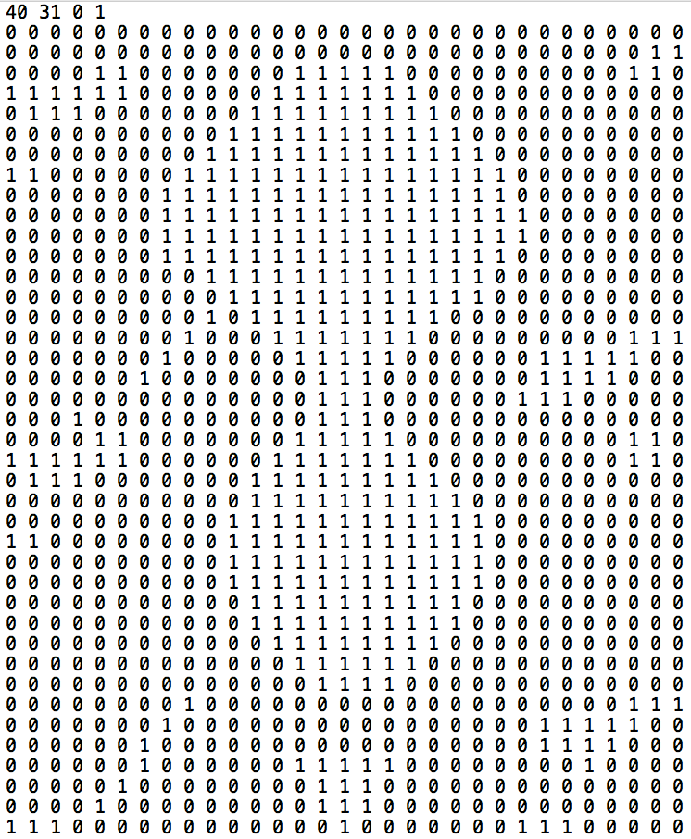 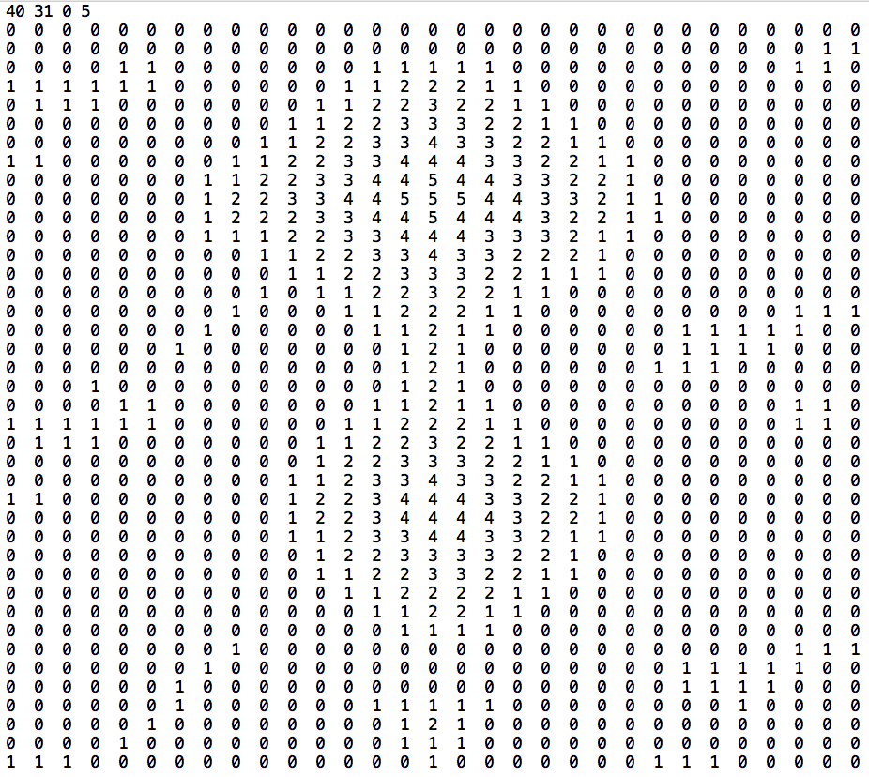

**Object_Data_distanceSkeleton_thr_4: Object_Data_distanceSkeleton_thr_4_CC:**

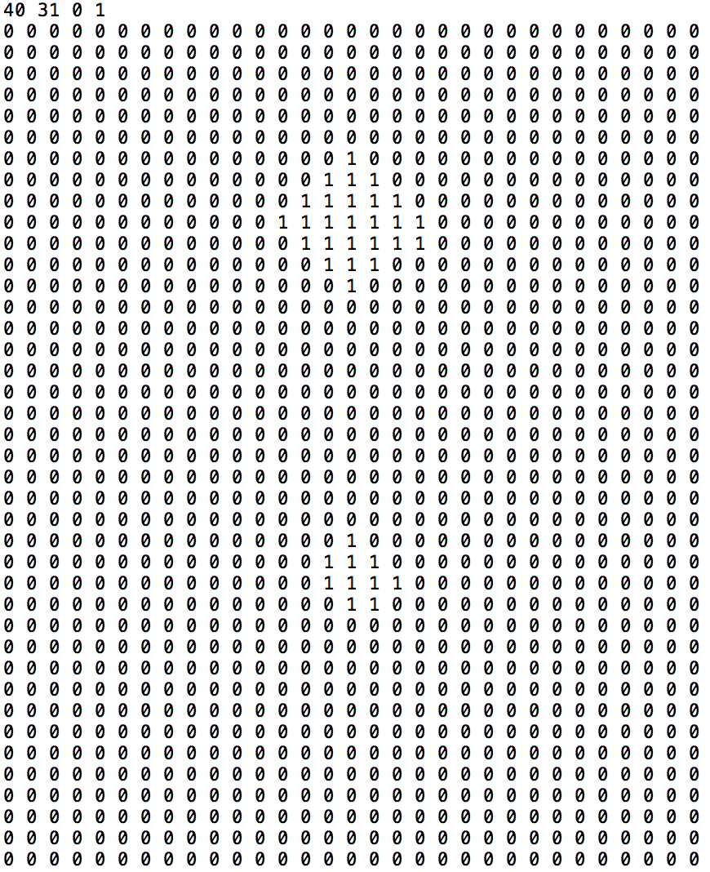 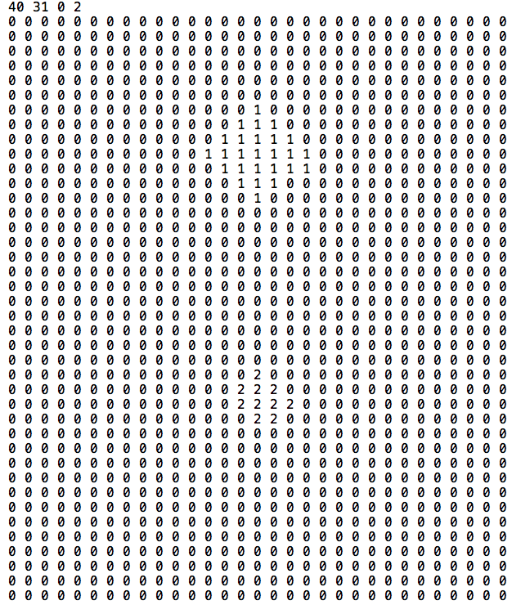

**outPut1:**

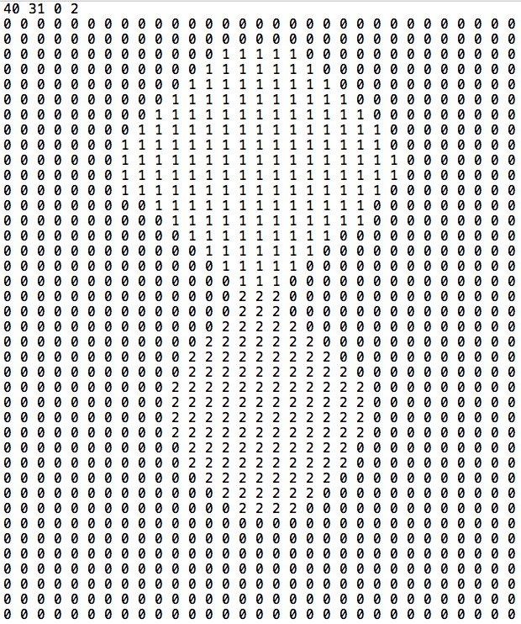

**outPut2:**

