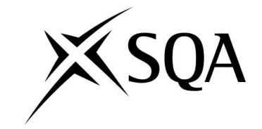

Higher National Unit Specification: General Information
Statement and Confirmation of Own Work
Unit Title : Software Development Object Oriented Programming
Unit code : H171 35
Superclass : CB
Publication Date : November
Source : Scottish Qualifications Authority
Version : 01
Student declaration
I have read and understood SQA HND’s Policy on Academic Dishonesty and Plagiarism.
I can confirm the following details:
Student ID/Registration number :
Name : MOE KHANT ZAW
Centre Name : KMD Institute (Yangon)
Assessor’s Name : Daw Myat Mon Thant
Student Signature :MOE
Submitted Date : 24.11.2019

Contents
Introduction 3
Analysis 3
Assumption 3
Outcome (1) Implementation 4
Design Documentation 4
Class Diagram 6
How the program operates 6
Encapsulation 6
Inheritance 10
Outcome (2) Working Solution 34
User Interfaces 34
Outcome (3) Testing 39
Test Plan 39
Test Scripts 40
Test Scripts 42
Test Scripts 44
Test Scripts 48
Test Scripts 50
Test Scripts 52
Test Scripts 54
Test Scripts 56
Test Scripts 58
Test Scripts 60
Test Scripts 62
Test Scripts 64
Test Scripts 66
Test Scripts 68
Test Scripts 70
Test Scripts 72

Introduction
Retro Games Ltd has commissioned me to design and develop a Sokoban. Sokoban was created in December 1982 be thinking rabbit, a software house in japan. Sokoban is a type of puzzle video game in which the player pushes crates or boxes around in a warehouse, trying to get them to storage locations. Sokoban was hit in japan, and had sold over 400,000 units in that country by the time Spectrum HoloByte imported it to the united states. A review in Computer game world praised the game for being “pure and simple, very playable and mentally challenging”, citing its addictive qualities. Implementations of sokoban have been written for numerous computer platforms, including almost all home computer and personal computer system. Versions also exit for video game, consoles, mobile phones, graphic calculators, digital cameras and electronic organizers. Sokoban can be studied using the theory of computational complexity. The problem of solving sokoban puzzles has been proven to be NP-hard. Further work showed that it was significantly more difficult than NP problems;

Analysis
The game is played on a board of squares, where each square is a floor or a wall. Some floor squares contain boxes, some floor squares are marked as storage locations. The player is confined to the board, and may move horizontally or vertically onto empty squares. The player can also move into a box, which pushes it into the square beyond. Boxes may not be pushed into other boxes or walls, and they cannot be pulled. The number of boxes is equal to the number of storage locations. The puzzle is solved when all boxes are at storage location.
So, the game consists of the pusher who must push a number of boxes into a set of designated storage locations, without getting himself or the boxes stuck. The warehouse is a set of barriers, passages and storage areas. All elements are aligned into a two-dimensional grid. The tricky part is that the pusher may only push one box at a time cannot pull the box and cannot occupy the same grid location as a box or barrier. Thus, pushing a box into a corner or allowing two boxes to come together on a wall means those boxes cannot be moved further. A puzzle is considered solved if all boxes are pushed into storage locations. The number of storage location is equal to the number of boxes. Any box may occupy any storage location, (the locations and boxes are unlabeled), although our constructions are such that there is usually only one feasible location for each box.

Assumption
To develop simplified version of Sokoban. I have to know how Sokoban game work. I should know the game rule too. To Know how the game work, I have to play it first. After playing this game I realizes the game rule. To designed the game. I create the project and create some class. The main class is named as SokobanGame. It is the main class file. And the warehouse keeper. Unlike diamond and wall, it can move around the map like crate. So, I add some move method into the crate and warehouse keeper class. For the diamond and wall classes, they don’t need Move method because it actually can’t move like crate and warehouse keeper. And in the movement class I add 4 Boolean methods named as RightMove,

Outcome (1) Implementation

Design Documentation
Use Case

Class Diagram

How the program operates

Encapsulation
/*
* To change this license header, choose License Headers in Project Properties.
* To change this template file, choose Tools | Templates
* and open the template in the editor.
*/
package sokobangame;

/**
*
* @author moekh
*/
import java.awt.Image;

public class Movement{

public final int space=30;
public int x;
public int y;
public Image thingsImage;

public Image getImage() {
return thingsImage;
}

public void setImage(Image thingsImage) {
this.thingsImage = thingsImage;
}
public Movement(int x,int y)
{
this.x=x;
this.y=y;

}
public int getX() {
return x;
}

public void setX(int x) {
this.x = x;
}

public int getY() {
return y;
}

public void setY(int y) {
this.y = y;
}

public boolean LeftMove(Movement actor)
{
if(this.getX()-space==actor.getX() && (this.getY()==actor.getY()))
{
return true;
}
else{
return false;
}
}
public boolean RighMove(Movement actor)
{
if(this.getX()+space==actor.getX() && (this.getY()==actor.getY()))
{
return true;
}
else{
return false;
}
}
public boolean TopMove(Movement actor)
{
if(this.getY()-space==actor.getY() && (this.getX()==actor.getX()))
{
return true;
}
else{
return false;
}
}
public boolean BottomMove(Movement actor)
{
if(this.getY()+space==actor.getY() && (this.getX()==actor.getX()))
{
return true;
}
else{
return false;
}
}

}

Inheritance

package sokobangame;

import java.awt.Color;
import java.awt.Graphics;
import java.awt.Graphics2D;
import java.awt.Image;
import java.awt.event.KeyAdapter;
import java.awt.event.KeyEvent;
import java.io.IOException;
import java.util.ArrayList;
import javax.swing.*;

public class SokobanGame extends JFrame
{
JLabel lblUN, lblMoveCount,lblCurrentLevel;
JLabel lblWarehouse_keeperImg, lblCratesImg,lblDiamondImg,lblWallImg;
JLabel lblInstruction1, lblInstructions2, lblInstructions3;
JLabel lblUpArrow,lblDownArrow,lblLeftArrow,lblRightArrow;
JLabel lblGameBoarsImage;
JPanel pnlGameBoard;
Wall objWall;
Crates objCrates;
Diamond objDiamond;

private int movecount = 0;
private final int OFFSET = 180;
private final int SPACE = 30;
private final int LeftMove = 1;
private final int RighMove = 2;
private final int TopMove = 3;
private final int BottomMove = 4;
private ArrayList alWalls = new ArrayList();
private ArrayList alBaggs = new ArrayList();
private ArrayList alAreas = new ArrayList();
private int width = 0;
private int height = 0;
private Warehouse_keeper dlite_soko;
private boolean completestaus =false;
String LevelComplete = "";
map m = new map();

public SokobanGame ()
{
this.setTitle("Sokoban Game");
this.setSize(600,500);
this.setLayout(null);
lblUN = new JLabel("Moe Khant Zaw");
lblMoveCount= new JLabel();
lblCurrentLevel=new JLabel();
lblUN.setBounds(40,30, 130, 50);
this.add(lblUN);
lblMoveCount.setBounds(20, 60, 100, 30);
this.add(lblMoveCount);
lblCurrentLevel.setBounds(20, 100, 100, 30);
this.add(lblCurrentLevel);
pnlGameBoard = new JPanel();
pnlGameBoard.setBounds(130, 20, 350, 430);
this.add(pnlGameBoard);

lblGameBoarsImage = new JLabel();
lblGameBoarsImage.setBounds(10,10,350,450);
lblInstruction1 = new JLabel("Use the Arrow Key");
lblInstruction1.setBounds(10,180,130,30);
this.add(lblInstruction1);
lblUpArrow= new JLabel(new ImageIcon("up.png"));
lblUpArrow.setBounds(30,210,30,30);
this.add(lblUpArrow);
lblLeftArrow= new JLabel(new ImageIcon("left.png"));
lblLeftArrow.setBounds(10,230,30,30);
this.add(lblLeftArrow);
lblRightArrow= new JLabel(new ImageIcon("right.png"));
lblRightArrow.setBounds(50,230,30,30);
this.add(lblRightArrow);
lblDownArrow= new JLabel(new ImageIcon("down.png"));
lblDownArrow.setBounds(30,250,30,30);

this.add(lblDownArrow);
lblInstructions2= new JLabel("Restart Level");
lblInstructions2.setBounds(10,280,100,30);
this.add(lblInstructions2);
lblInstructions3= new JLabel("Press R");
lblInstructions3.setBounds(10,300,100,30);
this.add(lblInstructions3);

Crates c = new Crates(40,40);
lblCratesImg = new JLabel(new ImageIcon(c.getImage()));
lblCratesImg.setSize(40,40);

Wall w= new Wall(40,40);
lblWallImg= new JLabel(new ImageIcon(w.getImage()));
lblWallImg.setSize(40,40);

Diamond a= new Diamond(30,30);
lblDiamondImg= new JLabel(new ImageIcon(a.getImage()));
lblDiamondImg.setSize(40,40);

Warehouse_keeper wk= new Warehouse_keeper(30,30);
lblWarehouse_keeperImg=new JLabel(new ImageIcon(wk.getImage()));
lblWarehouse_keeperImg.setSize(40,40);

LevelComplete= m.level_1;
lblCurrentLevel.setText("Level_1");
startGameBoard(LevelComplete);
repaint();
pnlGameBoard.add(lblGameBoarsImage);
pnlGameBoard.addKeyListener(new MovementKeyAdapter());
pnlGameBoard.setFocusable(true);
this.setVisible(true);
}

public final void startGameBoard(String level)
{
int x= OFFSET;
int y=130;
for (int i=0; i< level.length();i++)
{
char item = level.charAt(i);
if(item =='\n'){
y += SPACE;
if(this.width< x)
{
this.width=x;
}
x=OFFSET;
}else if (item =='#'){
objWall = new Wall(x,y);
alWalls.add(objWall);
x += SPACE;
}else if (item =='.'){
objDiamond = new Diamond(x,y);
alAreas.add(objDiamond);
x += SPACE;
}else if(item =='$'){
objCrates= new Crates(x,y);
alBaggs.add(objCrates);
x += SPACE;
}else if(item =='@'){
dlite_soko= new Warehouse_keeper(x,y);
x+=SPACE;
}else if (item ==' '){
x+=SPACE;
}
height=y;
}
}

public void buildLevel_Map(Graphics g)
{
Graphics2D g2d=(Graphics2D) g;
ImageIcon iia = new ImageIcon();
Image img = iia.getImage();
g2d.drawImage(img, 0, 0,null);
g2d.fillRect(0, 0, lblGameBoarsImage.getWidth(), lblGameBoarsImage.getHeight());

ArrayList alLevelMap = new ArrayList();
alLevelMap.addAll(alWalls);
alLevelMap.addAll(alAreas);
alLevelMap.addAll(alBaggs);
alLevelMap.add(dlite_soko);

for (int i = 0; i < alLevelMap.size(); i++)
{

Movement item =(Movement) alLevelMap.get(i);

if ((item instanceof Warehouse_keeper)|| (item instanceof Crates ))
{
g2d.drawImage(item.getImage(), item.getX()+2,item.getY() +2,lblGameBoarsImage);

}
else
{
g2d.drawImage(item.getImage(), item.getX(),item.getY(),lblGameBoarsImage);
}

if(completestaus)
{
g2d.setColor(new Color(0,0,0));
g2d.drawString("Completed", 25, 20);
if(LevelComplete.equals("level_1"))
{
LevelComplete ="level_2";
startGameBoard(LevelComplete);
}
else if(LevelComplete.equals("level_2"))
{
LevelComplete ="level_3";
startGameBoard(LevelComplete);
}
else if(LevelComplete.equals("level_3"))
{
LevelComplete ="level_4";
startGameBoard(LevelComplete);
}
else if(LevelComplete.equals("level_4"))
{
LevelComplete ="level_5";
startGameBoard(LevelComplete);
}
}
}
}

@Override
public void paint(Graphics g){
Graphics2D g2d=(Graphics2D) g;
super.paint(g2d);
lblGameBoarsImage.paint(g);
buildLevel_Map(g2d);
}

class MovementKeyAdapter extends KeyAdapter{

@Override
public void keyPressed(KeyEvent e)
{
if(completestaus)
{
return;

}
int key= e.getKeyCode();

if(key ==KeyEvent.VK_LEFT)
{
if(checkWallCollision(dlite_soko,LeftMove))
{
JOptionPane.showMessageDialog(null,"Left Wall");
repaint();
}
if(checkBagCollision(LeftMove)){
JOptionPane.showMessageDialog(null,"Left Wall");
repaint();
}
movecount+=1;
dlite_soko.Move(-SPACE,0);
}

else if(key ==KeyEvent.VK_RIGHT)
{
if(checkWallCollision(dlite_soko,RighMove))
{
JOptionPane.showMessageDialog(null,"Right Wall");
repaint();
}
if(checkBagCollision(RighMove)){
JOptionPane.showMessageDialog(null,"Right Wall");
repaint();
}
movecount+=1;
dlite_soko.Move(SPACE,0);
}

else if(key ==KeyEvent.VK_UP ) {
if(checkWallCollision(dlite_soko,TopMove))
{
JOptionPane.showMessageDialog(null,"Top Wall");
repaint();
}
if(checkBagCollision(TopMove)){
JOptionPane.showMessageDialog(null,"Top Wall");
repaint();
}
movecount+=1;
dlite_soko.Move(0,-SPACE);
}

if(key ==KeyEvent.VK_DOWN)
{
if(checkWallCollision(dlite_soko,BottomMove))
{
JOptionPane.showMessageDialog(null,"Bottom Wall");
repaint();
}
if(checkBagCollision(BottomMove)){
JOptionPane.showMessageDialog(null,"Bottom Wall");
repaint();
}
movecount+=1;
dlite_soko.Move(0,SPACE);
}
else if(key ==KeyEvent.VK_R)
{
nextlevel();
}
lblMoveCount.setText(String .valueOf(movecount));
repaint();
}
}

public int nextlevel()
{
alAreas.clear();
alBaggs.clear();
alWalls.clear();
startGameBoard(LevelComplete);
movecount=0;
if(completestaus)
{
completestaus= false;
}
return movecount;
}

private boolean checkWallCollision(Movement warehousekeeper, int type)
{
if(type==LeftMove)
{
for(int i=0;i<alWalls.size();i++)
{
Wall walls = (Wall) alWalls.get(i);
if(warehousekeeper.LeftMove(walls))
{
return true;
}
}
return false;
}
else if(type==RighMove)
{
for(int i=0;i<alWalls.size();i++)
{
Wall walls = (Wall) alWalls.get(i);
if(warehousekeeper.RighMove(walls))
{
return true;
}
}
return false;
}
else if(type==TopMove)
{
for(int i=0;i<alWalls.size();i++)
{
Wall walls = (Wall) alWalls.get(i);
if(warehousekeeper.TopMove(walls))
{
return true;
}
}
return false;
}
else if(type==BottomMove)
{
for(int i=0;i<alWalls.size();i++)
{
Wall walls = (Wall) alWalls.get(i);
if(warehousekeeper.BottomMove(walls))
{
return true;
}
}
return false;
}
return false;
}
public void LevelComplete(){

int num = alBaggs.size();
int compl = 0;

for (int i = 0; i < num; i++) {
Crates bag = (Crates) alBaggs.get(i);
for (int j = 0; j < num; j++) {
Diamond area = (Diamond) alAreas.get(j);
if (bag.getX() == area.getX()
&& bag.getY() == area.getY()) {
compl += 1;
}
}
}

if (compl == num) {

completestaus = false;
if (LevelComplete.equals(m.level_1)) {

LevelComplete = m.level_2;
lblCurrentLevel.setText("Level 2");
startGameBoard(LevelComplete);
} else if (LevelComplete.equals(m.level_2)) {
LevelComplete = m.level_3;
lblCurrentLevel.setText("Level 3");
startGameBoard(LevelComplete);
} else if (LevelComplete.equals(m.level_3)) {
LevelComplete = m.level_4;
lblCurrentLevel.setText("Level 4");
startGameBoard(LevelComplete);
} else {
LevelComplete = m.level_5;
lblCurrentLevel.setText("Level 5");
startGameBoard(LevelComplete);
}
JOptionPane.showMessageDialog(null, "Level Complete");
nextlevel();
repaint();
}
}

private boolean checkBagCollision(int collision_type) {

switch (collision_type) {
case LeftMove:
for (int i = 0; i < alBaggs.size(); i++) {

Crates bag = (Crates) alBaggs.get(i);
if (dlite_soko.LeftMove(bag)) {

for (int j = 0; j < alBaggs.size(); j++) {
Crates item = (Crates) alBaggs.get(j);
if (!bag.equals(item)) {
if (bag.LeftMove(item)) {
return true;
}
}
if (checkWallCollision(bag,
LeftMove)) {
return true;
}
}
bag.Move(-SPACE, 0);
LevelComplete();
}
}
return false;
case RighMove:
for (int i = 0; i < alBaggs.size(); i++) {

Crates bag = (Crates) alBaggs.get(i);
if (dlite_soko.RighMove(bag)) {
for (int j = 0; j < alBaggs.size(); j++) {

Crates item = (Crates) alBaggs.get(j);
if (!bag.equals(item)) {
if (bag.RighMove(item)) {
return true;
}
}
if (checkWallCollision(bag,
RighMove)) {
return true;
}
}
bag.Move(SPACE, 0);
LevelComplete();
}
}
return false;
case TopMove:
for (int i = 0; i < alBaggs.size(); i++) {

Crates bag = (Crates) alBaggs.get(i);
if (dlite_soko.TopMove(bag)) {
for (int j = 0; j < alBaggs.size(); j++) {

Crates item = (Crates) alBaggs.get(j);
if (!bag.equals(item)) {
if (bag.TopMove(item)) {
return true;
}
}
if (checkWallCollision(bag,
TopMove)) {
return true;
}
}
bag.Move(0, -SPACE);
LevelComplete();
}
}

return false;
case BottomMove:
for (int i = 0; i < alBaggs.size(); i++) {

Crates bag = (Crates) alBaggs.get(i);
if (dlite_soko.BottomMove(bag)) {
for (int j = 0; j < alBaggs.size(); j++) {

Crates item = (Crates) alBaggs.get(j);
if (!bag.equals(item)) {
if (bag.BottomMove(item)) {
return true;
}
}
if (checkWallCollision(bag, BottomMove)) {
return true;
}
}
bag.Move(0, SPACE);
LevelComplete();
}
}
break;
default:
break;
}

return false;
}

public static void main(String[] args)
{
SokobanGame m = new SokobanGame();

}

}

package sokobangame;

import java.awt.Image;
import java.net.URL;
import javax.swing.ImageIcon;

public class Warehouse_keeper extends Movement{
public Warehouse_keeper(int x,int y)
{
super(x,y);
//URL url=this.getClass().getResource("actor.png");
ImageIcon ico=new ImageIcon("actor.png");
Image img=ico.getImage();
this.setImage(img);

}
public void Move(int x, int y) {
int MoveX=this.getX()+x;
int MoveY=this.getY()+y;
this.setX(MoveX);
this.setY(MoveY);
}

}

package sokobangame;
import java.awt.Image;
import java.net.URL;
import javax.swing.ImageIcon;

/*
* To change this license header, choose License Headers in Project Properties.
* To change this template file, choose Tools | Templates
* and open the template in the editor.
*/

/**
*
* @author home
*/
public class Diamond extends Movement{
public Diamond(int x,int y)
{
super(x,y);
// URL url=this.getClass().getResource();
ImageIcon ico=new ImageIcon("diamond.png");
Image img=ico.getImage();
this.setImage(img);

}
}

/*
* To change this license header, choose License Headers in Project Properties.
* To change this template file, choose Tools | Templates
* and open the template in the editor.
*/
package sokobangame;

/**
*
* @author moekh
*/

import java.awt.Image;
import java.net.URL;
import javax.swing.ImageIcon;
public class Wall extends Movement{
public Wall(int x,int y)
{
super(x,y);
//URL url=this.getClass().getResource("box.png");
ImageIcon ico=new ImageIcon("wall.jpeg");
Image img=ico.getImage();
this.setImage(img);
}
}

package sokobangame;

import java.awt.Image;
import java.net.URL;
import javax.swing.ImageIcon;

public class Crates extends Movement{

public Crates(int x,int y)
{
super(x,y);
//URL url=this.getClass().getResource("box.png");
ImageIcon icon=new ImageIcon("box.png");
Image img=icon.getImage();
this.setImage(img);

}
public void Move(int x, int y) {
int MoveX=this.getX()+x;
int MoveY=this.getY()+y;
this.setX(MoveX);
this.setY(MoveY);
}

}

/*
* To change this license header, choose License Headers in Project Properties.
* To change this template file, choose Tools | Templates
* and open the template in the editor.
*/
package sokobangame;

/**
*
* @author moekh
*/

import java.awt.Image;
import java.net.URL;
import javax.swing.ImageIcon;
public class Wall extends Movement{
public Wall(int x,int y)
{
super(x,y);
//URL url=this.getClass().getResource("box.png");
ImageIcon ico=new ImageIcon("wall.jpeg");
Image img=ico.getImage();
this.setImage(img);
}
}

Coupling and Cohesion

In object oriented design, cohesion refers all about how a single class is designed. Cohesion is the Object Oriented principle most closely associated with making sure that a class is designed with a single, well-focused purpose.
The more focused a class is, the cohesiveness of that class is more. The advantages of high cohesion is that such classes are much easier to maintain (and less frequently changed) than classes with low cohesion. Another benefit of high cohesion is that classes with a well-focused purpose tend to be more reusable than other classes.

Outcome (2) Working Solution

User Interfaces

Level 1
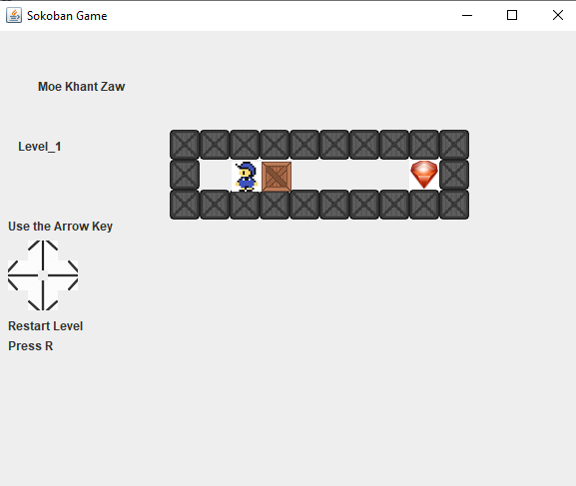
Level 2
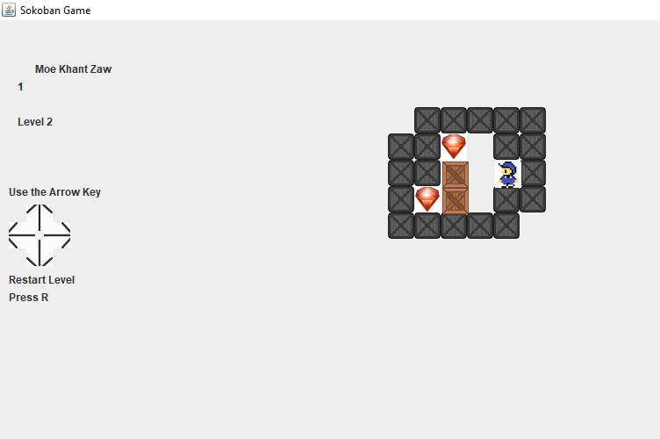

Level 3
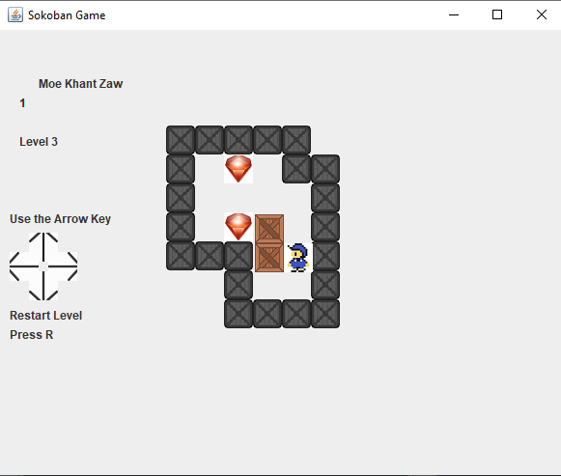

Level 4

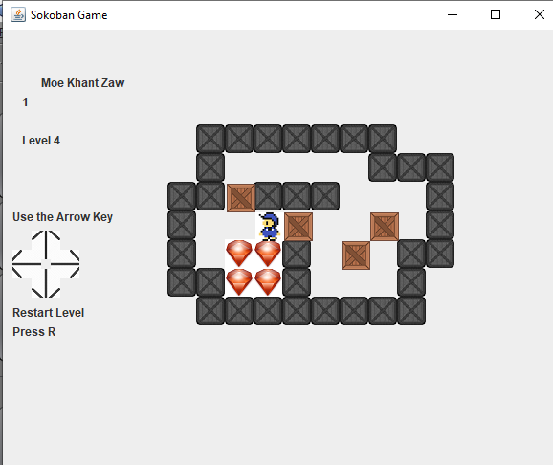

Level 5
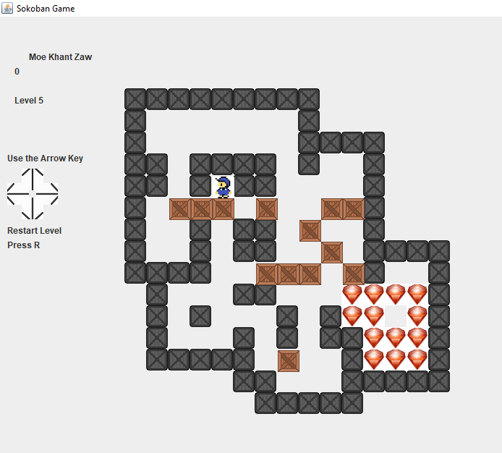

Involved Classes
Pre-defined Classes
Color
A graphics context provides the capabilities of drawing on the screen. The graphics context maintains states such as the color and font used in drawing, as well as interacting with the underlying operating system to perform the drawing.
Graphic2D
The graphic2D extends the graphics class to provide more sophisticated control over geometry, coordinate transformations, color management, and text layout. This is the fundamental class for rendering 2-dimensional shapes, text and images on the java platform.
Image
An image in java is primarily an object of the image class. It is a part of the java.awt package. Image class are used in loading image, drawing image, manipulating image.
Image icon
ImageIcon is an implementation of the icon interface that paints icons from images. Images can be created from a URL, Filename, or byte array. The icon painticon method draws the icon at the specified location.
Areas
The areas object stores and manipulates a resolution-independent description of an enclosed area of 2-dimensional space.
Actor
Actor model provides a higher level of abstraction for writing concurrent and distributed systems.
IO Exception

Outcome (3) Testing

Test Plan
No | Date | Test Data | Type of Testing | Objective
1 | 12/2/2019 | Level 1 | Unit testing | Test if the actor actually moves to the right once right key is pressed.
2 | 12/2/2019 | Level 1 | Unit testing | Test if the actor actually moves to the left once left key is pressed.
3 | 12/2/2019 | Level 2 | Unit testing | Test if the actor actually moves to the up once when up key is pressed
4 | 12/2/2019 | Level 2 | Unit testing | Test if the actor actually moves to the down once down key is pressed.
5 | 12/5/2019 | Level 1 | Unit testing | Test if the actor can actually push the crate to the right.
6 | 12/5/2019 | Level 2 | Unit testing | Test if the actor can actually push the crate to the Left.
7 | 12/5/2019 | Level 3 | Unit testing | Test if the actor can actually push the crate to the Top.
8 | 12/5/2019 | Level 3 | Unit testing | Test if the actor can actually push the crate to the bottom.
9 | 12/7/2019 | Level 3 | Black Box | Test the actor can pass through the right wall
10 | 12/7/2019 | Level 3 | Black Box | Test the actor can pass through the left wall
11 | 12/7/2019 | Level 3 | Black Box | Test the actor can pass through the Top wall
12 | 12/7/2019 | Level 3 | Black Box | Test the actor can pass through the bottom wall
13 | 12/11/2019 | Level 3 | Black Box | Test that the crate can’t actually go through the right wall.
14 | 12/11/2019 | Level 3 | Black Box | Test that the crate can’t actually go through the left wall.
15 | 12/11/2019 | Level 3 | Black Box | Test that the crate can’t actually go through the top wall.
16 | 12/11/2019 | Level 3 | Black Box | Test that the crate can’t actually go through the bottom wall.
17 | 12/11/2019 | Level 4 | Black Box | Test the Level can really finish

Test Scripts
Test Case No | 1
Test Objective | Test if the actor actually moves to the right once right key is pressed.
Test Procedure | Press right arrow key once
Expected Result | The actor is moved to the right
Actual Result | See figure-2

Before testing (figure-1)
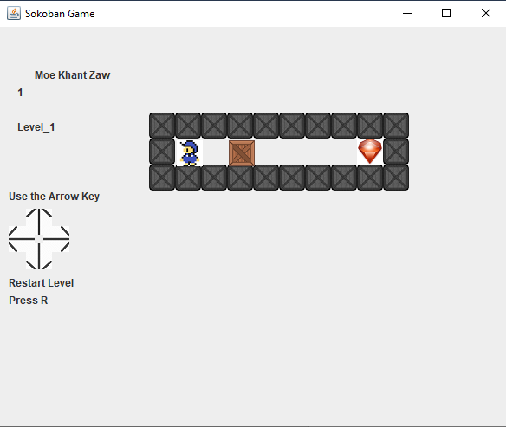

After testing (figure-2)

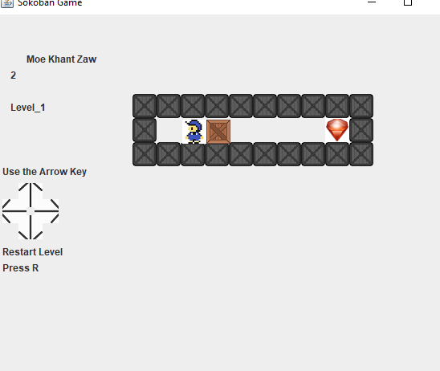

Test Scripts
Test Case No | 2
Test Objective | Test if the actor actually moves to the left once left key is pressed.
Test Procedure | Press left arrow key once
Expected Result | The actor is moved to the left
Actual Result | See figure-2

Before testing (figure-1)
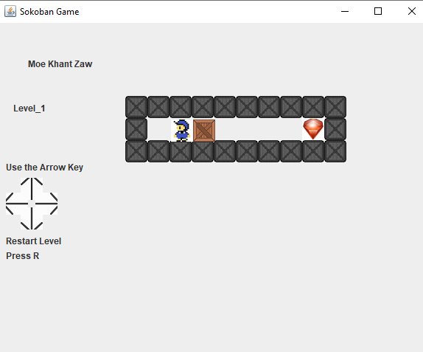

After testing (figure-2)
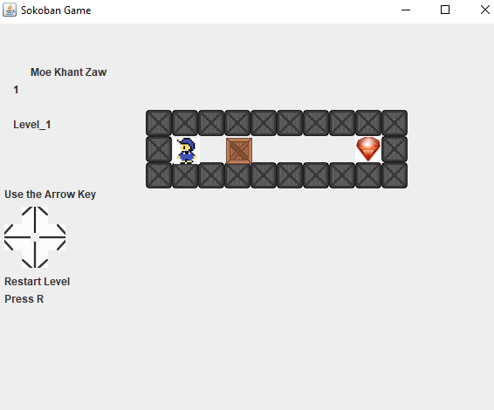

Test Scripts
Test Case No | 3
Test Objective | Test if the actor actually moves to the up once when up key is pressed
Test Procedure | Press up arrow key once
Expected Result | The actor is moved to the up
Actual Result | See figure-2

Before testing (figure-1)
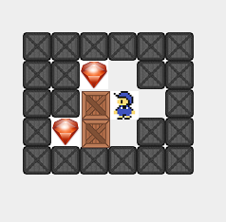
After testing (figure-2)
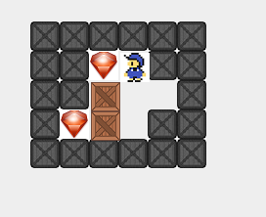

Test Scripts
Test Case No | 4
Test Objective | Test if the actor actually moves to the down once down key is pressed.
Test Procedure | Press down arrow key once
Expected Result | The actor is moved to the down
Actual Result | See figure-2

Before testing (figure-1)
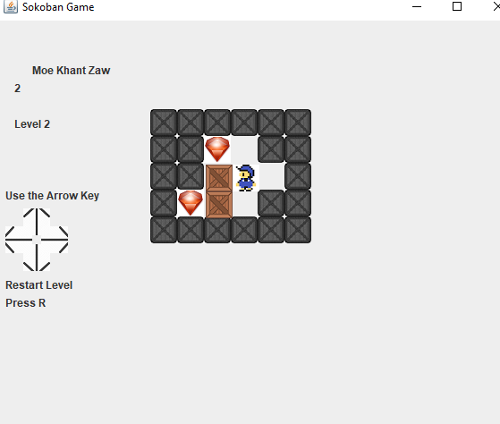

After testing (figure-2)
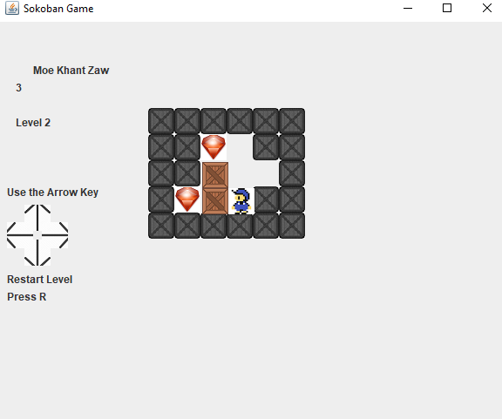

Test Scripts
Test Case No | 5
Test Objective | Test if the actor can actually push the crate to the right.
Test Procedure | Move the actor beside the crate and push the crate to the right
Expected Result | The actor and crate are moved to the right
Actual Result | See figure-2

Before testing (figure-1)
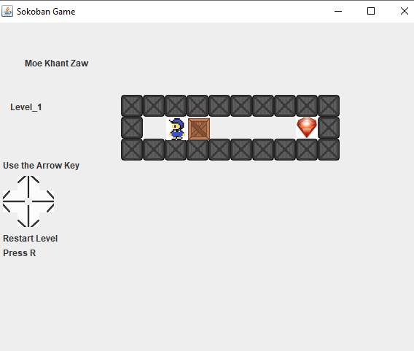

After testing (figure-2)
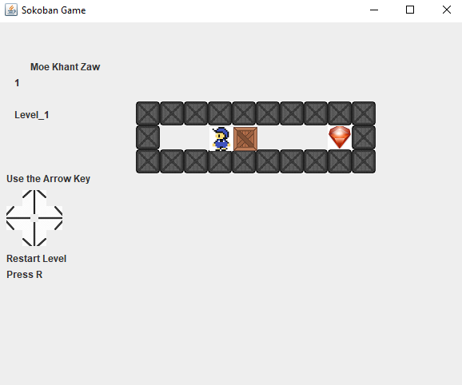

Test Scripts
Test Case No | 6
Test Objective | Test if the actor can actually push the crate to the left.
Test Procedure | The actor is moved and the crate is also moved to the left
Expected Result | The actor and crate is moved to the left
Actual Result | See figure-2

Before testing (figure-1)

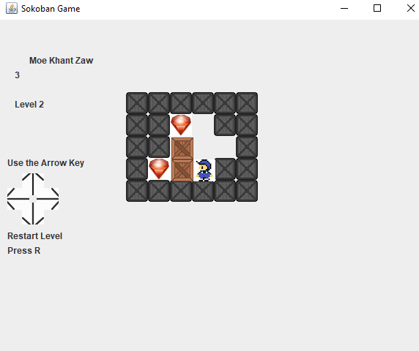
After testing (figure-2)
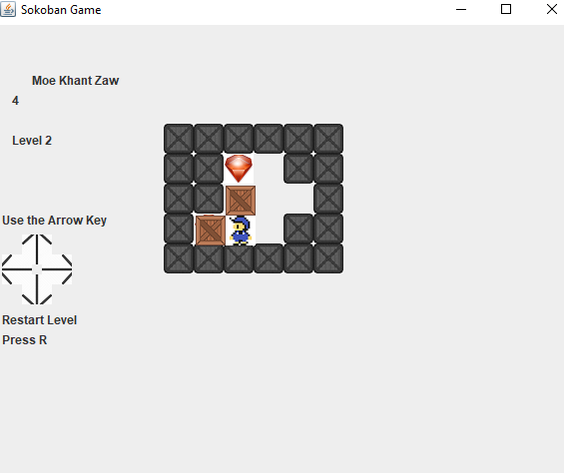

Test Scripts
Test Case No | 7
Test Objective | Test if the actor can actually push the crate to the top.
Test Procedure | Move the character to the crate and Press up key arrow key once
Expected Result | The actor and crate are moved to the top
Actual Result | See figure-2

Before testing (figure-1)

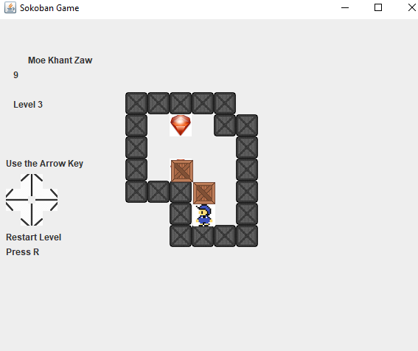
After testing (figure-2)
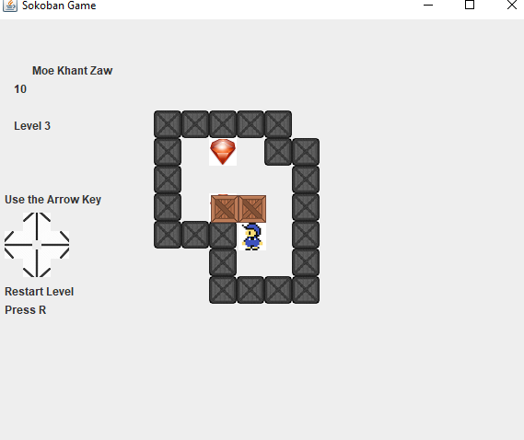

Test Scripts
Test Case No | 8
Test Objective | Test if the actor can actually push the crate to the bottom.
Test Procedure | Move the character to the crate and Press bottom key arrow key once
Expected Result | The actor and crate are moved to the bottom
Actual Result | See figure-2

Before testing (figure-1)
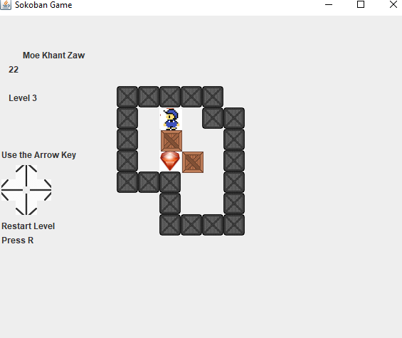

After testing (figure-2)
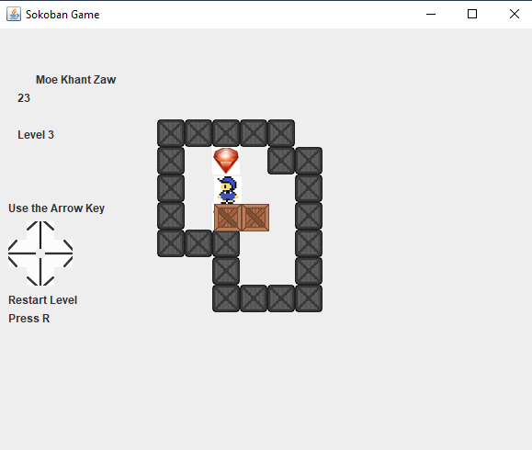

Test Scripts
Test Case No | 9
Test Objective | Test the actor can pass through the right wall
Test Procedure | Move the actor to the right wall
Expected Result | Message box will show as Right Wall
Actual Result | See figure-2

Before testing (figure-1)
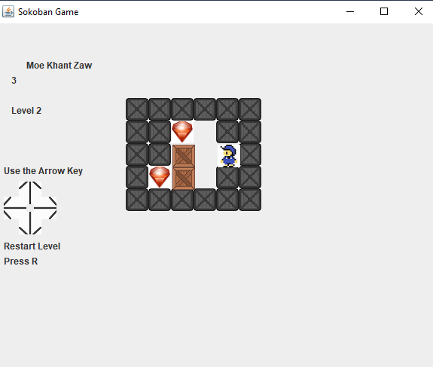
After testing (figure-2 )
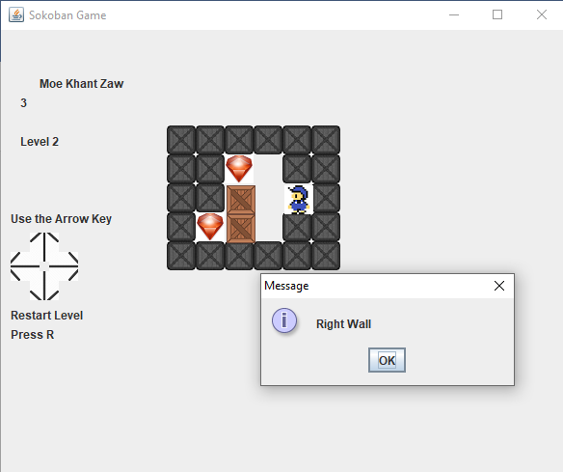

Test Scripts

Test Case No | 10
Test Objective | Test the actor can pass through the left wall
Test Procedure | Move the actor to the left wall
Expected Result | Message box will show as left Wall
Actual Result | See figure-2

Before testing (figure-1)
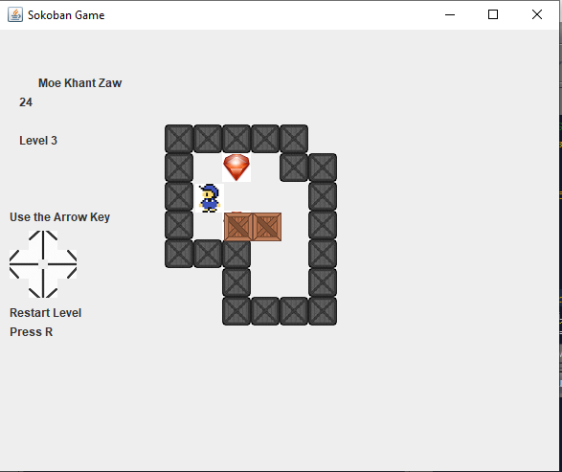
After testing (figure-2 )
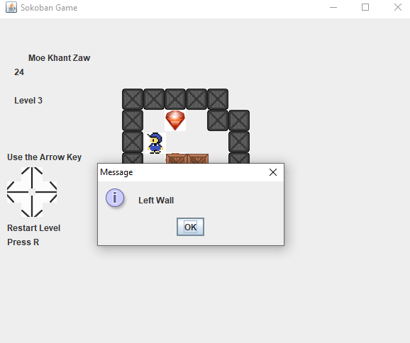

Test Scripts

Test Case No | 11
Test Objective | Test the actor can pass through the top wall
Test Procedure | Move the actor to the top wall
Expected Result | Message box will show as top Wall
Actual Result | See figure-2

Before testing (figure-1)
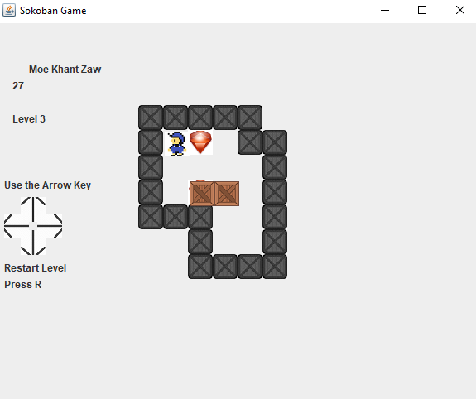
After testing (figure-2)
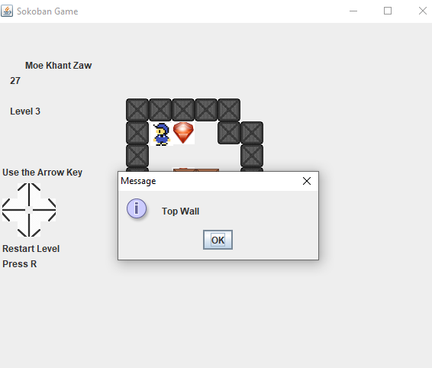

Test Scripts

Test Case No | 12
Test Objective | Test the actor can pass through the bottom wall
Test Procedure | Move the actor to the Bottom wall
Expected Result | Message box will show as Bottom Wall
Actual Result | See figure-2

Before testing (figure-1)
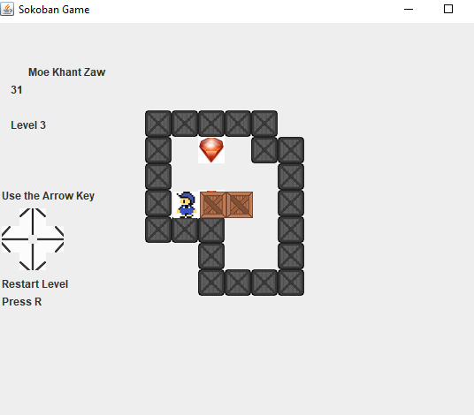

After testing (figure-2)
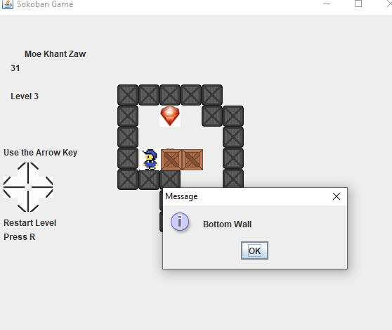

Test Scripts

Test Case No | 13
Test Objective | Test that the crate can’t actually go through the right wall.
Test Procedure | Push the crate to the right wall
Expected Result | Message box will show as Right Wall
Actual Result | See figure-2

Before testing (figure-1)
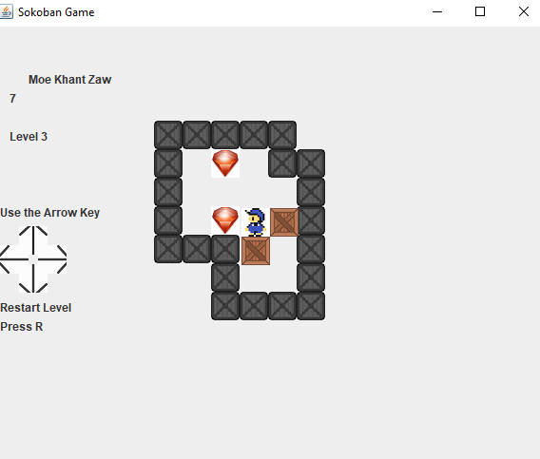
After testing (figure-2)
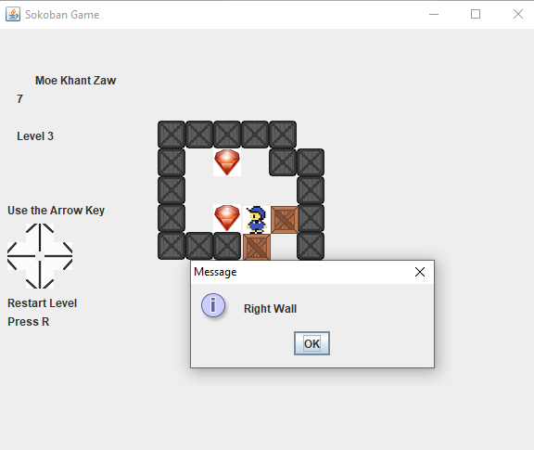

Test Scripts

Test Case No | 14
Test Objective | Test that the crate can’t actually go through the left wall.
Test Procedure | Push the crate to the left wall
Expected Result | Message box will show as left Wall
Actual Result | See figure-2

Before testing (figure-1)
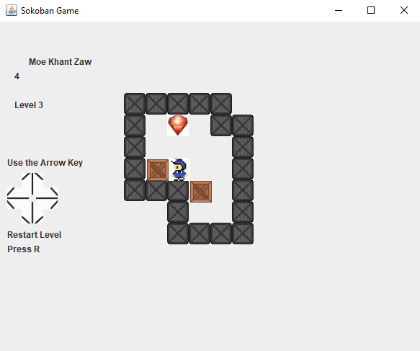
After testing (figure-2)
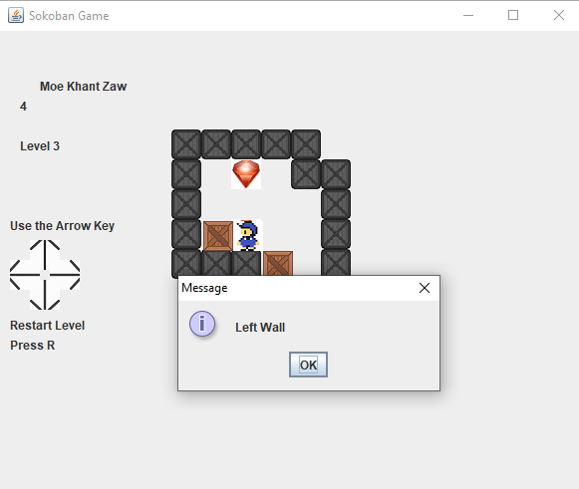

Test Scripts

Test Case No | 15
Test Objective | Test that the crate can’t actually go through the top wall.
Test Procedure | Push the crate to the Top wall
Expected Result | Message box will show as Top Wall
Actual Result | See figure-2

Before testing (figure-1)
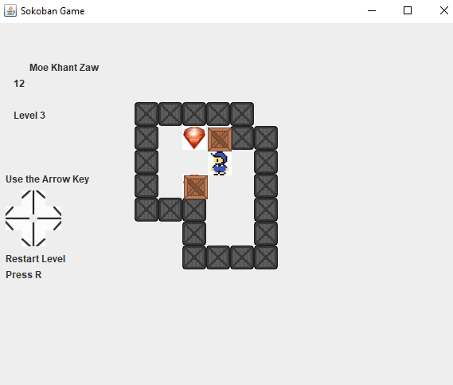
After testing (figure-2)
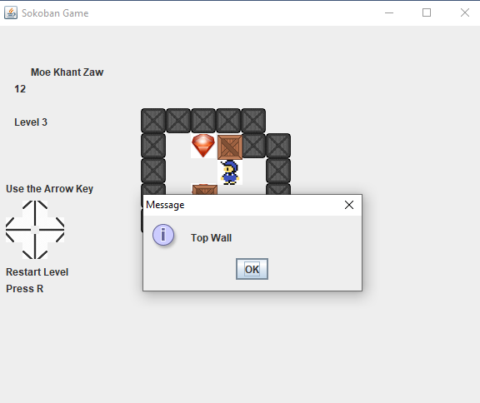

Test Scripts

Test Case No | 16
Test Objective | Test that the crate can’t actually go through the bottom wall.
Test Procedure | Push the crate to the bottom wall
Expected Result | Message box will show as Bottom Wall
Actual Result | See figure-2

Before testing (figure-1)
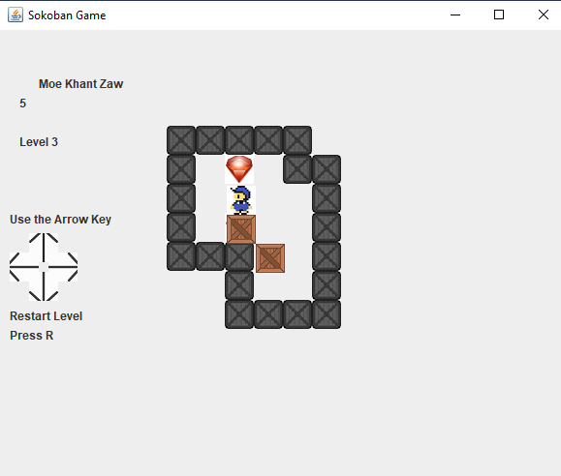
After testing (figure-2)
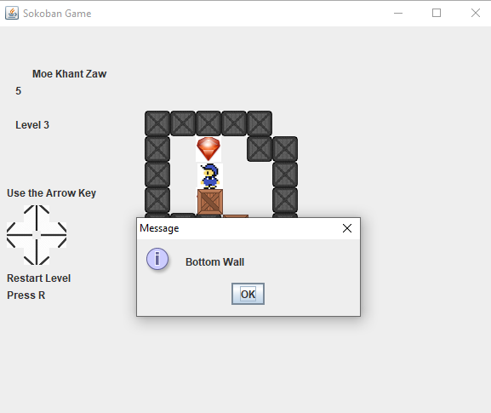

Test Scripts

Test Case No | 17
Test Objective | Test the Level can really finish
Test Procedure | Push the crate to the diamond
Expected Result | Message box will show as level complete
Actual Result | See figure-2

Before Testing (figure -1 )

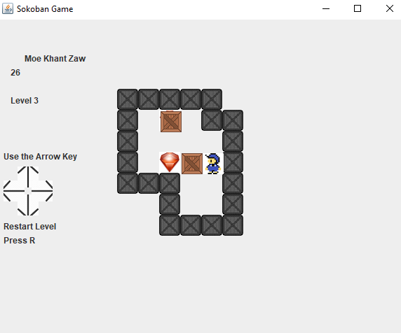
After testing (figure-2)
