**Lab2**

1- Create an array that contain values (PHP, HTML, CSS, JavaScript)

2- Print the array elements using loop (2 ways)

3- Create an associative array called Info according to the following -Please add your info-

Name

age

Email

Collage

4- Print all the data in HTML Table like above

5- Create form as following in “form.php” page.

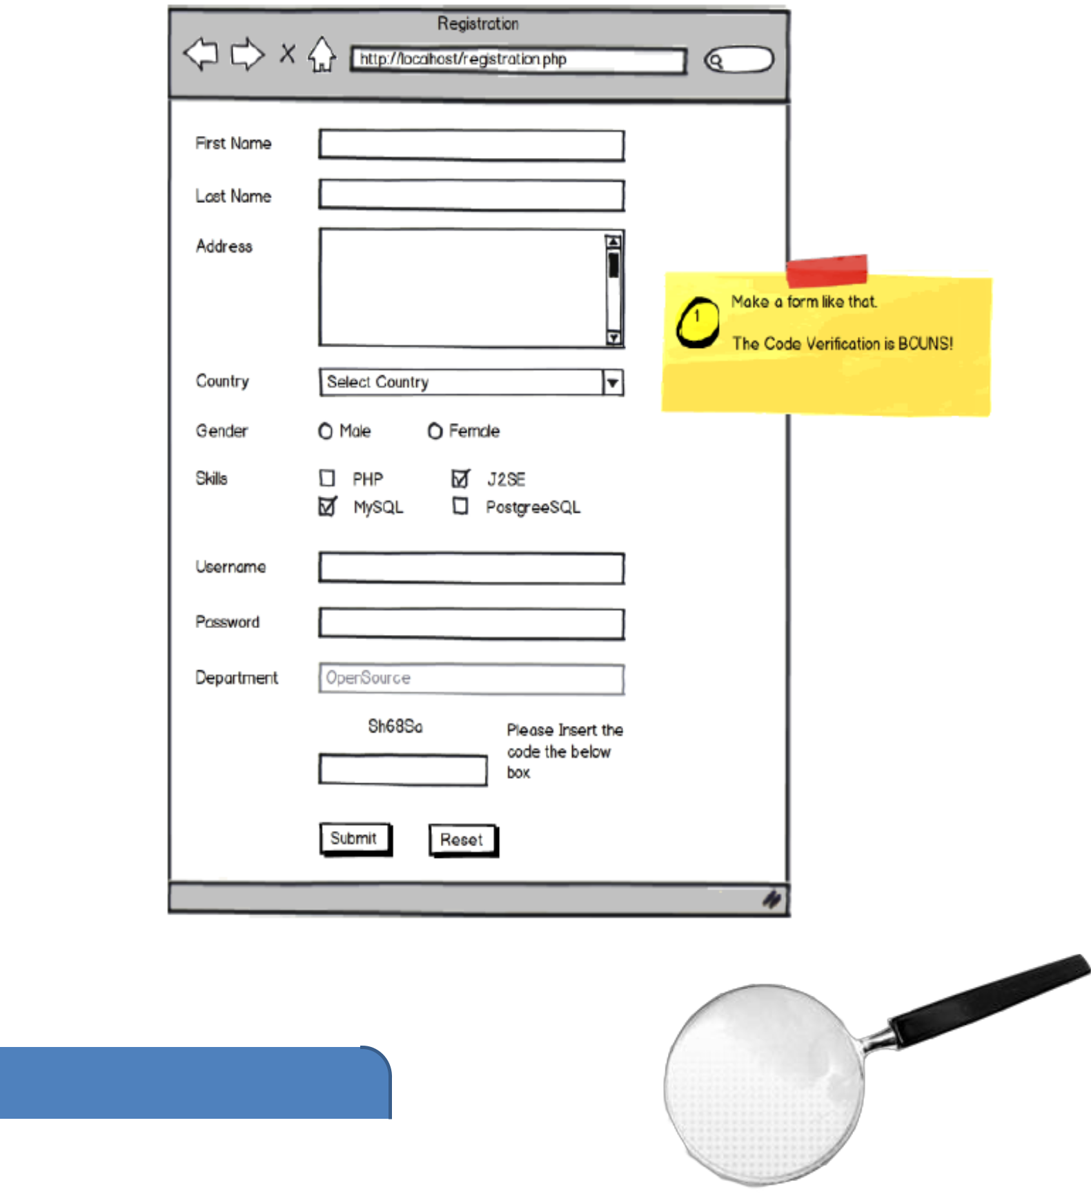6- Send all data inputs to another page called “data.php.