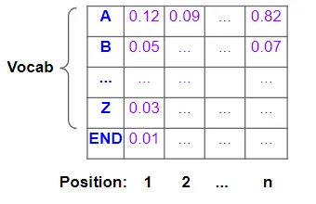
Beam Search

With Greedy Search, we took just the single best word at each position. In contrast, Beam Search expands this and takes the best ’N’ words.

