DexSuite Deformable Manipulation
Gaussian-splat deformable toys with Newton VBD — setup, training, replay, and status

Note: the Google Drive links (assets, policies) are set below. Still fill in the path-variables in section 2.0 (ISAACLAB_ROOT, NEWTON_ROOT, OUTPUT_FOLDER, ...) and the fork remotes in section 2.1 for your machine.

1. What the task does
This task (Isaac-Dexsuite-Deformable-Kuka-Allegro-Lift-v0) trains a Kuka arm with an Allegro hand to lift a set of soft, deformable toys. Each toy is a heterogeneous 3D Gaussian-splat asset whose visual surface is driven by a coarse tetrahedral (VBD) simulation proxy: Newton advances the soft body, and the task skins the Gaussian splat centers onto the deforming tet mesh for rendering.
Concretely, the task combines three things:
- Soft-body physics. Six plush toys are simulated as Newton VBD deformables. Each selected asset must share the same number of simulation vertices (an Isaac Lab dense-tensor batching constraint, not a VBD constraint); tetrahedron counts may differ.
- Dexterous manipulation. A Kuka/Allegro robot is driven by an RSL-RL policy to lift the deformable object. The robot keeps its full Isaac Lab actuator model (armature, joint friction, effort limits, implicit drive) via the MuJoCo/Warp articulation path.
- Gaussian-splat rendering. A task-specific visualizer evaluates per-splat barycentric skinning weights every frame and writes the deformed Gaussian centers to a ParticleField3DGaussianSplat prim — a bridge that standard USD deformable schemas do not yet provide.
The default stable_kinematic preset drives the robot kinematically (Featherstone–VBD): it follows position targets exactly and is the most stable choice for early policy training. The two-way presets (stable_two_way / fast_two_way) instead use the NewtonCoupledMJWarpVBDManager so the arm dynamically responds to deformable contact.

2. Step-by-step: run a training

2.0 Path variables (set these once)
Every command in this section uses the variables below. Set each one to a location on your machine — replacing the placeholders with your checkouts and the folders where you unpacked the Google Drive archives. Nothing else in the guide hard-codes an absolute path.
# --- Repos / environment ---
# ISAACLAB_ROOT: your IsaacLab checkout (branch nicolasm/isaaclab-task-dexsuite-vdb).
# Run every ./isaaclab.sh command from here.
ISAACLAB_ROOT="/path/to/IsaacLab"
# NEWTON_ROOT: your Newton checkout (branch with commit 20ca8c6e).
NEWTON_ROOT="/path/to/newton"
# ISAACLAB_ENV: the uv env ./isaaclab.sh -p selects. Read it from the launcher line
# "[INFO] Using Python: .../<env>/bin/python" (e.g. env_isaaclab or
# env_isaaclab_isaacsim).
ISAACLAB_ENV="env_isaaclab"
# --- Google Drive download ---
# OUTPUT_FOLDER: where you unzipped the Drive "assets" and "policies" folders.
# After unzip it must contain: assets/ policies/
OUTPUT_FOLDER="$ISAACLAB_ROOT/outputs"
# $OUTPUT_FOLDER/
# |-- assets/
# | |-- source/ # 6 original baked.*.usdz
# | `-- preprocessed/
# | |-- dexsuite_toys_collision_4mm_512_global/ # uniform material (USE THIS)
# | `-- dexsuite_toys_collision_4mm_512_vomp_mean_1e5/ # VoMP material (broken)
# | vbd_tets/ packaged/ manifest.json
# `-- policies/
# `-- 26-07-05_11-20-48/model_12500.pt # pre-trained policy
# Original source toys (baked.*.usdz):
TOY_SOURCE_DIR="$OUTPUT_FOLDER/assets/source"
# Pre-processed set to run. Use the GLOBAL (uniform) material variant:
ASSET_ROOT="$OUTPUT_FOLDER/assets/preprocessed/dexsuite_toys_collision_4mm_512_global"
# The VoMP material variant is currently NOT working (see section 4.2) -- do not use:
# ASSET_ROOT="$OUTPUT_FOLDER/assets/preprocessed/dexsuite_toys_collision_4mm_512_vomp_mean_1e5"
# Trained policy .pt (the pre-trained one from the Drive, or one of your own runs
# under $ISAACLAB_ROOT/logs/rsl_rl/dexsuite_deformable_kuka_allegro_lift/<run>/):
CHECKPOINT="$OUTPUT_FOLDER/policies/26-07-05_11-20-48/model_12500.pt"
# --- Only needed to REGENERATE assets from scratch (section 2.2, Option B) ---
# VOMP_ROOT: your VoMP checkout, with the inference env installed and
# weights/inference.json present. For a fresh build, also set ASSET_ROOT
# to a NEW output dir instead of a downloaded one.
VOMP_ROOT="/path/to/VoMP"

2.1 Check out the right branches
This task depends on a specific IsaacLab branch and a specific Newton commit.
Repository | Branch | Remote / fork
IsaacLab | nicolasm/isaaclab-task-dexsuite-vdb | github.com/moennen/IsaacLab
Newton | nicolasm/fixes-for-vbb-coupling-dexsuite-tests-main | github.com/moennen/newton

The task specifically needs the Newton commit:
commit 20ca8c6e65561e6354e34b484273c1e84d0d4245
Author: Nicolas Moenne-Loccoz
"Scale particle-shape soft contacts for replicated worlds"

Why this commit is required:
- At the API layer it is optional. The commit adds a soft_contact_max argument to SolverVBD. The coupled managers pass it only when the installed SolverVBD accepts it (feature-detected via inspect.signature), so an upstream Newton without the commit degrades silently rather than erroring.
- At the simulation layer it is mandatory for multi-env training. The commit makes Newton's particle-shape soft-contact allocation and generation world-aware (keyed on particle_world / shape_world) so each replicated world only tests its own and global shapes. Without it, replicated (--num_envs > 1) deformable scenes size contacts by global all-pairs — incorrect and quadratic in the number of worlds. Single-env replay is only weakly affected, but RL training runs many envs and therefore needs it.
Install Newton (editable) into the Isaac Lab environment after checking it out:
cd "$NEWTON_ROOT"
git checkout nicolasm/fixes-for-vbb-coupling-dexsuite-tests-main
# confirm the required commit is present:
git log --oneline | grep 'Scale particle-shape soft contacts'
cd "$ISAACLAB_ROOT"
git checkout nicolasm/isaaclab-task-dexsuite-vdb
# Isaac Lab is uv-managed and the env python has no pip, so use 'uv pip'.
# Activate the env that ./isaaclab.sh -p uses ($ISAACLAB_ENV), then install
# Newton editable:
source "$ISAACLAB_ROOT/$ISAACLAB_ENV/bin/activate"
uv pip install -e "$NEWTON_ROOT"
# equivalently, without activating (point --python at that same env):
# uv pip install --python "$ISAACLAB_ROOT/$ISAACLAB_ENV/bin/python" -e "$NEWTON_ROOT"

2.2 Get the assets
The task consumes pre-processed VBD tet proxies and skinned-Gaussian packages built from six source toy USDZ files. You have two options.
Option A — download the pre-processed assets (fastest).
The Google Drive provides two folders, assets/ and policies/. Unzip both into OUTPUT_FOLDER (section 2.0). assets/source/ holds the six original toys; assets/preprocessed/<variant>/ holds the ready-to-run VBD tets, skinned-Gaussian packages, and manifest for each material variant; policies/ holds the pre-trained policy. Once OUTPUT_FOLDER is set, the section 2.0 variables already point at everything, so you can skip to section 2.3.
Google Drive — original USD + all pre-processed assets (unzip 'assets/' into $OUTPUT_FOLDER): https://drive.google.com/drive/folders/1TP-hj-9kvRn_oR8J2LMY_5cd7UVCrdAw?usp=drive_link
Option B — regenerate the assets from source.
Run from IsaacLab/. Requires the six source USDZ files, the Isaac Lab environment, and VoMP's inference-only environment with its weights/inference.json checkpoint. The toys are Z-up; keep that convention in both the PLY export and the VBD build.
Shared setup:
cd "$ISAACLAB_ROOT"
# TOY_SOURCE_DIR and ASSET_ROOT come from the path-variables box (section 2.0).
TARGET_NUM_VERTICES=512
TARGET_MAX_EXTENT=0.335
COLLISION_SHELL=0.004
SKINNING_CHUNK_SIZE=128
GAUSSIAN_USDS=(
"$TOY_SOURCE_DIR/baked.BluehairRagdoll.usdz"
"$TOY_SOURCE_DIR/baked.bublik_octopus.usdz"
"$TOY_SOURCE_DIR/baked.knit_meow.usdz"
"$TOY_SOURCE_DIR/baked.mer_elephant.usdz"
"$TOY_SOURCE_DIR/baked.stink_raccoon.usdz"
"$TOY_SOURCE_DIR/baked.sunflower_baby.usdz"
)

Step 1 — export the Gaussian fields for VoMP (standard 3DGS PLY, not a mesh):
./isaaclab.sh -p -m isaaclab_tasks_experimental.manager_based.manipulation.dexsuite_deformable.tools.export_gaussian_usd_to_ply \
"${GAUSSIAN_USDS[@]}" \
--output-dir "$ASSET_ROOT/vomp_ply" \
--target-max-extent "$TARGET_MAX_EXTENT" \
--source-z-up

Step 2 — infer one VoMP material file per PLY (keep the same order as GAUSSIAN_USDS):
# VOMP_ROOT comes from the path-variables box (section 2.0).
PLY_DIR="$ASSET_ROOT/vomp_ply"
MATERIAL_DIR="$PLY_DIR/materials"
mkdir -p "$MATERIAL_DIR"
PLY_FILES=()
for USD in "${GAUSSIAN_USDS[@]}"; do
PLY_FILES+=("$PLY_DIR/$(basename "${USD%.*}").ply")
done
VOMP_MATERIALS=()
for PLY in "${PLY_FILES[@]}"; do
NAME="$(basename "${PLY%.ply}")"
MATERIAL="$MATERIAL_DIR/$NAME.npz"
(
cd "$VOMP_ROOT"
micromamba run -n vomp-inference python scripts/extract_gaussian_materials.py \
"$PLY" --output "$MATERIAL" --config weights/inference.json
)
VOMP_MATERIALS+=("$MATERIAL")
done

Step 3 — build the VBD tet proxies and skinned Gaussian packages:
./isaaclab.sh -p -m isaaclab_tasks_experimental.manager_based.manipulation.dexsuite_deformable.tools.build_gaussian_vbd_asset_set \
"${GAUSSIAN_USDS[@]}" \
--output-dir "$ASSET_ROOT" \
--target-num-vertices "$TARGET_NUM_VERTICES" \
--target-max-extent "$TARGET_MAX_EXTENT" \
--collision-shell "$COLLISION_SHELL" \
--source-z-up \
--skinning-chunk-size "$SKINNING_CHUNK_SIZE" \
--vomp-materials "${VOMP_MATERIALS[@]}" \
--youngs-modulus-correction-factor 1e5

This writes six manifest entries, one legacy VBD source per asset in vbd_tets/, and one Gaussian-skinned package per asset in packaged/. Omit --vomp-materials to build the uniform-material (global) variant instead. See section 4.2 for what --youngs-modulus-correction-factor does and why it is needed.

2.3 Point the task at the assets
export DEXSUITE_DEFORMABLE_ASSETS="$ASSET_ROOT/vbd_tets/baked.BluehairRagdoll_vbd_tet.usda,$ASSET_ROOT/vbd_tets/baked.bublik_octopus_vbd_tet.usda,$ASSET_ROOT/vbd_tets/baked.knit_meow_vbd_tet.usda,$ASSET_ROOT/vbd_tets/baked.mer_elephant_vbd_tet.usda,$ASSET_ROOT/vbd_tets/baked.stink_raccoon_vbd_tet.usda,$ASSET_ROOT/vbd_tets/baked.sunflower_baby_vbd_tet.usda"
export DEXSUITE_SKINNED_GAUSSIAN_ASSETS="$ASSET_ROOT/packaged/baked.BluehairRagdoll_skinned_vbd_tet.usda,$ASSET_ROOT/packaged/baked.bublik_octopus_skinned_vbd_tet.usda,$ASSET_ROOT/packaged/baked.knit_meow_skinned_vbd_tet.usda,$ASSET_ROOT/packaged/baked.mer_elephant_skinned_vbd_tet.usda,$ASSET_ROOT/packaged/baked.stink_raccoon_skinned_vbd_tet.usda,$ASSET_ROOT/packaged/baked.sunflower_baby_skinned_vbd_tet.usda"
export DEXSUITE_DEFORMABLE_ASSETS_ARE_Z_UP=1
export DEXSUITE_DEFORMABLE_PARTICLE_RADIUS=0.004

DEXSUITE_DEFORMABLE_PARTICLE_RADIUS must match the collision shell used at build time (4 mm here).

2.4 Launch training
Train the RSL-RL policy (choose the two-way preset that the robot dynamics need):
./isaaclab.sh -p scripts/reinforcement_learning/rsl_rl/train.py \
--task Isaac-Dexsuite-Deformable-Kuka-Allegro-Lift-v0 presets=stable_two_way

Remember which preset you trained with — replay must use the same one. For example, the reference checkpoint 2026-07-05_11-20-48/model_12500.pt was trained with presets=fast_two_way.

Exact command used for the reference policy (run 2026-07-05_11-20-48)
This is the configuration that produced the last trained policy (logs/rsl_rl/dexsuite_deformable_kuka_allegro_lift/2026-07-05_11-20-48/model_12500.pt). It uses the fast_two_way two-way coupled preset and runs headless. The original run pointed at the VoMP asset variant, but VoMP materials are currently not working (section 4.2), so the command below uses the global (uniform) variant instead. The two differences from the generic command above are --headless and presets=fast_two_way (not stable_two_way).
# Use the GLOBAL (uniform) material variant. The original reference run used the
# VoMP variant, but VoMP materials are currently not working (see section 4.2).
ASSET_ROOT="$OUTPUT_FOLDER/assets/preprocessed/dexsuite_toys_collision_4mm_512_global"
export DEXSUITE_DEFORMABLE_ASSETS="$ASSET_ROOT/vbd_tets/baked.BluehairRagdoll_vbd_tet.usda,$ASSET_ROOT/vbd_tets/baked.bublik_octopus_vbd_tet.usda,$ASSET_ROOT/vbd_tets/baked.knit_meow_vbd_tet.usda,$ASSET_ROOT/vbd_tets/baked.mer_elephant_vbd_tet.usda,$ASSET_ROOT/vbd_tets/baked.stink_raccoon_vbd_tet.usda,$ASSET_ROOT/vbd_tets/baked.sunflower_baby_vbd_tet.usda"
export DEXSUITE_SKINNED_GAUSSIAN_ASSETS="$ASSET_ROOT/packaged/baked.BluehairRagdoll_skinned_vbd_tet.usda,$ASSET_ROOT/packaged/baked.bublik_octopus_skinned_vbd_tet.usda,$ASSET_ROOT/packaged/baked.knit_meow_skinned_vbd_tet.usda,$ASSET_ROOT/packaged/baked.mer_elephant_skinned_vbd_tet.usda,$ASSET_ROOT/packaged/baked.stink_raccoon_skinned_vbd_tet.usda,$ASSET_ROOT/packaged/baked.sunflower_baby_skinned_vbd_tet.usda"
export DEXSUITE_DEFORMABLE_ASSETS_ARE_Z_UP=1
export DEXSUITE_DEFORMABLE_PARTICLE_RADIUS=0.004
./isaaclab.sh -p scripts/reinforcement_learning/rsl_rl/train.py \
--task Isaac-Dexsuite-Deformable-Kuka-Allegro-Lift-v0 \
--headless \
presets=fast_two_way

Everything else was left at the task/agent defaults (so no extra flags were needed on the command line). For the record, the run resolved to:
- num_envs = 1024 (task default in dexsuite_deformable_env_cfg.py).
- seed = 42, max_iterations = 15000, num_steps_per_env = 32 (RSL-RL agent-cfg defaults). The saved checkpoint stopped at iteration 12500 (model_12500.pt), i.e. the run was ended before max_iterations.
- episode_length_s = 6.0 with the gravity curriculum enabled (events.variable_gravity + curriculum.gravity_adr active). This is unlike the reference play command, which disables the gravity curriculum, forces constant -9.81 m/s², and caps the episode at 4 s.
Note: the global (uniform) material variant is used here (and for the reference play in section 3), because the VoMP material variant is currently not working (section 4.2). DEXSUITE_SKINNED_GAUSSIAN_ASSETS is not strictly required for headless training but is exported here for consistency with section 2.3.

3. Step-by-step: run a play demo

3.1 Get a trained policy
You can replay your own checkpoint from logs/rsl_rl/, or download the reference pre-trained policy.
Google Drive — pre-trained policy (unzip 'policies/' into $OUTPUT_FOLDER): https://drive.google.com/drive/folders/1Ickiq-F8jdHURHZhALrRJwyDslHuTrRM?usp=drive_link
The pre-trained policy ships in the Drive's policies/ folder. With OUTPUT_FOLDER set (section 2.0), CHECKPOINT already points at policies/26-07-05_11-20-48/model_12500.pt; you can also replay one of your own runs. The reference policy was trained with presets=fast_two_way; use the global (uniform) material variant for both training and replay, since the VoMP variant is currently not working (section 4.2).

3.2 Reference Kit-visualizer replay
This is the canonical Kit-visualizer replay of the packaged toy set. It uses the global (uniform) material variant (built without --vomp-materials), forces constant gravity (disabling the gravity curriculum and variable-gravity event so the episode uses a fixed −9.81 m/s²), and caps the episode at 4 s.
# Reference replay uses the GLOBAL (uniform) material variant.
ASSET_ROOT="$OUTPUT_FOLDER/assets/preprocessed/dexsuite_toys_collision_4mm_512_global"
export DEXSUITE_DEFORMABLE_ASSETS="$ASSET_ROOT/vbd_tets/baked.BluehairRagdoll_vbd_tet.usda,$ASSET_ROOT/vbd_tets/baked.bublik_octopus_vbd_tet.usda,$ASSET_ROOT/vbd_tets/baked.knit_meow_vbd_tet.usda,$ASSET_ROOT/vbd_tets/baked.mer_elephant_vbd_tet.usda,$ASSET_ROOT/vbd_tets/baked.stink_raccoon_vbd_tet.usda,$ASSET_ROOT/vbd_tets/baked.sunflower_baby_vbd_tet.usda"
export DEXSUITE_SKINNED_GAUSSIAN_ASSETS="$ASSET_ROOT/packaged/baked.BluehairRagdoll_skinned_vbd_tet.usda,$ASSET_ROOT/packaged/baked.bublik_octopus_skinned_vbd_tet.usda,$ASSET_ROOT/packaged/baked.knit_meow_skinned_vbd_tet.usda,$ASSET_ROOT/packaged/baked.mer_elephant_skinned_vbd_tet.usda,$ASSET_ROOT/packaged/baked.stink_raccoon_skinned_vbd_tet.usda,$ASSET_ROOT/packaged/baked.sunflower_baby_skinned_vbd_tet.usda"
export DEXSUITE_DEFORMABLE_ASSETS_ARE_Z_UP=1
export DEXSUITE_DEFORMABLE_PARTICLE_RADIUS=0.004
./isaaclab.sh -p scripts/reinforcement_learning/rsl_rl/play.py \
--task Isaac-Dexsuite-Deformable-Kuka-Allegro-Lift-Kit-Play-v0 \
--num_envs 1 \
--visualizer kit \
--checkpoint "$CHECKPOINT" \
presets=fast_two_way \
env.sim.gravity=[0.0,0.0,-9.81] \
env.events.variable_gravity=null \
env.curriculum.gravity_adr=null \
env.episode_length_s=4.0

Generic replay form (use the same preset that produced the checkpoint):
./isaaclab.sh -p scripts/reinforcement_learning/rsl_rl/play.py \
--task Isaac-Dexsuite-Deformable-Kuka-Allegro-Lift-Play-v0 \
--checkpoint "$CHECKPOINT" \
presets=stable_two_way

To sanity-check the scene with no policy, run a zero-action agent:
./isaaclab.sh -p scripts/environments/zero_agent.py \
--task Isaac-Dexsuite-Deformable-Kuka-Allegro-Lift-Kit-Play-v0 --num_envs 1 --visualizer kit

4. Current limitations and TODOs
This section merges the known limitations with the corresponding follow-up work. Each subsection ends with a TODO box.

4.1 Rendering
Kit visualizer (Isaac Sim) — slow interactive performance.
The Kit visualizer does the real Gaussian skinning: it evaluates barycentric weights and, on the fast path, binds the authored Gaussian positions through Fabric and runs the skinning Warp kernel entirely on the GPU (no device-to-host copy). If Fabric binding is unavailable or incomplete, it falls back to copying centers to the CPU and calling USD positions.Set() once per visible environment — substantially slower. Even on the fast path, interactive replay through Isaac Sim is heavy; keep max_visible_envs and max_gaussians_per_env small for interactive replay.
Play replay bakes every candidate deformable body as deformable_0 through deformable_N-1 and activates one per environment on reset. The Kit renderer keeps one padded Gaussian field per environment; the Newton debug viewer keeps one point cloud per candidate and hides inactive candidates. Candidate assets may have different particle counts in play, and each Gaussian package is validated against its own body. Explicit Gaussian manifests must reference packaged *_skinned_vbd_tet.usda files; old *_vbd_tet.usda entries are resolved to a sibling packaged file when available.
Newton visualizer — works, but Gaussians render as spheres.
The Newton visualizer is an OpenGL debug view (newton.viewer.ViewerGL, via pyglet), not a Gaussian renderer. It logs the skinned Gaussian centers as a colored point cloud (log_points with per-point radii derived from splat scale). The deformable physics is correct and visualized, but each splat appears as a sphere/point rather than an oriented, anisotropic Gaussian.
Common to both visualizers: only the splat centers are skinned. Splat scale, orientation, and spherical-harmonic appearance stay at their rest values, so large local stretch, shear, or rotation is not reflected in the Gaussian covariance yet.
TODO
• Improve Kit/Isaac Sim interactive performance for Gaussian replay (reduce or remove the CPU fallback; keep the fully GPU-resident Fabric path).
Fix Kit GPU interop for ParticleField3DGaussianSplat positions. The Fabric scene delegate currently treats only points and widths as GPU-interoperable; Gaussian positions therefore fall through to CPU/Vt updates and generate a fresh UJITSO PointsGeometryProcessor cache build every frame. Extend the delegate’s GPU-interoperability and omni:rtx:pointsGPU mapping to positions, rebuild/redeploy Kit, then verify that a Fabric-skinned replay has no per-frame PointsGeometryProcessor cache builds.
• Add real Gaussian rendering in the Newton visualizer (draw oriented splats instead of spheres/points).
• Deform each splat's full covariance (scale + orientation), not only its center.

4.2 Materials
Global (uniform) materials — working.
When the assets are built without --vomp-materials, every toy uses one uniform Newton deformable material: density = 300 kg/m³, k_mu = 1.0e5 Pa, k_lambda = 1.0e5 Pa (k_damp = 1e-5). This is the variant used by the reference play command and it behaves correctly and stably.
VoMP materials — available, but with issues.
When built with --vomp-materials, the builder assigns spatially-varying material from VoMP's inferred field. Confirmed against the builder source:
- Per-tet elasticity. Young's modulus and Poisson ratio are looked up at each tetrahedron centroid and converted to Lamé parameters newton:tetMu and newton:tetLambda (shape [num_tets]).
- Per-vertex mass. Density is sampled at vertices, converted to per-tet mass via tet volume, then mass-lumped equally onto the four corner vertices, producing newton:particleMass (shape [num_vertices]). So yes — mass is per-vertex and material is per-tet, as claimed.
Issue 1 — VoMP material values are off for these toys.
VoMP predicts far too stiff a material for plush toys. Measured directly from the six VoMP NPZ outputs, the raw Young's modulus clusters around 10⁸–10¹⁰ Pa (combined mean ≈ 1.55×10⁹ Pa) — rigid-plastic stiffness, three to five orders of magnitude above the ≈10⁵ Pa expected for soft toys. The histogram below shows the raw per-toy distribution; the dashed line marks the 1e5 Pa training target.
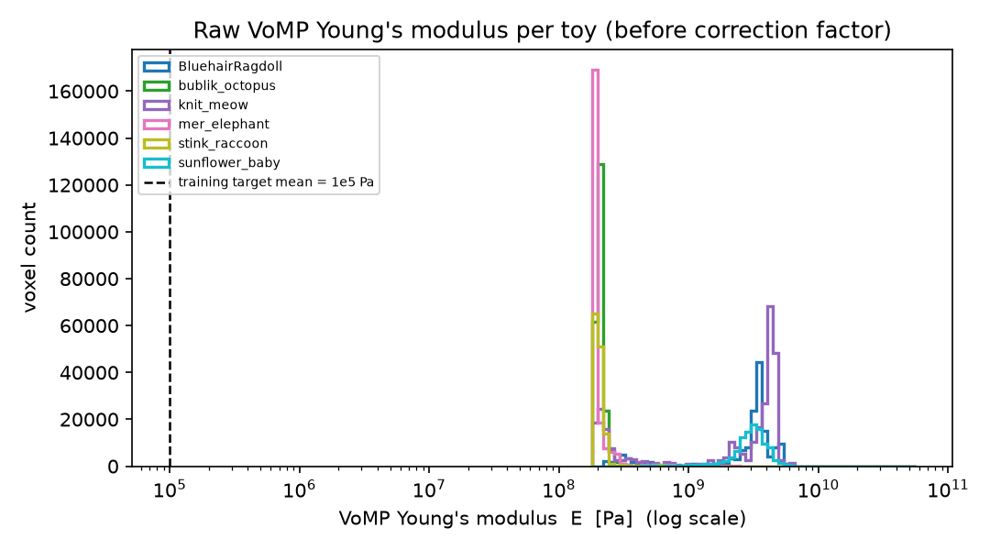
Figure 1. Raw VoMP Young's modulus per toy (before the correction factor). All values sit far to the right of the 1e5 Pa target.
The build pipeline works around this with --youngs-modulus-correction-factor (default 1e5): one shared scale is applied across all supplied VoMP assets so their combined arithmetic-mean modulus becomes 1e5 Pa, while preserving relative variation between and within toys. Pass 1.0 to keep raw VoMP values. This is a global re-scaling, not a fix for the underlying VoMP bias.
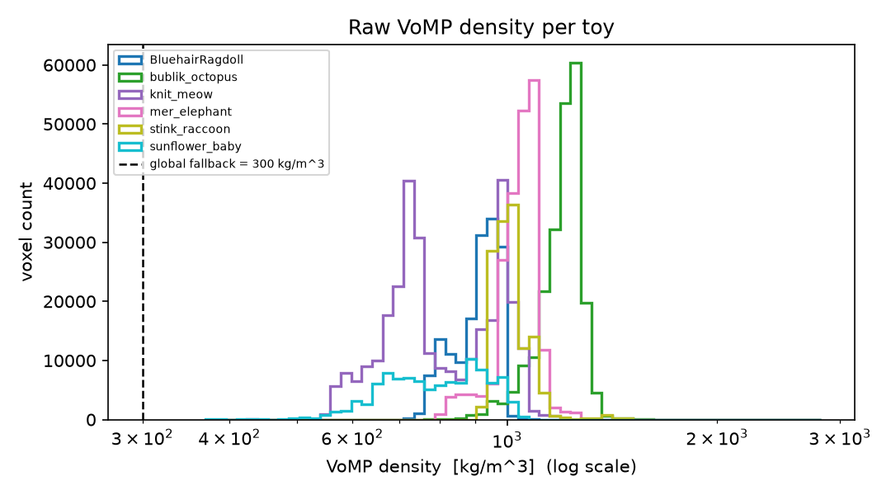
Figure 2. Raw VoMP density per toy. Density is closer to plausible (hundreds–thousand kg/m³) but still varies widely; the global fallback is 300 kg/m³.
Issue 2 — tet meshes with VoMP material do not behave correctly.
Even after the Young's-modulus correction, the per-tet VoMP variant does not simulate as expected. Two structural details in the spawner are the likely mechanical causes:
- Double-authored material. The VBD spawner writes the per-tet arrays (newton:tetMu/tetLambda/particleMass) and then also creates and binds the uniform global physics_material on the same prim. Both are present simultaneously, so behavior depends on which one Newton's ingestion prioritizes.
- Inconsistent load-time scaling. newton:particleMass is volume-scaled at load, while the Lamé parameters are left unscaled — a plausible source of the wrong effective stiffness-to-mass ratio.
TODO
• Debug VoMP materials: verify the exported field is physically sensible (the current GPa-scale moduli are not), and stop relying on a single global correction factor.
• Fix the double-authored material so per-tet VoMP arrays and the uniform physics_material do not both bind to the same prim.
• Make load-time scaling consistent between particleMass (volume-scaled) and the Lamé parameters (currently unscaled).
• Validate per-tet VoMP simulation behavior against the known-good global variant.

4.3 Solver
Why we are not using the Newton coupled solver.
Newton's native SolverVBD is a unified coupled solver: it can advance VBD particles and AVBD rigid bodies together. The blocker for this task is robot-actuator support, not soft-body coupling. The Kuka/Allegro robot's Isaac Lab configuration uses armature, joint friction, effort limits, and implicit drive control. SolverVBD supports target stiffness/damping and feedforward force, but not joint armature, joint friction, joint effort limits, or MuJoCo's joint target modes. Using it would therefore change or omit the configured robot dynamics and actuator limits.
Instead, the two-way presets use NewtonCoupledMJWarpVBDManager, which keeps the MuJoCo/Warp articulation and actuator features while using VBD for the soft body. It collides first, injects normal and Coulomb-friction reactions into the rigid-body force buffer, steps MuJoCo/Warp with those reactions, then steps VBD using the same contacts. The default stable_kinematic preset instead uses Featherstone–VBD with a kinematically driven robot — it follows position targets exactly and is more stable for early policy training.
TODO
• Extend the Newton coupled solver (SolverVBD) to support the full robot actuator model — joint armature, joint friction, joint effort limits, and MuJoCo joint target modes — so the task can use the native coupled solver if/when that support lands.

