Code Generation GUI example tutorial

Example for tutorial: Population model (from : Robust steady state optimization with state dependent delays)
Starting from your systems equations:

.
μ, γ and β are not fixed but vary over time, but slowly compared to dynamics of the system. Here only two of them will be modeled as uncertain parameters ( μ and γ) and β will be fixed (β=1). In this model we have a state dependent delay as well.

The goal is to find a minimum of the following equation:
with
For the robustness constraints we determined that we need steady states of our systems equations to be exponentially stable with σ=-0.1.
For Initialization we choose the initial parameter vector to be:

To enter these systems dynamics to the normal vector method project you start codeGenGUI.m.
First you give the name of your project:
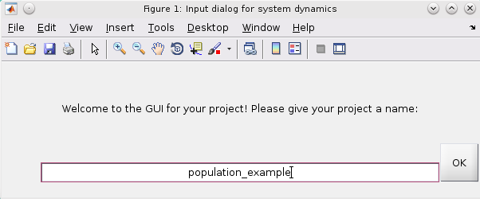

In the next step you provide the directory of the maple modules. (Caution you need to click onto the input field and press enter, you can not just click OK that will lead to an error)
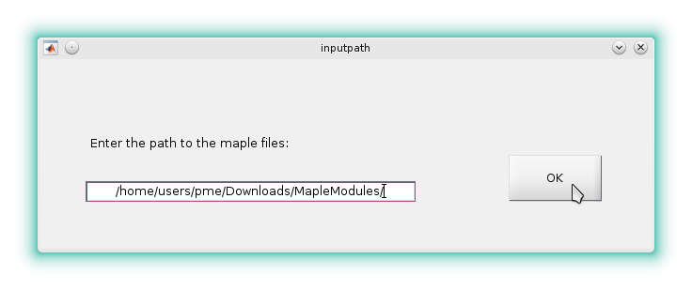
Then you are asked to enter the systems properties.
It starts by defining the states. First you need to provide the amount of states.
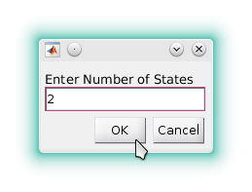

After that you provide the names of the states.
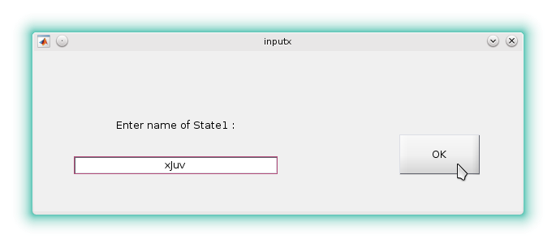
In this example the second state was named: xMat.

Next you enter the expressions for the delays, again after giving the number of delays.
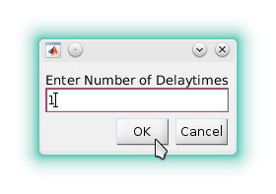

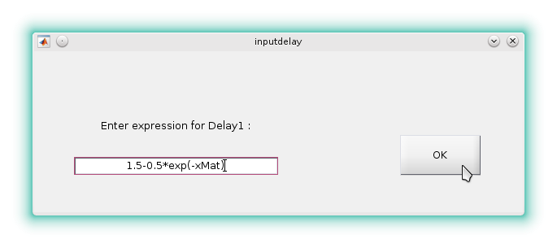
Now the parameters, modeled as uncertain parameter are entered.
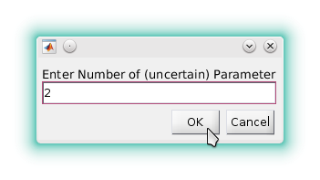

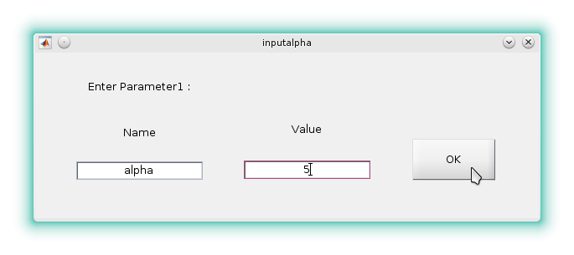
Here you provide a name and a value. The second parameter was: gamma;2.
Now the systems (differential) equations need to be entered.
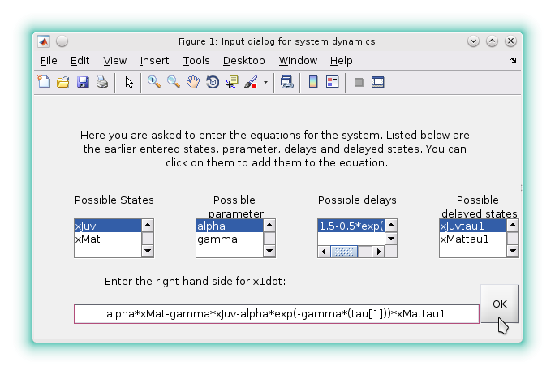
In this dialog the parameter already given are listed so you know, what can be entered in the right way. But you can also use variables which you will give a numeric value. That can be done in the next step, where we will add for this example the third parameter which will not be uncertain.
The second equation in this example was: alpha*exp(-gamma*(tau[1]))*xMattau1-beta*xMat^2

After entering the equations a window will appear where the parameter entered by you are listed, so you can check weather they are correct. If they are not correct you can press the button on the right to get to the input dialog of the property and you can re-enter the values.
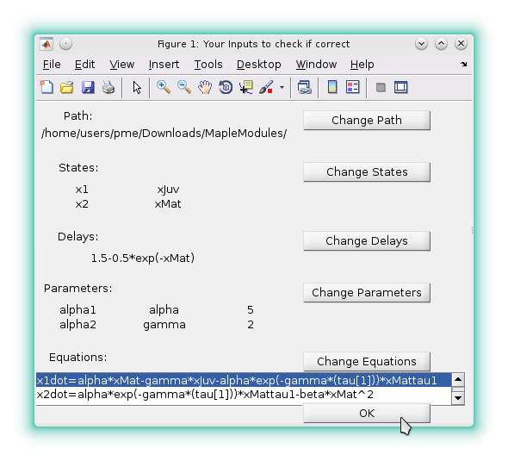

In the second equation the variable beta was used and not introduced to the program before, such variables con be added in the next step, where you add explicit algebraic equations.
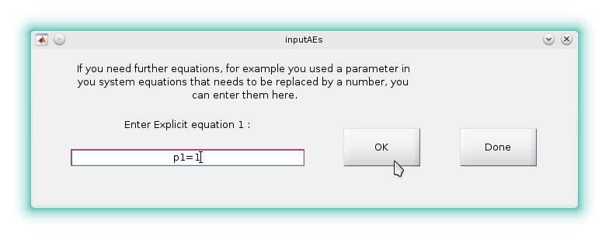
The second equation added here was: beta=p1
OK will add the equation to the program. When you do not need to add anymore equations you click Done. (Caution: when you enter an equation and click done (without clicking OK) the entered equation will not be added to the program).
Next you are asked what kind of manifold you want.
You click on the right manifold and then OK.
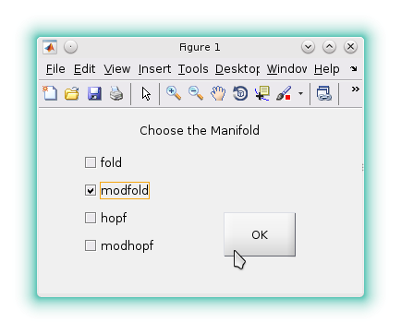

If you have chosen modhopf or modfold you need to provide the maximum real part for exponential stability:
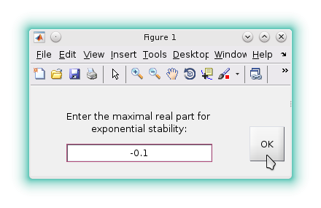

Then the program will compile the files for maple, the returning c files to mexfiles.

