

CENTENNIAL COLLEGE
PROGRESS CAMPUS


COMP225005.51416.2025M

Software Requirements Specification (SEC. 005)

Professor: Bindu Goel

Assignment #2 (Part A, B, and C)
PRESENTED BY :
Moesha Aurelle Emaleu Deutou 301444365

TABLE OF CONTENTS
1 INTRODUCTION 3
1.1 Purpose 3
1.2 Document Conventions 3
1.3 Intended Audience and Reading Suggestions 4
1.4 Product Scope 4
1.5 References 4
2 OVERALL DESCRIPTION 5
2.1 Product Perspective 5
2.2 Product Functions 5
2.3 User Classes and Characteristics 5
2.4 Operating Environment 5
2.5 Assumptions and Dependencies 6
3 EXTERNAL INTERFACE REQUIREMENTS 6
3.1 User Interfaces 6
3.2 Hardware Interfaces 6
3.3 Software Interfaces 7
3.4 Communications Interfaces 7
3.5 Use Case Table 7
4 SYSTEM FEATURES 8
4.1 Functional Requirements List 8
4.2 Formal Use Case Description 10
4.2.1 Swimlane Diagram 12
4.2.2 Use case diagram 13
5 NONFUNCTIONAL REQUIREMENTS 13
APPENDIX A 14
APPENDIX C 15
APPENDIX D 16
APPENDIX E 20
E.1 First Cut Domain Class Diagram (Noun Technique) 20
E.2 Class Diagram 21
E.3 Class responsibilities and collaboration “CRC cards” 22
E.4 State Diagrams 22
E.5 Sequence Diagrams 24
E.6 Party Analyses Pattern 24
E.7 Gen AI 25

INTRODUCTION

Purpose

The Intelligent Freight Logistics Dispatch System (IFLDS) is a new software product designed to address the issue of inefficient vehicle dispatch and load matching in freight logistics companies. It provides an intelligent platform that automates cargo assignment based on load type, vehicle availability, driver hours, and location. It aims to improve delivery efficiency, reduce fuel costs, and ensure compliance with driver work hour regulations. The system will be integrated into existing logistics operations to streamline fleet management and enhance real-time communication between dispatchers, drivers, and shippers.
Version 1.2.0 delivers the core functionality, which includes:
- A dispatcher dashboard for efficient management of fleet operations and cargo assignments.
- A mobile application enabling drivers to receive, manage, and update delivery assignments in real time.
- A web portal that allows shippers to place orders and track their shipments seamlessly.

Document Conventions

This Software Requirements Specification (SRS) document follows standard documentation conventions to ensure clarity, consistency, and readability. The following typographical and structural conventions are applied:
- All requirements have IDs like FR01 (for functional) or NFR01 (for non-functional)
- Titles and headings are bold
- Important terms are explained in a table below
- Use case IDs match the requirement they are based on (e.g., FR01 → UC01)

Acronyms | Description
IFLDS | Intelligent Freight Logistics Dispatch System
GPS | Global Positioning System
API | Application Programming Interface
ETA | Estimated Time of Arrival
UI | User Interface
AI | Artificial Intelligence
IoT | Internet of Things
UX | User Experience
CRM | Customer Relationship Management Systems

Intended Audience and Reading Suggestions
This document is intended for the following audiences:
- Developers: For understanding system functionality and architecture.
- Project Managers: For tracking progress and ensuring the system aligns with business goals.
- Testers: To verify and validate system functionality.
- Clients & End Users: For general awareness of system capabilities and expectations.
- Technical Writers: For preparing help documentation and user manuals.

Product Scope

The Intelligent Freight Logistics Dispatch System (IFLDS) is an integrated logistics management solution that facilitates efficient and intelligent freight dispatching. The system empowers logistics companies to automate dispatch workflows, optimize delivery scheduling, track vehicles and cargo in real-time, and enhance communication among all logistics stakeholders. By leveraging AI-based route planning and predictive analytics, IFLDS aims to reduce fuel costs, improve delivery times, and enhance fleet utilization. The system aligns with corporate goals to improve operational efficiency, customer satisfaction, and data-driven decision-making in logistics.

References
- https://ratings.freightwaves.com/best-truck-dispatching-software/
- https://shipsy.io/blogs/dispatch-logistics-software/
- https://www.sciencedirect.com/science/article/abs/pii/S1366554519309767#preview-section-references
- https://www.fleetio.com/hello/fleet-management-software-optimize-profit?kw=fleet%20management%20optimization%20systems&cpn=687560094&campaignid=687560094&utm_campaign=search_bing_topkeywords_nonbrandfleet&adgroupid=1326013325157388&utm_content=search&utm_source=bing&utm_term=fleet%20management%20optimization%20systems&utm_medium=cpc&extensionid=&targetid=kwd-82876988410407:loc-32&matchtype=e&device=c&adid=&msclkid=e2c30cbba31915f977a5648074cfb5d8
- https://www.dat.com/solutions/freight-matching
- https://smartroutes.io/blogs/5-best-dispatch-software/
- https://www.simplyfleet.app/features/fleet-integrations
- Visio use case diagram
- Visio detailed class diagrams
SECTION 2#

OVERALL DESCRIPTION

Product Perspective
The Intelligent Freight Logistics Dispatch System (IFLDS) is an innovative, standalone software crafted to enhance how freight companies handle deliveries, manage drivers, and communicate with clients. It features three key components: a web dashboard for dispatchers and managers, a mobile app for drivers, and a client portal for placing and tracking shipment requests. IFLDS is designed to seamlessly integrate with external tools like Google Maps for real-time tracking, Twilio for SMS updates, and payment systems like Stripe and PayPal, as well as CRM systems for managing customer data. With its modular design, the system can easily scale to accommodate more users and deliveries as needed. It utilizes APIs for real-time data exchange and is hosted in the cloud, ensuring it’s always accessible. Each user type, dispatchers, drivers, and clients, benefits from a tailored user interface that meets their specific needs. This makes IFLDS a valuable and modern solution that boosts coordination and efficiency in freight logistics.

Product Functions
The IFLDS will provide the following major features:
- AI-based route optimization for dispatchers
- Real-time GPS tracking of freight and vehicles
- Mobile application for driver task updates and navigation
- Automated ETA updates and SMS notifications to clients
- Digital proof of delivery capture (signature/photo)
- Dashboard for fleet performance and analytics
- Role-based access control for system users

User Classes and Characteristics
The operational stakeholders (end users) of the IFLDS system are grouped into the following user classes based on the nature of their roles:
- Dispatchers – assign and track shipments
- Fleet Managers – manage vehicles and drivers
- Drivers – use mobile app to complete deliveries
- Clients – use web portal to track their orders
- IT Admins – maintain system and fix issues
- Compliance Officers – check that rules are followed
- Product Owners – make business decisions

Operating Environment

The system will run in the following environment:

- Web Platform: Node.js backend, MongoDB database, React frontend
- Mobile App: Android and iOS (React Native)
- APIs: RESTful APIs with JSON format
- Browser Support: Chrome, Firefox, Safari, Edge
- Hosting: Cloud-based (AWS or Azure)

Assumptions and Dependencies
- Users have internet access
- Google Maps, Twilio, and Stripe/PayPal APIs are available
- Drivers use phones with Android 10+ or iOS 14+
- System runs on modern web browsers
- Hosted on a reliable cloud platform
- Currently only for North America
- The interface is simple and easy to learn
SECTION 3#

EXTERNAL INTERFACE REQUIREMENTS

User Interfaces
The IFLDS will provide multiple access interfaces for different types of users:
- Web interface for dispatchers and clients (built with React.js)
- Mobile app for drivers (built with React Native)
- Supports the latest versions of Chrome, Firefox, Edge, and Safari
- Data sent and received using JSON format

Hardware Interfaces
The IFLDS system interfaces with various hardware components, both directly and indirectly. The system must support the following hardware interfaces:
- Smartphones with GPS (for driver app)
- Vehicle GPS devices (for tracking)
- Barcode scanners (optional, for packages)
- Servers with 16 GB RAM and 4 CPUs for cloud hosting

Software Interfaces
The IFLDS system will interface with the following software components:
- Operating Systems: Windows, macOS, Linux (for web); Android/iOS (for mobile)
- APIs: Google Maps, Twilio, Stripe
- Databases: MySQL, Redis (for real-time updates)
- ERP Systems: Connects to SAP or Oracle if needed
- Authentication: OAuth2 and token-based login
- Data Formats: JSON, XML, CSV, JWT

Communications Interfaces
The IFLDS system depends on several communications interfaces to function effectively across all users and systems:
- All data sent over HTTPS
- Drivers use Wi-Fi or mobile data (3G/4G/5G)
- System supports email and SMS notifications
- Real-time updates sync every 15–30 seconds
- Secure communication using TLS 1.2+
- Low latency: under 300ms for GPS and dispatch updates

Use Case Table

Use Case Name | Related Requirements IDs | Actor(s) | Brief Description
Assign Freight Task | FR01, FR06 | Logistics Dispatcher, Fleet Manager | Assign freight delivery tasks dynamically in real-time based on driver availability, proximity, and load capacity to optimize fleet utilization and minimize delays.
Optimize Delivery Route | FR02, FR10 | Fleet Manager | Dynamic routing algorithm incorporating traffic, weather, and delivery windows to reduce fuel costs by 15-20%.
Receive Delivery Assignment | FR03, FR06 | Driver | Notify drivers promptly via mobile app when new delivery assignments are made, providing all necessary details, including pickup location, destination, and special instructions.
Update Delivery Status | FR03, FR06 | Driver | Real-time GPS-powered status updates (On Route/Delayed/Completed) with automated client notifications.
Capture Proof of Delivery | FR05 | Driver | Allow drivers to capture proof of delivery using digital signatures or photographs, especially for high-value or sensitive shipments, ensuring accountability and record-keeping.
Track Shipment Status | FR04, FR06 | Client Representative | Provide customers and client company representatives with live shipment tracking dashboards showing real-time location and estimated delivery times for transparency and planning.
Manage Delivery Schedule | FR05, FR06 | Logistics Dispatcher, Client Representative | Allow dispatchers and clients to schedule, reschedule, cancel, and prioritize deliveries, including urgent/time-sensitive requests, with appropriate approval workflows.
Generate Fleet Performance Reports | FR08 | Logistics Admin, Company Executive | Automatically generate detailed reports on delivery times, driver performance, vehicle utilization, and route efficiency to support decision-making and continuous improvement.
Communicate with Drivers | FR06 | Logistics Dispatcher, Driver | Facilitate in-app messaging between dispatchers and drivers to enhance coordination, reduce communication delays, and quickly address delivery exceptions or emergencies.
Process Payments and Invoicing | FR06 | Logistics Admin | Automate invoicing and payment processing related to deliveries, generating accurate billing information and financial reports for customers and internal accounting.
Manage Driver Availability | FR01, FR06 | Fleet Manager, Driver | Allow drivers to update their availability status (e.g., on duty, off duty, break) to assist dispatchers and fleet managers in real-time resource planning.

SECTION #4

SYSTEM FEATURES
This section outlines the major functional features of the IFLDS system based on system services and user requirements. Features are described with their priority, usage flow, and related functional requirements.

Functional Requirements List

Requirement ID | Requirement Title | Short Description | Priority | Requester
FR01 | Real-Time Dispatching | The system shall assign freight delivery tasks to drivers in real-time based on availability and location. | High | Fleet Manager
FR02 | Route Optimization | The system shall calculate the most efficient delivery routes to minimize travel time and fuel consumption. | High | Fleet Manager
FR03 | Driver Mobile App | The system shall provide a mobile app for drivers to receive assignments, update delivery status, and communicate with dispatch. | High | Driver
FR04 | Customer Delivery Tracking | The system shall allow customers to track the real-time location and estimated delivery time of their shipments. | High | Customer Service Representative
FR05 | Schedule Management | The system shall enable scheduling and rescheduling of deliveries by customers with approval from dispatch. | Medium | Customer Service Representative
FR06 | Notification System | The system shall send automatic notifications to customers and drivers for status updates, delays, or changes. | High | Customer Service Representative
FR07 | Fleet Maintenance Alerts | The system shall monitor vehicle usage and alert fleet managers when maintenance is due based on mileage or time. | Medium | Fleet Manager
FR08 | Reporting Dashboard | The system shall generate reports on fleet performance, delivery times, and driver efficiency. | Medium | Company Executive
FR09 | User Access Control | The system shall provide role-based access control for different user types such as drivers, dispatchers, and managers. | High | IT Security Officer
FR10 | Integration with GPS APIs | The system shall integrate with third-party GPS services to track vehicles and optimize routes. | High | IT Administrator

Formal Use Case Description
Use Case: Assign Freight Delivery Task — Optimize Driver Assignment (AFD-OA)
Iteration: 1, last modification: June 30, 2025 by Moesha Aurelle Emaleu Deutou
Primary Actor: Logistics Dispatcher (Sarah Lim)

Goal in Context:
To optimally assign freight deliveries to available drivers based on real-time location, capacity, and compliance data.
Preconditions:
- Dispatcher is authenticated (FR09)
- At least one pending delivery exists
- Driver GPS and hours-of-service (HOS) data are current
Trigger:
New delivery request enters the dispatch queue
Scenario:
- The dispatcher selects the delivery request from the dashboard.
- The system evaluates:
  - Driver proximity (within a 50-mile radius)
  - Available drive hours (minimum 2 hours remaining)
  - Vehicle capacity (with a 20% buffer)
- The system displays the top 3 driver matches with ETA estimates.
- The dispatcher confirms the assignment or manually overrides the system's suggestion.
- The system then:
  - Sends an encrypted push notification to the selected driver (FR06)
  - Updates the customer portal with the new estimated time of arrival (FR04)
  - Logs the assignment in the audit trail for future reference (FR08)
Exceptions:
- No available drivers meet the criteria:
- System alerts dispatcher to expand the search radius or delay the assignment
- Driver rejects the assignment:
- System notifies dispatcher and suggests the next-best alternative driver
- The GPS signal is lost:
- System uses the last known location and prompts the dispatcher to input a ZIP code as a fallback
Priority: High (Core functionality for first release)
Frequency of Use: 50–100 times daily during peak hours
Channel to Primary Actor: Web-based dispatch dashboard
Secondary Actors:
- Fleet Manager (Daniel Chou) — manages exception scenarios
- Notification Service (e.g., Twilio API) — handles delivery of push alerts
Open Issues:
- Optimal refresh rate for driver location updates (currently set at 15 seconds)
- Handling assignment logic when more than 80% of drivers are already at capacity
- Verification and audit trail policy for manual dispatcher overrides

Swimlane Diagram

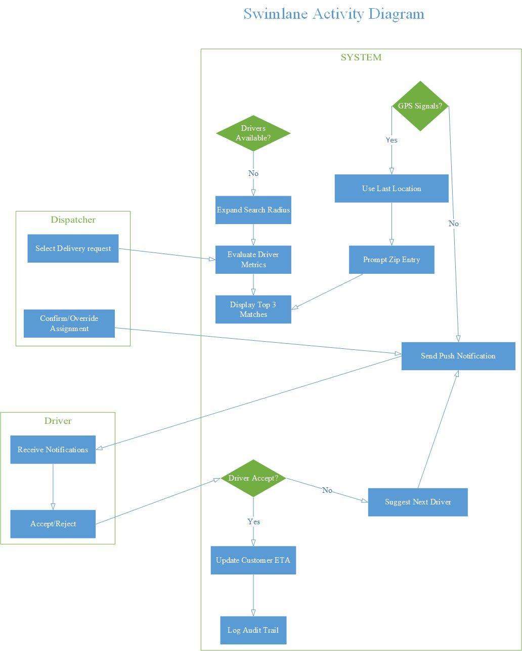

Use case diagram

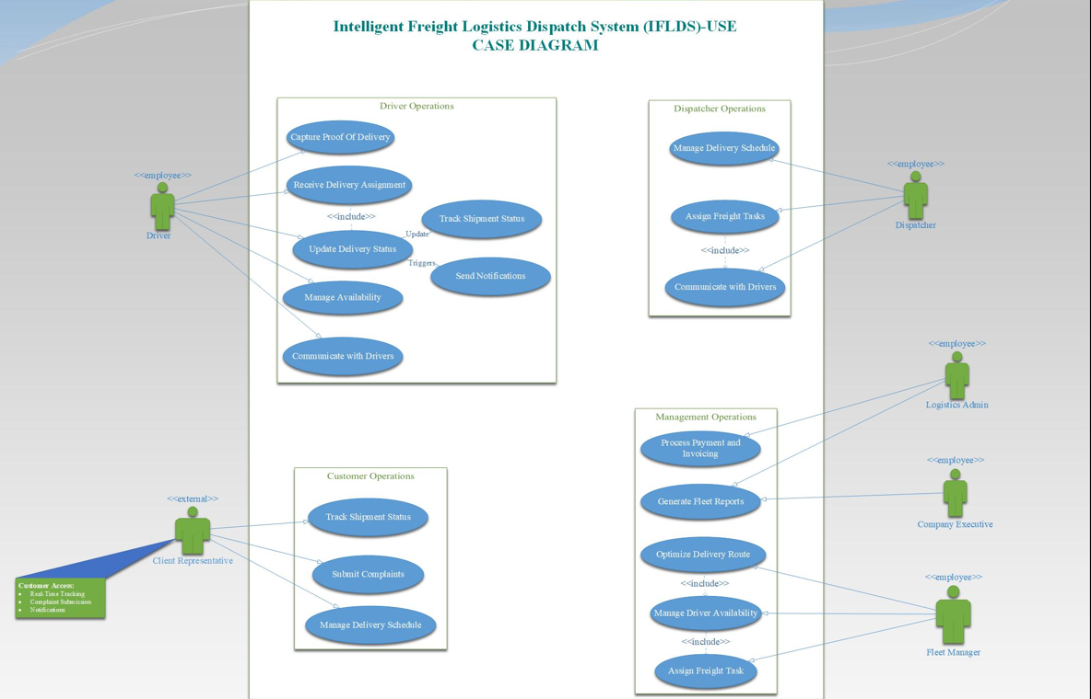
SECTION #5

Nonfunctional Requirements

Requirement ID | Requirement Title | Short Description | Priority | Requester
NFR01 | System Performance | The system shall handle up to 500 concurrent users and process dispatch requests within 2 seconds. | High | IT Administrator
NFR02 | Security and Data Privacy | The system shall implement encryption for data in transit and at rest, and comply with relevant data privacy laws. | High | IT Security Officer
NFR03 | Mobile Compatibility | The driver mobile app shall be compatible with iOS (version 12 and above) and Android (version 8 and above). | Medium | Driver
NFR04 | Browser Compatibility | The web interface shall support modern browsers, including Chrome, Firefox, Safari, and Edge. | High | Customer Service Representative
NFR05 | System Availability | The system shall be available 99.5% of the time, excluding planned maintenance periods. | High | Company Executive
NFR06 | Scalability | The system shall be scalable to support additional fleet vehicles and users without performance degradation. | Medium | IT Administrator

APPENDIX A:
A simple diagram that shows the major components of the overall system,
subsystem interconnections, and external interfaces
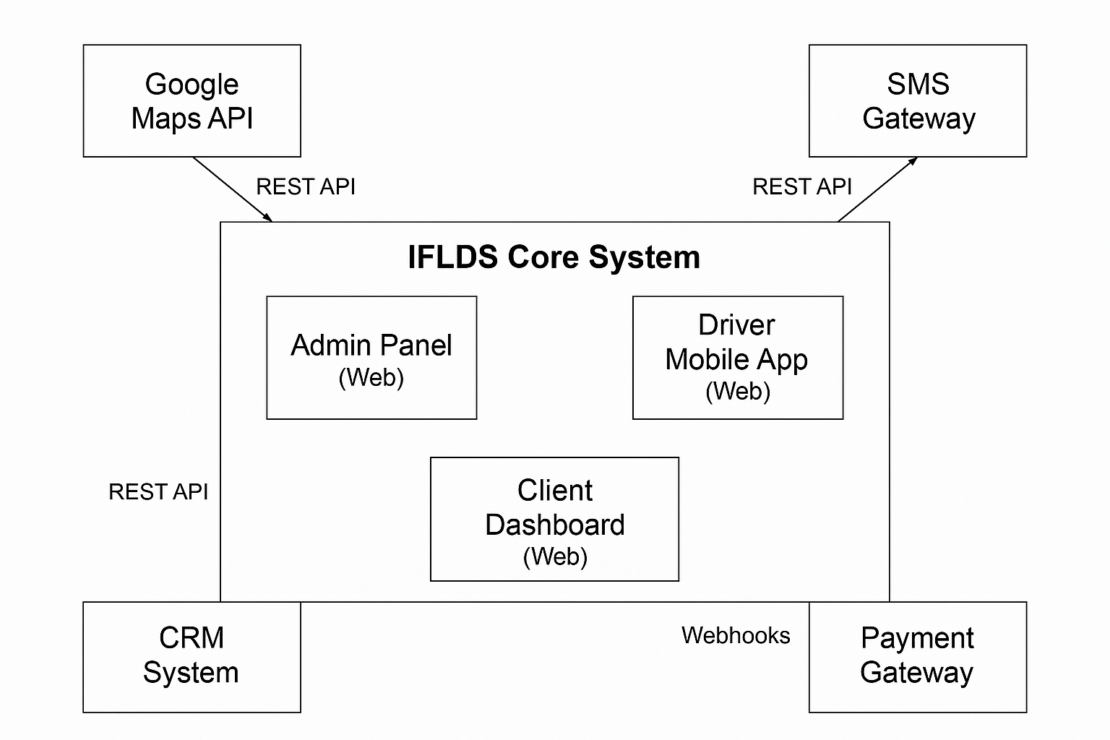
APPENDIX C
STAKEHOLDER REGISTER
Stakeholder Register for Intelligent Freight Logistics Dispatch System (IFLDS). This register identifies all key stakeholders involved in the project and their roles and interests.
Stakeholder Name | Position | Internal /External | Contact Details | Role Type | Interest Level
Maya Singh | Lead Software Developer | Internal | maya.singh@ifldsdev.com | Executive (Development) | High
Carlos Reyes | Backend Developer | Internal | carlos.reye@ifldsdev.com | Executive (Development) | High
Linda Zhou | Frontend Developer | Internal | linda.zhou@ifldsdev.com | Executive (Development) | High
Ethan Park | QA Tester | Internal | ethan.park@ifldsqa.com | Executive (Quality) | Medium
Louis Tran | IT Systems Administrator | Internal | louis.tran@iflds.com | Executive (IT Support) | Medium
Dr. Felix Zhang | Product Owner / Investor | External | felixzhang@loginvest.com | Executive (Investor) | High
Lydia Mensah | Compliance Officer | Internal | lydia.mensah@iflds.com | Executive (Governance) | Medium
Naomi Cole | Client Company Representative | External | naomi.cole@clientco.com | Operational (Advisory) | High
Sarah Lim | Logistics Dispatcher | External | sarah.lim@clientco.com | Operational (End User) | High
Daniel Chou | Fleet Manager | External | danielchou@clientco.com | Operational (End User) | High
James Owusu | Driver | External | N/A (Mobile App User) | Operational (End User) | Medium

APPENDIX D
INTERVIEW QUESTIONS
“You are a software engineer conducting requirements engineering for a software project. Your task is to interview Fleet Managers to gather detailed information about their needs and how they will interact with the system. The project is described as follows: You are developing an Intelligent Freight Logistics Dispatch System (IFLDS), a centralized web-based platform with integrated mobile applications for drivers and dashboards for clients. The system will manage freight dispatching, real-time vehicle tracking, communication between dispatchers and drivers, proof of delivery capture, and integration with mapping APIs, SMS gateways, and payment processing services. It is designed to optimize operational efficiency and scale with fleet size. Your goal is to understand the fleet manager’s current workflows, operational challenges, and expectations to ensure the system supports their role effectively.”
Question | Stakeholder Position | Answer
Round 1: Fleet Manager
1) What are the biggest bottlenecks you face in coordinating drivers and delivery schedules? | Fleet Manager | Difficulty handling last-minute delivery requests and reassigning drivers quickly.
2) How should the system handle urgent deliveries compared to normal ones? | Fleet Manager | Urgent deliveries should be prioritized and flagged, with alerts sent to available drivers immediately.
3) What kind of real-time updates do you need to track driver location and status? | Fleet Manager | GPS tracking with status updates on delivery progress and driver availability.
4) Are there any integration needs with existing fleet management tools? | Fleet Manager | Yes, integration with maintenance and fuel tracking systems would be useful.
5) What reporting features would help you improve fleet performance? | Fleet Manager | Weekly reports on delivery times, driver efficiency, and vehicle utilization.
Round 2: Driver
6) How do you prefer receiving delivery assignments? | Driver | Via a mobile app notification with detailed instructions.
7) What are the common issues you face when delivering goods? | Driver | Receiving late assignment info and unclear delivery addresses.
8) How important is offline access to delivery details when the signal is weak? | Driver | Very important, as signal drops are common in remote areas.
9) What proof of delivery methods do you think should be supported? | Driver | Digital signatures and photo capture for high-value shipments.
10) Would you use in-app communication with dispatchers? | Driver | Yes, it would reduce phone calls and speed up responses.
Round 5: Logistics Dispatcher
11) How do you currently assign deliveries to drivers? | Logistics Dispatcher | Assignments are mostly manual via phone or SMS, which can cause delays and missed communications.
12) What features would help improve dispatcher-driver communication? | Logistics Dispatcher | In-app messaging with status updates and alerts to confirm receipt would improve coordination.
13) How do you track delivery progress and handle exceptions (e.g., delays or failed deliveries)? | Logistics Dispatcher | We rely on driver calls; a real-time tracking system with alerts would be a game changer.
14) Should the system allow dispatchers to override automatic assignments? | Logistics Dispatcher | Yes, manual override should be possible for special cases or urgent deliveries.
15) What reporting or dashboard views do you need daily? | Logistics Dispatcher | Live delivery status, driver availability, and pending assignments overview.
Round 4: IT Administrator
16) What existing IT infrastructure will the system need to integrate with? | IT Administrator | We use a hybrid of cloud storage and on-premise servers; compatibility with both is essential.
17) Are there security requirements or protocols the system must follow? | IT Administrator | Yes, data encryption, user authentication, and secure APIs are mandatory.
18) How should system updates and maintenance be handled to minimize downtime? | IT Administrator | Scheduled updates during off-peak hours with rollback options in case of failure.
19) Do you require data backup and disaster recovery features? | IT Administrator | Absolutely, with regular backups and a tested recovery plan.
20) What user roles and permission levels are necessary in the system? | IT Administrator | Role-based access control for dispatchers, drivers, managers, and administrators.
Round 8: Logistics Admin
21) How is payment processing and invoicing currently handled? | Logistics Admin | Manually via Excel spreadsheets and emailed invoices, which is time-consuming and error-prone.
22) Would you prefer automated invoicing and payment tracking in the new system? | Logistics Admin | Yes, automation would save time and reduce errors significantly.
23) What billing cycles and payment terms do you operate on? | Logistics Admin | Monthly billing with 30-day payment terms is standard
24) Are there any regulatory or tax compliance requirements for invoicing? | Logistics Admin | Yes, invoices must include tax breakdowns and comply with local financial regulations.
25) Should the system generate financial reports related to deliveries and payments? | Logistics Admin | Yes, comprehensive reports on revenue per route, pending payments, and billing summaries would be valuable.

APPENDIX E
E.1 First Cut Domain Class Diagram (Noun Technique)
Step 1: Key Analysis Classes Identified via Noun Technique:

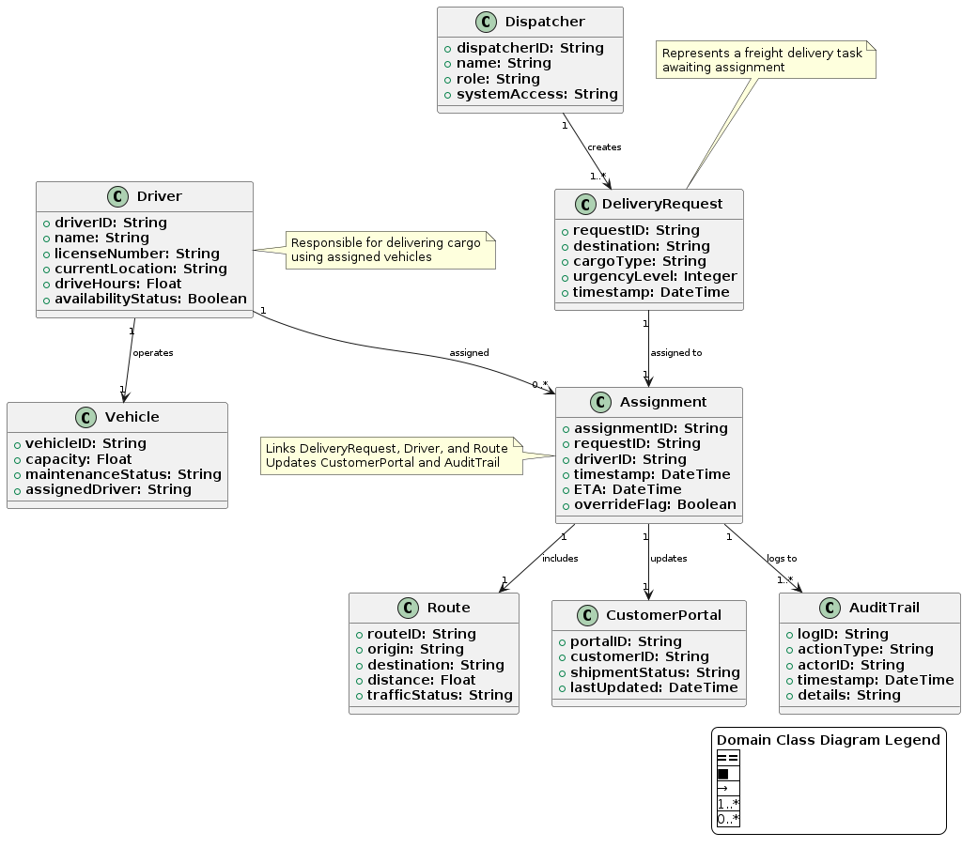

E.2 class diagrams
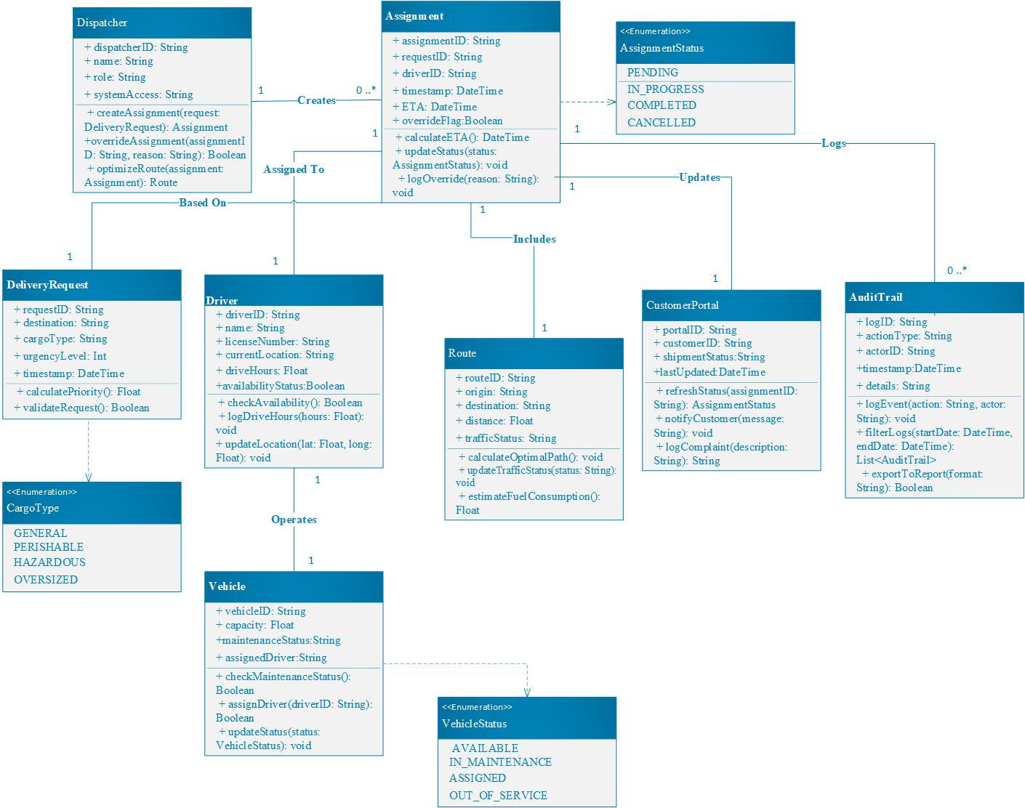

E.3 Class responsibilities and collaboration “CRC cards”
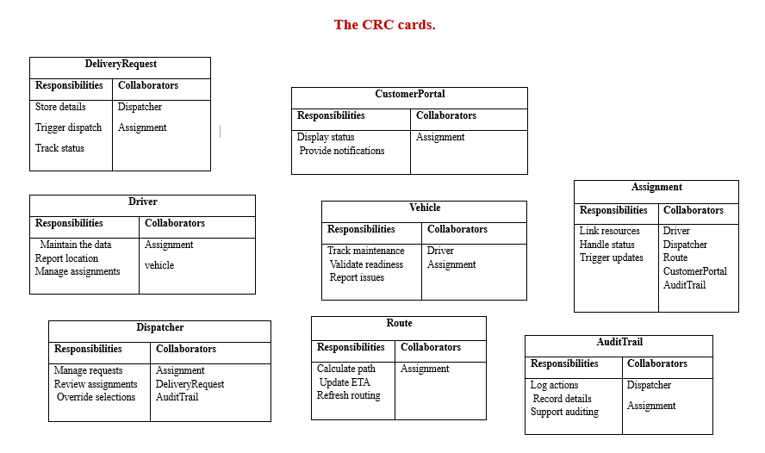E.4 State Diagrams
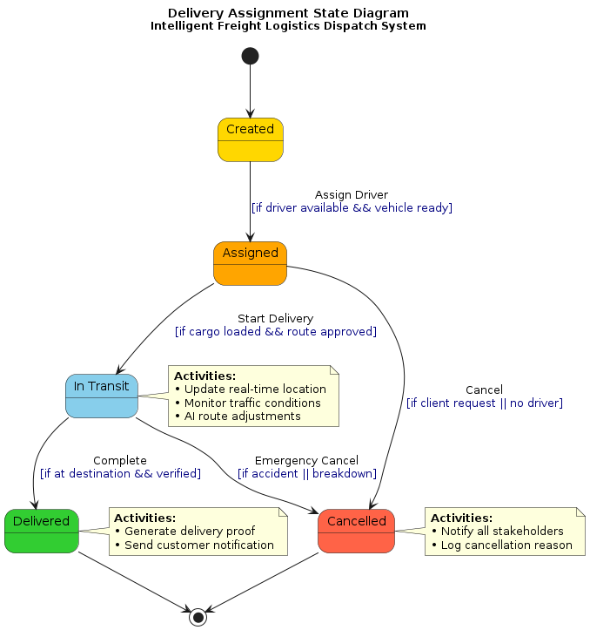

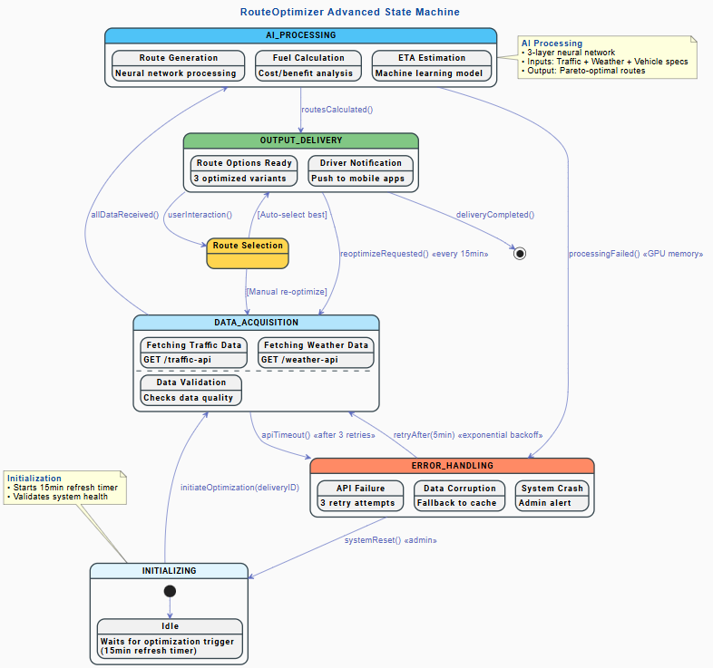

E.5 Sequence diagram
- View the full interactive sequence diagram here.

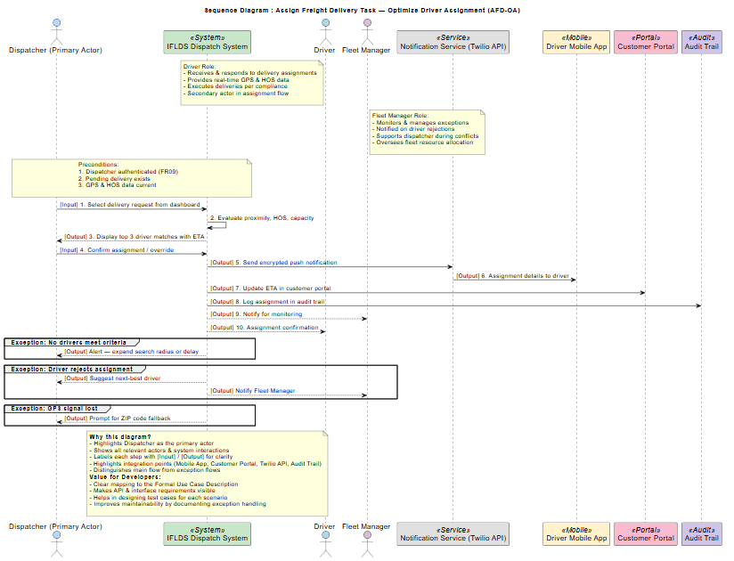
E.6 Party Analysis pattern
The Party Analysis Pattern is a reusable object model introduced by Martin Fowler to represent individuals, organizations, or roles within a system in a flexible way. This pattern is especially useful in systems where entities can assume multiple roles or where relationships between entities are dynamic and context-dependent. In the context of the Intelligent Freight Logistics Dispatch System (IFLDS), applying the Party pattern would involve restructuring the class diagram to generalize entities like Driver, Dispatcher, Client, and Fleet Manager as subclasses of a central Party class. This would allow these entities to inherit common attributes (e.g., contact details, authentication) while enabling them to take on multiple roles (e.g., a Driver could also act as a Dispatcher in some scenarios). The pattern would also simplify relationships, such as associations between parties (e.g., communication logs, assignment approvals), by treating them uniformly.
Value of Using the Party Pattern in IFLDS:
- Flexibility: Roles can be added or modified without altering the core class structure. For example, a Driver could later be assigned administrative privileges without duplicating code.
- Scalability: New user types (e.g., Auditors, Third-Party Vendors) can be integrated seamlessly.
- Maintainability: Shared functionality (e.g., notification handling, access control) is centralized in the Party superclass, reducing redundancy.
- Real-World Alignment: Mirrors real logistics ecosystems where stakeholders often interact in multifaceted roles (e.g., a Fleet Manager might also place orders as a Client).
Updated Class Diagram:
An updated UML class diagram would include:
- A Party abstract class with attributes like partyId, name, and contactInfo.
- Subclasses like UserParty (for system users) and OrganizationParty (for corporate clients).
- Role classes (e.g., DriverRole, DispatcherRole) linked via association to Party, enabling dynamic role assignment.
- Relationships like PartyCommunication (for messages) and PartyAssignment (for task delegation).
This pattern is feasible and beneficial for IFLDS, as it aligns with the system’s need for dynamic role management and complex stakeholder interactions.

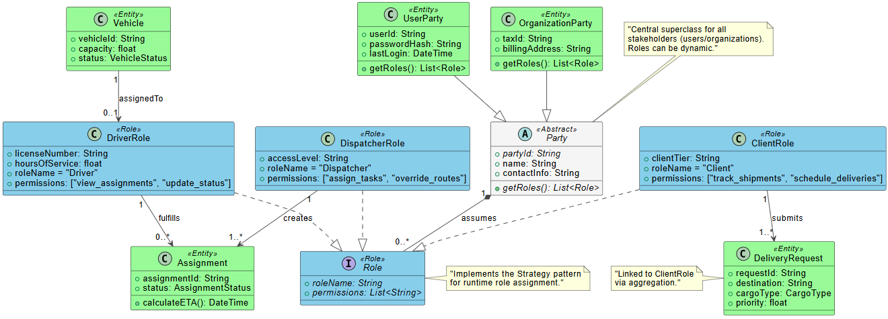

E.7 Gen AI class diagram
OUTPUT:
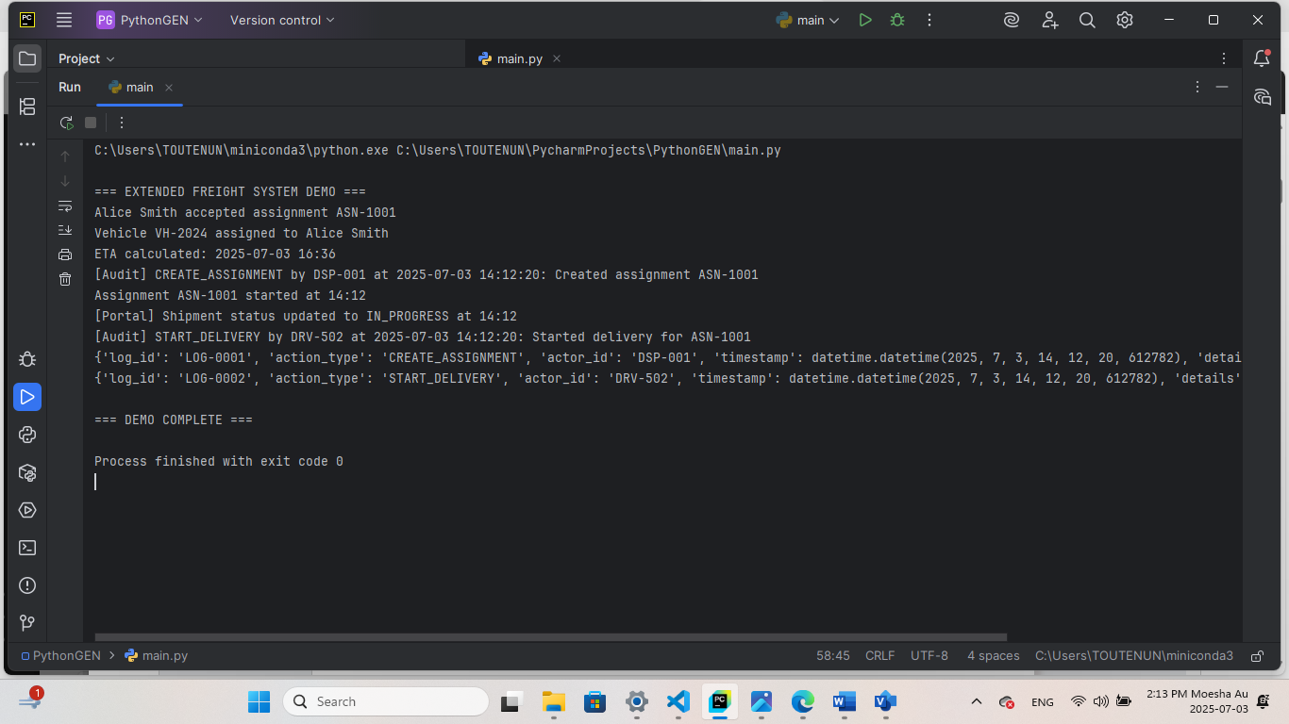
CODE:
from datetime import datetime, timedelta
from enum import Enum, auto
from typing import Optional, Tuple, List
# === Enums ===
class CargoType(Enum):
GENERAL = auto()
PERISHABLE = auto()
HAZARDOUS = auto()
OVERSIZED = auto()
class VehicleStatus(Enum):
AVAILABLE = auto()
IN_MAINTENANCE = auto()
ASSIGNED = auto()
class AssignmentStatus(Enum):
PENDING = auto()
IN_PROGRESS = auto()
COMPLETED = auto()
CANCELLED = auto()
# === Core Classes ===
class DeliveryRequest:
def __init__(self, request_id: str, destination: str,
cargo_type: CargoType, urgency_level: int,
timestamp: datetime = None):
self.request_id = request_id
self.destination = destination
self.cargo_type = cargo_type
self.urgency_level = urgency_level
self.timestamp = timestamp or datetime.now()
def calculate_priority(self) -> float:
base_score = min(self.urgency_level / 10, 1.0)
return base_score * (1.2 if self.cargo_type == CargoType.PERISHABLE else 1.0)
def __str__(self):
return f"DeliveryRequest[{self.request_id}] to {self.destination} ({self.cargo_type.name})"
class Driver:
def __init__(self, driver_id: str, name: str, license_number: str,
current_location: str = "Depot", drive_hours: float = 0.0,
availability_status: bool = True):
self.driver_id = driver_id
self.name = name
self.license_number = license_number
self.current_location = current_location
self.drive_hours = drive_hours
self.availability_status = availability_status
self.current_assignment: Optional['Assignment'] = None
def accept_assignment(self, assignment: 'Assignment') -> bool:
if self.availability_status:
self.current_assignment = assignment
self.availability_status = False
print(f"{self.name} accepted assignment {assignment.assignment_id}")
return True
print(f"{self.name} cannot accept - not available")
return False
def update_location(self, coordinates: Tuple[float, float]):
self.current_location = f"{coordinates[0]},{coordinates[1]}"
print(f"{self.name} location updated to {self.current_location}")
class Vehicle:
def __init__(self, vehicle_id: str, capacity: float,
status: VehicleStatus = VehicleStatus.AVAILABLE,
assigned_driver: Optional[Driver] = None):
self.vehicle_id = vehicle_id
self.capacity = capacity
self.status = status
self.assigned_driver = assigned_driver
self.maintenance_log: List[str] = []
def assign_driver(self, driver: Driver) -> bool:
if self.status == VehicleStatus.AVAILABLE:
self.assigned_driver = driver
self.status = VehicleStatus.ASSIGNED
print(f"Vehicle {self.vehicle_id} assigned to {driver.name}")
return True
print(f"Vehicle {self.vehicle_id} not available for assignment")
return False
class Route:
def __init__(self, route_id: str, origin: str, destination: str,
distance: float, traffic_status: str = "Normal"):
self.route_id = route_id
self.origin = origin
self.destination = destination
self.distance = distance
self.traffic_status = traffic_status
self.waypoints: List[str] = []
def add_waypoint(self, location: str):
self.waypoints.append(location)
print(f"Added waypoint {location} to route {self.route_id}")
class Assignment:
def __init__(self, assignment_id: str, request: DeliveryRequest,
driver: Driver, vehicle: Vehicle, route: Route,
override_flag: bool = False):
self.assignment_id = assignment_id
self.request = request
self.driver = driver
self.vehicle = vehicle
self.route = route
self.status = AssignmentStatus.PENDING
self.timestamp = datetime.now()
self.eta: Optional[datetime] = None
self.override_flag = override_flag
def calculate_eta(self) -> datetime:
hours = self.route.distance / 50 # Avg speed = 50 km/h
self.eta = datetime.now() + timedelta(hours=hours)
print(f"ETA calculated: {self.eta.strftime('%Y-%m-%d %H:%M')}")
return self.eta
def start_delivery(self):
self.status = AssignmentStatus.IN_PROGRESS
print(f"Assignment {self.assignment_id} started at {datetime.now().strftime('%H:%M')}")
# === New Classes ===
class Dispatcher:
def __init__(self, dispatcher_id: str, name: str, role: str, system_access: str):
self.dispatcher_id = dispatcher_id
self.name = name
self.role = role
self.system_access = system_access
self.assigned_requests = []
def create_assignment(self, request: DeliveryRequest, driver: Driver,
vehicle: Vehicle, route: Route,
override: bool = False) -> Optional[Assignment]:
if not driver.availability_status:
print(f"Driver {driver.name} is not available.")
return None
if vehicle.status != VehicleStatus.AVAILABLE:
print(f"Vehicle {vehicle.vehicle_id} is not available.")
return None
assignment_id = f"ASN-{len(self.assigned_requests) + 1001}"
assignment = Assignment(assignment_id, request, driver, vehicle, route, override_flag=override)
success = driver.accept_assignment(assignment)
if success:
vehicle.assign_driver(driver)
assignment.calculate_eta()
AuditTrail.log_action("CREATE_ASSIGNMENT", self.dispatcher_id, f"Created assignment {assignment_id}")
self.assigned_requests.append(assignment)
return assignment
return None
class CustomerPortal:
def __init__(self, portal_id: str, customer_id: str):
self.portal_id = portal_id
self.customer_id = customer_id
self.shipment_status = "Pending"
self.last_updated = datetime.now()
def update_status(self, assignment: Assignment):
self.shipment_status = assignment.status.name
self.last_updated = datetime.now()
print(f"[Portal] Shipment status updated to {self.shipment_status} at {self.last_updated.strftime('%H:%M')}")
class AuditTrail:
logs: List[dict] = []
@classmethod
def log_action(cls, action_type: str, actor_id: str, details: str):
timestamp = datetime.now()
log_entry = {
"log_id": f"LOG-{len(cls.logs) + 1:04}",
"action_type": action_type,
"actor_id": actor_id,
"timestamp": timestamp,
"details": details
}
cls.logs.append(log_entry)
print(f"[Audit] {action_type} by {actor_id} at {timestamp.strftime('%Y-%m-%d %H:%M:%S')}: {details}")
@classmethod
def show_logs(cls):
for log in cls.logs:
print(log)
# === DEMO ===
if __name__ == "__main__":
print("\n=== EXTENDED FREIGHT SYSTEM DEMO ===")
req = DeliveryRequest("REQ-1002", "456 Oak Ave", CargoType.HAZARDOUS, 9)
driver = Driver("DRV-502", "Alice Smith", "LIC-123456")
vehicle = Vehicle("VH-2024", 1800.0)
route = Route("RT-401", "Depot B", "456 Oak Ave", 120.0)
dispatcher = Dispatcher("DSP-001", "Karen Jones", "Logistics Manager", "Full Access")
portal = CustomerPortal("PORT-001", "CUST-789")
assignment = dispatcher.create_assignment(req, driver, vehicle, route)
if assignment:
assignment.start_delivery()
portal.update_status(assignment)
AuditTrail.log_action("START_DELIVERY", driver.driver_id, f"Started delivery for {assignment.assignment_id}")
AuditTrail.show_logs()
print("\n=== DEMO COMPLETE ===")

