Regressão Múltipla

## Load data

boston = readxl::read_excel("boston.xlsx")  
b = boston#[,-1]  
#b = b[-c(365),]

## Manipulacao inicial dos dados

### Adicionando labels

b$chas=as.factor(b$chas)  
levels(b$chas)=c("otherwise", "bounds river")

### Sumario dos dados

summary(b)

## id crim zn indus   
## Min. : 1.0 Min. : 0.00632 Min. : 0.00 Min. : 0.46   
## 1st Qu.:127.2 1st Qu.: 0.08204 1st Qu.: 0.00 1st Qu.: 5.19   
## Median :253.5 Median : 0.25651 Median : 0.00 Median : 9.69   
## Mean :253.5 Mean : 3.61352 Mean : 11.36 Mean :11.14   
## 3rd Qu.:379.8 3rd Qu.: 3.67708 3rd Qu.: 12.50 3rd Qu.:18.10   
## Max. :506.0 Max. :88.97620 Max. :100.00 Max. :27.74   
## chas nox rm age   
## otherwise :471 Min. :0.3850 Min. :3.561 Min. : 2.90   
## bounds river: 35 1st Qu.:0.4490 1st Qu.:5.886 1st Qu.: 45.02   
## Median :0.5380 Median :6.208 Median : 77.50   
## Mean :0.5547 Mean :6.285 Mean : 68.57   
## 3rd Qu.:0.6240 3rd Qu.:6.623 3rd Qu.: 94.08   
## Max. :0.8710 Max. :8.780 Max. :100.00   
## dis rad tax ptratio   
## Min. : 1.130 Min. : 1.000 Min. :187.0 Min. :12.60   
## 1st Qu.: 2.100 1st Qu.: 4.000 1st Qu.:279.0 1st Qu.:17.40   
## Median : 3.207 Median : 5.000 Median :330.0 Median :19.05   
## Mean : 3.795 Mean : 9.549 Mean :408.2 Mean :18.46   
## 3rd Qu.: 5.188 3rd Qu.:24.000 3rd Qu.:666.0 3rd Qu.:20.20   
## Max. :12.127 Max. :24.000 Max. :711.0 Max. :22.00   
## lstat medv   
## Min. : 1.73 Min. : 5.00   
## 1st Qu.: 6.95 1st Qu.:17.02   
## Median :11.36 Median :21.20   
## Mean :12.65 Mean :22.53   
## 3rd Qu.:16.95 3rd Qu.:25.00   
## Max. :37.97 Max. :50.00

### Filtrando dados

b = filter(b,medv <50)  
  
#b$dis = ifelse(b$dis >= 3, 3, b$dis)  
b$rad = ifelse(b$rad >= 9, 9, b$rad)  
b$tax = ifelse(b$tax >= 500, 500, b$tax)  
#b$nox = ifelse(b$nox >= 0.8, 0.75, b$nox)  
#b$rm = ifelse(b$rm >= 7.5, 7.5, b$rm)  
b$zn = ifelse(b$zn > 0, 1, 0)  
  
#b = filter(b, id != 366)

### Ajustando valors

b = filter(b,medv <50)

### Transformando log

#b$crim = log(b$crim)  
b$lstat = log(b$lstat)  
b$dis = log(b$dis)  
#b$medv = log(b$medv)

## Regressao incial

### Fazendo Regressão com todas as variaveis

reg.mlt=lm(data=b, medv ~ crim + zn + indus + chas + nox + rm + age + dis +  
 rad + tax + ptratio + lstat)  
  
summary(reg.mlt)

##   
## Call:  
## lm(formula = medv ~ crim + zn + indus + chas + nox + rm + age +   
## dis + rad + tax + ptratio + lstat, data = b)  
##   
## Residuals:  
## Min 1Q Median 3Q Max   
## -10.8140 -2.1758 -0.4094 1.8289 11.3871   
##   
## Coefficients:  
## Estimate Std. Error t value Pr(>|t|)   
## (Intercept) 52.535978 3.916696 13.413 < 2e-16 ***  
## crim -0.138100 0.023065 -5.987 4.20e-09 ***  
## zn 0.277078 0.518403 0.534 0.593   
## indus -0.048217 0.045578 -1.058 0.291   
## chasbounds river 0.698504 0.692180 1.009 0.313   
## nox -15.016129 2.943598 -5.101 4.88e-07 ***  
## rm 2.774363 0.344769 8.047 6.79e-15 ***  
## age -0.004892 0.010365 -0.472 0.637   
## dis -4.884288 0.680164 -7.181 2.67e-12 ***  
## rad 0.490316 0.102869 4.766 2.49e-06 ***  
## tax -0.014161 0.002941 -4.815 1.98e-06 ***  
## ptratio -0.741094 0.097881 -7.571 1.93e-13 ***  
## lstat -6.936314 0.530948 -13.064 < 2e-16 ***  
## ---  
## Signif. codes: 0 '***' 0.001 '**' 0.01 '*' 0.05 '.' 0.1 ' ' 1  
##   
## Residual standard error: 3.498 on 477 degrees of freedom  
## Multiple R-squared: 0.807, Adjusted R-squared: 0.8022   
## F-statistic: 166.2 on 12 and 477 DF, p-value: < 2.2e-16

### Testando multicolinearidade

VIF > 5 indica alta chance de multicolinearidade.

round(vif(reg.mlt),1)

## crim zn indus chasbounds river   
## 1.6 2.1 3.9 1.1   
## nox rm age dis   
## 4.7 2.0 3.4 5.3   
## rad tax ptratio lstat   
## 2.5 3.5 1.7 3.7

### Detecção de anomalias

Cooks Distances -> Pontos Influentes Studentized residuals -> Outliers em Y hat-values -> Outliers em X

influenceIndexPlot(reg.mlt , vars=c("Cook","Studentized","hat"))

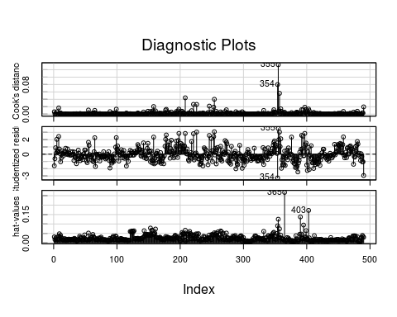

## Regressao com seleção de variáveis

reg.mlt2=step(reg.mlt)

## Start: AIC=1240.03  
## medv ~ crim + zn + indus + chas + nox + rm + age + dis + rad +   
## tax + ptratio + lstat  
##   
## Df Sum of Sq RSS AIC  
## - age 1 2.73 5840.0 1238.3  
## - zn 1 3.50 5840.8 1238.3  
## - chas 1 12.46 5849.8 1239.1  
## - indus 1 13.70 5851.0 1239.2  
## <none> 5837.3 1240.0  
## - rad 1 278.02 6115.3 1260.8  
## - tax 1 283.74 6121.0 1261.3  
## - nox 1 318.46 6155.8 1264.1  
## - crim 1 438.71 6276.0 1273.5  
## - dis 1 631.06 6468.4 1288.3  
## - ptratio 1 701.53 6538.8 1293.6  
## - rm 1 792.44 6629.7 1300.4  
## - lstat 1 2088.57 7925.9 1387.9  
##   
## Step: AIC=1238.26  
## medv ~ crim + zn + indus + chas + nox + rm + dis + rad + tax +   
## ptratio + lstat  
##   
## Df Sum of Sq RSS AIC  
## - zn 1 3.81 5843.8 1236.6  
## - chas 1 12.11 5852.1 1237.3  
## - indus 1 13.07 5853.1 1237.4  
## <none> 5840.0 1238.3  
## - rad 1 278.91 6118.9 1259.1  
## - tax 1 281.08 6121.1 1259.3  
## - nox 1 341.70 6181.7 1264.1  
## - crim 1 436.03 6276.1 1271.5  
## - dis 1 695.08 6535.1 1291.4  
## - ptratio 1 711.05 6551.1 1292.6  
## - rm 1 828.92 6669.0 1301.3  
## - lstat 1 2688.93 8529.0 1421.8  
##   
## Step: AIC=1236.58  
## medv ~ crim + indus + chas + nox + rm + dis + rad + tax + ptratio +   
## lstat  
##   
## Df Sum of Sq RSS AIC  
## - chas 1 11.57 5855.4 1235.5  
## - indus 1 14.31 5858.1 1235.8  
## <none> 5843.8 1236.6  
## - tax 1 278.16 6122.0 1257.4  
## - rad 1 285.77 6129.6 1258.0  
## - nox 1 346.31 6190.1 1262.8  
## - crim 1 432.36 6276.2 1269.6  
## - dis 1 745.77 6589.6 1293.4  
## - rm 1 840.21 6684.0 1300.4  
## - ptratio 1 886.12 6730.0 1303.8  
## - lstat 1 2689.46 8533.3 1420.1  
##   
## Step: AIC=1235.55  
## medv ~ crim + indus + nox + rm + dis + rad + tax + ptratio +   
## lstat  
##   
## Df Sum of Sq RSS AIC  
## - indus 1 12.55 5868.0 1234.6  
## <none> 5855.4 1235.5  
## - rad 1 302.01 6157.4 1258.2  
## - tax 1 305.29 6160.7 1258.5  
## - nox 1 338.43 6193.8 1261.1  
## - crim 1 442.89 6298.3 1269.3  
## - dis 1 742.69 6598.1 1292.1  
## - rm 1 848.83 6704.2 1299.9  
## - ptratio 1 913.32 6768.7 1304.6  
## - lstat 1 2684.21 8539.6 1418.5  
##   
## Step: AIC=1234.6  
## medv ~ crim + nox + rm + dis + rad + tax + ptratio + lstat  
##   
## Df Sum of Sq RSS AIC  
## <none> 5868.0 1234.6  
## - rad 1 326.38 6194.3 1259.1  
## - nox 1 392.34 6260.3 1264.3  
## - tax 1 395.85 6263.8 1264.6  
## - crim 1 433.55 6301.5 1267.5  
## - dis 1 757.11 6625.1 1292.1  
## - rm 1 870.67 6738.6 1300.4  
## - ptratio 1 1001.80 6869.8 1309.8  
## - lstat 1 2770.00 8638.0 1422.1

### Novo sumario da regressao

summary(reg.mlt2)

##   
## Call:  
## lm(formula = medv ~ crim + nox + rm + dis + rad + tax + ptratio +   
## lstat, data = b)  
##   
## Residuals:  
## Min 1Q Median 3Q Max   
## -10.2445 -2.2169 -0.3962 1.8000 11.3857   
##   
## Coefficients:  
## Estimate Std. Error t value Pr(>|t|)   
## (Intercept) 53.285115 3.851023 13.837 < 2e-16 ***  
## crim -0.135371 0.022708 -5.961 4.84e-09 ***  
## nox -15.828758 2.791156 -5.671 2.45e-08 ***  
## rm 2.780929 0.329181 8.448 3.54e-16 ***  
## dis -4.449171 0.564771 -7.878 2.24e-14 ***  
## rad 0.521068 0.100740 5.172 3.40e-07 ***  
## tax -0.015417 0.002707 -5.696 2.13e-08 ***  
## ptratio -0.792582 0.087463 -9.062 < 2e-16 ***  
## lstat -7.099162 0.471127 -15.068 < 2e-16 ***  
## ---  
## Signif. codes: 0 '***' 0.001 '**' 0.01 '*' 0.05 '.' 0.1 ' ' 1  
##   
## Residual standard error: 3.493 on 481 degrees of freedom  
## Multiple R-squared: 0.806, Adjusted R-squared: 0.8028   
## F-statistic: 249.8 on 8 and 481 DF, p-value: < 2.2e-16

### Nova deteccao de multicolinearidade

round(vif(reg.mlt2),1)

## crim nox rm dis rad tax ptratio lstat   
## 1.6 4.3 1.9 3.7 2.4 3.0 1.4 2.9

### Novas anomalias

influenceIndexPlot(reg.mlt2 , vars=c("Cook","Studentized","hat"))

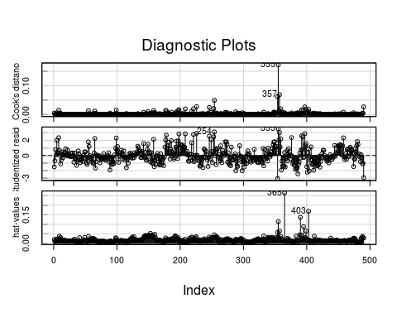

## Criar previsoes

b$medv_HAT=fitted.values(reg.mlt2) #Previsoes  
b$RES=residuals(reg.mlt2) #Resuduais das previsoes  
b$EP=b$RES/b$medv*100 #Erro percentual das previsoes

### Erro percentual

hist(b$EP, xlab = 'Erro Percentual (%)', main = '')

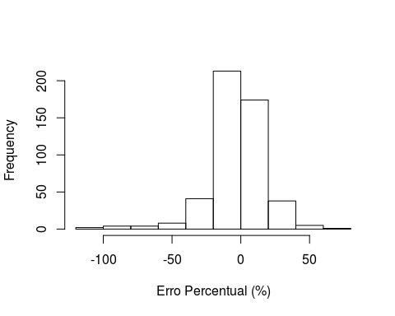

### Previsao e real

#plot(x = b$medv, y = b$medv_HAT, xlab = 'Preco Real', ylab = 'Previsao')  
  
p = ggplot(b) +  
 geom_point(aes(x = medv, y = medv_HAT,   
 name = id #rownames(b)  
 )) +  
 geom_smooth(method='lm',aes(x = medv, y = medv) )

## Warning: Ignoring unknown aesthetics: name

#ggplotly(p)  
p

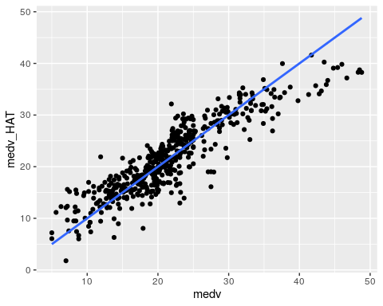

### Teste anova

anova(reg.mlt2)

## Analysis of Variance Table  
##   
## Response: medv  
## Df Sum Sq Mean Sq F value Pr(>F)   
## crim 1 6129.0 6129.0 502.3943 < 2.2e-16 ***  
## nox 1 4128.7 4128.7 338.4309 < 2.2e-16 ***  
## rm 1 8322.5 8322.5 682.2021 < 2.2e-16 ***  
## dis 1 171.9 171.9 14.0905 0.0001955 ***  
## rad 1 54.8 54.8 4.4911 0.0345843 *   
## tax 1 1038.3 1038.3 85.1134 < 2.2e-16 ***  
## ptratio 1 1767.8 1767.8 144.9093 < 2.2e-16 ***  
## lstat 1 2770.0 2770.0 227.0586 < 2.2e-16 ***  
## Residuals 481 5868.0 12.2   
## ---  
## Signif. codes: 0 '***' 0.001 '**' 0.01 '*' 0.05 '.' 0.1 ' ' 1

### Root mean sqared error

mean((b$medv - b$medv_HAT) ** 2) **0.5

## [1] 3.460554

## Fazer previsao

crim = 0.2651  
zn = 0.0  
indus = 9.69  
chas = 0.0  
nox = 0.5380  
rm = 6.208  
age = 77.50  
dis = log(3.207)  
rad = 5.0  
tax = 330  
ptratio = 19.05  
lstat = log(11.36)  
  
novo=data.frame(  
 crim = crim,  
 zn = zn,  
 indus = indus,  
 chas = chas,  
 nox = nox,  
 rm = rm,  
 age = age,  
 dis = dis,  
 rad = rad,  
 tax = tax,  
 ptratio = ptratio,  
 lstat = lstat  
 )  
lprice.hat=predict(reg.mlt2, novo)  
lprice.hat

## 1   
## 21.97985