Déploiement sur VPS
Config serveur
- sudo apt clean all && sudo apt update && sudo apt dist-upgrade :Cleaning and updating server
- sudo apt install nginx :install nginx
- sudo rm /etc/nginx/sites-available/default supprimer server configuration
- sudo rm /etc/nginx/sites-enabled/default supprimer server configuration
- sudo ln -s /etc/nginx/sites-available/configuration /etc/nginx/sites-enabled/configuration
- sudo nano /etc/nginx/sites-available/configuration
sudo cat /etc/nginx/sites-available/configuration
allow 80

# Back (Server / API)
server {
listen 80;
ssl_protocols TLSv1.2 TLSv1.3;
ssl_ciphers 'ECDHE-ECDSA-AES256-GCM-SHA384:ECDHE-RSA-AES256-GCM-SHA384:ECDHE-ECDSA-CHACHA20-POLY1305:ECDHE-RSA-CHACHA20-POLY1305:ECDHE-ECDSA-AES128-GCM-SHA256:ECDHE-RSA-AES128-GCM-SHA256';
ssl_prefer_server_ciphers on;
ssl_session_cache shared:SSL:10m;
ssl_session_timeout 10m;
location / {
# Simple requests
if ($request_method ~* "(GET|POST|PUT|DELETE)") {
add_header "Access-Control-Allow-Origin" "*" always;
}

# Preflighted requests
if ($request_method = "OPTIONS" ) {
add_header "Referrer-Policy" "origin";
add_header "Access-Control-Allow-Origin" "*";
add_header "Access-Control-Allow-Methods" "GET, POST, PUT, DELETE, OPTIONS, HEAD";

add_header 'Access-Control-Max-Age' 1728000;
add_header 'Content-Type' 'text/plain; charset=utf-8';
add_header 'Content-Length' 0;
add_header "Access-Control-Allow-Headers" "Authorization, Origin, X-Requested-With, Content-Type, Accept, x-access-token, id";

return 204;
}

include proxy_params;
client_max_body_size 200M;
proxy_pass http://localhost: 5057;
}
}
start "serve -s build -l 5052" --name cerebro
sudo certbot certificates
- sudo apt install git :install git
- sudo apt install nodejs
- sudo apt install npm
- sudo npm i -g pm2
(C:\USERS\MEDIKACOM\APPDATA\ROAMING\NPM\node_modules\pm2\index.js)
Cd /var/www/facture/server
pm2 start index.js --name cmdtest -i 4:pointer 3al fichier index server
- sudo pm2 startup ubuntu
- pm2 save
- sudo systemctl restart nginx
- sudo systemctl start nginx
Pm2
- pm2 status :status du serveur
- pm2 log :erreur du serveur
- pm2 restart app_name
- pm2 reload app_name
- pm2 stop app_name
- pm2 delete app_name
reboot
pm2 startup
sudo env PATH=$PATH:/usr/local/bin /usr/local/lib/node_modules/pm2/bin/pm2 startup systemd -u medica --hp /home/medica
pm2 save
pm2 status
Config git :

- git init
- git add .
- git commit -m "first commit"
- git branch -M main
- git remote add origin https://github.com/mayssalah/hh.git
- git push -u origin main
- pour ignorer files : git update-index --assume-unchanged <filename>
Git update :

- git add .
git commit -m "cicd"
git fetch
git pull
git push

Config git CICD:

- settings->actions->runner
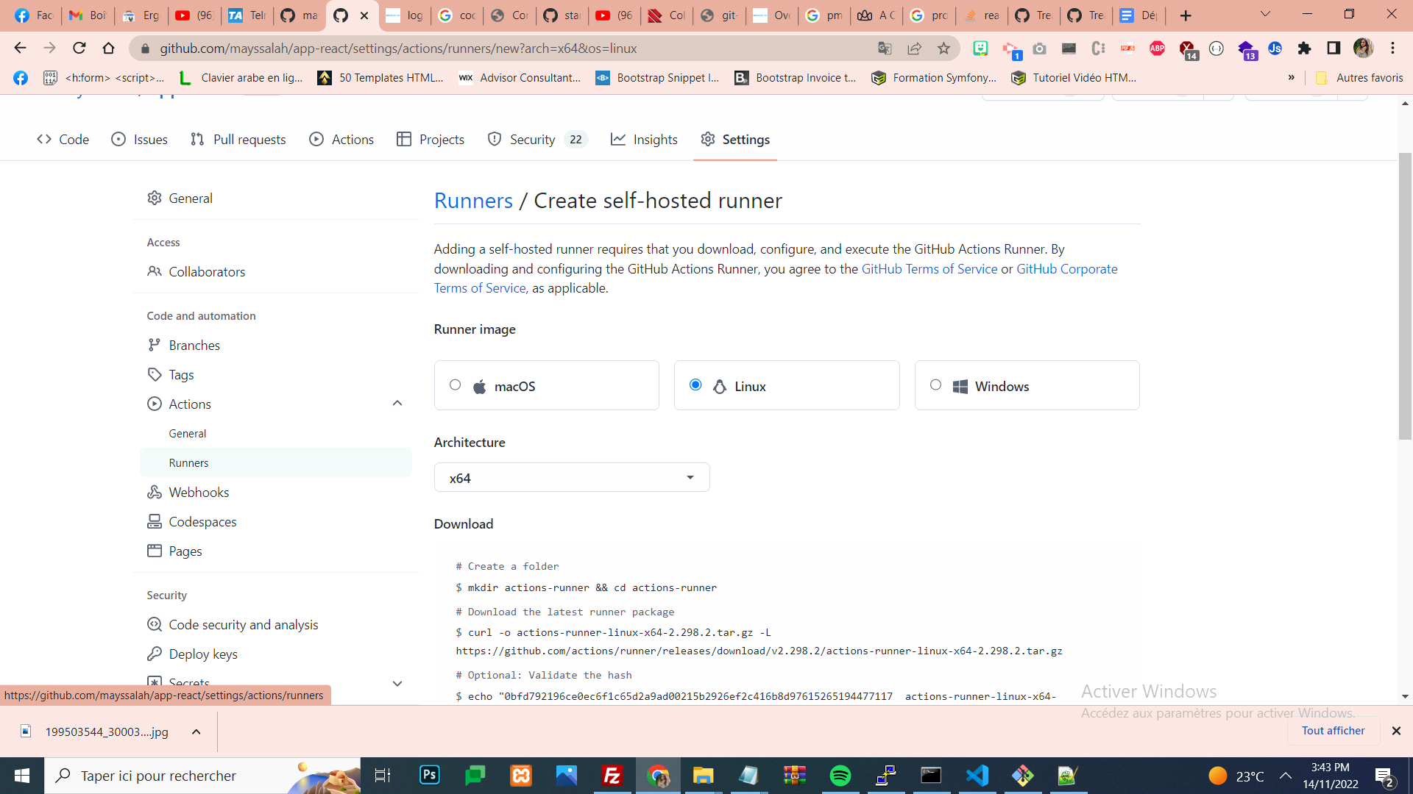
- Copier coller les commandes pour création du runner CICD
- sudo chmodd -R 777 /var/www/medis-cicd
- Puis créer un dossier .github/workflows sous votre projet
- Dans le dossier .github/workflows créer un fichier de type yml par exemple node.yml:
name: Node.js CI

on:
push:
branches: [ main ]
pull_request:
branches: [ main ]

jobs:
build:

runs-on: self-hosted

steps:
- uses: actions/checkout@v3
- name: Use Node.js ${{ matrix.node-version }}
uses: actions/setup-node@v3
with:
node-version: ${{ matrix.node-version }}
- run: |
cd server
npm i
cd ../client
npm i
CI=false
npm run build
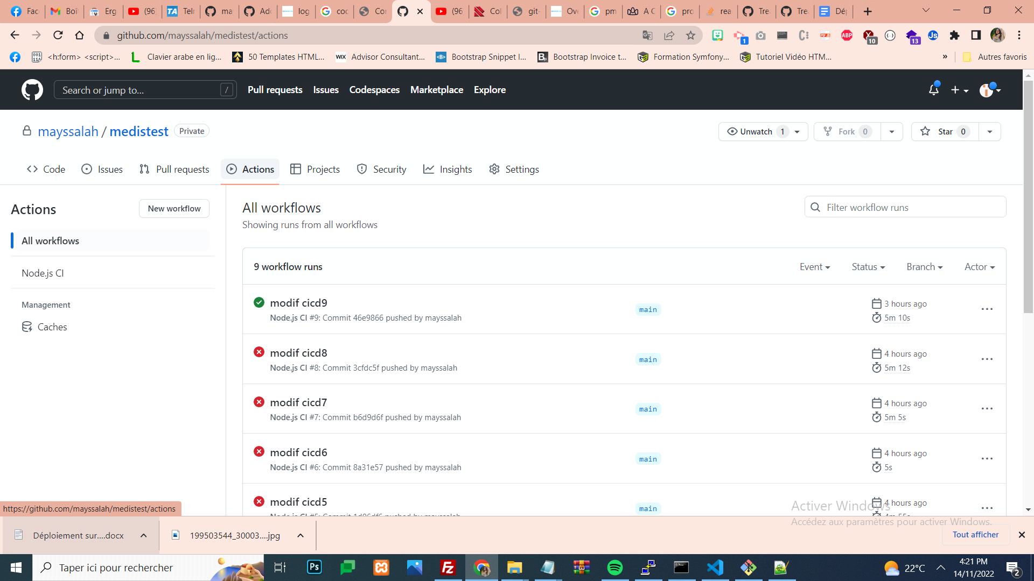

Référence :
- Auto Deploy React HYPERLINK "https://www.youtube.com/watch?v=6-RtA6FlbgQ"& HYPERLINK "https://www.youtube.com/watch?v=6-RtA6FlbgQ" Node.js with Github Actions CI/CD
- Learn How To Deploy a React App To a VPS | Ubuntu 20.04 Server With NGINX
- Deploy Node.js and React Apps | Full Deployment /w Nginx VPS, SSL
- https://github.com/safak/youtube/tree/mern-deployment

run app in background
npm install -g node-windows
cd path\to\your\app
npx winser -i
net start sessionnodejs
net stop sessionnodejs

run app python in background
"C:\Program Files\Python312\pythonw.exe" test.py

One of your dependencies, babel-preset-react-app, is importing the "@babel/plugin-proposal-private-property-in-object" package without declaring it in its dependencies. This is currently working because "@babel/plugin-proposal-private-property-in-object" is already in your node_modules folder for unrelated reasons, but it may break at any time. babel-preset-react-app is part of the create-react-app project, which is not maintianed anymore. It is thus unlikely that this bug will ever be fixed. Add "@babel/plugin-proposal-private-property-in-object" to your devDependencies to work around this error. This will make this message go away. Compiled with warnings.
npm install --save-dev @babel/plugin-proposal-private-property-in-object
# Remove existing Node.js and npm
sudo apt-get remove nodejs npm

# Install n (Node Version Manager)
sudo npm install -g n

# Install the latest stable version of Node.js
sudo n stable
hash -r

# Verify Node.js and npm versions
node -v
npm -v

# Navigate to your project directory
cd /var/www/commande/client

# Remove existing node_modules and package-lock.json
rm -rf node_modules package-lock.json

# Reinstall dependencies
npm install

# Run npm audit fix
npm audit fix

sudo apt-get remove nodejs npm
12 sudo npm install -g n
13 npm install --save-dev @babel/plugin-proposal-private-property-in-object
14 sudo apt install npm
15 sudo npm install -g n
16 sudo n stable

107 sf -h
108 df -h
109 cd /dev/roo
110 cd /dev
111 ls -l
112 dir
113 cd root
114 cd \
115 dir
116 pwd
117 cd \
118 cd ..
119 pwd
120 du -hs /var/www/html/* |sort -h |tail -5
121 du -hs /var/www/* |sort -h |tail -5
122 du -hs /var/www/blextraction/* |sort -h |tail -5
123 du -hs /var/www/blextraction/server* |sort -h |tail -5
124 du -hs /var/www/blextraction/server/* |sort -h |tail -5
125 du -hs /var/www/blextraction/* |sort -h |tail -5
126 du -hs /* |sort -h |tail -5
127 du -hs
128 du -hs /var/www//* |sort -h |tail -5
129 du -hs /var/www/* |sort -h |tail -5
130 du -hs /var/www/blextraction/* |sort -h |tail -5
131 du -hs /var/www/blextraction/sever/* |sort -h |tail -5
132 systemctl status
133 free
134 top
135 free
136 top
137 whoami
138 pwd
Pm2 in windows

npm install -g pm2-windows-service
pm2-service-install
? Perform environment setup? Yes
? Set PM2_HOME? (press Enter)
? PM2 service name? pm2
? Start PM2 service at startup? Yes
? Set PM2_SERVICE_SCRIPTS (the list of start-up scripts for pm2)? (Y/n) n
Set PM2_SERVICE_PM2_DIR (the location of the global pm2 to use with the service)? [recommended] (Y/n)Yes
? Specify the directory containing the pm2 version to be used by the service
(C:\USERS\MEDIKACOM\APPDATA\ROAMING\NPM\node_modules\pm2\index.js) ENTER

pm2 save
path C:\pm2
sudo apt install fail2ban
sudo apt install libnginx-mod-security
sudo nano /etc/nginx/nginx.conf
modsecurity on;
modsecurity_rules_file /etc/nginx/modsec/main.conf;
sudo mkdir -p /etc/nginx/modsec
cd /etc/nginx/modsec
sudo git clone https://github.com/coreruleset/coreruleset.git
sudo cp coreruleset/crs-setup.conf.example crs-setup.conf
sudo systemctl restart nginx
limit_req_zone $binary_remote_addr zone=api_limit:10m rate=10r/s;
server {
location /api/ {
limit_req zone=api_limit burst=20 nodelay;
proxy_pass http://localhost:4079;
}
}
if ($query_string ~* "union.*select.*\(") {
return 403;
}

Cloudflare (WAF)
↓
Nginx (rate limit)
↓
Node (validation + prepared queries)
↓
Database

sudo certbot renew --nginx
XkhUKigcy4Wlwq1TSzofULnThlJiUF6xFcx1U0iI
sudo journalctl -u llmback -f
udo fail2ban-client status sshd
Clean cache sudo sync; sudo sysctl -w vm.drop_caches=3
Free -h

