Amiga boot selector   
TTL version

# ► Description

This boot selector allows your Amiga 500, 1000, 2000 and 3000 to use external floppy drives / emulators as the internal drive DF0: by swapping the address lines for those drives.

Contrary to other selectors this one uses two TTL logic chips to switch the signals automatically, after all drives have been scanned once. It also supports switching the external drive if your Amiga has two internal ones.

The idea to realize the boot selector this way was brought up in the [www.a1k.org](http://www.a1k.org) community forum by Jens Schönfeld ([www.icomp.de](http://www.icomp.de) / [www.c64.de](http://www.c64.de)). User ‘o.eschi’ from a1k.org created a first PCB layout for Jens’ schematics and handed them over to me (Marko Oette). User ‘e5frog’ from Commodore Amiga Group on Facebook did some nice changes to optimize the board layout.

I did some changes to it to be able to use it in an A1000 and A2000/3000 as well. User ‘Skylight’ from a1k.org helped developing the A1000 combability.

# ► License

The boot selectors circuit diagram, the PCB layout and the documentation are open source. They are licensed under the GPL v. 2 license. See <https://www.gnu.org/licenses/old-licenses/gpl-2.0.en.html> to read the license.

In short:

You can use this in your free or commercial products. If you do modify it, you must open source / publish your changes as well. Please keep the license and credit of the original authors.

EVERYTHING HERE IS PROVIDED "AS IS" WITHOUT WARRANTY OF ANY KIND, EITHER EXPRESSED OR IMPLIED, INCLUDING, BUT NOT LIMITED TO, THE IMPLIED WARRANTIES OF MERCHANTABILITY AND FITNESS FOR A PARTICULAR PURPOSE. THE ENTIRE RISK AS TO THE QUALITY AND PERFORMANCE OF THE ITEM IS WITH YOU. SHOULD THE ITEM PROVE DEFECTIVE, YOU ASSUME THE COST OF ALL NECESSARY SERVICING, REPAIR OR CORRECTION.

# ► Usage

The boot selector has a 2 pin “DISABLE” jumper. If it is open the selected drives will be swapped.

Close it, to disable swapping.

You can connect a switch and a wire to the pin header as well. Do your Amiga a favor and don’t drill any holes in the case. There are more intelligent ways to solve that problem. See last page. 😉

# ► Configuration

Before installing the boot selector, you will have to check / modify the solder jumpers on the bottom of the boot selector. They are used to ‘configure’ the device to work in several Amiga models.

* SJ2 is /SEL2
* SJ1 is /SEL1
* SJX is /NEWSELX and /SELX

## Amiga 500 / 2000 (one internal drive) / 3000 (one internal drive)

The Amiga 500/2000/3000 has one internal (DF0:) and 1-3 external drives (DF1, DF2, DF3).

Usually you will be swapping DF0: with DF1:. The trigger to do so is /SEL3.

*Picture: Selector configured for A500 operation.*

SEL0|SEL3

SJ2 SJX SJ1

Trigger

## Amiga 1000

The Amiga 1000 has one internal (DF0:) and 1-3 external drives (DF1, DF2, DF3).

Usually you will be swapping DF0: with DF1:. The trigger to do so is /SEL0. Using /SEL0 as a trigger you will be able to load the Kickstart to the WOM using the external drive as well.

*Please be aware, that this only works in Amiga 1000 Models with Kickstart <= 1.3!  
If you run Kickstart >1.3 you can use /SEL3 as the trigger (like in an A500) but then the Kickstart will always be loaded from internal drive.*

*Picture: Selector configured for A1000 operation.*

SEL0|SEL3

SJ2 SJX SJ1

Trigger

## Amiga 2000 / 3000 (two internal drives)

The Amiga 2000/3000 has two internal (DF0:, DF1:) and 1-2 external drives (DF2, DF3).

Usually you will be swapping DF0: with DF2:. The trigger to do so is /SEL3.

*Picture: Selector configured for two internal drives operation.*

SEL0|SEL3

SJ2 SJX SJ1

Trigger

# ► Installation

The boot selector sits between the original ‘Even CIA’ (A2000: U301, A500: U8) and the main board. You will have to install it in the Even CIA’s socket. The CIA Chip goes into the boot selector.

Step 1: Remove the CIA chip from its socket.

If you don’t have a DIP puller by hand (who does?) use a flat screw driver to leverage the CIA chip. Only lift it a few mm on each side. Repeat the step until the chip lifts off the socket.

If some of the PINs got bend please carefully bend them back to the normal position. Ensure that they are straight and in a 90 degree angle to the chip.

*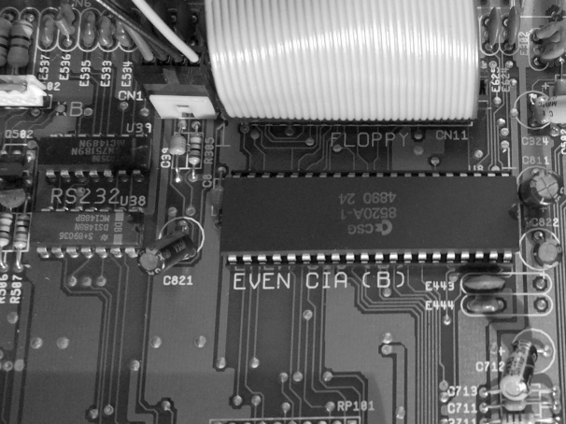  
Picture 1: Even CIA in an Amiga 500*

*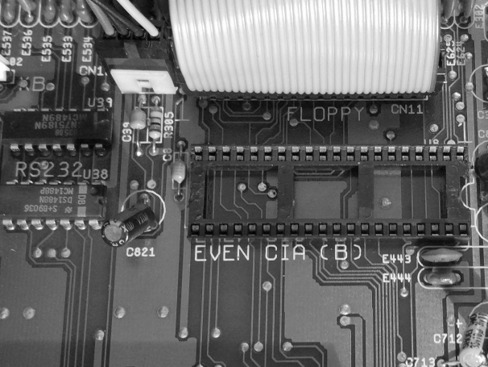  
Picture 2: CIA removed, empty socket*

Step 2: Install the CIA chip into the boot selector.

Place the boot selector on a flat surface (eg. a table). Pins facing down, ICs and CIA socket facing up. Put some sheets of paper or any other padding under the pins. (If you don’t you’ll have 40 small holes in your table!! So listen to me.)

Place the CIA on the socket (mark on the chip goes to the opposite of the ENABLE jumper!) and check that all pins are correctly aligned. If so, firmly press the CIA into the socket.

Check that all pins are sitting in the socket. If not, remove the CIA again and repeat until everything is OK. You will only have 2-3 tries until the pins of the CIA break!

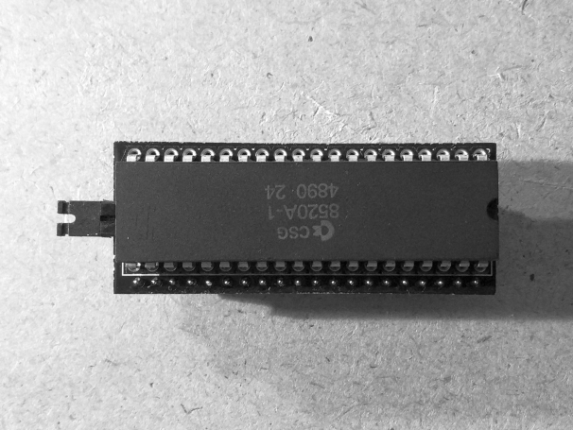  
*Picture 3: CIA installed in the boot selector*

Step 3: Install the boot selector in the CIA Socket of the Amiga Motherboard.

Place the boot selector on the empty CIA socket. The ENABLE jumper points away from the mark on the socket. The mark on the CIA chip points to the mark on the socket.

Firmly press the boot selector down into the socket. It will go in approx. 4mm. You should not be able to lift it up easily anymore. If so: all done!

*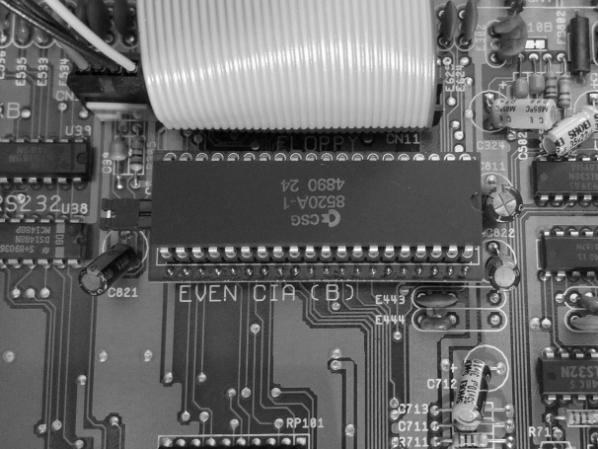  
Picture 4a: Boot selector installed in the Amiga 500.*

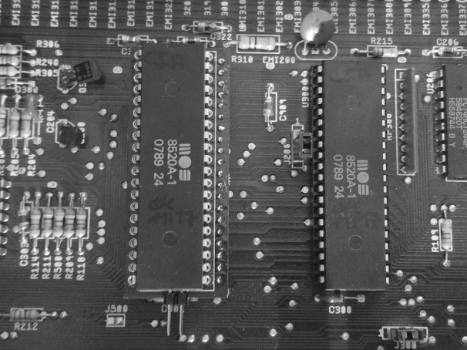

*Picture 4b: Boot selector installed in the Amiga 2000.*

# ► Building the boot selector

The boot selector comes as DIY kit. You need some basic soldering skills, a soldering iron (380-400°C) and solder wire. Building time is 10 minutes.

Helpful is an empty 40 PIN DIP socket.

## Components

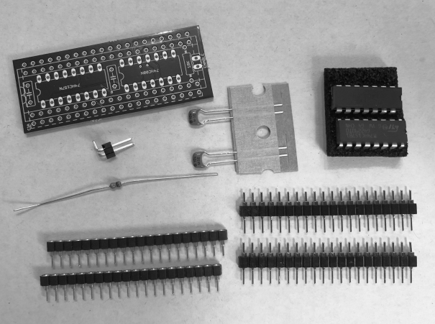Required components:

* The board (PCB)
* 2x 20 pin header for connecting to the CIA socket on the motherboard of the Amiga
* 2x 20 pin socket for mounting the CIA chip
* 2x 100nF ceramic capacitor
* 1x 10K Ohms resistor
* 1x 74HC00N TTL IC
* 1x 74HC157N TTL IC
* 1x 2-PIN Head (90 degree), the   
  DISABLE jumper/switch

## Building it up

Step 1: Place the PCB facing with the bottom side towards you. If you can read the text on the PCB you did it right.

Put the 2x 20 PIN headers in the drills. There is a dashed rectangle marking them.

*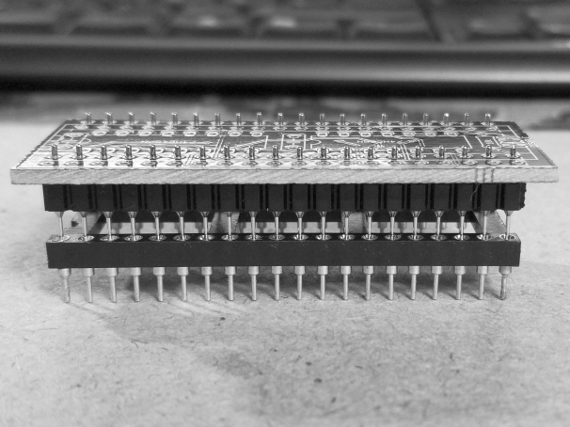  
Picture 5: Pin headers in the correct position, using a DIP40 socket to keep them aligned.*

Rotate the PCB by 180° so that the top is now facing to you. Align the pin headers. They need to be aligned perpendicular to the PCB. If you have a 40-PIN DIP socket available you can use it to align the two pin headers. If not – you need to do it manually.

Keep the pin headers aligned and solder one pin in the middle of each header. – Now check that the heads are aligned correctly. They must fit into the empty socket. If they don’t, heat the solder and realign the header.

If they are aligned correctly – solder the remaining pins. Please keep the soldering iron on each pin for at least 2 seconds so the solder flows into the drills.

Step 2: Place the two 20 pin sockets in the remaining drills. There is a dashed rectangle marking them. Rotate the PCB, align them properly and solder them like in “Step 1”.

*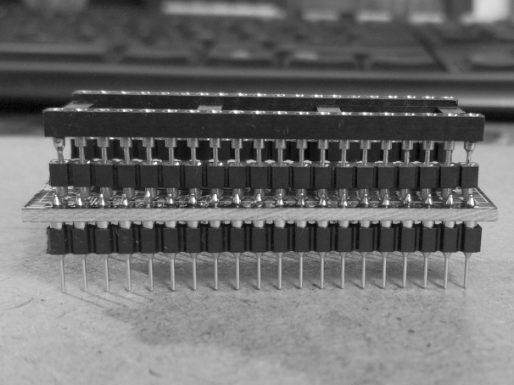  
Picture 6: Socket headers aligned and soldered, a DIP40 socket holding them in place*

Step 3: Rotate the board again, so the Front is facing to you. Place the two TTL ICs in their correct location, the ICs have labels and the mounting spaces are labeled as well. Watch for correct orientation. The ICs have marks that must match the mark on the silkscreen of the PCB. Rotate the PCB again and solder the ICs.

*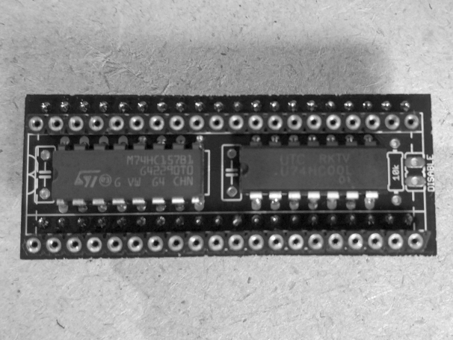  
Picture 7: ICs soldered*

Step 4: Solder the two capacitors, the resistor and the 2-pin jumper header. All go to the top of the PCB. The direction you solder them does not matter. The jumper should face away from the PCB. (Other way would not fit at all…)

*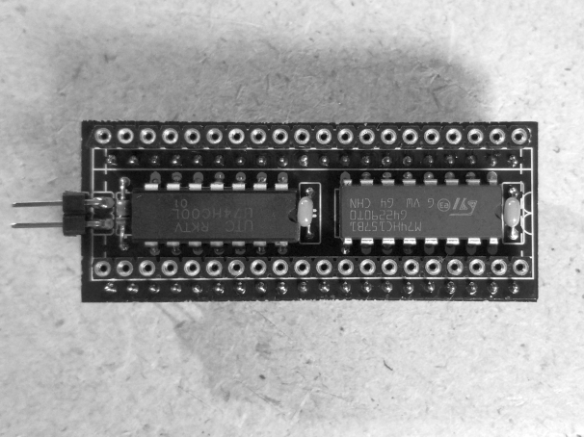  
Picture 8: Capacitors, resistor and jumper soldered*

Step 5: Configure the solder jumpers on the bottom according to the plan in chapter “Configuration”.

# ► Using the mouse button to disable the selector

One way to control the selector is to connect a jumper wire from ODD-CIA’s PIN8 (/FIRE0) to the left PIN of the DISABLE jumper.

That way the selector is on by default and DISABLED when the mouse button is pressed on Power-on / Reset.

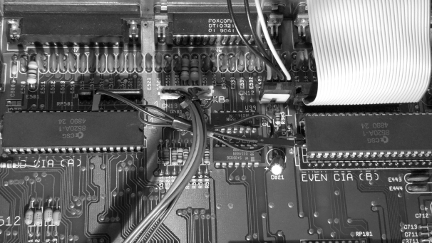  
*Picture 9: Jumper wire connected to enable mouse control*