# Department of Computing

**Course Code: CS332**

**Class: BSCS 10ABC**

**Lab 02: Client Server Communication**

**CLO4: Develop Distributed Applications/Systems**

**Date: February 13, 2023 and February 17, 2023**

# Instructors: Dr. Khurram Shahzad, Dr. Shah Khalid

# Lab 02: Client Server Communication

**Introduction**

This lab focuses on the concepts of client server communication.

**Objectives**

To understand the concepts and implement client server communication..

**Tools/Software Requirement**

MS Visual Studio 2013

**Description**

By using simple network applications, we can send files or messages over the internet. A socket is an object that symbolize a low-level connection point to the IP stack. This socket can be opened or closed or one of a set amount of intermediate states. A socket can deliver and receive data down this connection. Files is generally sent in blocks of a few kilobytes at a time for effectiveness; each of these blocks is named as a packet. Here are the list of well-known port numbers which usually used.

* Port 20, FTP Data
* Port 21, FTP Control
* Port 25, SMTP (email and outgoing)
* Port 53, DNS
* Port 80, HTTP (Web)

In this lab, we will explore the client server programming model in C#, however you are free to choose any language for the lab task.

**Consider Simple Client and SERVER programs in C#**

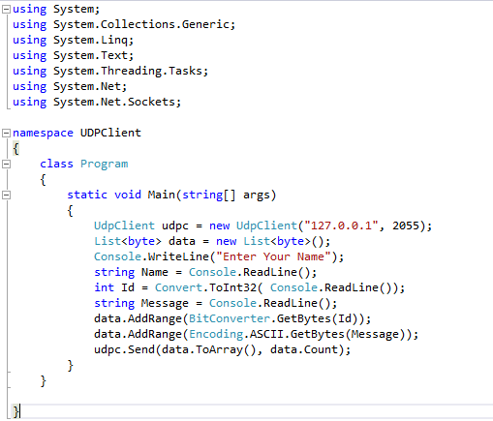

Figure : CLIENT CODE

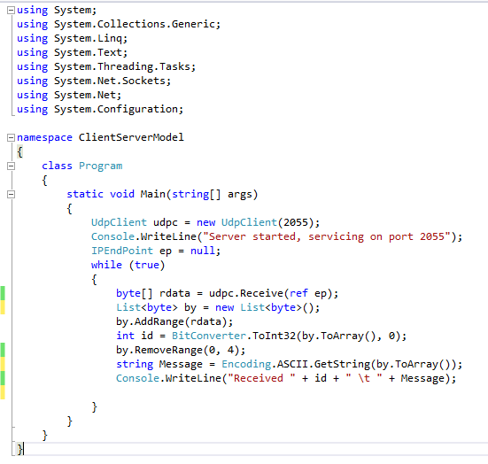

Figure : SERVER CODE

**Lab Tasks**

1. Your task is to use the above mentioned program and convert it to group chat using event publish/subscribe architecture as discussed in class. Write a middleware that act as a chat group. Users can join and leave that group. Middleware broadcast the received messages to all the connected users.
2. Add another feature in this middleware which is based on unicast i.e. message send to particular user will not be received by all other users in the group. For this you can assume the user ID of all users is well-known or middleware can provide you that. Moreover, all the communication must be go through the middleware.

**Deliverables**

Upload the project code files on LMS.