Name: SUN RUI

Student ID: 18083229g

**Answer 1:**

a)

sort the column Age: [17, 18, 18, 22, 22, 27, 29, 34, 35, 38, 39, 39, 46, 54, 59]

sort the column Monthly Income: [3000, 4000, 7500, 7800, 7800, 7900, 8500, 14000, 18000, 21000, 24700, 30000, 31000, 31110, 40500]

sort the column Service Plan: [100, 100, 100, 200, 200, 400, 600, 600, 600, 600, 800, 1000, 1600, 1600, 1600]

sort the column Extra Usage: [0, 0, 0, 7, 25, 31, 31, 50, 54, 64, 211, 254, 290, 303, 311]

Equal-width:

Age: (59-17)/3=14 → a=[17, 31), b=[31, 45), c=[45, 59]

Monthly Income: (40500-3000)/3=12500 → x=[3000, 15500), y=[15500, 28000), z=[28000, 40500]

Service Plan: (1600-100)/3=500 → A=[100, 600), B=[600, 1100), C=[1100, 1600]

Extra Usage: (311-0)/3=103.67 →X=[0, 103.67), Y=[103.67, 207.34), Z=[207.34, 311.01]

Change the data into below table according to above ranges:

|  |  |  |  |  |  |  |
| --- | --- | --- | --- | --- | --- | --- |
| **(0)** | **(i)** | **(ii)** | **(iii)** | **(iv)** | **(v)** | **(vi)** |
| **Ref** | **Age** | **Sex** | **Monthly Income** | **Marital**  **Status** | **Service**  **Plan** | **Extra**  **Usage** |
| 1 | 54 c | FEMALE | 3000 x | YES | 100 A | 0 X |
| 2 | 59 c | FEMALE | 4000 x | NO | 600 B | 54 X |
| 3 | 38 b | MALE | 7800 x | NO | 200 A | 31 X |
| 4 | 18 a | FEMALE | 8500 x | NO | 600 B | 311 Z |
| 5 | 27 a | MALE | 14000 x | YES | 100 A | 211 Z |
| 6 | 29 a | FEMALE | 31000 z | YES | 1600 C | 25 X |
| 7 | 17 a | MALE | 7500 x | NO | 600 B | 254 Z |
| 8 | 22 a | FEMALE | 7900 x | NO | 200 A | 31 X |
| 9 | 34 b | MALE | 24700 y | NO | 100 A | 7 X |
| 10 | 46 c | FEMALE | 31110 z | YES | 600 B | 0 X |
| 11 | 39 b | FEMALE | 21000 y | YES | 800 B | 64 X |
| 12 | 35 b | FEMALE | 30000 z | NO | 1600 C | 0 X |
| 13 | 39 b | MALE | 40500 z | YES | 1600 C | 50 X |
| 14 | 18 a | MALE | 7800 x | NO | 1000 C | 290 Z |
| 15 | 22 a | MALE | 18000 y | YES | 400 A | 303 Z |

initial cluster centers：

|  |  |  |  |  |  |  |
| --- | --- | --- | --- | --- | --- | --- |
|  | Locus | | | | | |
| **Ref** | **Age** | **Sex** | **Monthly Income** | **Marital**  **Status** | **Service**  **Plan** | **Extra**  **Usage** |
| **1**(1) | 54 c | FEMALE | 3000 x | YES | 100 A | 0 X |
| **2**(8) | 22 a | FEMALE | 7900 x | NO | 200 A | 31 X |
| **3**(15) | 22 a | MALE | 18000 y | YES | 400 A | 303 Z |

cluster distances of first step:

|  |  |  |  |  |  |  |  |  |  |
| --- | --- | --- | --- | --- | --- | --- | --- | --- | --- |
| **(0)** | **(i)** | **(ii)** | **(iii)** | **(iv)** | **(v)** | **(vi)** | **distance** | | |
| **Ref** | **Age** | **Sex** | **Monthly Income** | **Marital**  **Status** | **Service**  **Plan** | **Extra**  **Usage** | **1** | **2** | **3** |
| 1 | 54 c | FEMALE | 3000 x | YES | 100 A | 0 X | **0** | 2 | 4 |
| 2 | 59 c | FEMALE | 4000 x | NO | 600 B | 54 X | **2** | 2 | 6 |
| 3 | 38 b | MALE | 7800 x | NO | 200 A | 31 X | 3 | **2** | 4 |
| 4 | 18 a | FEMALE | 8500 x | NO | 600 B | 311 Z | 4 | **2** | 4 |
| 5 | 27 a | MALE | 14000 x | YES | 100 A | 211 Z | 3 | 3 | **1** |
| 6 | 29 a | FEMALE | 31000 z | YES | 1600 C | 25 X | **3** | 3 | 4 |
| 7 | 17 a | MALE | 7500 x | NO | 600 B | 254 Z | 5 | **3** | 3 |
| 8 | 22 a | FEMALE | 7900 x | NO | 200 A | 31 X | 2 | **0** | 4 |
| 9 | 34 b | MALE | 24700 y | NO | 100 A | 7 X | 4 | **3** | 3 |
| 10 | 46 c | FEMALE | 31110 z | YES | 600 B | 0 X | **2** | 4 | 5 |
| 11 | 39 b | FEMALE | 21000 y | YES | 800 B | 64 X | **3** | 4 | 4 |
| 12 | 35 b | FEMALE | 30000 z | NO | 1600 C | 0 X | 4 | **3** | 6 |
| 13 | 39 b | MALE | 40500 z | YES | 1600 C | 50 X | **4** | 5 | 4 |
| 14 | 18 a | MALE | 7800 x | NO | 1000 C | 290 Z | 5 | **3** | 3 |
| 15 | 22 a | MALE | 18000 y | YES | 400 A | 303 Z | 4 | 4 | **0** |

update cluster centers:

|  |  |  |  |  |  |  |
| --- | --- | --- | --- | --- | --- | --- |
|  | Locus | | | | | |
| **Ref** | **Age** | **Sex** | **Monthly Income** | **Marital**  **Status** | **Service**  **Plan** | **Extra**  **Usage** |
| **1**(1) | 54 c | FEMALE | **z** | YES | **B** | 0 X |
| **2**(8) | 22 a | **MALE** | 7900 x | NO | 200 A | 31 X |
| **3**(15) | 22 a | MALE | 18000 y | YES | 400 A | 303 Z |

Equal-depth:

Age: a={17,18,18,22,22}, b={27,29,34,35,38}, c={39,39,46,54,59}

Monthly Income: x={3000,4000,7500,7800,7800}, y={7900,8500,14000,18000,21000}, z={24700,30000,31000,31110,40500}

Service Plan: A={100,100,100,200,200}, B={400,600,600,600,600}, C={800,1000,1600,1600,1600}

Extra Usage: X={0,0,0,7,25}, Y={31,31,50,54,64}, Z={211,254,290,303,311}

Change the data into below table according to above rules:

|  |  |  |  |  |  |  |
| --- | --- | --- | --- | --- | --- | --- |
| **(0)** | **(i)** | **(ii)** | **(iii)** | **(iv)** | **(v)** | **(vi)** |
| **Ref** | **Age** | **Sex** | **Monthly Income** | **Marital**  **Status** | **Service**  **Plan** | **Extra**  **Usage** |
| 1 | 54 c | FEMALE | 3000 x | YES | 100 A | 0 X |
| 2 | 59 c | FEMALE | 4000 x | NO | 600 B | 54 Y |
| 3 | 38 b | MALE | 7800 x | NO | 200 A | 31 Y |
| 4 | 18 a | FEMALE | 8500 y | NO | 600 B | 311 Z |
| 5 | 27 b | MALE | 14000 y | YES | 100 A | 211 Z |
| 6 | 29 b | FEMALE | 31000 z | YES | 1600 C | 25 X |
| 7 | 17 a | MALE | 7500 x | NO | 600 B | 254 Z |
| 8 | 22 a | FEMALE | 7900 y | NO | 200 A | 31 Y |
| 9 | 34 b | MALE | 24700 z | NO | 100 A | 7 X |
| 10 | 46 c | FEMALE | 31110 z | YES | 600 B | 0 X |
| 11 | 39 c | FEMALE | 21000 y | YES | 800 C | 64 Y |
| 12 | 35 b | FEMALE | 30000 z | NO | 1600 C | 0 X |
| 13 | 39 c | MALE | 40500 z | YES | 1600 C | 50 Y |
| 14 | 18 a | MALE | 7800 x | NO | 1000 C | 290 Z |
| 15 | 22 a | MALE | 18000 y | YES | 400 B | 303 Z |

|  |  |  |  |  |  |  |
| --- | --- | --- | --- | --- | --- | --- |
|  | Locus | | | | | |
| **Ref** | **Age** | **Sex** | **Monthly Income** | **Marital**  **Status** | **Service**  **Plan** | **Extra**  **Usage** |
| **1**(1) | 54 c | FEMALE | 3000 x | YES | 100 A | 0 X |
| **2**(8) | 22 a | FEMALE | 7900 y | NO | 200 A | 31 Y |
| **3**(15) | 22 a | MALE | 18000 y | YES | 400 B | 303 Z |

initial cluster centers：

cluster distances of first step:

|  |  |  |  |  |  |  |  |  |  |
| --- | --- | --- | --- | --- | --- | --- | --- | --- | --- |
| **(0)** | **(i)** | **(ii)** | **(iii)** | **(iv)** | **(v)** | **(vi)** | **distance** | | |
| **Ref** | **Age** | **Sex** | **Monthly Income** | **Marital**  **Status** | **Service**  **Plan** | **Extra**  **Usage** | **1** | **2** | **3** |
| 1 | 54 c | FEMALE | 3000 x | YES | 100 A | 0 X | **0** | 4 | 5 |
| 2 | 59 c | FEMALE | 4000 x | NO | 600 B | 54 Y | **3** | 3 | 5 |
| 3 | 38 b | MALE | 7800 x | NO | 200 A | 31 Y | 4 | **3** | 5 |
| 4 | 18 a | FEMALE | 8500 y | NO | 600 B | 311 Z | 5 | **2** | 2 |
| 5 | 27 b | MALE | 14000 y | YES | 100 A | 211 Z | 4 | 4 | **2** |
| 6 | 29 b | FEMALE | 31000 z | YES | 1600 C | 25 X | **3** | 5 | 5 |
| 7 | 17 a | MALE | 7500 x | NO | 600 B | 254 Z | 5 | 4 | **2** |
| 8 | 22 a | FEMALE | 7900 y | NO | 200 A | 31 Y | 4 | **0** | 4 |
| 9 | 34 b | MALE | 24700 z | NO | 100 A | 7 X | **4** | 4 | 5 |
| 10 | 46 c | FEMALE | 31110 z | YES | 600 B | 0 X | **2** | 5 | 4 |
| 11 | 39 c | FEMALE | 21000 y | YES | 800 C | 64 Y | **3** | 3 | 4 |
| 12 | 35 b | FEMALE | 30000 z | NO | 1600 C | 0 X | **4** | 4 | 6 |
| 13 | 39 c | MALE | 40500 z | YES | 1600 C | 50 Y | **4** | 5 | 4 |
| 14 | 18 a | MALE | 7800 x | NO | 1000 C | 290 Z | 5 | 4 | **3** |
| 15 | 22 a | MALE | 18000 y | YES | 400 B | 303 Z | 5 | 4 | **0** |

Update cluster centers:

|  |  |  |  |  |  |  |
| --- | --- | --- | --- | --- | --- | --- |
|  | Locus | | | | | |
| **Ref** | **Age** | **Sex** | **Monthly Income** | **Marital**  **Status** | **Service**  **Plan** | **Extra**  **Usage** |
| **1**(1) | 54 c | FEMALE | **z** | YES | **C** | 0 X |
| **2**(8) | 22 a | FEMALE | 7900 y | NO | 200 A | 31 Y |
| **3**(15) | 22 a | MALE | 18000 y | YES | 400 B | 303 Z |

b)

the clustering result of k-means by Python with package sklearn (**initial centers are 1, 8 and 15**):

samples of 1, 2, 10, 11 are cluster 1

samples of 3, 4, 6, 8, 9, 12 are cluster 2

samples of 5, 7, 13, 14, 15 are cluster 3

the program:

*# -*- encoding:utf-8 -*-  
  
# Name: SUN RUI ID:18083229g*import pandas as pd  
import numpy as np  
from sklearn import preprocessing  
from sklearn.cluster import KMeans  
  
  
def load_data(file_path):  
 df_data = pd.read_csv(file_path)  
 df_data.columns = ["Age", "Sex", "MonthlyIncome", "MaritalStatus", "ServicePlan", "ExtraUsage"]  
 scaled_data = preprocessing.scale(df_data)  
 return scaled_data  
  
def do_k_means(data):  
 centers = np.vstack((data[0], data[7], data[14]))  
 k_means = KMeans(n_clusters=3, init=centers, n_init=1, max_iter=1000)  
 return k_means.fit_predict(data), k_means.fit(data).cluster_centers_  
  
def print_clusters(cluster_index):  
 cluster_dict = {0:[],1:[],2:[]}  
 for i in range(len(cluster_index)):  
 cluster_dict[cluster_index[i]].append(i+1)  
 print("cluster result: {}".format(cluster_dict))  
  
if __name__ == '__main__':  
 df_scaled_data = load_data("data.csv")  
 cluster_index, cluster_center = do_k_means(df_scaled_data)  
 print("cluster index: {}".format(cluster_index))  
 print_clusters(cluster_index)  
 print("cluster centers:\n{}".format(cluster_center))

c）

to compare the performances between k-means and k-modes, I plan to use scatter picture to show the differences. Because the data has six attributes, I have to reduce dimensions from 6 to 2 or from 6 to 3 by PCA, so the information of origin data will be lossy and the results are a little different from part b). Let us see the results of k-means firstly: (**the code “*ref1*” is at the end of this assignment**)

The cluster result: (**initial centers are 1, 8 and 15**)

samples of 6, 10, 11, 12, 13 are cluster 1

samples of 1, 2, 3, 8, 9 are cluster 2

samples of 4, 5, 7, 14, 15 are cluster 3

the scatter pictures of k-means:

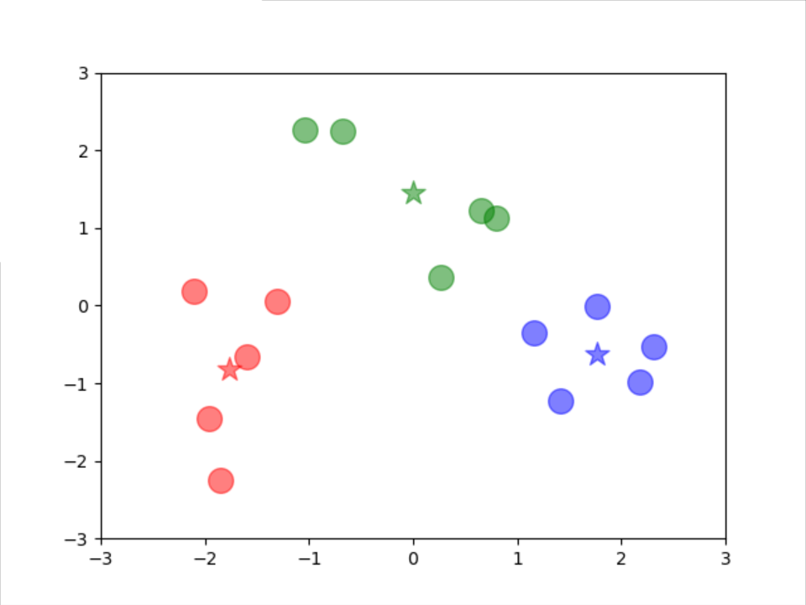 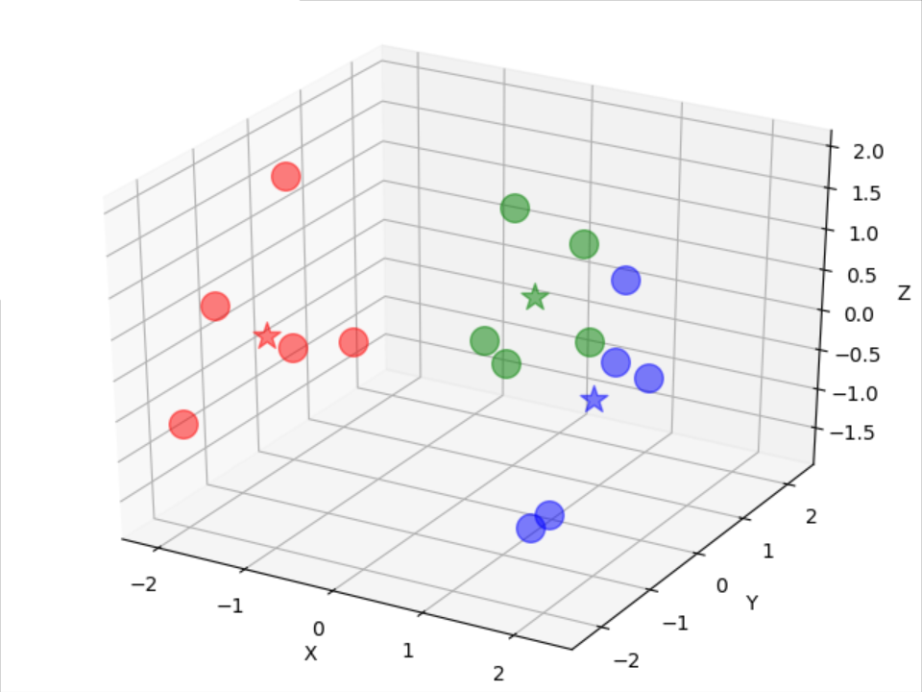

Let us see the results of k-modes: (**initial centers are 1, 8 and 15, the code “*ref2*” is at the end of this assignment**)

① Equal-width without reducing dimension:

samples of 1, 2, 6, 10, 11, 12, 13 are cluster 1

samples of 3, 4, 7, 8, 9, 14 are cluster 2

samples of 5, 15 are cluster 3

The result of cluster seems not good, because the cluster 3 only includes 2 samples.

reducing dimension:

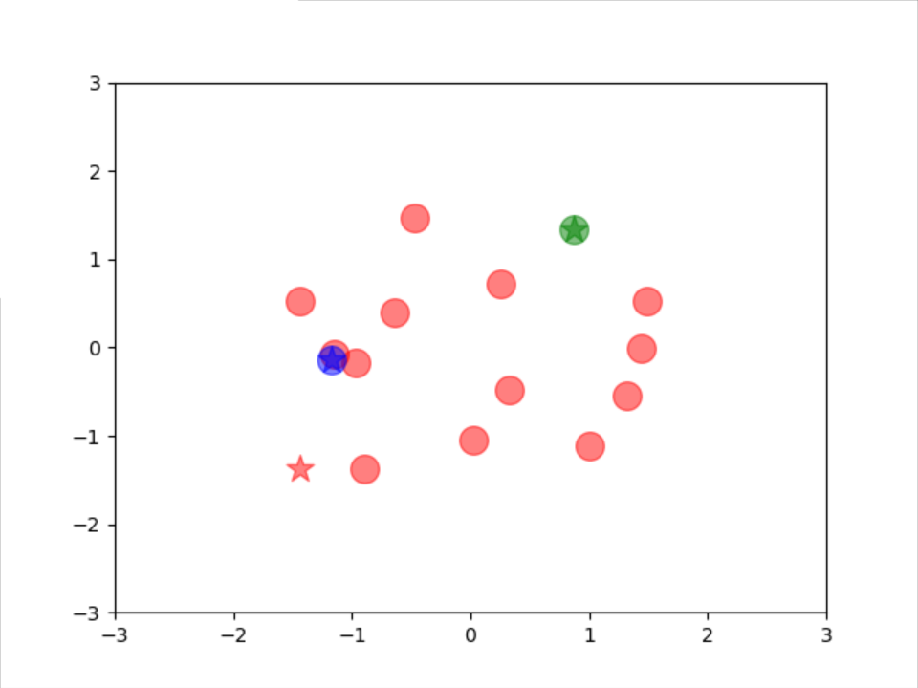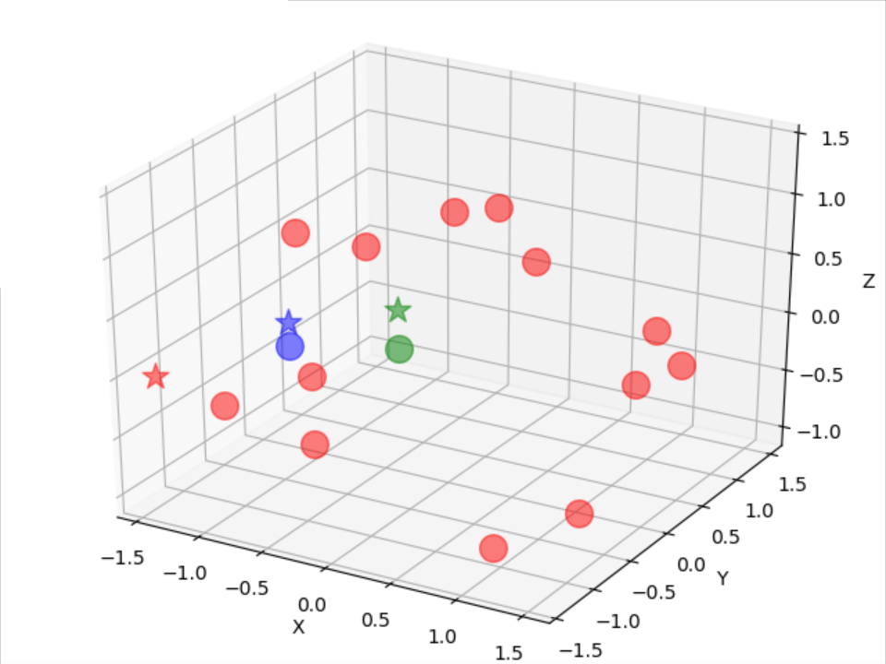

The clusters are different between 2-dimensions and 3-dimensions:

2-dimension: 0: [1, 2, 3, 5, 6, 7, 8, 9, 10, 12, 13, 14, 15], 1: [4], 2: [11]

3-dimension: 0: [2, 3, 4, 5, 6, 7, 8, 9, 10, 12, 13, 14, 15], 1: [1], 2: [11]

In conclusion, the result of k-modes of Equal-width is terrible.

② Equal-depth without reducing dimension:

samples of 1, 6, 10, 11, 12, 13 are cluster 1

samples of 2, 3, 4, 8 are cluster 2

samples of 5, 7, 9, 14, 15 are cluster 3

The result of cluster seems not bad, every cluster has about average number of samples.

reducing dimension:

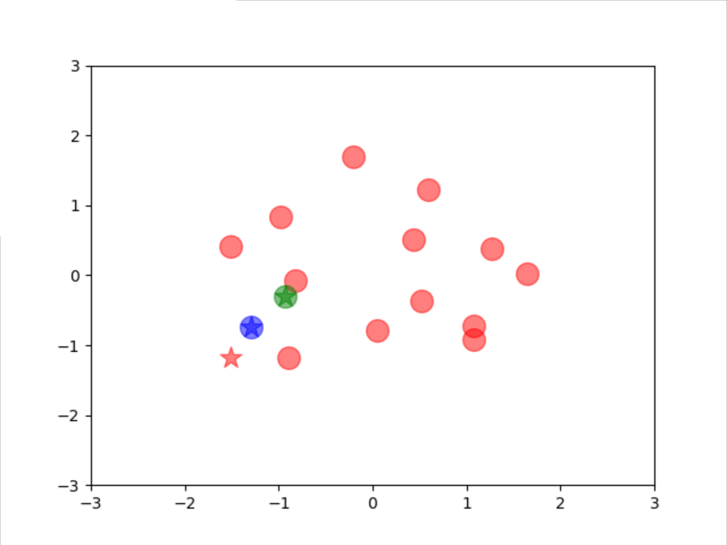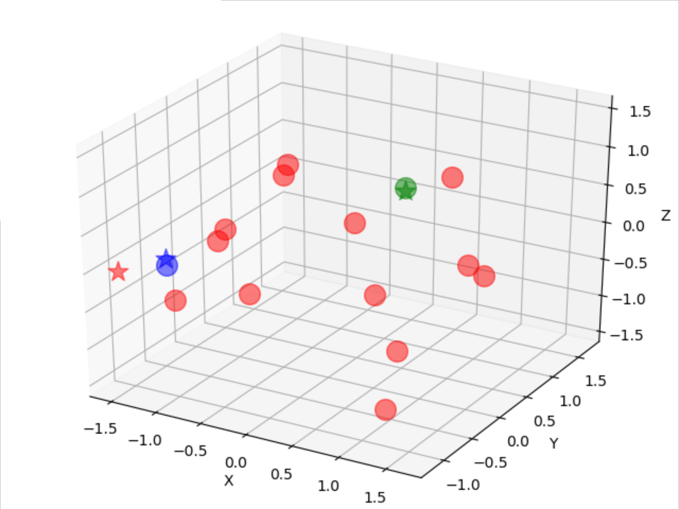

The clusters are different between 2-dimensions and 3-dimensions:

2-dimension: 0: [2, 3, 4, 5, 6, 7, 8, 9, 11, 12, 13, 14, 15], 1: [1], 2: [10]

3-dimension: 0: [1, 2, 3, 4, 5, 6, 7, 8, 11, 12, 13, 14, 15], 1: [9], 2: [10]

In conclusion, the result of k-modes of Equal-depth is also not good.

Draw a conclusion about part c), the k-means algorithm has better performance before and after reducing dimensions than k-modes algorithm. But the data must be done normalized.

The performance of equal-depth is better than equal-width before reducing dimension. However, these two ways will loss information after reducing dimension seriously.

**Answer 2:**

a)

Breadth First Search:

2

2

2

0

0

1

1

1

1

1

1

4

3

3

3

3

2

2

2

2

2

2

0

0

1

1

1

1

1

1

Result: ABCDFEGHJK

b)

The total number of shortest paths between every node:

|  |  |  |  |  |  |  |  |  |
| --- | --- | --- | --- | --- | --- | --- | --- | --- |
| σAB=1 | σAC=1 | σAD=1 | σAE=1 | σAF=1 | σAG=1 | σAH=1 | σAJ=2 | σAK=3 |
| σBC=1 | σBD=1 | σBE=1 | σBF=1 | σBG=3 | σBH=1 | σBJ=1 | σBK=2 |  |
| σCD=1 | σCE=1 | σCF=2 | σCG=1 | σCH=3 | σCJ=1 | σCK=1 |  |  |
| σDE=1 | σDF=1 | σDG=1 | σDH=2 | σDJ=1 | σDK=1 |  |  |  |
| σEF=1 | σEG=1 | σEH=1 | σEJ=2 | σEK=3 |  |  |  |  |
| σFG=2 | σFH=1 | σFJ=1 | σFK=2 |  |  |  |  |  |
| σGH=1 | σGJ=1 | σGK=1 |  |  |  |  |  |  |
| σHJ=1 | σHK=1 |  |  |  |  |  |  |  |
| σJK=1 |  |  |  |  |  |  |  |  |

The number of shortest paths of above table that pass along with every pair of neighbor node:

|  |  |  |  |  |  |  |  |  |  |  |  |  |  |  |  |
| --- | --- | --- | --- | --- | --- | --- | --- | --- | --- | --- | --- | --- | --- | --- | --- |
|  | AB | AC | AD | BF | CD | DE | DG | EG | EF | FH | FJ | GJ | HJ | HK | JK |
| AB | 1 | 0 | 0 | 0 | 0 | 0 | 0 | 0 | 0 | 0 | 0 | 0 | 0 | 0 | 0 |
| AC | 0 | 1 | 0 | 0 | 0 | 0 | 0 | 0 | 0 | 0 | 0 | 0 | 0 | 0 | 0 |
| AD | 0 | 0 | 1 | 0 | 0 | 0 | 0 | 0 | 0 | 0 | 0 | 0 | 0 | 0 | 0 |
| AE | 0 | 0 | 1 | 0 | 0 | 1 | 0 | 0 | 0 | 0 | 0 | 0 | 0 | 0 | 0 |
| AF | 1 | 0 | 0 | 1 | 0 | 0 | 0 | 0 | 0 | 0 | 0 | 0 | 0 | 0 | 0 |
| AG | 0 | 0 | 1 | 0 | 0 | 0 | 1 | 0 | 0 | 0 | 0 | 0 | 0 | 0 | 0 |
| AH | 1 | 0 | 0 | 1 | 0 | 0 | 0 | 0 | 0 | 1 | 0 | 0 | 0 | 0 | 0 |
| AJ | 1 | 0 | 1 | 1 | 0 | 0 | 1 | 0 | 0 | 0 | 1 | 1 | 0 | 0 | 0 |
| AK | 2 | 0 | 1 | 2 | 0 | 0 | 1 | 0 | 0 | 1 | 1 | 1 | 0 | 1 | 2 |
| BC | 1 | 1 | 0 | 0 | 0 | 0 | 0 | 0 | 0 | 0 | 0 | 0 | 0 | 0 | 0 |
| BD | 1 | 0 | 1 | 0 | 0 | 0 | 0 | 0 | 0 | 0 | 0 | 0 | 0 | 0 | 0 |
| BE | 0 | 0 | 0 | 1 | 0 | 0 | 0 | 0 | 1 | 0 | 0 | 0 | 0 | 0 | 0 |
| BF | 0 | 0 | 0 | 1 | 0 | 0 | 0 | 0 | 0 | 0 | 0 | 0 | 0 | 0 | 0 |
| BG | 1 | 0 | 1 | 2 | 0 | 0 | 1 | 1 | 1 | 0 | 1 | 1 | 0 | 0 | 0 |
| BH | 0 | 0 | 0 | 1 | 0 | 0 | 0 | 0 | 0 | 1 | 0 | 0 | 0 | 0 | 0 |
| BJ | 0 | 0 | 0 | 1 | 0 | 0 | 0 | 0 | 0 | 0 | 1 | 0 | 0 | 0 | 0 |
| BK | 0 | 0 | 0 | 2 | 0 | 0 | 0 | 0 | 0 | 1 | 1 | 0 | 0 | 1 | 1 |
| CD | 0 | 0 | 0 | 0 | 1 | 0 | 0 | 0 | 0 | 0 | 0 | 0 | 0 | 0 | 0 |
| CE | 0 | 0 | 0 | 0 | 1 | 1 | 0 | 0 | 0 | 0 | 0 | 0 | 0 | 0 | 0 |
| CF | 1 | 1 | 0 | 1 | 1 | 1 | 0 | 0 | 1 | 0 | 0 | 0 | 0 | 0 | 0 |
| CG | 0 | 0 | 0 | 0 | 1 | 0 | 1 | 0 | 0 | 0 | 0 | 0 | 0 | 0 | 0 |
| CH | 1 | 1 | 0 | 1 | 2 | 1 | 1 | 0 | 1 | 2 | 0 | 1 | 1 | 0 | 0 |
| CJ | 0 | 0 | 0 | 0 | 1 | 0 | 1 | 0 | 0 | 0 | 0 | 1 | 0 | 0 | 0 |
| CK | 0 | 0 | 0 | 0 | 1 | 0 | 1 | 0 | 0 | 0 | 0 | 1 | 0 | 0 | 1 |
| DE | 0 | 0 | 0 | 0 | 0 | 1 | 0 | 0 | 0 | 0 | 0 | 0 | 0 | 0 | 0 |
| DF | 0 | 0 | 0 | 0 | 0 | 1 | 0 | 0 | 1 | 0 | 0 | 0 | 0 | 0 | 0 |
| DG | 0 | 0 | 0 | 0 | 0 | 0 | 1 | 0 | 0 | 0 | 0 | 0 | 0 | 0 | 0 |
| DH | 0 | 0 | 0 | 0 | 0 | 1 | 1 | 0 | 1 | 1 | 0 | 1 | 1 | 0 | 0 |
| DJ | 0 | 0 | 0 | 0 | 0 | 0 | 1 | 0 | 0 | 0 | 0 | 1 | 0 | 0 | 0 |
| DK | 0 | 0 | 0 | 0 | 0 | 0 | 1 | 0 | 0 | 0 | 0 | 1 | 0 | 0 | 1 |
| EF | 0 | 0 | 0 | 0 | 0 | 0 | 0 | 0 | 1 | 0 | 0 | 0 | 0 | 0 | 0 |
| EG | 0 | 0 | 0 | 0 | 0 | 0 | 0 | 1 | 0 | 0 | 0 | 0 | 0 | 0 | 0 |
| EH | 0 | 0 | 0 | 0 | 0 | 0 | 0 | 0 | 1 | 1 | 0 | 0 | 0 | 0 | 0 |
| EJ | 0 | 0 | 0 | 0 | 0 | 0 | 0 | 1 | 1 | 0 | 1 | 1 | 0 | 0 | 0 |
| EK | 0 | 0 | 0 | 0 | 0 | 0 | 0 | 1 | 2 | 1 | 1 | 1 | 0 | 1 | 2 |
| FG | 0 | 0 | 0 | 0 | 0 | 0 | 0 | 1 | 1 | 0 | 1 | 1 | 0 | 0 | 0 |
| FH | 0 | 0 | 0 | 0 | 0 | 0 | 0 | 0 | 0 | 1 | 0 | 0 | 0 | 0 | 0 |
| FJ | 0 | 0 | 0 | 0 | 0 | 0 | 0 | 0 | 0 | 0 | 1 | 0 | 0 | 0 | 0 |
| FK | 0 | 0 | 0 | 0 | 0 | 0 | 0 | 0 | 0 | 1 | 1 | 0 | 0 | 1 | 1 |
| GH | 0 | 0 | 0 | 0 | 0 | 0 | 0 | 0 | 0 | 0 | 0 | 1 | 1 | 0 | 0 |
| GJ | 0 | 0 | 0 | 0 | 0 | 0 | 0 | 0 | 0 | 0 | 0 | 1 | 0 | 0 | 0 |
| GK | 0 | 0 | 0 | 0 | 0 | 0 | 0 | 0 | 0 | 0 | 0 | 1 | 0 | 0 | 1 |
| HJ | 0 | 0 | 0 | 0 | 0 | 0 | 0 | 0 | 0 | 0 | 0 | 0 | 1 | 0 | 0 |
| HK | 0 | 0 | 0 | 0 | 0 | 0 | 0 | 0 | 0 | 0 | 0 | 0 | 0 | 1 | 0 |
| JK | 0 | 0 | 0 | 0 | 0 | 0 | 0 | 0 | 0 | 0 | 0 | 0 | 0 | 0 | 1 |

Edge-Betweenness values of the edges:

|  |  |  |  |  |  |  |  |  |  |  |
| --- | --- | --- | --- | --- | --- | --- | --- | --- | --- | --- |
| Vertex | A | B | C | D | E | F | G | H | J | K |
| A | 0 | 7.333 | 2.833 | 5.167 |  |  |  |  |  |  |
| B | 7.333 | 0 |  |  |  | 9.667 |  |  |  |  |
| C | 2.833 |  | 0 | 6.167 |  |  |  |  |  |  |
| D | 5.167 |  | 6.167 | 0 | 5.333 |  | 9.0 |  |  |  |
| E |  |  |  | 5.333 | 0 | 7.333 | 2.667 |  |  |  |
| F |  | 9.667 |  |  | 7.333 | 0 |  | 6.833 | 5.5 |  |
| G |  |  |  | 9.0 | 2.667 |  | 0 |  | **10.333** |  |
| H |  |  |  |  |  | 6.833 |  | 0 | 2.833 | 2.667 |
| J |  |  |  |  |  | 5.5 | **10.333** | 2.833 | 0 | 6.333 |
| K |  |  |  |  |  |  |  | 2.667 | 6.333 | 0 |

c)

According to the result of part b), Edge-Betweenness value of JG is largest, so remove edge JG:

Update the total number of shortest paths between every node:

|  |  |  |  |  |  |  |  |  |
| --- | --- | --- | --- | --- | --- | --- | --- | --- |
| σAB=1 | σAC=1 | σAD=1 | σAE=1 | σAF=1 | σAG=1 | σAH=1 | σAJ=1 | σAK=2 |
| σBC=1 | σBD=1 | σBE=1 | σBF=1 | σBG=2 | σBH=1 | σBJ=1 | σBK=2 |  |
| σCD=1 | σCE=1 | σCF=2 | σCG=1 | σCH=2 | σCJ=1 | σCK=2 |  |  |
| σDE=1 | σDF=1 | σDG=1 | σDH=1 | σDJ=1 | σDK=2 |  |  |  |
| σEF=1 | σEG=1 | σEH=1 | σEJ=1 | σEK=2 |  |  |  |  |
| σFG=1 | σFH=1 | σFJ=1 | σFK=2 |  |  |  |  |  |
| σGH=1 | σGJ=1 | σGK=2 |  |  |  |  |  |  |
| σHJ=1 | σHK=1 |  |  |  |  |  |  |  |
| σJK=1 |  |  |  |  |  |  |  |  |

Update the number of shortest paths of above table that pass along with every pair of neighbor node:

|  |  |  |  |  |  |  |  |  |  |  |  |  |  |  |
| --- | --- | --- | --- | --- | --- | --- | --- | --- | --- | --- | --- | --- | --- | --- |
|  | AB | AC | AD | BF | CD | DE | DG | EG | EF | FH | FJ | HJ | HK | JK |
| AB | 1 | 0 | 0 | 0 | 0 | 0 | 0 | 0 | 0 | 0 | 0 | 0 | 0 | 0 |
| AC | 0 | 1 | 0 | 0 | 0 | 0 | 0 | 0 | 0 | 0 | 0 | 0 | 0 | 0 |
| AD | 0 | 0 | 1 | 0 | 0 | 0 | 0 | 0 | 0 | 0 | 0 | 0 | 0 | 0 |
| AE | 0 | 0 | 1 | 0 | 0 | 1 | 0 | 0 | 0 | 0 | 0 | 0 | 0 | 0 |
| AF | 1 | 0 | 0 | 1 | 0 | 0 | 0 | 0 | 0 | 0 | 0 | 0 | 0 | 0 |
| AG | 0 | 0 | 1 | 0 | 0 | 0 | 1 | 0 | 0 | 0 | 0 | 0 | 0 | 0 |
| AH | 1 | 0 | 0 | 1 | 0 | 0 | 0 | 0 | 0 | 1 | 0 | 0 | 0 | 0 |
| AJ | 1 | 0 | 0 | 1 | 0 | 0 | 0 | 0 | 0 | 0 | 1 | 0 | 0 | 0 |
| AK | 2 | 0 | 0 | 2 | 0 | 0 | 0 | 0 | 0 | 1 | 1 | 0 | 1 | 1 |
| BC | 1 | 1 | 0 | 0 | 0 | 0 | 0 | 0 | 0 | 0 | 0 | 0 | 0 | 0 |
| BD | 1 | 0 | 1 | 0 | 0 | 0 | 0 | 0 | 0 | 0 | 0 | 0 | 0 | 0 |
| BE | 0 | 0 | 0 | 1 | 0 | 0 | 0 | 0 | 1 | 0 | 0 | 0 | 0 | 0 |
| BF | 0 | 0 | 0 | 1 | 0 | 0 | 0 | 0 | 0 | 0 | 0 | 0 | 0 | 0 |
| BG | 1 | 0 | 1 | 1 | 0 | 0 | 1 | 1 | 1 | 0 | 0 | 0 | 0 | 0 |
| BH | 0 | 0 | 0 | 1 | 0 | 0 | 0 | 0 | 0 | 1 | 0 | 0 | 0 | 0 |
| BJ | 0 | 0 | 0 | 1 | 0 | 0 | 0 | 0 | 0 | 0 | 1 | 0 | 0 | 0 |
| BK | 0 | 0 | 0 | 2 | 0 | 0 | 0 | 0 | 0 | 1 | 1 | 0 | 1 | 1 |
| CD | 0 | 0 | 0 | 0 | 1 | 0 | 0 | 0 | 0 | 0 | 0 | 0 | 0 | 0 |
| CE | 0 | 0 | 0 | 0 | 1 | 1 | 0 | 0 | 0 | 0 | 0 | 0 | 0 | 0 |
| CF | 1 | 1 | 0 | 1 | 1 | 1 | 0 | 0 | 1 | 0 | 0 | 0 | 0 | 0 |
| CG | 0 | 0 | 0 | 0 | 1 | 0 | 1 | 0 | 0 | 0 | 0 | 0 | 0 | 0 |
| CH | 1 | 1 | 0 | 1 | 1 | 1 | 0 | 0 | 1 | 2 | 0 | 0 | 0 | 0 |
| CJ | 1 | 1 | 0 | 1 | 0 | 0 | 0 | 0 | 0 | 0 | 1 | 0 | 0 | 0 |
| CK | 2 | 2 | 0 | 2 | 0 | 0 | 0 | 0 | 0 | 1 | 1 | 0 | 1 | 1 |
| DE | 0 | 0 | 0 | 0 | 0 | 1 | 0 | 0 | 0 | 0 | 0 | 0 | 0 | 0 |
| DF | 0 | 0 | 0 | 0 | 0 | 1 | 0 | 0 | 1 | 0 | 0 | 0 | 0 | 0 |
| DG | 0 | 0 | 0 | 0 | 0 | 0 | 1 | 0 | 0 | 0 | 0 | 0 | 0 | 0 |
| DH | 0 | 0 | 0 | 0 | 0 | 1 | 0 | 0 | 1 | 1 | 0 | 0 | 0 | 0 |
| DJ | 0 | 0 | 0 | 0 | 0 | 1 | 0 | 0 | 1 | 0 | 1 | 0 | 0 | 0 |
| DK | 0 | 0 | 0 | 0 | 0 | 2 | 0 | 0 | 2 | 1 | 1 | 0 | 1 | 1 |
| EF | 0 | 0 | 0 | 0 | 0 | 0 | 0 | 0 | 1 | 0 | 0 | 0 | 0 | 0 |
| EG | 0 | 0 | 0 | 0 | 0 | 0 | 0 | 1 | 0 | 0 | 0 | 0 | 0 | 0 |
| EH | 0 | 0 | 0 | 0 | 0 | 0 | 0 | 0 | 1 | 1 | 0 | 0 | 0 | 0 |
| EJ | 0 | 0 | 0 | 0 | 0 | 0 | 0 | 0 | 1 | 0 | 1 | 0 | 0 | 0 |
| EK | 0 | 0 | 0 | 0 | 0 | 0 | 0 | 0 | 2 | 1 | 1 | 0 | 1 | 1 |
| FG | 0 | 0 | 0 | 0 | 0 | 0 | 0 | 1 | 1 | 0 | 0 | 0 | 0 | 0 |
| FH | 0 | 0 | 0 | 0 | 0 | 0 | 0 | 0 | 0 | 1 | 0 | 0 | 0 | 0 |
| FJ | 0 | 0 | 0 | 0 | 0 | 0 | 0 | 0 | 0 | 0 | 1 | 0 | 0 | 0 |
| FK | 0 | 0 | 0 | 0 | 0 | 0 | 0 | 0 | 0 | 1 | 1 | 0 | 1 | 1 |
| GH | 0 | 0 | 0 | 0 | 0 | 0 | 0 | 1 | 1 | 1 | 0 | 0 | 0 | 0 |
| GJ | 0 | 0 | 0 | 0 | 0 | 0 | 0 | 1 | 1 | 0 | 1 | 0 | 0 | 0 |
| GK | 0 | 0 | 0 | 0 | 0 | 0 | 0 | 2 | 2 | 1 | 1 | 0 | 1 | 1 |
| HJ | 0 | 0 | 0 | 0 | 0 | 0 | 0 | 0 | 0 | 0 | 0 | 1 | 0 | 0 |
| HK | 0 | 0 | 0 | 0 | 0 | 0 | 0 | 0 | 0 | 0 | 0 | 0 | 1 | 0 |
| JK | 0 | 0 | 0 | 0 | 0 | 0 | 0 | 0 | 0 | 0 | 0 | 0 | 0 | 1 |

Edge-Betweenness values of the edges except JG:

|  |  |  |  |  |  |  |  |  |  |  |
| --- | --- | --- | --- | --- | --- | --- | --- | --- | --- | --- |
| Vertex | A | B | C | D | E | F | G | H | J | K |
| A | 0 | 10.5 | 5.0 | 4.5 |  |  |  |  |  |  |
| B | 10.5 | 0 |  |  |  | 12.5 |  |  |  |  |
| C | 5.0 |  | 0 | 4.0 |  |  |  |  |  |  |
| D | 4.5 |  | 4.0 | 0 | 8.0 |  | 3.5 |  |  |  |
| E |  |  |  | 8.0 | 0 | **14.5** | 5.5 |  |  |  |
| F |  | 12.5 |  |  | **14.5** | 0 |  | 10.5 | 10.5 |  |
| G |  |  |  | 3.5 | 5.5 |  | 0 |  |  |  |
| H |  |  |  |  |  | 10.5 |  | 0 | 1 | 4.5 |
| J |  |  |  |  |  | 10.5 |  | 1 | 0 | 4.5 |
| K |  |  |  |  |  |  |  | 4.5 | 4.5 | 0 |

According to the result of above table, Edge-Betweenness value of FE is largest, so remove edge FE:

Update the total number of shortest paths between every node again:

|  |  |  |  |  |  |  |  |  |
| --- | --- | --- | --- | --- | --- | --- | --- | --- |
| σAB=1 | σAC=1 | σAD=1 | σAE=1 | σAF=1 | σAG=1 | σAH=1 | σAJ=1 | σAK=2 |
| σBC=1 | σBD=1 | σBE=1 | σBF=1 | σBG=1 | σBH=1 | σBJ=1 | σBK=2 |  |
| σCD=1 | σCE=1 | σCF=1 | σCG=1 | σCH=1 | σCJ=1 | σCK=2 |  |  |
| σDE=1 | σDF=1 | σDG=1 | σDH=1 | σDJ=1 | σDK=2 |  |  |  |
| σEF=1 | σEG=1 | σEH=1 | σEJ=1 | σEK=2 |  |  |  |  |
| σFG=1 | σFH=1 | σFJ=1 | σFK=2 |  |  |  |  |  |
| σGH=1 | σGJ=1 | σGK=2 |  |  |  |  |  |  |
| σHJ=1 | σHK=1 |  |  |  |  |  |  |  |
| σJK=1 |  |  |  |  |  |  |  |  |

Update the number of shortest paths of above table that pass along with every pair of neighbor node again:

|  |  |  |  |  |  |  |  |  |  |  |  |  |  |
| --- | --- | --- | --- | --- | --- | --- | --- | --- | --- | --- | --- | --- | --- |
|  | AB | AC | AD | BF | CD | DE | DG | EG | FH | FJ | HJ | HK | JK |
| AB | 1 | 0 | 0 | 0 | 0 | 0 | 0 | 0 | 0 | 0 | 0 | 0 | 0 |
| AC | 0 | 1 | 0 | 0 | 0 | 0 | 0 | 0 | 0 | 0 | 0 | 0 | 0 |
| AD | 0 | 0 | 1 | 0 | 0 | 0 | 0 | 0 | 0 | 0 | 0 | 0 | 0 |
| AE | 0 | 0 | 1 | 0 | 0 | 1 | 0 | 0 | 0 | 0 | 0 | 0 | 0 |
| AF | 1 | 0 | 0 | 1 | 0 | 0 | 0 | 0 | 0 | 0 | 0 | 0 | 0 |
| AG | 0 | 0 | 1 | 0 | 0 | 0 | 1 | 0 | 0 | 0 | 0 | 0 | 0 |
| AH | 1 | 0 | 0 | 1 | 0 | 0 | 0 | 0 | 1 | 0 | 0 | 0 | 0 |
| AJ | 1 | 0 | 0 | 1 | 0 | 0 | 0 | 0 | 0 | 1 | 0 | 0 | 0 |
| AK | 2 | 0 | 0 | 2 | 0 | 0 | 0 | 0 | 1 | 1 | 0 | 1 | 1 |
| BC | 1 | 1 | 0 | 0 | 0 | 0 | 0 | 0 | 0 | 0 | 0 | 0 | 0 |
| BD | 1 | 0 | 1 | 0 | 0 | 0 | 0 | 0 | 0 | 0 | 0 | 0 | 0 |
| BE | 1 | 0 | 1 | 0 | 0 | 1 | 0 | 0 | 0 | 0 | 0 | 0 | 0 |
| BF | 0 | 0 | 0 | 1 | 0 | 0 | 0 | 0 | 0 | 0 | 0 | 0 | 0 |
| BG | 1 | 0 | 1 | 0 | 0 | 0 | 1 | 0 | 0 | 0 | 0 | 0 | 0 |
| BH | 0 | 0 | 0 | 1 | 0 | 0 | 0 | 0 | 1 | 0 | 0 | 0 | 0 |
| BJ | 0 | 0 | 0 | 1 | 0 | 0 | 0 | 0 | 0 | 1 | 0 | 0 | 0 |
| BK | 0 | 0 | 0 | 2 | 0 | 0 | 0 | 0 | 1 | 1 | 0 | 1 | 1 |
| CD | 0 | 0 | 0 | 0 | 1 | 0 | 0 | 0 | 0 | 0 | 0 | 0 | 0 |
| CE | 0 | 0 | 0 | 0 | 1 | 1 | 0 | 0 | 0 | 0 | 0 | 0 | 0 |
| CF | 1 | 1 | 0 | 1 | 0 | 0 | 0 | 0 | 0 | 0 | 0 | 0 | 0 |
| CG | 0 | 0 | 0 | 0 | 1 | 0 | 1 | 0 | 0 | 0 | 0 | 0 | 0 |
| CH | 1 | 1 | 0 | 1 | 0 | 0 | 0 | 0 | 1 | 0 | 0 | 0 | 0 |
| CJ | 1 | 1 | 0 | 1 | 0 | 0 | 0 | 0 | 0 | 1 | 0 | 0 | 0 |
| CK | 2 | 2 | 0 | 2 | 0 | 0 | 0 | 0 | 1 | 1 | 0 | 1 | 1 |
| DE | 0 | 0 | 0 | 0 | 0 | 1 | 0 | 0 | 0 | 0 | 0 | 0 | 0 |
| DF | 1 | 0 | 1 | 1 | 0 | 0 | 0 | 0 | 0 | 0 | 0 | 0 | 0 |
| DG | 0 | 0 | 0 | 0 | 0 | 0 | 1 | 0 | 0 | 0 | 0 | 0 | 0 |
| DH | 1 | 0 | 1 | 1 | 0 | 0 | 0 | 0 | 1 | 0 | 0 | 0 | 0 |
| DJ | 1 | 0 | 1 | 1 | 0 | 0 | 0 | 0 | 0 | 1 | 0 | 0 | 0 |
| DK | 2 | 0 | 2 | 2 | 0 | 0 | 0 | 0 | 1 | 1 | 0 | 1 | 1 |
| EF | 1 | 0 | 1 | 1 | 0 | 1 | 0 | 0 | 0 | 0 | 0 | 0 | 0 |
| EG | 0 | 0 | 0 | 0 | 0 | 0 | 0 | 1 | 0 | 0 | 0 | 0 | 0 |
| EH | 1 | 0 | 1 | 1 | 0 | 1 | 0 | 0 | 1 | 0 | 0 | 0 | 0 |
| EJ | 1 | 0 | 1 | 1 | 0 | 1 | 0 | 0 | 0 | 1 | 0 | 0 | 0 |
| EK | 2 | 0 | 2 | 2 | 0 | 2 | 0 | 0 | 1 | 1 | 0 | 1 | 1 |
| FG | 1 | 0 | 1 | 1 | 0 | 0 | 1 | 1 | 0 | 0 | 0 | 0 | 0 |
| FH | 0 | 0 | 0 | 0 | 0 | 0 | 0 | 0 | 1 | 0 | 0 | 0 | 0 |
| FJ | 0 | 0 | 0 | 0 | 0 | 0 | 0 | 0 | 0 | 1 | 0 | 0 | 0 |
| FK | 0 | 0 | 0 | 0 | 0 | 0 | 0 | 0 | 1 | 1 | 0 | 1 | 1 |
| GH | 1 | 0 | 1 | 1 | 0 | 0 | 1 | 1 | 1 | 0 | 0 | 0 | 0 |
| GJ | 1 | 0 | 1 | 1 | 0 | 0 | 1 | 1 | 0 | 1 | 0 | 0 | 0 |
| GK | 2 | 0 | 2 | 2 | 0 | 0 | 2 | 2 | 1 | 1 | 0 | 1 | 1 |
| HJ | 0 | 0 | 0 | 0 | 0 | 0 | 0 | 0 | 0 | 0 | 1 | 0 | 0 |
| HK | 0 | 0 | 0 | 0 | 0 | 0 | 0 | 0 | 0 | 0 | 0 | 1 | 0 |
| JK | 0 | 0 | 0 | 0 | 0 | 0 | 0 | 0 | 0 | 0 | 0 | 0 | 1 |

Edge-Betweenness values of the edges except JG and FE:

|  |  |  |  |  |  |  |  |  |  |  |
| --- | --- | --- | --- | --- | --- | --- | --- | --- | --- | --- |
| Vertex | A | B | C | D | E | F | G | H | J | K |
| A | 0 | **25** | 6 | 18 |  |  |  |  |  |  |
| B | **25** | 0 |  |  |  | 24 |  |  |  |  |
| C | 6 |  | 0 | 3 |  |  |  |  |  |  |
| D | 18 |  | 3 | 0 | 8 |  | 8 |  |  |  |
| E |  |  |  | 8 | 0 |  | 5 |  |  |  |
| F |  | 24 |  |  |  | 0 |  | 10.5 | 10.5 |  |
| G |  |  |  | 8 | 5 |  | 0 |  |  |  |
| H |  |  |  |  |  | 10.5 |  | 0 | 1 | 4.5 |
| J |  |  |  |  |  | 10.5 |  | 1 | 0 | 4.5 |
| K |  |  |  |  |  |  |  | 4.5 | 4.5 | 0 |

According to the result of above table, Edge-Betweenness values of AB is largest, so remove edge AB:

Finally, we discover two communities in the graph, one community includes A, C, D, E and G, another community includes B, F, H, K and J.

***ref1:***

*# -*- encoding:utf-8 -*-  
  
# Name: SUN RUI ID:18083229g*import pandas as pd  
import numpy as np  
from sklearn import preprocessing  
from sklearn.cluster import KMeans  
import matplotlib.pyplot as plt  
from sklearn.decomposition import PCA  
from mpl_toolkits.mplot3d import Axes3D  
  
def load_data(file_path):  
 df_data = pd.read_csv(file_path)  
 df_data.columns = ["Age", "Sex", "MonthlyIncome", "MaritalStatus", "ServicePlan", "ExtraUsage"]  
 scaled_data = preprocessing.scale(df_data)  
 return scaled_data  
  
def do_k_means(data):  
 centers = np.vstack((data[0], data[7], data[14]))  
 k_means = KMeans(n_clusters=3, init=centers, n_init=1, max_iter=1000)  
 return k_means.fit_predict(data), k_means.fit(data).cluster_centers_  
  
def plot_distribution_2D(cluster_index, data, cluster_center2):  
 cluster0 = []  
 cluster1 = []  
 cluster2 = []  
 for i in range(len(cluster_index)):  
 if cluster_index[i] == 0:  
 cluster0.append(data[i])  
 if cluster_index[i] == 1:  
 cluster1.append(data[i])  
 if cluster_index[i] == 2:  
 cluster2.append(data[i])  
 color_ls = ["red", "green", "blue"]  
 all_clusters = [cluster0, cluster1, cluster2]  
 for each_cluster, color in zip(all_clusters, color_ls):  
 for each_item in each_cluster:  
 X = each_item[0]  
 Y = each_item[1]  
 plt.scatter(X, Y, s=200, c=color, alpha=.5)  
 for each_center,color in zip(cluster_center2, color_ls):  
 plt.scatter(each_center[0], each_center[1], s=200, c=color, alpha=.5, marker="*")  
 plt.xlim(-3, 3)  
 plt.ylim(-3, 3)  
 plt.show()

***ref1:***

def plot_distribution_3D(cluster_index, data, cluster_center3):  
 cluster0 = []  
 cluster1 = []  
 cluster2 = []  
 for i in range(len(cluster_index)):  
 if cluster_index[i] == 0:  
 cluster0.append(data[i])  
 if cluster_index[i] == 1:  
 cluster1.append(data[i])  
 if cluster_index[i] == 2:  
 cluster2.append(data[i])  
 color_ls = ["red", "green", "blue"]  
 all_clusters = [cluster0, cluster1, cluster2]  
 fig = plt.figure()  
 ax = Axes3D(fig)  
 for each_cluster, color in zip(all_clusters, color_ls):  
 for each_item in each_cluster:  
 X = each_item[0]  
 Y = each_item[1]  
 Z = each_item[2]  
 ax.scatter(X, Y, Z, s=200, c=color, alpha=.5)  
 for each_center,color in zip(cluster_center3, color_ls):  
 plt.scatter(each_center[0], each_center[1], s=200, c=color, alpha=.5, marker="*")  
 ax.set_zlabel('Z')  
 ax.set_ylabel('Y')  
 ax.set_xlabel('X')  
 plt.show()  
  
def print_clusters(cluster_index):  
 cluster_dict = {0: [], 1: [], 2: []}  
 for i in range(len(cluster_index)):  
 cluster_dict[cluster_index[i]].append(i+1)  
 print("cluster result: {}".format(cluster_dict))  
  
  
if __name__ == '__main__':  
 data = load_data("data.csv")  
  
 pca2 = PCA(2)  
 reduce_data2 = pca2.fit_transform(data)  
 cluster_index2, cluster_center2 = do_k_means(reduce_data2)  
 print_clusters(cluster_index2)  
 plot_distribution_2D(cluster_index2, reduce_data2, cluster_center2)  
  
 pca3 = PCA(3)  
 reduce_data3 = pca3.fit_transform(data)  
 cluster_index3, cluster_center3 = do_k_means(reduce_data3)  
 print_clusters(cluster_index3)  
 plot_distribution_3D(cluster_index3, reduce_data3, cluster_center3)

***ref2:***

*# -*- encoding:utf-8 -*-  
  
# Name: SUN RUI ID:18083229g*import pandas as pd  
import numpy as np  
from kmodes.kmodes import KModes  
import matplotlib.pyplot as plt  
from sklearn.decomposition import PCA  
from mpl_toolkits.mplot3d import Axes3D  
  
def load_data(file_path):  
 df_data = pd.read_csv(file_path)  
 df_data.columns = ["Age", "Sex", "MonthlyIncome", "MaritalStatus", "ServicePlan", "ExtraUsage"]  
 one_hot_data = np.array(pd.get_dummies(df_data))  
 return one_hot_data  
  
def do_k_modes(data):  
 centroids = np.vstack((data[0], data[7], data[14]))  
 k_modes = KModes(n_clusters=3, init=centroids, n_init=1, max_iter=10000)  
 return k_modes.fit_predict(data), k_modes.cluster_centroids_  
  
def plot_distribution_2D(cluster_index, data, cluster_center2):  
 cluster0 = []  
 cluster1 = []  
 cluster2 = []  
 for i in range(len(cluster_index)):  
 if cluster_index[i] == 0:  
 cluster0.append(data[i])  
 if cluster_index[i] == 1:  
 cluster1.append(data[i])  
 if cluster_index[i] == 2:  
 cluster2.append(data[i])  
 color_ls = ["red", "green", "blue"]  
 all_clusters = [cluster0, cluster1, cluster2]  
 for each_cluster, color in zip(all_clusters, color_ls):  
 for each_item in each_cluster:  
 X = each_item[0]  
 Y = each_item[1]  
 plt.scatter(X, Y, s=200, c=color, alpha=.5)  
 for each_center,color in zip(cluster_center2, color_ls):  
 plt.scatter(each_center[0], each_center[1], s=200, c=color, alpha=.5, marker="*")  
 plt.xlim(-3, 3)  
 plt.ylim(-3, 3)  
 plt.show()

***ref2:***

def plot_distribution_3D(cluster_index, data, cluster_center3):  
 cluster0 = []  
 cluster1 = []  
 cluster2 = []  
 for i in range(len(cluster_index)):  
 if cluster_index[i] == 0:  
 cluster0.append(data[i])  
 if cluster_index[i] == 1:  
 cluster1.append(data[i])  
 if cluster_index[i] == 2:  
 cluster2.append(data[i])  
 color_ls = ["red", "green", "blue"]  
 all_clusters = [cluster0, cluster1, cluster2]  
 fig = plt.figure()  
 ax = Axes3D(fig)  
 for each_cluster, color in zip(all_clusters, color_ls):  
 for each_item in each_cluster:  
 X = each_item[0]  
 Y = each_item[1]  
 Z = each_item[2]  
 ax.scatter(X, Y, Z, s=200, c=color, alpha=.5)  
 for each_center,color in zip(cluster_center3, color_ls):  
 plt.scatter(each_center[0], each_center[1], s=200, c=color, alpha=.5, marker="*")  
 ax.set_zlabel('Z')  
 ax.set_ylabel('Y')  
 ax.set_xlabel('X')  
 plt.show()  
  
def print_clusters(cluster_index):  
 cluster_dict = {0: [], 1: [], 2: []}  
 for i in range(len(cluster_index)):  
 cluster_dict[cluster_index[i]].append(i+1)  
 print("cluster result: {}".format(cluster_dict))  
  
if __name__ == '__main__':  
 data = load_data("data_depth.csv") *# data_width.csv* cluster_index1, cluster_center1 = do_k_modes(data)  
 print_clusters(cluster_index1)  
 pca2 = PCA(2)  
 reduce_data2 = pca2.fit_transform(data)  
 cluster_index2, cluster_center2 = do_k_modes(reduce_data2)  
 print_clusters(cluster_index2)  
 plot_distribution_2D(cluster_index2, reduce_data2, cluster_center2)  
 pca3 = PCA(3)  
 reduce_data3 = pca3.fit_transform(data)  
 cluster_index3, cluster_center3 = do_k_modes(reduce_data3)

print_clusters(cluster_index3)  
 plot_distribution_3D(cluster_index3, reduce_data3, cluster_center3)