1. What are semantic networks and frames?

Semantic networks are a classic AI representation technique used for propositional information and a propositional net that is either true or false. The structure of a semantic net is shown graphically in terms of nodes and the arcs connecting them. Nodes are sometimes referred to as objects, arcs as links or edges. The links are used to express relationships. Nodes are to represent physical objects, concepts, or situation. Thus, a semantic net is represented as a graph, where the nodes in the graph represent concepts, and the links represent binary relationships between concepts

Semantic frames are packets of information about types of entities and their instances，all the information relevant to a particular concept is stored in a single complex entity, called a frame. Frames support inheritance. Frames can be viewed as a structural representation of semantic nets.

1. In what ways do they satisfy the requirements for a KRL?

**Predicate logic:**

Syntax:

① Symbols used to represent facts

② Atomic propositions combined with logical connectives (and, or, not, implication, equivalence)

③ 𝑃 ∧ 𝑄,𝑃 ∨ 𝑄, 𝑃 ⟶ 𝑄, 𝑃𝑄, ¬𝑄

Semantics:

① Allow us to state precisely what statements like those above mean

② Defined in terms of what is true in the world.

③ We can determine truth or falsity (or truth value) using truth tables.

**Production rules:**

Forward chaining

① Start with some initial facts and keep using rules to draw new conclusions (take actions) given the facts.

② Data-driven

Backward chaining:

① Start with hypothesis or goal trying to prove.

② Keep looking for rules to conclude that hypothesis.

③ Set new sub-goal to prove as you go.

④ Goal driven.

**Semantic Network:**

① They allow us to structure the knowledge to reflect the structure of that part of the world which is being represented

② The semantics, i.e. real world meanings, are clearly identifiable.

③ There are very powerful representational possibilities as a result of “is a” and “is a part of” inheritance hierarchies.

④ They can be used to represent events and natural language sentences.

**Semantic Frame:**

① Frame systems are designed so that more generic frames are at the top of the hierarchy

② Frames attempt to model real-world objects by using generic knowledge for the majority of an object's attributes and specific knowledge for special cases

③ The object that has all of the typical characteristics is called a prototype

④ Frames may also be classified by their applications:

A situational frame contains knowledge about what to expect in a given situation. ◻

An action frame contains slots that specify the actions to be performed in a given situation. ◻

The combination of situational and action frames can be used to describe cause-and-effect relationships in the form of causal knowledge frames

1. Give some examples as to how they are used for knowledge representation.

**Predicate logic:**

Some books are interesting.

∃ x (book(x) Λ interesting(x))

Anybody that has a friend is not lonely

∀x (∃ y friend(x,y) 🡪 ~lonely(x))

**Production rules:**

Forward chaining: Backward chaining:

– R1: IF hot AND smoky THEN fire

– R2: IF alarm_beeps THEN smoky

– R3: IF alarm_beeps THEN ear_plugs

– R4: IF fire THEN switch_on_sprinklers

– R5: If smoky THEN poor_visibility

– F1: alarm_beeps

– F2: hot

– R1: IF hot AND smoky THEN fire

– R2: IF alarm_beeps THEN smoky

– R3: IF fire THEN switch_on_sprinklers

– R4: IF dry THEN switch_on_humidifier

– R5: If sprinklers_on THEN NOT dry (delete dry)

– F1: alarm_beeps

– F2: hot

– F3: dry

**Semantic networks：**

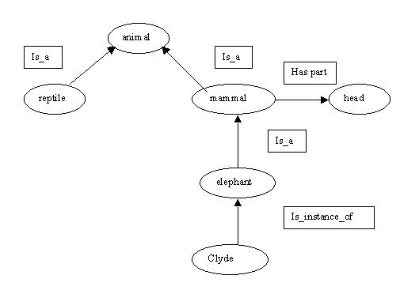

|  |
| --- |
| Nellie |
| instance: Elephant |
| Size:small |

|  |
| --- |
| Clyde |
| instance: Elephant |
| color:pink |
| owner:Fred |

**Semantic frames:** The symbol * means that the value of the feature is typical for the entity, represented by the frame.

|  |
| --- |
| Mammal |
| subclass: Animal |
| warm_blooded: yes |

|  |
| --- |
| Elephant |
| subclass: Mammal |
| *color: grey |
| *size: large |

d) Compared to (i) and (ii), what are their advantages and disadvantages?

**Predicate logic:**