Name: ___Mo_Felonda__

Section: __002_________

Net ID: __felonda_______

**CS/ECE 252 Introduction to Computer Engineering**

Fall 2018

Instructor: Adil Ibrahim

**Homework 1 (30 points)**

**Deadline: September 12th, 2018**

Primary contact for this homework: Amogh Joshi (asjoshi4@wisc.edu)

# Problem 1 (4 points)

1. List the date, time, and location of all exams for this course.

Exam 1: Wed, Sept. 26; during class time; 113 Brogden Psychology Building.

Exam 2: Fri, Oct. 19; during class time; 113 Brogden Psychology Building.

Exam 3: Wed, Nov. 14; during class time; 113 Brogden Psychology Building.

Exam 4: Fri, Dec. 7; during class time; 113 Brogden Psychology Building.

1. Do you have a conflict with any of the exams? If so, have you informed your instructor about the conflict?

I do not have any conflicts.

1. Do you have a final exam for this course? If so, what is its date, time, and location?

There is no final exam for this course.

# Problem 2 (4 points)

**(This question has no wrong answers.)**

1. What is your expected major(s)?

I will major in Computer Sciences (BS).

1. Please list all computer science courses you have taken in the past, if any.

I have taken CS200 and CS300 (Programming I & II) equivalents at Madison College (I transferred in this semester).

1. Please list all computer science courses you plan on taking concurrently, if any.

I am currently taking CS400 (Programming III) and CS240 (Discrete Mathematics).

1. Why are you taking this course? What do you hope to get out of this course?

# Aside from the course being a requirement for my major, I am interested in low level programming. I hope to be familiar with most aspects of computer science and this class will help me to achieve that.

# Problem 3 (9 points)

1. There cannot be more than one logic circuit implementation for a microarchitecture.

True/False?

False, there can be more than one implementation.

1. Briefly explain the difference between microarchitecture and ISA.

A microarchitecture is what implements the ISA (instruction set architecture). The ISA specifies what operations the computer can perform and what data is needed by each operation, while the microarchitecture is the detailed organization of the blocks that will carry out the implementation.

1. List at least five things specified by an ISA.
2. The operations a computer can perform.
3. The data needed by each operation.
4. The mechanisms that the computer can use to locate the operands (addressing nodes).
5. The number of unique locations that comprise the computer’s memory.
6. The number of individual ‘1’s and ‘0’s that are contained in each location.
7. List​ at ​least one advantage of programming in high-level languages compared to low-level​ languages. List one disadvantage. ​

High-level languages are advantageous because they are independent of the computer which the programs will execute with. A disadvantage of high-level languages is that, since they are not tied to the computer which the programs will execute with, they must be translated (compiled) to the target computer first and thus can be slower.

# Problem 4 (6 Points)

Assume​ ​that​ ​we​ ​have​ ​two​ ​"black​ ​boxes”, ​ ​shown​ ​in​ ​Figure​ ​(a)​ ​and​ ​(b).​ ​Black​ ​box​ ​shown in​ ​Figure​ ​(a)​takes​ ​two numbers as input and​ ​ ​outputs​ ​their​ ​sum.​ ​Black ​ box shown​ in​ Figure (​b) takes​ two​ numbers as input,​ ​and multiplies​ them together. As​ an example, Figure​ ​(c)​ ​shows​ ​how​ ​we​ ​can connect​ ​these​ ​boxes​ ​together to compute **p​ ​ ​*​ ​(m​ ​+​ ​n)**

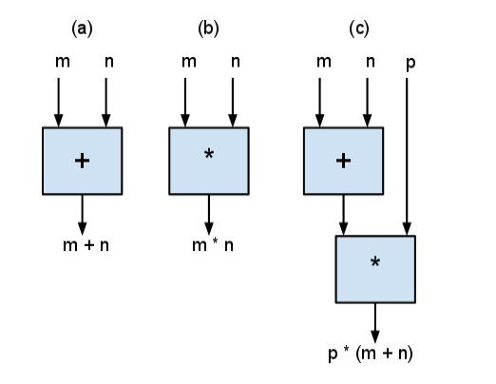

Show​ ​how​ ​to​ ​connect​ ​these​ ​boxes​ ​together​ ​to​ ​compute:

1. (p^2 * m^2) + n (Use at most 4 boxes)

First take two boxes, one having two p inputs, and the other having two m inputs, and have both boxes multiply their inputs. This is basically two cases of Figure (b), so we now have two outputs that are p^2 and m^2 respectively. Use another box like in Figure (b) to multiply these outputs as inputs together, giving an output of (p^2 * m^2). Finally, use a sum box like in Figure (a) using this output as an input, and have the other input be n. This will yield the goal. This process is as follow; inputs are blue, outputs are red, and the final result is green.

p*p >> p^2 / m*m >> m^2 / p^2 * m^2 >> (p^2 * m^2) / (p^2 * m^2) + n >> (p^2 * m^2) + n

1. m^2 + n^2 + 2*m*n (Use at most 2 boxes)

Take two of the boxes from Figure (b) and multiply their inputs together.

The output of both boxes is (m*n). Multiply these outputs together as inputs to get the goal. This process is as follows; inputs are blue, outputs are red, and the final result is green.

m*n >> m*n / m*n >> m*n

(m*n) * (m*n) >> (m^2 + 2*m*n + n^2) which is equivalent to m^2 + n^2 + 2*m*n.

# Problem 5 (4 points)

1. Name three characteristics of algorithms. Briefly explain each of these characteristics.
2. Definiteness – the notion that each step is precisely stated.
3. Effective Compatibility – the notion that each step can be carried out by a computer.
4. Finiteness – the notion that the procedure terminates.
5. Explain the difference between a compiler and an assembler.

# While a compiler translates high-level languages to the ISA, an assembler will translate assembly language to the ISA.

# Problem 6 (3 points)

Explain the following terms:

1. Operand

Operands are the part of the instructions which describe what data will be operated on, i.e. the individual data values.

1. Data Types

Data types are the legitimate representations for operands such that the computer can perform operations on that representation. It is a classification that specifies the nature of a value that an operand has.

1. Addressing modes

Addressing nodes are the mechanisms the computer can use to locate the operands.