Research Paper

The Financial Impact of the Coronavirus Recession on the Stock Market

17-1330 Moffat Kagiri Ngugi

17-1075 Lucy Wairimu Karing’u

Submitted to:

Mr. Samuel Kiranga, Ph.D.

ACM 490: Actuarial Project

School of Science, Health and Engineering

20th August 2020

Table of Contents

DECLARATION. 4

ACKNOWLEDGEMENT. 5

DEDICATION. 6

LIST OF ABBREVIATIONS. 7

ABSTRACT. 8

CHAPTER 1: INTRODUCTION. 9

Background. 9

Problem Statement 10

Research Objectives 11

Research Questions. 11

Significance of the Study 13

Assumptions. 13

Limitations 13

CHAPTER 2: LITERATURE REVIEW 14

Introduction. 14

Reviews. 14

CHAPTER 3: RESEARCH METHODOLOGY. 20

Introduction. 20

Research Design 20

Target population. 21

Data collection. 21

CHAPTER 4: DATA ANALYSIS RESULTS, PRESENTATION AND DISCUSSION. 24

Introduction. 24

Data analysis. 24

Discussion 28

CHAPTER 5: CONCLUSION AND RECOMMENDATIONS. 34

Conclusion. 34

Recommendations. 34

References 36

APPENDIX A: Historical Data 38

APPENDIX B: R source code 42

APPENDIX C: R Output 45

Statistical tests 45

VAR Estimation Results: 47

APPENDIX D: Projections 58

Tables 58

Fancharts 60

# DECLARATION.

We declare that this is our original work and has not been submitted to any other college, institution or university other than Daystar University for academic credit.

# ACKNOWLEDGEMENT.

We acknowledge our family members and friends whose support made it possible for us to go through the academia process successfully.

We also acknowledge our fellow students, and lecturers at the Daystar University whose wells of knowledge have made us better not only academically but also .

We would also like to specially acknowledge our supervisor, Mr. Samuel Kiranga, who has guided us tirelessly through the research project despite the ongoing pandemic. His guidance has been extremely beneficial and we shall be forever thankful.

Lastly we acknowledge the Almighty God for His invaluable support and provision throughout this whole time.

# DEDICATION.

We would like to dedicate this project to God for his never ending grace, our families for their endless support, friends and our fellow classmates for their encouragement.

# LIST OF ABBREVIATIONS.

GDP Gross Domestic Product.

NSE Nairobi Stock Exchange.

NASI NSE All Share Index.

CMA Capital Market Authority.

SME Small and Medium-sized Enterprises.

CBK Central Bank of Kenya.

ICT Information and Communication Technologies.

IT Information Technology.

KNBS Kenya National Bureau of Statistics.

VAR Vector Auto Regression.

MC Market Capitalization.

ET Equity Turnover.

CBT Corporate Bonds Turnover.

GBT Government Bonds Turnover.

TBT Total Bonds Turnover.

# ABSTRACT.

This study sought to establish the financial impact of recession on the Kenyan stock market. The study was guided by the research objectives: to analyze the impact of the impending economic crisis on the Kenyan markets and to propose ways to mitigate the impact of economic crises in the country. The selected variables included Gross Domestic Product (GDP), NSE 20 share index, the Nairobi All Shares Index (NASI), the total market capitalization, equity turnover, total bonds turnover, government bonds turnover and corporate bonds turnover. The study followed descriptive research design and used secondary data. This data was available for the period starting from the first quarter of 2009 to the second quarter of 2020.The study acquired GDP data from the Kenya National Bureau of Statistics (KNBS) in order to map the movements in stock market indices to the corresponding changes in the GDP and Capital Markets Authority (CMA).The data consisted of NSE 20 share index, the Nairobi All Shares Index (NASI), the total market capitalization, the total equity turnover, and the total bonds turnover. The study used the Vector Auto-Regression (VAR) model which is created using r programming language for statistics. The coefficients used in the entire system of the model are determined through ordinary least squares.

The study concluded that the variables could be grouped into Share indices, bonds indices, and the one macroeconomic variable. The share indices: NSE 20, NASI, and the total market capitalization have a very strong positive correlation with one another. The bond indices: corporate bond turnover, the government bond turnover, and the total bond turnover have a very weak negative correlation with the share indices. Lastly, the GDP which is the macroeconomic variable, showed a weak positive correlation to the share price indices and to corporate bonds turnover. This implied that the recession would have a minimal impact on the stock market but a more magnified one in the rest of the economy.

# CHAPTER 1: INTRODUCTION.

## Background.

On 12th March 2020, the cabinet secretary for health announced that Kenya had confirmed its first case of COVID 19. In that week, the total market capitalization in the Nairobi stock exchange plummeted by about 354 billion shillings as both foreign and local investors dumped stocks in a stampede due to the panic caused by the pandemic (Njugunah, 2020). After the announcement, the bourse halted trading as at 2:38pm on the same day, since the total market capitalization had dropped about 120 billion shillings from the start that morning (Juma, 2020). The measures taken by the government to mitigate the spread of the Sars-Cov-2 led to the near closure of a number of sectors in the country, causing a sharp economic shock. The period since the announcement has been characterized by a number of economic markers which suggest that the economy is at the start of a severe recession. These markers include a rise in unemployment, reduction in economic activities, a reduction of the demand of goods, and a drop in the Gross Domestic Product (GDP) (Barnier, 2020).

Common conditions which precede economic downturns are loose monetary policies and lax financial regulations. Like in the 2008-2009 economic crisis, these factors lead to an initial surge in economic growth to an unsustainable rate (boom) which is caused by misperceived risk. During this time, various players in the economy place economic resources in unsuitable projects which have much less value than they appear to have. In due time, the growth rate of the economy drops to the negatives (bust) (Hayes, 2020). The bust is the perceived crisis and it is vital to develop a mechanism to quantify it and if possible, predict and forestall it. As long as the business cycle keeps going, periods of economic expansion and contraction are expected. By extension, since there is no method to quantify the real willingness of people to lend in the market, there is always the possibility to misperceive risk in the market. As such, there is no defined way to avoid recessions. However, it is crucial to have a way of quantifying their impact on the economy and therefore, reduce it.

## Problem Statement

Although the coronavirus pandemic has created the markers of a recession, some of them have been observable for the past couple of months. For instance, according to Maina, (2019), various companies made layoff announcements were in 2019 leaving at least 7000 people unemployed. It suffices to say, therefore, that a recession has been impending for a while. Furthermore, the business cycle has been on a steady expansion for about 10 years since the 2008-2009 post-election economic contraction. Recessions have an immense financial impact on markets like they did on 12th March. According to the Austrian theory of economics, a recession can be seen as the period in which the economy heals or recovers from the effects of the malinvestment due to misperception of risk (Tempelman, 2010). During the recession, the market reverses the resources which were invested in overly risky ventures. This leads to the rise in unemployment as people lose jobs in companies which were set up during the preceding boom. Money is also re-routed by the market as the businesses which took more risk than they intended go bankrupt. Assets with a higher risk of incurring losses are rerouted as they are repossessed or as they lose value (Horwitz, 2012). As people lose money to the risks they misperceived, they minimize their spending reducing the demand of goods. This leads to a tough situation even for the companies which do not go under since the demand for their commodities declines. Unfortunately, the private sector, and the banking system seem to be aware of ‘tough times ahead’ but cannot effectively mitigate the impact to cushion the public or their employees.

## Research Objectives

Mitigating the financial impact of a recession on the market relies on the recognition of the magnitude and timing of the downturn. However, quantifying the impact of a recession is a difficult task since a recession cannot be accurately estimated beforehand. This paper is geared towards understanding the impact of recessions on the Kenyan economy. It studies the financial impact of the 2007-2008 recession and the coronavirus recession on the Kenyan capital market. With that, we can forge a way forward in financial regulation, monetary policy, corporate strategy and risk management with respect to the current state of uncertainty. As such, the paper has two objectives:

1) To analyze the impact of the impending economic crisis on the Kenyan markets, and

2) To propose ways to mitigate the impact of economic crises in the country.

## Research Questions.

As Were & Tiriongo, (2012) point out, the recession Kenya experienced in 2008-2010 was compounded by the preceding global economic crisis. However, its impact was more pronounced due to the contribution of the post-election violence which occurred in the first few weeks of 2008. The post-election violence caused a sharp economic shock by relocating the much needed labor in Kenyan farms. As a result the agriculture sector, which still remains the backbone of the economy, was crippled. The reduced agricultural production compounded the severe famine the country experienced soon after. Although these are observations on the intersection of macroeconomic and humanitarian events in the country, they can also be viewed as series of microeconomic events.

In essence, a certain farm lost all its employees in one part of the country as they were either killed in the violence or they fled to the areas considered their ancestral home. After that, the farm could not produce the usual amount of foodstuffs since some of the crop was destroyed in the violence and there was no one to tend to the remaining crop. Instead, the people who could provide labor in this hypothetical farm were jobless and dependent on other people. The entire crisis can be attributed to such microeconomic events as these. In the ongoing crisis, a similar situation is unfolding. In the transport sector, bus drivers and conductors have been rendered jobless as intercounty travel has been greatly reduced. This situation has been replicated in the education and entertainment sector as these services have been limited to the internet where the monetization of people’s services is much more difficult. In addition, the online platforms which host educators or entertainers cannot accommodate all of these workers. Even in the agriculture sector, the situation remains dire. Although the curfews and lockdowns effected to mitigate the spread of Sars-Cov-2 allow agricultural production to continue, they have inhibited some of the crucial associated processes. For instance, horticulture and floriculture have been greatly impacted by grounding of flights out of the country which usually transport their produce for export. Clearly, the unfolding crisis is much more complex for Kenya than the previous one was.

The financial impact of the ongoing recession is definitely worse than the impact of the 2008 downturn. Due to the differences between the two crises, the impact of the previous crisis cannot be used independently to determine the impact of the ongoing one. However, understanding how the recession will affect the various sectors of the economy, we can estimate the financial impact of the recession on the economy. As an estimator of the performance of the economy, this study looks into the financial impact of the coronavirus recession on the capital markets. As such, it seeks to answer the following questions:

1. To what extent will asset prices in the stock market be affected?
2. What sectors of the economy are most adversely affected by the recession? How?
3. What measures can companies take to mitigate the crisis?
4. What measures can the government take to mitigate the crisis?
5. What policy changes should be implemented as a response?

To answer these questions, the study evaluates the performance of capital markets through various phases of the business cycle. This includes the market trends in government and corporate bonds and share prices.

## Significance of the Study

This study is an instrumental guide for businesses navigating through a financial crisis. Ranging from large corporations to SMEs, any company can use thus study to evaluate the consistency of their decisions, the external business environment, and their risk appetite. In addition, the study shows the role of government in mitigating the impact of a recession. Government finance officers can, therefore, use the study in determining the best course of action to take.

## Assumptions.

1. The economic impact of the COVID-19 pandemic ended with the second quarter of 2020.
2. The coronavirus recession is driven by people being unable to work and do business, the direct influence of the disease is negligible.
3. Investors in the market are risk averse.
4. The investors seek profits and evade losses as much as they can.

## Limitations

While conducting this study, the main limitation was the lack of mobility due to the lockdown in effect from March 2020. Being in separate homes, this study relied on communication over the internet and telephone. The research survey was limited to the evaluation of information available over the internet as in person interviews or consultations were not possible. In addition, the evaluation of the coronavirus recession was difficult as it was unfolding in the same period this study was conducted.

# CHAPTER 2: LITERATURE REVIEW

## Introduction.

This chapter provides literatures from past researchers and scholars on the impact of recession on various economies in different countries as well as on its impact on stock markets.

By considering literatures from diverse past authors, the chapter forms the theoretical and the conceptual framework of the study on the financial impact of stock Markets in Kenya.

## Reviews.

(Were & Tiriongo, 2012)Kenya’s experience of the global financial crisis was compounded by a severe internal economic shock caused by the post election violence which ocurred in December 2007 and January 2008. The post election violence had an immediate effect on tourism as tourists would avoid the country for the next few months. The violence also crippled the agriculture and manufacturing sectors which made up a significant portion of the country’s GDP. As the country was starting to recover from the setback, the global economic crisis was started with the collapse of Lehman Brothers in September 2008.

The banking sector in Kenya was relatively insulated from the global crisis. However, the high perception of risk led to a rise in the number of non-performing loans, causing the tightening of risk assessment measures before issuing loans. These measures enabled the banking sector to maintain its financial well being.

In order to navigate out of the economic crisis, the Central Bank of Kenya implemented monetary policies which were aimed at calming the panic in the market and restoring confidence in the economy. The CBK made injections of liquidity into the banking sector and introduced the interbank repurchase agreements. The Central Bank made very clear communications about the monetary policies to all market players in order to restore confidence. The government, on its part, made a number of changes to fiscal policies in order to ease access to credit and complement monetary policies. It lowered tax rates and enabled the CBK to reduce the risk free rate of interest. In addition, it enabled the creation of Credit Reference Bureaus and made the Microfinance Act of 2008 putting microfinance instutions under the regulation of the CBK.

Around the same time, the government, the CBK and the banking system worked to broaden financial inclusion to as many Kenyans as possible through the use of agency banking and ICT innovations such as mobile money. Although monetary policy was effective in mitigating the economic crisis in developed economies, it failed in Kenya and a number of other developing countries. This was shown by the rise in the reserves of retail banks in the Central Bank while the rate of lending to the private sector remained roughly the same.

(Horwitz, 2012) The great recession was essentially caused by the misperception of risk in the market. This misperception was a result of artificially low interest rates in the United States. The most authoritative and empirically backed explanation of how the low interest rates led to a recession is presented by the Austrian business cycle theory. This paper explains that the causes of the 2007/2008 recession lie in the misguided monetary policy adopted years before and not in the workings of the market. As the Austrian theory explains, an artificially low interest rate leads to the belief that there is low risk in the market. Investors are willing to take more risk than they can handle under the illusion created by the rate of interest. In essence, the low rate of interest convinced the retail banks that the public was willing to wait longer for their money and as such, the banks could finance investors without much risk assessment using the money they had as deposits and even more with cheap loans from the central bank. The investors then take on risky projects, in the case of 2006, housing. Since the economy appears stable and safe for investment during the ‘boom’, the financial sector backs these projects with derivatives and asset-based securities. When the misperception of risk is manifested to the market, as it happened with the collapse of Lehman Brothers, the market starts to readjust. Business resources are reallocated to more appropriate parts of the economy during the ‘bust’. Due to the high level of globalization, the financial market in the United States was greatly linked with other countries. As such, a good number of derivatives and asset-based securities written on the real estate were foreign owned. This led to the escalation of the crisis to the global level. Although the government played a crucial role in setting off the cycle, the government cannot directly solve a recession using policy. As the Austrian theory suggests, the cycle is not a singular macroeconomic event, rather, it is a combination of many microeconomic events. Therefore, the government can only solve the recession by creating a business environment which enables entrepreneurs to do business and in so doing, reallocate resources of land, capital, and labour.

(Amir sufi, 2010) This micro-level analysis of the Great Recession provides us with important clues to understand the origins of the crisis, the link between credit and asset prices, the feedback effect from asset prices to the real economy and the role of household leverage in explaining the downturn. Financial crises are almost always preceded by a sharp rise in leverage or debt-based financing. This paper explains how credit booms is based on shifts in the supply of credit. Such shifts may be driven by a series of factors, but financial innovation (such as securitization) is often a core component. It further explains the traditional approach in asset pricing by discounting future cash flow making it clear that the availability of credit plays no role in the determination of asset prices. There is also an explanation about housing prices having accelerator effects that are largely perceived to work through the effect of collateral value on firm investment. However, it is believed that in years preceding the Great Recession, the major accelerator effect was driven by the impact of rising home equity on household spending.

It is generally difficult to isolate the impact of higher house prices on household expenditure. The usual worry is that unobserved common shocks, such as permanent income shocks, may co-determine house price, household consumption, and borrowing dynamics. The widespread availability of microeconomic data has therefore greatly enhanced our ability to understand the fundamental driving forces behind macroeconomic fluctuations and credit cycles. This research looked into employee’s microeconomic data in order to understand the link between household finance and the real economy. This discussion also serves as an example of the usefulness of incorporating microeconomic data and techniques in answering traditional macroeconomic questions.

**Irons, (2009)** makes his case about the impact of recessions on the real economy. He takes the microeconomic perspective and assesses the long term impacts of a recession, a fiscal stimulus, and an economic stimulus on the economy. This report argues that the short term economic conditions caused by a recession such as high levels of unemployment, reduced household incomes, and contraction in economic activities; do have long term consequences.

These consequences affect all units of the economy ranging from the government to the family and the individual. The government spends more of its reserves and at times, it incurs debt. Large corporations reduce spending on research and development. This causes a stagnation in the advancement of technology. The corporations may also halt corporate social responsibility programmes which affects the marginalized communities and the poor who usually benefit from such programmes. Smaller units of the economy are affected more adversely. Due to the financial difficulties caused by the recession, households usually make such decisions as forgoing learning in tertiary institutions or compromising on the quality of education or healthcare they get. As such, the economy eventually suffers collectively with a decline in investments, technology, education, and entrepreneural activity.

Economic scarring entails all the negative long term impact of economic crises on the economy. Irons, (2009) quotes previous research studies which provide evidence that the consequences of the scarring usually reach past generations. The report explains that some of the decisions families make to reduce their spending during economic crises usually affect their subsequent generations. For instance, when parents forego furthering their education in order to reduce their spending, they greatly reduce the probability of their children eventually getting tertiary education. The decisions by families to reduce their private investments also reduces the quality of their lives. As such the financial security of the family is compromised to the second and third generation by the impact of the recession.

Conversely, the temporary increase in government spending which is done to revive the economy effects a significant short-term boost to the national income while its cost is spread out over a long period after the recession ends. Therefore, the cost of the fiscal and economic stimuli should not be assessed without considering the boost they give to the economy and the economic scarring they curtail. The stimulus packages offered by governments during economic crises enable corporations to expand their operations. This creates jobs in large numbers to compensate for jobs lost during the crisis and attempt to generate economic growth. The stimulus packages create additional jobs through such programmes as the ‘Kazi Mtaani’ programme driven by the government of Kenya to cushion its youth from the financial impacts of the coronavirus recession. Stimulus packages used by the government to limit the impact of recessions are, therefore, a very quick and effective means to revive the economy from a recession.

Invalid source specified.During recessions, organizations tend to lay employees off as a downsizing measure. This is a response to the harshness and financial dents brought about by the crisis in the entire economy. However, they should not sack employees but engage their support to mitigate the adverse impact of recessions. They should find ways and means to cut down on unwarranted expenditure elsewhere. This could be through the ideas and ingenuity of the employees themselves. Creating new products or services can open the gates for a new demographic of consumers. The paper highlights the importance of corporate training in subjects such as Information Technology and the related IT “enabled services” during times of recession. It treats recession as a boon not as a bane – as an opportunity for employees to spend time learning and for employers to gain a competitive edge.

This paper concludes that training is only a comma not a full stop. Training is an investment not an expense. Despite the financial harm done by a recession, an organization should make the most out of it. It should maintain corporate training as a continuous process to ensure organizations remain competitive and productive.

# CHAPTER 3: RESEARCH METHODOLOGY.

## Introduction.

This chapter outlines the methodology that was used to carry out the research on the financial impact of recession on Kenyan markets. The chapter explains the methods to be used to collect secondary data necessary for the study. It also discusses the research design used, the target population, data collection methods and lastly data analysis.

## Research Design

Research design can be described as a systematic and organized effort to investigate a specific problem to provide a solution. It specifies the methods and procedures that will be used to collect and analyze data (Uma Sekaran, June 2016). This study followed a descriptive research design to explain the relationship between dependent and independent variables. Descriptive research design is a statistical method that quantitatively synthesizes the empirical evidence of a specific field of research. According to (Flick, 2009) Descriptive research design has become widely accepted in the field of finance and economics since it is proving to be very useful in policy evaluations and the techniques used give accurate information on the required fields.

The main aim of this study is to show how the market reacts to the slump in GDP in the emergence of a recession. The variables used in the study include the GDP, NSE 20 share index, the Nairobi All Shares Index (NASI), the total market capitalization, equity turnover, total bonds turnover, government bonds turnover and corporate bonds turnover. The study did not specify the independent or dependent variable since the method of analysis would determine that. Correlation coefficient was used to examine whether there is any relationship that exists between dependent and independent variables. This correlational research is classified as a type of descriptive method and thus it will state the degree of relationship between the variables. If the relationships are considerable and consistent, they permit a researcher to make forecasts about the variables. Therefore, through the descriptive research design we were able to analyze the impact of the impending economic crisis on the Kenyan financial markets, and propose ways in which the impact of this crisis in the country can be mitigated.

## Target population.

The target population refers to the entire group of people, events or things that the researcher intends to investigate (Walter R. Borg, 2003).This study targeted the 67 listed companies in Kenya from January 2009 up to June 2020. It had an emphasis on the 20 companies whose shares determine the NSE 20 share index.

## Data collection.

Data collection is the process of gathering and measuring information in order to be able to answer questions that prompted the undertaking of the research (Flick, 2009). This study was built around secondary data about stock market performance collected from the quarterly statistical bulletins published by the Capital Markets Authority (CMA). The data consisted of the NSE 20 share index, the Nairobi All Shares Index (NASI), the total market capitalization, the total equity turnover, and the total bonds turnover. This data was available for the period starting from the first quarter of 2009 to the second quarter of 2020 which was our research period. In addition, the study acquired GDP data from the Kenya National Bureau of Statistics (KNBS) in order to map the movements in stock market indices to the corresponding changes in the GDP. Within this 10 year period, the economy witnessed recovered from the economic turmoil of 2008-2007 and the famine which followed in 2011. After that, the GDP expanded consistently to reach the crest in 2018. The data was presented in monthly intervals in the quarterly statistical reports. This way, it allowed for an in-depth evaluation of the impact of the coronavirus recession.

According to (Mugenda & Mugenda, 2003) data must be cleaned, coded and properly analyzed in order to obtain meaningful information. Secondary data gathered was organized in spreadsheets for the purpose of analysis.

The impact of the recession on the performance of the stock market can be illustrated by this equation from the VAR:

$$NSE.20 =y_{1}.l1 + y_{2}.l1 + y_{3}.l1 + y_{4}.l1 + y_{5}.l1 + y_{6}.l1 + y_{7}l1 + y_{8}.l1 +y_{1}.l2 +y_{2}.l2 +y_{3}.l2 + y_{4}.l2 + y_{5}.l2 + y_{6}.l2 + y_{7}.l2 + y_{8}.l2 + const$$

Where:

* $y_{1}$ Is the NSE 20
* $y_{2}$ Is the NASI
* $y_{3}$ is the Market Capitalization(MC)
* $y_{4}$ is the equity turnover(ET)
* $y_{5}$ Is the corporate bonds turnover(CBT)
* $y_{6}$ is the government bonds turnover (GBT)
* $y_{7}$ is the total bonds turnover(TBT)
* $y_{8}$ is the Gross Domestic Product(GDP)

.

# CHAPTER 4: DATA ANALYSIS RESULTS, PRESENTATION AND DISCUSSION.

## Introduction.

This chapter provides the details as regards data analysis results and presentations of the study findings as set out in the research objective and research methodology. The study sought to establish the financial impact of recession on Kenyan stock markets.

## Data analysis.

In order to produce the relevant insights from this data, the study used the Vector Auto-Regression (VAR) model. This model was proposed by Christopher Sims in 1980 and it continues to prove its efficacy in solving problems of economics. Notably, vector auto regression takes into account the mutual effect that the indicators of economic performance have on each other. As such, this study discards the assumption that any pair of the indicators of financial or economic performance are mutually independent. Instead, the study assumes, at least for the sake of modelling, that all the variables available are endogenous. In essence, it assumes that both the macroeconomic indicator (Gross Domestic Product), and the stock market indices and statistics (NSE 20, NASI, Equity Turnover, and Bonds Turnover) are dependent variables. The VAR model is very easy to estimate and it produces very good results when used for predictions. The coefficients used in the entire system of the model are determined through ordinary least squares. This way, one can test any linear property in any or all of the equations. It is thus easier to test for the causality between the variables. The study used the R programming language for statistics to create the VAR model. The results of the analysis was organized in tables and graphs and then used to answer the study questions.

In the analysis to determine the impact of the coronavirus recession on the stock market, the study used the R programming language for statistics to create the VAR model. The VAR model revealed the stationary nature of each variable through the Philips Perron test. The study established the correlation and covariance between the variables as follows:

|  |  |  |  |  |  |  |  |  |
| --- | --- | --- | --- | --- | --- | --- | --- | --- |
|  | NSE20 | NASI | Market Capitalization in Bn Ksh | Total Equity Turnover in Bn Ksh | Corporate Bonds Turnover | Government Bonds Turnover | Total Bonds Turnover Bn Ksh | GDP in Bn Ksh |
| NSE20 | 94835.7 | 3598.881 | 50341.7 | 1233.026 | -19.4768 | -957.366 | -975.562 | 882.35 |
| NASI | 3598.88 | 174.591 | 2507.2 | 51.7879 | 1.5921 | -72.491 | -72.913 | 75.683 |
| Market Capitalization in Bn Ksh h | 50341.74 | 2507.228 | 36533.8 | 735.7715 | 16.9977 | -1010.19 | -1006.51 | 1114.486 |
| Total Equity Turnover in Bn Ksh | 1233.03 | 51.788 | 735.8 | 53.1403 | -0.4258 | -88.634 | -91.27 | 31.09 |
| Corporate Bonds Turnover | -19.48 | 1.592 | 17 | -0.4258 | 1.054 | -6.974 | -4.545 | 6.793 |
| Government Bonds Turnover | -957.37 | -72.491 | -1010.2 | -88.6339 | -6.9737 | 1325.683 | 1300.306 | -92.896 |
| Total Bonds Turnover Bn Ksh | -975.56 | -72.913 | -1006.5 | -91.27 | -4.5454 | 1300.306 | 1293.638 | -54.201 |
| GDP in Bn Ksh | 882.35 | 75.683 | 1114.5 | 31.09 | 6.7934 | -92.896 | -54.201 | 1183.728 |

Table 1 Covariance of the variables.

|  |  |  |  |  |  |  |  |  |
| --- | --- | --- | --- | --- | --- | --- | --- | --- |
|  | NSE20 | NASI | Market Capitalization in Bn Ksh | Total Equity Turnover in Bn Ksh | Corporate Bonds Turnover | Government Bonds Turnover | Total Bonds Turnover Bn Ksh | GDP in Bn Ksh |
| NSE20 | 1 | 0.8844 | 0.85525 | 0.54926 | -0.0616 | -0.08538 | -0.08808 | 0.08328 |
| NASI | 0.8844 | 1 | 0.99274 | 0.5377 | 0.1174 | 0.15068 | -0.15342 | 0.16648 |
| Market Capitalization in Bn Ksh | 0.85525 | 0.99274 | 1 | 0.52806 | 0.08662 | -0.14516 | -0.14641 | 0.16947 |
| Total Equity Turnover in Bn Ksh | 0.54926 | 0.5377 | 0.52806 | 1 | 0.0569 | -0.3339 | -0.3481 | 0.12396 |
| Corporate Bonds Turnover | -0.0616 | 0.1174 | 0.08662 | 0.0569 | 1 | -0.18656 | -0.12309 | 0.19232 |
| Government Bonds Turnover | -0.08538 | -0.1507 | -0.14516 | -0.3339 | -0.18656 | 1 | 0.99293 | -0.07416 |
| Total Bonds Turnover Bn Ksh | -0.08808 | -0.15342 | -0.14641 | -0.3481 | -0.12309 | 0.99293 | 1 | -0.0438 |
| GDP in Bn Ksh | 0.08328 | 0.16648 | 0.16947 | 0.12396 | 0.19232 | -0.07416 | -0.0438 | 1 |

Table 2 Correlation matrix of the variables.

## Discussion

The study shows, from the above correlation matrix, that the variables could be grouped into Share indices, bonds indices, and the one macroeconomic variable. The share indices: NSE 20, NASI, and the total market capitalization have a very strong positive correlation with one another. This is because through all phases of the business cycle, these three indicators complement each other. When the top 20 companies in the stock market perform well, they raise the average performance of all the companies listed in the bourse. Similarly, when the NASI appreciates, NSE 20 follows suit since the 20 shares which compose it are the most preferred stock in the market. When these two indicators rise, they inspire confidence in investors, effecting an eventual rise in the market capitalization due to a high demand of the shares. All of these indices have a strong correlation with the equity turnover. This indicates that when the listed companies are able to convert the equity they sell into real growth and development, investors at the stock market are more willing to invest in them.

The second category of indicators are the bond indices. These include the corporate bond turnover, the government bond turnover, and the total bond turnover. These indicators have a very weak negative correlation with the share indices. This is explained by the use of capital sourced from bonds. Bonds provide both the government and the listed companies with large amounts of capital without creating an urgent liability. Therefore, these entities offer bonds when they are in dire need of money, such as, during recessions. The government bonds take up a large portion of the total bonds turnover since the listed companies opt to rely on shares. In addition, the government requires a lot more money when the economy is receding so that it can cushion the public through fiscal and economic stimuli. Furthermore, the investors are only incentivized to invest in either bonds or shares: not both. When they stand to make profits trading shares, bonds appear to take too long to pay up. When the investors stand to make profits by acquiring bonds, trading in shares appears too risky. However, the investors who can afford to invest in bonds make up a very small portion of the stock market. These factors create the minimal but negative correlation between share indices and bond indices.

The gross domestic product is the best indicator of the economic performance in the country. It shows how much people are working and trading to gain wealth. Since wealth is directly proportional to people’s willingness to lend, the GDP was a good indicator of economic performance to use in the VAR model. The GDP showed a weak positive correlation to the share price indices and to corporate bonds turnover. It showed a weak negative correlation to the government bonds turnover and the total bonds turnover. This correlation is explained by the small number of capitalized businesses in the country, and the sizes of capitalized businesses. According to Kinuthia, (2020), SMEs play a key role in the growth of the Kenyan economy. By 2017, these enterprises made up more than 95% of the businesses in the country. With such small portion of the economy being financed by equity, the stock market data accounts for a very small portion of the economic fluctuations in the country. However, the Nairobi Stock Exchange oversees the trade of shares in companies from all sectors of the economy ranging from agriculture, to manufacturing, to power, and even financial services and insurance. This way, although the correlation to the GDP is weak, it is positive and consistent.

In addition to the analysis of the data, this study created projections for each of the variables above. The projections were made for the four quarters covering the second half of 2020 and the first half of 2021. The prediction was made with the assumption that the COVID-19 pandemic would be reined in before the end of the third quarter of 2020. However, the model takes into consideration how quickly Kenya has recovered from similar dips in the past. It also takes into consideration the momentum of the recession, seeing as it started in 2019 and not in 2020 when COVID-19 reached Kenya. Below are graphs showing the probable trend of NSE 20, total bonds turnover, and GDP in the next 4 quarters. The tables and graphs for the rest of the data are in Appendix 2.From the tables we are able to conclude that as much as the recession adversely affects the stock market, the market has an ability to remedy the recession.

The study determined that since its start in February 2020, the coronavirus has caused investor panic in a number of instances. From the secondary data collected, the study determined that since the beginning of the year, the recession has effected a significant reduction in the stock maeket performance. For instance the NSE 20 share index has gone down by about 700 points. As of December 2019, this index was at 2654.39 points. This value had reduced to 1942.12 by June 2020. The impact of the recession was so severe at the start that it undid the January effect in the Nairobi Securities Exchange. The January effect is an anomaly in the stock market which sees the first quarter of a period performing better than the last quarter of the preceding period (Kamau, 2003). The January effect was reversed since so far, the stock market has not reached the performance it had in December 2019. The January effect has been prevalent in the Nairobi Securities Exchange for decades (Nyamosi, 2011). Therefore, the impact on the stock market can be much worse if it is not mitigated on time.







# CHAPTER 5: CONCLUSION AND RECOMMENDATIONS.

## **Conclusion**.

As the graphs above depict, there is no sure way of determining the trend of economic indices such as GDP or share price indices. The study concluded that the variables could be grouped into Share indices, bonds indices, and the one macroeconomic variable. The share indices: NSE 20, NASI, and the total market capitalization have a very strong positive correlation with one another. The bond indices: corporate bond turnover, the government bond turnover, and the total bond turnover have a very weak negative correlation with the share indices. Lastly, the GDP which is the macroeconomic variable, showed a weak positive correlation to the share price indices and to corporate bonds turnover.

## Recommendations.

In order to achieve the highest rate of growth conceivable, companies should focus on keeping their employees, at least, healthy. In the ideal situation, companies should urge their employees to work from home. Where this limits the employees, the companies should utilize this time by offering training in customer service and skill improvement. This way, the company can cut down on losses due to suboptimal operations and instead, invest in their human resource. This way, when the economy eventually opens, the company will have healthy employees who are even better trained to serve. If this is adopted as a trend, listed companies will be twice as productive as they were before the pandemic. Although the pandemic is imposing many adverse effects on businesses, it has also provided a unique resource: time. How companies utilize it will determine their performances during the expansion.

The government also needs to take measures to ensure the safety and well-being of the public. Although it is a personal responsibility to stay safe from COVID-19, the government should keep in mind that in case of a second wave of the pandemic, it will have to bear losses in lives and money. Assuming that it is able to mitigate the pandemic effectively, the government will have an uphill task of reviving the economy from a recession the world has not seen in more than a century. Since the coronavirus recession is a global problem, foreign direct investments, loans, and grants will be difficult to secure. The government should consider offering bonds in the local stock market to attract as many investors as possible. With enough funds, the government would be able to sustain the fiscal and economic stimuli. This would reduce the impact of the recession on low income families, thus safeguarding their ability to afford essential needs. With sufficient measures, the government can inspire confidence in investors and businesspeople to get back to work, reviving the economy before it contracts any further.

It is important to note that although having a small number of capitalized businesses kept Kenya from harm’s way in the 2007-2008 global economic crisis, the opportunity cost is too high. Along with the crisis, Kenya missed out on the opportunity to grow along other economies. After the global crisis, the world economy has experienced about 13 years of continuous expansion. Although Kenya’s GDP has grown consistently, it could have grown much faster with the advantage of a robust capital market where at least 15% of its businesses are listed. The government should oversee the creation of financial policy to this effect.

In addition, further studies should explore the sector-wise relationship between GDP and stock market performance. The sector-wise impact of the recession on the stock market is the only research question the study did not manage to answer. This study accomplished its objectives without stratifying the stock market into its constituent sectors. Moreover, the insight into the impact of the recession on the various sectors requires a broad study independent from the general impact on the market. Such a study would go a long way in fostering methods of mitigating economic crises as it would inform the vital decisions of companies during crises.

# **References**

Amir sufi, A. M. (2010). The Great Recession: Lessons from Microeconomic Data. *American Economic Review Papers and Proceedings.*, 51-56.

Barnier, B. (2020, June 8). *Guide to Economic Recession*. Retrieved from investopedia: https://www.investopedia.com/terms/r/recession.asp

Botsch, R. E. (2011, July 9). *Concepts, Variables, and Measurement*. Retrieved from APLS 301 Scope and Research Methods: http://polisci.usca.edu/apls301/Text/Chapter%204.%20Concepts,%20Variables,%20and%20Measurement.htm

Donald Cooper, P. S. (2006). *Business Research Methods: 12th Edition.* India: McGraw-Hill Education (India) Pvt Limited.

Flick, U. (2009). An introduction to qualitative research . 528.

Hayes, A. (2020, April 13). *Boom And Bust Cycle*. Retrieved from Investopedia: https://www.investopedia.com/terms/b/boom-and-bust-cycle.asp

Horwitz, S. (2012). *Causes and Curses of the Great Recession.* London: The Institute of Economic Affairs.

Irons, J. (2009). *Economic Scarring: The long-term impacts of the recession.* Washington DC: Economic Policy Institute.

Juma, V. (2020, March 13). NSE halts trading as share prices collapse on virus scare. *The Daily Nation*.

Kamau, S. D. (2003). *Turn of the month and January effect on stock prices at Nairobi Stock Exchange.* Nairobi: University of Nairobi .

Kenya National Bureau of Statistics. (2020). *Economic Indicators.*

Kinuthia, K. (2020, February 24). SMEs driving Kenya’s economy. *Daily Nation*.

Maina, N. (2019, October 27). Nearly 7,000 workers laid off in Kenya since January this year. *People Daily Online*.

Mugenda, O., & Mugenda, A. (2003). Research Methods, Quantitative and Qualitative Approaches. *Open Access Library Journal*, 43.

Nairobi Securities Exchange. (2020). *Historical Data.*

Njugunah, M. (2020, March 13). First Case Of Coronavirus In Kenya Halts Trading At NSE As Panic Selling Escalates. *Capital Business*.

Nyamosi, J. N. (2011). *Testing the existence of January effect at the Nairobi stock exchange.* Nairobi.

Tempelman, J. H. (2010). Austrian Business Cycle Theory and the Global Financial Crisis: Confessions of a Mainstream Economist. *The Quarterly Journal of Austrian Economics*, 3-15.

Uma Sekaran, R. B. (june 2016). *Research MEthods For Business.* Illinois, USA: Southern Illinois University at Carbondale (SIUC).

Walter R. Borg, M. D. (2003). *Educational Research:An Introduction, 7th Edition.* Pearson: University of Oregon.

Were, M., & Tiriongo, S. (2012). *Central Bank’s Response to Economic Crises from a Developing African Economy Perspective: Lessons from Kenya’s Experience.* Nairobi: Central Bank of Kenya.

# APPENDIX A: Historical Data

Plots of Secondary data.

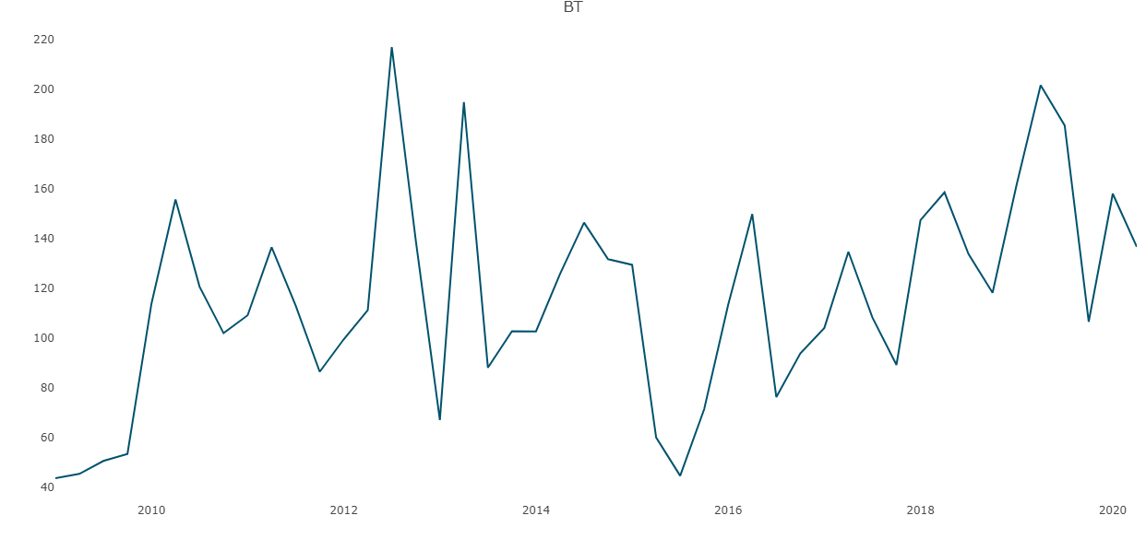

Figure 1 Bonds turnover (2009-2020) (Nairobi Securities Exchange, 2020).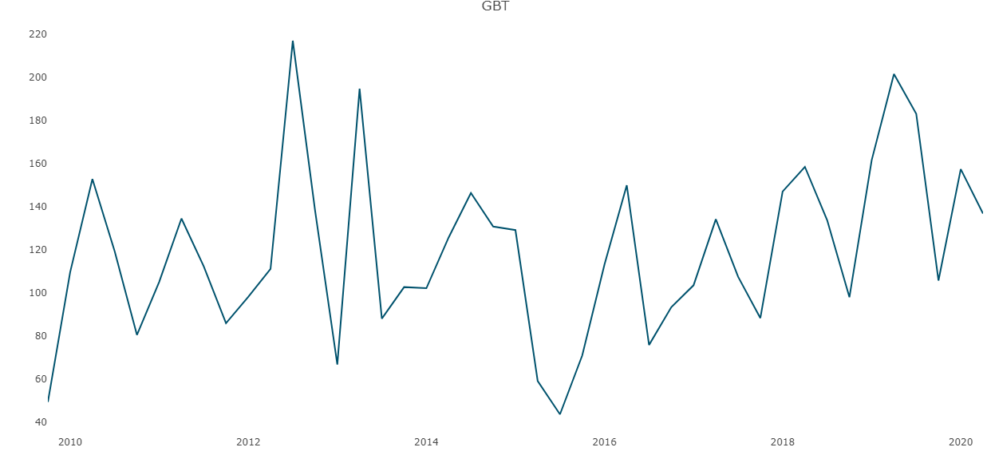

Figure 2 Government Bonds turnover (2009-2020) (Nairobi Securities Exchange, 2020).

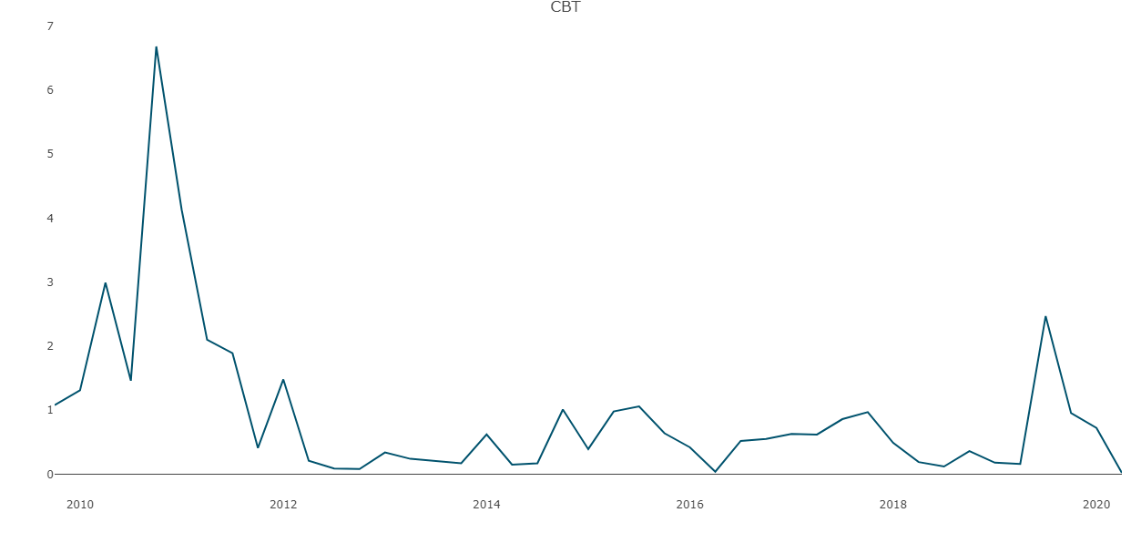

Figure 3 Corporate Bonds turnover (2009-2020) (Nairobi Securities Exchange, 2020).

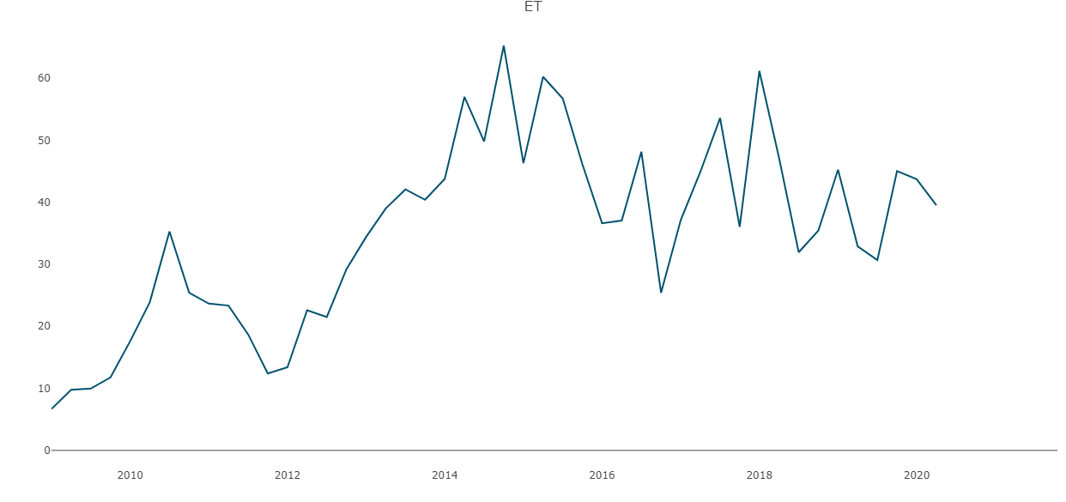

Figure 4 Equity turnover (2009-2020) (Nairobi Securities Exchange, 2020).

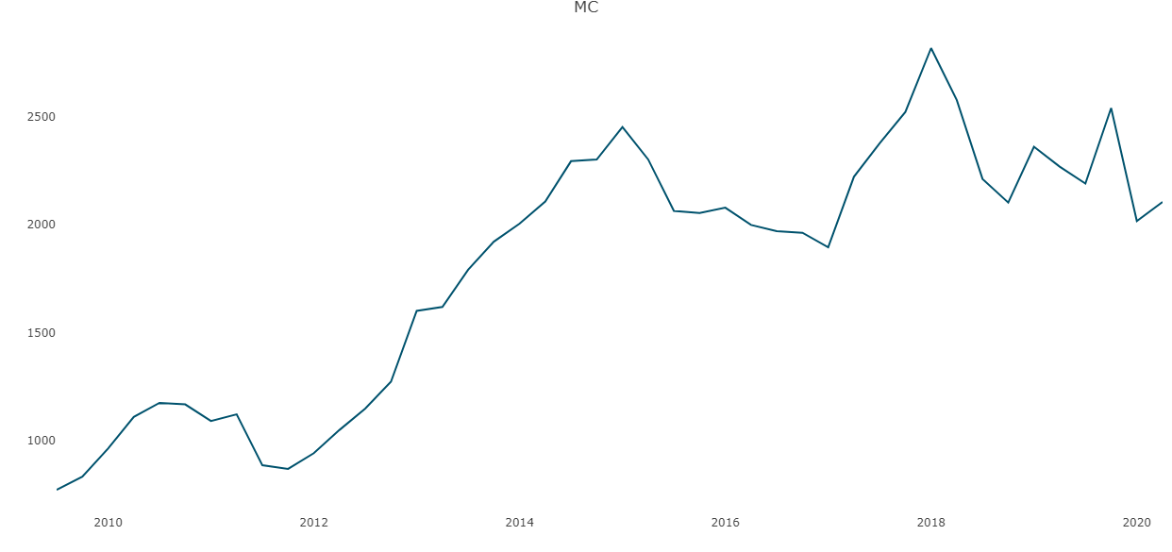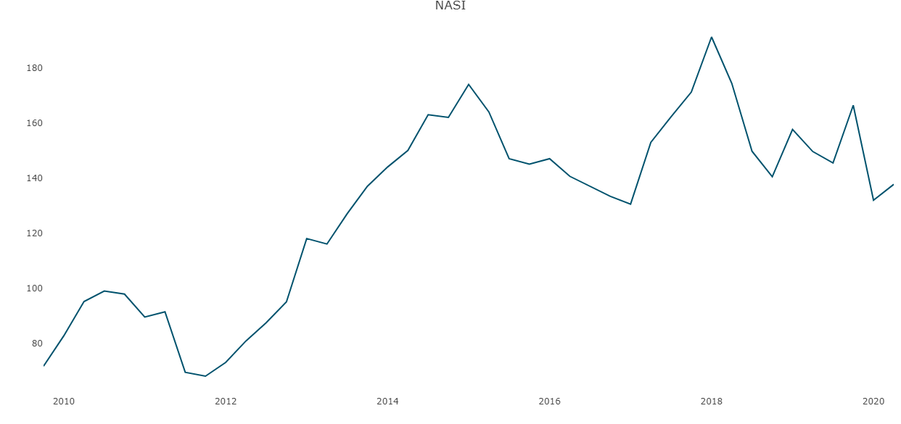

Figure 5 NASI (2009-2020) (Nairobi Securities Exchange, 2020).

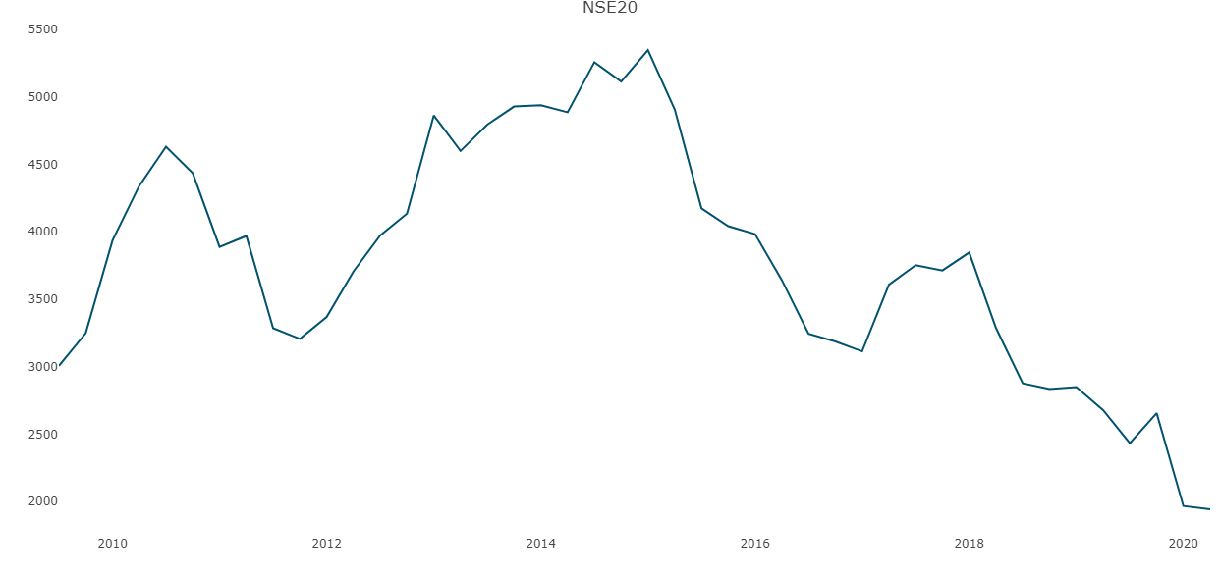

Figure 6 NSE 20 (2009-2020) (Nairobi Securities Exchange, 2020).

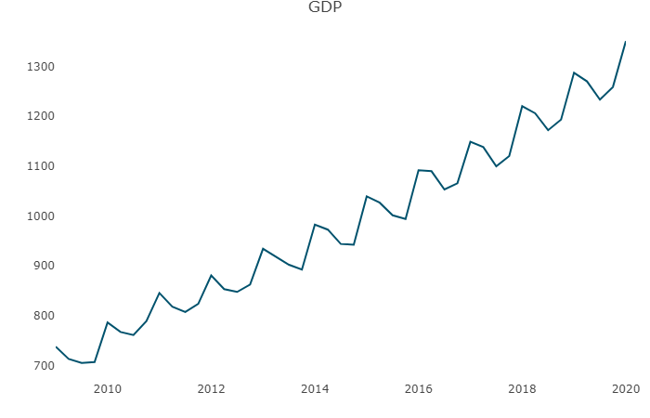

Figure 7 GDP (2009-2020) (Kenya National Bureau of Statistics, 2020).

# APPENDIX B: R source code

library(vars)

library(mFilter)

library(tseries)

library (TSstudio)

library(forecast)

library(tidyverse)

read_csv (file.choose())-> rawdata

head(rawdata)

NSE20 <- ts(rawdata$NSE20, start = c(2009,1,1), frequency = 4)

NASI <- ts(rawdata$NASI, start = c(2009,1,1), frequency = 4)

MC <- ts(rawdata$MC, start = c(2009,1,1), frequency = 4)

ET <- ts(rawdata$ET, start = c(2009,1,1), frequency = 4)

CBT <- ts(rawdata$CBT, start = c(2009,1,1), frequency = 4)

GBT <- ts(rawdata$GBT, start = c(2009,1,1), frequency = 4)

BT <- ts(rawdata$BT, start = c(2009,1,1), frequency = 4)

GDP <- ts(rawdata$GDP, start = c(2009,1,1), frequency = 4)

ts_plot(NSE20)

ts_plot(NASI)

ts_plot(MC)

ts_plot(ET)

ts_plot(CBT)

ts_plot(GBT)

ts_plot(BT)

ts_plot(GDP)

NSE20<-na.omit(NSE20)

NASI<-na.omit(NASI)

MC<-na.omit(MC)

ET<-na.omit(ET)

CBT<-na.omit(CBT)

GBT<-na.omit(GBT)

BT<-na.omit(BT)

pp.test(NSE20, lshort = TRUE)

pp.test(NASI, lshort = TRUE)

pp.test(MC, lshort = TRUE)

pp.test(ET, lshort = TRUE)

pp.test(CBT, lshort = TRUE)

pp.test(GBT, lshort = TRUE)

pp.test(BT, lshort = TRUE)

v1 <- cbind(NSE20, NASI, MC, ET, CBT, GBT, BT, GDP)

colnames(v1) <- cbind("NSE 20","NASI","Market Capitalization in Bn KSh",

"Total Equity Turnover in Bn Ksh", "Corporate Bonds Turnover",

"Government Bonds Turnover", "Total Bonds Turnover Bn KSh", "GDP in Bn. Ksh")

v1<-na.omit(v1)

lagselect <- VARselect(v1, lag.max = 4, type = "const")

lagselect$selection

Model <- VAR(v1, p = 2, type = "const", season = NULL, exog = NULL)

summary(Model)

Serial <- serial.test(Model, lags.pt = 5, type = "PT.asymptotic")

Serial

Arch <- arch.test(Model, lags.multi = 15, multivariate.only = TRUE)

Arch

Norm <- normality.test(Model, multivariate.only = TRUE)

Norm

Stability <- stability(Model, type = "OLS-CUSUM")

plot(Stability)

forecast <- predict(Model, n.ahead = 4, ci = 0.95)

par(mfrow=c(2,3))

fanchart(forecast, names = "NSE20", main = "Fanchart for NSE 20", xlab = "Horizon", ylab = "NSE20 (points)")

fanchart(forecast, names = "NASI", main = "Fanchart for NASI", xlab = "Horizon", ylab = "NASI (points)")

fanchart(forecast, names = "MC", main = "Fanchart for Market Capitalization", xlab = "Horizon", ylab = "Market Capitalization(Billion Ksh)")

fanchart(forecast, names = "ET", main = "Fanchart for Total Equity Turnover", xlab = "Horizon", ylab = "ET")

fanchart(forecast, names = "BT", main = "Fanchart for Total Bonds Turnover", xlab = "Horizon", ylab = "BT")

fanchart(forecast, names = "GDP", main = "Fanchart for Gross Domestic Product", xlab = "Horizon", ylab = "GDP")

forecast

# APPENDIX C: R Output

## Statistical tests

Phillips-Perron Unit Root Test

data: NSE20

Dickey-Fuller Z(alpha) = -6.9107, Truncation lag parameter = 3, p-value

= 0.6986

alternative hypothesis: stationary

Phillips-Perron Unit Root Test

data: NASI

Dickey-Fuller Z(alpha) = -8.1022, Truncation lag parameter = 3, p-value

= 0.6228

alternative hypothesis: stationary

Phillips-Perron Unit Root Test

data: MC

Dickey-Fuller Z(alpha) = -7.7325, Truncation lag parameter = 3, p-value

= 0.6471

alternative hypothesis: stationary

Phillips-Perron Unit Root Test

data: CBT

Dickey-Fuller Z(alpha) = -25.418, Truncation lag parameter = 3, p-value

= 0.01

alternative hypothesis: stationary

Phillips-Perron Unit Root Test

data: GBT

Dickey-Fuller Z(alpha) = -33.492, Truncation lag parameter = 3, p-value

= 0.01

alternative hypothesis: stationary

Phillips-Perron Unit Root Test

data: BT

Dickey-Fuller Z(alpha) = -29.64, Truncation lag parameter = 3, p-value

= 0.01

alternative hypothesis: stationary

## VAR Estimation Results:

=========================

Endogenous variables: NSE 20, NASI, Market Capitalization in Bn KSh, Total Equity Turnover in Bn Ksh, Corporate Bonds Turnover, Government Bonds Turnover, Total Bonds Turnover Bn KSh, GDP in Bn Ksh

Deterministic variables: const

Sample size: 40

Log Likelihood: -1176.583

Roots of the characteristic polynomial:

0.9942 0.9195 0.9195 0.7789 0.7789 0.7154 0.7154 0.636 0.5503 0.5503 0.526 0.526 0.5166 0.5166 0.3806 0.0006482

Call:

VAR(y = v1, p = 2, type = "const", exogen = NULL)

Estimation results for equation NSE.20:

=======================================

NSE.20 = NSE.20.l1 + NASI.l1 + Market.Capitalization.in.Bn.KSh.l1 + Total.Equity.Turnover.in.Bn.Ksh.l1 + Corporate.Bonds.Turnover.l1 + Government.Bonds.Turnover.l1 + Total.Bonds.Turnover.Bn.KSh.l1 + GDP.in.Bn..Ksh.l1 + NSE.20.l2 + NASI.l2 + Market.Capitalization.in.Bn.KSh.l2 + Total.Equity.Turnover.in.Bn.Ksh.l2 + Corporate.Bonds.Turnover.l2 + Government.Bonds.Turnover.l2 + Total.Bonds.Turnover.Bn.KSh.l2 + GDP.in.Bn..Ksh.l2 + const

Estimate Std. Error t value Pr(>|t|)

NSE.20.l1 1.3133 0.5472 2.400 0.0249 *

NASI.l1 -24.8155 51.3675 -0.483 0.6336

Market.Capitalization.in.Bn.KSh.l1 0.4355 3.0625 0.142 0.8882

Total.Equity.Turnover.in.Bn.Ksh.l1 13.2655 12.6681 1.047 0.3059

Corporate.Bonds.Turnover.l1 58.7053 86.4403 0.679 0.5038

Government.Bonds.Turnover.l1 8.5475 16.8694 0.507 0.6172

Total.Bonds.Turnover.Bn.KSh.l1 -7.2301 17.1228 -0.422 0.6768

GDP.in.Bn..Ksh.l1 -3.0063 2.0542 -1.464 0.1569

NSE.20.l2 -0.4571 0.4828 -0.947 0.3536

NASI.l2 -64.4984 54.6428 -1.180 0.2499

Market.Capitalization.in.Bn.KSh.l2 5.4254 3.5112 1.545 0.1359

Total.Equity.Turnover.in.Bn.Ksh.l2 -2.7190 10.9687 -0.248 0.8064

Corporate.Bonds.Turnover.l2 -86.4173 71.0469 -1.216 0.2362

Government.Bonds.Turnover.l2 -26.2935 16.9870 -1.548 0.1353

Total.Bonds.Turnover.Bn.KSh.l2 25.5509 17.0030 1.503 0.1465

GDP.in.Bn..Ksh.l2 -1.1013 1.8356 -0.600 0.5544

const 5135.6416 2169.9046 2.367 0.0267 *

---

Signif. codes: 0 ‘***’ 0.001 ‘**’ 0.01 ‘*’ 0.05 ‘.’ 0.1 ‘ ’ 1

Residual standard error: 308 on 23 degrees of freedom

Multiple R-Squared: 0.9232, Adjusted R-squared: 0.8698

F-statistic: 17.28 on 16 and 23 DF, p-value: 3.658e-09

Estimation results for equation NASI:

=====================================

NASI = NSE.20.l1 + NASI.l1 + Market.Capitalization.in.Bn.KSh.l1 + Total.Equity.Turnover.in.Bn.Ksh.l1 + Corporate.Bonds.Turnover.l1 + Government.Bonds.Turnover.l1 + Total.Bonds.Turnover.Bn.KSh.l1 + GDP.in.Bn..Ksh.l1 + NSE.20.l2 + NASI.l2 + Market.Capitalization.in.Bn.KSh.l2 + Total.Equity.Turnover.in.Bn.Ksh.l2 + Corporate.Bonds.Turnover.l2 + Government.Bonds.Turnover.l2 + Total.Bonds.Turnover.Bn.KSh.l2 + GDP.in.Bn..Ksh.l2 + const

Estimate Std. Error t value Pr(>|t|)

NSE.20.l1 0.016886 0.023476 0.719 0.479

NASI.l1 -0.201716 2.204011 -0.092 0.928

Market.Capitalization.in.Bn.KSh.l1 0.041084 0.131400 0.313 0.757

Total.Equity.Turnover.in.Bn.Ksh.l1 0.175061 0.543544 0.322 0.750

Corporate.Bonds.Turnover.l1 2.504705 3.708867 0.675 0.506

Government.Bonds.Turnover.l1 -0.283542 0.723812 -0.392 0.699

Total.Bonds.Turnover.Bn.KSh.l1 0.304214 0.734682 0.414 0.683

GDP.in.Bn..Ksh.l1 -0.092157 0.088137 -1.046 0.307

NSE.20.l2 -0.011001 0.020715 -0.531 0.600

NASI.l2 -2.136577 2.344542 -0.911 0.372

Market.Capitalization.in.Bn.KSh.l2 0.176571 0.150653 1.172 0.253

Total.Equity.Turnover.in.Bn.Ksh.l2 -0.263120 0.470631 -0.559 0.582

Corporate.Bonds.Turnover.l2 -3.000748 3.048390 -0.984 0.335

Government.Bonds.Turnover.l2 -0.688399 0.728856 -0.944 0.355

Total.Bonds.Turnover.Bn.KSh.l2 0.637861 0.729541 0.874 0.391

GDP.in.Bn..Ksh.l2 0.002211 0.078757 0.028 0.978

const 112.985630 93.103455 1.214 0.237

Residual standard error: 13.21 on 23 degrees of freedom

Multiple R-Squared: 0.9039, Adjusted R-squared: 0.8371

F-statistic: 13.53 on 16 and 23 DF, p-value: 4.192e-08

Estimation results for equation Market Capitalization in Bn Ksh:

================================================================

Market.Capitalization.in.Bn.KSh = NSE.20.l1 + NASI.l1 + Market.Capitalization.in.Bn.KSh.l1 + Total.Equity.Turnover.in.Bn.Ksh.l1 + Corporate.Bonds.Turnover.l1 + Government.Bonds.Turnover.l1 + Total.Bonds.Turnover.Bn.KSh.l1 + GDP.in.Bn..Ksh.l1 + NSE.20.l2 + NASI.l2 + Market.Capitalization.in.Bn.KSh.l2 + Total.Equity.Turnover.in.Bn.Ksh.l2 + Corporate.Bonds.Turnover.l2 + Government.Bonds.Turnover.l2 + Total.Bonds.Turnover.Bn.KSh.l2 + GDP.in.Bn..Ksh.l2 + const

Estimate Std. Error t value Pr(>|t|)

NSE.20.l1 0.20534 0.33960 0.605 0.551

NASI.l1 -9.48612 31.88232 -0.298 0.769

Market.Capitalization.in.Bn.KSh.l1 1.11629 1.90078 0.587 0.563

Total.Equity.Turnover.in.Bn.Ksh.l1 2.18668 7.86269 0.278 0.783

Corporate.Bonds.Turnover.l1 34.59417 53.65093 0.645 0.525

Government.Bonds.Turnover.l1 -4.98534 10.47037 -0.476 0.638

Total.Bonds.Turnover.Bn.KSh.l1 5.22890 10.62761 0.492 0.627

GDP in Bn Ksh.l1 -1.24989 1.27495 -0.980 0.337

NSE.20.l2 -0.09989 0.29965 -0.333 0.742

NASI.l2 -34.52525 33.91518 -1.018 0.319

Market.Capitalization.in.Bn.KSh.l2 2.67388 2.17929 1.227 0.232

Total.Equity.Turnover.in. Bn. Ksh.l2 -3.52434 6.80796 -0.518 0.610

Corporate.Bonds.Turnover.l2 -42.73639 44.09675 -0.969 0.343

Government.Bonds.Turnover.l2 -9.18249 10.54333 -0.871 0.393

Total.Bonds.Turnover.Bn.KSh.l2 8.48407 10.55324 0.804 0.430

GDP.in.Bn..Ksh.l2 0.35691 1.13927 0.313 0.757

const 1259.61782 1346.79611 0.935 0.359

Residual standard error: 191.1 on 23 degrees of freedom

Multiple R-Squared: 0.9283, Adjusted R-squared: 0.8784

F-statistic: 18.61 on 16 and 23 DF, p-value: 1.722e-09

Estimation results for equation Total.Equity.Turnover.in.Bn.Ksh:

================================================================

Total.Equity.Turnover.in.Bn.Ksh = NSE.20.l1 + NASI.l1 + Market.Capitalization.in.Bn.KSh.l1 + Total.Equity.Turnover.in.Bn.Ksh.l1 + Corporate.Bonds.Turnover.l1 + Government.Bonds.Turnover.l1 + Total.Bonds.Turnover.Bn.KSh.l1 + GDP.in.Bn..Ksh.l1 + NSE.20.l2 + NASI.l2 + Market.Capitalization.in.Bn.KSh.l2 + Total.Equity.Turnover.in.Bn.Ksh.l2 + Corporate.Bonds.Turnover.l2 + Government.Bonds.Turnover.l2 + Total.Bonds.Turnover.Bn.KSh.l2 + GDP.in.Bn..Ksh.l2 + const

Estimate Std. Error t value Pr(>|t|)

NSE.20.l1 0.012139 0.012952 0.937 0.3584

NASI.l1 0.393658 1.215948 0.324 0.7491

Market.Capitalization.in.Bn.KSh.l1 0.004925 0.072493 0.068 0.9464

Total.Equity.Turnover.in.Bn.Ksh.l1 -0.672207 0.299872 -2.242 0.0349 *

Corporate.Bonds.Turnover.l1 0.087744 2.046173 0.043 0.9662

Government.Bonds.Turnover.l1 -0.178860 0.399325 -0.448 0.6584

Total.Bonds.Turnover.Bn.KSh.l1 0.143040 0.405322 0.353 0.7274

GDP.in.Bn..Ksh.l1 -0.019589 0.048625 -0.403 0.6908

NSE.20.l2 0.007273 0.011428 0.636 0.5308

NASI.l2 -0.623145 1.293478 -0.482 0.6345

Market.Capitalization.in.Bn.KSh.l2 0.038661 0.083115 0.465 0.6462

Total.Equity.Turnover.in.Bn.Ksh.l2 -0.499962 0.259646 -1.926 0.0666 .

Corporate.Bonds.Turnover.l2 -0.306573 1.681789 -0.182 0.8570

Government.Bonds.Turnover.l2 0.044365 0.402108 0.110 0.9131

Total.Bonds.Turnover.Bn.KSh.l2 -0.083200 0.402486 -0.207 0.8381

GDP.in.Bn..Ksh.l2 0.066128 0.043450 1.522 0.1417

const -81.037086 51.364948 -1.578 0.1283

---

Signif. codes: 0 ‘***’ 0.001 ‘**’ 0.01 ‘*’ 0.05 ‘.’ 0.1 ‘ ’ 1

Residual standard error: 7.29 on 23 degrees of freedom

Multiple R-Squared: 0.8184, Adjusted R-squared: 0.6921

F-statistic: 6.478 on 16 and 23 DF, p-value: 3.396e-05

Estimation results for equation Corporate.Bonds.Turnover:

=========================================================

Corporate.Bonds.Turnover = NSE.20.l1 + NASI.l1 + Market.Capitalization.in.Bn.KSh.l1 + Total.Equity.Turnover.in.Bn.Ksh.l1 + Corporate.Bonds.Turnover.l1 + Government.Bonds.Turnover.l1 + Total.Bonds.Turnover.Bn.KSh.l1 + GDP.in.Bn..Ksh.l1 + NSE.20.l2 + NASI.l2 + Market.Capitalization.in.Bn.KSh.l2 + Total.Equity.Turnover.in.Bn.Ksh.l2 + Corporate.Bonds.Turnover.l2 + Government.Bonds.Turnover.l2 + Total.Bonds.Turnover.Bn.KSh.l2 + GDP.in.Bn..Ksh.l2 + const

Estimate Std. Error t value Pr(>|t|)

NSE.20.l1 0.0016873 0.0018241 0.925 0.365

NASI.l1 0.0721623 0.1712490 0.421 0.677

Market.Capitalization.in.Bn.KSh.l1 -0.0075816 0.0102096 -0.743 0.465

Total.Equity.Turnover.in.Bn.Ksh.l1 0.0296848 0.0422327 0.703 0.489

Corporate.Bonds.Turnover.l1 0.1898470 0.2881744 0.659 0.517

Government.Bonds.Turnover.l1 -0.0039194 0.0562393 -0.070 0.945

Total.Bonds.Turnover.Bn.KSh.l1 0.0060087 0.0570839 0.105 0.917

GDP.in.Bn..Ksh.l1 0.0045349 0.0068481 0.662 0.514

NSE.20.l2 -0.0025789 0.0016095 -1.602 0.123

NASI.l2 0.1915493 0.1821681 1.051 0.304

Market.Capitalization.in.Bn.KSh.l2 -0.0104099 0.0117056 -0.889 0.383

Total.Equity.Turnover.in.Bn.Ksh.l2 0.0306024 0.0365675 0.837 0.411

Corporate.Bonds.Turnover.l2 0.2052815 0.2368562 0.867 0.395

Government.Bonds.Turnover.l2 0.0343264 0.0566312 0.606 0.550

Total.Bonds.Turnover.Bn.KSh.l2 -0.0274530 0.0566845 -0.484 0.633

GDP.in.Bn..Ksh.l2 -0.0004479 0.0061194 -0.073 0.942

const -4.6927889 7.2340241 -0.649 0.523

Residual standard error: 1.027 on 23 degrees of freedom

Multiple R-Squared: 0.6157, Adjusted R-squared: 0.3483

F-statistic: 2.303 on 16 and 23 DF, p-value: 0.03321

Estimation results for equation Government.Bonds.Turnover:

==========================================================

Government.Bonds.Turnover = NSE.20.l1 + NASI.l1 + Market.Capitalization.in.Bn.KSh.l1 + Total.Equity.Turnover.in.Bn.Ksh.l1 + Corporate.Bonds.Turnover.l1 + Government.Bonds.Turnover.l1 + Total.Bonds.Turnover.Bn.KSh.l1 + GDP.in.Bn..Ksh.l1 + NSE.20.l2 + NASI.l2 + Market.Capitalization.in.Bn.KSh.l2 + Total.Equity.Turnover.in.Bn.Ksh.l2 + Corporate.Bonds.Turnover.l2 + Government.Bonds.Turnover.l2 + Total.Bonds.Turnover.Bn.KSh.l2 + GDP.in.Bn..Ksh.l2 + const

Estimate Std. Error t value Pr(>|t|)

NSE.20.l1 0.09112 0.06469 1.409 0.172

NASI.l1 -5.30362 6.07327 -0.873 0.392

Market.Capitalization.in.Bn.KSh.l1 0.25527 0.36208 0.705 0.488

Total.Equity.Turnover.in.Bn.Ksh.l1 0.71577 1.49777 0.478 0.637

Corporate.Bonds.Turnover.l1 2.43032 10.21998 0.238 0.814

Government.Bonds.Turnover.l1 -1.00149 1.99450 -0.502 0.620

Total.Bonds.Turnover.Bn.KSh.l1 1.11428 2.02446 0.550 0.587

GDP.in.Bn..Ksh.l1 0.12643 0.24287 0.521 0.608

NSE.20.l2 -0.08590 0.05708 -1.505 0.146

NASI.l2 0.53374 6.46051 0.083 0.935

Market.Capitalization.in.Bn.KSh.l2 0.03016 0.41513 0.073 0.943

Total.Equity.Turnover.in.Bn.Ksh.l2 -0.19368 1.29685 -0.149 0.883

Corporate.Bonds.Turnover.l2 2.24813 8.40000 0.268 0.791

Government.Bonds.Turnover.l2 -2.80029 2.00840 -1.394 0.177

Total.Bonds.Turnover.Bn.KSh.l2 2.57225 2.01029 1.280 0.213

GDP.in.Bn..Ksh.l2 -0.07417 0.21702 -0.342 0.736

const 132.14273 256.55153 0.515 0.611

Residual standard error: 36.41 on 23 degrees of freedom

Multiple R-Squared: 0.4887, Adjusted R-squared: 0.133

F-statistic: 1.374 on 16 and 23 DF, p-value: 0.2376

Estimation results for equation Total.Bonds.Turnover.Bn.KSh:

============================================================

Total.Bonds.Turnover.Bn.KSh = NSE.20.l1 + NASI.l1 + Market.Capitalization.in.Bn.KSh.l1 + Total.Equity.Turnover.in.Bn.Ksh.l1 + Corporate.Bonds.Turnover.l1 + Government.Bonds.Turnover.l1 + Total.Bonds.Turnover.Bn.KSh.l1 + GDP.in.Bn..Ksh.l1 + NSE.20.l2 + NASI.l2 + Market.Capitalization.in.Bn.KSh.l2 + Total.Equity.Turnover.in.Bn.Ksh.l2 + Corporate.Bonds.Turnover.l2 + Government.Bonds.Turnover.l2 + Total.Bonds.Turnover.Bn.KSh.l2 + GDP.in.Bn..Ksh.l2 + const

Estimate Std. Error t value Pr(>|t|)

NSE.20.l1 0.102376 0.063904 1.602 0.1228

NASI.l1 -5.412323 5.999419 -0.902 0.3763

Market.Capitalization.in.Bn.KSh.l1 0.241591 0.357676 0.675 0.5061

Total.Equity.Turnover.in.Bn.Ksh.l1 0.684438 1.479553 0.463 0.6480

Corporate.Bonds.Turnover.l1 2.315444 10.095704 0.229 0.8206

Government.Bonds.Turnover.l1 -0.821469 1.970250 -0.417 0.6806

Total.Bonds.Turnover.Bn.KSh.l1 0.928284 1.999839 0.464 0.6469

GDP.in.Bn..Ksh.l1 0.123938 0.239913 0.517 0.6104

NSE.20.l2 -0.099596 0.056387 -1.766 0.0906 .

NASI.l2 1.467767 6.381951 0.230 0.8201

Market.Capitalization.in.Bn.KSh.l2 -0.002126 0.410085 -0.005 0.9959

Total.Equity.Turnover.in.Bn.Ksh.l2 -0.252956 1.281080 -0.197 0.8452

Corporate.Bonds.Turnover.l2 2.302111 8.297857 0.277 0.7839

Government.Bonds.Turnover.l2 -2.921263 1.983979 -1.472 0.1545

Total.Bonds.Turnover.Bn.KSh.l2 2.726576 1.985844 1.373 0.1830

GDP.in.Bn..Ksh.l2 -0.073854 0.214381 -0.344 0.7336

const 123.442154 253.431840 0.487 0.6308

---

Signif. codes: 0 ‘***’ 0.001 ‘**’ 0.01 ‘*’ 0.05 ‘.’ 0.1 ‘ ’ 1

Residual standard error: 35.97 on 23 degrees of freedom

Multiple R-Squared: 0.4846, Adjusted R-squared: 0.1261

F-statistic: 1.352 on 16 and 23 DF, p-value: 0.2488

Estimation results for equation GDP.in.Bn..Ksh:

===============================================

GDP.in.Bn..Ksh = NSE.20.l1 + NASI.l1 + Market.Capitalization.in.Bn.KSh.l1 + Total.Equity.Turnover.in.Bn.Ksh.l1 + Corporate.Bonds.Turnover.l1 + Government.Bonds.Turnover.l1 + Total.Bonds.Turnover.Bn.KSh.l1 + GDP.in.Bn..Ksh.l1 + NSE.20.l2 + NASI.l2 + Market.Capitalization.in.Bn.KSh.l2 + Total.Equity.Turnover.in.Bn.Ksh.l2 + Corporate.Bonds.Turnover.l2 + Government.Bonds.Turnover.l2 + Total.Bonds.Turnover.Bn.KSh.l2 + GDP.in.Bn..Ksh.l2 + const

Estimate Std. Error t value Pr(>|t|)

NSE.20.l1 -0.05318 0.06113 -0.870 0.39330

NASI.l1 -7.62852 5.73890 -1.329 0.19680

Market.Capitalization.in.Bn.KSh.l1 0.69278 0.34214 2.025 0.05465

Total.Equity.Turnover.in.Bn.Ksh.l1 -0.59588 1.41530 -0.421 0.67764

Corporate.Bonds.Turnover.l1 -1.57284 9.65731 -0.163 0.87205

Government.Bonds.Turnover.l1 -4.35015 1.88469 -2.308 0.03033 *

Total.Bonds.Turnover.Bn.KSh.l1 4.24402 1.91300 2.219 0.03667 *

GDP.in.Bn..Ksh.l1 0.21229 0.22949 0.925 0.36455

NSE.20.l2 -0.01611 0.05394 -0.299 0.76787

NASI.l2 -1.23177 6.10482 -0.202 0.84187

Market.Capitalization.in.Bn.KSh.l2 0.09401 0.39228 0.240 0.81272

Total.Equity.Turnover.in.Bn.Ksh.l2 0.20777 1.22545 0.170 0.86685

Corporate.Bonds.Turnover.l2 1.43833 7.93753 0.181 0.85779

Government.Bonds.Turnover.l2 -0.37031 1.89783 -0.195 0.84701

Total.Bonds.Turnover.Bn.KSh.l2 0.49924 1.89961 0.263 0.79504

GDP.in.Bn..Ksh.l2 -0.27692 0.20507 -1.350 0.19005

const 1065.72201 242.42678 4.396 0.00021 ***

---

Signif. codes: 0 ‘***’ 0.001 ‘**’ 0.01 ‘*’ 0.05 ‘.’ 0.1 ‘ ’ 1

Residual standard error: 34.41 on 23 degrees of freedom

Multiple R-Squared: 0.9738, Adjusted R-squared: 0.9556

F-statistic: 53.42 on 16 and 23 DF, p-value: 2.195e-14

Portmanteau Test (asymptotic)

data: Residuals of VAR object Model

Chi-squared = 276.3, df = 192, p-value = 6.421e-05

**$JB**

JB-Test (multivariate)

data: Residuals of VAR object Model

Chi-squared = 9.9546, df = 16, p-value = 0.869

**$Skewness**

Skewness only (multivariate)

data: Residuals of VAR object Model

Chi-squared = 6.9166, df = 8, p-value = 0.5457

**$Kurtosis**

Kurtosis only (multivariate)

data: Residuals of VAR object Model

Chi-squared = 3.038, df = 8, p-value = 0.9319

# APPENDIX D: Projections

## Tables

$NSE.20

Fcst Lower Upper CI

[1,] 2272.726 1669.148 2876.305 603.5789

[2,] 2001.776 1187.302 2816.250 814.4741

[3,] 2266.178 1276.658 3255.697 989.5193

[4,] 2365.646 1269.667 3461.626 1095.9798

$NASI

Fcst Lower Upper CI

[1,] 137.9089 112.0113 163.8065 25.89758

[2,] 137.3186 103.6869 170.9503 33.63169

[3,] 147.0569 108.5033 185.6105 38.55357

[4,] 147.9917 107.2567 188.7268 40.73503

$Market.Capitalization.in.Bn.KSh

Fcst Lower Upper CI

[1,] 2101.728 1727.105 2476.352 374.6237

[2,] 2144.316 1658.411 2630.222 485.9055

[3,] 2277.838 1725.582 2830.093 552.2554

[4,] 2293.217 1709.716 2876.718 583.5009

$Total.Equity.Turnover.in.Bn.Ksh

Fcst Lower Upper CI

[1,] 13.47422 -0.8134124 27.76185 14.28763

[2,] 43.29003 22.0119897 64.56806 21.27804

[3,] 30.42392 8.2987464 52.54909 22.12517

[4,] 30.37419 5.9153346 54.83305 24.45886

$Corporate.Bonds.Turnover

Fcst Lower Upper CI

[1,] 1.0513518 -0.9608583 3.063562 2.012210

[2,] 1.0157214 -1.2034193 3.234862 2.219141

[3,] -0.3689659 -2.8065390 2.068607 2.437573

[4,] 0.3719402 -2.2067006 2.950581 2.578641

$Government.Bonds.Turnover

Fcst Lower Upper CI

[1,] 164.4458 93.08366 235.8080 71.36216

[2,] 160.8510 82.85067 238.8514 78.00036

[3,] 167.7329 83.62581 251.8400 84.10710

[4,] 178.4161 90.89104 265.9412 87.52507

$Total.Bonds.Turnover.Bn.KSh

Fcst Lower Upper CI

[1,] 168.5809 98.08654 239.0753 70.49439

[2,] 162.9755 85.50104 240.4499 77.47441

[3,] 166.9432 84.19023 249.6961 82.75293

[4,] 178.2701 92.62461 263.9155 85.64547

$GDP.in.Bn..Ksh

Fcst Lower Upper CI

[1,] 1264.683 1197.250 1332.116 67.43323

[2,] 1259.762 1163.474 1356.049 96.28729

[3,] 1297.720 1191.414 1404.026 106.30614

[4,] 1321.810 1210.520 1433.101 111.29014

## Fancharts











