CSI473 Project Design Report
Tsala Market — Team 16
Phase 1 draft — analysis and design artefacts. Phase 2 sections (8–16) are scoped but not yet due.
Field | Complete
Assignment/phase | Phase 1
Approved project title | Tsala Market
Approval decision/date | Pending — submitted for Laboratory 2 approval; lecturer decision not yet recorded
Team number | 16
Members and IDs | Thero Setlhare 201804745, Thusang Radingaka 202002221, Aobakwe Motingwa 201803690, Rodwell Patrick 201901812, Bonnie George 201801670
Repository URL | https://github.com/moffatrad/tsalamarket-CSI473
Submission tag
Date | 11 September 2026

1. Executive summary
Tsala Market is a price-transparency system for smallholder horticulture farmers in Botswana. Its boundary, established in the approved Project Problem Proposal, is deliberately narrow: it covers price lookup and a “Fair Price Check” offer validator for horticulture produce only, built on a crowd-sourced, Verified vs Community-reported price dataset. It explicitly excludes real payments, ML-based forecasting, and live integration with BAMB or telecom systems.
The problem the system addresses is a genuine, evidenced information asymmetry: the Botswana Agricultural Marketing Board (BAMB) publishes official producer prices for grains and pulses through an 11-branch network, but its mandate never extended to horticulture, leaving fruit and vegetable growers with no equivalent reference price and exposed to middlemen who set farm-gate prices unilaterally.
The major design decision made so far is to model the Fair Price Check methodology directly on BAMB's structure — standardized units, graded tiers, and a defined validity window — while adapting it for horticulture's informally traded largely ungraded produce. Concretely: every price is normalized to Pula per kilogram; entries are tagged Verified or Community-reported, with strict promotion conditions; a commodity/district/grade/market-level bucket needs a minimum of five independent Verified entries from at least two submitters before it is used; statistical outliers are excluded by a 1.5× interquartile-range rule; the reference figure is a median, not a mean; and every result is presented with a confidence label and an explicit disclaimer that it is indicative guidance, not a guaranteed price.
The demonstrated result for this Phase 1 submission is a validated analysis-and-design model, not yet running software: 17 functional requirements, a nine-use-case model with one fully dressed core use case (Check Fair Price), seven Given-When-Then acceptance criteria, seven measurable quality scenarios, twelve business rules/invariants, six CRC responsibility cards, a sequence diagram and a lifecycle diagram for the core workflow, and a traceability matrix cross-checked for internal consistency across all of the above. Three consistency gaps were identified during that cross-check and are tracked in Section 7 and Section 15, with the highest-risk one (an unmodelled “downgrade” path implied by one business rule) scheduled for correction before the next commit.

2. Problem evidence, stakeholders and scope

2.1 Problem statement
Smallholder horticulture farmers across Botswana consistently sell their produce without knowing what it is actually worth. Unlike grain and pulse producers, who can at least reference the monthly producer prices published by BAMB, horticulture growers have no equivalent pricing board at all — BAMB's mandate does not extend to fruits and vegetables, so no official body publishes a reference price for these crops. Farm-gate prices are set entirely by middlemen, disconnected from actual demand in urban markets such as Gaborone and Francistown, and farmers routinely accept below-market offers because they have no reliable reference point to negotiate from.

2.2 Evidence of the problem
Evidence / source | Date / origin | What it shows
BAMB's monthly producer pricing structure and 11-branch network | BAMB operations, ongoing | Confirms BAMB sets official prices for grains/pulses through a structured network, but its mandate does not extend to horticulture
Absence of any BAMB-equivalent pricing board for horticulture produce | Market structure observation | Confirms fruits and vegetables fall entirely outside BAMB's price-publication mandate
BAMB's bulk purchase / minimum-volume requirement (~200-bag threshold) | BAMB contract/purchase terms | Demonstrates a concrete barrier: most smallholders cannot produce enough volume to qualify for direct BAMB sales even for crops BAMB does cover

2.3 Approval conditions
The Project Problem Proposal was submitted for Laboratory 2 approval on 10/08/2026. As of this draft, the lecturer decision has not yet been recorded (see the header table above); no conditions have therefore been imposed to date. This section will be updated once feedback is received.

2.4 Goal and objectives
Goal: to reduce information asymmetry between smallholder horticulture farmers and buyers in Botswana by giving farmers accessible, verified price information — modelled on the transparency BAMB provides for grains — and a way to check whether an offer they've received is fair before they sell.
- Objective 1: Design and implement a multi-channel price-lookup system (web dashboard and USSD/SMS) covering horticulture produce.
- Objective 2: Develop a “Fair Price Check” feature comparing a farmer's offered price against a verified market average, returning a fairness flag.
- Objective 3: Implement a Verified vs Community-reported price-tagging and submission workflow to build a trustworthy crowd-sourced dataset.

2.5 Stakeholders
Stakeholder / role | Need | Concern
Smallholder Horticulture Farmer | Access accurate, timely prices and a way to check if an offer is fair | Reliability of the data source; usability without a smartphone
Market Vendor / Cooperative Lead | Coordinate group sales and submit/view price data for a ward/district | Time burden of manual data entry
Verified Buyer | Reach organized supply and post demand/pricing to relevant districts | Integrity of crowd-sourced price data
Extension Officer / Ministry of Agriculture | Regional oversight of price trends and underpayment incidents | Data privacy/anonymization of farmer-level data
System Admin | Manage user accounts, verify data sources, maintain data integrity | Risk of fraudulent or manipulated submissions

2.6 Scope
In scope | Out of scope
Price lookup and historical trend viewing (web + USSD/SMS) for horticulture produce | Full ML-based price forecasting
The Fair Price Check offer validator | Real payment processing or financial transactions
Verified vs. community-reported price tagging and submission workflow | Buyer trust/reputation rating system
Core user roles: Farmer, Vendor/Cooperative Lead, Verified Buyer, Extension Officer/Admin | Live integration with BAMB systems or real telecom USSD gateways

2.7 Assumptions and constraints
Assumptions | Constraints
Synthetic/anonymized price and user data will stand in for real horticulture farmer data, since no BAMB-equivalent dataset exists for this sector | The semester timeline requires a feasible vertical slice rather than the full multi-tier concept
Users have access to at least basic mobile phones (USSD/SMS), even without smartphones or mobile data | No live integration with BAMB or telecom USSD gateways is possible — simulated/mocked instead

3. Glossary
Stable terms used consistently across all Tsala Market artefacts (requirements, use cases, business rules, CRC cards, and diagrams):
Term | Definition
Fair Price Check | The core farmer-facing feature: a submitted offer price is compared against a verified market average and classified as Fair, Below Average, or Significantly Underpaid.
Verified / Community-reported | The two states a price entry can be in. Community-reported is the default at submission; Verified is reached only via one of three defined promotion conditions (see BR-02).
Farm-gate | The market level at which a farmer sells directly, as distinct from Wholesale/municipal market or Retail. The Fair Price Check always compares like-for-like at Farm-gate.
P/kg | Pula per kilogram — the single normalized unit every price is converted to before storage, using a commodity-specific conversion-factor table.
Grade (A/B/C) | A self-declared quality tier standing in for BAMB's official Grade 1–3 structure, since horticulture has no equivalent grading body. Undeclared entries default to Grade B.
District bucket | The pooling unit for aggregation: all Verified entries sharing a commodity × district × grade × market-level combination within the trailing 30 days.
Confidence label | High / Medium / Low — attached to every Fair Price Check result based on sample size, submitter diversity, and data recency.
IQR (interquartile range) | The statistical measure used to detect and exclude outlier submissions (entries beyond 1.5× IQR from a bucket's Q1–Q3 range) before the reference price is calculated.
BAMB | Botswana Agricultural Marketing Board — publishes official producer prices for grains/pulses, but its mandate does not extend to horticulture. Referenced throughout as the structural model for this project's methodology, not as a data source the system integrates with.
PriceEntry, PriceBucket, FairPriceCheckResult, ConversionFactorTable, AuditLogRecord, SystemConfiguration | The six candidate domain/analysis classes introduced by the CRC cards (Section 6) and used consistently across the sequence and lifecycle diagrams (Section 7).

4. Functional requirements and use cases

4.1 Functional requirements
17 functional requirements were derived from the goal, objectives and stakeholders above (full detail in docs/requirements.md), grouped into five areas. Each is stated as verifiable system behavior rather than a UI instruction or aspiration.
ID | Requirement summary
FR-01–FR-05 | Price submission and normalization: submit a Fair Price Check request; normalize every price to P/kg; reject unrecognized units at entry; tagged submissions from Vendors/Buyers; ungraded entries default to Grade B.
FR-06–FR-07 | Verification: promote an entry from Community-reported to Verified only under three defined conditions; exclude unverified entries from calculations.
FR-08–FR-13 | Aggregation and Fair Price Check: median reference price from a 30-day Verified pool; minimum 5-entry/2-submitter threshold with fallback; 1.5×IQR outlier exclusion; fairness-flag thresholds; confidence label; mandatory disclaimer.
FR-14–FR-15 | Access and reporting: farmer price/trend lookup via web + USSD/SMS; Extension Officer anonymized district dashboard.
FR-16–FR-17 | Administration: manual verification/correction with audit logging; Admin-configurable thresholds and windows.

4.2 Actors
- Smallholder Horticulture Farmer — primary actor for price lookup and Fair Price Check
- Market Vendor / Cooperative Lead — submits and corroborates price entries
- Verified Buyer — submits price entries; registered account gives immediate verification eligibility
- Extension Officer — views the anonymized, district-level aggregate dashboard
- System Admin — manual verification, user accounts, and system configuration

4.3 Use-case model
Nine use cases sit inside the Tsala Market system boundary. UC-01 (Check Fair Price) includes UC-09 (Retrieve Verified Market Average), since every check needs a computed reference value; UC-04 (Corroborate Price Entry) and UC-05 (Verify Price Entry Manually) both extend UC-03 (Submit Price Entry) as alternative, not-always-taken paths toward a Verified entry.
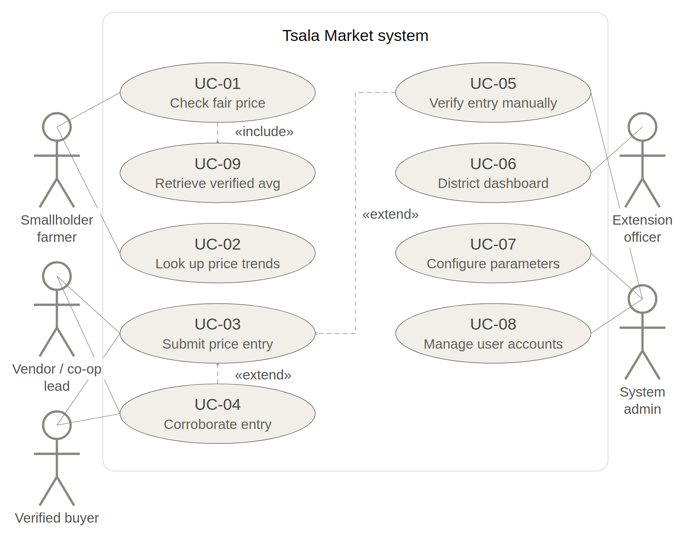
Figure 1 — Use-case diagram: actors, use cases, and include/extend relationships

4.4 Core use case — UC-01: Check Fair Price
Actor goal: a Smallholder Horticulture Farmer wants to know, before accepting or rejecting an offer, whether the price a buyer has just offered them is fair — a genuine decision, not a single click or field entry.
Primary actor: Smallholder Horticulture Farmer. Secondary actors: System (pricing engine), Extension Officer (anonymized log, asynchronous).
Main success scenario (condensed): the farmer selects “Check My Offer”, enters commodity, district and offered price; the system normalizes the price, retrieves the matching Verified bucket (30-day window), excludes outliers, computes the median reference, classifies a fairness flag and confidence label, attaches the mandatory disclaimer, logs an anonymized query, and returns the result. The farmer then accepts, negotiates, or seeks another buyer.
Alternative flows: A1 (no grade declared — defaults to Grade B); A2 (unrecognized unit — rejected at entry, not guessed); A3 (insufficient verified data — the required failure/exception condition: widen to a fallback bucket, or report insufficient data and issue no flag at all); A4 (farmer abandons the session — no result logged). Full step-by-step detail is in docs/use-cases/UC-01-check-fair-price.md.

4.5 Acceptance criteria
Seven Given-When-Then criteria were written against UC-01's main flow and its four alternative flows (full detail in docs/acceptance-criteria.md):
- AC-01: Fair offer returns the correct “Fair” flag and reference price
- AC-02: Underpaid offer returns “Significantly Underpaid” at the correct threshold boundary
- AC-03: Insufficient verified data triggers the fallback rather than a fabricated result
- AC-04: Unrecognized unit is rejected at entry, not silently converted
- AC-05: Ungraded lookup defaults to Grade B and states the assumption
- AC-06: Confidence label reflects sample size, submitter diversity and recency
- AC-07: Every result carries the indicative-guidance disclaimer, without exception

5. Quality requirements
Seven measurable quality-attribute scenarios were written in the full six-part form (source, stimulus, artifact, environment, response, response measure) so every response level is a number or a checkable pass/fail condition (full detail in docs/quality-scenarios.md):
ID | Attribute | Response measure
QS-01 | Performance | 95% of Fair Price Check requests return within 5 seconds end-to-end; 100% within 10 seconds
QS-02 | Availability | ≥99% uptime measured monthly; unplanned outages restored within 30 minutes
QS-03 | Usability | ≥80% of first-time USSD users complete a check unaided in ≤5 screens
QS-04 | Security / Privacy | 100% of audited records contain no farmer data more precise than district level
QS-05 | Reliability / Data integrity | 100% of entries beyond 1.5×IQR excluded from calculation and queued for review within 1 minute
QS-06 | Scalability | At 2,000 submissions/day, response time increase ≤20%; 0% of valid submissions dropped
QS-07 | Auditability | 100% of manual Admin actions logged within 1 second; zero omissions on spot-check

Each scenario translates into a concrete design obligation: QS-01/QS-06 constrain the PriceBucket aggregation implementation to an indexed, incrementally-updatable structure rather than a full recompute per query; QS-04/QS-11 constrain the data model to never persist farmer location below district granularity (BR-11); QS-05 constrains PriceBucket to run outlier exclusion before every reference calculation, not as an offline batch job; and QS-07 constrains AuditLogRecord to be append-only.

6. Analysis/domain model and responsibilities
A formal domain class model with attributes and multiplicities (models/domain-model.*) has not yet been produced — it is the next artefact planned (see Section 15). In its place, the candidate analysis classes below were derived directly from the business rules and are already load-bearing in the sequence diagram (Section 7), so this section documents responsibilities ahead of formal class modelling rather than after it.

6.1 Business rules and invariants
Twelve domain-level invariants were extracted — statements that must always hold true about the data and its state, independent of any screen (full detail in docs/business-rules.md):
Rule | Statement (summary)
BR-01 | A price entry has exactly one verification status at all times — never both, never unset
BR-02 | Verification status only promotes forward, under three defined conditions
BR-03 | All stored prices are normalized to P/kg; nothing is persisted in its original unit
BR-04 | An entry with no declared grade defaults to Grade B, never A or C
BR-05 | Only Verified entries within the trailing 30 days may feed a calculation
BR-06 | A bucket needs ≥5 independent Verified entries from ≥2 submitters before producing a result
BR-07 | Statistical outliers (>1.5×IQR) are excluded from calculation but never deleted
BR-08 | The reference price is always the median of qualifying entries, never the mean
BR-09 | Fairness classification thresholds apply uniformly unless reconfigured by an Admin
BR-10 | A result is never returned without a confidence label and disclaimer attached
BR-11 | Farmer location is never stored more precisely than district level
BR-12 | Every manual Admin action that alters an entry's classification is immutably logged

6.2 Responsibility allocation (CRC cards)
Six CRC cards allocate responsibilities to the class holding the information needed to perform them (information-expert principle), each with a stated design rationale (full detail in docs/crc-cards.md):
Class | Core responsibility | Key collaborators
PriceEntry | Knows its own commodity, grade, normalized price, verification status; converts its own unit and defaults its own grade | ConversionFactorTable, AuditLogRecord
PriceBucket | Pools qualifying entries, checks eligibility, excludes outliers, computes the median reference price | PriceEntry, SystemConfiguration
FairPriceCheckResult | Bundles the fairness flag, confidence label and disclaimer as one inseparable object | PriceBucket, SystemConfiguration
ConversionFactorTable | Owns the unit-to-kg conversion factors as centralized reference data | PriceEntry, Admin
AuditLogRecord | Immutable record of every manual Admin action and outlier exclusion | PriceEntry, PriceBucket, Admin
SystemConfiguration | Owns all Admin-adjustable thresholds and windows | PriceBucket, FairPriceCheckResult, Admin

Design rationale (representative example): AuditLogRecord is deliberately a separate class from PriceEntry rather than a self-tracked history field, because if PriceEntry tracked its own change history, an Admin correcting an entry could also quietly rewrite the record of that correction. The alternative considered — embedding a mutable change-log array on PriceEntry itself — was rejected because it cannot satisfy BR-12's immutability requirement without an external enforcement mechanism duplicating what a separate, append-only class provides for free.

7. Interaction and lifecycle

7.1 Interaction model — sequence diagram
The sequence diagram below models UC-01's main success scenario end to end, from the farmer's USSD interaction through to the logged, disclaimed result. Every lifeline is a real analysis element from Section 6 — not a generic “System” box — so every message corresponds to a responsibility a CRC card already claims. Two nested alt blocks capture the unrecognized-unit rejection (A2) and the insufficient-data fallback (A3), including the sub-case where even the fallback bucket does not qualify and no fairness flag is issued at all.
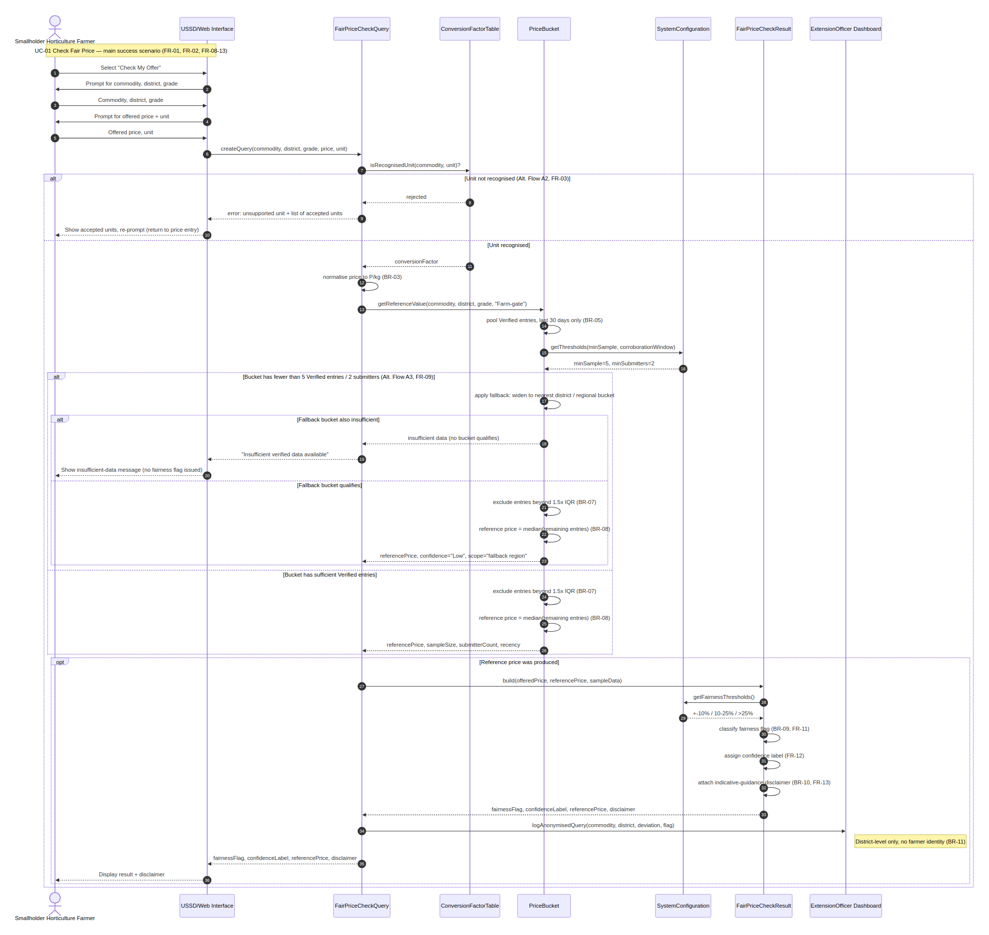
Figure 2 — Sequence diagram for UC-01: Check Fair Price

7.2 Lifecycle model — price entry verification
Rather than re-modelling the Fair Price Check interaction as an activity diagram (which would duplicate Figure 2), this lifecycle model captures the complementary side of the system: how a PriceEntry moves from Community-reported to Verified (BR-01/BR-02), and what happens to it afterward. Three swimlanes separate responsibility — the Submitter who creates the raw entry, the System that normalizes, defaults, and checks the three independent promotion conditions from BR-02, and the Admin who owns the manual-confirm path. Two exceptional outcomes are color-coded in amber: unit rejection at entry (FR-03) and outlier exclusion at calculation time (BR-07).
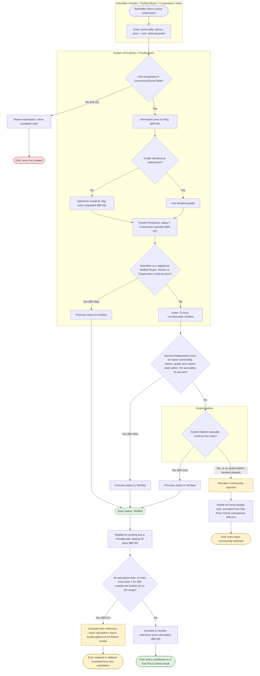
Figure 3 — Activity/lifecycle diagram: PriceEntry from submission to Verified status

7.3 Consistency explanation
Cross-checking all Phase 1 artefacts against each other (docs/consistency-matrix.md) surfaced three inconsistencies, tracked here rather than silently corrected so the review trail is visible:
- Gap 1 — undocumented class: FairPriceCheckQuery coordinates real behavior on the sequence diagram (query construction, calling ConversionFactorTable and PriceBucket, logging the anonymized query) but has no CRC card in Section 6.2. Resolution: add a seventh CRC card before the domain model is finalized.
- Gap 2 — grade-default modelled twice: BR-04 places grade-defaulting at submission time (Figure 3); UC-01's Alternative Flow A1 places it at lookup time, without either artefact acknowledging the other. Resolution: rename Alt. Flow A1 to be explicitly about lookup-time default-to-B for comparison purposes, distinct from BR-04's submission-time default.
- Gap 3 (highest risk) — unmodelled downgrade path: BR-02 asserts an Admin can “downgrade” a Verified entry back to Community-reported, but no FR describes it, Figure 3 has no Verified→Community-reported transition, and CRC-01 does not list it as a responsibility. This is the highest-risk gap under the Consistency marking criterion. Resolution adopted: BR-02's wording will be narrowed to remove the downgrade claim, and the capability will be listed as explicitly out of scope alongside the other exclusions in Section 2.6, rather than left as an unmodelled implication.

8. Architecture and decisions
Not yet due for this Phase 1 submission. Architecture drivers and alternatives will be derived from the quality scenarios in Section 5 (particularly QS-01 performance and QS-06 scalability) once Phase 2 begins. No ADRs exist yet — the first is expected to cover the choice between a relational store (favored by the bucket/median aggregation in BR-05–BR-08) versus a document store for PriceEntry.

9. Data, API/service and deployment design
Not yet due for this Phase 1 submission. The logical data model will formalize the six candidate classes from Section 6.2 into a schema; API contracts for the USSD/web dual-channel access pattern (FR-14) are not yet specified. Scheduled for Phase 2.

10. Detailed design, patterns and framework
Not yet due for this Phase 1 submission. Interface/class-level design, applicable patterns (e.g. Strategy for the pluggable fairness-classification thresholds in BR-09), and framework choice are deferred until the architecture in Section 8 is settled.

11. User-interface, accessibility and usability
Not yet due for this Phase 1 submission. Task flows and wireframes for the USSD menu (constrained by QS-03's ≤5-screen usability target) and the web dashboard have not yet been produced. Scheduled for Phase 2, alongside a usability test against QS-03's response measure.

12. Implementation vertical slice
Not yet due for this Phase 1 submission. No code has been written yet. The planned first vertical slice is UC-01 (Check Fair Price) end-to-end, since it is the only use case fully dressed and sequence-modelled so far (Sections 4.4 and 7.1). Repository structure and setup instructions will be added once implementation begins.

13. Testing and results
Not yet due for this Phase 1 submission. No tests have been executed against running code. The seven acceptance criteria (Section 4.5) and seven quality scenarios (Section 5) are already written in a directly testable form and are intended to become the first test suite once the Section 12 vertical slice exists.

14. Reconciliation and change history
Not yet due for this Phase 1 submission. There is no code yet to reconcile against the model. This section will track any point where implementation reveals a model must change — the reverse direction of the three consistency gaps already tracked in Section 7.3, which were found by cross-checking models against each other rather than against code.

15. Risks, technical debt and release recommendation
Residual risks and technical debt carried forward from Phase 1:
- The three consistency gaps in Section 7.3 remain open at time of writing; Gap 3 (BR-02's unmodelled downgrade path) is scheduled for correction before the next commit and is the single highest risk to the Consistency marking criterion if left unresolved.
- Ten of seventeen functional requirements have concrete acceptance-criteria or quality-scenario evidence; the remaining seven (mostly FR-04, FR-06, FR-14, FR-17) are traced to a use case and analysis element but await dressed use cases for UC-02–UC-08.
- No formal domain class model exists yet (Section 6) — candidate classes are consistent across CRC cards, business rules and the sequence/lifecycle diagrams, but have not been checked for correct multiplicities.
- Sections 8–14 are entirely unstarted, as this is a Phase 1 (analysis and design) submission; the release recommendation is therefore: not ready for any release, further design and implementation work required before Phase 2 review.

16. Academic integrity and AI-use record
An AI assistant (Claude, Anthropic) was used throughout the Phase 1 laboratories to help draft and structure artefacts: functional requirements, the use-case model and UC-01's full dress, acceptance criteria, quality scenarios, business rules, CRC cards, the sequence and lifecycle diagrams, the traceability and consistency matrices, and the assembly of this report from the team's approved project proposal and BAMB reference documents.
The assistant was used for drafting, structuring, and cross-checking consistency across artefacts (including surfacing the three gaps recorded in Section 7.3) rather than for making independent domain decisions — the underlying problem, evidence, and scope originate from the team's own approved Project Problem Proposal.
This section is a draft disclosure and should be reviewed and confirmed by the team before submission: the team should verify that every generated artefact was read, understood, and where necessary corrected by a team member, and adjust the description above to accurately reflect which specific contributions were AI-drafted versus team-authored, per the module's academic integrity policy.

References
- Botswana Agricultural Marketing Board (2026) Producer/Market Prices for Scheduled Produce, July/August 2026. Internal pricing notice, signed L. C. Scheepers, Chief Executive Officer.
- Botswana Agricultural Marketing Board (2020) 2020/2021 Production Contract Prices. Internal pricing schedule, signed L. Morakaladi, Chief Executive Officer.
- University of Botswana, CSI473 (2026) Laboratory 2–5 Student Briefs and Project Problem Proposal and Approval Form template. Course materials, Semester 1, 2026/27.

Appendices
- Appendix A: Approval form — CSI473_Project_Problem_Proposal_and_Approval_Form.docx (submitted separately, Laboratory 2).
- Appendix B: Traceability matrix — full requirement → use case → analysis element → verification chain, docs/traceability-matrix.md (summarized in Section 4.1).
- Appendix C: Consistency matrix — full cross-check detail behind Section 7.3, docs/consistency-matrix.md.
- Appendix D: ADRs — none recorded yet; to be added once architecture work begins in Phase 2 (Section 8).
- Appendix E: Contribution record — to be added before final submission.

