ANVL ATHLETICS
FORGED UNDER PRESSURE
Professional Brand Document
Brand Identity | Design System | Drop 01: The Oath
A body built through pressure, repetition, discipline, and heat.
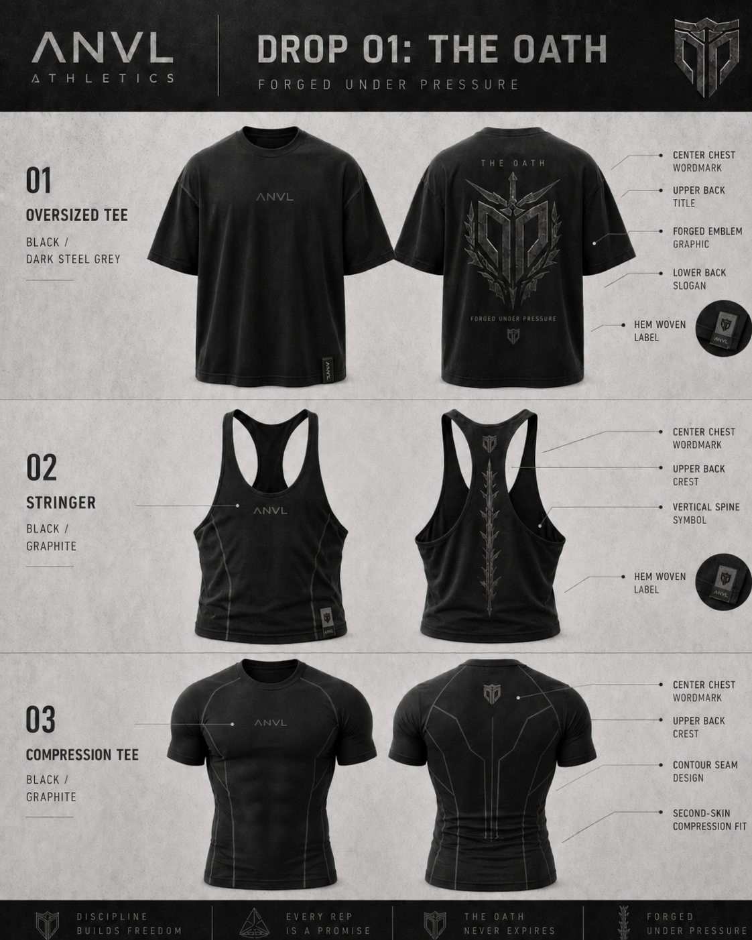
Approved product direction board for ANVL Athletics - Drop 01: The Oath

00

Contents
A structured guide for the ANVL Athletics brand and first product drop.

Section | Description
1. Brand Foundation | Brand name, meaning, tagline, target audience, positioning, and tone.
2. Branding System | Logo system, color palette, typography, visual language, and brand phrases.
3. Design Assets | Approved design boards, logo/graphic system notes, and garment placement system.
4. First Drop: The Oath | Collection overview, product lineup, colorways, and strategic role.
5. Product Specifications | Detailed specs for oversized tee, stringer, and compression tee.
6. Production & Quality Notes | Fabric, print, sample testing, and supplier communication requirements.
7. Decision Log | Summary of locked decisions so far.

01

Brand Foundation
The strategic base of ANVL Athletics.

ANVL Athletics is a premium bodybuilding gymwear brand built around the idea that a strong body is forged through pressure, repetition, discipline, and heat. The brand should feel international and refined, with a darker, more serious lifting identity than generic local activewear.
Element | Locked Direction
Full Name | ANVL Athletics
Short Mark | ANVL
Tagline | Forged Under Pressure
Brand Meaning | A body built through pressure, repetition, discipline, and heat.
Drop 01 Name | The Oath
Core Category | Premium bodybuilding gymwear
Primary Market | Lebanon - male lifters and serious gym culture, with scalable international appeal
Brand Personality | Disciplined, powerful, premium, industrial, subtle warrior-coded, serious but not costume-like

Target Customer
Male lifters, approximately 18-35, who value physique-enhancing gymwear and premium aesthetics.
Customers who like the energy of Gymshark, YoungLA, Alphalete, Darc Sport, and Squatwolf, but want a local brand with a distinct identity.
People who want gymwear that works during training but still looks strong outside the gym.

Positioning Statement
ANVL Athletics creates premium bodybuilding gymwear for serious lifters - forged through discipline, built to enhance the physique, and designed with subtle warrior-inspired details that feel modern, dark, and premium.

02

Branding System
Logo, colors, typography, language, and visual identity rules.

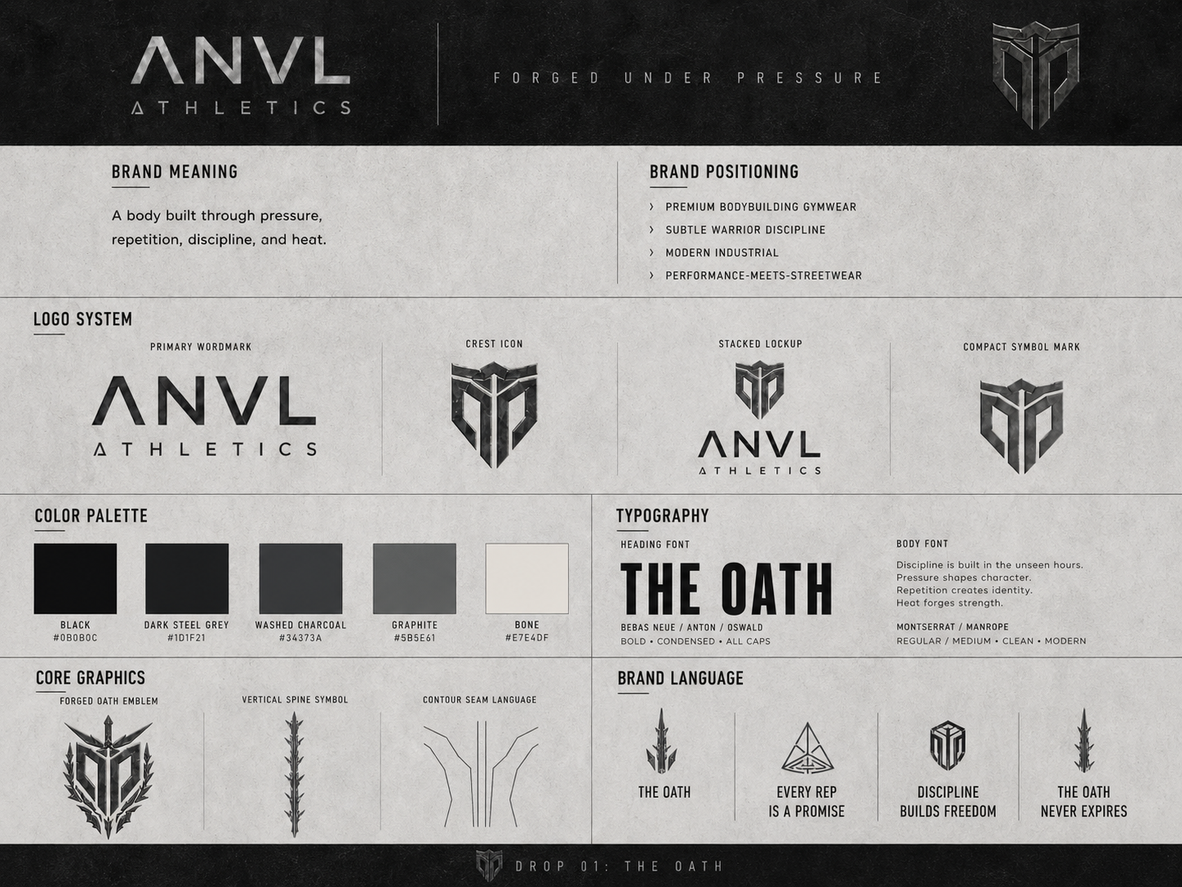
Approved ANVL Athletics brand identity board

Logo System
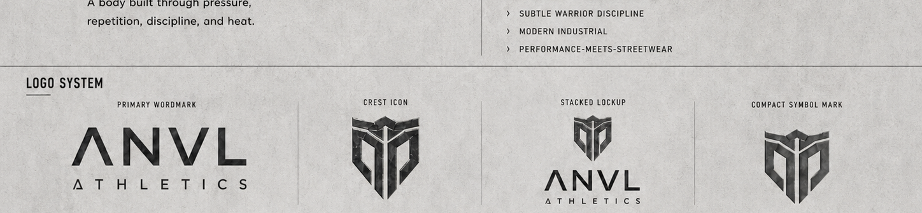
Logo system: primary wordmark, crest icon, stacked lockup, and compact symbol mark
Logo Asset | Usage
Primary Wordmark: ANVL | Use as the main visible mark on product fronts, website header, packaging, and social content.
Full Lockup: ANVL Athletics | Use for brand documents, tags, packaging, profile headers, and formal brand presentation.
Crest / Shield Icon | Use as the recurring symbol on upper back, hem labels, packaging seals, and micro-details.
Compact Symbol Mark | Use where space is limited: woven label, neck print, favicon, sticker, or zipper/label detail.

Color Palette & Typography
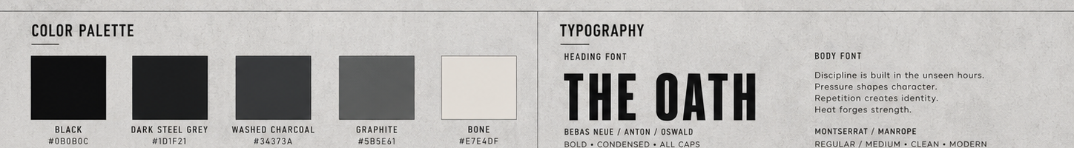
Color palette and typography direction
Color | Hex | Recommended Use
Black | #0B0B0C | Primary brand base, garments, backgrounds, high-end visuals.
Dark Steel Grey | #1D1F21 | Tonal graphics, steel accents, oversized tee graphic color.
Washed Charcoal | #34373A | Washed tee body color and secondary dark base.
Graphite | #5B5E61 | Seam lines, compression details, subtle logo accents.
Bone | #E7E4DF | Minimal contrast accent, especially on charcoal stringer.

Type Role | Recommended Direction
Headings | Bold condensed sans, all caps - examples: Bebas Neue, Anton, Oswald.
Body Copy | Clean modern sans - examples: Montserrat, Manrope.
Logo/Wordmark | Custom angular geometric wordmark inspired by ANVL concept, not a generic font.
Text Style | Wide letter spacing, uppercase micro-copy, disciplined spacing, minimal slogans.

03

Design Assets
Approved visual boards and graphic language.

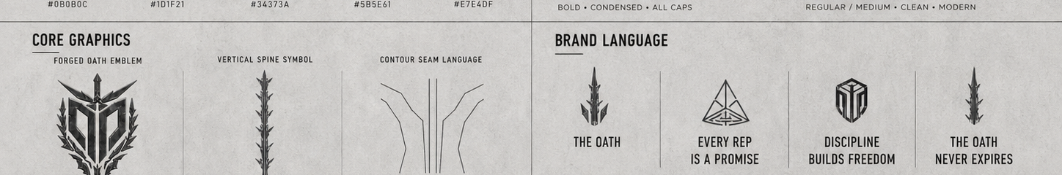
Core graphics and brand language system

Core Graphic Assets
Forged oath emblem / sigil: used on the oversized tee back graphic. It should feel like vow, discipline, protection, and commitment.
Vertical spine symbol: used on the stringer back. It should be longer than the first concept and run farther down the back.
Contour seam language: used on the compression tee to create a sculpted, superhero-like performance look.
Crest icon: used repeatedly as the premium symbol mark across the drop.

Graphic Placement System
Product | Front | Back | Text Level
Oversized Tee | Small centered ANVL chest wordmark. | The Oath title, forged oath emblem/sigil, Forged Under Pressure slogan, lower crest. | Highest storytelling.
Stringer | Small centered ANVL chest wordmark. | Upper-back crest plus longer vertical spine symbol. | Low - no slogan text.
Compression Tee | Small centered ANVL chest wordmark. | Upper-back crest and tonal contour seam / panel design. | Very low - no slogan text.


Final approved product design board with latest refinements

04

First Drop: The Oath
A compact first collection designed to validate market demand while establishing ANVL’s visual DNA.

Drop 01, The Oath, should introduce ANVL Athletics through three strong product categories: a heavyweight oversized tee, a premium old-school stringer, and a strong superhero-like compression tee. Each product has two planned colorways, but the design language remains cohesive through the same dark forged palette and shared logo system.
Product | Strategic Role | Colorways
Oversized Tee | Statement hero piece / pump-cover / streetwear identity. | Black + Dark Steel Grey; Washed Charcoal + Black
Stringer | Bodybuilding identity piece / old-school lifter cut. | Black + Graphite; Charcoal + Bone
Compression Tee | Technical hero item / superhero-like physique enhancement. | Black + Graphite; Dark Steel Grey + Black

Collection Design Rule
Each piece should use one dominant base color and one secondary accent color. Accents should appear in logos, seam lines, graphics, woven labels, or small details - not as loud color blocking. The overall balance should remain premium and controlled.

05

Product Specifications
Detailed item-level direction for the first ANVL drop.

5.1 Oversized Tee
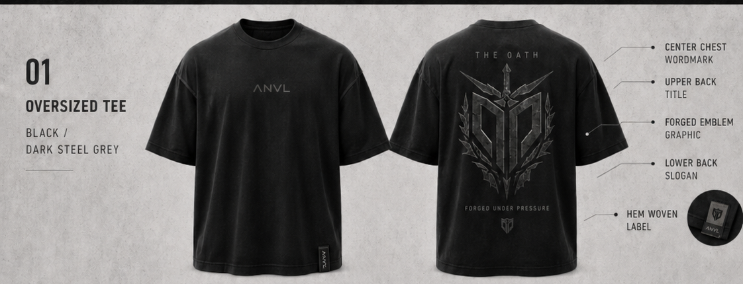
Oversized Tee - approved graphic placement and fit direction
Category | Specification
Role | Main statement piece and visual storytelling item.
Fit | Regular oversized length, boxy silhouette, drop shoulders, wide sleeves, thick collar. Not cropped.
Feel | Heavy streetwear pump-cover feel. Structured and premium.
Fabric | 100% heavyweight cotton jersey.
Target GSM | 240-260 GSM.
Construction | Thick ribbed crew neck, reinforced shoulder seams, double stitching, strong hem finish.
Front Design | Small centered ANVL wordmark.
Back Design | The Oath title, large forged oath emblem/sigil, Forged Under Pressure slogan, small crest.
Colorways | Black + Dark Steel Grey; Washed Charcoal + Black.
Quality Checks | Wash 3-5 times, inspect shrinkage, neck stretch, print cracking, shape retention, opacity, and overall premium feel.

5.2 Stringer
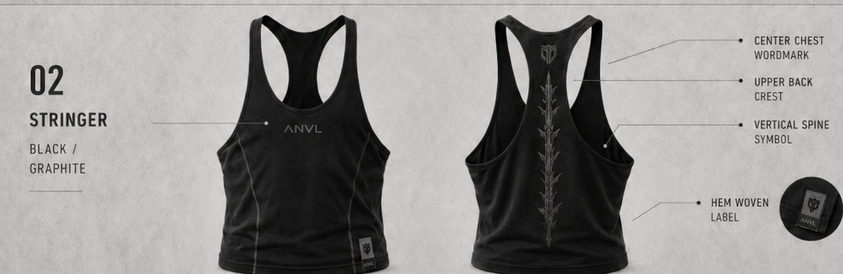
Stringer - premium old-school cut with longer back spine symbol
Category | Specification
Role | Bodybuilding identity piece; the most gym-specific item in the drop.
Fit | Premium old-school lifter stringer; more revealing than normal tank, controlled deep armholes, racerback, wider straps than extreme classic version.
Feel | Soft, breathable, stretchy, premium, not flimsy.
Fabric | Stretch cotton blend, recommended 95% cotton / 5% elastane or equivalent premium blend.
Target GSM | 180-220 GSM.
Construction | Shape-retentive training garment; comfortable on skin; reinforced edges around armholes and neck.
Front Design | Small centered ANVL wordmark.
Back Design | Upper-back crest and longer vertical forged/spine symbol. No slogan text.
Colorways | Black + Graphite; Charcoal + Bone.
Quality Checks | Test stretch recovery, armhole comfort, chest coverage, back cut, wash stability, and label placement.

5.3 Compression Tee
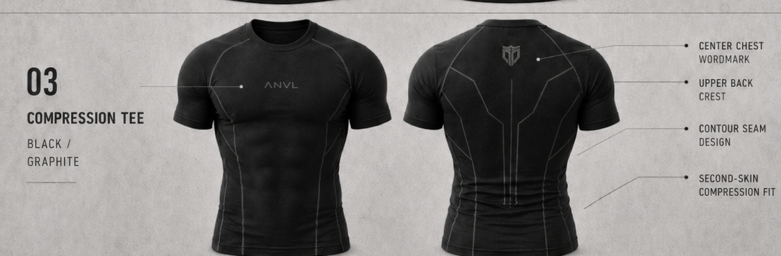
Compression Tee - strong superhero-like compression direction
Category | Specification
Role | Technical hero item and strongest performance product.
Fit | Strong compression, superhero-like, second-skin, ultra-fitted chest/shoulders/arms/torso.
Feel | Smooth, dense, supportive, physique-enhancing, premium performance.
Fabric | Recommended 72% polyamide / 21% polyester / 7% elastane.
Target GSM | 270-300 GSM.
Construction | 4-way stretch, sweat-wicking, strong recovery after stretch, contour seam/panel construction.
Front Design | Small centered ANVL chest wordmark.
Back Design | Upper-back crest and tonal angular contour seam language. No slogan text.
Colorways | Black + Graphite; Dark Steel Grey + Black.
Quality Checks | Test compression strength, breathability, sleeve tightness, stretch recovery, seam comfort, and print stretch performance.

06

Production & Quality Notes
Guidance for FittDesign, manufacturers, and sample review.

Supplier / Designer Brief
The supplier should treat this document as a creative and technical direction guide. Exact factory-ready tech packs still need final graded measurements, size specs, seam details, print method confirmation, fabric sourcing, and sample approval.
Confirm whether design costs are per product or for the full three-product drop.
Request factory-ready tech packs for each product, including measurement/spec sheets and print placement dimensions.
Ask for fabric swatches before sampling, especially for the compression tee fabric density and stretch recovery.
Produce and test samples before committing to bulk production.
Keep the first production run small and focused to test the Lebanese market.

Print & Branding Finish Recommendations
Product | Recommended Finish
Oversized Tee | Matte screen print, water-based print, or premium high-density print for the forged back emblem. Avoid cheap shiny print.
Stringer | Soft flexible print or high-quality heat transfer that does not crack with stretch.
Compression Tee | Technical heat transfer or silicone transfer that stretches cleanly with compression fabric.
Labels | Woven hem label plus inside neck print instead of scratchy neck tag.

Sample Approval Checklist
Fit matches intended silhouette on an athletic body: oversized tee, old-school stringer, strong compression tee.
Fabric feels premium and holds shape after 3-5 washes.
Logos are correctly placed, centered, and proportioned.
Back graphics are readable but subtle and premium.
Compression tee does not become see-through under stretch.
Stringer is revealing but still sellable and not too extreme.
Packaging and labels feel aligned with the premium dark industrial identity.

07

Decision Log
All major locked decisions to date.

Area | Decision
Brand Name | ANVL Athletics
Tagline | Forged Under Pressure
Brand Meaning | A body built through pressure, repetition, discipline, and heat.
Drop Name | Drop 01: The Oath
Brand Direction | Premium bodybuilding gymwear with subtle abstract warrior/discipline identity.
Logo Direction | Approved ANVL wordmark and crest/shield direction from concept board.
Oversized Tee | Heavy streetwear, regular oversized length, not cropped; 240-260 GSM cotton.
Stringer | Premium old-school lifter cut; more revealing; longer back spine symbol; 180-220 GSM stretch cotton.
Compression Tee | Strong superhero-like compression; 72/21/7 polyamide-polyester-elastane; 270-300 GSM.
Visual Refinement | Oversized tee back graphic should be more oath-related: forged sigil/emblem, shield/crest, vow/discipline/protection/commitment feeling.
Approved Aesthetic | Premium industrial lookbook style with black, graphite, charcoal, dark steel grey, and bone accents.

Note: all names, logos, and symbols are creative working directions. Before production, conduct trademark/domain/social-handle checks and confirm commercial usage rights for any final fonts, marks, and graphics.

