ml_hw10

Mohammad

2023-04-04

### Data preparation

First we load the exposome data file then merge exposome and phenotype data sets, then remove the ID variable. Next, we partition the data into training and testing data (70/30 split)

#Load data using path of where file is stored  
load("/Users/mofouda/Desktop/Spring 23/Machine learning/Assignmets/hw10/ml_hw10/data/exposome.RData")  
  
#Merge all data frames into a single data frame  
studydata <-   
 merge(exposome, phenotype, by="ID") %>%   
 merge(covariates, by="ID") %>%   
 select(-ID)  
  
#Partition data for use in demonstration  
set.seed(123)  
  
train.index <-   
 studydata$e3_bw %>%   
 createDataPartition(p = 0.7, list = FALSE)  
  
train_df <-   
 studydata[train.index, ]  
  
test_df <-   
 studydata[-train.index, ]

### Step 1: Data Exploration of Training Data

In this step we perform some data exploration by providing some descriptive measures (for continuous measures: means and ranges, for categorical/binary: frequency counts), examining correlations between features, examining missingness.

The studydata dataframe has 1301 observations and 241 features.

str(studydata)

## 'data.frame': 1301 obs. of 241 variables:  
## $ h_abs_ratio_preg_Log : num 0.8967 0.8925 0.7787 0.0891 0.6048 ...  
## $ h_no2_ratio_preg_Log : num 2.87 2.98 3.06 3.09 3.85 ...  
## $ h_pm10_ratio_preg_None : num 25.9 25.9 26.1 15 35.2 ...  
## $ h_pm25_ratio_preg_None : num 17.4 18.5 18.7 16.4 14.9 ...  
## $ hs_no2_dy_hs_h_Log : num 2.53 1.93 2.88 1.39 3.2 ...  
## $ hs_no2_wk_hs_h_Log : num 2.58 2.65 2.59 2.46 3.5 ...  
## $ hs_no2_yr_hs_h_Log : num 2.61 2.76 2.36 2.4 3.31 ...  
## $ hs_pm10_dy_hs_h_None : num 22.5 14.1 46.9 29.8 29.8 ...  
## $ hs_pm10_wk_hs_h_None : num 20.9 29.1 31.5 25.2 24.9 ...  
## $ hs_pm10_yr_hs_h_None : num 31.4 31.3 27.5 24 24.8 ...  
## $ hs_pm25_dy_hs_h_None : num 16.95 11.16 28.45 4.62 14.92 ...  
## $ hs_pm25_wk_hs_h_None : num 17 15.9 21.3 11 13.9 ...  
## $ hs_pm25_yr_hs_h_None : num 18.4 17.7 16.8 12.7 13.4 ...  
## $ hs_pm25abs_dy_hs_h_Log : num 0.0974 -0.4304 0.9156 -0.2833 0.9156 ...  
## $ hs_pm25abs_wk_hs_h_Log : num 0.0712 0.2143 0.7197 -0.1387 -0.138 ...  
## $ hs_pm25abs_yr_hs_h_Log : num 0.3211 0.2815 0.0987 0.1777 0.2205 ...  
## $ h_accesslines300_preg_dic0 : num 0 0 0 1 1 0 0 0 0 0 ...  
## $ h_accesspoints300_preg_Log : num 1.96 2.37 1.27 4.53 3.06 ...  
## $ h_builtdens300_preg_Sqrt : num 405 311 375 565 585 ...  
## $ h_connind300_preg_Sqrt : num 1.89 6.54 6.26 14.49 18.68 ...  
## $ h_fdensity300_preg_Log : num 10.3 10.3 10.3 13.8 12.2 ...  
## $ h_frichness300_preg_None : num 0 0 0 0.2456 0.0877 ...  
## $ h_landuseshan300_preg_None : num 0.364 0.401 0.288 0.633 0.459 ...  
## $ h_popdens_preg_Sqrt : num 85 85 85 66.5 96.2 ...  
## $ h_walkability_mean_preg_None: num 0.175 0.2 0.15 0.35 0.275 0.35 0.2 0.225 0.175 0.375 ...  
## $ hs_accesslines300_h_dic0 : num 0 0 0 1 1 0 0 0 0 0 ...  
## $ hs_accesspoints300_h_Log : num 1.675 2.774 0.577 4.584 3.621 ...  
## $ hs_builtdens300_h_Sqrt : num 407 383 375 480 210 ...  
## $ hs_connind300_h_Log : num 4.57 3.75 2.88 5.47 4.82 ...  
## $ hs_fdensity300_h_Log : num 10.3 10.3 10.3 14 11 ...  
## $ hs_landuseshan300_h_None : num 0.354 0.321 0.479 0.454 0.51 ...  
## $ hs_popdens_h_Sqrt : num 84.99 10.25 10.25 66.54 4.56 ...  
## $ hs_walkability_mean_h_None : num 0.375 0.2 0.25 0.525 0.3 0.375 0.3 0.325 0.275 0.525 ...  
## $ hs_accesslines300_s_dic0 : num 0 0 0 1 0 0 0 0 0 0 ...  
## $ hs_accesspoints300_s_Log : num 0.577 2.186 2.186 3.285 2.186 ...  
## $ hs_builtdens300_s_Sqrt : num 385 383.6 366.4 406.3 61.9 ...  
## $ hs_connind300_s_Log : num 2.37 3.47 3.98 5.65 4.74 ...  
## $ hs_fdensity300_s_Log : num 10.3 10.3 10.3 12.3 11 ...  
## $ hs_landuseshan300_s_None : num 0.28 0.368 0.325 0.521 0.521 ...  
## $ hs_popdens_s_Sqrt : num 84.99 84.99 84.99 25.71 4.56 ...  
## $ h_Absorbance_Log : num -0.1351 -0.0577 -0.4372 -0.8705 0.564 ...  
## $ h_Benzene_Log : num 0.572 0.88 1.379 1.168 0.133 ...  
## $ h_NO2_Log : num 4.58 3.37 4.3 2.5 6.92 ...  
## $ h_PM_Log : num 2.6 2.33 2.33 1.66 3.62 ...  
## $ h_TEX_Log : num 2.53 2.84 2.88 2.67 3.43 ...  
## $ e3_alcpreg_yn_None : Factor w/ 2 levels "0","1": 1 1 1 1 1 1 1 2 1 1 ...  
## $ h_bfdur_Ter : Factor w/ 3 levels "(0,10.8]","(10.8,34.9]",..: 1 1 3 2 2 3 1 3 1 1 ...  
## $ h_cereal_preg_Ter : Factor w/ 3 levels "(0,9]","(9,27.3]",..: 1 1 2 3 1 3 2 1 3 1 ...  
## $ h_dairy_preg_Ter : Factor w/ 3 levels "(0,17.1]","(17.1,27.1]",..: 3 3 3 1 1 3 3 2 1 3 ...  
## $ h_fastfood_preg_Ter : Factor w/ 3 levels "(0,0.25]","(0.25,0.83]",..: 2 3 3 3 3 2 3 3 3 3 ...  
## $ h_fish_preg_Ter : Factor w/ 3 levels "(0,1.9]","(1.9,4.1]",..: 3 3 3 1 3 3 1 2 2 2 ...  
## $ h_folic_t1_None : Factor w/ 2 levels "0","1": 1 1 2 1 1 1 1 1 1 2 ...  
## $ h_fruit_preg_Ter : Factor w/ 3 levels "(0,0.6]","(0.6,18.2]",..: 2 2 2 2 2 2 2 3 2 2 ...  
## $ h_legume_preg_Ter : Factor w/ 3 levels "(0,0.5]","(0.5,2]",..: 3 3 3 3 2 3 2 3 2 3 ...  
## $ h_meat_preg_Ter : Factor w/ 3 levels "(0,6.5]","(6.5,10]",..: 2 3 2 3 1 3 1 3 1 1 ...  
## $ h_pamod_t3_None : Factor w/ 4 levels "None","Often",..: 4 1 2 2 4 4 3 2 2 4 ...  
## $ h_pavig_t3_None : Factor w/ 3 levels "High","Low","Medium": 2 2 2 3 3 3 2 2 2 2 ...  
## $ h_veg_preg_Ter : Factor w/ 3 levels "(0,8.8]","(8.8,16.5]",..: 2 2 2 1 2 2 1 1 2 1 ...  
## $ hs_bakery_prod_Ter : Factor w/ 3 levels "(0,2]","(2,6]",..: 2 1 2 3 2 2 3 3 3 3 ...  
## $ hs_beverages_Ter : Factor w/ 3 levels "(0,0.132]","(0.132,1]",..: 3 2 2 1 2 1 3 1 1 3 ...  
## $ hs_break_cer_Ter : Factor w/ 3 levels "(0,1.1]","(1.1,5.5]",..: 1 1 2 3 2 3 2 2 3 3 ...  
## $ hs_caff_drink_Ter : Factor w/ 2 levels "(0,0.132]","(0.132,Inf]": 1 2 2 1 1 1 2 1 1 1 ...  
## $ hs_dairy_Ter : Factor w/ 3 levels "(0,14.6]","(14.6,25.6]",..: 1 1 1 3 1 3 3 3 2 2 ...  
## $ hs_fastfood_Ter : Factor w/ 3 levels "(0,0.132]","(0.132,0.5]",..: 2 2 2 2 2 1 2 3 3 3 ...  
## $ hs_KIDMED_None : num 2 0 1 2 4 5 2 3 3 3 ...  
## $ hs_mvpa_prd_alt_None : num 47.89 31.83 117.58 -2.03 -7.85 ...  
## $ hs_org_food_Ter : Factor w/ 3 levels "(0,0.132]","(0.132,1]",..: 2 3 2 2 1 3 2 1 3 1 ...  
## $ hs_pet_cat_r2_None : Factor w/ 2 levels "0","1": 1 1 1 2 1 1 2 1 1 2 ...  
## $ hs_pet_dog_r2_None : Factor w/ 2 levels "0","1": 1 1 1 1 2 1 1 1 1 1 ...  
## $ hs_pet_None : Factor w/ 2 levels "No","Yes": 2 1 1 2 2 2 2 1 2 2 ...  
## $ hs_proc_meat_Ter : Factor w/ 3 levels "(0,1.5]","(1.5,4]",..: 2 2 3 1 3 3 2 2 1 1 ...  
## $ hs_readymade_Ter : Factor w/ 3 levels "(0,0.132]","(0.132,0.5]",..: 1 3 3 3 1 1 2 3 1 1 ...  
## $ hs_sd_wk_None : num 389 523 446 180 454 ...  
## $ hs_total_bread_Ter : Factor w/ 3 levels "(0,7]","(7,17.5]",..: 1 3 1 3 2 3 1 2 3 2 ...  
## $ hs_total_cereal_Ter : Factor w/ 3 levels "(0,14.1]","(14.1,23.6]",..: 1 2 2 3 2 3 1 1 3 2 ...  
## $ hs_total_fish_Ter : Factor w/ 3 levels "(0,1.5]","(1.5,3]",..: 1 1 1 2 3 3 1 2 2 2 ...  
## $ hs_total_fruits_Ter : Factor w/ 3 levels "(0,7]","(7,14.1]",..: 3 1 1 3 3 3 1 2 3 3 ...  
## $ hs_total_lipids_Ter : Factor w/ 3 levels "(0,3]","(3,7]",..: 3 3 3 2 3 2 1 3 3 3 ...  
## $ hs_total_meat_Ter : Factor w/ 3 levels "(0,6]","(6,9]",..: 2 1 3 1 2 3 1 1 1 1 ...  
## $ hs_total_potatoes_Ter : Factor w/ 3 levels "(0,3]","(3,4]",..: 3 2 2 1 1 3 1 3 1 3 ...  
## $ hs_total_sweets_Ter : Factor w/ 3 levels "(0,4.1]","(4.1,8.5]",..: 1 3 3 3 1 3 1 2 3 2 ...  
## $ hs_total_veg_Ter : Factor w/ 3 levels "(0,6]","(6,8.5]",..: 3 2 3 3 1 3 1 3 1 2 ...  
## $ hs_total_yog_Ter : Factor w/ 3 levels "(0,6]","(6,8.5]",..: 1 1 1 3 1 3 3 2 1 1 ...  
## $ hs_dif_hours_total_None : num 9.46 9.6 9.97 10.09 10.52 ...  
## $ hs_as_c_Log2 : num -4.283 -6.43 -7.978 0.632 0.651 ...  
## $ hs_as_m_Log2 : num -19.5 -9.58 -14.92 1.84 1.29 ...  
## $ hs_cd_c_Log2 : num -4.14 -4.25 -4.05 -5.26 -3.75 ...  
## $ hs_cd_m_Log2 : num -3.071 -2.599 -2.966 -0.935 -0.935 ...  
## $ hs_co_c_Log2 : num 1.02 -2.62 -2.56 -3 -1.61 ...  
## $ hs_co_m_Log2 : num -4.08 -2.41 -2.63 -2.81 -0.55 ...  
## $ hs_cs_c_Log2 : num 0.251 0.202 0.39 0.669 0.903 ...  
## $ hs_cs_m_Log2 : num 0.151 -0.272 0.536 0.714 0.138 ...  
## $ hs_cu_c_Log2 : num 9.71 9.94 9.93 10.19 9.44 ...  
## $ hs_cu_m_Log2 : num 10.22 10.51 10.26 10.09 9.89 ...  
## $ hs_hg_c_Log2 : num -2.152 -1.3 -0.911 1.48 2.862 ...  
## $ hs_hg_m_Log2 : num -3.1203 -1.0233 0.0841 2.211 3.2345 ...  
## $ hs_mn_c_Log2 : num 3.46 2.88 3 3.22 2.88 ...  
## $ hs_mn_m_Log2 : num 3.61 4.16 2.88 3.25 3.49 ...  
## $ hs_mo_c_Log2 : num 0.949 1.07 -0.484 -5.866 -0.252 ...  
## [list output truncated]

#Descriptive statistics  
summaries <-  
 studydata %>%   
 select(h_abs_ratio_preg_Log, hs_no2_dy_hs_h_Log, h_accesspoints300_preg_Log, hs_walkability_mean_h_None,  
 h_Benzene_Log, h_NO2_Log, e3_alcpreg_yn_None, h_dairy_preg_Ter, h_meat_preg_Ter, h_pamod_t3_None,  
 hs_cu_c_Log2, hs_pfoa_m_Log2, e3_asmokcigd_p_None, h_trafnear_preg_pow1over3, hs_wgtgain_None,  
 e3_sex_None, h_edumc_None, hs_child_age_None,hs_asthma, hs_zbmi_who, hs_Gen_Tot, e3_bw) %>%   
 summary()  
  
summaries

## h_abs_ratio_preg_Log hs_no2_dy_hs_h_Log h_accesspoints300_preg_Log  
## Min. :-0.47756 Min. :0.3797 Min. :1.270   
## 1st Qu.: 0.09776 1st Qu.:2.2867 1st Qu.:1.963   
## Median : 0.30203 Median :2.9618 Median :2.879   
## Mean : 0.39089 Mean :2.8307 Mean :2.670   
## 3rd Qu.: 0.72516 3rd Qu.:3.4474 3rd Qu.:3.349   
## Max. : 1.70921 Max. :5.1849 Max. :4.528   
## hs_walkability_mean_h_None h_Benzene_Log h_NO2_Log   
## Min. :0.100 Min. :-0.3296 Min. :1.573   
## 1st Qu.:0.275 1st Qu.: 0.3141 1st Qu.:2.979   
## Median :0.300 Median : 0.5600 Median :3.617   
## Mean :0.326 Mean : 0.5987 Mean :3.833   
## 3rd Qu.:0.375 3rd Qu.: 0.8437 3rd Qu.:4.576   
## Max. :0.600 Max. : 1.9975 Max. :7.093   
## e3_alcpreg_yn_None h_dairy_preg_Ter h_meat_preg_Ter h_pamod_t3_None  
## 0:896 (0,17.1] :270 (0,6.5] :427 None : 42   
## 1:405 (17.1,27.1]:380 (6.5,10]:387 Often :474   
## (27.1,Inf] :651 (10,Inf]:487 Sometimes :191   
## Very Often:594   
##   
##   
## hs_cu_c_Log2 hs_pfoa_m_Log2 e3_asmokcigd_p_None  
## Min. : 9.079 Min. :-5.4760 Min. : 0.000   
## 1st Qu.: 9.681 1st Qu.: 0.4107 1st Qu.: 0.000   
## Median : 9.828 Median : 1.2007 Median : 0.000   
## Mean : 9.828 Mean : 1.0479 Mean : 0.494   
## 3rd Qu.: 9.966 3rd Qu.: 1.7450 3rd Qu.: 0.000   
## Max. :12.123 Max. : 4.9836 Max. :15.238   
## h_trafnear_preg_pow1over3 hs_wgtgain_None e3_sex_None h_edumc_None  
## Min. : 0.000 Min. : 0.0 female:608 1:178   
## 1st Qu.: 7.937 1st Qu.: 9.0 male :693 2:449   
## Median :12.119 Median :12.0 3:674   
## Mean :14.989 Mean :13.5   
## 3rd Qu.:21.397 3rd Qu.:18.0   
## Max. :39.321 Max. :55.0   
## hs_child_age_None hs_asthma hs_zbmi_who hs_Gen_Tot   
## Min. : 5.437 Min. :0.0000 Min. :-3.5800 Min. : 0.00   
## 1st Qu.: 6.500 1st Qu.:0.0000 1st Qu.:-0.4000 1st Qu.: 10.00   
## Median : 8.033 Median :0.0000 Median : 0.2800 Median : 20.00   
## Mean : 7.976 Mean :0.1091 Mean : 0.4032 Mean : 24.38   
## 3rd Qu.: 8.920 3rd Qu.:0.0000 3rd Qu.: 1.1300 3rd Qu.: 33.44   
## Max. :12.101 Max. :1.0000 Max. : 4.7200 Max. :133.00   
## e3_bw   
## Min. :1100   
## 1st Qu.:3080   
## Median :3398   
## Mean :3389   
## 3rd Qu.:3720   
## Max. :5260

#Examine Missingness  
Amelia::missmap(studydata)

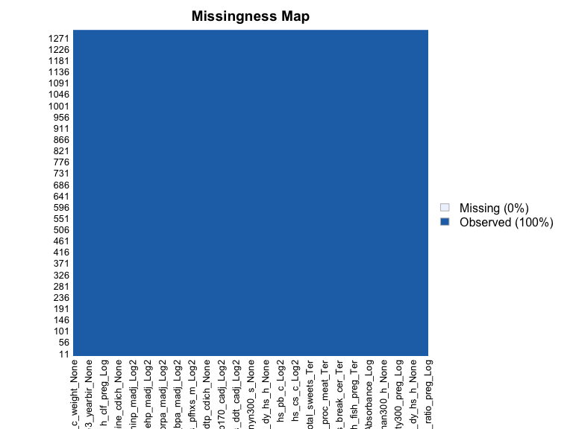

#Examine correlations between features  
cor_studydata <-  
 studydata %>%   
 select(where(is.numeric)) %>%   
 cor(use = "complete.obs") %>%   
 findCorrelation(cutoff=0.4)

### Step 2: Research Question

A hypothesis-generating question we could explore using our data is:

Is there a correlation between maternal pre- and postnatal environmental exposures and child neurological behavior aged 6-11 years?

### Step 3: Implement pipeline to address research question

Using a random forest algorithm to train the model for feature selection. We can get the most important variable in predicting the neurological behavior in children aged 6-11 years. We can then use this data to generate a hypothesis regarding these environmental exposures and neuro hehavior outcomes in children.

This code chunk uses different combinations of the features in the studydata dataset to train the model. We run 200 trees in this model. Variable number of trees could be used to train the model to get the best model. However, computational capacity is a limitation so we restrict to 200 trees only. We use Roomt Mean Square Error to evaluate the model since this is a regression problem.

# Try mtry of all, half of all, sqrt of all,   
mtry <-   
 c(ncol(train_df)-1, sqrt(ncol(train_df)-1), 0.5*ncol(train_df)-1)  
  
mtrygrid <-   
 expand.grid(.mtry = round(mtry))  
  
control <-   
 trainControl(method = "cv", number = 10)  
  
set.seed(123)  
 rf <-   
 train(hs_Gen_Tot ~., data = train_df, method = "rf", preProc=c("center", "scale"),   
 trControl = control, metric = "RMSE", tuneGrid = mtrygrid, importance = TRUE, ntree = 200)  
  
rf$results

## mtry RMSE Rsquared MAE RMSESD RsquaredSD MAESD  
## 1 15 17.73645 0.1550397 13.46433 1.765867 0.07137011 1.040905  
## 2 120 17.64688 0.1604324 13.36714 1.685357 0.06505855 1.038523  
## 3 240 17.79705 0.1506898 13.46285 1.820752 0.06374355 1.156041

varImp(rf)

## rf variable importance  
##   
## only 20 most important variables shown (out of 296)  
##   
## Overall  
## hs_pm10_yr_hs_h_None 100.00  
## h_cohort5 92.01  
## hs_cd_m_Log2 77.70  
## hs_no2_yr_hs_h_Log 74.00  
## hs_pm10_wk_hs_h_None 66.67  
## hs_bpa_madj_Log2 63.78  
## h_Benzene_Log 61.14  
## hs_pfos_c_Log2 59.48  
## hs_pm10_dy_hs_h_None 58.95  
## hs_prpa_cadj_Log2 58.72  
## h_connind300_preg_Sqrt 58.03  
## hs_mbzp_cadj_Log2 56.86  
## hs_hum_dy_hs_h_None 56.44  
## hs_pcb180_cadj_Log2 54.75  
## hs_hum_mt_hs_h_None 54.33  
## hs_dif_hours_total_None 52.97  
## hs_c_height_None 52.79  
## hs_mn_m_Log2 52.50  
## hs_fdensity300_h_Log 52.31  
## hs_accesspoints300_s_Log 51.20

rf$finalModel

##   
## Call:  
## randomForest(x = x, y = y, ntree = 200, mtry = param$mtry, importance = TRUE)   
## Type of random forest: regression  
## Number of trees: 200  
## No. of variables tried at each split: 120  
##   
## Mean of squared residuals: 321.4377  
## % Var explained: 12.85

varImpPlot(rf$finalModel)

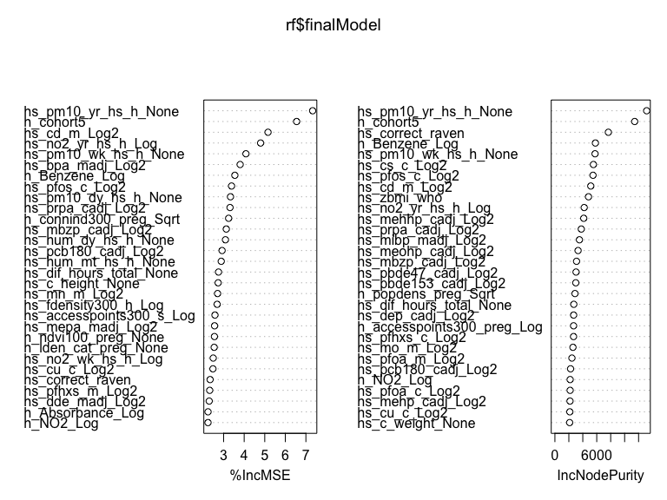

### Model Evaluation in test

We then use the model to evaluate the performance in the test dataset.

set.seed(123)  
  
predictions <- predict(rf, test_df)  
RMSE(predictions, test_df$hs_Gen_Tot)

## [1] 17.72965