ml_hw6

# Goal

To use the NHANES data to predict Diabetes using similar 11 variables. Those are restricted to the following:

* Age
* Race1
* Education
* HHIncome
* Weight
* Height
* Pulse
* Diabetes
* BMI
* PhysActive
* Smoke100

## Preprocessing

set.seed(123)  
  
data(NHANES)  
  
#Check missingness in the data  
Amelia::missmap(NHANES)

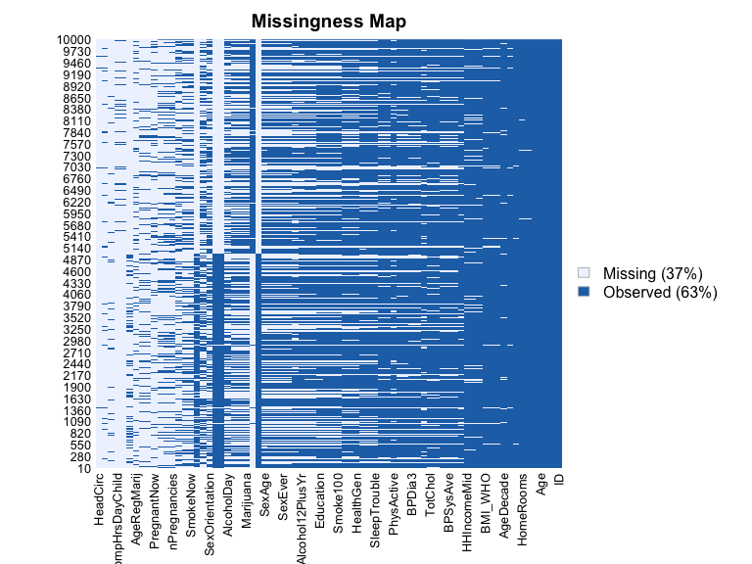

nhanes <-  
 NHANES %>%   
 as_tibble(NHANES) %>%   
 select(Age, Race1, Education, HHIncome, Weight, Height, Pulse, Diabetes, BMI, PhysActive, Smoke100) %>%   
 janitor::clean_names() %>%   
 drop_na()  
  
#Check data structure and balance of the outcome  
str(nhanes)

## tibble [6,356 × 11] (S3: tbl_df/tbl/data.frame)  
## $ age : int [1:6356] 34 34 34 49 45 45 45 66 58 54 ...  
## $ race1 : Factor w/ 5 levels "Black","Hispanic",..: 4 4 4 4 4 4 4 4 4 4 ...  
## $ education : Factor w/ 5 levels "8th Grade","9 - 11th Grade",..: 3 3 3 4 5 5 5 4 5 2 ...  
## $ hh_income : Factor w/ 12 levels " 0-4999"," 5000-9999",..: 6 6 6 7 11 11 11 6 12 10 ...  
## $ weight : num [1:6356] 87.4 87.4 87.4 86.7 75.7 75.7 75.7 68 78.4 74.7 ...  
## $ height : num [1:6356] 165 165 165 168 167 ...  
## $ pulse : int [1:6356] 70 70 70 86 62 62 62 60 62 76 ...  
## $ diabetes : Factor w/ 2 levels "No","Yes": 1 1 1 1 1 1 1 1 1 1 ...  
## $ bmi : num [1:6356] 32.2 32.2 32.2 30.6 27.2 ...  
## $ phys_active: Factor w/ 2 levels "No","Yes": 1 1 1 1 2 2 2 2 2 2 ...  
## $ smoke100 : Factor w/ 2 levels "No","Yes": 2 2 2 2 1 1 1 2 1 1 ...

summary(nhanes[, "diabetes"])

## diabetes   
## No :5697   
## Yes: 659

#Partition the data  
train.index <- createDataPartition(nhanes$diabetes, p = 0.7, list = FALSE)  
  
training <- nhanes[train.index, ]  
testing <- nhanes[-train.index, ]

## Prediction models

To predict diabetes using the 11 features from NHANES, we will use the following three algorithms to create the models:

### Classification Tree

Best tune for cp = 0.001. Accuracy = 0.7045. age , bmi, and weight are the highest ranked importance variables

set.seed(123)  
  
diabetestree <-  
 train(diabetes~ . , data = training, method = "rpart",   
 trControl= trainControl(method = "cv", number = 10, sampling = "down"),   
 preProc = c("center", "scale"), tuneGrid = expand.grid(cp = seq(0.001, 0.3, by = 0.01)))  
  
#Get best tune and results   
diabetestree$bestTune

## cp  
## 1 0.001

diabetestree$results

## cp Accuracy Kappa AccuracySD KappaSD  
## 1 0.001 0.7044851 0.2225926 0.02841200 0.03349895  
## 2 0.011 0.6692093 0.2027177 0.04085624 0.03930518  
## 3 0.021 0.6426893 0.1774506 0.04719608 0.04582471  
## 4 0.031 0.6269443 0.1755479 0.05187012 0.04626204  
## 5 0.041 0.6090081 0.1640054 0.04768762 0.04897937  
## 6 0.051 0.5793452 0.1431098 0.03648829 0.02745343  
## 7 0.061 0.5793452 0.1431098 0.03648829 0.02745343  
## 8 0.071 0.5793452 0.1431098 0.03648829 0.02745343  
## 9 0.081 0.5793452 0.1431098 0.03648829 0.02745343  
## 10 0.091 0.5793452 0.1431098 0.03648829 0.02745343  
## 11 0.101 0.5793452 0.1431098 0.03648829 0.02745343  
## 12 0.111 0.5793452 0.1431098 0.03648829 0.02745343  
## 13 0.121 0.5793452 0.1431098 0.03648829 0.02745343  
## 14 0.131 0.5793452 0.1431098 0.03648829 0.02745343  
## 15 0.141 0.5793452 0.1431098 0.03648829 0.02745343  
## 16 0.151 0.5793452 0.1431098 0.03648829 0.02745343  
## 17 0.161 0.5793452 0.1431098 0.03648829 0.02745343  
## 18 0.171 0.5793452 0.1431098 0.03648829 0.02745343  
## 19 0.181 0.5793452 0.1431098 0.03648829 0.02745343  
## 20 0.191 0.5793452 0.1431098 0.03648829 0.02745343  
## 21 0.201 0.5793452 0.1431098 0.03648829 0.02745343  
## 22 0.211 0.5793452 0.1431098 0.03648829 0.02745343  
## 23 0.221 0.5793452 0.1431098 0.03648829 0.02745343  
## 24 0.231 0.5793452 0.1431098 0.03648829 0.02745343  
## 25 0.241 0.5793452 0.1431098 0.03648829 0.02745343  
## 26 0.251 0.5793452 0.1431098 0.03648829 0.02745343  
## 27 0.261 0.5793452 0.1431098 0.03648829 0.02745343  
## 28 0.271 0.5793452 0.1431098 0.03648829 0.02745343  
## 29 0.281 0.5793452 0.1431098 0.03648829 0.02745343  
## 30 0.291 0.5793452 0.1431098 0.03648829 0.02745343

#Plot the tree  
rpart.plot(diabetestree$finalModel)

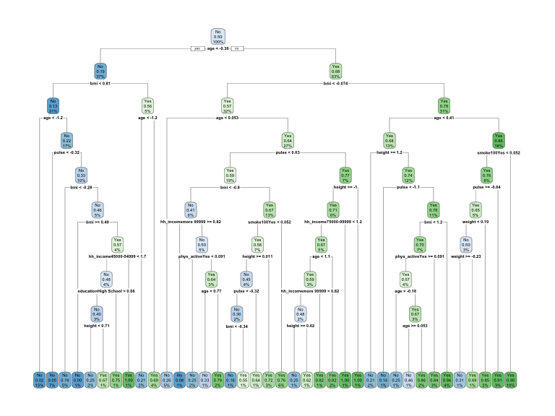

#Variable importance  
varImp(diabetestree)

## rpart variable importance  
##   
## only 20 most important variables shown (out of 35)  
##   
## Overall  
## age 100.0000  
## bmi 69.7194  
## weight 49.7904  
## height 29.0285  
## pulse 28.3578  
## educationCollege Grad 22.7297  
## phys_activeYes 11.6649  
## hh_incomemore 99999 11.2164  
## race1White 4.5234  
## smoke100Yes 4.4698  
## hh_income45000-54999 4.0866  
## race1Mexican 3.7162  
## race1Hispanic 1.9055  
## educationSome College 1.8275  
## hh_income55000-64999 1.1010  
## hh_income65000-74999 1.0431  
## educationHigh School 0.8472  
## hh_income75000-99999 0.7452  
## hh_income20000-24999 0.5552  
## `hh_income55000-64999` 0.0000

#Obtain accuracy and other metrics  
confusionMatrix(diabetestree)

## Cross-Validated (10 fold) Confusion Matrix   
##   
## (entries are percentual average cell counts across resamples)  
##   
## Reference  
## Prediction No Yes  
## No 62.6 2.6  
## Yes 27.0 7.8  
##   
## Accuracy (average) : 0.7045

### Support Vector Classifier

Support Vector Machine with a linear classifier

The best tune for C = 1.9, accuracy = 0.7126

set.seed(123)  
  
#Trainmodel using different values for cost (C)  
svm <-   
 train(diabetes ~ ., data = training, method = "svmLinear",  
 trControl = trainControl(method = "cv", number = 10, sampling = "down"),   
 preProcess = c("center", "scale"), tuneGrid = expand.grid(C = seq(0.001, 2, length = 30)))  
  
#Get results  
svm$bestTune

## C  
## 29 1.931069

svm$results

## C Accuracy Kappa AccuracySD KappaSD  
## 1 0.00100000 0.6887583 0.2070623 0.02558989 0.02698443  
## 2 0.06993103 0.7008957 0.2355595 0.03337312 0.04468051  
## 3 0.13886207 0.6954994 0.2266883 0.03123086 0.04431058  
## 4 0.20779310 0.7044837 0.2376260 0.02652449 0.03992456  
## 5 0.27672414 0.6990970 0.2283955 0.02458018 0.03718135  
## 6 0.34565517 0.7105506 0.2418594 0.03477403 0.04902698  
## 7 0.41458621 0.6939259 0.2225483 0.02544033 0.03236684  
## 8 0.48351724 0.7044968 0.2377812 0.03233465 0.05017294  
## 9 0.55244828 0.7076368 0.2373929 0.02664660 0.03807518  
## 10 0.62137931 0.7092104 0.2408223 0.02536140 0.03986034  
## 11 0.69031034 0.7096558 0.2457647 0.02616778 0.04077049  
## 12 0.75924138 0.6988667 0.2253068 0.02967305 0.04591711  
## 13 0.82817241 0.7038090 0.2357510 0.03312764 0.04433242  
## 14 0.89710345 0.7078635 0.2368134 0.02669722 0.04559831  
## 15 0.96603448 0.7083120 0.2371555 0.03047789 0.04163927  
## 16 1.03496552 0.7080807 0.2437129 0.02309712 0.03750777  
## 17 1.10389655 0.7103238 0.2382504 0.02969149 0.05097114  
## 18 1.17282759 0.7083105 0.2398567 0.02187385 0.03569114  
## 19 1.24175862 0.7069551 0.2338967 0.02616952 0.04393282  
## 20 1.31068966 0.6979703 0.2305565 0.02847907 0.04096510  
## 21 1.37962069 0.7053851 0.2371905 0.03253801 0.04564507  
## 22 1.44855172 0.7049311 0.2386977 0.03117527 0.04663823  
## 23 1.51748276 0.7020138 0.2337670 0.03239458 0.04487877  
## 24 1.58641379 0.6970674 0.2341420 0.02459489 0.03814218  
## 25 1.65534483 0.7065112 0.2318920 0.03037704 0.04460001  
## 26 1.72427586 0.7067349 0.2415578 0.03300357 0.04457183  
## 27 1.79320690 0.7047144 0.2331321 0.02882514 0.03916682  
## 28 1.86213793 0.7092194 0.2407636 0.02858939 0.04047193  
## 29 1.93106897 0.7125650 0.2467470 0.03252101 0.05436676  
## 30 2.00000000 0.7101122 0.2434769 0.03240846 0.04978576

#Visualize accuracy versus values of C  
plot(svm)

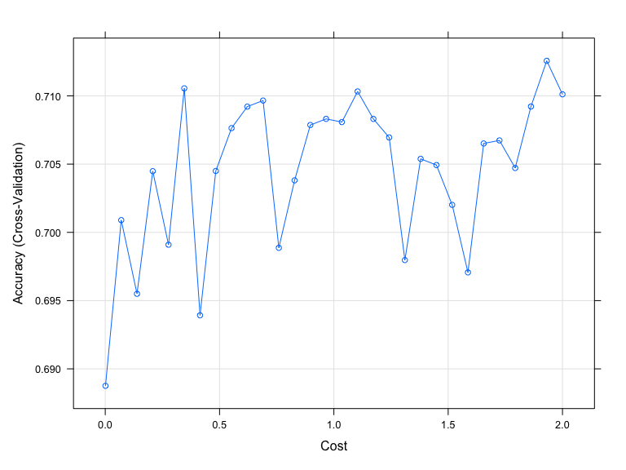

#Obtain metrics of accuracy from training  
confusionMatrix(svm)

## Cross-Validated (10 fold) Confusion Matrix   
##   
## (entries are percentual average cell counts across resamples)  
##   
## Reference  
## Prediction No Yes  
## No 63.0 2.1  
## Yes 26.7 8.3  
##   
## Accuracy (average) : 0.7126

#See information about final model  
svm$finalModel

## Support Vector Machine object of class "ksvm"   
##   
## SV type: C-svc (classification)   
## parameter : cost C = 1.93106896551724   
##   
## Linear (vanilla) kernel function.   
##   
## Number of Support Vectors : 544   
##   
## Objective Function Value : -1011.328   
## Training error : 0.252165

### Logistic regression.

Accuracy = 0.7148

set.seed(123)   
  
glm <-  
 train(diabetes ~., data = training, method = "glm",  
 trControl = trainControl("cv", number = 10, sampling = "down"), family = "binomial",  
 preProc = c("center", "scale"))  
  
#Model performance  
confusionMatrix(glm)

## Cross-Validated (10 fold) Confusion Matrix   
##   
## (entries are percentual average cell counts across resamples)  
##   
## Reference  
## Prediction No Yes  
## No 63.6 2.5  
## Yes 26.0 7.9  
##   
## Accuracy (average) : 0.7148

## Model selection and evaluation

The Support Vector Classifier SVC (accuracy = 0.7126) and traditional logistic regression (accuracy = 0.7148) models performed similarly. However, SVC offer a clear margin of separation in the data making it better in classification of observations and more stable which makes it the “optimal” model to predict diabetes in testing data. . Evaluating the SVC model on the testing data yields high accuracy = 0.7051, sensitivity = 0.8223, and a little lower specificity = 0.6916

set.seed(123)  
  
#Make predictions in test set  
preds <- predict(svm, testing)  
  
#Get evaluation metrics from test set  
confusionMatrix(preds, testing$diabetes, positive = "Yes")

## Confusion Matrix and Statistics  
##   
## Reference  
## Prediction No Yes  
## No 1182 35  
## Yes 527 162  
##   
## Accuracy : 0.7051   
## 95% CI : (0.6841, 0.7255)  
## No Information Rate : 0.8966   
## P-Value [Acc > NIR] : 1   
##   
## Kappa : 0.2442   
##   
## Mcnemar's Test P-Value : <2e-16   
##   
## Sensitivity : 0.82234   
## Specificity : 0.69163   
## Pos Pred Value : 0.23512   
## Neg Pred Value : 0.97124   
## Prevalence : 0.10336   
## Detection Rate : 0.08499   
## Detection Prevalence : 0.36149   
## Balanced Accuracy : 0.75698   
##   
## 'Positive' Class : Yes   
##

## Limitations and considerations

Excluding the missing observations from the data reduces model generalizability and real life data representation. Additionally, using SVC models limits the interpretability. These are two analytical limitations. Moreover, when conducting predictions using this model in practice, close attention must be paid to social and cultural context that may have an impact both on making and using diabetes predictions in different communities.