ml_hw9

Mohammad

2023-03-27

## Goal: use three different algorithms (random forest, SVC and logistic regression) to generate a clinical risk score for diabetes, then compare the three models.

### Data Processing

The code below to load and subset the data and remove missing observations.

set.seed(123)  
  
data(NHANES)  
  
#Check missingness in the data  
Amelia::missmap(NHANES)

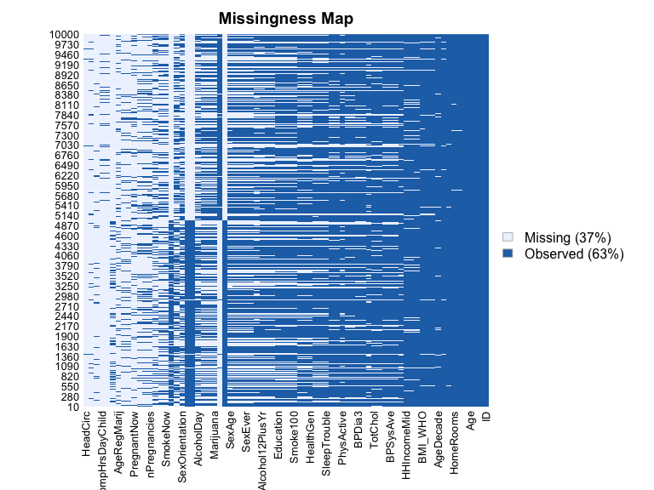

nhanes <-  
 NHANES %>%   
 as_tibble(NHANES) %>%   
 select(Age, Race1, Education, Poverty, Weight, Height, Pulse, Diabetes, BMI, PhysActive, Smoke100, BPSysAve, BPDiaAve, TotChol) %>%  
 janitor::clean_names() %>%   
 drop_na() %>%   
 distinct()  
  
str(nhanes)

## tibble [3,880 × 14] (S3: tbl_df/tbl/data.frame)  
## $ age : int [1:3880] 34 49 45 66 58 54 58 50 33 60 ...  
## $ race1 : Factor w/ 5 levels "Black","Hispanic",..: 4 4 4 4 4 4 3 4 4 4 ...  
## $ education : Factor w/ 5 levels "8th Grade","9 - 11th Grade",..: 3 4 5 4 5 2 3 4 3 3 ...  
## $ poverty : num [1:3880] 1.36 1.91 5 2.2 5 2.2 2.03 1.24 1.27 1.03 ...  
## $ weight : num [1:3880] 87.4 86.7 75.7 68 78.4 74.7 57.5 84.1 93.8 74.6 ...  
## $ height : num [1:3880] 165 168 167 170 182 ...  
## $ pulse : int [1:3880] 70 86 62 60 62 76 94 74 96 84 ...  
## $ diabetes : Factor w/ 2 levels "No","Yes": 1 1 1 1 1 1 1 1 1 1 ...  
## $ bmi : num [1:3880] 32.2 30.6 27.2 23.7 23.7 ...  
## $ phys_active: Factor w/ 2 levels "No","Yes": 1 1 2 2 2 2 2 2 1 1 ...  
## $ smoke100 : Factor w/ 2 levels "No","Yes": 2 2 1 2 1 1 2 1 2 2 ...  
## $ bp_sys_ave : int [1:3880] 113 112 118 111 104 134 127 142 128 152 ...  
## $ bp_dia_ave : int [1:3880] 85 75 64 63 74 85 83 68 74 100 ...  
## $ tot_chol : num [1:3880] 3.49 6.7 5.82 4.99 4.24 6.41 4.78 5.22 5.59 6.39 ...

summary(nhanes[, "diabetes"])

## diabetes   
## No :3437   
## Yes: 443

### Partitioning data

Partition data into a 70/30 training/testing split.

set.seed(123)  
  
train.index <-   
 nhanes$diabetes %>%   
 createDataPartition(p = 0.7, list = FALSE)  
  
train_df <-   
 nhanes[train.index, ]  
  
test_df <-   
 nhanes[-train.index, ]

### Models

Here we construct three models in the training set using each of the three algorithms to predict diabetes. For the random forest, we try 3 different values of mtry. For SVC, vary the cost parameter using a vector of values in a grid. We use up sampling for all three models.

### Model 1: Random Forest with 3 values of mtry and 3 values of ntree

# Try mtry of all, half of all, sqrt of all,   
# Try ntree of 100, 300, 500  
mtry <-   
 c(ncol(train_df)-1, sqrt(ncol(train_df)-1), 0.5*ncol(train_df)-1)  
  
mtrygrid <-   
 expand.grid(.mtry = round(mtry))  
  
control <-   
 trainControl(method = "cv", number = 10, sampling = "up")  
  
tree_num <-   
 seq(100,500, by = 200)  
  
results_trees <-   
 list()  
  
for (ntree in tree_num){  
 set.seed(123)  
 nrf <-   
 train(diabetes ~ ., data = train_df, method = "rf", trControl = control, metric = "Accuracy", tuneGrid = mtrygrid,  
 importance = TRUE, ntree = ntree)  
 index <-   
 toString(ntree)  
   
 results_trees[[index]] <-   
 nrf$results  
}  
  
output <-   
 bind_rows(results_trees, .id = "ntrees")  
  
best_tune <-   
 output[which.max(output[,"Accuracy"]), ]  
  
best_tune$mtry

## [1] 4

results_trees

## $`100`  
## mtry Accuracy Kappa AccuracySD KappaSD  
## 1 4 0.8822308 0.2018155 0.009860566 0.09889773  
## 2 6 0.8789166 0.2143566 0.015879691 0.09688263  
## 3 13 0.8693551 0.2174717 0.018426986 0.08851178  
##   
## $`300`  
## mtry Accuracy Kappa AccuracySD KappaSD  
## 1 4 0.8840718 0.2128822 0.01392709 0.10100945  
## 2 6 0.8811279 0.2229898 0.01474166 0.09654646  
## 3 13 0.8693496 0.2153955 0.01495737 0.08781172  
##   
## $`500`  
## mtry Accuracy Kappa AccuracySD KappaSD  
## 1 4 0.8825971 0.1997113 0.01375111 0.09427232  
## 2 6 0.8818673 0.2174401 0.01593452 0.11629653  
## 3 13 0.8711906 0.2264867 0.01572046 0.09032385

mtrygrid <- expand.grid(.mtry = best_tune$mtry)  
  
set.seed(123)  
 rf_bt <-   
 train(diabetes ~., data = train_df, method = "rf", trControl = control, metric = "Accuracy", tuneGrid = mtrygrid,  
 importance = TRUE, ntree = as.numeric(best_tune$ntrees))  
  
confusionMatrix(rf_bt)

## Cross-Validated (10 fold) Confusion Matrix   
##   
## (entries are percentual average cell counts across resamples)  
##   
## Reference  
## Prediction No Yes  
## No 86.5 9.5  
## Yes 2.1 1.9  
##   
## Accuracy (average) : 0.8841

varImp(rf_bt)

## rf variable importance  
##   
## Importance  
## age 100.000  
## tot_chol 45.944  
## bmi 42.133  
## weight 38.705  
## bp_dia_ave 35.573  
## height 35.547  
## bp_sys_ave 32.401  
## pulse 28.165  
## poverty 26.979  
## race1White 16.411  
## educationHigh School 10.713  
## education9 - 11th Grade 9.193  
## educationSome College 8.704  
## race1Hispanic 4.896  
## race1Mexican 3.113  
## smoke100Yes 3.053  
## race1Other 2.031  
## phys_activeYes 1.242  
## educationCollege Grad 0.000

varImpPlot(rf_bt$finalModel)

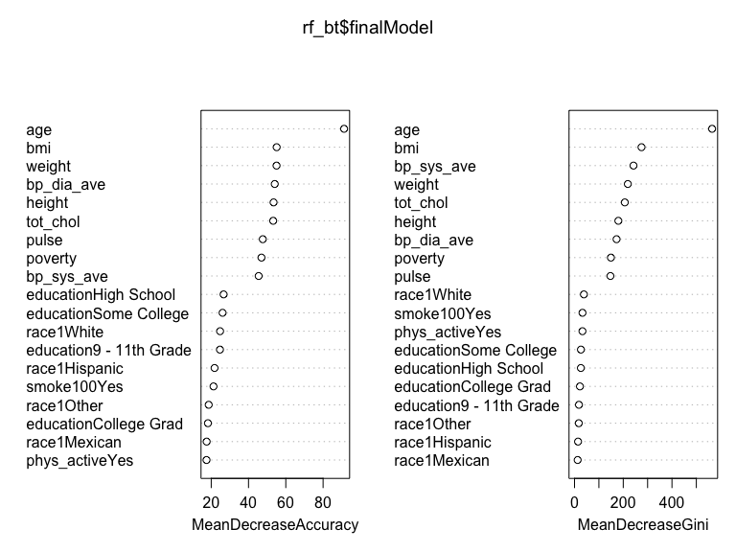

Increasing the number of cross validations to 10 instead of 5 and using up sampling instead of down improves accuracy to 0.88. The most important variables were age, total cholesterol, and BMI respectively.

### Model 2: Support Vector Classifier

set.seed(123)  
  
control <-   
 trainControl(method = "cv", number = 5, sampling = "up", classProbs = TRUE)  
  
#Repeat expanding the grid search  
set.seed(123)  
  
nsvc <- train(diabetes ~ ., data = train_df, method = "svmLinear", trControl= control, preProcess = c("center", "scale"),  
 probability = TRUE, tuneGrid = expand.grid(C = seq(0.0001,100, length = 10)))  
  
nsvc$bestTune

## C  
## 4 33.3334

nsvc$results

## C Accuracy Kappa AccuracySD KappaSD  
## 1 0.0001 0.7504726 0.2726347 0.020967977 0.02508331  
## 2 11.1112 0.7519303 0.3038273 0.009914273 0.02045453  
## 3 22.2223 0.7500907 0.3002407 0.006220660 0.02273034  
## 4 33.3334 0.7537760 0.3064334 0.013284874 0.02952343  
## 5 44.4445 0.7438367 0.2892485 0.008212017 0.01689901  
## 6 55.5556 0.7519303 0.3026514 0.009923693 0.03363297  
## 7 66.6667 0.7511971 0.3005226 0.015074564 0.02156431  
## 8 77.7778 0.7482511 0.2935487 0.004620121 0.01629018  
## 9 88.8889 0.7515661 0.2988514 0.011146146 0.03616381  
## 10 100.0000 0.7534077 0.3013072 0.009368784 0.01798691

confusionMatrix(nsvc)

## Cross-Validated (5 fold) Confusion Matrix   
##   
## (entries are percentual average cell counts across resamples)  
##   
## Reference  
## Prediction No Yes  
## No 66.4 2.4  
## Yes 22.2 9.0  
##   
## Accuracy (average) : 0.7538

Initially I used up sampling, increasing the number of cross validation to 10 and the tuneGrid length to 50 took too long (more than 60 minutes and was still running). I reduced the tuneGrid length to 20 but the issue persisted. I then reduced the number of cross validations to 5 and the tuneGrid to 10. It still took 45+ minutes for my laptop to execute it but it eventually worked. The resulting accuracy was 0.75

### Model 3: Logistic Regression

set.seed(123)  
  
control <-   
 trainControl(method = "cv", number = 10, sampling = "up")  
  
nlogit <-  
 train(diabetes~., data = train_df, method = "glm", family = "binomial", preProcess = c("center", "scale"),  
 trControl = control)  
  
nlogit$results

## parameter Accuracy Kappa AccuracySD KappaSD  
## 1 none 0.7486298 0.2980781 0.02392869 0.03546849

confusionMatrix(nlogit)

## Cross-Validated (10 fold) Confusion Matrix   
##   
## (entries are percentual average cell counts across resamples)  
##   
## Reference  
## Prediction No Yes  
## No 65.9 2.5  
## Yes 22.6 8.9  
##   
## Accuracy (average) : 0.7486

coef(nlogit$finalModel)

## (Intercept) age race1Hispanic   
## -0.04350520 1.31349538 0.02086556   
## race1Mexican race1White race1Other   
## 0.05551193 -0.26939327 0.24446686   
## `education9 - 11th Grade` `educationHigh School` `educationSome College`   
## -0.17335794 -0.16244844 -0.03506694   
## `educationCollege Grad` poverty weight   
## -0.13087396 -0.14040898 -1.53316087   
## height pulse bmi   
## 0.80836958 0.26293717 2.14713855   
## phys_activeYes smoke100Yes bp_sys_ave   
## 0.03546320 0.26374878 0.16989078   
## bp_dia_ave tot_chol   
## 0.01924155 -0.22818866

Using up sampling and 10 fold cross validation in a logistic regression model resulted in an accuracy of 0.75. The most important variables were age, total cholesterol, and BMI respectively.

### Output predicted probabilities from each of the three models applied within the testing set.

#Predict in test-set and output probabilities  
rf_probs <-  
 predict(nrf, test_df, type = "prob")  
  
#Pull out predicted probabilities for Diabetes=Yes  
rf_pp <-  
 rf_probs[,2]  
  
svc_probs <-  
 predict(nsvc, test_df, type = "prob")  
  
svc_pp <-   
 svc_probs[,2]  
  
#Predict in test-set using response type  
logit_probs <-  
 predict(nlogit, test_df, type = "prob")  
  
logit_pp <- logit_probs[,2]

### Plot and compare calibration curves across the three algorithms.

pred_prob <-   
 data.frame(Class = test_df$diabetes, logit = logit_pp, rf = rf_pp, svc = svc_pp)  
  
calplot <-   
 (calibration(Class ~ logit + rf + svc, data = pred_prob, class = "Yes", cuts = 10))  
  
xyplot(calplot, auto.key = list(columns = 3))

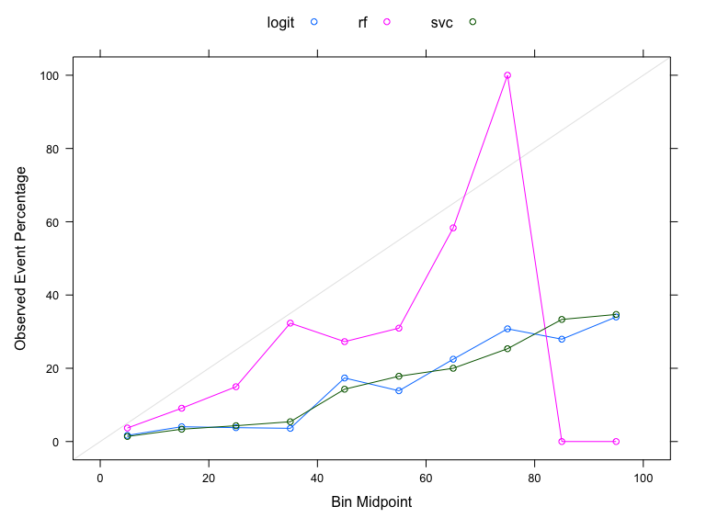

### Calibrate the probabilities from SVC and RF

Partition testing data into 2 sets: set to train calibration and then set to evaluate results

Method 1: Platt’s Scaling-train a logistic regression model on the outputs of your classifier

set.seed(123)  
  
cal_index <-  
 test_df$diabetes %>%   
 createDataPartition(p=0.5, list=F)  
  
cal_data <-  
 test_df[cal_index, ]  
  
final_data <-  
 test_df[-cal_index, ]  
  
#Calibration of RF  
  
#Predict on test-set without scaling to obtain raw pred prob in test set  
rf.probs.nocal <-  
 predict(nrf, final_data, type="prob")  
  
rf.pp.nocal <-  
 rf.probs.nocal[,2]  
  
#Apply model developed on training data to calibration dataset to obtain predictions  
rf.probs.cal <-   
 predict(nrf, cal_data, type="prob")  
  
rf.pp.cal <-  
 rf.probs.cal[,2]  
  
#Add to dataset with actual values from calibration data  
calibrf.data.frame <-  
 data.frame(rf.pp.cal, cal_data$diabetes)  
  
colnames(calibrf.data.frame) <-  
 c("x", "y")  
  
#Use logistic regression to model predicted probabilities from calibration data to actual vales  
calibrf.model <-   
 glm(y ~ x, data = calibrf.data.frame, family = binomial)  
  
#Apply calibration model above to raw predicted probabilities from test set  
data.test.rf <-  
 data.frame(rf.pp.nocal)  
  
colnames(data.test.rf) <-   
 c("x")  
  
platt.data.rf <-  
 predict(calibrf.model, data.test.rf, type="response")  
  
platt.prob.rf <-  
 data.frame(Class = final_data$diabetes, rf.platt = platt.data.rf, rf=rf.pp.nocal)  
  
calplot.rf <-   
 (calibration(Class ~ rf.platt+rf, data=platt.prob.rf, class="Yes", cuts=10))  
  
xyplot(calplot.rf, auto.key=list(columns=2))

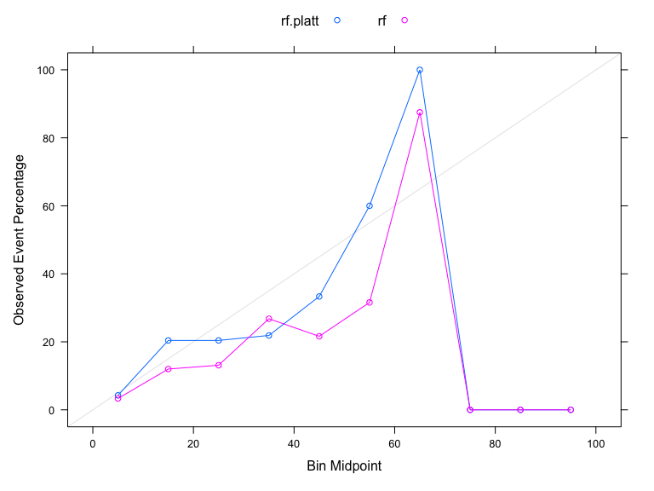

#Calibration of SVC  
  
#Predict on test-set without scaling  
svc.nocal <-  
 predict(nsvc,final_data, type="prob")  
  
svc.pp.nocal <-  
 svc.nocal[,2]  
  
  
#Apply model developed on training data to calibration dataset to obtain predictions  
svc.cal <-  
 predict(nsvc, cal_data, type = "prob")  
svc.pp.cal <-  
 svc.cal[,2]  
  
#Add to dataset with actual values from calibration data  
  
calib.data.frame <-  
 data.frame(svc.pp.cal, cal_data$diabetes)  
  
colnames(calib.data.frame) <-  
 c("x", "y")  
  
calib.model <-  
 glm(y ~ x, data=calib.data.frame, family = binomial)  
  
#Predict on test set using model developed in calibration  
data.test <-   
 data.frame(svc.pp.nocal)  
  
colnames(data.test) <-  
 c("x")  
  
platt.data <-   
 predict(calib.model, data.test, type="response")  
  
platt.prob <-   
 data.frame(Class = final_data$diabetes, svc.platt=platt.data, svc=svc.pp.nocal)  
  
calplot <-  
 (calibration(Class ~ svc.platt+svc, data=platt.prob, class="Yes", cuts=10))  
  
xyplot(calplot, auto.key = list(columns=2))

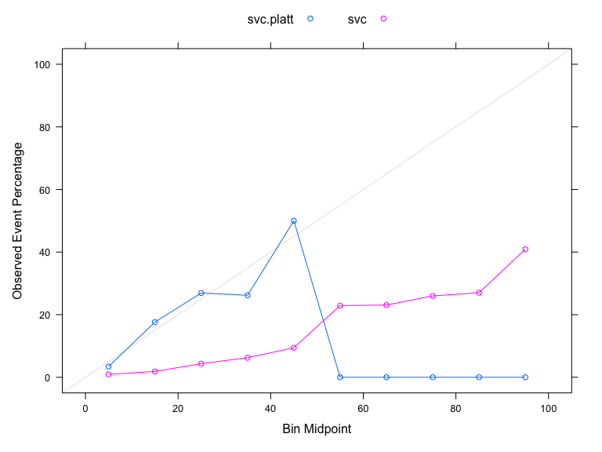

Based on the accuracy results and the calibrated curves, the random forest model would be the “optimal model”. One additional evaluation to perform prior to implementing the model in a clinical setting is examining the data to ensure its quality (accurate and representative) to avoid any unintended consequnces on minorities or under-privileged communities.