Capstone 1 Proposal

For my first capstone project, I plan to create a website that allows for users to search for songs by artist or song title using the Spotify API. After the query, the user will have the opportunity to view the lyrics to the song using the Musixmatch API. On a panel to the right of the page, I also plan to implement a suggestions tab that has a list of song recommendations based on the currently viewed song page.

Users that use the application without being logged in will be able to view songs and conduct searches but logged in users will get some more of a user experience. Users that create an account and log in will be able to favorite songs that will be added to a page on their profile that will list their favorites. The ‘favorites’ page will display a list of each song that the user has favorited. Each element in this list will be a link tag that the user can click on to view the song details page that displays the lyrics as well as recommendations. In addition to being able to add favorites to a user profile, users will also be able to remove a song from their favorites list by clicking a remove button.

Logged in users will be able to view the profiles of other users and view their favorites list. This ability will be exclusive to only users who are logged into an account.

The general database schema will look as follows:

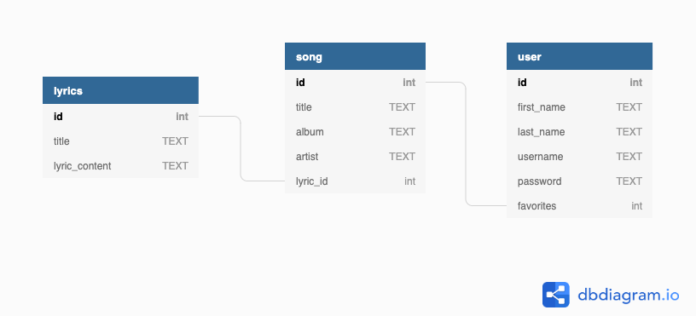
The “user” table will include the user information as well as a “favorites” element that connects in relationship to the song table. The song table will include the information relating to the song as well as a lyrics element that links to the lyrics that will be obtained from Musixmatch.

One potential issue that I might run into with regards to the combination of the APIs would be if a user searches for a song that may be on the Spotify database but not be in the Musixmatch. To account for this situation, I need to ensure that the “lyric_id” column of the “song” is not required. In the case of a song being queried through the Spotify API and not being found within the Musixmatch database, I will need to prepare a template page that lets the user know that the lyrics information for the specific song is not available.

