Mostafa Mahmoud Ashour
MEP Engineer

Address : Hadayk Al Ahram, Giza ,Egypt.
Mobile : +2 010 002 975 66
Mail 1 : mostafaa.ashor@gmail.com
linkedIn : linkedin.com/in/mostafa-ashour-b06334107/

Personal Profile

- Religion : Muslim
- Nationality : Egyptian
- Date of birth : 12/05/1991
- Social status : Married
- Military status : Complete

Education
- BSc degree 2009 - 2014

- University :Cairo university
- Faculty :Engineering
- Department :Mechanical
- Cumulative Grade :Passing
- Graduation project :HVAC
- Project Grade :Very Good

Project Brief
- HVAC Graduation Project under supervision of prof. Dr. Essam E. Khalil

- Mech. Design of Boiler .
- Mech. Design of HEX.
- Air Handling Unit.


Work Experience
- SOLERA 2/2021 – Now
Job title : Mechanical Site Engineer
- Speed Hospital: working on HVAC, Firefighting and plumbing systems construction.
- ZED El Sheikh Zayed: working on HVAC, Firefighting and plumbing systems construction.


- Archirodon Construction (Overseas) Co. S.A. 5/2020 – 2/2021
Job title : Mechanical Site Engineer
- Helwan Facility: working on HVAC, Firefighting and plumbing systems
construction and QC (MIR, IR, ITP)
- Kattamia Facility: working on HVAC, Firefighting and plumbing systems
construction.


- HASSAN ALLAM TECHNOLOGIES (HAT) 7/2018 – 5/2020
Job title : Mechanical Site Engineer
- MANSOURA1: working on HVAC, Firefighting and plumbing systems construction.
- EXPO Sharm Elsheikh: Working on Rain water system, Infrastructure of Firefighting, Plumbing and Rain water
-Firefighting: 14 Fire Hydrant 6" , 4 OS&Y Valves
8" 1100 mtrs.
6" 400 mtrs.
-Plumbing: Water supply &Drainage system for 5 gates

8" 960 mtrs.
6" 362 mtrs.
4" 50 mtrs.

-Storm:

20" 78 mtrs.
12" 500 mtrs.
8" 100 mtrs.
6" 150 mtrs


- Wady El Nil Contracting & Real-estate Investments Co. 3/2017 – 7/2018
Job title : Mechanical Site Engineer
- Islamic Research complex: working on HVAC & Fire fighting system construction.
- Total area of the building was 14,850 m²
- Total cost of HVAC,Firefighting and Elevators:
      - HVAC: 30,000,000
      - Firefighting: 8,400,000
      - Elevators: 7,042,000

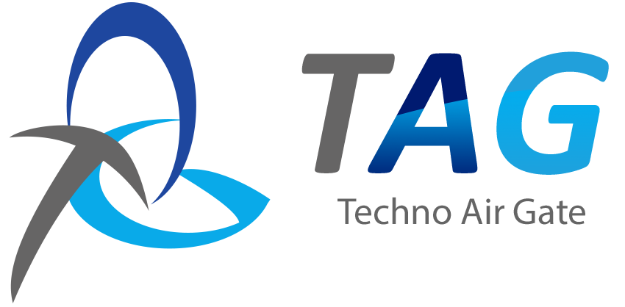
- Techno Air Gate company (TAG-Egypt) 6/2016 – 3/2017
Job title : Test & Balance Engineer
Responsibilites :
- Responsible for HVAC systems solutions and clean room services at pharmaceutical companies and other projects.
- Doing TAB works on HVAC system and Chilled water system at HCC (Health Care City).
- Doing TAB works on HVAC system at Suez Canal Hospital (Open Heart Section).
- Doing TAB works on Chilled/Hot water system at VACSERA.
- Doing TAB works and gap analysis on Chilled water system at FIBCO.
- Doing TAB works on HVAC system at MYWAY.
- Doing TAB works on Chilled water system at XD EGEMAC.
- Doing TAB Works on Chilled water system at Kafr El-Shaikh hospital.

- TARGET Egypt Company 11/2015 – 6/2016
Job title : Test & Balance Engineer
Responsibilites :
- Responsible for HVAC systems solutions and clean room servives at pharmaceutical companies and other projects.
- Doing TAB Works on HVAC and Chilled water system at Point90 Mall.
- Doing TAB works on HVAC and Chilled Water system at AstraZeneca Pharma.
- Doing TAB works on HVAC System at SEDICO Pharmaceutical Company.
- Doing TAB works on Chilled Water System at DEO Kairo.
- Doing TAB and validation works on HVAC System at GSK (Glaxo smith kline).
- Doing TAB works on HVAC system at Coca-Cola factory.

- Techno Air Gate company (TAG-Egypt) 10/2014 – 4/2015
Job title : Test & Balance Engineer
Responsibilites :
- Responsible for HVAC systems solutions and CleanRoom Servives at pharmaceutical companies
- Doing Commissioning & TAB works For Solid, Blistering and Beta lactam Area's AHUs at October pharma Factory.
- Doing Commissioning & TAB works for all AHUs at BIOPHARM Factory
- Doing Commissioning & TAB works for all AHUs of the following areas at Al ANDALOUS Factory:
- Semi solid area - Store area.
- Weighing area - Tablet & Capsule area.

- Working with ELECMA consult Co. to do TAB works for AHUs of Syrup area at RAMEDA

- Working with KARMA Co. to do the following tests at CHEMI PHARM:
- Air Balance
- Air Velocity test

- Doing Commissioning & TAB works for all AHUs of ampoule Area
at SANOFI
Summer Training
- Summer training at Arab Contractors Company – 2010.
- Summer training at Oil & petroleum Pipes – 2011.
Certifications
- AUTOCAD 2D
- ANSYS Fluent (CFD)
Skills
- Technical:
have a solid background of :
- Test and Balance Technical devices
- ICDL and Microsoft Office skills
Interpersonal:
- Delivery and Quality Focused.
- Leadership character.
- Self learning.
- Very ambitious character.
- Strong analytical and problem solving.
- Very good presenter.
- Very good in team work.
Languages
- Arabic : Mother tongue
- English : Very good


Activities
- Member at STP (cairo uni. Activity )
- IT Member at Life Makersصناع الحياة
Hobbies and Interests
Reading , Sports and Technology

