**Moghazy Refaat,Moaz Mohamed ,Mohamed omar ,Omar Mohamed ,Ramadan El-sayed ,Ahmed El-Sayed ,Ahmed Elsayed Ali ,Fawzy Ibrahim,Elsaeed Mohamad,Omar Alaa .**

**Machine learning techniques for the recommendation of agricultural in Egypt, using NPK five pins and Water footprint of Egyptian crops and its economics.**

**Abstract**

Machine learning (ML) possesses the capability to leverage agricultural data pertaining to crop yield in relation to diverse soil nutrient levels and climatic variations, thereby facilitating the recommendation of suitable crops or additional nutrients to optimize overall production. The objective of this research was to assess the effectiveness of five distinct ML models utilizing a dataset acquired from the Kaggle repository, with the intention of formulating actionable recommendations for crop selection or the identification of necessary nutrient(s) for specific locations. The datasets encompass variables such as NPK, soil pH, and three climatic factors: temperature, precipitation, and humidity. The models in question, namely Support Vector Classifier, LGBM Classifier, Random Forest, Logistic Regression, and Decision Tree Classifier, were trained employing the yield data consist of 22 crop .The Accuracy of models 0.8750, 0.9682, 0.9159, 0.9727, 0.9159 As a result, it has become possible to determine the quality of the produce at the consumer level through this device. The system’s effectiveness is evaluated through field experiments ,comparing its performance with traditional methods. The results demonstrate the device’s ability to enhance crop productivity and optimize resource utilization, promoting sustainable agricultural practices and food security. The research contributes to Water footprint, demonstrating the potential of ML techniques in improving soil nutrient management, facilitating informed decision-making about crop fertilizers, and assessing the quality of produced crops at the consumer level.

**Keywords:** Crop recommendation, Water Footprint, NPK Sensor, Machine learning, Soil nutrients, Agriculture.

**1.Introduction**

The country’s economy heavily depends on farming, since the sector helps ensure all Egyptians have enough to eat and increases economic growth. But today, problems for agriculture include less land available for farming, not enough water supply, and damage caused by climate change [4]. People all around the world still struggle with food shortage, as pests, diseases, and changing weather make the issue more acute. The use of AI and ML is increasingly acknowledged as an effective solution to improve how agriculture operates and cut down on losses [5-10]. Soil analyses and crop advices in traditional farming tend to be laborious and sometimes inaccurate. They allow for more efficient and well-thought-out steps when deciding how to allocate resources. Having fertile soil is very important for growing good yields of crops [13-27]. It is important for soil to remain productive that there is the proper combination of organic and inorganic nutrients. By using AI technologies, farmers can manage soil nutrients better and thus promote sustainability [54]. Agronomists often grow crops where productivity is reduced. With AI added to precision agriculture, The most suitable types of crops can be selected based on environmental conditions. Forecasting soil moisture levels, crop yields, and possible disease outbreaks is done through the use of Support vector machines (SVM), Random forest (RF), and Artificial neural networks (ANN). They are designed to improve both the way decisions are taken and how risks are managed in the agricultural domain. Notable applications of AI include Agro Consultant, which provides crop recommendations tailored to specific soil and climatic conditions, and IoT-integrated ML models that deliver real-time strategic guidance for agricultural practices[37]. Despite the advantages afforded by these technologies, challenges persist in the refinement of ML models to enhance their accuracy and operational efficiency. Diligent data collection, thorough training, and effective implementation are critical to fully realizing the potential of AI in the agricultural sector [42-47]. AI needs to be used in Egyptian farming to cope with the increasing demand for food, protect the environment, and support economic success[36,39]. Developing AI-centered methods in farming will help maintain the future of the country’s farms. To produce accurate forecasts and advice considering what each crop needs in nutrients, its current stage of growth, and the current climate. It also lets users see the most valuable soil elements for plant growth and calculates how much water is used by the farm. This research effort could completely change how farmers care for the soil and make plans for growing crops. With its ability to give accurate, up-to-date information on soil and advise on most suitable crops, the Crop Filtration Machine for each soil powered by Machine learning works to help farmers become more productive, save resources, ensure food security, and uphold sustainable practices in agriculture. Contributions to this work include: Building and creating a crop recommendation device with integrated machine learning to constantly monitor soil moisture, humidity, temperature and NPK levels by using a five-container NPK sensor. It allows for up-to-date data, helping farmers make the right and timely choices. Look over the gathered data with Machine learning methods and let farmers know what crops to plant from the results. Doing this can make crops prosper, produce a larger harvest, and make agriculture more economical. Testing the device in practical situations and evaluating how it fairs against the previous methods. The assessment shows that the device is better than traditional methods and can change the way farming is done. I am using a structure for this paper as follows: The second section thoroughly studies the significant research on the topic. Part 3 of the paper covers the way the study is performed and the tools or materials that were used, like crop taxonomy sensors, data transmission and analysis, machine-learning models, and the framework that was suggested. In Section 4, we discuss results, covering gathering and pre-processing data, evaluation measures, applying the modals, and assessing their performances. Section 5 focuses on reviewing the findings of the study and its limitations.

**2. Related works**

Soil nutrient management and figuring out the right crops to use are really important for keeping farming healthy and productive. Typically, farmers use old methods that involve self-analysis and a lot of labor to decide which crops to grow and what soil nutrition to use. As a result, they do not achieve the best results or high crop yields. However, new machine learning (ML) systems have helped us find better ways to deal with these kinds of problems. This literature review looks at what research and new ideas are out there that use machine learning to help keep track of soil nutrients and suggest the right crops to grow. Systems for monitoring soils using machine learning are now capturing a lot of interest. These systems have sensors that check for things like how much moisture is in the soil, how acidic it is, or what nutrients are there, and help gather data about the soil in real time [40]. The collected data goes to an office in the middle where it’s checked and used to make decisions. For example, an IoT-based system that has sensors for soil moisture and nutrients to check the condition of the soil as it happens in real-time [2]. The collected data was then used to help figure out better ways to water the plants and give them nutrients, and to save money on things like water and fertilizer. Machine learning techniques have been found to work well when looking at soil data and making guesses about how much nutrients are in the land. Machine learning algorithms can find patterns and connections in big sets of data, which helps them make better predictions and help people make good, forward-thinking choices. In a study by ref [8], researchers created an ML model that looked at past data, nearby weather, and what the crops needed, all to figure out how much of certain nutrients were likely to be in the soil. The model did a good job of picking out whether plants were low or too high on certain nutrients, which made it easier to change how much fertilizer was being used when needed. Crop recommendation systems help farmers choose the best crops for their fields based on things like the type of soil and what people are most likely to want to buy. ML algorithms have been used to make crop suggestions that check things like the soil’s nutrients, the weather, and what farm activities are popular in the market [12]. For instance, ref [53] suggested a system that uses machine-learning to analyze past harvest records, local weather trends, and the nutrients in the soil. Through the system, advisors could suggest crops that were the most suitable, leading to higher yields and income for farmers. A system with an NPK sensor, an Arduino panel, a Raspberry pi, a LCD screen, and a battery got introduced. Machine learning methods used. With this method, it becomes possible to check how many minerals are in the soil and determine the proper recipe for using fertilizer [38]. The fertilizer recommendation is important because it helps farmers get better harvests and make sure farming methods don’t harm the environment in the long run. Most of the time, recommending fertilizers is done by experts who analyze data with their experience, which is known to take a considerable amount of time and may not always be accurate. Thanks to more advanced machine learning techniques, there has been a rise in using them to help improve the methods for recommending fertilizers [3]. Represents a way to use machine learning to help suggest which crops and fertilizers are best to plant in each area. They applied various approaches from machine learning. Many studies show that peopled have made a lot of progress with devices that help farmers watch soil nutrients and pick which crops to grow. Internet of Things technology and machine learning help to offer real-time information about the soil and recommend individual solutions for farmers. They offer a lot of potential for increasing the amount of crops grown, making better use of resources, and supporting sustainable ways of farming. Future research should work on making machine-learning systems more accurate and able to work for larger groups, look into how to keep food secure for everyone once it leaves the farm, and find new sources of data to help the technology work well. Below is a simple table that shows the main points from the new study in table 1.

**3. Methods and materials**

We are going to present the methods and materials used in the study, which include sensors 3.1, approaches for transmission and analysis of data 3.2, the layout of the machine learning model 3.3, and the proposed framework 3.4. The

The hardware used for the study was purchased throughAmazon.com, a reputable online store from the US.

Various brands donated the different features for this car. The NPK five pin coming out of China was taken as an information collection tool and used for making crop recommendation devices. UK Electronic Technology Company created the Raspberry Pi 3 - Model B.

**3.1 crop recommendation devices and sensors**

The study involved an integrated soil sensor named the five-pin NPK diagram, as well as its Max RS485-TTL module. In Table 2, you’ll find the descriptions and key features of the main parts of the system we propose for crop recommendation.

**3.1.1 NPK five-pin sensor**

The NPK sensor is an important tool in this research because it lets scientists see if the soil needs more of any of the basic nutrients.

part of the process for collecting and analyzing data. This sensor can help check and measure things like soil temperature, moisture, saltiness, pH, and the amount of nitrogen, phosphorus, and potassium in the soil. Specifically designed for using in agriculture, the NPK sensor helps people check soil nutrients quickly and accurately at any given time. These measurements are important for checking if soil is healthy, finding out how many nutrients it has, and understanding the general environment around the plants. The NPK sensor works well, is fast in giving a reading, and gives a steady answer. it gets less affected by the salt in the soil and can grow in different kinds of soil. Can stay buried in the soil for a long time , is not easily affected by electrolysis over time, can hold up against corrosion, can be sealed with vacuum, and is completely waterproof. Which makes it a helpful way to gather information that is correct and can actually be used to make decisions. It has quick answers, works well with other instruments, and can accurately sense different cultural practices for farming. This sensor was picked because it gets the right information pretty well. Integrating into the research framework helps scientists do better soil monitoring, which then makes it easier to create smart algorithms that can figure out what nutrients are in the soil and tell farmers what crops would grow best.it is used in scientific experiments, water-saving irrigation, greenhouses, flowers and vegetables, grassland pastures, quick soil testing, plant growing, sewage treatment, grain storage, and measuring the amount of water and temperature in different kinds of soils.

**3.1.2 Max RS485 TTL module**

You use this MAX485 TTL to RS-485 module to connect the Soil NPK Sensor with the Arduino, as it can easily be powered up using the 5 Volts from the Arduino. Max485 is commonly found in industry since it is great for sending data longer distances or across areas with a lot of electrical noise. It allows up to 2.5MBit/Sec of data to be sent, yet at longer distances, its maximum speed decays. A total of 32 devices can communicate on the same Bus/cable using the RS-485, as long as it is configured as master and slave. An article describing how to communicate with several controllers using the MAX485 interface module with Arduino has already been written. The term Max RS485-TTL is used for a type of communication standard that allows data to be sent over far distances, mostly in industrial and farm sensor systems. RS485 is a form of bus standard that allows multiple gadgets to connect in one network. TTL (Transistor-Transistor Logic) is a type of logic to make communication at a lower voltage simpler. For soil sensors and IoT applications, using this standard enables stable and long-distance communication of data to other devices.

**3.2 Data collection and preprocessing**

The Indian Chamber of Food and Agriculture gathered the dataset from the Kaggle repository [56], which is used for this research. There are a total of 2,200 data points, including 22 types of agricultural crops, the effect of NPK fertilizer, the pH level of the soil, and rainfall, temperature, and humidity. The average values in the dataset for external nitrogen, phosphorus and potassium fertilizers in agriculture are 50.55, 53.36 and 48.14 kg / hector, respectively, for the given environmental conditions. The researchers kept track of a temperature of 25.62 ° C ± 5.06 ° C, a relative humidity (RH) of 71.48% ± 22.26%, a pH level of 6.47 ± 0.77, and a precipitation amount of 103.46 ± 54.96 mm during the study. On the other hand, horticultural crops usually got an average of 50.55 kg/ha of nitrogen fertilizer, 53.36 kg/ha of phosphorus fertilizer, and 48.15 kg/ha of potassium fertilizer. To determine how effective the models are. It shows exceptional traits with a selection of geographical areas and different crop species. Therefore revealing that they could be used in many regions with the same environmental conditions. Tasks involved in this study include learning and verifying the dataset from various crop recommendation regions consisting of 2,200 records. Data for 22 different types of crops, such as apples, bananas, black grams, grapes, beans, chickpeas, coconut, coffee, cotton, jute, lentils, corn, moth grains, mung beans, pomegranates, peas, pigeons, watermelons, masks, oranges, papayas, rice and watermelon, was used to create our crop recommendation system. This makes it possible to suggest a suitable crop for farming by looking at 7 important factors that include nitrogen (N), potassium (K), phosphorus (P), temperature, humidity and soil moisture that display in 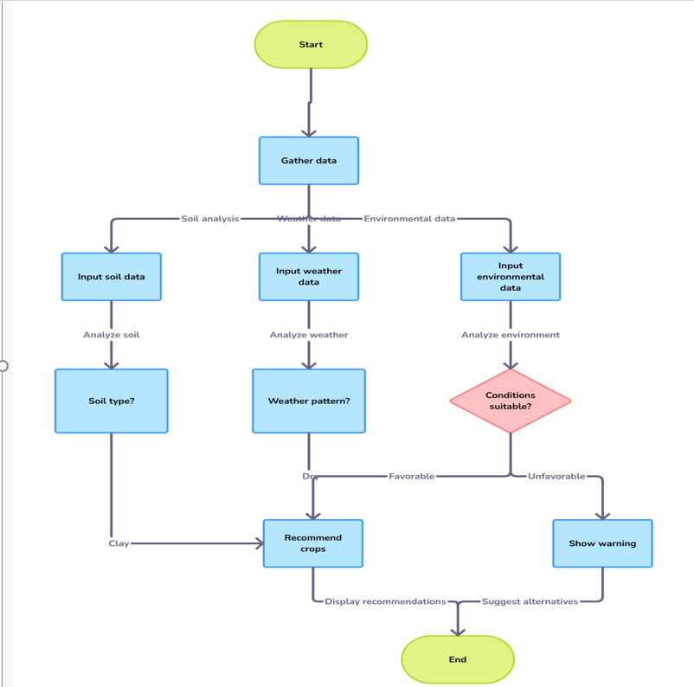the flowchart fig.5.

Fig.5 A flowchart illustrating a system for recommending crops based on gathered soil.

**3.3 Crop forecasting is possible with the help of machine learning.**

The objective of the study was to create groups of crops using their NPK fertilizer, pH level in the soil, and other climate related parameters, using regression algorithms (Figure 1). Five different machine-learning algorithms were utilized to achieve the goal; among them were SVC, RFC, LR, LGBM, and DTC.

**3.3.1 Support Vector Classifier**

The SVC algorithm is used in agriculture to classify crops by looking at things such as NPK fertilizer levels, soil pH, and the climate. The process works by selecting the appropriate ‘super-level’ to make different crop classes easier to tell apart in a high-dimensional space. It performs well when there are nonlinear links in the data, and input features are made higher by kernel functions, resulting in easy separation of the data. To train the decision tree model, the settings were kernel “rbf”, best estimator, c=1.0, gamma = “scale”, random state 42, and probability = True.

**3.3.2 Decision Tree Classifier (DTC)**

Decision Tree Classifier (DTC) is a way of training computers to help sort out crops by looking at things like how much fertilizer they get, how acidic or basic their soil is, and the weather they face. The model works by splitting the training data into smaller groups using different tests for each attribute, and then finding out which attribute helps you learn the most at each stage. This creates a tree-shaped outline where each part of the tree stands for a choice made based on a certain trait, and the end parts, or leaf nodes, show the different kinds of crops. Specifically, the tree was trained using settings such as maximum features set to "auto", using the best estimator, setting alpha to 0.001, setting the standard method as "entropy", using random state 42, and using a maximum depth of 5.

**3.3.3 Light gradient Boost Machine Classifier**

By using gradient boosting, the LGBM Classifier (LGBM) is able to quickly and correctly tell what crops are by noting their amounts of fertilizer, type of soil, and levels of rain. Since LGBM adds new splits to its branches thoughtfully, it can form very deep trees quickly even when working with a lot of data. While training the decision tree model, num_leavels = 31, estimators = 100, learning_rate = 0.05, and random state = 42 were included.

**3.3.4 Logistic regression**

Logistic regression is a common statistical method used for crop classification that looks at things like how much NPK fertilizer is used, the soil pH, and the weather to figure out which type of crop it is. Rather than trees, logistic regression works under the assumption that there is a straight-line connection between features and the probability of a crop class, which is why it is easy to use for different types of classification problems. The decision tree model was trained using estimators=100 and random state = 42.

**3.3.5 Random Forest Classifier**

A combination of multiple decision trees in Random Forest helps improve the way crops are identified and also reduces over handling of the data. She builds a number of decision trees while training and then uses the average predictions to form a reliable and general model. With this technology, Random Forest can deal with nonlinear combinations and features, which is why it is ideal for agricultural data that reports NPK levels, soil pH, and climate. The values estimators=100 and random state = 42 were set during the training stage of the decision tree model.

Random forest

Accuracy

Data acquisition

Data pre-processing

Exploratory Data analysis

LGBM

Logistic Regression

SVM

Decision Tree

Objectives

Data Preparation

Cropping Strategy

Evaluation

Modeling

Precision

F1 score

Recall

Confusion matrix

Rice

Cotton

Coffee

**.**

**.**

**.**

Fig.1. Describe the way to effectively perform analyses and suggest possible farming methods by using machine learning methods.

**Table1**

**Most recent studies of soil monitoring system**

|  |  |  |  |  |
| --- | --- | --- | --- | --- |
| Application Area | Method | Dataset | Key findings | Limitation |
| An automated remote field monitoring system | LoRaWAN | Real-time data. | Visualization in the cloud. | Data Analysis technique is not mentioned. |
| Soil monitoring system | IoT | Real-time data. | Efficiently identify soil type and display corresponding data | Data Analysis technique is not mentioned. |
| Soil Classification based on micronutrients. | ELM | Private | Accuracy 94 % | The dataset consists exclusively of the Tamil Nadu region. |
| Crop recommendation | MLP | Kaggle Dataset | 98.22 % accuracy | Detailed analysis was not conducted. |
| To assist the farmer by developing crop recommendation platform | RF | Kaggle Dataset | Random forest achieved 97.18 % accuracy | Random forest achieved 97.18 % accuracy |
| To support farmers with ongoing crop and field information regularly. | MSVM- DAG-FFO | Own dataset | The proposed mode achieved the accuracy of 97.3 % | Didn’t develop any platform from where farmers can get support. |
| Correct Selection of Crop | SCS | Dataset from Pakistan. | Accuracy 97.4 % | Dataset contains only two types of soil. And the technique is only suitable for a few crops. |

**3.4. Proposed framework**

The framework includes the use of a five-pin sensor system in agriculture to monitor different aspects, like soil nutrient levels (NPK), how moist the soil is, its pH, and the current temperature. The gathered information goes straight to machine learning algorithms to identify crops that work well on this soil. As this sensor collects real-time data, farmers are able to observe soil conditions and decide how to irrigate and fertilize their fields, as well as which crops will grow well in the soil. This helps farmers pick which crops they want to grow and often increases the amount of crops they can harvest. Additionally, it checks the nutritional value of the crops, amounts of pesticides, and for anything that might make the food harmful by studying information from all the sensors. Because it uses machine learning, the system can quickly analyze much data and decide how to best care for agricultural fields, which leads to greater production and less risk of contamination. The proposed framework looks like what you can see in Fig.2.

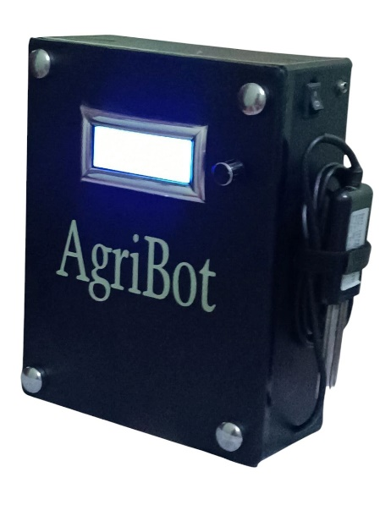

`

Fig.2 Crop recommendation device.

Fig.2 This is a simple program that helps farmers manage their soil by letting them see how much nutrients their soil needs and what kinds of crops might do well with that amount of nutrients.

4. Experimental results

In this part, we will explain the outcomes of the experiment.

We succeeded in achieving it in our work. This will include how we set up our field study and which methods we used to gather and analyze information, as well as some notes on how we checked if our system was working properly. Finally, we will look at the outcomes we got from the research and explain our results in a clear way we display the difference between ML algorithms that we are used in this paper in Table 2.

Table 2. Evaluation the performance between ML Algorithms in this study.

|  |  |  |  |  |
| --- | --- | --- | --- | --- |
| Classifier | Precision | Accuracy | F1_score | Recall |
| Random Forest | 97.6% | 97.3% | 97.3% | 97.3% |
| Decision Tree Classifier | 97% | 96.8% | 96.9% | 96.8% |
| SVC | 86.8% | 87.5% | 85.8% | 87.5% |
| Logistic Regression | 92.3% | 91.6% | 91.5% | 91.6% |
| LGBM Classifier | 96.6% | 96.4% | 96.4% | 96.4% |

**4.1 Model evaluation metrics**

It is important to assess and improve our model before using it on simulations by using various performance measures. A variety of metrics should be considered, besides accuracy, to avoid making inaccurate predictions after using the model on new examples. To judge how effective our study is, we depend on the following evaluation measures (accuracy 4.1.1, Precision 4.1.2, recall 4.1.3, F1-Measur 4.1.4).

**4.1.1Accuracy**

It refers to (1) how many samples are classified correctly.

The relation to the size of the dataset:

Accuracy= (TP+TN)/(TP+TN+FP+FN) (1)

**4.1. 2 Precision**

The formula to find Precision (2) is to divide the true positives by the predicted positive samples.

**Precision= (TP)/((TP+FP))**

**4.1.3 Recall**

Recall (3) is the same as true positive rate (TPR) and means dividing recommended and predicted crops or fertilizers by the total of all crops or fertilizers. It can be defined as:

**Recall= $\frac{(TP)}{(TP+FN)}$** (3)

**4.1.4 F1 measure**

It is the precision and recall’s harmonic mean (average) defined in equation (4).

**F1-Score=((2*precision*Recall))/(Precision+Recall)** (4)

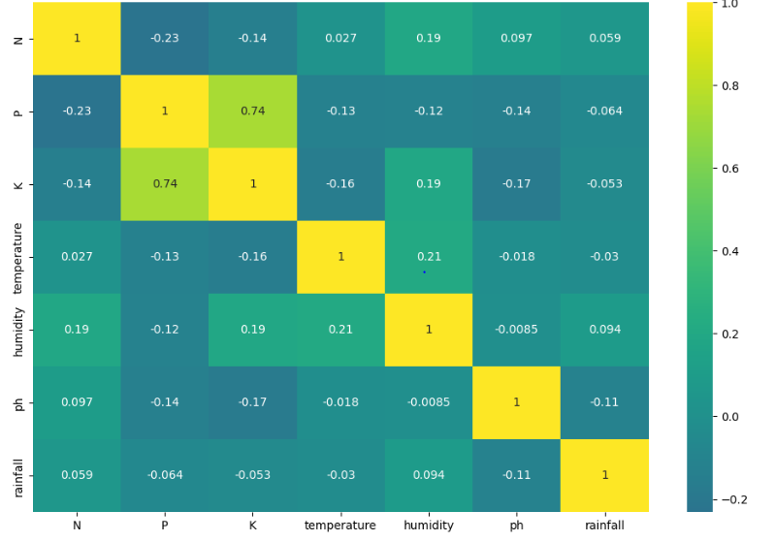

Fig. 3. Correlation among the features of the crop advice dataset means that the values of one variable are linked in some way to the values of another variable.

**4.2. Analysis of results**

Here, we look at the outcomes from running LGBM, SVC, Random Forest, Logistics Regression and DT in the context of Crop Recommendation 4.2.1. The performance of the workbooks was checked using different methods, like looking at how accurate they were, as well as things like precision, recall, and F1 score.

**4.2.1.Crop recommendation**

The accuracy scale shows how healthy the plants are doing during the farming process. Recommendations made by the system. Represents accuracy The ratio of properly suggested crops shows how accurately the system picks out the right crops out of all the options it suggests, and recall shows how well it finds and suggests the crops you’re looking for. F1 result combines both Accuracy and recall help me give a fair idea about how well the workbook is doing its job. Figure 3 shows the results of checking 5 different ways of testing the random forest classifier, and the numbers on each scale show how well it works in terms of accuracy, precision, recall, and F1 score. The random forest classifier got the best accuracy out of all the ways of finding shapes, getting a result of 97.3% correct, finding 97.6% of what was actually there, and correctly picking out the right shape 97.3% of the time. Other models also work well. The support bus classifier had an accuracy of 87.5%, 86.8% accuracy, recall of 87.5%, grade F1 of 85.8%, while the logistic regression classifier got an accuracy of 91.5%, accuracy of 92.3%, recall of 91.5%, F1 score of 91.5%, LGBM classifier got a score of 96.3% for accuracy, accuracy was 96.6%, recall was 96.6%, F1 score was 96.9%, and the decision tree classifier ended up with a score of 96.8% for accuracy, accuracy was 97.0%, recall was 96.8%, and F1 score was 96.9%.

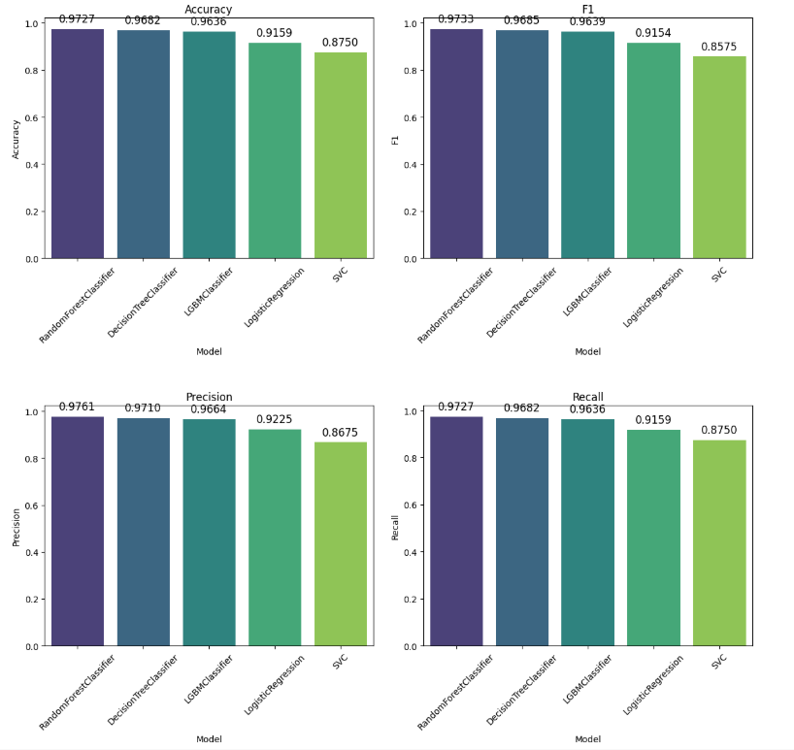

Fig. 3. Comparisons of 5 different model’s evaluation metrics.

In addition, the confusion matrix was analyzed to gain insight into the specific types of classification errors committed by the system presented in Figure 4. When analyzing the results, it is clear that the model displays a large number of accurate positive and negative predictions across various categories. However, there are cases where the model generates incorrect output. Specifically, there are 50 iterations where the model misclassified certain categories. Such errors may have the potential to influence crop selection decisions in the agricultural field. Table 4 represents a comparative performance analysis of various machine-learning algorithms used in the modern literature to recommend the right crop for cultivation in agricultural fields. Indicates that the random forest classifier shows promising performance with 97% accuracy grade in accurately recommending crops based on specific input parameters.

Logistic Regression Decision Tree

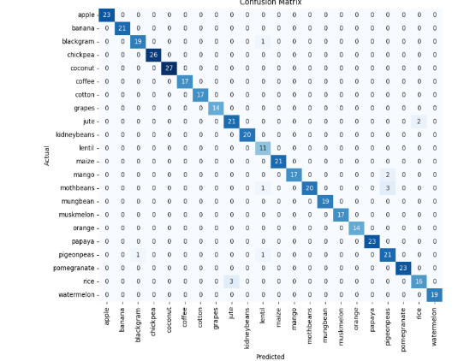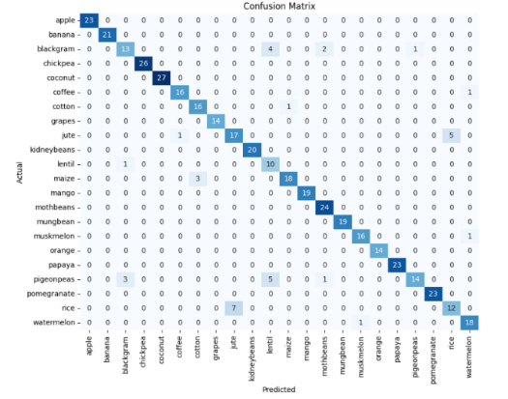

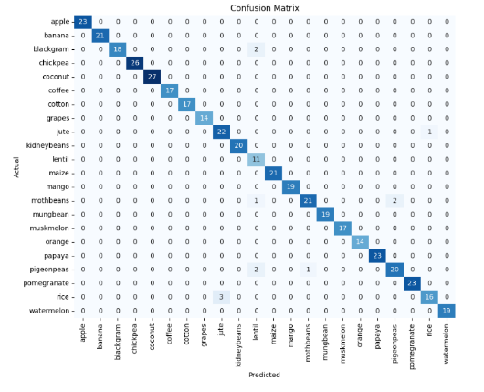 Random Forest LGBM Classifier

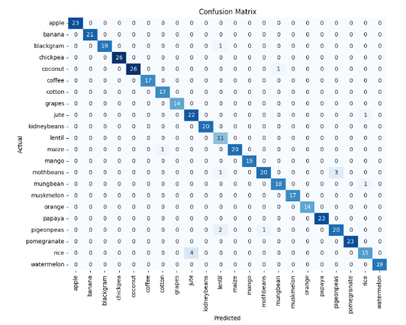

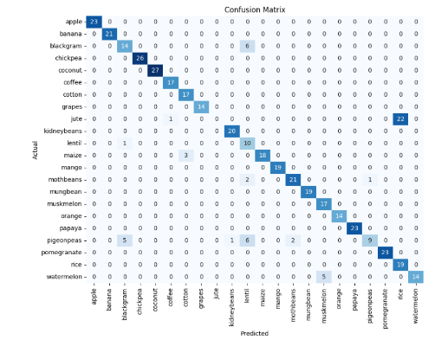**SVC**

Fig. 4. Confusion matrix of five model classifiers.

Our research shows that the developed device and framework are highly promising in the field of precision agriculture. An important outcome of using machine learning methods in our project was the ability to monitor soil nutrients in real time. Using the NPK Five Pins sensor in the crop field, we gathered data on nutrient contents (NPK), humidity, air temperature and relative soil moisture. The gathered information was transmitted to the decision-making form. Machine learning algorithms and in particular the LGMB classifier and Random Forest, played a crucial part in selecting the most appropriate crops for a given environment. Both algorithms were trained and fine-tuned using the inbuilt datasets before achieving precision in diagnosing the best crop type and the optimal fertilizer. Crop types and moisture levels in general. LGBM performed well in determining the highest yield by using variables including N, P, K, atmospheric temperature, humidity, soil pH, soil moisture and rainfall. Random forest algorithm was better at identifying the best fertilizer based on factors consisting of nitrogen, potassium, phosphorus, temperature, humidity, soil type, crop type and soil moisture. Our evaluation demonstrated that the models we developed were highly accurate in suggesting the right crops and fertilizers in most cases. It should be taken into account that occasionally the models might make incorrect predictions, which may affect farmers’ choices regarding crops and fertilizers. Continued efforts in research and development are critical to increasing the accuracy and usability of the recommendation system for farmers.

**4.3. Experimental setup**

The study was conducted using the eighth generation Intel Core (TM) i5 with a 100200H processor registered at a speed of up to 2.4 GHz and 8 GB of RAM. Many tests were performed using different machine learning techniques using the Visual Studio tool. To collect various data from the crop field, NPK sensor that explained in table3.

Table.3.Sensor Ranges.

|  |  |  |
| --- | --- | --- |
| NPK Soil Sensor five pins and Measure 7 Parameter | Range | Description |
| 0-1999 | Compute the ratio of Nitrogen, Phosphorus and potassium present content in soil. |
| Temperature | $$±.5℃$$ |
| Conductivity | 0-1000us/cm |
|  |  |
| PH | 3-9pH |
| Humidity | 0-100% |

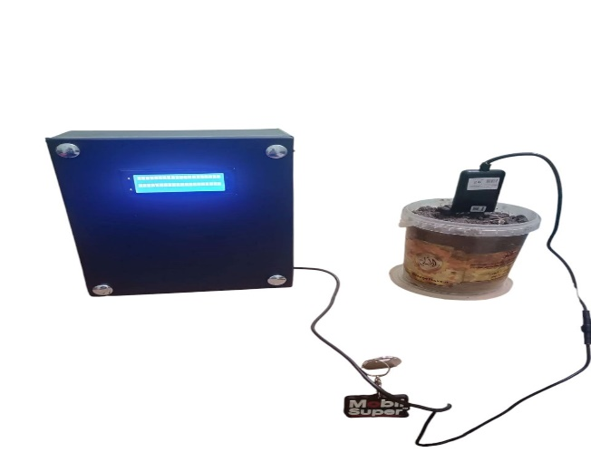

Download Image

**5. Conclusion**

Results demonstrated that integrating sensor data and machine learning effectively enabled the development of an novel ML based tool that accurately monitors soil nutrients and suggests suitable crops for cultivation. A set of sensors was employed to gather fundamental data on soil nutrients, moisture , humidity and temperature. Employing machine learning algorithms like the LGBM classifier and Random Forest has helped to accurately predict crops and recommend the right fertilizers. Although further work is necessary to refine the device and improve its accuracy, the use of machine learning has demonstrated its ability to give farmers valuable advice at any given time during the growing process. Ongoing efforts to address obstacles and expand research initiatives will help us enhance this device’s performance and promote progress in the field of precision agriculture.

**Reference**

|  |  |
| --- | --- |
|  | |
| [1] Barthwal, Ashutosh, et al. "Site specific NPK recommendation in wheat (Triticum aestivum) for sustained crop and soil productivity in mollisols of Tarai region." *Indian Journal of Agronomy* 58.2 (2013): 208-214.  [2] Gottemukkala, Lavanya, et al. "Sustainable Crop Recommendation System Using Soil NPK Sensor." *E3S Web of Conferences*. Vol. 430. EDP Sciences, 2023.‏  ‏ | |
|  | |  |
|  | |
|  | |
|  | |
|  | |
|  | |
|  | |
|  | |  |
|  | |
| [3] Dey, Biplob, Jannatul Ferdous, and Romel Ahmed. "Machine learning based recommendation of agricultural and horticultural crop farming in India under the regime of NPK, soil pH and three climatic variables." *Heliyon* 10.3 (2024).‏ | |
|  |  |

|  |  |
| --- | --- |
|  | |
| [5] Csathó, Péter, et al. "Evaluation of different fertilizer recommendation systems on various soils and crops in Hungary." *Communications in Soil Science and Plant Analysis* 40.11-12 (2009): 1689-1711.‏ | |
|  | |  |
|  |
| [6] Wu LiangQuan, Wu LiangQuan, et al. "Basic NPK fertilizer recommendation and fertilizer formula for maize production regions in China." (2015): 802-817.‏   |  | | --- | |  | | [7] Shtull-Trauring, E., et al. "NPK in treated wastewater irrigation: Regional scale indices to minimize environmental pollution and optimize crop nutritional supply." *Science of The Total Environment* 806 (2022): 150387.‏   |  | | --- | |  | | [8] Singh, Poonam, Madhoolika Agrawal, and Shashi Bhushan Agrawal. "Evaluation of physiological, growth and yield responses of a tropical oil crop (Brassica campestris L. var. Kranti) under ambient ozone pollution at varying NPK levels." *Environmental Pollution* 157.3 (2009): 871-880.‏  [9] Shinde, Mansi, et al. "Crop recommendation and fertilizer purchase system." *International Journal of Computer Science and Information Technologies* 7.2 (2016): 665-667.‏  [10] Fodor, Nándor, et al. "Crop nutrient status and nitrogen, phosphorus, and potassium balances obtained in field trials evaluating different fertilizer recommendation systems on various soils and crops in Hungary." *Communications in soil science and plant analysis* 44.5 (2013): 996-1010.‏  [11] Rakshit, Rajiv, et al. "Effect of super-optimal dose of NPK fertilizers on nutrient harvest index, uptake and soil fertility levels in wheat crop under a maize (Zea mays L.)-wheat (Triticum aestivum L. cropping system)." *International Journal of Bio-resource and Stress Management* 6.1 (2015): 15-23.‏  [12] Baligar, V. C., and O. L. Bennett. "NPK-fertilizer efficiency—a situation analysis for the tropics." *Fertilizer research* 10 (1986): 147-164.‏  [13] Cao, Hanbing, et al. "Tailoring NPK fertilizer application to precipitation for dryland winter wheat in the Loess Plateau." *Field Crops Research* 209 (2017): 88-95.‏  [14] Lee, Choon-Soo, et al. "Newly recommended rates of NPK fertilizers based on soil testing for some upland crops." *Korean Journal of Soil Science and Fertilizer* 26.2 (1993): 111-120.‏  [15] Abbas, G. J. Z. K., et al. "Effect of organic manures with recommended dose of NPK on the performance of wheat (Triticum aestivum L.)." (2012): 683-687.‏   |  | | --- | |  | | [16]Rurinda, Jairos, et al. "Science-based decision support for formulating crop fertilizer recommendations in sub-Saharan Africa." *Agricultural Systems* 180 (2020): 102790.‏ | |  |  |  |  | | --- | |  | | [17] Ghotane, Ranjeet, et al. "Recommendation system for soil fertilizer using NPK."‏ |  |  | | --- | |  | |  |   [18] Saeed, Dilzar Faiz, and Alwand Tahir Dizayee. "(NPK) fertilizer application levels in Onion Crops and Using the Diagnosis and Recommendation Integrated System–DRIS." *Journal of Kirkuk University for Agricultural Sciences* 14.2 (2023).‏  [19] Yaduvanshi, N. P. S. "Effect of five years of rice-wheat cropping and NPK fertilizer use with and without organic and green manures on soil properties and crop yields in a reclaimed sodic soil." *Journal of the Indian Society of Soil Science* 49.4 (2001): 714-719.‏  [20] Ahmed, Usman, et al. "A nutrient recommendation system for soil fertilization based on evolutionary computation." *Computers and Electronics in Agriculture* 189 (2021): 106407.‏  [21] Ghosh, P. K., et al. "Comparative effectiveness of cattle manure, poultry manure, phosphocompost and fertilizer-NPK on three cropping systems in vertisols of semi-arid tropics. I. Crop yields and system performance." *Bioresource technology* 95.1 (2004): 77-83.‏  [22] Keawmuangmoon, Tewin, and Attachai Jintrawet. "iCassFert-NPK: The Design and Web-based Implementation of an interactive web-based approach for cassava production NPK fertilizer recommendations in Thailand." *Khon Kaen Agriculture Journal* 42 (2014): 66-72.‏  [23] Kulkarni, Nidhi H., et al. "Improving crop productivity through a crop recommendation system using ensembling technique." *2018 3rd international conference on computational systems and information technology for sustainable solutions (CSITSS)*. IEEE, 2018.‏  [24] Islam, Md Shofiqul, et al. "Unbalanced fertilizer use in the Eastern Gangetic Plain: The influence of Government recommendations, fertilizer type, farm size and cropping patterns." *PLoS One* 17.7 (2022): e0272146.‏  [25] Gosai, Dhruvi, et al. "Crop recommendation system using machine learning." *International Journal of Scientific Research in Computer Science, Engineering and Information Technology* 7.3 (2021): 558-569.‏  [26] Lee, Gye-Jun, et al. "Recommendations of NPK fertilizers based on soil testing and Yied response for carrot in highland." *Korean Journal of Soil Science and Fertilizer* 42.6 (2009): 467-471.‏  [27] Lee, Gye-Jun, et al. "Recommendations of NPK Fertilizers based on Soil Testing and Yied Response for Radish in Highland." *Korean Journal of Soil Science and Fertilizer* 42.3 (2009): 167-171.‏  [28] Puli, Mohana Rao, et al. "Effect of organic and inorganic sources of nutrients on NPK uptake by rice crop at various growth periods." *Research Journal of Agricultural Sciences* 8.1 (2017): 64-69.‏  [29] Suthar, Surindra. "Impact of vermicompost and composted farmyard manure on growth and yield of garlic (Allium stivum L.) field crop." (2009): 27-38.‏  [30] Gondwe, Rodney L., et al. "Available soil nutrients and NPK application impacts on yield, quality, and nutrient composition of potatoes growing during the main season in Japan." *American Journal of Potato Research* 97 (2020): 234-245.‏  [31] Senapaty, Murali Krishna, Abhishek Ray, and Neelamadhab Padhy. "IoT-enabled soil nutrient analysis and crop recommendation model for precision agriculture." *Computers* 12.3 (2023): 61.‏  [32] Verma, S. P., and S. C. Modgal. "Production potential and economics of fertilizer application as resource constraint in maize-wheat crop sequence." (1983): 89-92.‏   |  | | --- | |  | | [33] Verma, S. P., and S. C. Modgal. "Production potential and economics of fertilizer application as resource constraint in maize-wheat crop sequence." (1983): 89-92.‏  [34] Bhavya, Tanneru, Ramyalaxmi Seggam, and Ravi Kumar Jatoth. "Fertilizer recommendation for rice crop based on NPK nutrient deficiency using deep neural networks and random forest algorithm." *2023 3rd International Conference on Artificial Intelligence and Signal Processing (AISP)*. IEEE, 2023.‏  [35] Jayadeva, H. M., et al. "Methane emission as influenced by different crop establishment techniques and organic manures." *Agricultural Science Digest* 29.4 (2009): 241-245.‏  [36] Varshitha, D. N., and Savita Choudhary. "An artificial intelligence solution for crop recommendation." *Indonesian Journal of Electrical Engineering and Computer Science* 25.3 (2022): 1688-1695.‏  [37] Usman, M., M. G. Nangere, and I. Musa. "Effect of three levels of NPK fertilizer on growth parameters and yield of maize-soybean intercrop." *International Journal of Scientific and Research Publications* 5.9 (2015): 1-6.‏  [38] Kumar, Prince, et al. "Site-specific nutrient requirements of NPK for potato (Solanum tuberosum L.) in Western Indo-gangetic plains of India based on QUEFTS." *Journal of plant nutrition* 41.15 (2018): 1988-2000.‏  [39] Srinivasan, S., and A. Angayakanni. "Fertilizer recommendation based on soil test crop response for high targeted yield." *Oryza–An International Journal on Rice* 47.4 (2010): 287-290.‏  [40] Misbah, Khalil, et al. "Multi-sensors remote sensing applications for assessing, monitoring, and mapping NPK content in soil and crops in African agricultural land." *Remote Sensing* 14.1 (2021): 81.‏  [41] Ramamurthy, V., et al. "Soil-based fertilizer recommendations for precision farming." *Current Science* (2009): 641-647.‏  [42] Zhang, Yue, et al. "Quantifying the relationships of soil properties and crop growth with yield in a NPK fertilizer application maize field." *Computers and Electronics in Agriculture* 198 (2022): 107011.‏  [43] Yadav, R. L., B. S. Dwivedi, and P. S. Pandey. "Rice-wheat cropping system: assessment of sustainability under green manuring and chemical fertilizer inputs." *Field crops research* 65.1 (2000): 15-30.‏  [44] Mallarino, Antonio, John Sawyer, and Stephen Barnhart. "A general guide for crop nutrient and limestone recommendations in Iowa." (2013).‏  [45] Jia, Zenghui, et al. "Multi-stage fertilizer recommendation for spring maize at the field scale based on narrowband vegetation indices." *Computers and Electronics in Agriculture* 213 (2023): 108236.‏  [46] Kumar, R., and C. M. Singh. "Crop yields and economics under fertilizer resource constraints along with different FYM application in maize-wheat cropping sequence." (1997): 103-107.‏  [47] Ahmad, M., et al. "Role of organic and inorganic nutrient sources in improving wheat crop production." (2012).‏  [48] Li, Juan, et al. "NPK fertilizations recommended based on agronomic benefits on rice in Fujian." (2019): 146-154.‏  [49] Prasad, Heerendra, et al. "Effect of organic manures and biofertilizer on plant growth, yield and quality of horticultural crop: A review." *Int. J. Chem. Stud* 5.1 (2017): 217-221.‏  [50] Chaudhary, Seema, G. S. Dheri, and B. S. Brar. "Long-term effects of NPK fertilizers and organic manures on carbon stabilization and management index under rice-wheat cropping system." *Soil and Tillage Research* 166 (2017): 59-66.‏  [51] Singh, P. K., P. B. Deshbhratar, and D. S. Ramteke. "Effects of sewage wastewater irrigation on soil properties, crop yield and environment." *Agricultural water management* 103 (2012): 100-104.‏  [52] Vimaladevi, M., et al. "FertiForecast: Identification of Fertilizer Based on NPK Levels using Machine Learning Algorithms." *2024 International Conference on Computing and Data Science (ICCDS)*. IEEE, 2024.‏  [53] Choudhary, Anil K., and V. K. Suri. "Effect of organic manures and inorganic fertilizers on productivity, nutrient uptake and soil fertility in rice (Oryza sativa)-wheat (Triticum aestivum) crop sequence in western Himalayas." *Curr Adv Agric Sci* 1.2 (2009): 65-69.‏  [54] Paul, Jai, et al. "Bioresource nutrient recycling and its relationship with biofertility indicators of soil health and nutrient dynamics in rice–wheat cropping system." *Communications in Soil Science and Plant Analysis* 45.7 (2014): 912-924.‏  [55] Bhatnagar, Vaibhav, and Ramesh C. Poonia. "A prototype model for decision support system of NPK fertilization." *Journal of Statistics and Management Systems* 21.4 (2018): 631-638.‏ | |  |  |   [56] <https://www.kaggle.com/datasets/atharvaingle/crop-recommendation-dataset>  [57] A.Y. Hoekstra, A.K. Chapagain, M.M. Alday, M.M. Mekonnen  [58] El-Marsafawy, Samia Mahmoud, and Ali Ibrahim Mohamed. "Water footprint of Egyptian crops and its economics." *Alexandria Engineering Journal* 60.5 (2021): 4711-4721.‏   |  |  | | --- | --- | |  |  | | |  |  | | |  |  | |
|  |  |