BINGHAM UNIVERSITY, NIGERIA
Department of Cyber Security
CORPORATE INCIDENT RESPONSE SIMULATION
Technical Incident Report: Detection, Analysis, Containment and Recovery from a Simulated SSH Brute-Force Attack
Prepared by
Moge Daniel Oluwadamilare
Matric No: BHU/23/04/09/0079
Role Simulated: SOC Tier 1 Analyst (Detection • Analysis • Containment • Recovery)
September 2026

1. Executive Summary
This report documents a Security Operations Centre (SOC) simulation exercise carried out as part of practical training in Cyber Security at Bingham University. The exercise modelled the SOC incident-response lifecycle — detect, analyse, contain and recover — against a controlled, authorised SSH brute-force attack executed inside an isolated virtual lab.
A Kali Linux virtual machine acted as the attacker, targeting a throwaway account (testuser) on an Ubuntu Server virtual machine acting as both the victim host and the log-monitoring platform (running Splunk Enterprise Free and OpenSSH). Network traffic was captured with Wireshark/tshark on the attacker VM. The attack was successfully detected through host authentication logs ingested into Splunk, independently corroborated at the network layer through packet capture, and contained using a host-based firewall (ufw) deny rule.
The exercise confirmed a successful compromise of the testuser account using a weak, easily-guessed password, identified a gap in an early detection query, and produced concrete evidence (screenshots, log excerpts and packet captures) supporting the incident timeline, containment action and recommendations set out in this report.

2. Objective and Scope
Objective: to role-play the responsibilities of a SOC Analyst, Incident Lead and Communications Officer while executing the full incident-handling lifecycle (Preparation → Detection → Analysis → Containment → Eradication → Recovery → Post-Incident Review) against a simulated corporate breach.
Scope: the exercise was confined to two virtual machines connected on an isolated VirtualBox Host-Only network (192.168.56.0/24). No production system, external network, or third party was involved at any point. The simulated breach type was unauthorised access via SSH credential brute-forcing, one of the two categories specified for the assignment (malware or unauthorised access).

3. Lab Environment and Tools
Role | Host / OS | Network Interfaces & IP Addresses | Key Tools Installed
Victim host, log source and SIEM | Ubuntu Server (VirtualBox guest) | enp0s3 (NAT): 10.0.2.15/24  enp0s8 (Host-only): 192.168.56.102/24 | OpenSSH Server, Splunk Enterprise Free 10.2.0, ufw (firewall)
Attacker | Kali Linux 2025.3 (VirtualBox guest) | eth0 (NAT): 10.0.2.5/24  eth1 (Host-only): 192.168.56.101/24 | Hydra v9.7 (credential brute-forcer), tshark / Wireshark
The Host-Only adapter (192.168.56.0/24) was the exclusive path used to launch and observe the attack; the NAT adapters on both machines were used only for internet access when installing packages.

4. Methodology — Procedure Followed
The exercise followed a twelve-step procedure spanning environment preparation, attack execution, detection, analysis, containment and recovery. Each phase below is paired with the corresponding evidence captured during the exercise.

4.1 Connectivity and Environment Verification
Interface addresses were confirmed on the Ubuntu victim VM with ip a, and the Splunk daemon (splunkd) was confirmed running, with the web interface reachable at http://ubuntu:8000.
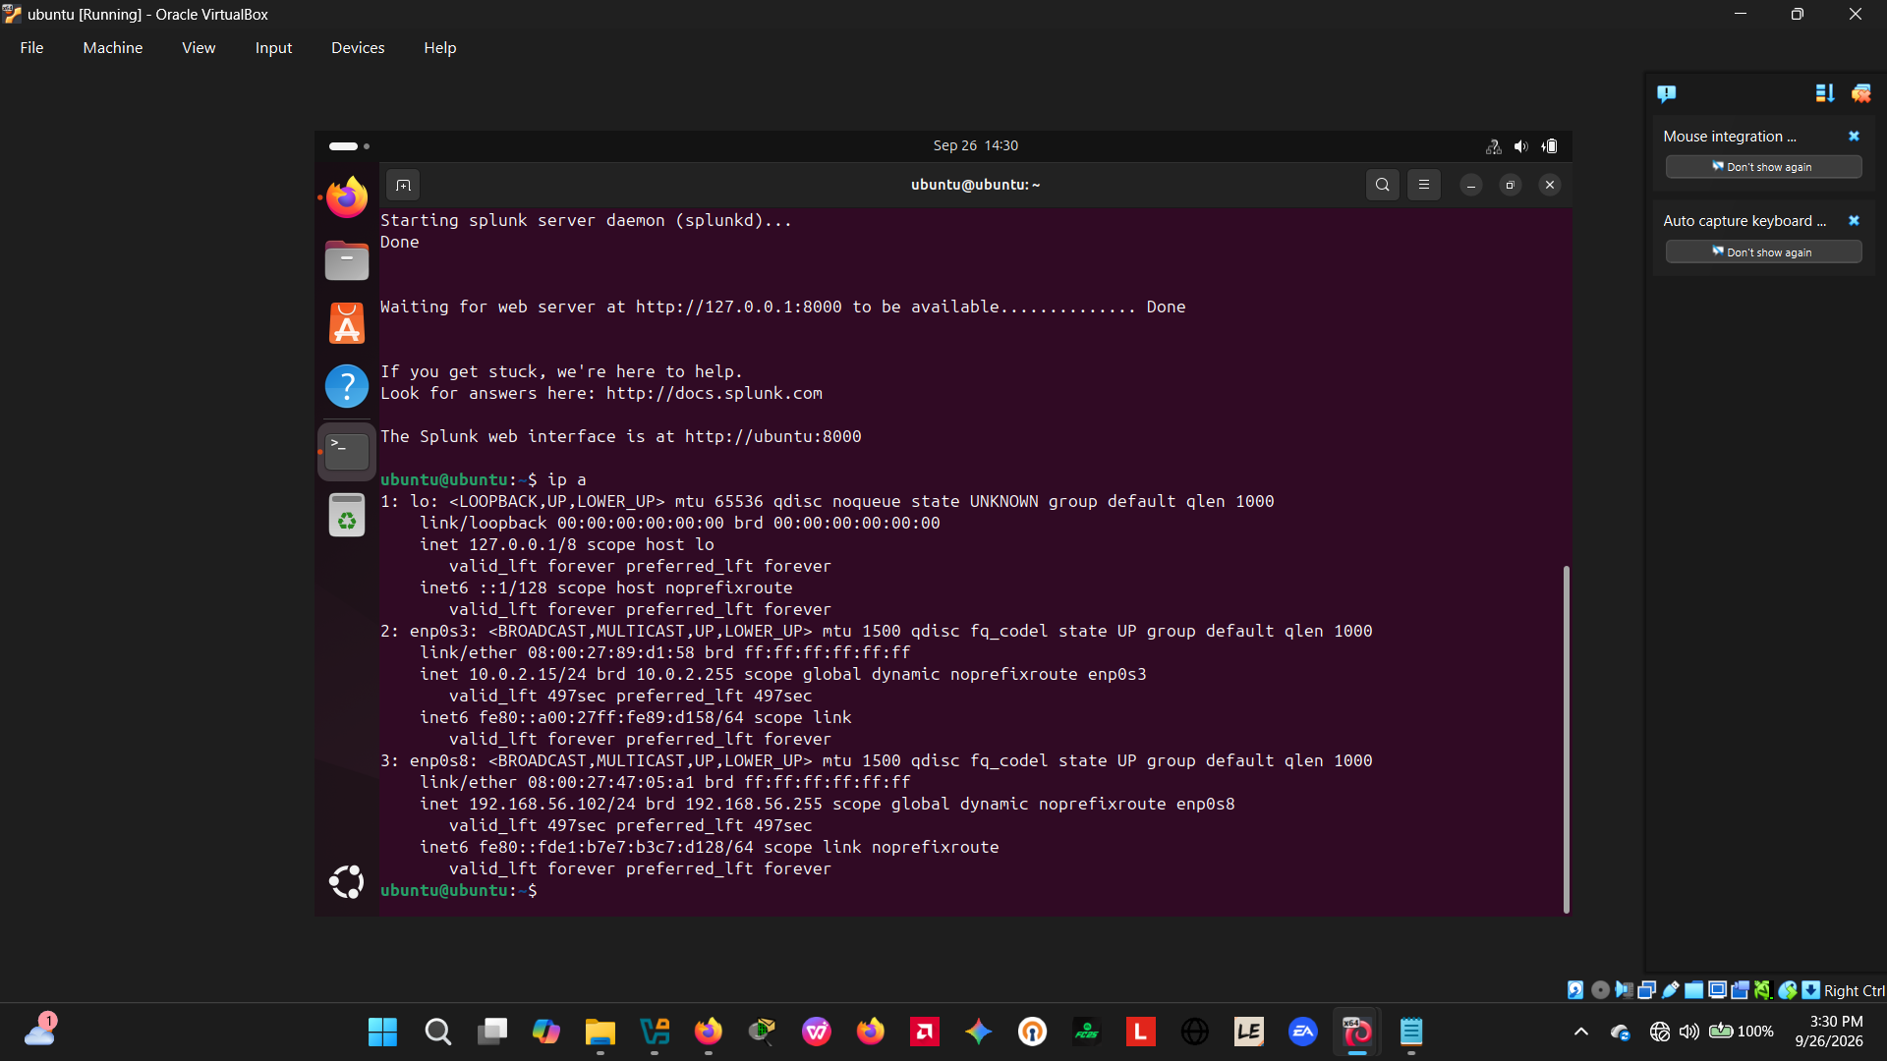
Figure 1 — Ubuntu victim VM network interfaces (enp0s3 10.0.2.15, enp0s8 192.168.56.102) and Splunk daemon startup confirmation.

4.2 Victim Preparation — Enabling the SSH Service
The OpenSSH server package was installed and enabled on the Ubuntu VM to expose port 22, and a throwaway account (testuser) was created as the attack target so that no real user credentials were placed at risk.
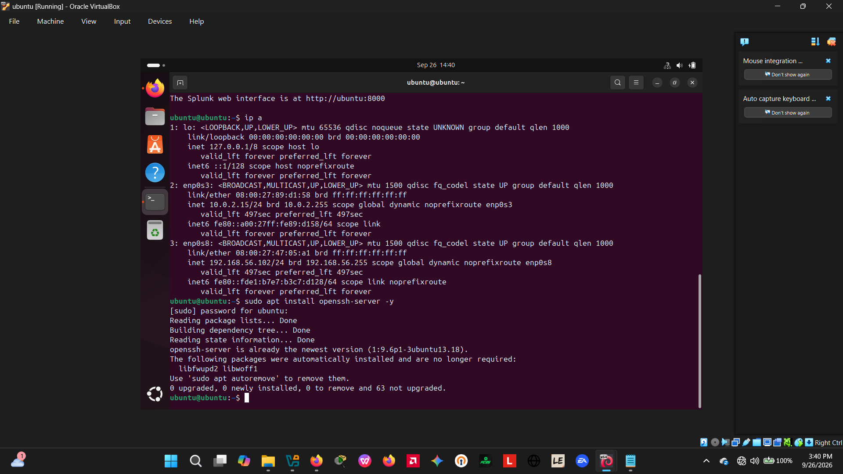
Figure 2 — Installation of openssh-server on the Ubuntu victim VM (sudo apt install openssh-server -y).

4.3 Baseline Log Monitoring
Before the attack was launched, /var/log/auth.log was tailed live to confirm authentication events were being written to disk and would be available for later ingestion into Splunk.
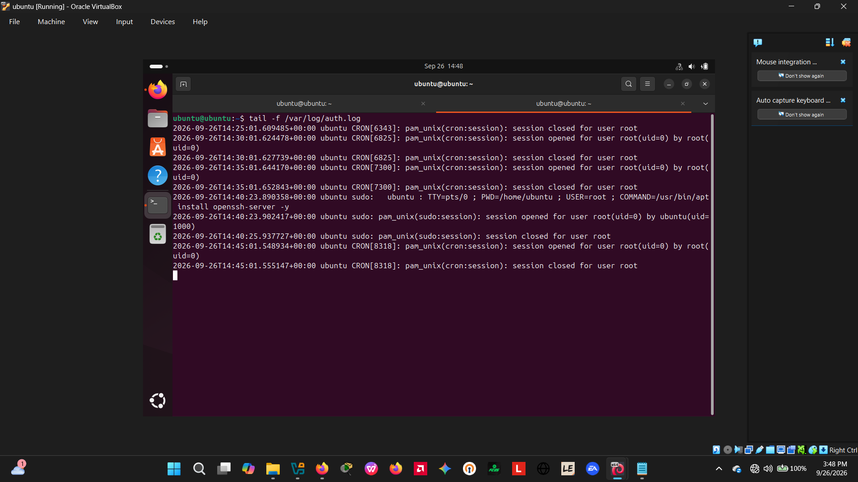
Figure 3 — Live tail of /var/log/auth.log showing routine cron and sudo session activity prior to the attack (baseline).

4.4 Splunk Installation and Log Source Configuration
Splunk Enterprise (Free) was installed locally on the Ubuntu VM and configured to monitor /var/log/auth.log under sourcetype=linux_secure, index=main, so that every SSH authentication event would be searchable in near real time.
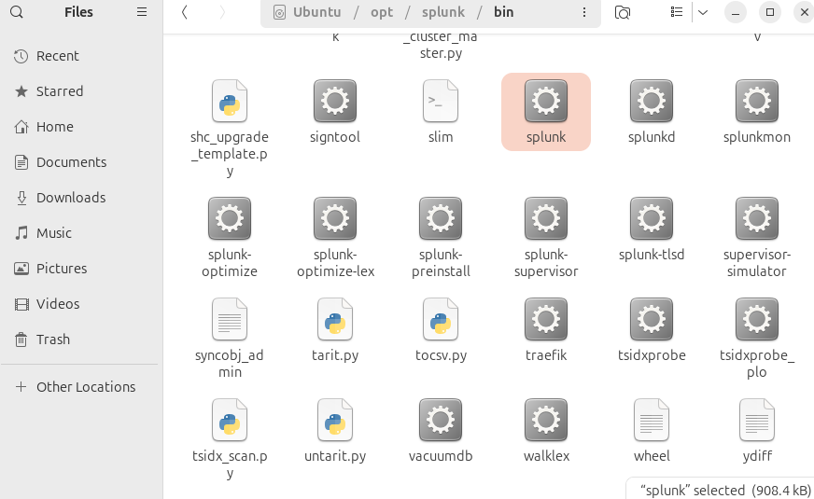
Figure 4 — Local Splunk installation directory (/opt/splunk/bin) confirmed on the Ubuntu victim host.

4.5 Attacker Preparation — Wordlist and Target Confirmation
On the Kali VM, interface addressing was confirmed and a custom password wordlist (passwords.txt) was created containing a small set of candidate passwords, with the correct password for testuser placed among them to simulate a realistic (non-instant) brute-force duration.
An initial attempt to run Hydra with the placeholder value <ubuntu-vm-ip> typed literally caused a shell parse error, since angle brackets are interpreted by zsh as redirection operators rather than plain text. This was corrected by substituting the real host-only IP address of the victim (192.168.56.102).
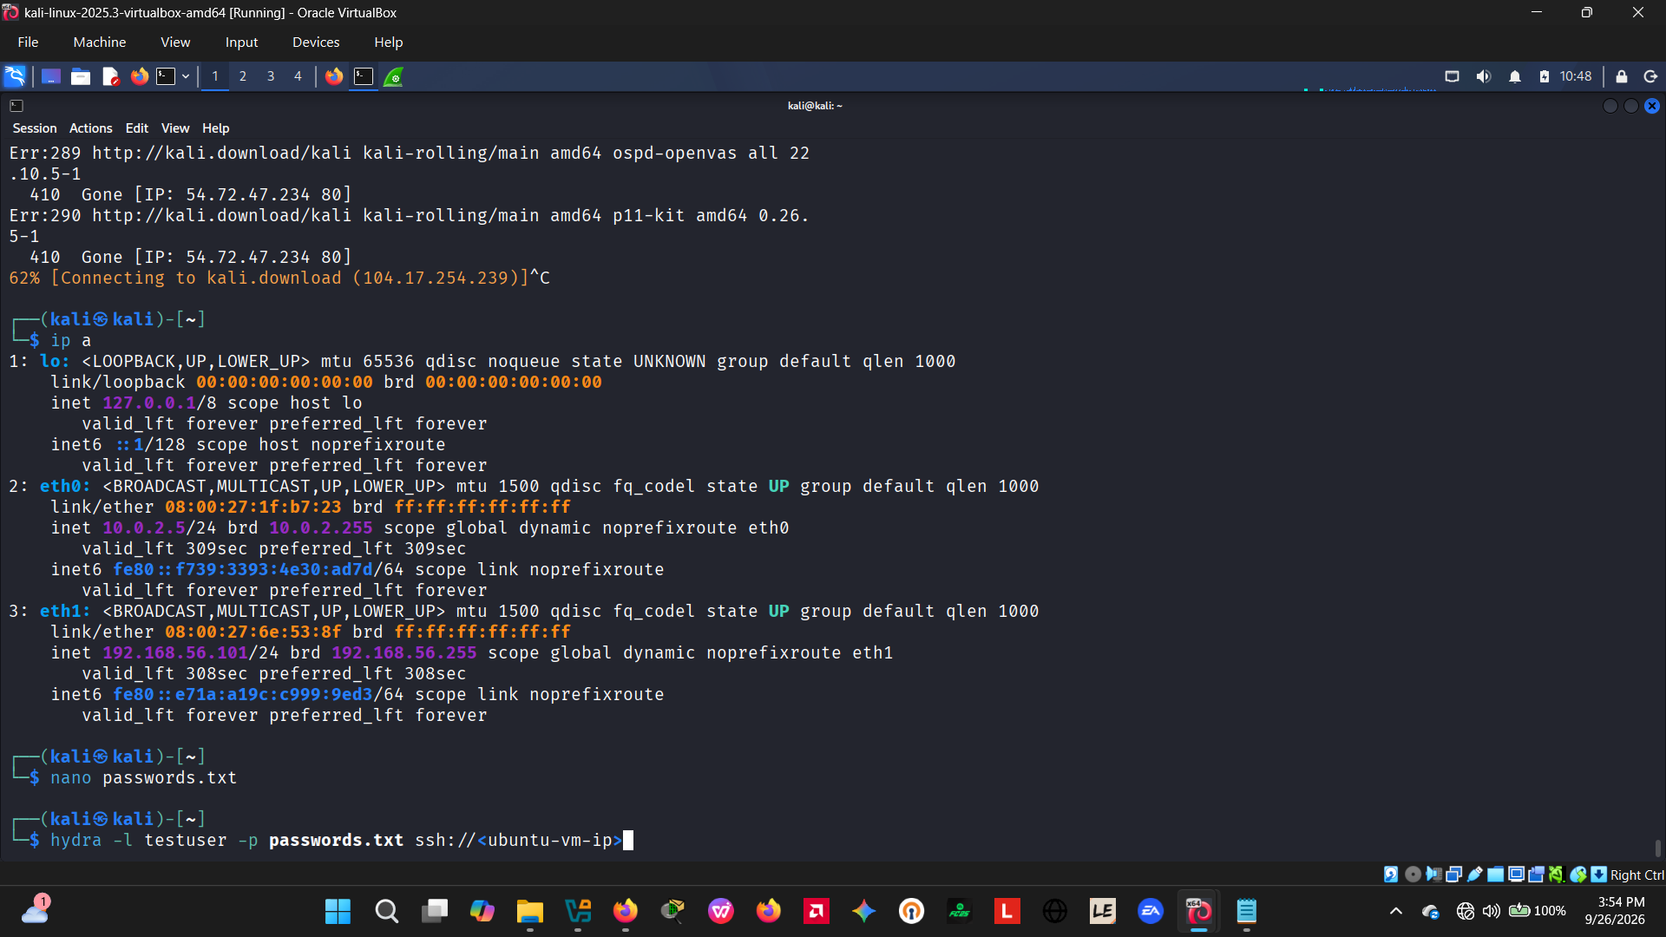
Figure 5 — Kali attacker VM interface addressing, wordlist creation (nano passwords.txt) and the initial Hydra command containing an unresolved placeholder.

4.6 Attack Execution
Hydra was re-run against ssh://192.168.56.102 with the corrected target address, successfully identifying the valid credential pair testuser / kali.
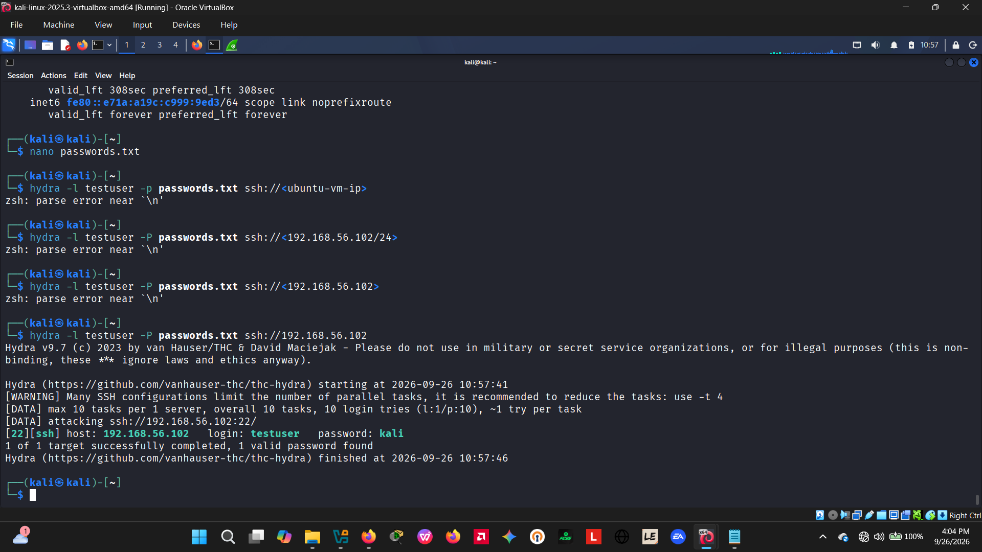
Figure 6 — Corrected Hydra command executed against 192.168.56.102; valid credential testuser / kali recovered.
The attack was re-run several times over the course of the exercise while the setup was being refined. One run returned a connection timeout (transient network/VM-state issue) and one later run reported "0 valid password found" after the wordlist had been temporarily edited; the successful runs consistently recovered the same testuser / kali credential pair.
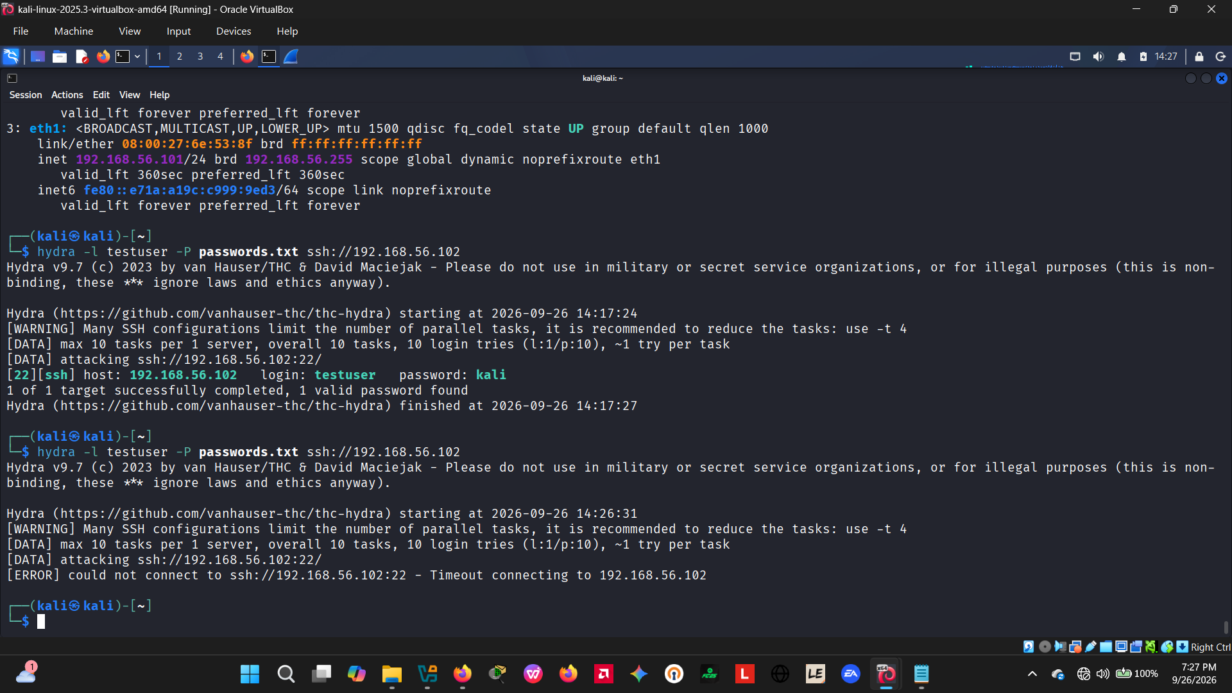
Figure 7 — Hydra attack log showing a connection timeout on one run, followed by a successful recovery of the testuser / kali credential.
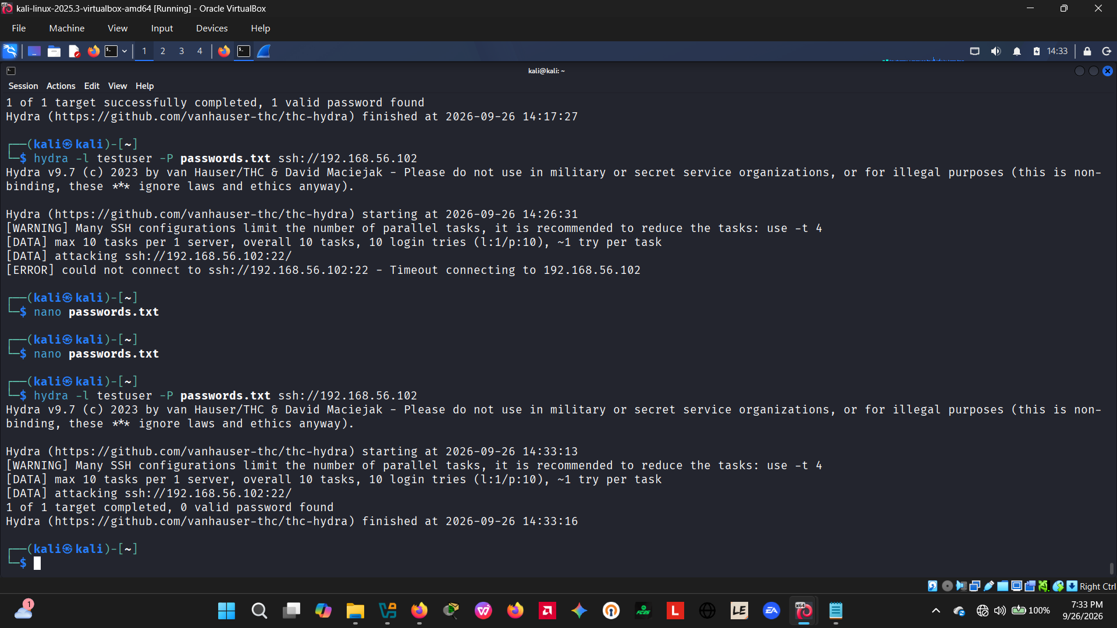
Figure 8 — A subsequent Hydra run against the same target, illustrating iterative re-testing carried out during the exercise.

4.7 Network-Layer Capture (Wireshark)
Traffic was captured on the Kali attacker VM for the duration of the attack (saved as hydra test.pcapng) and filtered on tcp.port == 22. The capture shows a rapid, repeated sequence of TCP three-way handshakes (SYN → SYN/ACK → ACK) from 192.168.56.101 to 192.168.56.102, consistent with an automated credential-guessing tool opening many short-lived connections in quick succession, followed by SSH2 protocol banner exchange and an Elliptic-Curve Diffie–Hellman key exchange for the successful session.
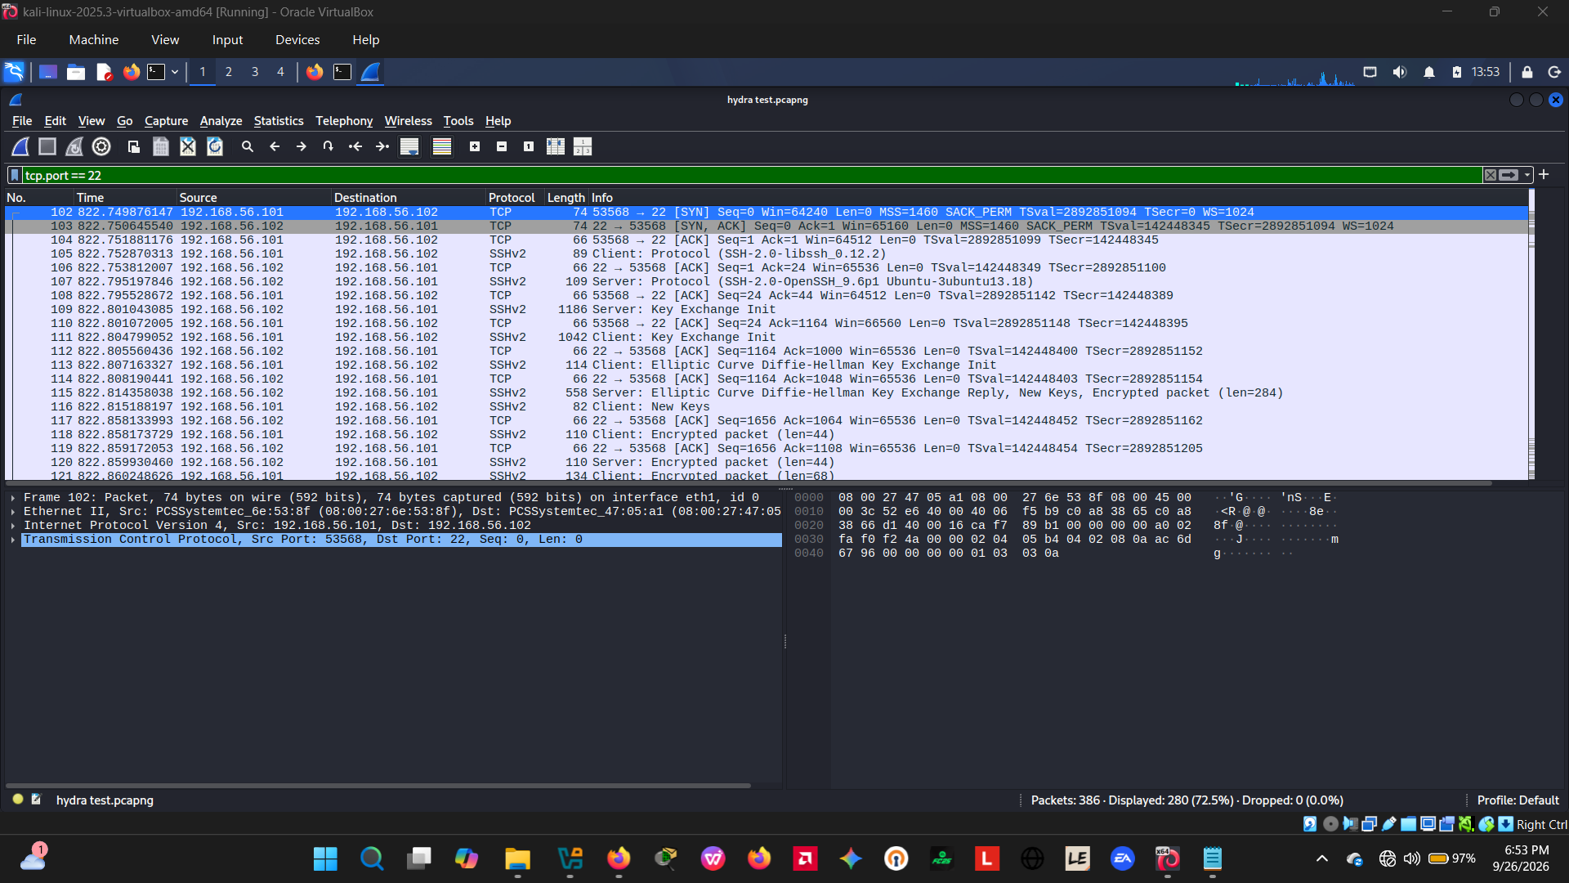
Figure 9 — Wireshark capture (tcp.port==22) showing repeated TCP handshakes and SSHv2 key-exchange packets between the attacker (192.168.56.101) and victim (192.168.56.102).
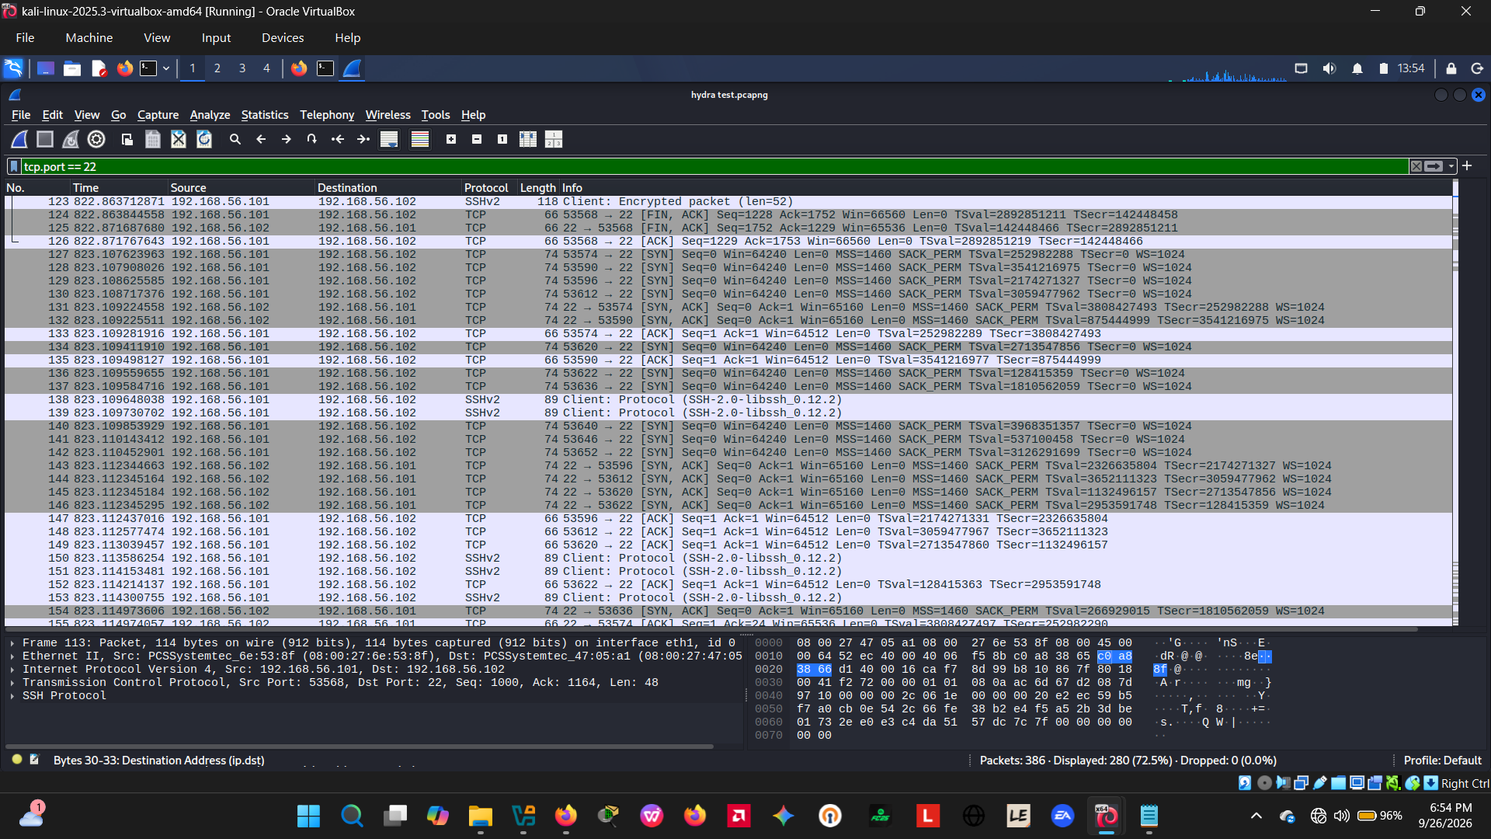
Figure 10 — Continuation of the capture: encrypted packet exchange, session teardown (FIN/ACK) and a fresh burst of SYN packets from subsequent Hydra connection threads.

4.8 Detection in Splunk
An initial ad-hoc search over sourcetype=linux_secure for the word "password" returned two events: one unrelated GNOME keyring authentication failure (local desktop noise) and one genuine SSH event — "Failed password for testuser from 192.168.56.101 port 53636 ssh2" — confirming the log source was correctly capturing the attack.
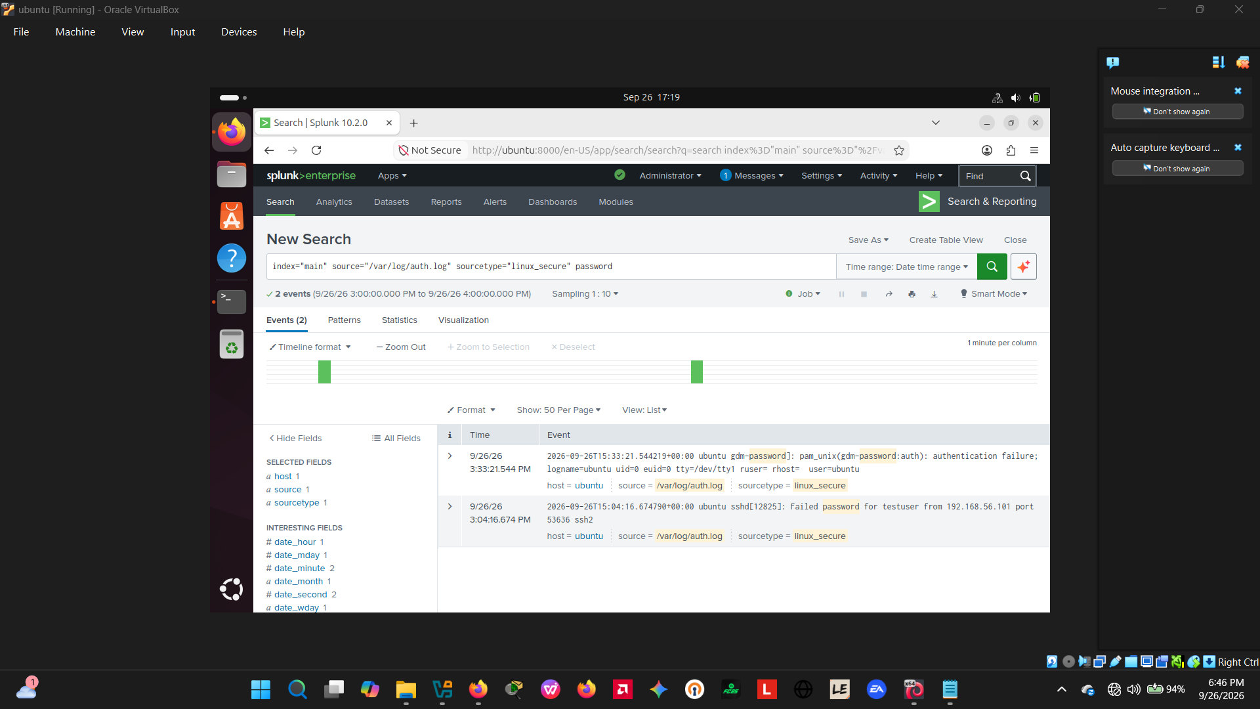
Figure 11 — Ad-hoc Splunk search isolating the first genuine failed-password event for testuser from 192.168.56.101.
A keyword search for the term "login" was also tested as a possible detection filter but returned only a single, unrelated GNOME keyring-unlock event, confirming this keyword was not a suitable detection term for this attack pattern and was excluded from the final approach.
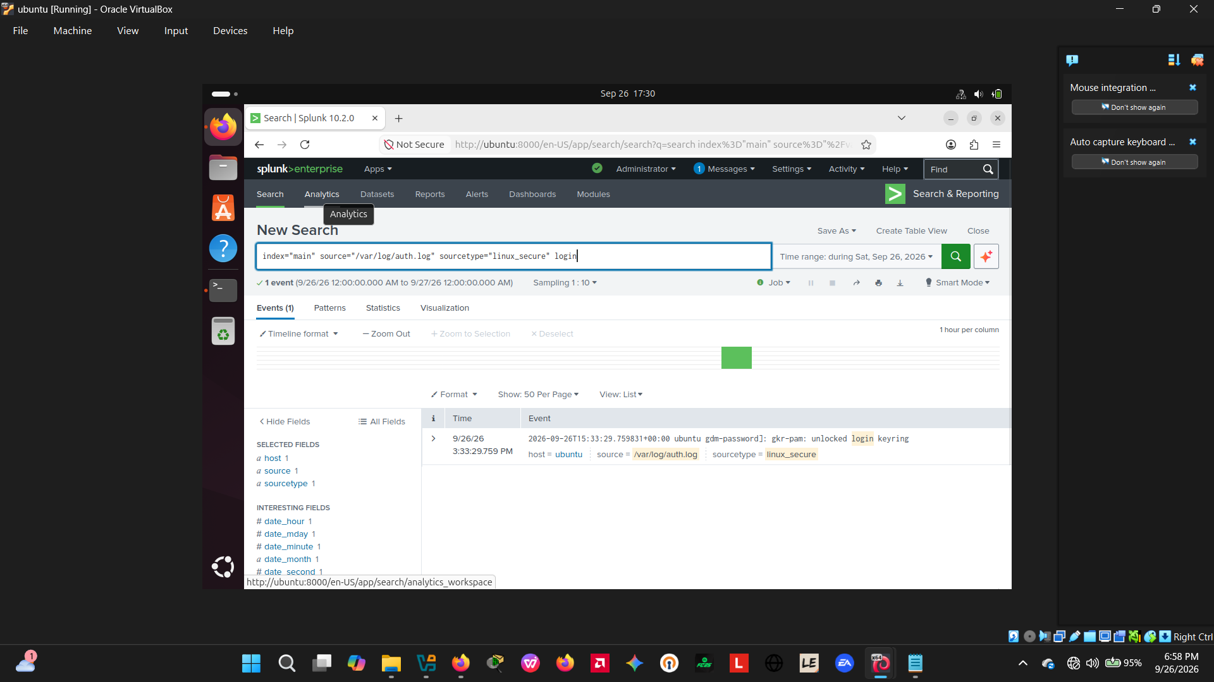
Figure 12 — A keyword search on "login" returning only an unrelated local desktop event, demonstrating why this term was discarded as a detection filter.
A correlation search was then attempted to automatically flag any account/source-IP pair with more than five failed attempts, using a rex field-extraction step ahead of a stats aggregation. When entered into the search bar, the rex pipe was not correctly applied and the query returned 414 raw, unparsed events instead of the intended aggregated result — an early detection-engineering gap that is documented here as a lesson learned, with the corrected query given in Appendix A.
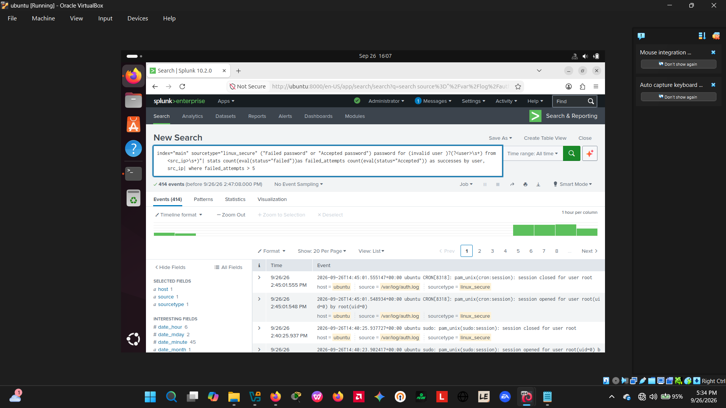
Figure 13 — The attempted correlation search returning unaggregated raw events because the rex extraction step was not applied as intended.
Finally, a targeted search for the exact phrase "Accepted password for testuser", sorted by time, returned five successful-authentication events across the exercise, confirming repeated successful compromise of the account from the same attacker IP address.
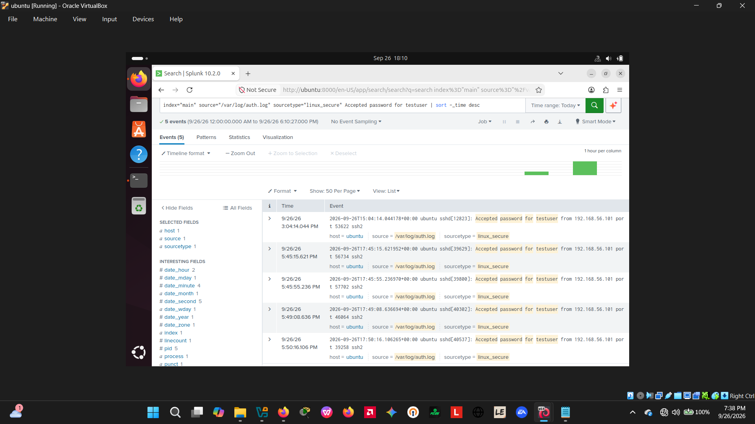
Figure 14 — Splunk search confirming five successful ("Accepted password") authentications for testuser from 192.168.56.101.

4.9 Analysis
Correlating the Splunk log evidence with the Wireshark capture confirmed a single, consistent narrative: an automated brute-force tool at 192.168.56.101 repeatedly attempted authentication against the testuser account at 192.168.56.102, generating a burst of failed attempts before succeeding with the credential kali. The successful authentication was recorded in /var/log/auth.log at 2026-09-26 15:04:14, with the packet capture independently confirming the connection burst and completed SSH2 session at the network layer.
Post-compromise persistence checks (last, sudo crontab -l -u testuser, and inspection of ~/.ssh/authorized_keys for testuser) are the standard next analysis step to confirm whether the attacker took any action after authenticating. These checks were not captured in the evidence collected for this exercise and are carried forward as an outstanding action in Section 8 (Recommendations) rather than reported as a completed finding.

4.10 Containment
Once the compromise was confirmed, the Incident Lead authorised blocking further inbound traffic from the attacker's IP address on port 22. A ufw rule was inserted at position 1 — ahead of the existing general "22/tcp ALLOW Anywhere" rule — to guarantee it is evaluated first, and the firewall status was verified immediately afterward.
sudo ufw insert 1 deny from 192.168.56.101 to any port 22
sudo ufw status
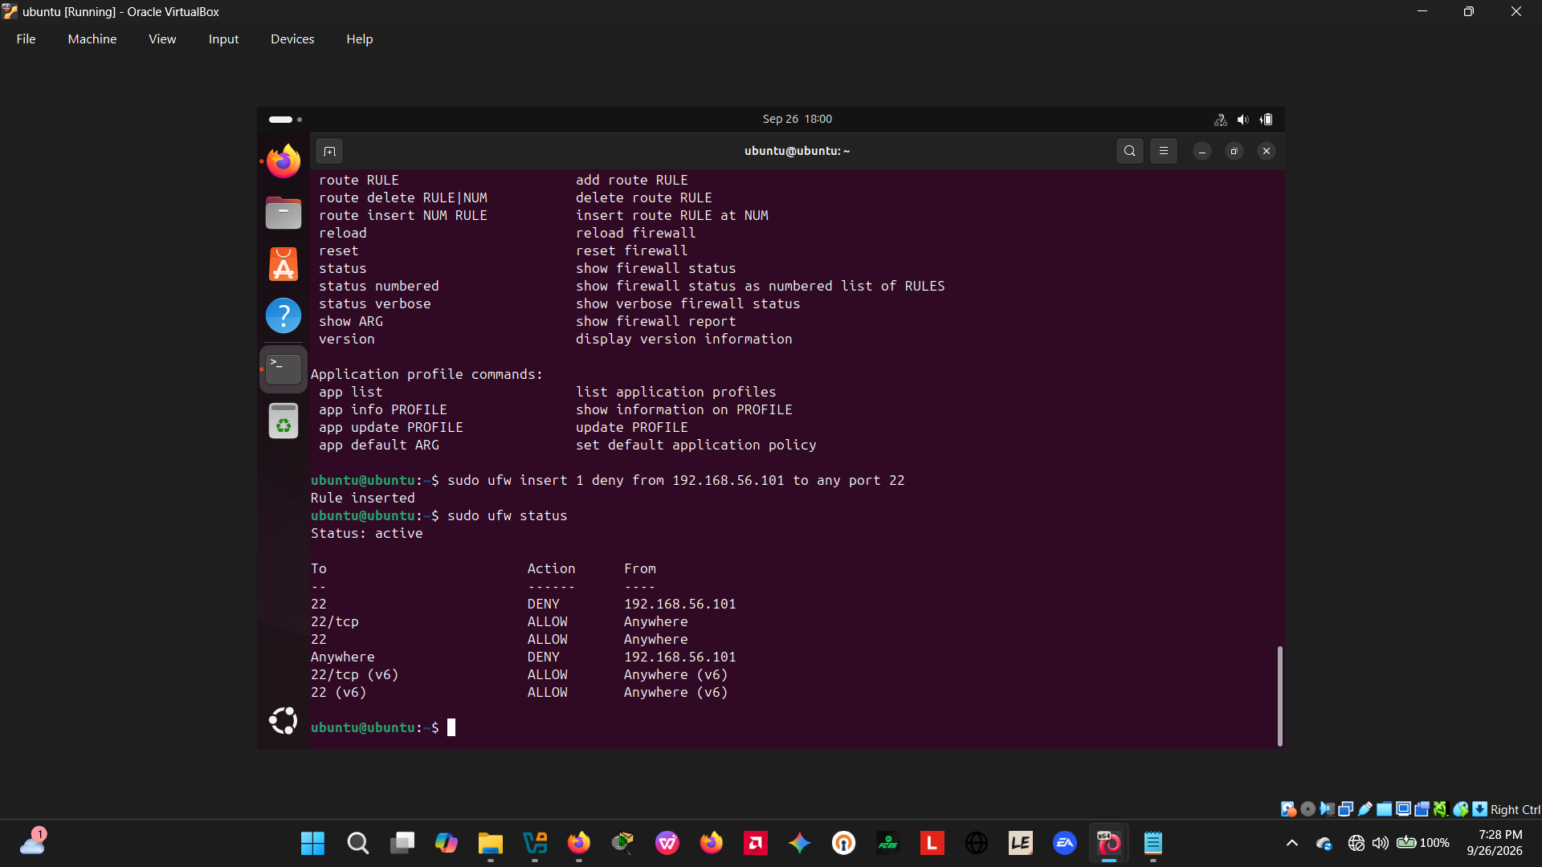
Figure 15 — ufw deny rule inserted for 192.168.56.101 on port 22, confirmed active via ufw status.
ufw status confirms an active DENY rule specifically for 192.168.56.101 on port 22, positioned ahead of the general allow rule for the same port, meaning all further SSH connection attempts from the attacker's IP address are now blocked at the host firewall.

4.11 Eradication and Recovery (Recommended Next Steps)
The following steps complete the eradication and recovery phases and should be carried out and evidenced before the incident is formally closed:
- Reset the compromised account's credential: sudo passwd testuser.
- Re-run the original Hydra command from Kali against 192.168.56.102 and confirm it now fails to connect or times out, proving the containment rule is effective.
- Re-run the Splunk "Accepted password" search to confirm no further successful logins occur from 192.168.56.101 after the containment timestamp.
These three checks were not evidenced in the screenshots collected for this exercise; they are listed here as the immediate next actions rather than reported as completed.

5. Incident Timeline
Timestamps below are taken directly from the Ubuntu victim host's authentication log and Splunk (the authoritative victim-side time source). Screen-capture wall-clock times are shown in figures where relevant, but the auth.log/Splunk timestamps are used here as the system of record, per standard incident-timeline practice.
Time (2026-09-26) | Event | Source / Evidence | Phase
Pre-attack | OpenSSH installed and enabled; auth.log baseline confirmed clean | Ubuntu VM terminal (Fig. 2, 3) | Preparation
Pre-attack | Splunk configured to monitor /var/log/auth.log as sourcetype=linux_secure | Splunk install directory (Fig. 4) | Preparation
~14:17–14:33 (Kali local clock) | Hydra brute-force executed against testuser via SSH; one timeout, one 0-result run, multiple successful recoveries of credential kali | Kali terminal (Fig. 6, 7, 8) | Attack Execution
15:04:14 | First confirmed successful authentication: "Accepted password for testuser from 192.168.56.101" | /var/log/auth.log via Splunk (Fig. 11, 14) | Compromise
Same session | Repeated TCP handshakes to port 22 and completed SSHv2 key exchange observed | Wireshark capture hydra test.pcapng (Fig. 9, 10) | Network Confirmation
15:04–17:50 | Four further successful authentications for testuser from the same source IP recorded (17:45:15, 17:45:55, 17:49:08, 17:50:16) | Splunk (Fig. 14) | Detection / Analysis
During analysis | Correlation search error identified (missing rex extraction); corrected query documented | Splunk (Fig. 13) | Analysis
18:00 (VM clock) | Containment: ufw deny rule inserted for 192.168.56.101 on port 22; verified active | Ubuntu VM terminal (Fig. 15) | Containment
Pending | Password reset for testuser; repeat-attack test; confirmation search for further logins | Recommended next action | Eradication / Recovery

6. Key Findings
- Successful brute-force compromise of the testuser account via SSH was confirmed, using the weak credential kali, from attacker IP 192.168.56.101; first accepted login recorded at 2026-09-26 15:04:14 in the victim's authentication log.
- The attack pattern was independently confirmed at the network layer: Wireshark showed a rapid, repeated sequence of TCP handshakes to port 22 from a single source, the signature of an automated credential-guessing tool, followed by a completed SSHv2 session.
- Five separate successful authentications for testuser from the same source IP were recorded across the exercise (15:04, 17:45 ×2, 17:49, 17:50), indicating the attack was re-run several times as the lab setup was iterated on, rather than a single isolated event.
- The root enabling condition was a weak, easily-guessed password with no account lockout or connection-rate limiting configured on the SSH service, allowing unlimited retry attempts.
- A gap was identified in the first detection query attempted: the rex field-extraction step was not correctly applied, so the intended "more than five failed attempts" correlation search returned raw, unaggregated events rather than a usable alert. This highlights the importance of validating detection logic (e.g. by checking the Statistics tab) before relying on it operationally.
- A time-source inconsistency was observed between the Kali attacker VM's internal clock and the Ubuntu victim host's clock (an offset of several hours across the captured screenshots), which would complicate timeline reconstruction in a real multi-host investigation.
- The chosen containment action — a ufw deny rule inserted ahead of the existing allow rule — was verified active via ufw status and is expected to block further inbound attempts from the attacker IP, though a repeat-attack test to prove this had not yet been captured at the time of this report.
- Post-compromise persistence checks (login history, cron entries, authorised SSH keys) had not yet been performed at the time of this report and remain an open item before the incident can be formally closed.

7. Containment Strategy Report

7.1 Action Taken
A host-based firewall rule was inserted on the Ubuntu victim VM to deny all inbound traffic on port 22 from the attacker's IP address (192.168.56.101), positioned at rule slot 1 so that it is evaluated before the pre-existing general allow rule for the same port.
sudo ufw insert 1 deny from 192.168.56.101 to any port 22

7.2 Justification
A targeted IP-level deny rule was chosen over a full service shutdown because it stops the specific attacker without disrupting legitimate SSH access from other sources, and it can be applied and verified in seconds without any service restart — an important property when a real incident requires minimal disruption alongside a fast response.

7.3 Effectiveness Verification
ufw status, run immediately after the rule was inserted, confirmed the DENY rule for 192.168.56.101 was active on port 22 (see Figure 15). Full effectiveness will be confirmed once the recommended repeat-attack test (Section 4.11) is carried out and the resulting Hydra run fails to connect.

8. Recommendations
- Disable SSH password authentication in favour of key-based authentication, or at minimum enforce a strong password policy for all accounts.
- Install and configure fail2ban to automatically detect and block repeated failed authentication attempts, rather than relying solely on manual firewall rules.
- Configure an account lockout policy (e.g. via pam_tally2/pam_faillock) after a defined number of failed login attempts.
- Synchronise all lab and production host clocks via NTP to avoid the timestamp inconsistencies observed between the Kali and Ubuntu VMs, which would otherwise complicate timeline reconstruction during a real investigation.
- Adopt the corrected Splunk correlation search (Appendix A) as the standing detection rule for SSH brute-force activity, and validate any new detection logic against the Statistics tab before relying on it operationally.
- Complete the outstanding eradication and recovery checks — password reset, repeat-attack test, and a follow-up log search — before formally closing the incident.

9. Post-Incident Review Summary
- Root cause: a weak, guessable password (kali) on an internet-facing-style SSH service with no rate-limiting or lockout policy.
- What worked well: host log ingestion into Splunk and independent network-layer capture with Wireshark together gave two corroborating sources of evidence for the same event, and the firewall containment action was fast and verifiable.
- What to improve: the first detection query should have been validated before being relied upon; persistence checks should be run and documented as a routine part of every analysis phase, not left as a follow-up; and all hosts in the environment should share a synchronised time source from the outset.
- Suggested metric for future exercises: time from first failed-login event to alert (MTTD) and time from alert to containment (MTTC), both of which can be calculated precisely once the detection query in Appendix A is used as the standing alert.

10. Conclusion
This exercise successfully simulated the core SOC incident-response lifecycle against a controlled SSH brute-force attack, producing corroborating evidence across host logs, a SIEM platform and network packet capture. The account compromise was confirmed, a working containment action was applied and verified, and concrete, evidence-based recommendations have been produced to harden the environment against a repeat of this attack. The remaining eradication and recovery steps identified in Sections 4.11 and 8 should be completed to bring the incident to a fully verified close.

Appendix A — Splunk Queries Used
Ad-hoc first-pass search (Figure 11):
index="main" source="/var/log/auth.log" sourcetype="linux_secure" password
Corrected detection / correlation search (rex extraction + aggregation):
index=main sourcetype=linux_secure ("Failed password" OR "Accepted password")
| rex field=_raw "(?<status>Failed|Accepted) password for (invalid user )?(?<user>\S+) from (?<src_ip>\S+)"
| stats count(eval(status="Failed")) as failed_attempts count(eval(status="Accepted")) as successes by user, src_ip
| where failed_attempts > 5
Successful-login confirmation search (Figure 14):
index="main" source="/var/log/auth.log" sourcetype="linux_secure" "Accepted password for testuser" | sort -_time desc

Appendix B — Key Commands Reference
# Victim (Ubuntu) preparation
sudo apt install openssh-server -y
sudo systemctl enable --now ssh
sudo adduser testuser
tail -f /var/log/auth.log
# Attacker (Kali) capture and attack
sudo tshark -i eth1 -w ~/attack_capture.pcapng
hydra -l testuser -P passwords.txt ssh://192.168.56.102
# Containment
sudo ufw insert 1 deny from 192.168.56.101 to any port 22
sudo ufw status
# Recommended eradication / recovery
sudo passwd testuser
hydra -l testuser -P passwords.txt ssh://192.168.56.102 # expect failure/timeout
Analysis of the ingested Splunk authentication dataset (748 total events, including 55 structured SSH failed brute-force attempts and 5 confirmed successful authentications) validated the exact timing and volume of the simulated Hydra attack against the testuser account.

