MidiAndMusicXmlPlayer
Manual
Table of Contents
1 User Manual 3
1.1 Installation 3
1.2 Run 3
1.2.1 Open Menu 3
1.2.2 Drop the MIDI-file or MusicXML-file on the program 4
1.2.3 Drop the MIDI-file or MusicXML-file on the program window 4
1.2.4 File menu 5
1.2.5 View menu 5
1.2.6 Option menu 6
1.2.7 Help menu 6
1.2.8 Elements of the window 6
2 Programmer Manual 7
2.1 Program Structure 8
2.1.1 MidiAndMusicXmlPlayer 8
2.1.2 UnitMessage 8
2.1.3 UnitMidiGui 8
2.1.4 UnitMidiDefinitions 8
2.1.5 UnitMidiIn 8
2.1.6 UnitMidiMixer 8
2.1.7 UnitMidiOpenDialog/UnitOpenDialog 8
2.1.8 UnitMidiPlayUnitScore 8
2.1.9 UnitText 9
2.1.10 UnitXml 9
2.2 Midi 9
3 Music Xml 9
3.1 Part map 10
3.2 Determine the number of verses 11
3.3 Repeats and Voltas 12
3.4 Music Xml with Arpeggiate and Grace notes 12
3.5 Music Xml flow 12
3.6 Music Xml 13
4 Panorama 13
5 Testing 13
6 Reducing the number of time samples in MusicXML 14
7 Option file 14
8 Hot keys 15
9 Parts and Tracks 16
10 Reading a file 17
11 Percussion and MIDI 18
12 Compiling on MAC 18
12.1 Application loader 19
13 Lazarus compiler options for MAC 22
14 Apple validation 25
15 Apple validation 27
16 Microsoft validation 28
17 Unicode? 30
18 Codesigning gdb 31
19 Microsoft validation 32
20 Appendix A: Note Pitch values 33
21 Appendix B: State diagrams 34
22 Appendix C 34

User Manual

Installation
All programs can be downloaded from www.programfabriken.com, but for MAC it is easyer to get it from Apples AppStore. For PC you get the program in a zip file. You copy MidiAndMusicXmlPlayer.exe to where you want it and make a shortcut. An MSI-file can also be downloaded it you like this more.
Note: You should not place MidiAndMusicXmlPlayer.exe on the desktop, because Microsoft have restricted drag and drop on Windows 10.

Run
There are three ways to open a file:

- Use the open menu
- Drop the MIDI-file or MusicXML-file on the program
- Drop the MIDI-file or MusicXML-file in the program window

Open Menu
Start MidiAndMusicXml by clicking on it. Then use the menus. Looks like this:

Fig. 1
Select the menu Open and select a MIDI-file of MusicXML-file

Drop the MIDI-file or MusicXML-file on the program
Start MidiAndMusicXml by dropping the file onto the program. (The MIDI file Honning.mid was edited by Notation Composer – and now dropped onto MidiAndMusicXmlPlayer)

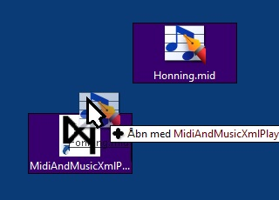
Fig 2

Drop the MIDI-file or MusicXML-file on the program window
Start MidiAndMusicXml by dropping the file in the program the program window. Note that the icon changes when entering the window.
Fig. 3

While loading the program this window is shown:
Fig. 4

Main menus:

File menu
- Open: Open a MIDI file or MusicXML file
- Exit and delete Options: This deletes the option file and next time the file is opened all setting are default.
- Exit: Exit the program (And save options and settings)

View menu
- Decoding: Shows the commands in the MIDI file as hexadecimal values
- Mixer: Makes it possible to change the volume of each voice/instrument

Option menu
- Auto Play: A checkmark will start playing next time the window is opened
- Windows: Midi Device Select: If another Synthesizer is installed on the computer, then this can be selected. Note that the Windows sounds are rather bad. I can recommend the free soundfont FluidR3_GM. The free program VirtualMidiSynth from Coolsoft can be used to install the font.
- Mac: Create a directory in /home/<user>/Library/Audio/Sounds/Banks called MidiAndMusicXmlPlayer. Copy an .sf2- soundfont into this, e.g. /home/<user>/Library/Audio/Sounds/Banks/MidiAndMusicXmlPlayer/FluidR3_GM.sf2

Help menu
- Install: If MidiAndMusicXmlPlayer.exe is not installed, this meny will occur.
- About: Shows the version of the program

Elements of the window

The checkmarks select which voices/instruments to be played. To the right the panorama can be set. Use this to better identify the instruments and voices. The tempo can be changed in percent of the original value. The limit is from 10% to 1000%.
The whole tune may be transposed. The value is in note halfsteps
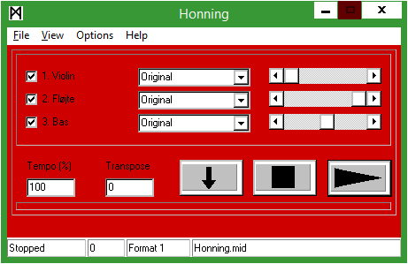
Fig. 5
The buttons are:
- Left: Set mark – i.e. Start of looping. When pressed a circle occur – press this to start looping.
- Middle: Stop playing
- Right: Start playing or Pause (The pause symbol occurs when playing)

Information in the status bar:
- Stopped, Playing, Paused
- Midi-event Counter
- Fomat: May be Midi Format 0, Midi Format 1 or MusicXML
- File Name

Programmer Manual
The program part consist of the main unit, forms and other units. Forms are also units, but have a windows associated to it – all based on the object TForm. Other units may be objects or just functions to implement some functionality described below.

Program parts:
- MidiAndMusicXmlPlayer: The main program, that starts all other forms and units.
- UnitMessage: A form that shows start up message and error messages and activates UnitMidiGui (See fig. 3)
- UnitMidiGui: Form that is the main window showing the channels and buttons to start, stop and cycle (See fig. 5)
- UnitMidiDefinitions: General definitions for all units. Included are also functions and procedures for all units
- UnitMidiIn: Provides a window with decoded input from the midi file
- UnitMidiMixer: A window with a mixer to adjust the level of each channel
- UnitMidiOpenDialog/UnitOpenDialog: A window to select the file to be played (Not used)
- UnitMidiPlay: Thread to play the midi-file
- UnitScore: Only for test – shows notes.
- UnitText: Show the text of a song if text is present in the Midi- or Music Xml file
- UnitXml: Converts a Music Xml to Midi-events.

Program Structure

MidiAndMusicXmlPlayer
This is the main program. The program may start with a parameter or no parameter. If a parameter is present, then the message window is shown with the message "Loading ....". If there is no parameter, then the GUI windows is shown with data. Now a MIDI of MusicXML file can be opened either with the open meny of by drag and drop.

UnitMessage
The program UnitMessage.pas is a form, i.e. appears as a window when loading a file and in case of errors and warnings. When a file is loaded, the window is made invisible and instead the MidiGui-window is shown

UnitMidiGui
This is the main window showing the tracks and with buttons for playing, pausing and stopping the music. Also reading midi into event are done here.

UnitMidiDefinitions
Common definitions for all programs. Contains the basic datastructures for Midi-data.

UnitMidiIn

UnitMidiMixer

UnitMidiOpenDialog/UnitOpenDialog

UnitMidiPlayUnitScore

UnitText

UnitXml

State Diagrams are shown in appendix.

Midi

MIDI:

F0-Message:
The F0 message ends with F7. See 'This is not how I read the specification' ec.

Channel Name:
See B0-message in "ReadFileMidiTrack".

Metaevent 3 and 4 may contain the channel/instrument name. The order may be different

Metaevent 6 and 8 may contain the song name but event metaevent 3 and 4 for track 0 are sometimes used. The order may differ, therefore a variable MidiData.MidiCurrentTrackName

If events come at a time MidiData.MidiCurrentTrackName is not set, the name is set later with the function Channel(...)

Especially when a C0 (Instrument command) event is encountered, the name is set only for Format 1.

DO A FLOW CHART OF THIS

Music Xml

My basic principle is:
The Music Xml file is divided in parts. The Midi-file is divided in tracks (format 1). Each part in Music Xml becomes a Midi track.
My program has a state machine, which reads the Music Xml file and saves data in a array with an element for every time division. This array called NoteInfo. Each element in NoteInfo is a record/structure of three sets. One set of notes to start at this time division (NoteOn), one set of notes to stop at this time division (NoteOff) and one set for notes to continue (NoteContinue). All notes has a duration value, but can be tied - then the note is added to the continue-set and prolonged later when the tied note continues.

When the whole file is read into NoteInfo, then the data in NoteInfo is processed into Midi-events.

Midi-events come with a delay called Delta. When a note is in the NoteOff-set the Midi-event NoteOff will be generated with a delta corresponding the the number of time divisions since last event. When a note is in the NoteOn-set the Midi-event NoteOn will be generated with a delta corresponding the the number of time divisions since last event.

Of cause thing are more complicated - ties may have no end - there are grace notes and arpeggiata. A short pause must be generated between notes and the note shortened accordingly etc.. But the basic principle is the above.

Part map
Basic rule: A part becomes a midi track. Data of the current state is saved in a TXmlStateData structure. Variables handling the part and track number are:
- PartNumber: 1
- PartNumberMax: E.g. 3
- PartMap: E.g. ("P1","P2","P3")
- PartNumberOf: E.g. 2
- PartNames: E.g. (Violin,Klassisk Guitar,Akustisk bas)
- PartId: string; E.g. "P3"
- TrackNumber: E.g. 3

PartNumber: integer; // Part as specified in <part>
PartNumberMax: integer; // Max part number to handle PartMap
PartMap: array[0..Tracks] of string; // Which part goes to which track
PartNumberOf: integer; // Number of parts
PartNames: array[0..Tracks] of string;
PartId: string;

INSTRUMENT?

Determine the number of verses
For every note lyrics may be specified. The lyric syllable has a number. In a simple song with no repeats, this will be just the verse number.
With both repeats and verses the following scheme is used:
For all note let cur be the current number stated in the songtext. Let Max be an array of max values for textnumbers of current repeat level. Let nr be the number of numbers in a volta. Let index be the index to max.

Index:=0;
Max[0]:=1;
for i:=0 to IndexMax do Max[i]:=1;
if Symbol=RepeatStart then
begin
increment(index);
if cur<Max[index] then Max[index]:=cur;
end
if (Symbol=RepeatEnd) and not(Volta) then
begin
cur:=(Max[index]+1) div 2;
decrement(index);
if cur<Max[index] then Max[index]:=cur;
end
if (Symbol=RepeatEnd) and OpenVolta then
begin
cur:=(Max[index]+VoltaNumber-1) div 2;
decrement(index);
if cur<Max[index] then Max[index]:=cur;
end
if ClosedVoltaStart then
begin
increment(index);
Max[index]:=nr;
end
if ClosedVoltaEnd then
begin
cur:=Max[index] div nr;
decrement(index);
if cur<Max[index] then Max[index]:=cur;
end

The real variable name of cur is XmlStateData.LyricVerseNumber and the Max array is RepeatMaxVerseNumber.

Repeats and Voltas
Music Xml allows both repeats and voltas. Nested repeats are allowed and when a new repeat start is encountered the previous is stacked by using the function PushRepeat. The functions PopRepeat is used to restore the old repeat.

The music xml is converted to an array XmlInfo. The index to this array is the time quants defined by the variable divisions. For every time kvant three sets define:

- NoteOff: The notes that shall be stopped at this time kvant
- NoteOn: The notes that shall be started at this time kvant
- NoteContinue: The notes that shall continue at time quant due to tie-commands

A continued note will also have a NoteOn and this imformation is used to stop notes that have a tie but no corresponding note at continuation.

Music Xml with Arpeggiate and Grace notes

Both arpeggiata and grace notes are notes that should be played in front of normal notes. The time for that must be stolen from the previous note or pause. This might even be another measure or the end of the tune.

Music Xml flow

When processing the Music Xml file an array of time divisions saves the note data. It is called NoteInfo[...]. The function MidiNoteOn(...) places the data for each note. Every array item has a set of notes to be on and off. The function MidiNoteOn with add a note to the set of NoteOn and also add the note to the set NoteOff in the time division added the note duration.
A third set is called NoteContinue. A note specified with <tie> will be added to NoteContinue.

Music Xml

"An unsupported command was encountered" ?

XML:

Some events are ignored:

XmlStateCue: 'cue/'

Panorama

Two typed of information of panorama is in function:

- A value saying that panorama is changed and the value from the midi file should not be used ()
- A value saying that the scrollbar value has changed and a command shall be send to the midi-interface (MidiDataPanoramaChangedValue)

Defined in ()

- UnitMidi: TMidiData.MidiDataPanoramaChangedValue
- UnitDefinitions: MidiDataPanoramaChangedValue

Testing
Here are listed some sources of test files for MusicXml.

- http://www.musicxml.com/for-developers/musicxml-dtd/
- Music XML-TestSuite-0.1
- XmlSamples
- http://en.wikipedia.org/wiki/List_of_musical_symbols
- http://www.lilypond.org/
- http://www.lilypond.org/doc/v2.18/input/regression/musicxml/collated-files.html
- http://www.musicxml.com/music-in-musicxml/example-set/

Unreadable: http://www.lilypond.org/doc/v2.18/input/regression/musicxml/collated-files.pdf

Music symbols for MusicXML:
http://www.musicxml.com/UserManuals/MusicXML/MusicXML.htm#EL-MusicXML.htm

Reducing the number of time samples in MusicXML

MusicXml uses a time division. Some programs use the lowest possible division. The music program Finale uses a division near to as low as possible. For example a melody could be in 4/4 and have only quarter notes. Then the division could be = 1. If just one eigth note is present, the division must be 2. If there is also a triol than the division must be = 6. But the division may be much higher as tunes made with the music notation program Sibelius. The division might be 768 with one triol. The tune would then use 128 times as much memory as the same tune produced by Finale. However, MidiAndMusicXmlPlayer uses this scheme to reduce memory by doing a factorisation of the durations and divisions.

In order to minimize the memory used the time division and duration values are reduced. The biggist common divisor is found and all time values divided with this value. However – only primes up to 100 are used. There are 25 values: (2, 3, 5, 7, 11, 13, 17, 19, 23, 29, 31, 37, 41, 43, 47, 53, 59, 61, 67, 71, 73, 79, 83, 89, 97).

This is done for the whole tune. A further reduction could be done by identifying parts needing high division and changing the division while playing.The total performance in speed and memory should be considered. Factorisation takes time but reduces memory. The above scheme makes a non measurable descrease in speed but big decrease in memory for the Sibelius files.

Option file

A file with the extension ".option" added to the file name is placed on PC in directory:
C:\Users\<UserName>\MidiOptions\<FileName>.MidiOptions ????
The MAC computers use a method called "Sandboxing". The option-files are placed in the sandbox and not directly visible for a user.
The directory on MAC can be accessed by the menu "Go"-"Goto folder":
"/Users/<username>/Library/Containers/com.programfabriken.
MidiAndMusicXmlPlayer/Data/Library/Application Support/com.programfabriken.
MidiAndMusicXmlPlayer"

“/Users/<username>/Library/Containers/com.programfabriken.MidiAndMusicXmlPlayer/Data/Library/Application Support/com.programfabriken.MidiAndMusicXmlPlayer”

Currently 75 option values are used.
1: Magic Number = 746533
2..17: Checkboxes for channels 0..15. The value 0 = off, The value 1 = on
18..33: Instrument selection, 1 = piano, ????
34..49: Panorama selection, 0..127. The sound position. Left = ????
50: MainVolume
51..66: Channel volume, 0..127. The value 0 = off, The value 127 = max
67: Autoplay. The value 1 indicates that playing is started automatically
68: Synthesizer selection (i.e. soundfont)
69: Tempo: Default tempo = 100. Percent of default tempo can be selected 10..1000
70: Transpose: The value 0 = no transposing, positive = number of halfsteps up, negative = number of halfsteps down.
71: The position of the window in pixels. Left
72: The position of the window in pixels. Top
73: The position of the mixer window in pixels. Left – currently not used.
74: The position of the mixer window in pixels. Top – currently not used.
75: 1: Magic Number = 746533.

When new versions comes with changed option file (incompatible with old) this magic number will be changed. This causes default values to be used. All options and setting must be reentered (in order to avoid inconsistency in the settings)

Hot keys
For PC the following hot keys exist:
T: Shows the text of a song
O: Open a new file
D: Show a decoded Midi-file
M: Show Mixer
ESC: Close program

Parts and Tracks
Normally a MusicXml-part will become a Midi-track. However in some cases a part may produce more tracks. This is due to the <instrument ...> definition.
As an example the test file telemann.xml will produce this data:
XmlStateData.PartMap: ('"P1"','"P2"','','',....)
XmlStateData.MidiInstrument: ('"P1-I1"','"P2-I1"','"P2-I2"','"P2-I3"','"P2-I4"','"P2-I5"','"P2-I6"','','',....)
XmlStateData.MidiInstrumentPart: (0,1,1,1,1,1,1,.......)

OBS: indsæt nye værdier for telemann.xml (de originale!)
OBS: Beskriv forskellige pas. (Preread etc.)

The size of the array is the variable MidiInstrumentMax.
Two important variables are PartNumber and Tracknumber (part of the TxmlStateData structure). If there are no instrument definitions, then these will be the same – but when a part has more instruments, then the PartNumber will be bigger.
This means: There are two parts, P1 and P2, but there are seven instruments with the names shows in the array MidiInstrument[...]. Part number start with zero. Therefore the MidiIntrumentPart shows that part one has one instrument and all the others are in part two.
The picture Fig .1 shows notes of same time and length (from Georg Philipp Telemann - Liebe! Liebe! Was ist schöner als die Liebe?). They must be divided up in different tracks, because the basic algorithm can not handle two notes starting and stopping at the same time-division.
Fig. 1
fkjghfg

Reading a file

Diagram:

Percussion and MIDI

Some MIDI percussion instruments have a pitch – note value. But some instruments do not. In Midi non pitch intruments are in track 10 (Numbered 1..16) and instead of a instrument in form of a command "Program" definition (C0..CF) all the instruments are defined by the note value.
The definitions needed are <midi-instrument ...> definitions

Compiling on MAC

I used this procedure:

- Install MAC OS 10 (Yosemite)
- Install Xcode via AppStore (iTunes)
- Open terminal window. To install "command line tools" Write the command line:
"xcode-select --install
- See wiki.freepascal.org about the Lazarus installation
- Download Lazarus, f.x. Lazarus-1.4.0-20160419-i386-macos.dmg
- Download FPC + Fpc source
- Install these packages
- ?? forms.ppu /Developer/Lazarus/lcl/units/i386-Darwin/forms.ppu. Project path include..
- Application loader

When starting Lazarus: problem with "can't find Forms. Seems to be in path:
/Developers/lazarus/lcl/units/i386-Darwin/forms.ppu
but ....

Additional path?

Tools-Build Lazarus

Use application bundle

Install MacPorts in order to proceed with GDB:
see: http://ntraft.com/installing-gdb-on-os-x-mavericks/

Application loader
First you must get Command Line Tools p.t. from:
https://developer.apple.com/download/more
(Command Line Toold (MacOs 10.13 for Xcode 9.4)
Then you must get the certificates:
- MAC Development -> mac_development.cer
- mac_installer.cer
- Mac Submission Certificate -> mac_app.cer ->3rd party Mac Developer Application
- MidiAndMusicXmlPlayerMacBook.provisionprofile
- DeveloperIDCA.cer
- AppleWWDRCA.cer
- Developer ID Installer -> developerID_installer.cer -> 3rd Party Mac Developer Installer: Mogens Lundholm (5K5D6JEV2V)
- Developer ID Application ——————————> developerID_application.cer ——> Developer ID Application: Mogens Lundholm (5K5D6JEV2V)
For all certificates select allways trust.
....
Login to https://developer.apple.com/account (ps. You must have an account first)
In the window, hit the drop-down box showing iOs, tvOs, watchOs and change to macOs.

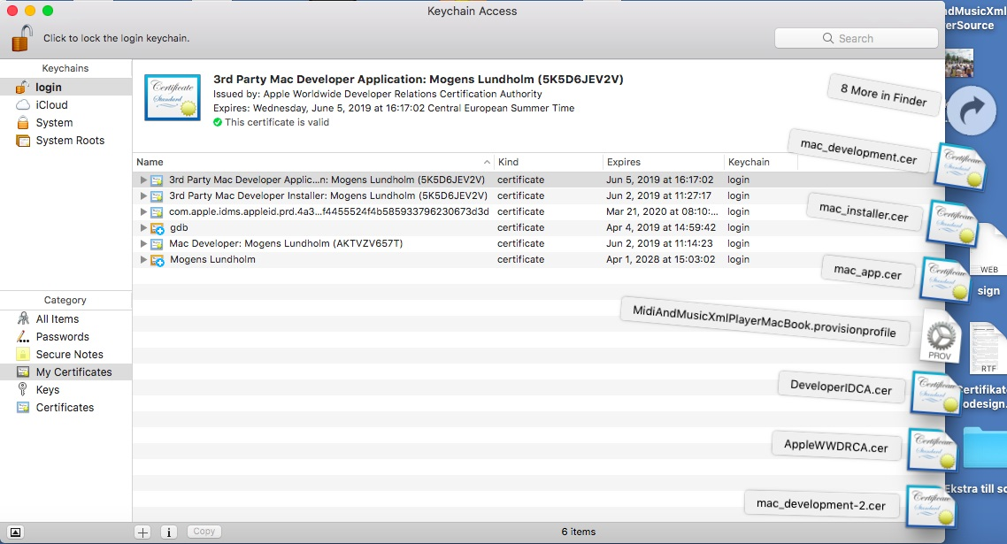

This goes for Lazarus 1.4.2. Some time in the future, this might be changed.
Before uploading the program: MidiAndMusicXmlPlayer.pkg. Find the previous version of MidiAndMusicXmlPlayer.app. Rightclick to open the content of the app – both new and old. From the old version, copy the icon-file MidiAndMusicXmlPlayer.icns into the new. Then copy the old the Info.plist file into the new and edit the version numbers: CFBundleInfoShortVersionString – change to next number (e.g. 1.36 to 1.37 etc.). Then increase the CFBundleVersion (e.g. 10 to 11).
Move the file MidiAndMusicXmlPlayer (about 10 Mbyte) into MacOs and replace the link.
Move MidiAndMusicPlayer to the desktop.

Then produce the packet:
(Note that a file Entitlements.plist must be present on the desktop)
Codesign and Productbuild:
cd Desktop
xattr -cr .

xattr -cr MidiAndMusicXmlPlayer.app
xattr -lr .

codesign -f -s "3rd Party Mac Developer Application: Mogens Lundholm (5K5D6JEV2V)" --entitlements "Entitlements.plist" MidiAndMusicXmlPlayer.app

productbuild --component /Users/mogenslundholm/Desktop/MidiAndMusicXmlPlayer.app /Applications --sign "3rd Party Mac Developer Installer: Mogens Lundholm (5K5D6JEV2V)" --product /Users/mogenslundholm/Desktop/MidiAndMusicXmlPlayer.app/Contents/Info.plist /Users/mogenslundholm/Desktop/MidiAndMusicXmlPlayer.pkg

Then upload to AppStore with Application Loader:

Administer program on Web-page: iTunesConnect.apple.com/Webobjects/iTunesconnect.woa.

How to check the program binary:

$ otool -hv MidiAndMusicXmlPlayer

Mach header:
magic caps | cputype | cpusubtype | filetype | ncmds | sizeofcmds | flags
MH_MAGIC_64 | X86_64 | ALL LIB64 | EXECUTE | 28 | 4424 | NOUNDEFS DYLDLINK TWOLEVEL

Mandatory menus on MacOs:
You can add menus to by making a menu with the caption of the "museum" symbol (⌘).

From 2018-06-01 MacOs/Cocoa will add a menu with the program name MidiAndMusicXmlPlayer with menus Quit and Minimize. Also to the View menu they add the menu Maximize. The Maximize menu is grey and total irrelevant but don't know to get rid of it.

POSIX SEMAPHORE PROBLEM: fpc VERSION 2.6.4 compiles OK, but not accepted by Apple.

Lazarus compiler options for MAC

Adsfsadf

adsfsdaf
With 64bit – there shall be no options!

adsfasdf

asdfs

Options to be set

Tools -> Toolsoptions -> Compiler Executable
Set the value to ppcx64

Project -> Project Options -> Config and target -> Target
set the value to x86_64

Apple validation
In user section in Apple's handling WEB page:
- Mac Development
- Mac App Store
- Mac Installer Distribution

OBS: Dele af dette er på dansk.
1. Certificat.p12 —> Mogens Lundholm, självsignerat rotcertifikat ? installer .pfx (pfx seem to be the same as p12, just rename or?)

2. Fra Add Mac Certificate:
Intermidiate Certificates
Worldwide Developer Relations Certificate Authority

AppleWWWDRA.cer

får fra http://developer.apple.com/certificationauthority/AppleWWDCRA.cer

Worldwide Developer Relations Certificate Authority gives a certificate with file name "AppleWWDRCA.cer". In Keymanager this appears as "Apple Worldwide Developers Relations Certificate Authority"

But
Developer ID Certificate Authority creates file: DeveloperIDCA.cer

3. CertificateSigningRequest.cert signing request
(via KeyChainAccess/ Nyckelhanterare)

4. Mac provisioning profiles - Mac distribution
Herunder laver man et andet certifikat

5 . Apple Push Notification service SSL (Sandbox & Production)
Nytt namn: Apple Production Mac Push Services: com.programfabriken.MidiAndMusicXmlPlayer
download namn: aps_production
Namn installerad: Apple Production Mac Push Services: com.programfabriken.MidiAndMusicPlayer

6 . Apple Push Notification service SSL (Sandbox)
Nytt namn: Apple Production Mac Push Services: com.programfabriken.MidiAndMusicXmlPlayer
download namn: aps_development ????
Namn installerad: Apple Development Mac Push Services: com.programfabriken.MidiAndMusicPlayer

7. Production: Mac App Store / Mac Installer Distribution
nyt navn i Member Center”Download”
nyt ”Mac Installer Distribution: Mogens Lundholm”
Download namn: mac_installer.cer
namn i KeyChain: 3rd Party Mac Installer: Mogens Lundholm (5K5D6JEV2V)

——> ikke samtidigt med ovanstående
8. Mac Development
nyt namn: Download, Install and Backup
Name: Mac Developer: Mogens Lundholm
Download namn: mac_development.cer
KeyChain : 3rd Party Mac Developer Installer: Mogens Lundholm (5K5D6JEV2V)

9. Mac App Store - Mac App Distribution
nyt namn: Mac App Distribution: Mogens Lundholm
Download namn: mac_app
3rd Party Mac Developer Application: Mogens Lundholm (5K5D6JEV2V)

http://www.blackdogfoundry.com/blog/difference-between-the-various-apple-certificate-names/
Perhaps it is just me, but I can never remember the differences between the various names that Apple uses for its development/distribution certifications – particularly the Mac ones. It also doesn’t help that the names they user differ between the keychain and the Member Centre.
This post quickly describes the differences:
Certificate type | Keychain Name and Description
iOS Development | iPhone Developer: Team Member Name  Used to run an iOS app on devices and use certain app services during development.
iOS Distribution | iPhone Distribution: Team Name  Used to distribute your iOS app on designated devices for testing or to submit it to the App Store.
Mac Development | Mac Developer: Team Member Name  Used to enable certain app services during development and testing.
Mac App Distribution | 3rd Party Mac Developer Application: Team Name  Used to sign a Mac app before submitting it to the Mac App Store.
Mac Installer Distribution | 3rd Party Mac Developer Installer: Team Name  Used to sign and submit a Mac Installer Package, containing your signed app, to the Mac App Store.
Developer ID Application | Developer ID Application: Team Name  Used to sign a Mac app before distributing it outside the Mac App Store.
Developer ID Installer | Developer ID Installer: Team Name  Used to sign and distribute a Mac Installer Package, containing your signed app, outside the Mac App Store.

sdjfkhg

Apple validation

xattr -cr MidiAndMusicXmlPlayer.app

cd Desktop/

xattr -cr MidiAndMusicXmlPlayer.app

codesign -f -s "3rd Party Mac Developer Application: Mogens Lundholm (5K5D6JEV2V)" --entitlements "Entitlements.plist" MidiAndMusicXmlPlayer.app

xattr -lr MidiAndMusicXmlPlayer.app

productbuild --component /Users/mogenslundholm/Desktop/MidiAndMusicXmlPlayer.app /Applications --sign "3rd Party Mac Developer Installer: Mogens Lundholm (5K5D6JEV2V)" --product /Users/mogenslundholm/Desktop/MidiAndMusicXmlPlayer.app/Contents/Info.plist /Users/mogenslundholm/Desktop/MidiAndMusicXmlPlayer.pkg

xattr -lr MidiAndMusicXmlPlayer.pkg

_________________

Entitlements.plist:

<?xml version="1.0" encoding="UTF-8"?>
<!DOCTYPE plist PUBLIC "-//Apple//DTD PLIST 1.0//EN" "http://www.apple.com/DTDs/PropertyList-1.0.dtd">
<plist version="1.0">
<dict>
<key>com.apple.security.app-sandbox</key>
<true/>
<key>com.apple.security.files.user-selected.read-only</key>
<true/>
</dict>
</plist>

Microsoft validation
Buying DigiCert certificate also gives reputation on the net.
First the Microsoft Windows kit must be installed. Commands:
cd C:\Program Files (x86)\Windows Kits\8.1\bin\x64
signtool sign /t http://timestamp.digicert.com /a "C:\Data\MidiAndMusicXmlPlayer\Build-Xe\MidiAndMusicXmlPlayer.exe"
signtool sign /t http://timestamp.digicert.com /a "C:\Data\MidiAndMusicXmlPlayer\Build-Laz\MidiAndMusicXmlPlayer.exe"

Then a package must be made:

cd C:\Program Files (x86)\Windows Kits\8.1\bin\x64

MakeAppx pack /d C:\Data\MidiAndMusicXmlPlayer\Certifikat-Firma-Windows\Microsoft /p C:\Data\MidiAndMusicXmlPlayer\Certifikat-Firma-Windows\Microsoft\MidiAndMusicXmlPlayer.appx

Adress of Microsoft developer:
https://login.microsoftonline.com/common/oauth2/authorize?client_id=4990cffe-04e8-4e8b-808a-1175604b879f&response_mode=form_post&response_type=code+id_token&scope=openid+profile&state=OpenIdConnect.AuthenticationProperties%3dDQJPa6apj-N5807kih84TTsGlJRlcLN9ZGBATUiP4ojnjNRgJ-h-2azxtB3WBOQvnGbFgQTnY1sprsUz9aO2Eq8zUNXCp6XfgtnbMWJixN-QnQFtGF0BpSpbss-gjxyAEcvjylS5bVkQ0hvwdYoCz9ntZJFATtTqidYC4cSQDPo33WQDP4iGTmQVU4C7x3wsSymzqRooM4JvAilC3bk7mo97Fd06VZgrb_pP8-L3MfpNcoNv&nonce=636149973049696314.YmM0NTcxYWItZmMzYS00ZGRhLWE5YzQtZjNjZDBhMjZjYTNlNWNmNDRjMmItNzE4OC00MjY1LWI2ZjQtZjI0YTQyNGRkMzYx&redirect_uri=https%3a%2f%2fdeveloper.microsoft.com%2faad%2fauthPostGateway&prompt=select_account&mkt=en-US

https://msdn.microsoft.com/windows/uwp/publish/upload-app-packages

MakeAppx pack /d C:\Data\MidiAndMusicXmlPlayer\Certifikat-Firma-Windows\Microsoft /p C:\Data\MidiAndMusicXmlPlayer\Certifikat-Firma-Windows\Microsoft\MidiAndMusicXmlPlayer.appx

The package must be uploaded to the Microsoft developer Dashboard.
(After creating an account and specifying a product name)
https://developer.microsoft.com/en-us/dashboard/overview
This is how the dashboard looks:

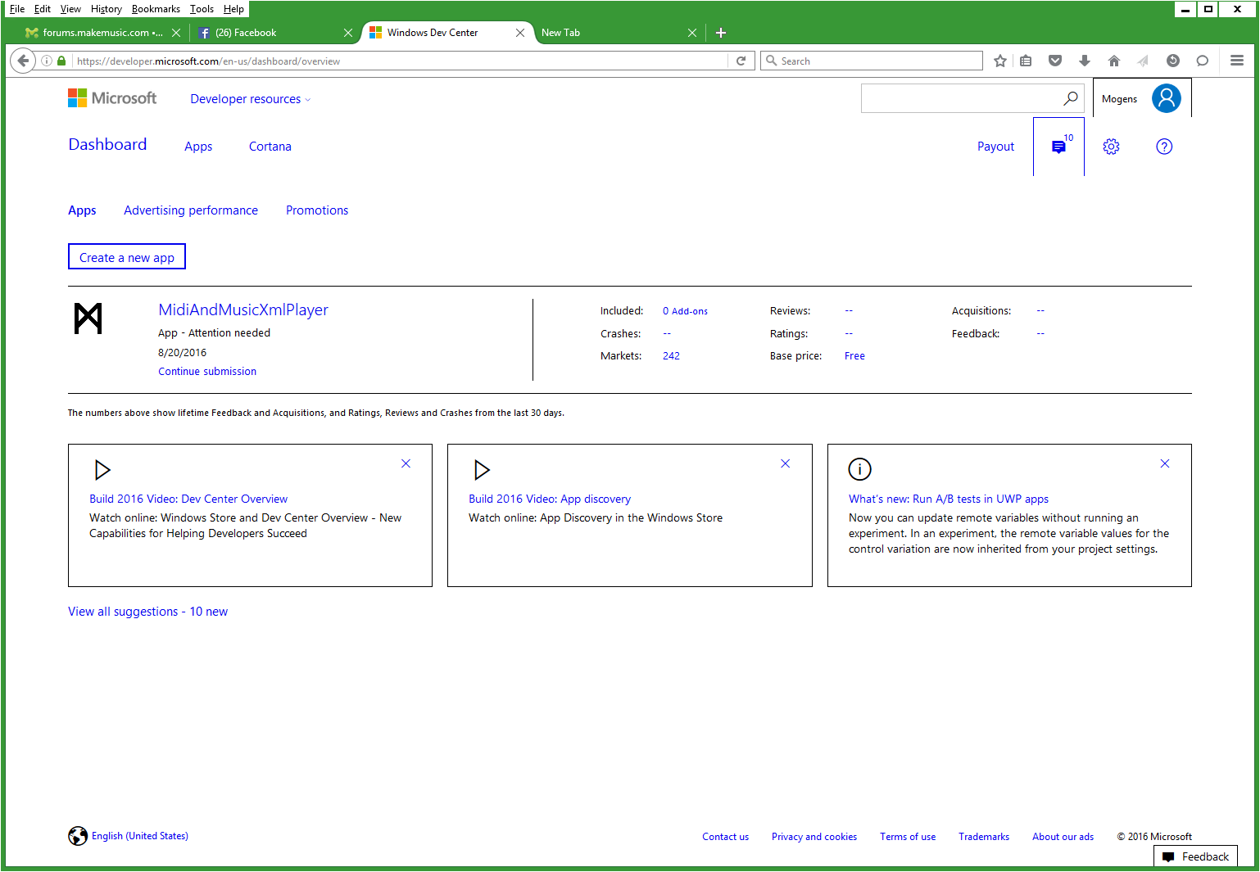

alkjdf

Unicode?
There are:
Textfile-encodings: Ansi, Utf8, Utf16, Utf32 – total 4
Xml-file spec: Utf8, Utf16, Utf32 – total 3
Compilers: Delphi, Delphi-Xe, Lazarus – total 3
Execution modes: Direct, Bat-file – total 2
File Specification ways: Open Menu, Drop on exe-file, Drop in window – total 3
Text positions: File name, Caption, Intrument text – total 3
Teoretically this makes 4*3*3*2*2*3*3 = 1296 combinations of text encodings. Many of these are not relevant. Difficult to test automatically because the result is only graphical and will be different in exact pixel values.

Codesigning gdb
Do debug Lazarus on MAC you need a codesigned gdb (Gnu debugger)
You need to create a certificate and sign gdb:
- Open application “Keychain Access” (/Applications/Utilities/Keychain Access.app)
- Open menu /Keychain Access/Certificate Assistant/Create a Certificate...
- Choose a name (gdb-cert in the example), set “Identity Type” to “Self Signed Root”, set “Certificate Type” to “Code Signing” and select the “Let me override defaults”. Click “Continue”.
- You might want to extend the predefined 365 days period to 3650 days.
- Click several times on “Continue” until you get to the “Specify a Location For The Certificate” screen, then set “Keychain to System”.
- If you can't store the certificate in the “System” keychain, create it in the “login” keychain, then export it. You can then import it into the “System” keychain.
- In keychains select “System”, and you should find your new certificate. Use the context menu for the certificate, select “Get Info”, open the “Trust” item, and set “Code Signing” to “Always Trust”.
- You must quit “Keychain Access” application in order to use the certificate and restart “taskgated” service by killing the current running “taskgated” process. Alternatively you can restart your computer.
Finally you can sign gdb:
- if installed via Homebrew:
codesign -s gdb-cert /usr/local/bin/gdb
- if installed via Fink:
codesign -s gdb-cert /sw/bin/gdb
SE OGSÅ:
http://www.getlazarus.org/setup/macintosh/

Microsoft validation

- Get a certificate. E.g. Comodo certificate.
- Codesign the program
- Generate an installation file
- Codesign the setup file
- Windows App Cert Kit.

Appendix A: Note Pitch values

The pitch values in decimal, hex and letter. This converts Midi-pitch to note value. The mid-piano is C4 (C-note, octave=4, sharp/flat=[+|-]). Observe that the transpose value may alter the note value.

Flat notes:

0:00:C-1 16:10:E0 32:20:A1- 48:30:C3 64:40:E4 80:50:A5- 96:60:C7 112:70:E8
1:01:D-1- 17:11:F0 33:21:A1 49:31:D3- 65:41:F4 81:51:A5 97:61:D7- 113:71:F8
2:02:D-1 18:12:G0- 34:22:B1- 50:32:D3 66:42:G4- 82:52:B5- 98:62:D7 114:72:G8-
3:03:E-1- 19:13:G0 35:23:B1 51:33:E3- 67:43:G4 83:53:B5 99:63:E7- 115:73:G8
4:04:E-1 20:14:A0- 36:24:C2 52:34:E3 68:44:A4- 84:54:C6 100:64:E7 116:74:A8-
5:05:F-1 21:15:A0 37:25:D2- 53:35:F3 69:45:A4 85:55:D6- 101:65:F7 117:75:A8
6:06:G-1- 22:16:B0- 38:26:D2 54:36:G3- 70:46:B4- 86:56:D6 102:66:G7- 118:76:B8-
7:07:G-1 23:17:B0 39:27:E2- 55:37:G3 71:47:B4 87:57:E6- 103:67:G7 119:77:B8
8:08:A-1- 24:18:C1 40:28:E2 56:38:A3- 72:48:C5 88:58:E6 104:68:A7- 120:78:C9
9:09:A-1 25:19:D1- 41:29:F2 57:39:A3 73:49:D5- 89:59:F6 105:69:A7 121:79:D9-
10:0A:B-1- 26:1A:D1 42:2A:G2- 58:3A:B3- 74:4A:D5 90:5A:G6- 106:6A:B7- 122:7A:D9
11:0B:B-1 27:1B:E1- 43:2B:G2 59:3B:B3 75:4B:E5- 91:5B:G6 107:6B:B7 123:7B:E9-
12:0C:C0 28:1C:E1 44:2C:A2- 60:3C:C4 76:4C:E5 92:5C:A6- 108:6C:C8 124:7C:E9
13:0D:D0- 29:1D:F1 45:2D:A2 61:3D:D4- 77:4D:F5 93:5D:A6 109:6D:D8- 125:7D:F9
14:0E:D0 30:1E:G1- 46:2E:B2- 62:3E:D4 78:4E:G5- 94:5E:B6- 110:6E:D8 126:7E:G9-
15:0F:E0- 31:1F:G1 47:2F:B2 63:3F:E4- 79:4F:G5 95:5F:B6 111:6F:E8- 127:7F:G9

Sharp notes:

0:00:C-1 16:10:E0 32:20:G1+ 48:30:C3 64:40:E4 80:50:G5+ 96:60:C7 112:70:E8
1:01:C-1+ 17:11:F0 33:21:A1 49:31:C3+ 65:41:F4 81:51:A5 97:61:C7+ 113:71:F8
2:02:D-1 18:12:F0+ 34:22:A1+ 50:32:D3 66:42:F4+ 82:52:A5+ 98:62:D7 114:72:F8+
3:03:D-1+ 19:13:G0 35:23:B1 51:33:D3+ 67:43:G4 83:53:B5 99:63:D7+ 115:73:G8
4:04:E-1 20:14:G0+ 36:24:C2 52:34:E3 68:44:G4+ 84:54:C6 100:64:E7 116:74:G8+
5:05:F-1 21:15:A0 37:25:C2+ 53:35:F3 69:45:A4 85:55:C6+ 101:65:F7 117:75:A8
6:06:F-1+ 22:16:A0+ 38:26:D2 54:36:F3+ 70:46:A4+ 86:56:D6 102:66:F7+ 118:76:A8+
7:07:G-1 23:17:B0 39:27:D2+ 55:37:G3 71:47:B4 87:57:D6+ 103:67:G7 119:77:B8
8:08:G-1+ 24:18:C1 40:28:E2 56:38:G3+ 72:48:C5 88:58:E6 104:68:G7+ 120:78:C9
9:09:A-1 25:19:C1+ 41:29:F2 57:39:A3 73:49:C5+ 89:59:F6 105:69:A7 121:79:C9+
10:0A:A-1+ 26:1A:D1 42:2A:F2+ 58:3A:A3+ 74:4A:D5 90:5A:F6+ 106:6A:A7+ 122:7A:D9
11:0B:B-1 27:1B:D1+ 43:2B:G2 59:3B:B3 75:4B:D5+ 91:5B:G6 107:6B:B7 123:7B:D9+
12:0C:C0 28:1C:E1 44:2C:G2+ 60:3C:C4 76:4C:E5 92:5C:G6+ 108:6C:C8 124:7C:E9
13:0D:C0+ 29:1D:F1 45:2D:A2 61:3D:C4+ 77:4D:F5 93:5D:A6 109:6D:C8+ 125:7D:F9
14:0E:D0 30:1E:F1+ 46:2E:A2+ 62:3E:D4 78:4E:F5+ 94:5E:A6+ 110:6E:D8 126:7E:F9+
15:0F:D0+ 31:1F:G1 47:2F:B2 63:3F:D4+ 79:4F:G5 95:5F:B6 111:6F:D8+ 127:7F:G9

Octave: -1 to 9, Note value C to B.

Appendix B: State diagrams

This is the main state diagram. Subdiagrams are:

Appendix C: Apple Data
On developer.appl.com:

Appendix C

App Name: Midi and MusicXml Player
App Version Number: 1.69
App SKU: MidiMusicXmlPlayer
App Apple ID: 932096300

Appendix D
codesign -f -s "3rd Party Mac Developer Application: Mogens Lundholm (5K5D6JEV2V)" --entitlements "Entitlements.plist" MidiAndMusicXmlPlayer.app

productbuild --component /Users/mogenslundholm/Desktop/MidiAndMusicXmlPlayer.app /Applications --sign "3rd Party Mac Developer Installer: Mogens Lundholm (5K5D6JEV2V)" --product /Users/mogenslundholm/Desktop/MidiAndMusicXmlPlayer.app/Contents/Info.plist /Users/mogenslundholm/Desktop/MidiAndMusicXmlPlayer.pkg

6 Certificates Total
Name | Type | Expires
Mogens Lundholm | Developer ID Installer | Oct 22, 2019
Name:
Mogens Lundholm
Type:

Developer ID Installer ———————————> developerID_installer.cer —-> Developer ID Installer: Mogens Lundholm (5K5D6JEV2V)
////3rd Party Mac Developer Installer: Mogens Lundholm (5K5D6JEV2V)

Expires:
Oct 22, 2019
Created By:
Mogens Lundholm (mogens@lundholm.org)

Mogens Lundholm | Developer ID Application | Oct 22, 2019
Name:
Mogens Lundholm
Type:
Developer ID Application ——————————> developerID_application.cer ——> Developer ID Application: Mogens Lundholm (5K5D6JEV2V)
Expires:
Oct 22, 2019
Created By:
Mogens Lundholm (mogens@lundholm.org)

Mogens Lundholm | Developer ID Installer | May 24, 2021
Name:
Mogens Lundholm
Type:
Developer ID Installer —————————> developerID_installer-2.cer
Expires:
May 24, 2021
Created By:
Mogens Lundholm (mogens@lundholm.org)

Mogens Lundholm | Developer ID Installer | May 24, 2021
Name:
Mogens Lundholm
Type:
Developer ID Installer ——————> developerID_installer-3
Expires:
May 24, 2021
Created By:
Mogens Lundholm (mogens@lundholm.org)

Mogens Lundholm | Mac Development | Jun 02, 2019
Name:
Mogens Lundholm
Type:
Mac Development ——————> mac_development.cer —-> Mac Developer: Mogens Lundholm (AKTVZV657T)
Expires:
Jun 02, 2019
Created By:
Mogens Lundholm (mogens@lundholm.org)

Mogens Lundholm | Mac Installer Distribution | Jun 02, 2019
Name:
Mogens Lundholm
Type:
Mac Installer Distribution ——————_> mac_installer.cer —> 3rd Party Mac Developer Installer: Mogens Lundholm (5K5D6JEV2V)

Expires:
Jun 02, 2019
Created By:
Mogens Lundholm (mogens@lundholm.org)

Appendix Offtopic

To get rid of the apple start up sound:
Make a file mute.sh
#!/bin/bash
osascript -e 'set volume with output muted'
sudo chmod u+x mute.sh
sudo defaults read com.apple.loginwindow LogoutHook /<path>/mute.sh

Other commands:
nm

The idea was to make a better open window dialog. But dropped it because this was not accepted by Apple.

