Media Ratings Platform (MRP) – Protocol
GitHub Link: https://github.com/moggedkk/Media_Ratings_Platform
Layers

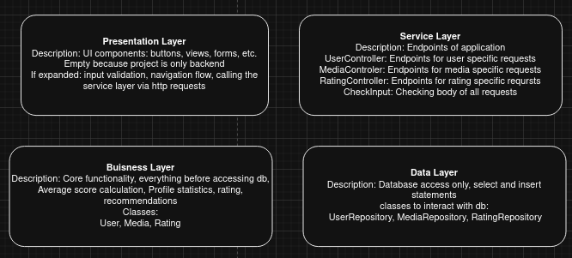
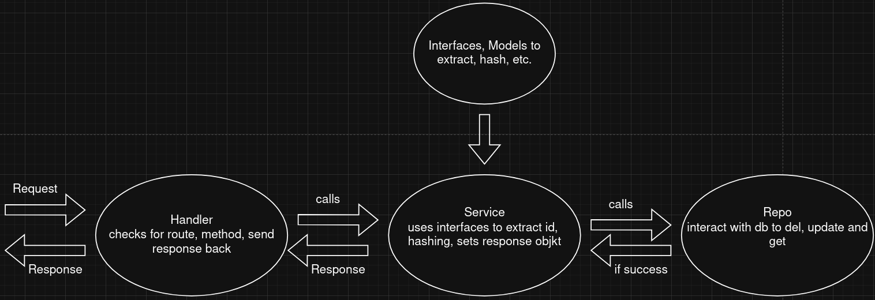
Workflow

App Design Overview
The application follows a layered architecture separating HTTP handling, business logic, and database access:
- HTTP Handlers
  - Receive incoming requests, check the path and method, and route them to the appropriate service.
  - Return a standardized Response object to the client via ResponseSender.
- Service Layer
  - Contains business logic: validation, hashing, data conversion, and constructing response objects.
  - Calls repository methods to interact with the database.
- Repository Layer
  - Handles all database operations for User, Media..etc
  - Performs CRUD operations, joins, and transactions, returning domain models to the service.
Flow Summary: Request → Handler → Service → Repository → Service → Handler → Client.

Class diagrams → Seperate pdf file in folder

Endpoints which already work → postman collection in folder
POST - Register User
POST – Login User
POST - Create Media Entry
DEL – Delete Media Entry
PUT – Update Media Entry
GET – Get Media by ID

Packages: pom.xml
postgresql – for interacting with db
lombok – for creating getter/setter
password4j - for hashing
jackson-databind - for json serialisation/deserialization

Database schema – current
