E-COMMERCE SALES PERFORMANCE ANALYSIS
USING DATA ANALYTICS AND AI
Project Report
Submitted by: Paras
B.Tech CSE
Data Analytics and AI Internship Project

1. Abstract
This project presents an end-to-end e-commerce sales analytics solution using Python and machine learning. The workflow includes data cleaning, exploratory data analysis, visualization, statistical analysis, sales prediction and AI/ML-based insights. The raw dataset contains 1503 records and the cleaned dataset contains 1500 records.

2. Introduction
E-commerce platforms generate large volumes of transaction data. Data analytics can convert transaction records into useful information about products, regions, channels, customers and sales patterns. Machine learning can further support prediction.

3. Problem Statement
Businesses need a structured method to clean transaction data, understand sales performance, identify important patterns and estimate sales from order-level features.

4. Objectives
1. Clean and preprocess order data.
2. Analyze sales by category, region and channel.
3. Study monthly sales patterns.
4. Analyze relationships among discount, quantity, ratings and sales.
5. Build sales prediction models.
6. Evaluate models with MAE, RMSE and R².
7. Identify important predictive features.
8. Generate AI/ML-based insights.

5. Scope
The project covers data preparation, exploratory analysis, visualization, statistics, regression modeling, model evaluation and interpretation. It is an educational internship project using synthetic data.

6. Technologies Used
Python, Pandas, NumPy, Matplotlib, Seaborn, Scikit-learn, Joblib and Jupyter Notebook.

7. Dataset Description
The dataset includes order ID, order date, year, region, product category, channel, customer segment, payment method, quantity, unit price, discount, shipping cost, customer rating, return status and sales amount.

8. Data Preprocessing
Duplicate records were removed and missing values were handled using median imputation for numerical fields and mode imputation for Region. The raw dataset contains 1503 records and the cleaned dataset contains 1500 records.

9. Exploratory Data Analysis
In the generated dataset, Electronics has the highest total category sales, South has the highest regional sales, and Marketplace has the highest channel sales.

10. Machine Learning Methodology
Sales_INR is the target variable. Categorical variables are one-hot encoded and numerical variables are imputed and standardized. The dataset is divided into 80% training and 20% testing data. Linear Regression and Random Forest Regressor are trained.

11. Model Evaluation
Linear Regression — MAE: 929.46, RMSE: 1249.58, R²: 0.8655.
Random Forest — MAE: 395.59, RMSE: 604.83, R²: 0.9685.

12. AI/ML-Based Insights
AI/ML ANALYTICAL INSIGHTS
Project: E-Commerce Sales Performance Analysis using Data Analytics and AI
Student: Paras

1. Highest total-sales category: Electronics.
2. Highest total-sales region: South.
3. Highest total-sales channel: Marketplace.
4. Average order sales: INR 5,050.49.
5. Observed return rate: 6.87%.
6. Linear Regression — MAE: 929.46, RMSE: 1249.58, R²: 0.8655.
7. Random Forest — MAE: 395.59, RMSE: 604.83, R²: 0.9685.
8. Feature importance is used to understand which inputs contribute most to model predictions.
9. The dataset is synthetic and these results are for educational demonstration only.

13. Results and Discussion
Average order sales are approximately INR 5,050.49 and the observed return rate is approximately 6.87%. The project demonstrates how descriptive analytics and machine learning can be combined in a reproducible workflow.

14. Limitations
The dataset is synthetic and does not represent an actual company's customers or market. Model performance on synthetic data should not be interpreted as production performance.

15. Future Scope
Future versions can add real-time dashboards, customer segmentation, demand forecasting, recommendation systems, anomaly detection, time-series models and deployment through Streamlit or a web API.

16. Conclusion
The project demonstrates how Data Analytics and AI can be combined to understand e-commerce sales performance and build predictive models.

17. References
Python documentation; Pandas documentation; NumPy documentation; Matplotlib documentation; Scikit-learn documentation; Seaborn documentation; Joblib documentation.

Figure 1: Sales by Product Category
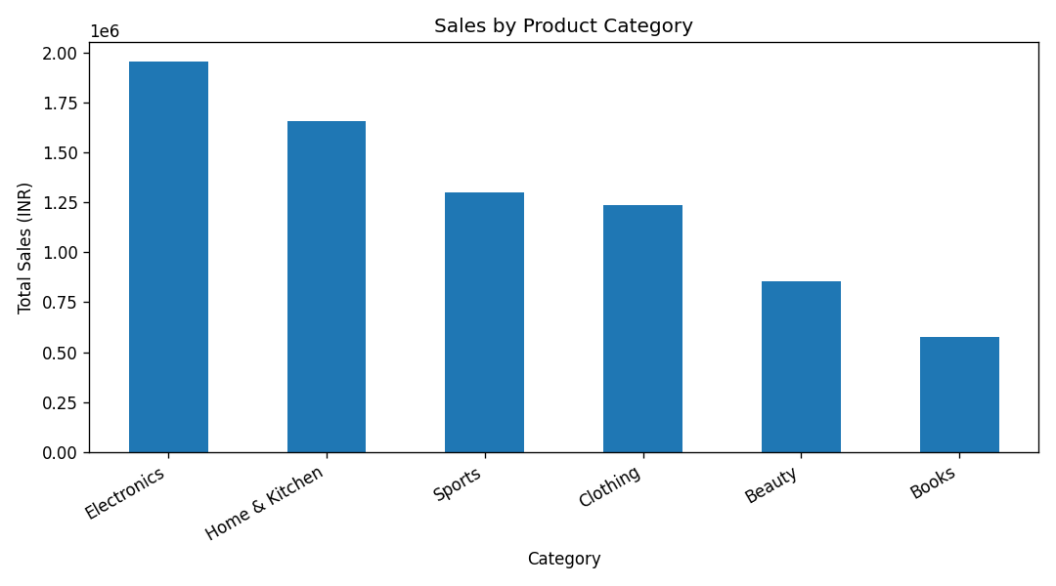

Figure 2: Sales by Region
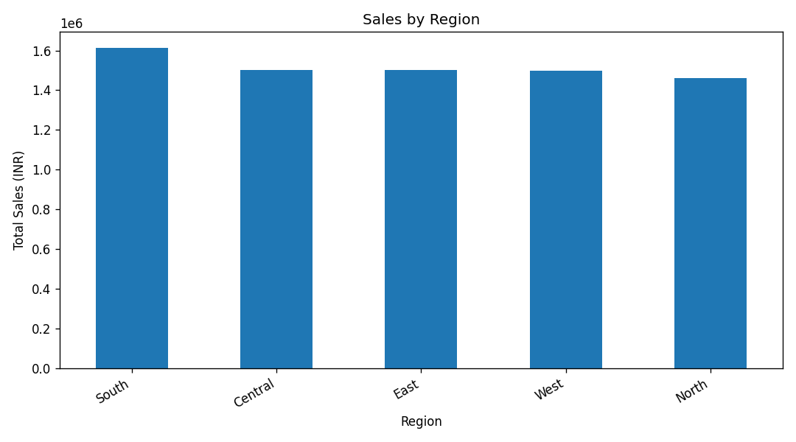

Figure 3: Sales by Channel
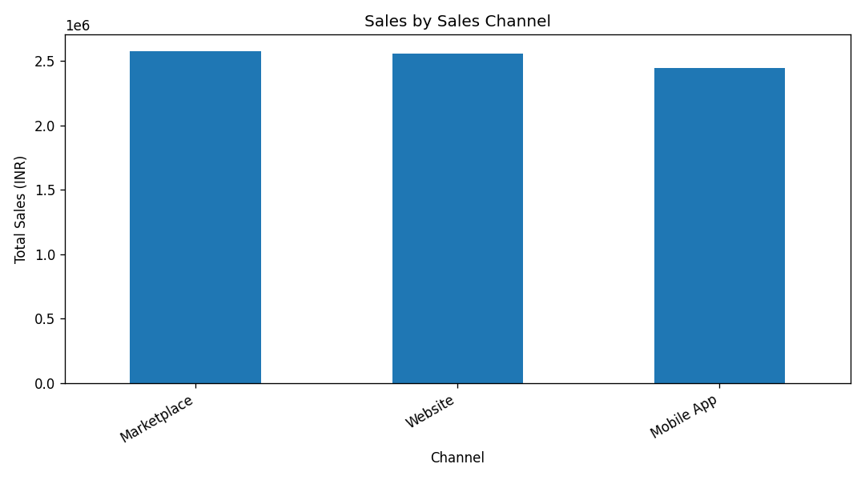

Figure 4: Monthly Sales Trend
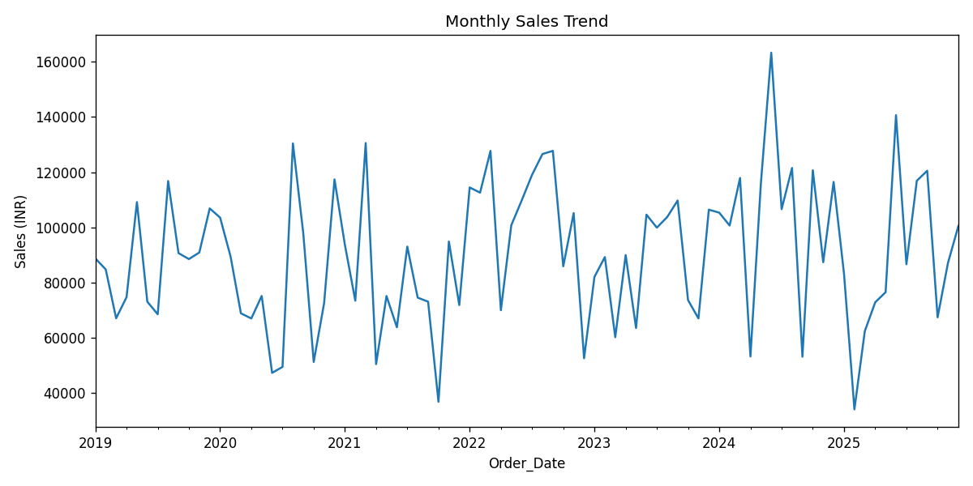

Figure 5: Discount vs Sales
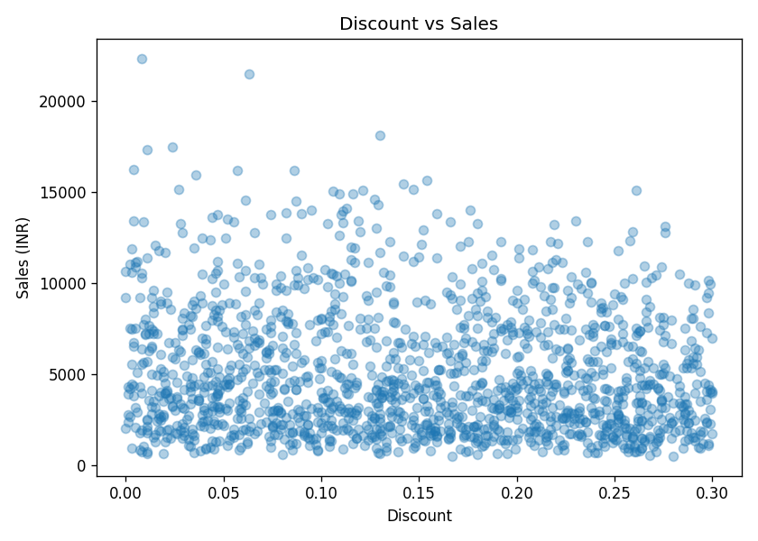

Figure 6: Correlation Heatmap
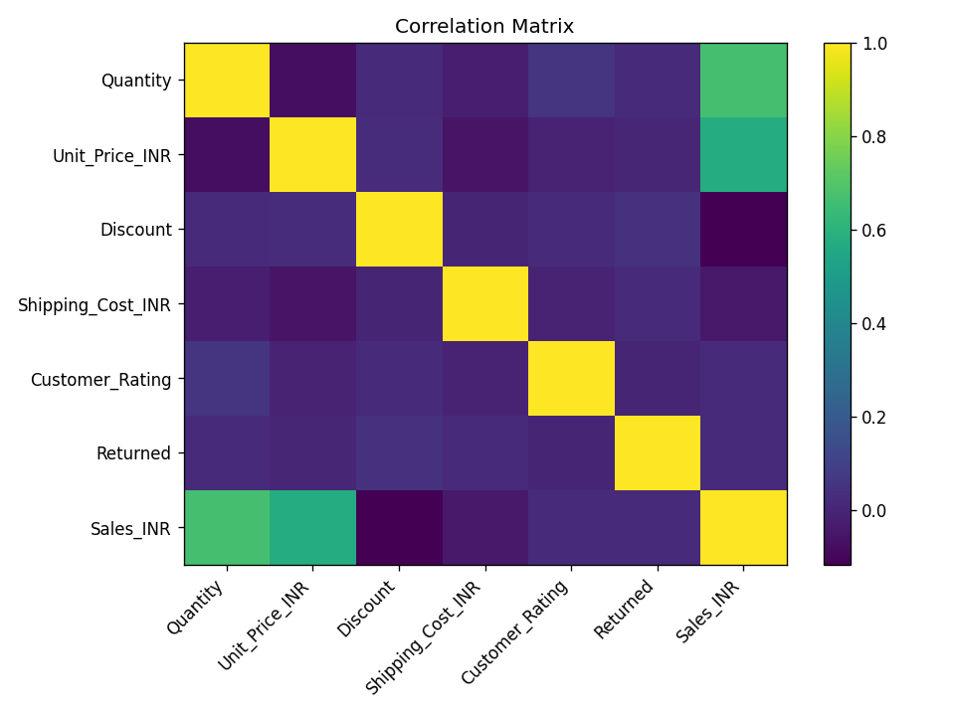

Figure 7: Actual vs Predicted Sales
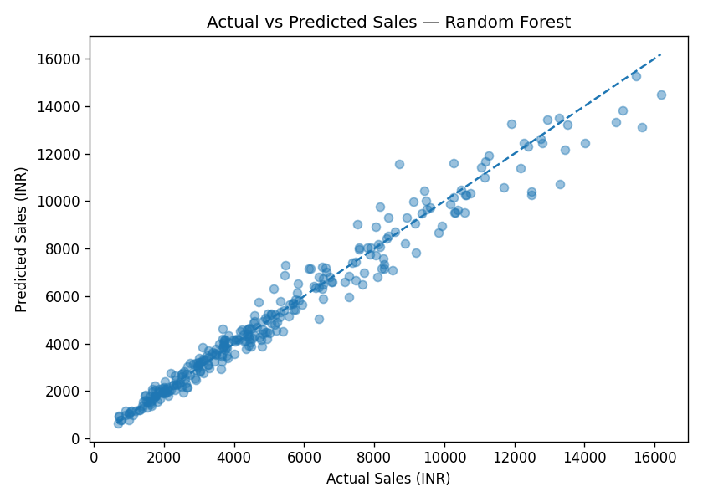

Figure 8: Feature Importance
