**Question 01:** Three sides a, b, and c form a triangle if:

a + b > c

a + c > b

c + b > a

In that case the area of the triagle is given by the formula:

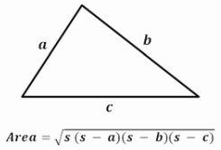

where:



Write a **64-bit x86-64** assembly language that prompts for and reads the three sides of the triangle each in centimeter. It then displays the area of the triangle in square centimeters if the input is valid otherwise it displays an appropriate error message.

Sample program runs:

|  |
| --- |
|  |
|  |
|  |
|  |

**Question 02:** Given two sides **a** and **b** of a triangle and the angle $C$ between these two sides, the area of the triangle is given by:

area = (a * b * sin $C$) / 2

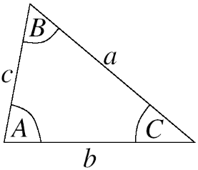

Write a **32-bit x86-64** assembly language program that prompts for and reads sides **a** and **b** of a triangle each in centimeters and the angle **C** between these two sides in degrees. It then displays the area of the triangle in square centimeters if the input is valid; otherwise it displays an appropriate error message.

**Note:** The C library defines π as the constant **M_PI**

**Sample program runs:**

|  |
| --- |
|  |
|  |
|  |

**Question 03:** Write a **64-bit x86-64** assembly language program that given a collection of Nnumbers will find the smallest value, the frequency of the smallest value (i.e., the number of times the smallest value appears in the collection), and the average of the negative numbers in the collection.

1. Get the value of N from the user.
2. If N <= 0 display an appropriate error message and terminate the program; otherwise
3. Read the values as entered from the user. (If N =5, then there are 5 values the user is going to enter).
4. Find the smallest, the frequency of the smallest value, and the average the negative numbers in the collection.

**Hint:** To find the smallest value, read the first value **before the loop** then assume that this first value entered by the user is the smallest value and its frequency is 1. **Within the loop** compare the assumed smallest value with other values **read inside the loop** and change the smallest value and frequency accordingly.

**Note:** Your solution must not use arrays and data files.

Sample program runs:

|  |
| --- |
|  |
|  |
|  |