| EX.NO:-12 | **Fuzzy inference System** |
| --- | --- |
| DATE: 27/05/2024 |

**Fuzzy inference system:**

You can implement a fuzzy inference system in Python using the scikit-fuzzy library, which provides tools for fuzzy logic. Here's a simple example of how you might create a fuzzy inference system for controlling the speed of a car based on the distance to an obstacle:

**PROGRAM:**

**CODING**

import numpy as np

import skfuzzy as fuzz

from skfuzzy import control as ctrl

# Create fuzzy variables

distance = ctrl.Antecedent(np.arange(0, 11, 1), 'distance')

speed = ctrl.Consequent(np.arange(0, 101, 1), 'speed')

# Define membership functions for distance

distance['near'] = fuzz.trimf(distance.universe, [0, 0, 5])

distance['medium'] = fuzz.trimf(distance.universe, [0, 5, 10])

distance['far'] = fuzz.trimf(distance.universe, [5, 10, 10])

# Define membership functions for speed

speed['slow'] = fuzz.trimf(speed.universe, [0, 0, 50])

speed['medium'] = fuzz.trimf(speed.universe, [0, 50, 100])

speed['fast'] = fuzz.trimf(speed.universe, [50, 100, 100])

# Define rules

rule1 = ctrl.Rule(distance['near'], speed['slow'])

rule2 = ctrl.Rule(distance['medium'], speed['medium'])

rule3 = ctrl.Rule(distance['far'], speed['fast'])

# Create the control system

speed_ctrl = ctrl.ControlSystem([rule1, rule2, rule3])

car_speed = ctrl.ControlSystemSimulation(speed_ctrl)

# Input distance and compute speed

car_speed.input['distance'] = 7

car_speed.compute()

# Print the computed speed

print("Computed speed:", car_speed.output['speed'])

In this example, we first define the fuzzy variables distance and speed using the Antecedent and Consequent classes, respectively. We then define the membership functions for each variable using fuzz.trimf. Next, we define the rules that determine the speed based on the distance using the ctrl.Rule class. After defining the rules, we create the control system using ctrl.ControlSystem and ctrl.ControlSystemSimulation. Finally, we input a distance value and compute the speed using compute(), and print the computed speed. This is a simple example to demonstrate the basic structure of a fuzzy inference system in Python using scikit-fuzzy. You can expand on this example by adding more variables, membership functions, and rules to create a more complex fuzzy inference system for your specific application.

# OUTPUT:

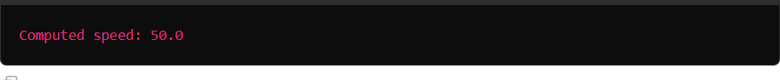

# Result:

The given Unification and resolution is compiled and implemented.