1. Expressions of variance of men and women

**Given that the variance of u in the model is given by $var(µ/male)=exp(α_{0}+α_{1}*male)$, the expression for the variance of males and females will be given by:**

$$var\left(male\right)=exp(α_{0}+α_{1}*male)$$

$$var\left(female\right)=exp(α_{0})$$

**The null hypothesis states that there is no difference in variance of µ is between males and females while alternative hypothesis states that there is a significant difference in variance of µ is between males and females.**

**In other words:**

H0: ${E(µ}^{2}|x_{1},..x_{n}$)=E($µ^{2})=σ^{2}$

H1: ${E(µ}^{2}\left|x_{1},..x_{n}\right)={E(µ}^{2}\left|gender\right)$ which means there is heteroskedasticity present

1. Model building

**The model is**

$sleep=3840.85-.16*totwrk-11.71*educ-8.70*age+.13*agesq-.02*yngkid+87.75*male$**.**

**The model shows that there is a significant difference in average sleeping minutes between males and females with males having 87 more minutes sleeping in a week than their female counterparts at 5% level of significance when other factors are held constant. There is a notable difference in variance of mu between males and females with variance in sleeping among males being higher than that of females.**

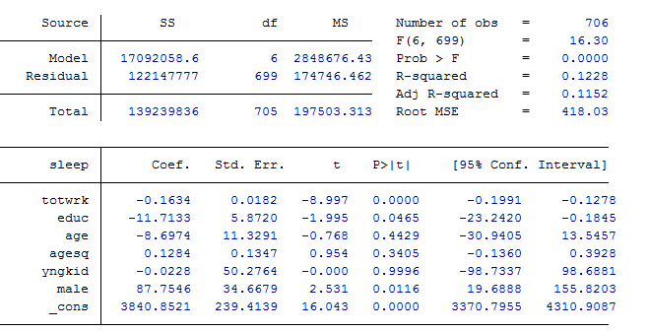

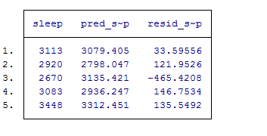

1. Test for difference in variance

The coefficient of male is negative and a very high value (-28849.63) indicating that the variance of error is higher for female than for males. However, this difference is NOT statistically significant with p-value of 0.291 at 5% not even 20% percent of significance level.

Hence p-value >0.05 The result shows that there is no statistical difference in variance between males and females.

regress sleep totwrk educ age agesq yngkid male

predict res, r

gen ressq = res*res

regress ressq male

