Vit Model Verileri:  
Epoch 1, Train Loss: 0.08602353450218876, Validation Loss: 0.050156798676452924

Epoch 2, Train Loss: 0.028368875700760427, Validation Loss: 0.047057778404662444

Epoch 3, Train Loss: 0.019409072221491457, Validation Loss: 0.04484176035141631

Classification Report:

precision recall f1-score support

Fabrika 0.98 0.99 0.99 2449

Tasit 0.99 0.98 0.99 2631

accuracy 0.99 5080

macro avg 0.99 0.99 0.99 5080

weighted avg 0.99 0.99 0.99 5080

Sensitivity: 0.98

Specificity: 0.99  
  
Eğitim Süresi: 32219.38 saniye

Çıkarım Süresi: 851.59 saniye  
  
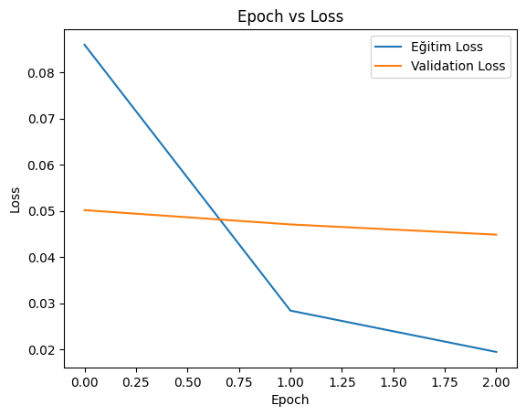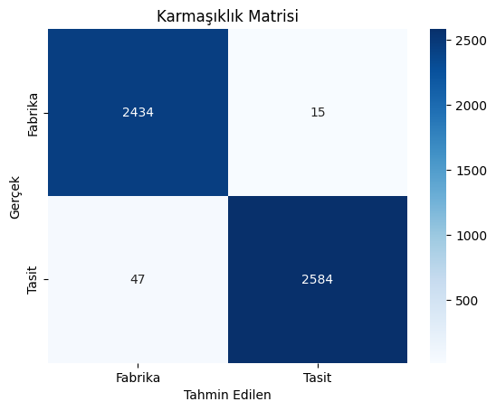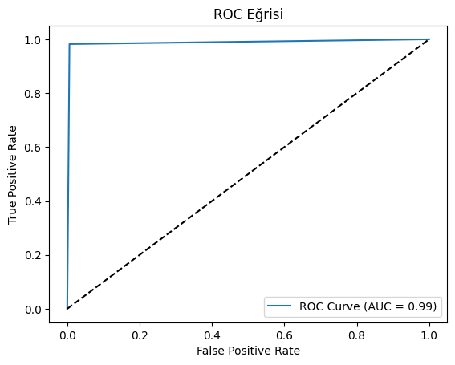  
  
Deit model verileri:  
Epoch 1, Train Loss: 0.06599989565626506, Validation Loss: 0.03164525710869252

Epoch 2, Train Loss: 0.014200233568829383, Validation Loss: 0.03430877626967271

Epoch 3, Train Loss: 0.009049842611409441, Validation Loss: 0.027959955657705385

Classification Report:

precision recall f1-score support

Fabrika 0.99 0.99 0.99 2469

Tasit 0.99 0.99 0.99 2611

accuracy 0.99 5080

macro avg 0.99 0.99 0.99 5080

weighted avg 0.99 0.99 0.99 5080

Sensitivity: 0.99

Specificity: 0.99

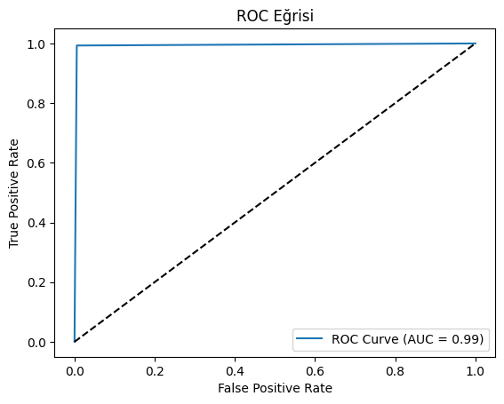

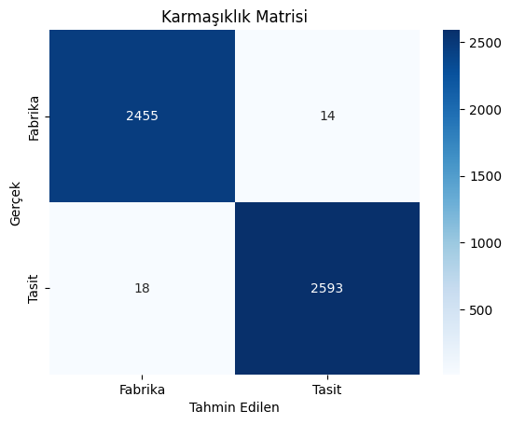

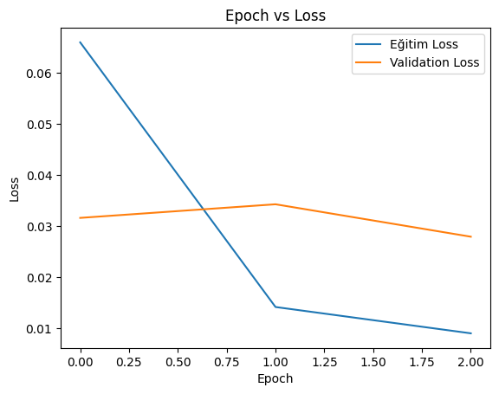

Eğitim Süresi: 32638.19 saniye

Çıkarım Süresi: 841.46 saniye  
  
  
Beit Modeli Verileri:  
Epoch 1, Train Loss: 0.07724765260707528, Validation Loss: 0.03962227256760681

Epoch 2, Train Loss: 0.026924575750686696, Validation Loss: 0.041380136293569965

Epoch 3, Train Loss: 0.02212869774251828, Validation Loss: 0.04102452892979238

Classification Report:

precision recall f1-score support

Fabrika 0.99 0.98 0.98 2388

Tasit 0.98 0.99 0.99 2692

accuracy 0.99 5080

macro avg 0.99 0.98 0.99 5080

weighted avg 0.99 0.99 0.99 5080

Sensitivity: 0.99

Specificity: 0.98

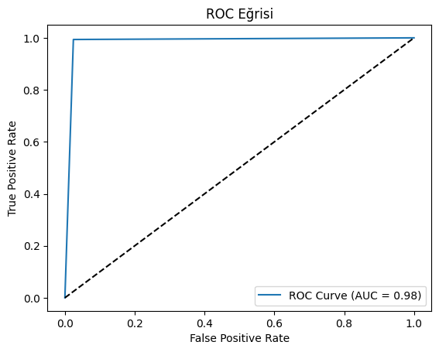

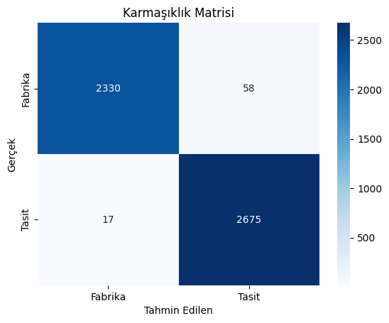

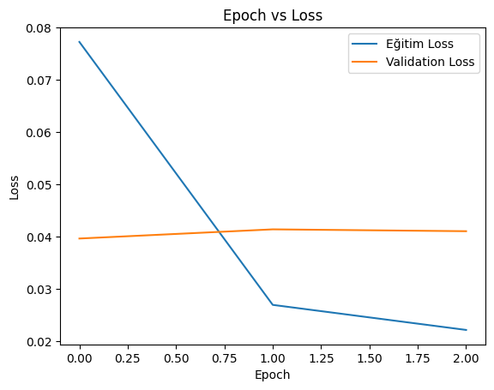

Eğitim Süresi: 34946.67 saniye

Çıkarım Süresi: 789.98 saniye

EfficientNet modeli verileri:

Epoch 1, Train Loss: 0.12297846447808419, Validation Loss: 0.043795826581289186

Epoch 2, Train Loss: 0.034852705302365915, Validation Loss: 0.022626209945517516

Epoch 3, Train Loss: 0.01948281630883305, Validation Loss: 0.0197058224430236

Classification Report:

precision recall f1-score support

Fabrika 0.99 0.99 0.99 2446

Tasit 1.00 0.99 0.99 2634

accuracy 0.99 5080

macro avg 0.99 0.99 0.99 5080

weighted avg 0.99 0.99 0.99 5080

Sensitivity: 0.99

Specificity: 0.99

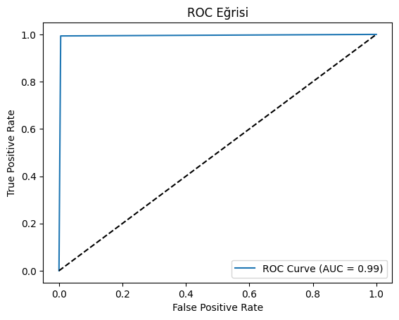

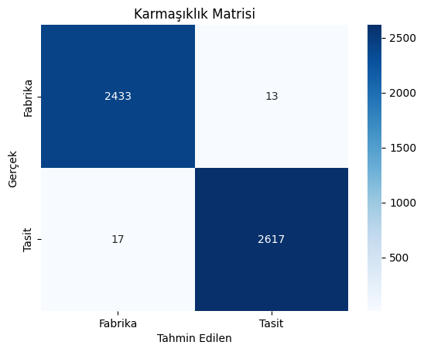

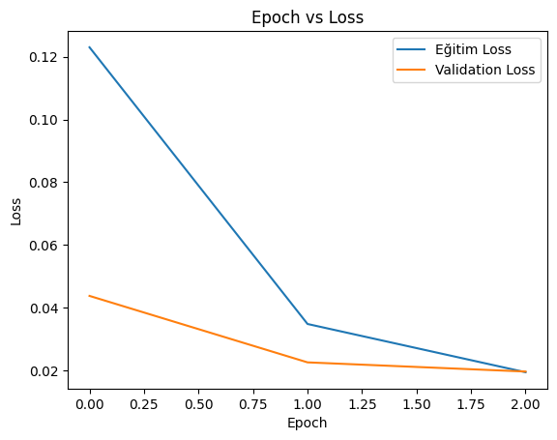

Eğitim Süresi: 3305.98 saniye

Çıkarım Süresi: 96.39 saniye

Swin Transformer modeli verileri:  
Epoch 1, Train Loss: 0.08345580184960547, Validation Loss: 0.04730187782596024

Epoch 2, Train Loss: 0.03267803534223262, Validation Loss: 0.03005136456011074

Epoch 3, Train Loss: 0.026057147955434914, Validation Loss: 0.030126217927867197

Classification Report:

precision recall f1-score support

Fabrika 0.99 0.99 0.99 2423

Tasit 0.99 0.99 0.99 2657

accuracy 0.99 5080

macro avg 0.99 0.99 0.99 5080

weighted avg 0.99 0.99 0.99 5080

Sensitivity: 0.99

Specificity: 0.99

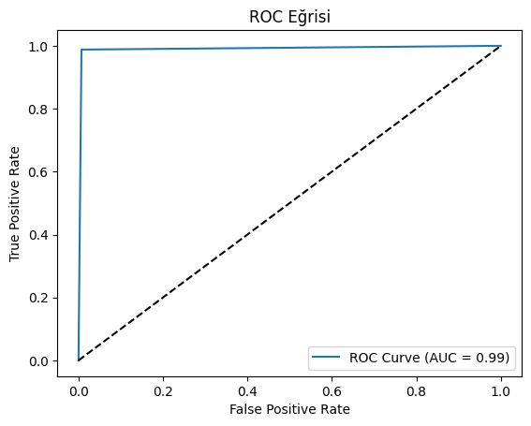

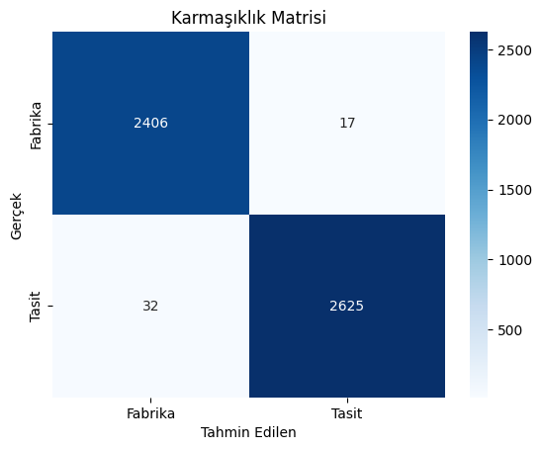

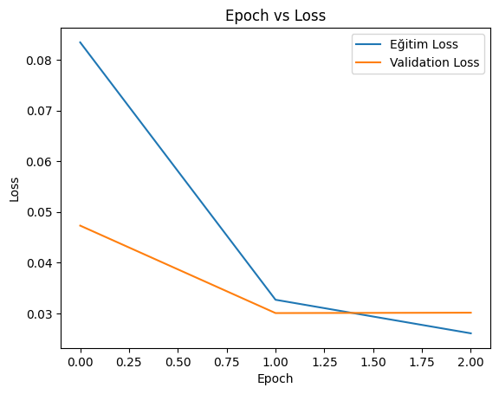

Eğitim Süresi: 58981.40 saniye

Çıkarım Süresi: 1349.00 saniye