ميزان MIZAN
Use Case Diagram — Explanation
Project | Mizan — Shared Household Expense Tracker
Document | Use Case Diagram — Explanation
Version | 1.0
Author | Mohammed Bteibt
Date | March 2026

1. Purpose of This Document
This document explains the use case diagram for Mizan. It describes what actions users can perform in the system, which parts of the system are triggered as a result, and how external systems like Supabase and the user's bank app fit into the overall picture. Each use case in the diagram is described in full, including who initiates it, what happens, and how it connects to other use cases through include relationships.

2. Use Case Diagram

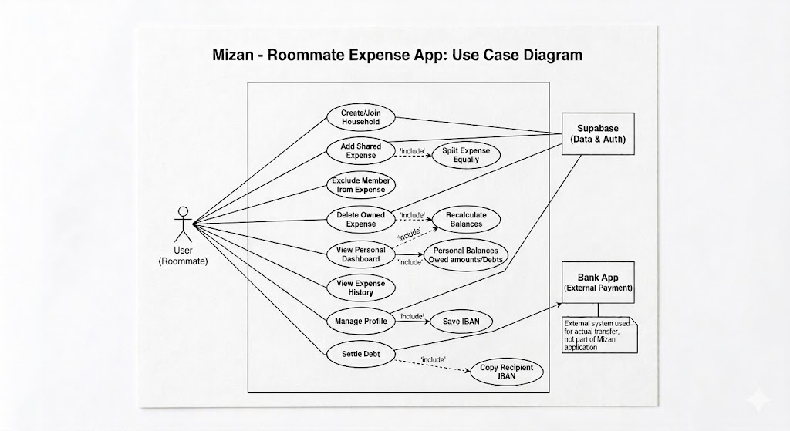

3. Actors
The diagram includes one primary actor and two external systems.

Actor | Type | Description
User (Roommate) | Primary | Any authenticated household member. All users have the same permissions, there is no admin or owner role in v1.
Supabase (Data & Auth) | External System | Handles all database reads and writes, user authentication, and real-time balance broadcasting. Shown outside the system boundary in the diagram.
Bank App (External Payment) | External System | The user's own banking application, used to complete the actual money transfer after copying the IBAN. Entirely outside Mizan — the app has no visibility into whether the transfer happened.

All household members are treated as the same actor with equal permissions. There is no distinction between an admin, an owner, and a regular member in Mizan v1. Any user can add expenses, delete their own expenses, view balances, and settle debts.

4. Use Cases
The table below describes each use case in the diagram. Use cases marked with an «include» relationship automatically trigger a second use case as part of their execution.

Use Case | Actor | Description
Create / Join Household | User | The user either creates a new household with a name, or joins an existing one by entering a 6-character invite code. This must happen before any expenses can be logged.
Add Shared Expense | User | The user logs a new expense with a description, amount, and category. Automatically triggers the splitting logic.  «include» Split Expense Equally
Split Expense Equally | System | Triggered whenever an expense is added. Divides the total amount by the number of included members and updates each person's balance accordingly.
Exclude Member from Expense | User | When adding an expense, the user can toggle off specific household members. The cost is then split only among those who remain included.
Delete Owned Expense | User | A user can delete any expense they personally paid for. Requires confirmation. Automatically triggers a balance recalculation.  «include» Recalculate Balances
Recalculate Balances | System | Triggered when an expense is deleted or a settlement is recorded. Recomputes the net balance for all affected members from the full expense and settlement history.
View Personal Dashboard | User | Displays the logged-in user's personal balance view — who they owe and who owes them. Reads the current calculated balances from the database.
View Expense History | User | Shows all household expenses organised by month. Each entry displays the description, amount, category, who paid, and the date.
Manage Profile | User | The user can update their full name and IBAN from the profile settings page.  «include» Save IBAN
Save IBAN | System | When the user submits their profile, their IBAN is stored in the database and becomes available to household members during the settle flow.
Settle Debt | User | When a user owes money, they click the Settle button on that row. The system retrieves the payee's IBAN so the user can copy it and complete the bank transfer manually.  «include» Copy Recipient IBAN
Copy Recipient IBAN | System / Bank App | The payee's saved IBAN is fetched and displayed in a modal. The user copies it and switches to their bank app to complete the transfer. The actual payment happens entirely outside Mizan.

5. «include» Relationships Explained
In UML use case diagrams, an «include» relationship means that one use case always triggers another as a required part of its execution. The included use case is not optional — it happens every time the base use case runs. Mizan has four include relationships in its diagram.

Add Shared Expense «include» Split Expense Equally
Every time a user adds an expense, the system must immediately calculate how to divide the cost among the included household members. This is not a separate action the user takes, it happens automatically and invisibly as soon as the expense is saved. The split logic reads the total amount, checks the Expense_Exclusions table for any excluded members, and divides the remainder equally. Without this step the expense exists in the database but nobody's balance would reflect it.

Delete Owned Expense «include» Recalculate Balances
When a user deletes an expense they paid for, the amounts that were owed as a result of that expense are no longer valid. The system must immediately recalculate the net balance for every household member who was included in that expense. This happens automatically on deletion. The recalculation reads the full remaining expense history and settlement history and recomputes all balances from scratch, which guarantees accuracy regardless of how many expenses have been added or deleted.

Manage Profile «include» Save IBAN
When a user submits their profile settings, their IBAN is written to their record in the database. The save is a required part of the profile update, it is not possible to update your profile without the IBAN field being processed. The saved IBAN is what gets retrieved and displayed to other household members when they click the Settle button on a debt they owe to this user.

Settle Debt «include» Copy Recipient IBAN
When a user clicks the Settle button on a debt they owe, the system fetches the payee's saved IBAN from the database and displays it in a modal. This retrieval is a required step, the settle flow cannot complete without it. Once the IBAN is displayed, the user copies it manually and switches to their bank app to complete the transfer. The dashed «include» line in the diagram indicates this step crosses the system boundary into the external Bank App actor, which is outside Mizan's control entirely.

6. System Boundary
The rectangle in the diagram represents the Mizan system boundary — everything inside it is built and controlled by the team. Everything outside it is an external dependency.

Inside the system boundary
All use cases initiated by the user: creating households, adding expenses, viewing dashboards, settling debts.
All system-triggered use cases: splitting expenses, recalculating balances, saving IBANs, displaying recipient IBANs.
The Supabase backend is shown outside the boundary as an external service the app depends on, not code the team wrote.

Outside the system boundary
Supabase — a third-party hosted platform. Mizan uses it but does not build or control it.
The Bank App — entirely external. Mizan has no visibility into whether a transfer was actually made.
The actual money movement between users happens outside Mizan. The app only records that the user marked the debt as settled.

