Name: Flip Resume – Book Style Resume Theme
Overview:
Flip Resume, a unique book style resume template, built on Bootstrap 3, comes with eight pre-set colors. It has a unique style so you can have an awesome resume portfolio. Your dream job is not far away with this kind of presentation.
All the pages are divided into sections, with each section having identifier of its respective page; add/remove sections according to your preference. Comments are mentioned properly in each section to guide you with modifications. We are providing W3C validated HTML and CSS.
SASS pre-processor is used to generate CSS to ease out the customization. SASS is a way to store information in variable to reuse the same throughout the stylesheet and provide consistency.
Few Example Pages:
Home Page:
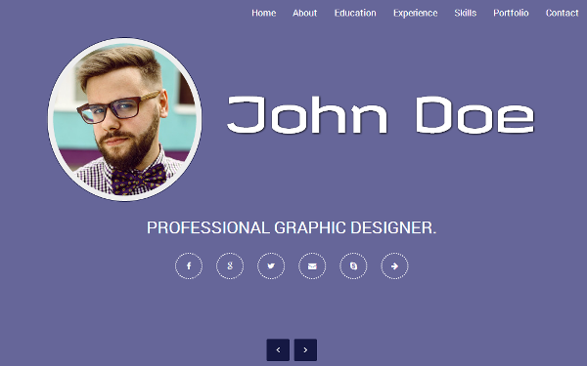
About Page:
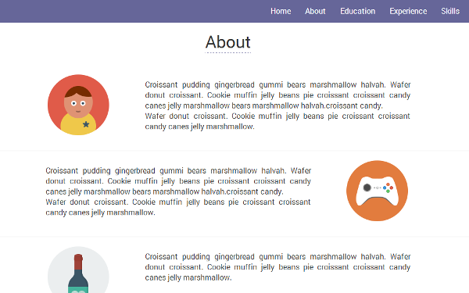
Skills Page:
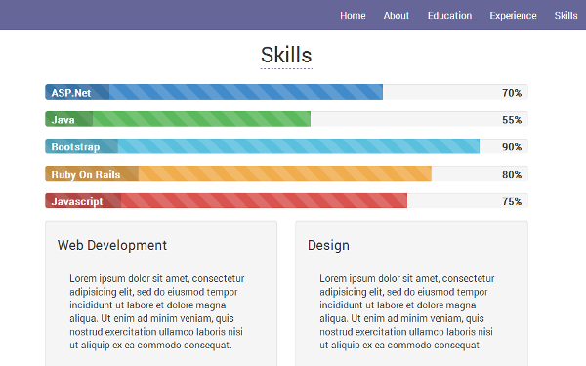
Features:
- Built on Twitter Bootstrap 3.2
- Fully responsive
- Built with SASS
- 8 pre-set colors
- Unique Book style flip design
- Animated About, Education, Experience, Skills and Portfolio pages
- Skill Page in form of animated progress graph with percentage
- Contact page with Google map.
- Clean HTML code with proper comments for easy customization.
- W3C validated mark-up
Attributions:
Plugins and Components:
- Twitter bootstrap 3 - http://getbootstrap.com/
- jQuery - http://jquery.com/
- Animate.css – http://daneden.github.io/animate.css/
- BookBlock - https://github.com/codrops/BookBlock
- Tab Slide out - http://www.building58.com/examples/tabSlideOut.html
- Modernizer - http://modernizr.com/
- PacePreloader – http://github.hubspot.com/pace/docs/welcome/
Textures, photographs, and other images:
- Pixabay - http://pixabay.com/en/
- Icon finder - https://www.iconfinder.com/
Icons and other glyphs:
- Font Awesome - http://fontawesome.io/
Fonts:
- Google font – http://www.google.com/fonts/
Others:
- Google Maps - http://hpneo.github.io/gmaps/

