SQLShield: Leakage-Resistant SQL Injection Detection with Fine-Tuned CodeBERT, Classical Baselines, and Cross-Source Evaluation

Mahmoud Baklizi¹ Mohammad Alkhazaleh²* Musab Zghoul² Osama Qtaish³

¹University of Petra, Faculty of Information Technology, Department of Computer Science, Amman, Jordan
²Isra University, Faculty of Information Technology, Department of Computer Science, Amman, Jordan
³Isra University, Faculty of Information Technology, Department of Software Engineering, Amman, Jordan
* Corresponding author’s Email: m.alkhazaleh@iu.edu.jo

Abstract: High benchmark accuracy in SQL injection (SQLi) detection can mislead when preprocessing leakage, near-duplicate variants, baseline representation, and source shift are left uncontrolled. SQLShield is a leakage-resistant evaluation framework comparing fine-tuned CodeBERT and BERT-base against four word-level and two character-level TF-IDF baselines on a 56,621-query corpus partitioned by normalized-text group. On the fixed 5,654-query test set, CodeBERT reaches 99.95% accuracy (95% Wilson CI: 99.84-99.98) with three errors, but a character 3-5-gram LinearSVC reaches 99.84% with nine at a fraction of the training cost, and the paired difference is not statistically significant (exact McNemar p=0.109375). Across three independent group-aware partitions the ordering of the leading models is unstable: the six-error gap falls to zero at one partition, and BERT-base and the character baseline change places. On overlap-free cross-source residuals all eight models fail in one direction, at balanced accuracy between 0.501 and 0.559, while the direction that does transfer separates them by an order of magnitude in false positives on the same residual: 5 for the character baseline, 128 for BERT-base and 769 for CodeBERT. Performance survives near-duplicate family consolidation down to Jaccard 0.7. Cross-source transfer is sharply asymmetric: A->B retains discrimination (ROC-AUC=0.99025) whereas B->A collapses at the transferred operating point (balanced accuracy=0.5039) while retaining above-chance ranking (ROC-AUC=0.7033). Neither mixed-source benchmark accuracy nor model class alone establishes source portability.
Keywords: SQL Injection Detection, CodeBERT, Character n-grams, Data Leakage, Group-Aware Splitting, Near-Duplicate Sensitivity, Cross-Source Generalization, Evaluation Validity

- Introduction
Web application security is mission-critical as databases underpin enterprise, healthcare, financial, and e-commerce systems. SQL Injection (SQLi) has remained prominent for over two decades and is consistently listed by OWASP among the top injection vulnerabilities [1]. The Verizon 2026 Data Breach Investigations Report [2], covering over 31,000 incidents and 22,000 confirmed breaches across 145 countries, found that exploitation of software vulnerabilities is now the leading initial access vector at 31% of breaches, surpassing stolen credentials for the first time in the report's nineteen-year history. Injection flaws in internet-facing applications remain a recurring instance of this class. A successful SQLi attack can enable unauthorized data disclosure, privilege escalation, authentication bypass, database manipulation, and in severe cases broader system compromise.
Halfond, Viegas, and Orso [3] established the canonical classification of SQL injection attacks into three broad categories based on communication channel and intent. In-band attacks retrieve results through the same channel used for injection, and include tautology injection (WHERE 1=1), UNION-based extraction, and stored injection. Inferential, or blind, attacks return nothing directly; they read information out of the system's behaviour instead. A boolean probe infers whether a condition holds from how the response changes, while a time-based probe calls a delay function such as WAITFOR DELAY or SLEEP() and encodes its answer in the response latency. Out-of-band attacks send data elsewhere entirely, over channels such as DNS lookups or HTTP callbacks. Each category has dozens of syntactic disguises available to it through encoding (URL, Base64, hexadecimal), added whitespace, comments (/**/, --, #), or alternating case. Signature matching cannot enumerate that space, which is why detection has to reach the semantic level.
An SQLi incident carries operational, legal, and reputational costs at once, and exposing regulated data can pull in data-protection or sector-specific compliance obligations as well. Pressure of this kind calls for accurate detectors, but equally for evaluation that makes leakage, training variability, and domain shift visible instead of hiding them behind a single benchmark score.
The traditional defenses — static signatures, parameterized queries, and rule-based Web Application Firewalls (WAFs) — still fall short against payloads written with evasion in mind. ModSecurity's Core Rule Set maintains hundreds of hand-crafted patterns that are bypassed by encoding and comment injection, while parameterized queries cannot protect legacy systems or third-party components. The underlying limitation is that rule-based detection requires explicit enumeration of malicious patterns, which is provably incomplete against an adversary who knows the rules.
The transformer architecture [4] changed sequence modeling through multi-head self-attention, which captures long-range token dependencies without the sequential constraints of recurrent networks [5]. This is potentially useful for SQLi detection because malicious intent can depend on relationships among tokens separated across a query, and transfer learning from pre-trained models reduces the task-specific labelled data required [6, 7]. CodeBERT [8] is a code-oriented bimodal model pre-trained on roughly 2.1 million paired natural-language/code examples and 6.4 million unimodal code examples across six programming languages. SQL is not among those six, so whether code-oriented pre-training helps SQLi detection beyond a general-purpose transformer is an empirical question, tested here through the CodeBERT-versus-BERT-base comparison.
Despite substantial progress, SQLi detection research exhibits several of the evaluation pitfalls catalogued for security machine learning more broadly [9]: many studies report high accuracy without simultaneously controlling normalized duplicate leakage, stress-testing near-duplicate payload families, quantifying transformer run-to-run variability, applying paired statistical tests on identical test instances, evaluating source-to-source transfer, or testing strong character-level classical representations that preserve punctuation-rich local patterns. Rather than treat a single held-out accuracy figure as proof of superiority or portability, SQLShield takes on these evaluation dimensions together. The paper makes five contributions:
1. A source-specific preprocessing and leakage-control protocol that builds a 56,621-query corpus, removes contradictory normalized groups, and partitions 45,915 normalized-text groups so that none is split across train, validation, and test.
2. A controlled eight-model benchmark in which CodeBERT and BERT-base are compared against four word-level TF-IDF baselines (Random Forest, XGBoost, LinearSVC, Logistic Regression) and two character 3–5-gram TF-IDF baselines (LinearSVC, Logistic Regression) on one fixed split, with five training seeds per transformer to gauge stability.
3. Paired statistical validation: two-sided exact McNemar tests on the fixed test predictions, corrected for multiplicity with both Holm and Bonferroni across seven primary CodeBERT comparisons, and 95% Wilson score intervals for fixed-test accuracy.
4. A near-duplicate sensitivity analysis that builds payload families from 5-character shingles using MinHash-LSH candidates and exact Jaccard verification, then re-splits with row-level StratifiedGroupKFold at Jaccard thresholds of 0.9, 0.8, and 0.7 to see whether near-perfect performance survives stronger family isolation.
5. Bidirectional overlap-free cross-source evaluation, with validation-only threshold transfer, source-conditioned test analysis, and a benign-only fingerprint diagnostic, which together expose a pronounced asymmetric distribution shift behind the near-perfect mixed-source numbers.
Section 2 reviews related work. Section 3 sets out the preprocessing and leakage controls, the models, and the statistical, near-duplicate, and cross-source protocols. Section 4 reports results; Sections 5 and 6 examine source shift and source-conditioned reliability; Section 7 discusses implications and limitations; and Section 8 concludes.
- Related Work
SQLi detection has moved from hand-crafted rules to statistical feature engineering and then to deep contextual representation learning, each generation buying accuracy while exposing a new weakness in generalization or robustness. We review six threads and name the gaps SQLShield sets out to close.
2.1 Rule-Based and Signature Detection
Static signatures and regular expressions were the first line of defense for WAFs. ModSecurity's Core Rule Set, the de facto open-source standard, maintains hundreds of hand-crafted patterns that work well on canonical signatures but can be circumvented by encoding, comment injection, and other obfuscation. Alghawazi et al. [10] reviewed machine-learning approaches to SQLi detection, traced the shift from rule-based to data-driven defenses, and stressed how much dataset construction, feature representation and evaluation design matter when detectors are compared.
Grammar and parse-tree techniques complement signature matching by exploiting the formal structure of SQL as a deterministic context-free language. Halfond et al. [3] proposed AMNESIA, which uses static analysis to model the parse trees of legitimate queries and flags any runtime query that departs from the allowlisted grammar. Such methods are precise on known structural patterns, but parsing every query at request time is expensive at WAF throughput, and grammar models presuppose statically known query construction, an assumption that breaks for ORMs and dynamically composed queries.

2.2 Classical Machine Learning Approaches
Through the 2010s, TF-IDF features paired with classical classifiers became the dominant approach. Shar and Tan [11] predicted injection vulnerabilities by mining input-sanitization patterns from source code, reaching 79% precision and 71% recall, and showed that statistical learning over code artefacts works while static analysis alone cannot enumerate the dynamic payload variations seen at runtime.
Kar et al. [12] introduced SQLiGoT, which represents the structural relationships in SQL-like input as graph-of-token features and classifies them with an SVM. Hosam et al. [13] used 13 engineered features extracted from user inputs. Oudah et al. [14] compared four models under different TF-IDF settings, with SVM highest (0.997) followed by XGBoost (0.995). These studies show classical ML can be highly competitive on benchmark data, with performance depending strongly on representation and evaluation design. In earlier work we compared classical detectors for SQL injection across several feature representations and proposed a hybrid detection framework [15]. The present paper does not extend that detector design; it asks whether a benchmark comparison of this kind can support a conclusion about detector quality at all once leakage, near-duplicate families, baseline representation and source shift are controlled.

2.3 Deep Learning: CNN and Recurrent Architectures
Convolutional networks for text, pioneered by Kim [16] with TextCNN, demonstrated the value of learned local n-gram extraction. Abdulhamza and Al-Janabi [17] applied a 2D-CNN to SQLi detection and reported 99.66% accuracy. Fixed receptive fields, however, motivate complementary sequential or contextual representations when dependencies span longer portions of a query.
Recurrent architectures, notably the LSTM of Hochreiter and Schmidhuber [5], address sequential dependencies through gated memory. Alazzawi [18] proposed an RNN-based detector learning syntactic and semantic query features and reported improvement over rule-based detection. Alghawazi et al. [19] evaluated an RNN-autoencoder against ANN, CNN, Decision Tree, Naïve Bayes, SVM, Random Forest, and Logistic Regression baselines, reporting 94% accuracy and F1=0.92. Both use evaluation settings different from the leakage-resistant, multi-seed, cross-source protocol adopted here.
Sun et al. [20] proposed a hybrid detector combining an enhanced TextCNN, Bi-LSTM, an attention mechanism, and BERT-derived word vectors, reporting all evaluation indicators above 99.57%. That study used a different evaluation design and did not provide the normalized-group leakage control, five-seed stability analysis, paired fixed-test McNemar comparisons, or bidirectional overlap-free cross-source audit reported here.

2.4 Transformer-Based Approaches
Lodha and Gundawar [6] evaluated multiple machine- and deep-learning approaches and reported BERT as best-performing, at 99.98% validation accuracy. Because that is a validation metric rather than a leakage-controlled held-out result, it is not directly comparable with the protocol used here; SQLShield therefore includes BERT-base as a common-split baseline rather than treating cross-paper differences as evidence of architectural superiority.
Liu and Dai [7] proposed a hybrid BERT-LSTM architecture combining transformer representations with recurrent modeling and attention, reporting 97.3% accuracy, 96.3% precision, 96.2% recall, and 95.8% F1. Because its architecture and evaluation protocol differ from the controlled comparison used here, SQLShield evaluates CodeBERT directly against BERT-base on the identical group-aware split and fixed paired test set.
Ammar and Alharbi [21] provide the most closely related prior work, fine-tuning CodeBERT on 30,919 SQL queries and reporting 99.90% accuracy. The dataset they cite, sajid576, overlaps one of the sources used here, so cross-paper metric comparisons must be read cautiously when preprocessing and split construction differ. Because their method is fine-tuned CodeBERT with a linear classification head, the CodeBERT row of Table 4 is that method re-evaluated under the leakage-controlled protocol used here, rather than an independent architecture; the 99.90% and 99.95% figures therefore differ in evaluation protocol rather than in detector design. SQLShield carries the line further with source-specific preprocessing, normalized-group leakage control, an eight-model fixed test covering word- and character-level classical representations, five-seed stability analysis, exact paired significance with multiple-comparison correction, and bidirectional overlap-free cross-source evaluation.

2.5 Evaluation Validity, Leakage, and Dataset Shift in Security ML
None of the concerns behind SQLShield are unique to SQL injection; they sit within an established literature on evaluation validity in security machine learning. Arp et al. [9] identify ten recurring pitfalls — sampling bias, data snooping, spurious correlations and inappropriate baselines among them — and, reviewing top-venue security papers, show both how common these pitfalls are and how much they can inflate reported performance. Working on malware, Pendlebury et al. [22] found that removing spatial and temporal bias from an experimental design cuts apparent accuracy substantially, which makes partition construction an experimental variable in its own right rather than a preprocessing detail. The problem is not confined to security: surveying seventeen fields, Kapoor and Narayanan [23] trace non-reproducible results in hundreds of papers to eight distinct forms of leakage, among which contamination by duplicate or near-duplicate records is one of the most common. Closest to our own setting, Allamanis [24] shows that near-duplicate fragments pervade mined code corpora, that leaving them in inflates reported metrics, and that deduplicated evaluation gives lower but more honest estimates.
These findings are acute for SQLi detection. Public corpora are often assembled from templated generators, so superficially distinct payloads may be minor variants within one family, and corpora of different origin may encode source-specific formatting, class priors, or negative-class construction rules a classifier can exploit without learning injection semantics. SQLShield therefore treats four items as separate, explicitly reported validity checks: normalized-group separation (Section 3.1), near-duplicate family isolation at multiple thresholds (Section 3.5), representation-matched classical baselines (Section 3.2), and bidirectional overlap-free cross-source transfer (Section 3.6). These correspond respectively to the data-snooping, near-duplicate contamination, inappropriate-baseline, and sampling-bias failure modes identified in [9, 22-24].
Explainability methods such as LIME [25] and Shapley-value approaches such as SHAP [26] can support analyst review of flagged queries, but explanation quality does not substitute for leakage or distribution-shift controls; direct transformer attribution is therefore left for future work.

2.6 Summary and Identified Research Gaps
Table 1 collects the six threads reviewed above, the accuracy each study reports, and the specific gap that motivates the evaluation framework proposed here.
Table 1. Summary of related work and research gaps
Reference | Method | Acc. | Year | Gap vs. SQLShield
Alghawazi et al. [10] | Systematic review: ML/DL SQLi | — | 2022 | Review study; no leakage-controlled common split or cross-source audit
Shar & Tan [11] | Static sanitization mining | ~79% | 2013 | Static analysis only; no runtime common-split benchmark or cross-source transfer test
Abdulhamza [17] | 2D-CNN | 99.66% | 2022 | No pre-training; no paired significance; no normalized-group or cross-source evaluation
Sun et al. [20] | TextCNN + Bi-LSTM + attention + BERT | >99.57% | 2023 | No leakage-controlled multi-seed or cross-source audit
Lodha & Gundawar [6] | ML/DL benchmark + BERT | 99.98% (val.) | 2023 | Validation metric; no leakage-controlled paired cross-source test
Liu & Dai [7] | BERT + LSTM hybrid | 97.3% | 2024 | Different protocol; no paired cross-source audit
Ammar & Alharbi [21] | CodeBERT fine-tuning | 99.90% | 2025 | Different preprocessing/split; no common-split paired significance or source-shift evaluation
Baklizi et al. [15] | Comparative classical ML + hybrid framework | — | 2026 | Our earlier study; no group-aware split or source audit
SQLShield (Ours) | CodeBERT + BERT + 6 ML (word/char TF-IDF) + group split + 5 seeds + McNemar + cross-source | 99.95% | 2026 | Leakage-controlled benchmark + strong representation baselines + paired significance + source-shift audit
Note: Accuracies are quoted from the original publications and were obtained on different datasets, pipelines, and partitions; several are validation rather than held-out figures. They are therefore not comparable with one another or with the SQLShield row, and only characterise each study's reported operating point. As Sections 4.3 and 4.6 show, differences of this magnitude on 5,654 queries amount to a handful of errors and fall within overlapping 95% Wilson intervals. The “Gap vs. SQLShield” column carries the comparison this table supports.
Each limitation attributed to prior work above is matched to quantitative evidence produced inside the present evaluation framework rather than asserted from the literature. Inappropriate baseline representation: holding the classifier fixed and changing only the feature space cuts LinearSVC errors from 25 to nine and lifts F1 from 0.9943 to 0.9980 (Section 4.3), and exact McNemar testing then fails to separate the strongest classical model from CodeBERT (p=0.109375, Section 4.5), so a benchmark reporting word-level baselines alone overstates the transformer margin. Duplicate and near-duplicate contamination: consolidating payload families at Jaccard 0.9, 0.8, and 0.7 changes the number of distinct groups from 45,915 to 38,526 and moves F1 between 0.9981 and 0.9989 (Section 4.7). Sampling bias and source dependence: 54.73% of Source-B rows and 59.67% of Source-A rows share normalized text with the opposite source (Section 3.1), 87.61% of overlap-free Source-A benign queries begin with SELECT against 0% of Source B, source identity is recoverable from benign text alone at 99.71% accuracy (Section 5.2), and B→A transfer is not repaired by the validation-selected threshold (Section 5.1). Single-split reporting: on the primary fixed split the top-three ordering rests on three to nine errors out of 5,654 test rows, with overlapping 95% Wilson intervals, and the repartitioning experiment of Section 4.4 shows further that this ordering changes across valid group-aware partitions (Table 4).
The originality claimed here is therefore methodological rather than architectural. Fine-tuned CodeBERT is not a new detector for SQL injection, character n-gram representations are long established, and recent work already explores lightweight attention models, multiple embedding strategies, LSTM variants, and structural-transformer hybrids. What this paper contributes is an evaluation protocol — normalized-group isolation, near-duplicate family sensitivity at multiple thresholds, paired exact significance testing with multiplicity correction, and bidirectional overlap-free source-shift diagnosis — together with the finding that this protocol changes the conclusions a reader would otherwise draw from a single benchmark accuracy figure. Claims of detector-level superiority are correspondingly limited to what the paired tests support, which for CodeBERT against the strongest character-level baseline is no significant difference.
- Methodology
Fig. 1 presents the primary protocol: source-specific ingestion and cleaning, normalized-text leakage control, group-aware splitting, an eight-model benchmark, five-seed stability analysis, exact paired significance testing, and bidirectional cross-source diagnostics. The near-duplicate sensitivity analysis is described in Section 3.5.

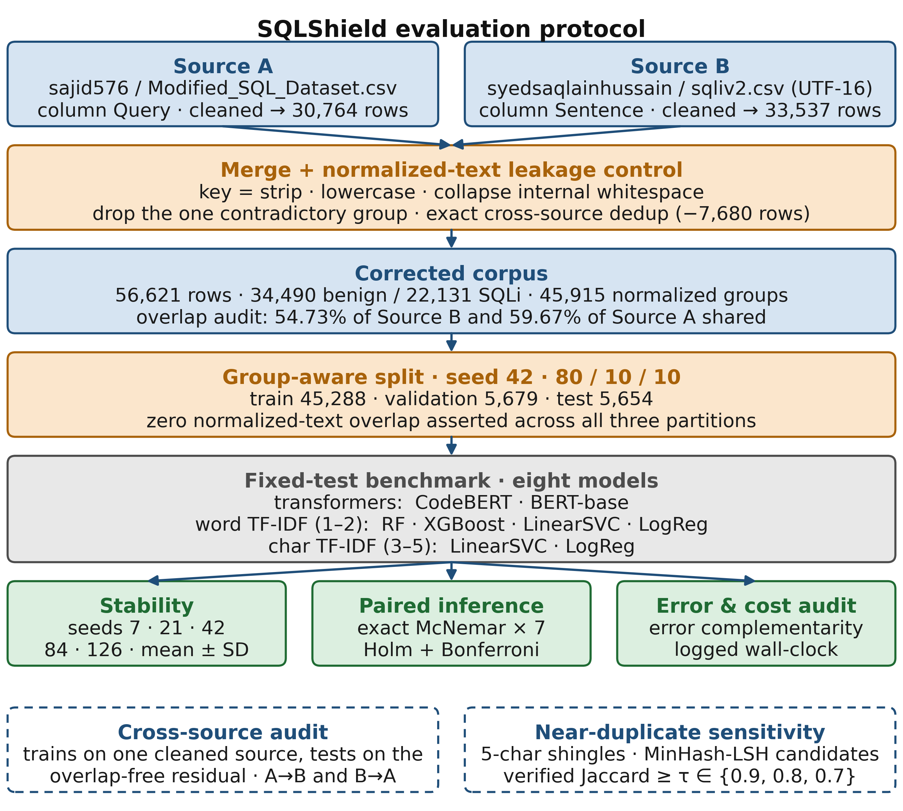
Figure. 1 SQLShield evaluation protocol. The two Kaggle sources are parsed and cleaned independently before merging, so source-specific text columns cannot be collapsed. Amber stages are leakage controls; row counts are given at each stage. Solid arrows trace the fixed-test pipeline through the group-aware split to the eight-model benchmark and its three reported analyses. Dashed branches denote audits that construct their own partitions and are reported separately: the cross-source audit branches from the cleaned per-source corpora, and the near-duplicate sensitivity analysis re-splits the merged corpus (Section 3.5).

3.1 Dataset Collection and Preprocessing
Two public Kaggle sources were used: sajid576/sql-injection-dataset (Modified_SQL_Dataset.csv; column Query) and syedsaqlainhussain/sql-injection-dataset (sqliv2.csv; UTF-16; column Sentence). Sources are parsed separately before concatenation so source-specific text columns cannot be lost during schema harmonization. Per source, text is stripped, labels are coerced and restricted to {0,1}, missing rows are dropped, and strings of length ≤2 are discarded. Exact (text,label) duplicates are removed within source, preserving contradictory examples long enough to detect label conflicts.
A normalized_text key is then formed by stripping, lowercasing, and collapsing internal whitespace. Once the sources are concatenated, any normalized group carrying both labels is dropped in full; exactly one such group exists (#NAME?, two Source-A rows). Text duplicated exactly across the two sources is then removed. The corrected corpus contains 56,621 rows (34,490 benign; 22,131 SQLi) across 45,915 normalized groups. The cleaned sources also overlap substantially: 18,355 of 33,537 Source-B rows (54.73%) and 18,356 of 30,764 Source-A rows (59.67%) share normalized_text with the other source. This suggests shared provenance or reuse without establishing a direction of derivation, and means source labels imply more independent diversity than exists at the normalized-text level. These overlap percentages count rows that share a normalized_text group with the opposite source; they are not the number of rows removed during corpus construction, because a normalized group may contain several distinct textual variants of which only exact duplicates are deleted. The construction reconciles as follows: strict per-source cleaning leaves 30,766 Source-A and 33,537 Source-B rows; removing the two rows of the single label-conflicted normalized group reduces Source A to 30,764, so the two sources contribute 64,301 rows to the merge, and a further 7,680 are removed by exact cross-source deduplication, yielding the 56,621-row corrected corpus spanning 45,915 normalized groups. Splitting is performed at the normalized-group level: groups are stratified by group label into 80% train and 20% temporary, the latter split equally into validation and test using seed 42, yielding 45,288 training, 5,679 validation, and 5,654 test rows. Assertions verify zero normalized_text overlap across all three partition pairs. Table 2 summarises the corrected corpus and the resulting group-aware partition.
Table 2. Corrected dataset statistics and group-aware split
Split / quantity | Samples | Percentage
Total corrected corpus | 56,621 | 100%
Benign (Class 0) | 34,490 | 60.91%
SQLi (Class 1) | 22,131 | 39.09%
Unique normalized groups | 45,915 | —
Training set | 45,288 | 79.98%
Validation set | 5,679 | 10.03%
Test set (held-out) | 5,654 | 9.99%

3.2 Model Architectures
CodeBERT [8] is a bimodal pre-trained model (125M parameters) on the RoBERTa-base architecture [27], pre-trained on 2,137,293 paired natural-language/code examples and 6,452,446 unimodal code examples across six languages using masked language modelling and replaced token detection. For binary classification we append a linear head:
f(x) = softmax(W · h_{[CLS]} + b) (1)
where h_{[CLS]} ∈ R⁷⁶⁸ is the pooled [CLS] token representation from the final transformer layer.
BERT-base [28] (110M parameters), pre-trained on BooksCorpus and English Wikipedia, is included as a general-purpose transformer baseline. Both are base-sized 12-layer encoders but differ in pre-training corpus, tokenizer, objective, BERT/RoBERTa design choices, and parameter count, so the comparison is informative about model choice rather than an isolated causal test of code-domain pre-training.
The word-level classical baselines use scikit-learn's TfidfVectorizer (ngram_range=(1,2), max_features=10,000; default word analyzer) with Random Forest (n_estimators=200), XGBoost (n_estimators=200, eval_metric='logloss'), Logistic Regression (max_iter=1000), and LinearSVC (max_iter=2000), all with random_state=42. To test whether the word representation understates classical performance on punctuation-rich SQLi strings, we add two character-level baselines using TfidfVectorizer(analyzer='char', ngram_range=(3,5), max_features=50,000, lowercase=True) with the same LinearSVC and Logistic Regression settings, since character n-grams preserve local subword and punctuation patterns that the default word analyzer discards. No transformer hyperparameter tuning is performed for the headline comparison; both transformers use the pre-specified configuration in Table 3, and all eight models use the identical fixed split.

3.3 Training Hyperparameters and Multi-Seed Protocol
Table 3 lists the transformer training configuration, the optimizer and learning-rate schedule, the split and training seeds, and the hardware on which every run was executed.
Table 3. Transformer training and reproducibility configuration
Parameter | Value
Base models | microsoft/codebert-base · bert-base-uncased
Max sequence length | 128 tokens
Batch size | 32
Epochs | 4
Optimizer | AdamW [29] · weight_decay=0.01
Learning rate schedule | 2e-5 peak · linear warmup (10%) · linear decay
Gradient clipping | max_norm = 1.0
Seeds | Split seed=42; training seeds={7,21,42,84,126}
Hardware | NVIDIA Tesla T4; one GPU used per training run. Host: Intel Xeon at 2.00 GHz, 2 physical cores and 4 logical threads, 31 GB RAM. All classical fitting, prediction and timing runs on this CPU. Verification session: Python 3.12.13, PyTorch 2.10.0 with CUDA 12.8, scikit-learn 1.6.1

3.4 Statistical Significance Testing
Fixed-test accuracy is a binomial proportion, so we additionally report two-sided 95% Wilson score confidence intervals for accuracy. Wilson intervals are preferred here to a symmetric normal approximation because the observed accuracies are very close to one and the number of errors is small. We do not attach Wilson intervals to F1, ROC-AUC, or PR-AUC because those statistics are not single binomial proportions; interval estimation for those metrics would require a separate bootstrap or analytic procedure.
To assess paired error-rate differences on the identical held-out test samples, we apply the two-sided exact McNemar test [30]. The test uses only discordant predictions and exact binomial inference, avoiding the large-sample chi-square approximation when discordant counts are small. The primary family contains seven CodeBERT comparisons: BERT-base, Random Forest, XGBoost, word-level LinearSVC, word-level Logistic Regression, character-level LinearSVC, and character-level Logistic Regression. We report raw exact p-values and control family-wise error using both Holm adjustment and Bonferroni correction (raw α=0.05/7=0.007143).
For each comparison, one discordant count records samples CodeBERT misclassifies while the comparator is correct, and the other records the reverse. Under H0, conditional on the total number of discordant pairs, either direction is equally likely. Statistical testing is performed on the fixed seed-42 transformer predictions and the deterministic classical predictions; the five-seed analysis separately quantifies training variability on the same data split.
All pairwise tests use the same 5,654-query held-out test set. McNemar therefore evaluates disagreement in paired predictions on that specific split; it does not replace the multi-seed stability analysis and should not be interpreted as a test over independently resampled datasets.

3.5 Near-Duplicate Family Sensitivity Protocol
The primary benchmark prevents leakage only at exact normalized_text equality, where normalization consists of trimming, lowercasing, and internal-whitespace collapse. To test whether performance is sustained when syntactically similar payload variants are grouped more aggressively, we conduct a separate sensitivity analysis over the complete corrected corpus at Jaccard thresholds τ∈{0.9,0.8,0.7}. Each unique normalized string is represented by its set of 5-character shingles. MinHash with 256 permutations and MinHash-LSH are used only to generate candidate pairs, with the LSH threshold set 0.05 below the target τ. Every candidate pair is then verified using exact shingle-set Jaccard similarity, and an undirected edge is retained only when exact Jaccard≥τ. Connected components of the verified graph define fuzzy near-duplicate families. All rows belonging to one family remain in a single partition.
For each τ, row-level StratifiedGroupKFold with 10 folds, shuffle=True, and split seed 42 is used to preserve class balance while keeping every fuzzy family intact. One validation fold and one test fold are selected solely by minimum deviation from 80/10/10 row and class-count targets; the remaining eight folds form training. No model outcomes are used in fold-pair selection. CodeBERT is then fine-tuned from microsoft/codebert-base with the same seed-42 hyperparameters as the primary experiment. The τ=1.0 point denotes the existing exact-normalized-group baseline and is not retrained. Because MinHash-LSH is an approximate candidate generator and 5-character Jaccard captures syntactic rather than semantic similarity, this experiment is interpreted as a near-duplicate sensitivity analysis rather than a mathematical guarantee that every semantically equivalent SQLi family has been identified. The recall of that candidate stage has been measured directly. On a random sample of 5,000 unique normalized texts, every one of the 12.5 million pairs was scored by exhaustive Jaccard computation and compared against the pairs the LSH stage proposes under the same parameters: candidate recall is 0.924 at tau=0.9, 0.949 at tau=0.8 and 0.935 at tau=0.7, missing 12, 42 and 132 qualifying pairs respectively. The measurement uses the settings that produced Table 8 — 256 permutations, MinHash seed 12345 and a candidate threshold of max(0.10, tau−0.05) — so it characterises that candidate generator and not a similar one. Recall is lowest at the strictest threshold, where the narrower candidate band admits fewer pairs. The fuzzy families of Section 4.7 therefore under-merge by five to eight per cent depending on threshold, so the near-duplicate effect reported there is a lower bound rather than a point estimate. This measurement holds for the sampled subset and need not transfer unchanged to the full 45,915-group corpus. Separating grouping effects from partition effects would require repeated fuzzy-family splits, which Section 8 identifies as an extension.

3.6 Cross-Source Evaluation Protocol
For cross-source evaluation, all external rows whose normalized_text appears anywhere in the cleaned training source are removed before fitting. Source-specific training data are split group-wise 90/10 into train and validation using seed 42, while the overlap-free residual source serves only as external test. All eight models are evaluated under this protocol in both directions; the classical models are fitted on the training partition alone, so that no model is given more data than the transformers, and both transformers are trained at seed 42. Threshold transfer selects thresholds exclusively on source-domain validation before applying them unchanged externally. A benign-only character n-gram Logistic Regression tests whether source identity is recoverable from text alone.
- Experimental Results

4.1 Training Convergence
Fig. 2 shows the seed-42 training trajectories. CodeBERT validation F1 peaks at 0.999551 after epoch 1 and BERT-base at 0.999776 after epoch 3; the differing peak epochs illustrate why checkpoints are selected on validation F1 rather than the final epoch. Training loss decreases monotonically for both, while validation F1 shows small late-epoch fluctuations.
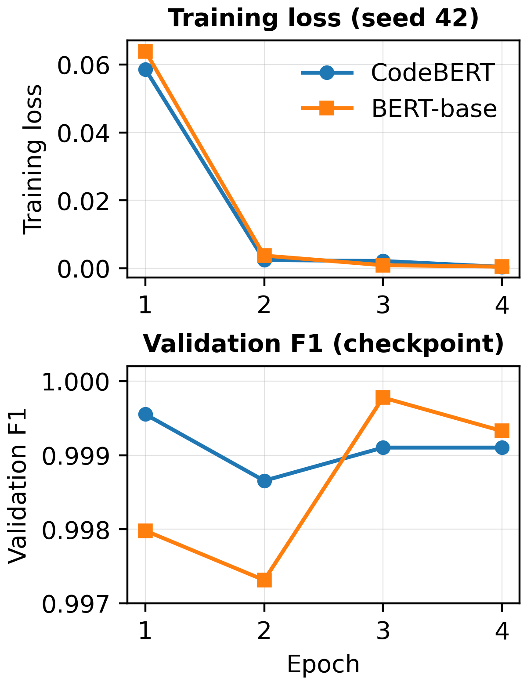

Figure. 2 Seed-42 training convergence. Left: training loss across four epochs. Right: validation F1 used for best-checkpoint selection; CodeBERT peaks at epoch 1 and BERT-base at epoch 3.

4.2 Confusion Matrix Analysis
Fig. 3 presents the CodeBERT seed-42 confusion matrix on the 5,654-query test set. Of 3,450 benign queries, 3,449 are correct and one is a false positive (FPR=0.029%); of 2,204 SQLi queries, 2,202 are detected and two are false negatives (FNR=0.091%). Accuracy is 99.95% (95% Wilson CI: 99.84%-99.98%), precision=0.9995, recall=0.9991, F1=0.9993, ROC-AUC=0.99997, PR-AUC=0.99996. The interval is reported alongside the point estimate to avoid implying six-decimal precision from three observed errors.
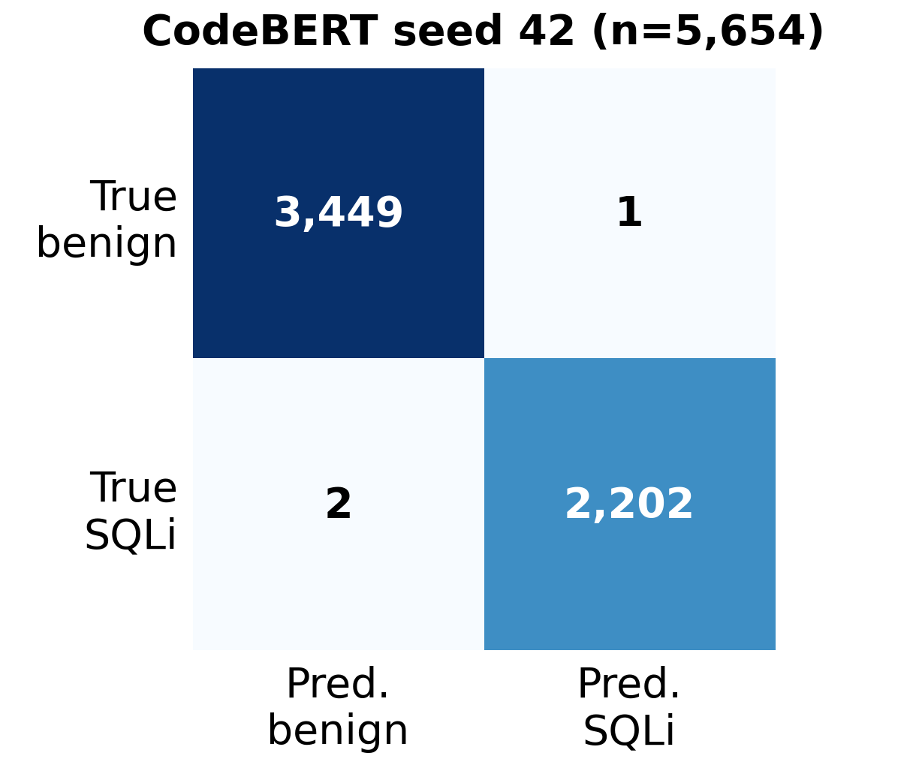
Figure. 3 CodeBERT seed-42 confusion matrix on the corrected fixed test set (n=5,654): TN=3,449, FP=1, FN=2, TP=2,202.

4.3 Fixed-Test Performance Across All Models
Fig. 4 and Table 4 place all eight models on the same test set. Error counts run from three for CodeBERT and six for BERT-base up to 52 for word Logistic Regression, with character LinearSVC on nine, Random Forest 16, character Logistic Regression 20, XGBoost 21, and word LinearSVC 25. CodeBERT takes the highest F1 (0.9993) and ROC-AUC (0.99997). The strongest classical model behind it is character 3-5-gram LinearSVC, at 99.84% accuracy (95% Wilson CI: 99.70%-99.92%), F1=0.9980, ROC-AUC=0.99959, PR-AUC=0.99952. Most telling is what happens when only the representation changes: keeping LinearSVC and swapping word for character TF-IDF cuts errors from 25 to nine (64%) and lifts F1 from 0.9943 to 0.9980, enough to reorder the classical ranking. Because a single pre-specified configuration could understate what the classical family is capable of, the character and word baselines were also tuned by a grid search over n-gram range, vocabulary size, regularisation strength and class weighting, with every candidate selected on the validation partition alone and the winner of each family scored on the fixed test set exactly once. Tuning moves the strongest classical model from nine errors to eight, at a 2-5 character range, a 20,000-feature vocabulary, C=2 and balanced class weights, which leaves it five errors behind CodeBERT rather than six. The weaker families gain more: word Logistic Regression falls from 52 errors to 24 and character Logistic Regression from 20 to 11. Selection on validation does not guarantee an improvement on test, and word LinearSVC is a case in point, moving from 25 errors to 30. The paired significance comparison in Section 4.5 is reported for the pre-specified configuration; the tuned predictions are released so that the McNemar family can be recomputed against them.
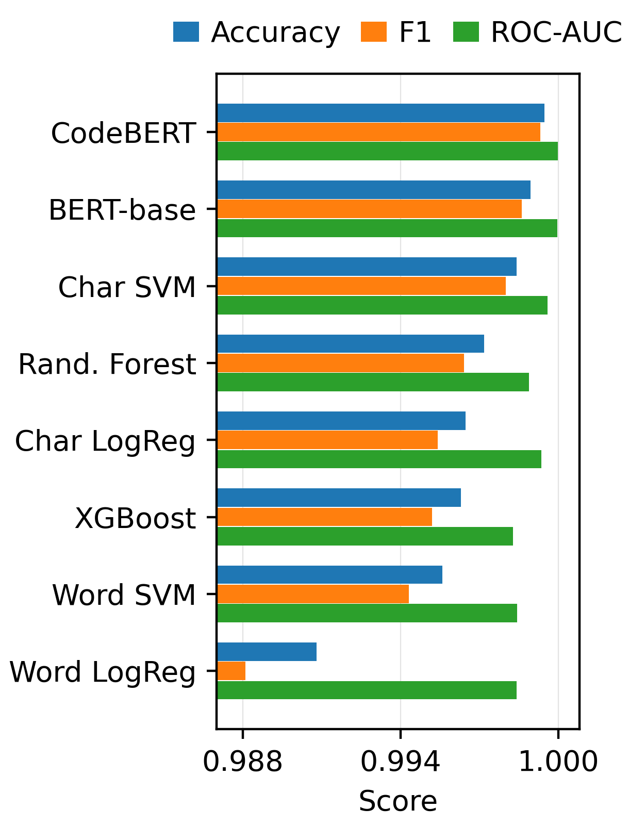
Figure. 4 Corrected fixed-test comparison across all eight models (accuracy, F1, and ROC-AUC). Transformer values use seed 42; character baselines use 3–5-gram TF-IDF with 50,000 features on the same fixed split.

4.4 Comprehensive Model Comparison and Multi-Seed Stability
Over five training seeds [7, 21, 42, 84, 126] on the same split, CodeBERT averages 0.999399+/-0.000097 accuracy and 0.999229+/-0.000124 F1, against 0.998762+/-0.000354 and 0.998411+/-0.000454 for BERT-base; it also holds the higher F1 in every one of the five runs, at 3.4+/-0.55 errors against 7.0+/-2.0 (Fig. 5). We read this as stability rather than superiority: five seeds is a small sample, and the paired McNemar comparison is non-significant. The character baselines are deterministic and play no part in this protocol.
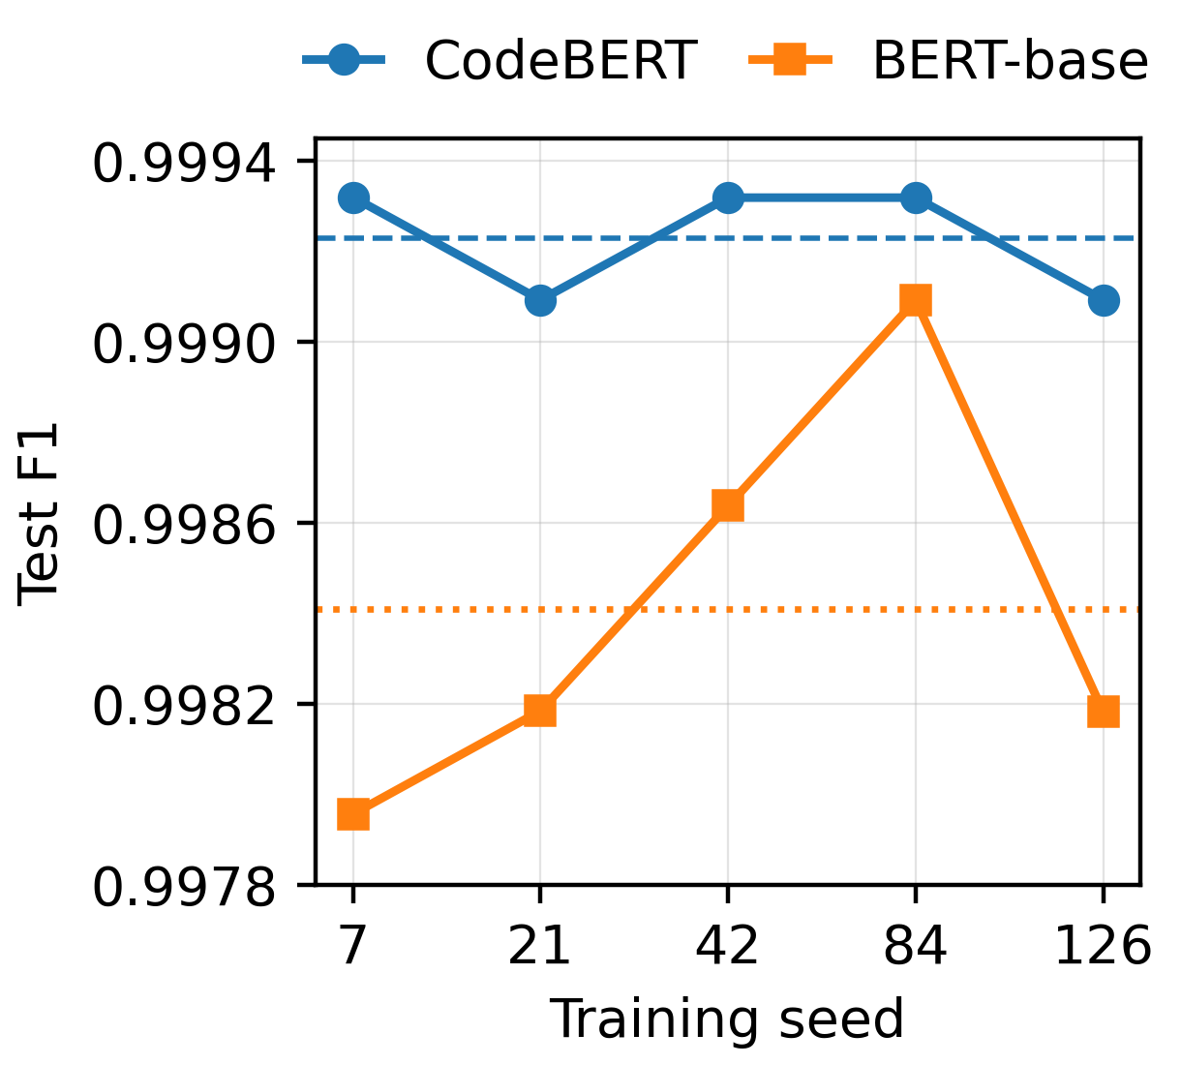
Figure. 5 Test F1 across five training seeds on the same corrected group-aware split. CodeBERT is numerically higher in all five runs and exhibits lower run-to-run variability
Seed variation of this kind measures optimizer and initialization behaviour on one fixed partition, not the uncertainty introduced by the partition itself. To separate the two, the corrected corpus was repartitioned twenty times under the identical grouping rule and 80/10/10 proportions, changing only the partition seed, and every classical model was refitted and rescored on each. The partitions move the results considerably more than the seeds do. Character LinearSVC averages 10.65 errors with a standard deviation of 2.94 and a range of 4 to 16; Random Forest averages 18.90 with a range of 10 to 29; XGBoost averages 22.70 with a range of 11 to 34; and word Logistic Regression averages 58.55 with a range of 39 to 80. Two consequences follow. First, the nine errors that character LinearSVC records on the fixed split sit close to its own mean across partitions, so that split is not unrepresentative. Second, and more importantly, the ordering of the leading models is not stable under repartitioning. Both transformers were rerun on three of these partitions, giving the error counts in the final column of Table 4. The six-error gap between CodeBERT and the strongest classical model on the published split is not a fixed quantity: it is six errors at seed 42, zero at seed 101, where both record four, and four at seed 202. BERT-base and the character baseline exchange places outright, the baseline taking four errors against five at seed 101 and losing seven to three at seed 202, so a transformer-versus-classical ordering that the published split appears to establish is reversed by changing nothing but the partition seed. Ordering is stable only at the extremes, word Logistic Regression ranking last on every partition. The non-significant McNemar result of Section 4.5 is therefore corroborated by an independent route: the observed difference lies inside the variation that repartitioning alone produces. CodeBERT is the steadiest model over the three partitions, at three to four errors, but three partitions are too few to claim lower partition sensitivity as a property of the architecture. Across those three partitions the distributions are F1=0.999243±0.000133 and balanced accuracy 0.999380±0.000116 for CodeBERT, 0.998940±0.000348 and 0.999133±0.000287 for BERT-base, and 0.998486±0.000570 and 0.998597±0.000532 for character LinearSVC, the classical baseline varying about four times as widely as CodeBERT on both measures. The paired difference in error count against CodeBERT, taken partition by partition, is the quantity that settles the comparison: BERT-base is 3, 1 and 0 errors behind at seeds 42, 101 and 202, and character LinearSVC is 6, 0 and 4 behind, so each competitor draws level with CodeBERT on one of the three partitions. The remaining models never draw level, Random Forest staying 11 to 13 errors behind and word Logistic Regression 46 to 57. What the fixed split supports is therefore a separation between the top three models and the rest, not an ordering within them. The three partitions differ slightly in test size (5,654, 5,643 and 5,661 rows), so these error counts are not measured on identical populations either.
Table 4. Complete eight-model comparison on corrected held-out test set (n=5,654)
Model | Accuracy (95% Wilson CI) | F1 | Precision | Recall | ROC-AUC | Errors | Errors on 3 partitions
CodeBERT (seed 42) | 99.95% (99.84–99.98) | 0.9993 | 0.9995 | 0.9991 | 0.99997 | 3 | 3 / 4 / 3
BERT-base (seed 42) | 99.89% (99.77–99.95) | 0.9986 | 0.9991 | 0.9982 | 0.99996 | 6 | 6 / 5 / 3
Char LinearSVC | 99.84% (99.70–99.92) | 0.9980 | 0.9991 | 0.9968 | 0.99959 | 9 | 9 / 4 / 7
Random Forest | 99.72% (99.54–99.83) | 0.9964 | 0.9977 | 0.9950 | 0.99888 | 16 | 16 / 16 / 14
Char Logistic Reg. | 99.65% (99.45–99.77) | 0.9954 | 0.9986 | 0.9923 | 0.99935 | 20 | 20 / 23 / 21
XGBoost | 99.63% (99.43–99.76) | 0.9952 | 0.9977 | 0.9927 | 0.99827 | 21 | 21 / 17 / 20
Word LinearSVC | 99.56% (99.35–99.70) | 0.9943 | 0.9955 | 0.9932 | 0.99842 | 25 | 25 / 42 / 31
Word Logistic Reg. | 99.08% (98.80–99.30) | 0.9881 | 0.9931 | 0.9832 | 0.99840 | 52 | 52 / 61 / 49

4.5 Statistical Significance - Exact McNemar Test
Table 5 and Fig. 6 report the seven exact McNemar comparisons. CodeBERT cannot be separated from BERT-base (7 discordant pairs; p=0.453125), nor from character LinearSVC (10 discordant pairs; p=0.109375; Holm p=0.218750; Bonferroni p=0.765625). Against Random Forest, XGBoost, word LinearSVC, word Logistic Regression, and character Logistic Regression the differences do survive both corrections. CodeBERT is therefore numerically the best model here, yet once a strong character-level baseline joins the comparison the data stop supporting any general separation between transformers and classical methods. All eight aligned 5,654-row prediction files are released, and the verification script recomputes the confusion metrics and all seven comparisons from those predictions rather than from hard-coded summary constants.

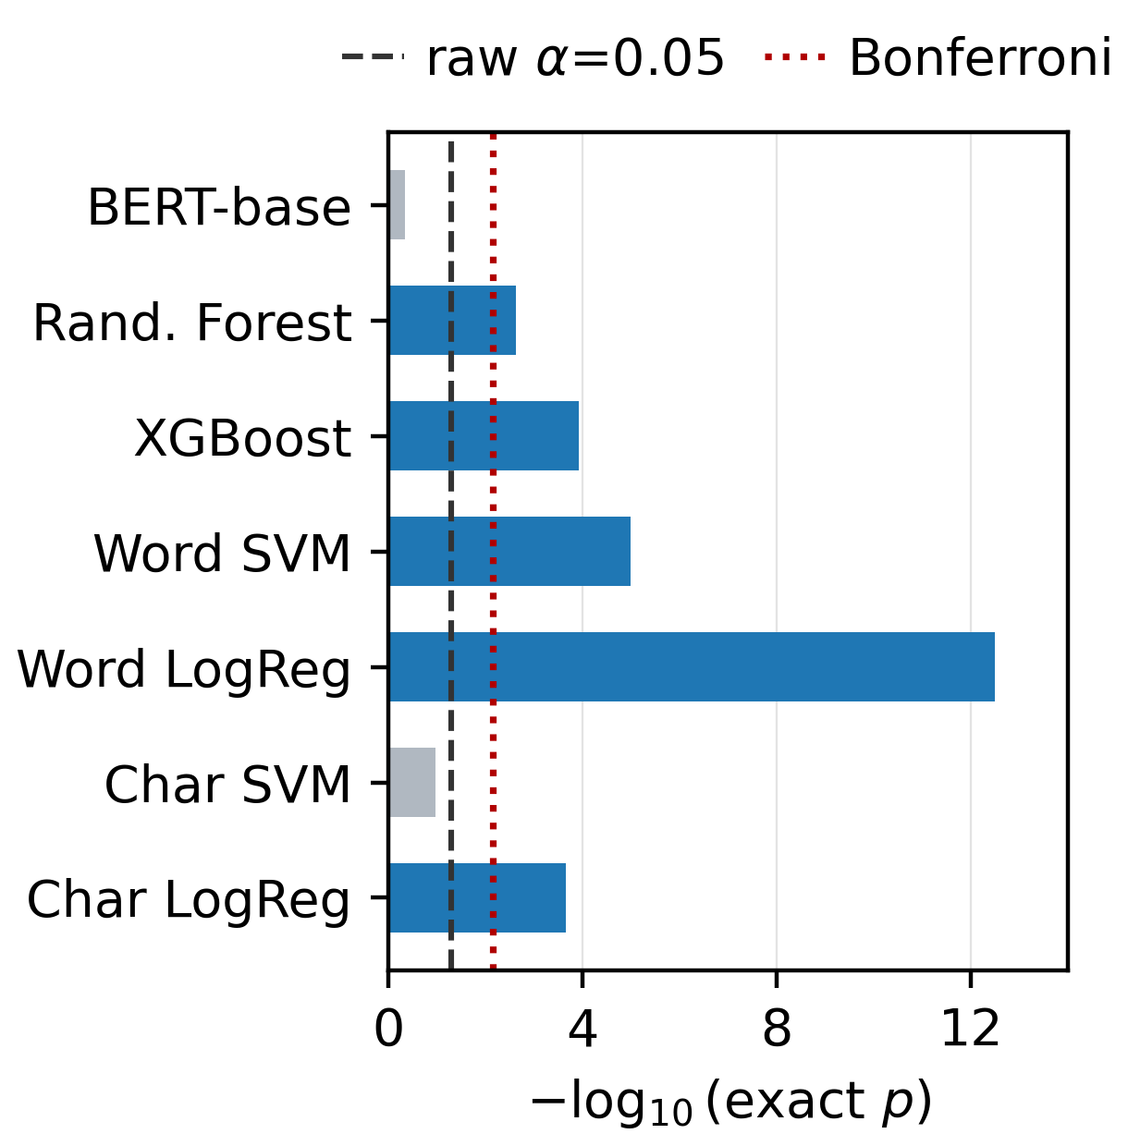
Figure. 6 Two-sided exact McNemar results shown as -log10(p). Dashed and dotted lines mark raw α=0.05 and Bonferroni family-wise raw α=0.05/7=0.007143. CodeBERT versus BERT-base and versus character LinearSVC are non-significant; the other five comparisons remain significant after both corrections.

Table 5. Final two-sided exact McNemar tests across seven primary comparisons
Comparison | CB wrong / other correct | CB correct / other wrong | Exact p | Holm p | Bonf. p | Decision
CodeBERT vs BERT-base | 2 | 5 | 0.453125 | 0.453125 | 1.000000 | Not significant
CodeBERT vs Random Forest | 2 | 15 | 0.002350 | 0.007050 | 0.016449 | Significant
CodeBERT vs XGBoost | 2 | 20 | 1.211e-4 | 6.056e-4 | 8.478e-4 | Significant
CodeBERT vs Word LinearSVC | 2 | 24 | 1.049e-5 | 6.294e-5 | 7.343e-5 | Significant
CodeBERT vs Word Logistic Reg. | 2 | 51 | 3.180e-13 | 2.226e-12 | 2.226e-12 | Significant
CodeBERT vs Char LinearSVC | 2 | 8 | 0.109375 | 0.218750 | 0.765625 | Not significant
CodeBERT vs Char Logistic Reg. | 2 | 19 | 2.213e-4 | 8.850e-4 | 0.001549 | Significant

4.6 Error Complementarity and Computational Trade-off
The three CodeBERT errors are not simply a subset of the nine made by character LinearSVC. The paired McNemar counts put CodeBERT wrong and character LinearSVC right on two instances, and the reverse on eight; with totals of three and nine, that leaves exactly one instance missed by both. The error union therefore contains 11 distinct instances, giving an error-set Jaccard overlap of only 1/11 (9.1%) and indicating substantial failure-mode complementarity despite the small aggregate F1 difference.
Table 6 sets out all three CodeBERT errors from the released per-sample predictions. Two properties matter. The residual failures are extremely short, low-context strings rather than a recurring SQLi template; and the shared error, the arithmetic-like ‘5739-5738’, shows that benchmark labels can attach malicious intent to strings carrying little explicit SQL syntax, so its interpretation is dataset-dependent. Character LinearSVC fails differently again, with two false positives and seven false negatives.
Table 6. The three CodeBERT seed-42 fixed-test errors and character-LinearSVC comparison
Test text | Source | True | CodeBERT output | Char LinearSVC | Relation
5739-5738 | A | SQLi | Benign (p=0.00014) | Benign | Shared FN
sort | A | Benign | SQLi (p=0.68686) | Benign | CodeBERT-only FP
hi or a = a | B | SQLi | Benign (p=0.05485) | SQLi | CodeBERT-only FN
Note: p denotes the CodeBERT softmax probability assigned to the SQLi class. Character LinearSVC outputs are shown as class decisions because its decision score is not a calibrated probability.
Table 7 places that difference beside measured serving cost. Given the non-significant paired difference, character LinearSVC answers a query in 0.92 ms on the CPU path against 9.25 ms for CodeBERT on a T4, which makes it a strong resource-efficient baseline; CodeBERT remains the accuracy-first option where reducing the residual error count justifies an accelerator and a 475 MB model.
Table 7. Controlled inference cost on the corrected fixed test set
Model | Batch-1 latency, median / p95 (ms) | Throughput (queries/s) | Parameters or features | Model size / peak GPU memory
CodeBERT | 9.250 / 10.144 | 176 | 124.6 M parameters | 475.5 MB / 618.4 MB
BERT-base | 9.523 / 9.834 | 144 | 109.5 M parameters | 417.7 MB / 560.1 MB
Char LinearSVC | 0.923 / 1.290 | 5,113 | 50,000 features | —
Char Logistic Reg. | 0.952 / 1.401 | 5,104 | 50,000 features | —
Random Forest | 56.499 / 59.367 | 504 | 10,000 features | —
XGBoost | 1.360 / 1.538 | 12,433 | 10,000 features | —
Word LinearSVC | 0.770 / 1.138 | 19,475 | 10,000 features | —
Word Logistic Reg. | 0.806 / 1.121 | 18,978 | 10,000 features | —
Note: measured in one pass over 1,000 fixed-test queries with three repetitions, batch-1 latency taken per query and throughput at batch 32. Transformers run on one NVIDIA Tesla T4 at a fixed sequence length of 128 tokens; the classical pipelines run on the host CPU, an Intel Xeon at 2.00 GHz, 2 physical cores and 4 logical threads, 31 GB RAM, where vectorization and prediction are timed together. Both families were measured in the same session on the same machine. Padding every input to the full 128 tokens makes the transformer latencies an upper bound on what dynamic padding would cost in deployment. The transformers were measured with pretrained encoders and a freshly initialised classification head, since inference cost is determined by architecture and input length rather than by the values of the fitted weights. Random Forest is the outlier on both measures, at 56.5 ms per query and 504 queries per second: its 200 trees are traversed sequentially, and a batch of 32 is too small to amortise that traversal the way a larger one would.

4.7 Near-Duplicate Sensitivity Analysis
Table 8 reports seed-42 CodeBERT results under progressively stronger fuzzy-family isolation. Distinct families fall from 45,915 exact normalized groups at tau=1.0 to 43,675, 40,705, and 38,526 at tau=0.9, 0.8, and 0.7. No fuzzy family contains both labels at any threshold. Despite this consolidation, F1 remains 0.9989, 0.9981, and 0.9988 against 0.9993 at the exact-group baseline, with 5, 9, and 5 errors versus 3. Because the four rows are scored on test sets of different size (5,654, 5,652, 5,754, and 5,525 rows), these raw error counts are not measured on the same population and must not be compared directly; the corresponding error rates are 0.053%, 0.088%, 0.156%, and 0.090%.
The pattern is not monotonic because each threshold induces a different group structure and therefore a different group-disjoint test partition; the thresholds are not paired evaluations on identical instances. Changes in raw error counts and in F1 across these rows therefore combine two effects that this design cannot separate — the strength of the grouping threshold and the composition of the resulting test partition — and should not be read as a sequential robustness curve measured on a fixed population. A further confound is that tau=1.0 uses the original stratified normalized-group split whereas tau<1.0 uses row-level StratifiedGroupKFold, so differences from the tau=1.0 row combine stronger family grouping with a change of split procedure. These results are therefore a robustness stress test, not an isolated causal effect of the threshold. Across the three fuzzy settings, ROC-AUC remains at least 0.99994, PR-AUC at least 0.99991, balanced accuracy at least 0.9981, and MCC at least 0.9968.
Table 8. CodeBERT near-duplicate sensitivity across 5-character-shingle Jaccard thresholds (seed 42)
τ | Fuzzy clusters | Test n | F1 | ROC-AUC | PR-AUC | Bal. Acc. | Errors
1.0 | 45,915 | 5,654 | 0.9993 | 0.99997 | 0.99996 | 0.9994 | 3
0.9 | 43,675 | 5,652 | 0.9989 | 0.99997 | 0.99995 | 0.9989 | 5
0.8 | 40,705 | 5,754 | 0.9981 | 0.99997 | 0.99996 | 0.9981 | 9
0.7 | 38,526 | 5,525 | 0.9988 | 0.99994 | 0.99991 | 0.9988 | 5
Note: tau=1.0 is the exact normalized_text split under the original stratified group-split procedure, whereas tau<1.0 uses StratifiedGroupKFold, so the baseline-to-fuzzy comparison is confounded by both grouping strength and split construction. Fuzzy families are connected components of exact-Jaccard-verified 5-character-shingle edges from MinHash-LSH candidates. The identical maxima at tau=0.8 and 0.7 (400 exact groups; 700 rows) are observed outputs, not implementation caps, though the summary audit alone cannot confirm the same component attains both. Only CodeBERT seed 42 is retrained per threshold. The four rows are also scored on test sets of different size, so the error counts in the final column are not measured on a common population and are not directly comparable across rows; the corresponding error rates are 0.053% (τ=1.0), 0.088% (τ=0.9), 0.156% (τ=0.8), and 0.090% (τ=0.7). Candidate generation by MinHash-LSH is approximate, with measured recall of 0.924, 0.949 and 0.935 at tau=0.9, 0.8 and 0.7 on a 5,000-text sample scored exhaustively under the same parameters (Section 3.5), so the fuzzy families are a lower bound on the near-duplicate structure present in the corpus.
- Cross-Source Generalization and Source-Shift Diagnostics
Mixed-source group-aware testing measures generalization to unseen normalized groups when both domains appear in training. To probe stricter portability, we evaluate leave-one-source-out residual transfer after removing every normalized-text overlap between training and external source. Because 54.73% of Source B and 59.67% of Source A overlap the opposite source, the external sets are residual, overlap-free subsets rather than complete source distributions, and by construction emphasize source-specific differences.

5.1 Bidirectional Cross-Source Generalization
In A→B, 18,355 overlapping Source-B rows are removed, leaving 15,182 external queries (15,004 benign; 178 SQLi; SQLi prevalence 1.17%). CodeBERT retains ROC-AUC=0.990252, PR-AUC=0.839063, recall=0.971910, and balanced accuracy=0.960329, but precision falls to 0.183652 because 769 benign queries are flagged as SQLi. In B→A, removing 18,356 overlaps leaves 12,408 external queries (12,313 benign; 95 SQLi; prevalence 0.766%), and performance collapses at the transferred operating point: accuracy=0.015474, precision=0.007717, recall=1.0, F1=0.015315, balanced accuracy=0.503939, and MCC=0.007797, with 12,216 false positives and no false negatives. The failure is located at the decision threshold rather than in the ranking: the same run retains ROC-AUC=0.703293 (Table 9), so B→A discrimination is degraded and near-chance once thresholded, not absent. References to a B→A “collapse” throughout this paper denote operating-point failure, not the loss of all discriminative signal.
The asymmetry is not an artefact of the default 0.5 decision threshold. A threshold of 0.921525, selected solely on Source-B validation data to maximize both validation F1 and balanced accuracy, produces identical B→A confusion counts. External Source-A benign scores are strongly shifted toward the SQLi class, indicating source-induced representation and calibration failure, a shift that is not repaired by the validation-selected threshold used here. Because this experiment evaluates the overlap-free residual of Source A, the failure should be interpreted as a portability problem on the non-shared portion of the domain rather than as an estimate of performance on the complete Source-A distribution. Fig. 7 contrasts the two transfer directions across the reported metrics. Two results follow from running the protocol of Section 3.6 over all eight models. First, every model fails in the B→A direction, at balanced accuracy between 0.501 and 0.559 for the classical family, 0.504 for CodeBERT and 0.531 for BERT-base, which places the published collapse inside the range the corpora produce rather than singling out a detector. Second, the A→B direction, where transfer succeeds, separates the models by an order of magnitude in false positives on the same 15,182-row residual: character LinearSVC raises 5, BERT-base 128 and CodeBERT 769, giving F1 of 0.9391, 0.7303 and 0.3089. The collapse in precision is therefore not a property of transformers as a class, since BERT-base is closer to the classical baseline than to CodeBERT on the same data. These same three runs also make the paper’s central point about evaluation validity in the sharpest form available anywhere in this study. Ranked by F1 the order is character LinearSVC (0.9391), BERT-base (0.7303) and CodeBERT (0.3089); ranked by balanced accuracy on the identical predictions it changes to BERT-base (0.9901), CodeBERT (0.9603) and character LinearSVC (0.9549), moving the classical baseline from first place to last. Nothing about the data or the models changes between those two orderings, only the summary statistic: balanced accuracy averages the two class-wise rates and so barely registers 769 false positives among 15,004 benign rows, while F1 is dominated by the resulting precision of 0.1837. A benchmark that reports one of these numbers and not the other can therefore be made to support either conclusion. It is also worth recording that all four transformer runs reached validation F1 between 0.9978 and 1.0000 on their own source before being tested on the other, so the failures reported here are failures of transfer and not of fitting.

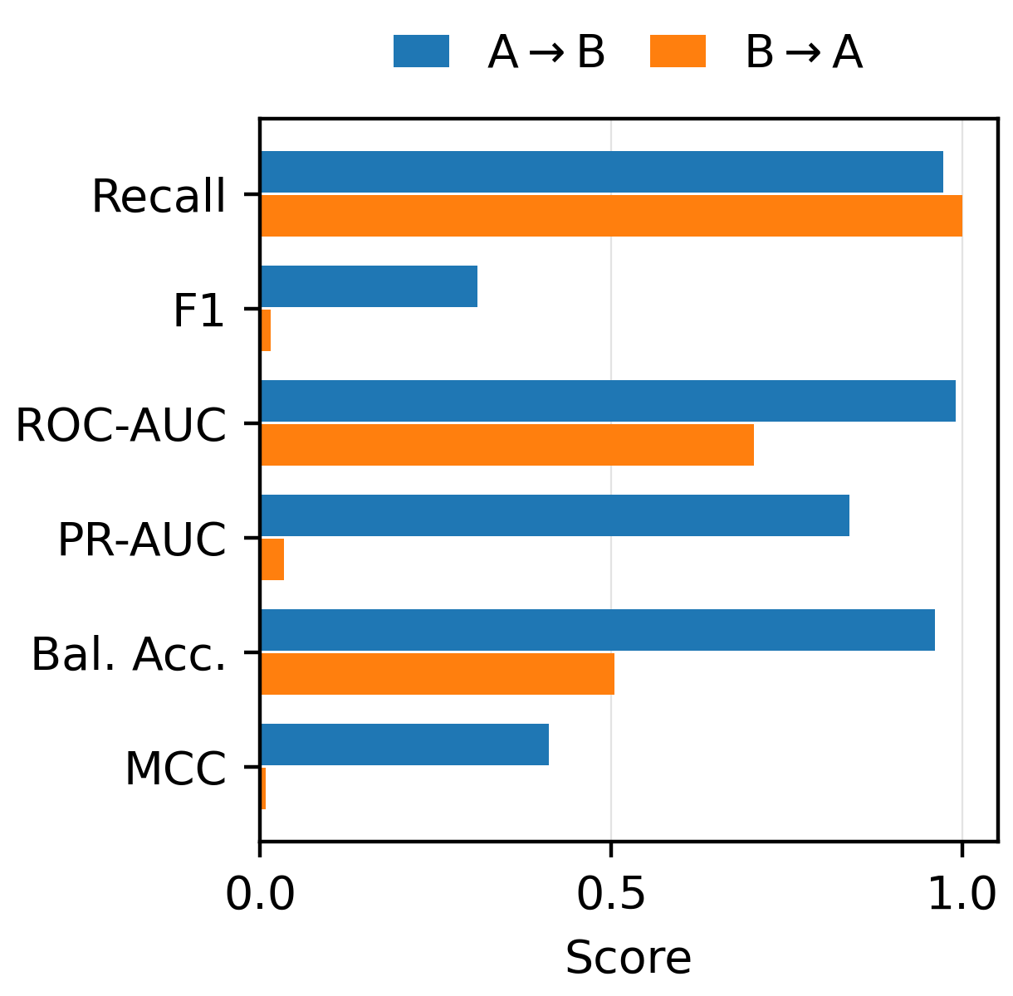
Figure. 7 Bidirectional overlap-free cross-source performance. A→B retains strong ranking and balanced discrimination, whereas B→A collapses because almost all Source-A benign queries are classified as SQLi.

5.2 Benign-Class Composition and Source-Fingerprint Diagnostic
The benign-only diagnostic reveals a large class-conditional shift in the negative class, which suggests that benign examples are constructed differently in the two sources. Among overlap-free benign queries, 87.61% of Source-A queries begin with SELECT against 0% of Source B; 83.59% contain FROM against 0.047%; and 35.61% contain WHERE against 0.013%. Source-A benign strings are also longer (55.38 vs. 28.24 characters; 9.72 vs. 3.88 words) and contain far more quotes and parentheses. A character 3–5-gram Logistic Regression trained only to predict which source a benign query came from reaches 99.71% accuracy, 99.67% balanced accuracy, F1=0.99734, and ROC-AUC=0.998904. These observations establish a large difference in P(X | Y=benign), but they do not by themselves prove concept shift in P(Y | X). They do, however, offer a mechanistic explanation for the B→A failure: a model trained on Source B may associate SQL-like structure itself with the positive class, so legitimate SQL-style benign queries from Source A are systematically flagged as attacks. Negative-class composition must therefore be treated as an explicit dataset-design variable rather than a nuisance source effect. Fig. 8 shows the structural features whose prevalence differs most sharply between the two benign populations.

- Source-Conditioned Reliability Within the Mixed-Source Test
The cross-source collapse does not mean the headline result is driven by one source. Disaggregating the fixed 5,654-query test set by source, CodeBERT remains near-perfect on both: Source A (3,118 rows) yields F1=0.999113 with two errors and Source B (2,536 rows) yields F1=0.999535 with one. BERT-base yields 0.997781 on A and 0.999536 on B; Random Forest yields 0.995113 and 0.997675. Mixed-source training thus supports excellent within-domain performance for both represented sources, while leave-one-source-out transfer exposes a separate portability limitation. Fig. 9 reports the source-conditioned F1 for the three models.

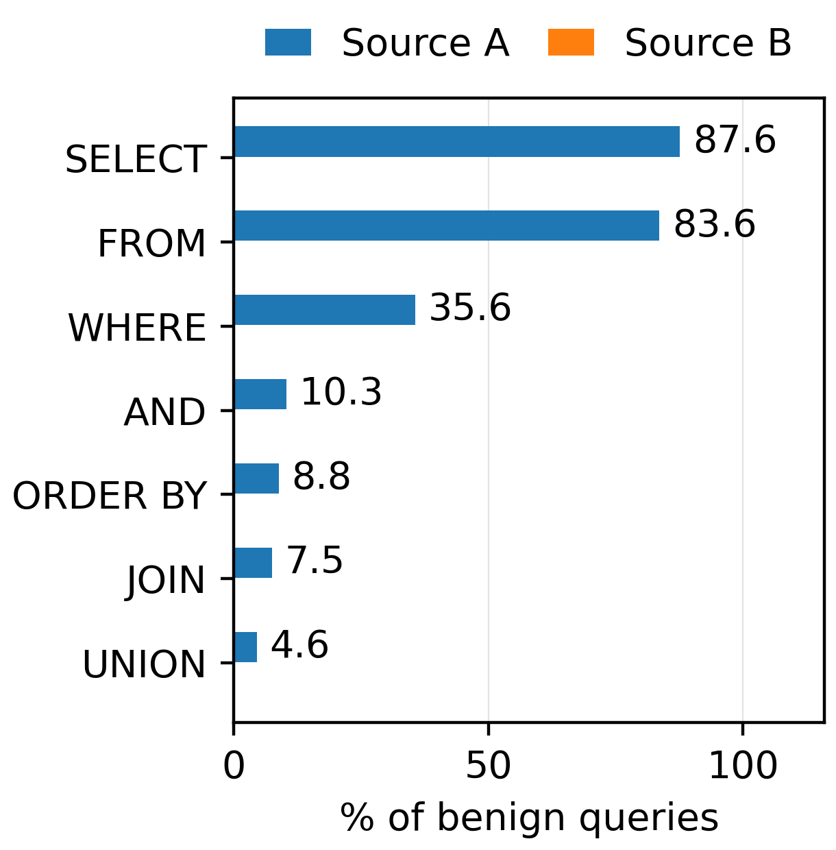
Figure. 8 Largest structural differences between overlap-free benign queries from Source A and Source B. Source A contains conventional SQL syntax at dramatically higher rates.

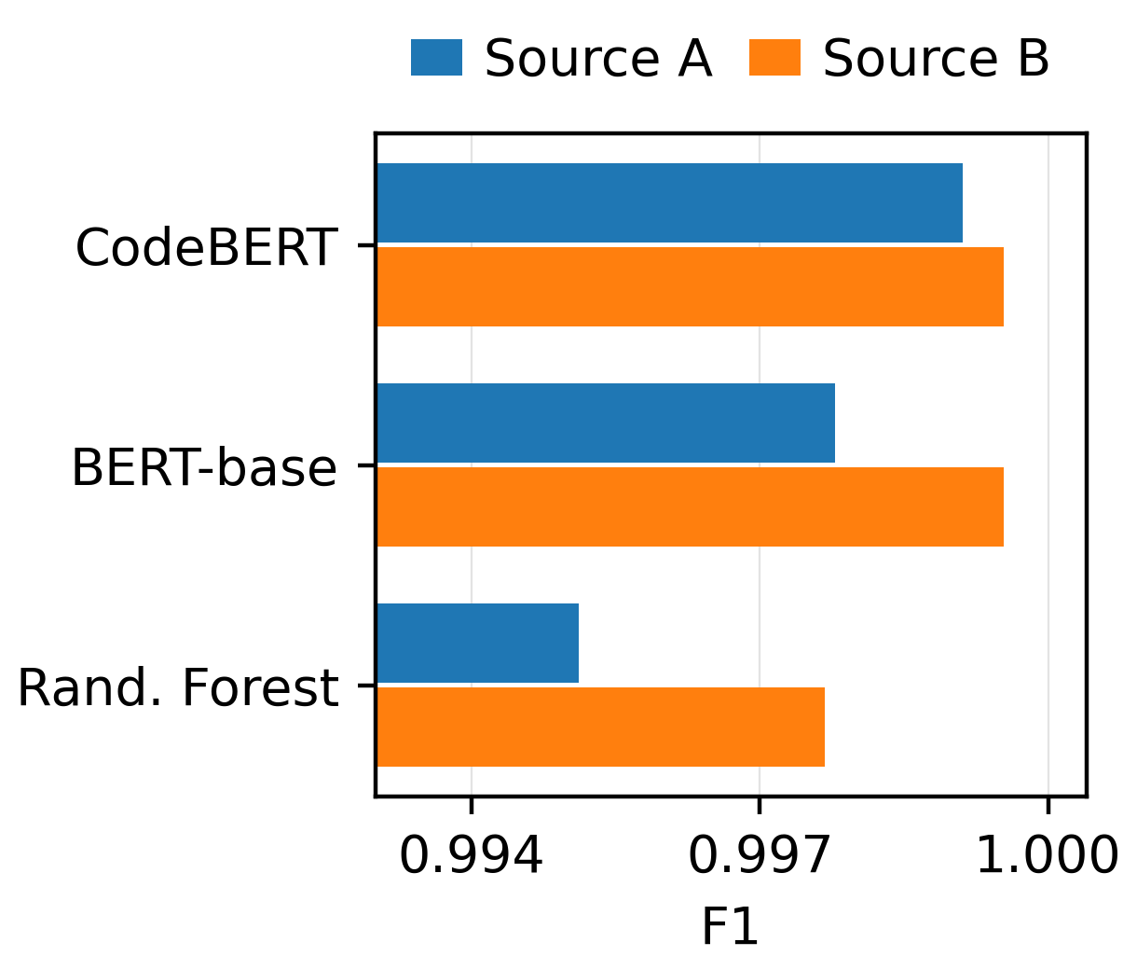
Figure. 9 Source-conditioned F1 within the corrected mixed-source fixed test. CodeBERT remains near-perfect on both represented source domains.

Table 9. Overlap-free cross-source model comparison (seed 42)
Direction | Residual external set | Precision / Recall / F1 | ROC-AUC / PR-AUC | Balanced Acc. / MCC
A → B | 15,182 (178 SQLi; 1.17%) | 0.183652 / 0.971910 / 0.308929 | 0.990252 / 0.839063 | 0.960329 / 0.410801
B → A | 12,408 (95 SQLi; 0.766%) | 0.007717 / 1.000000 / 0.015315 | 0.703293 / 0.034568 | 0.503939 / 0.007797
A → B | Char LinearSVC, same residual | 0.964286 / 0.910112 / 0.939130 | 0.996553 / 0.938049 | 0.954890 / 0.938920
B → A | Char LinearSVC, same residual | 0.008714 / 0.957895 / 0.017297 | 0.781690 / 0.055485 | 0.559228 / 0.028189
A → B | BERT-base, same residual | 0.578947 / 0.988764 / 0.730290 | 0.997234 / 0.980094 | 0.990116 / 0.753241
B → A | BERT-base, same residual | 0.008166 / 0.989474 / 0.016199 | 0.847645 / 0.454101 | 0.531121 / 0.020950

The combined evidence separates two questions. Group-aware mixed-source testing asks whether the model handles unseen normalized groups when both domains are in training; SQLShield performs extremely well here. Cross-source residual testing asks something different: can a model trained on one source handle the non-overlapping part of the other? The answer depends strongly on direction, and for B→A the validation-selected operating point tested here does not repair the transfer failure, although ranking discrimination remains above chance (ROC-AUC=0.703293). Because the residual sets exclude the 54.73–59.67% shared material, they throw non-shared characteristics into relief and are not complete source-to-source deployment estimates. Reporting both keeps the mixed-source score from being mistaken for source-independent generalization.
- Discussion

7.1 Comparison with Prior Work
The conclusion to draw from Section 4 is not that transformers always win, but that leakage resistance, error complementarity and deployment cost under source shift form a three-way trade-off. The character-level extension changes how the model comparison should be read. CodeBERT still makes the fewest errors, three, but character LinearSVC makes nine and exact McNemar testing cannot separate the two (p=0.109375). The reduction of 66.7% in raw errors is therefore not sufficient to claim statistical superiority, and the two models barely share a failure mode (Section 4.6). Within the same classifier family, character LinearSVC cuts errors by 64% relative to word LinearSVC and fits in 5.91 s against the 4,030.7 s, 4,032.6 s and 4,058.1 s logged for the three fuzzy-family CodeBERT retraining runs (mean 4,040.5 s). The primary fixed-split CodeBERT run was not timed separately, so these training times are reported as logged reference values rather than as a matched wall-clock comparison. Serving cost separates them further: Table 7 gives 0.92 ms per query against 9.25 ms and 5,113 queries per second against 176, with no accelerator and a 50,000-feature vectorizer in place of 124.6 M parameters and 618.4 MB of device memory. These measurements establish character LinearSVC as a resource-efficient baseline that any deployment-oriented transformer should have to justify itself against.
A direct numerical comparison against the accuracies reported by recent detectors is deliberately not attempted, and the results of this paper explain why it would mislead. Published SQL injection accuracies are produced on different corpora, under different cleaning and deduplication rules, and on partitions built by different procedures, so the quantity being compared is not held fixed. The magnitude of that problem can be read off the present experiments. Changing nothing but the partition seed moves the error count of a fixed character LinearSVC from four to sixteen across valid group-aware test partitions, while BERT-base and character LinearSVC exchange their ordering (Section 4.4). Enforcing normalized-group isolation removes 7,680 rows from the merged corpus before any model is fitted (Section 3.1), and consolidating near-duplicate families at Jaccard 0.7 reduces the number of distinct groups by 7,389, from 45,915 to 38,526 (Section 4.7). Each of these protocol choices moves reported accuracy by more than the differences that typically separate one published system from another, so a table of accuracies drawn from different papers ranks evaluation protocols rather than detectors.
Two consequences follow for how this paper positions itself. First, where a comparison can be made on equal terms it is made: Ammar and Alharbi [21] fine-tune CodeBERT with a linear classification head, so the CodeBERT row of Table 4 is that method re-evaluated under leakage control, and the gap between 99.95% and 99.90% is a difference of evaluation protocol rather than of detector design. Second, the comparison this paper does make is internal and paired: eight models on one corpus, one grouping rule, shared partitions, exact McNemar testing with multiplicity correction, and aligned per-sample predictions released for the primary fixed-test comparison. A fair head-to-head evaluation of UniEmbed, lightweight attention models, recent LSTM systems and structural-transformer hybrids would require re-implementing each on this corrected corpus and these partitions, which is identified as the primary extension in Section 8. Until that is done, this paper claims no ranking against those systems, and the reader should not infer one from the accuracies collected in Table 1.

7.2 Limitations and Threats to Validity
(1) Dataset scope. Both corpora are public academic benchmarks with strong source-specific textual fingerprints, and they share a large amount of normalized text (54.73% of Source B; 59.67% of Source A), which points to shared provenance without establishing a direction of derivation. Production traffic may differ in syntax, prevalence and generation process, so the absolute figures reported here are properties of these corpora and not estimates of deployment accuracy. Following Arp et al. [9], the pitfalls controlled here do not exhaust their catalogue: base-rate realism and lab-only evaluation remain untested, because both corpora are curated rather than sampled at deployment prevalence. (2) Task scope. The task is binary. No attack subtype is recognised, adversarial robustness is not evaluated, and no direct attribution of transformer decisions is attempted. (3) Residual cross-source design. After overlap removal each external set contains only the non-shared portion of its source and therefore emphasizes source-specific differences by construction, leaving 178 SQLi samples for A→B and 95 for B→A. The benign-class evidence supports a severe class-conditional shift in P(X | Y=benign) but does not establish concept shift in P(Y | X), and the collapse in the B→A direction persists under the validation-selected threshold as well as the default one. (4) Partition sensitivity. Model ordering is not stable across group-aware partitions. Twenty repartitions for the classical family and three shared with the transformers establish that the leading ordering changes, but three are too few to characterise its distribution, and the two families are not tuned to the same degree: the transformers stay at their pre-specified configuration while a validation-only grid search is reported for the classical baselines (Section 4.3). Paired significance therefore pertains to the fixed seed-42 predictions, and no ordering claim among the top three models is supported. (5) Near-duplicate measurement. The τ=1.0 and τ<1.0 rows use different split procedures, so grouping strength is confounded with split construction; each threshold induces a different test partition; character Jaccard measures syntactic rather than semantic similarity; and MinHash-LSH is an approximate candidate generator whose recall is 0.924, 0.949 and 0.935 at the three thresholds (Section 3.5), which makes the reported near-duplicate effect a lower bound. The equal 400-group and 700-row maxima at τ=0.8 and τ=0.7 are observed outputs rather than clustering caps. (6) Reported statistics. Wilson intervals are given for accuracy only; F1 and AUC would require bootstrap or analytic intervals. (7) Cost measurement. The inference benchmark of Table 7 uses batch sizes 1 and 32 with full-length padding on one machine, so it is an upper bound on the cost of dynamic padding and does not cover other hardware or batch sizes.
Taken together, these limitations bound what may be generalised from this study. Three conclusions are supported within the evidence presented. First, on corpora of this kind, controlling normalized-group leakage and adding a character-level classical baseline is sufficient to remove the apparent statistical advantage of a fine-tuned transformer, so a reported accuracy difference of this magnitude does not by itself establish architectural superiority. Second, mixed-source benchmark accuracy and leave-one-source-out portability are distinct properties that can diverge sharply on the same corpus and must therefore be reported separately. Third, the composition of the negative class is an experimental variable in its own right, since source identity is recoverable from benign text alone at 99.71% accuracy. Three conclusions are not supported. The absolute performance figures are properties of two overlapping public benchmark corpora rather than estimates of production accuracy. No ordering claim among the top three models is supported, because that ordering changes across valid group-aware partitions. And the failure in the B→A direction is not attributable to any one detector: all eight models fail under the identical protocol, which locates the problem at the level of the corpora for the models tested here, while leaving open whether a detector of a different design would succeed where these do not.
- Conclusion
SQLShield shows that a leakage-resistant protocol changes what a near-perfect SQLi benchmark score means. On a 5,654-query group-aware test set, CodeBERT reaches 99.95% accuracy (95% Wilson CI: 99.84-99.98) with three errors - but a character 3-5-gram LinearSVC reaches 99.84% with nine, a difference that is not statistically significant (exact McNemar p=0.109375), while character LinearSVC offers a substantially lighter deployment path at 0.92 ms batch-1 CPU latency against 9.25 ms for CodeBERT on a T4. The two models share only one error within an eleven-error union, so their failure modes are largely complementary rather than nested. Performance survives near-duplicate family consolidation down to a Jaccard threshold of 0.7, indicating that the headline result is not an artefact of case-and-whitespace deduplication alone.
What it does not survive is a change of source. The two public corpora overlap by 55-60% at the normalized-text level, their non-overlapping benign subsets differ sharply in SQL-like structure, and B->A residual transfer collapses to near-chance balanced accuracy (0.5039), and the validation-selected threshold does not repair the failure, even though ranking discrimination remains above chance (ROC-AUC=0.7033); the failure is one of calibration and thresholding rather than a total loss of discriminative signal. The practical conclusion is that a single mixed-source accuracy figure - however high, and however carefully the split is constructed - is insufficient evidence of deployment readiness. Baseline representation, near-duplicate structure, dataset provenance, negative-class construction, and cross-source transfer each alter the interpretation, and each must be reported separately.
Future work will pursue: (1) validation on independently collected production-like traffic; (2) source-invariant or domain-adaptive training against the B->A failure; (3) repeated fuzzy-family splits and multi-seed near-duplicate experiments beyond the subset candidate-recall measurement already reported in Section 3.5; (4) semantic or template-aware family construction beyond character-shingle Jaccard; (5) multi-seed cross-source experiments; (6) extension of the inference benchmark of Table 7 to CPU-only and edge-class hardware, and to dynamic rather than fixed-length padding; (7) bootstrap intervals for F1 and PR-AUC; (8) adversarial robustness evaluation; (9) multi-class subtype recognition; and (10) direct CodeBERT attribution via Integrated Gradients; (11) expansion of the eight-model comparison from the three transformer partitions reported here to a set large enough to report distributions of F1, balanced accuracy and paired model differences rather than error counts alone; (12) extension of the validation-only hyperparameter search of Section 4.3 to the transformer configurations, which remain at their pre-specified settings; and (13) head-to-head reproduction of representative post-2024 SQL injection detectors on the identical corrected corpus and group-aware partitions.

Data availability
The two source datasets are publicly available on Kaggle as sajid576/sql-injection-dataset (Modified_SQL_Dataset.csv) and syedsaqlainhussain/sql-injection-dataset (sqliv2.csv). The primary protocol applies source-specific parsing, (text,label) deduplication within source, normalized-text conflict removal, exact cross-source deduplication, and a stratified group-aware split over normalized_text, giving 45,288 training, 5,679 validation, and 5,654 test rows. The accompanying repository releases all eight aligned per-sample prediction CSVs; its strict verifier independently recomputes the fixed-test confusion metrics and all seven exact McNemar comparisons from those 5,654 predictions, and the error-analysis script exports the three CodeBERT mistakes and the full CodeBERT-versus-character-LinearSVC error union. The near-duplicate protocol rebuilds the same 56,621-row corpus, forms verified 5-character-shingle Jaccard families at tau=0.9, 0.8, and 0.7, and applies row-level StratifiedGroupKFold with seed 42 before retraining CodeBERT seed 42. To permit reproduction of the reported numbers from the raw datasets rather than verification of metrics from already generated predictions, the repository additionally releases the exact train/validation/test row assignments for the primary group-aware split, the fuzzy-family cluster assignments at τ=0.9, 0.8 and 0.7 with the mixed-label flag that lets a reader check the no-conflicting-labels claim directly, the per-seed transformer predictions retained from the multi-seed experiment, the preprocessing outputs immediately before and after each deduplication stage together with a row-count table for every stage, a SHA-256 manifest, and a pinned environment file covering Python, scikit-learn, XGBoost, PyTorch, Transformers, datasketch, and the remaining dependencies. Each row of these artefacts is keyed by a truncated SHA-256 of its normalized text rather than by the text itself, so every assignment is pinned exactly while the raw corpora remain undistributed and are obtained from Kaggle; a reader rebuilds the corpus and joins on that key. They are released in the package and can also be regenerated deterministically from the two raw sources by two scripts, export_reproducibility_artifacts.py for the preprocessing audit and the primary group-aware split and run_fuzzy_sensitivity.py in cluster-only mode for the threshold-specific fuzzy-family assignments, so a reader who does not trust the shipped copies can rebuild them; rerunning them reproduces 30,766 and 33,537 cleaned rows, the single label-conflicted group, 64,301 rows entering the merge, 7,680 removed by exact cross-source deduplication, the 56,621-row corrected corpus across 45,915 normalized groups, the 45,288/5,679/5,654 partition, and 43,675, 40,705 and 38,526 fuzzy families at the three thresholds. Two limits of the archive are recorded rather than glossed. Four of the ten multi-seed transformer prediction files survive; the remaining six were not written in the original sessions, which is logged in the repository provenance file, and the summary statistics of Section 4.4 are computed from the run records rather than from those predictions. The package versions of the original sessions were likewise not captured, so the released environment file is a frozen compatibility environment that reproduces the reported results rather than an exact historical export, and it is labelled as such. The reproducibility package is publicly available as GitHub Release v1.5.0, which contains the v1.4.0 evidence bundle unchanged together with the experiments added during revision, at: https://github.com/moh1984/sqlshield-leakage-resistant-sqli/releases/tag/v1.5.0.

Conflicts of interest
The authors declare no conflict of interest.

Author contributions
Conceptualization, M.B. and M.A.; methodology, M.A.; software, M.A.; validation, M.B., M.Z., and O.Q.; formal analysis, M.A.; investigation, M.Z.; resources, M.B.; data curation, M.Z.; writing—original draft preparation, M.A.; writing—review and editing, M.B. and O.Q.; visualization, M.A.; supervision, M.B.; project administration, O.Q. All authors have read and agreed to the published version of the manuscript.

References
- OWASP Foundation, "A03:2021 – Injection", OWASP Top 10:2021, 2021, Accessed: Sep. 13, 2026, [Online], Available: https://top10.owasp.org/2021/A03_2021-Injection/.
- Verizon, "2026 Data Breach Investigations Report", 19th ed., Verizon Business, 2026, Accessed: Sep. 13, 2026, [Online], Available: https://www.verizon.com/business/resources/reports/dbir/.
- W. G. J. Halfond, J. Viegas, and A. Orso, "A Classification of SQL Injection Attacks and Countermeasures", In: Proc. of the IEEE International Symposium on Secure Software Engineering (ISSSE 2006), Arlington, VA, USA, pp.13-15, 2006.
- A. Vaswani, N. Shazeer, N. Parmar, J. Uszkoreit, L. Jones, A. N. Gomez, Ł. Kaiser, and I. Polosukhin, "Attention is All You Need", In: Proc. of Advances in Neural Information Processing Systems (NeurIPS 2017), Long Beach, CA, USA, Vol.30, pp.5998-6008, 2017.
- S. Hochreiter and J. Schmidhuber, "Long Short-Term Memory", Neural Computation, Vol.9, No.8, pp.1735-1780, 1997.
- S. Lodha and A. Gundawar, "SQL Injection and Its Detection Using Machine Learning Algorithms and BERT", In: Proc. of the International Conf. on Cognitive Computing and Cyber Physical Systems (IC4S 2022), Virtual Event, Lecture Notes of the Institute for Computer Sciences, Social Informatics and Telecommunications Engineering, Vol.472, pp.3-16, 2023.
- Y. Liu and Y. Dai, "Deep Learning in Cybersecurity: A Hybrid BERT-LSTM Network for SQL Injection Attack Detection", IET Information Security, Vol.2024, No.1, Article 5565950, pp.1-16, 2024.
- Z. Feng, D. Guo, D. Tang, N. Duan, X. Feng, M. Gong, L. Shou, B. Qin, T. Liu, D. Jiang, and M. Zhou, "CodeBERT: A Pre-Trained Model for Programming and Natural Languages", In: Proc. of Findings of the Association for Computational Linguistics: EMNLP 2020, Online, pp.1536-1547, 2020.
- D. Arp, E. Quiring, F. Pendlebury, A. Warnecke, F. Pierazzi, C. Wressnegger, L. Cavallaro, and K. Rieck, "Dos and Don’ts of Machine Learning in Computer Security", In: Proc. of the 31st USENIX Security Symposium, Boston, MA, USA, pp.3971-3988, 2022.
- M. Alghawazi, D. Alghazzawi, and S. Alarifi, "Detection of SQL Injection Attack Using Machine Learning Techniques: A Systematic Literature Review", Journal of Cybersecurity and Privacy, Vol.2, No.4, pp.764-777, 2022.
- L. K. Shar and H. B. K. Tan, "Predicting SQL Injection and Cross Site Scripting Vulnerabilities Through Mining Input Sanitization Patterns", Information and Software Technology, Vol.55, No.10, pp.1767-1780, 2013.
- D. Kar, S. Panigrahi, and S. Sundararajan, "SQLiGoT: Detecting SQL Injection Attacks Using Graph of Tokens and SVM", Computers & Security, Vol.60, pp.206-225, 2016.
- E. Hosam, H. Hosny, W. Ashraf, and A. S. Kaseb, "SQL Injection Detection Using Machine Learning Techniques", In: Proc. of the 8th International Conf. on Soft Computing & Machine Intelligence (ISCMI 2021), Cairo, Egypt, pp.15-20, 2021.
- M. A. Oudah, M. F. Marhusin, and A. Narzullaev, "SQL Injection Detection Using Machine Learning with Different TF-IDF Feature Extraction Approaches", In: Proc. of the International Conf. on Information Systems and Intelligent Applications (ICISIA 2022), Virtual Event, Lecture Notes in Networks and Systems, Vol.550, pp.707-720, 2023.
- M. Baklizi, M. Alkhazaleh, and L. Al Sardy, “Machine Learning Models for SQL Injection Detection: A Comparative Analysis and Hybrid Framework Proposal”, In: Proc. of the 2nd International Conf. on Computational Intelligence Approaches and Applications, Amman, Jordan, pp.1-6, 2026.
- Y. Kim, "Convolutional Neural Networks for Sentence Classification", In: Proc. of the 2014 Conf. on Empirical Methods in Natural Language Processing (EMNLP 2014), Doha, Qatar, pp.1746-1751, 2014.
- F. R. Abdulhamza and R. J. S. Al-Janabi, "SQL Injection Detection Using 2D-Convolutional Neural Networks (2D-CNN)", In: Proc. of the 2022 International Conf. on Data Science and Intelligent Computing (ICDSIC 2022), Karbala, Iraq, pp.212-217, 2022.
- A. Alazzawi, "SQL Injection Detection Using RNN Deep Learning Model", Journal of Applied Engineering and Technological Science, Vol.5, No.1, pp.531-541, 2023.
- M. Alghawazi, D. Alghazzawi, and S. Alarifi, "Deep Learning Architecture for Detecting SQL Injection Attacks Based on RNN Autoencoder Model", Mathematics, Vol.11, No.15, Article 3286, 2023.
- H. Sun, Y. Du, and Q. Li, "Deep Learning-Based Detection Technology for SQL Injection Research and Implementation", Applied Sciences, Vol.13, No.16, Article 9466, 2023.
- B. B. Ammar and A. M. Alharbi, "SQL Injection Detection Using Fine-Tuned CodeBERT", Engineering, Technology & Applied Science Research, Vol.15, No.5, pp.27852-27857, 2025.
- F. Pendlebury, F. Pierazzi, R. Jordaney, J. Kinder, and L. Cavallaro, "TESSERACT: Eliminating Experimental Bias in Malware Classification Across Space and Time", In: Proc. of the 28th USENIX Security Symposium, Santa Clara, CA, USA, pp.729-746, 2019.
- S. Kapoor and A. Narayanan, "Leakage and the Reproducibility Crisis in Machine-Learning-Based Science", Patterns, Vol.4, No.9, Article 100804, 2023.
- M. Allamanis, "The Adverse Effects of Code Duplication in Machine Learning Models of Code", In: Proc. of the 2019 ACM SIGPLAN International Symposium on New Ideas, New Paradigms, and Reflections on Programming and Software (Onward! 2019), Athens, Greece, pp.143-153, 2019.
- M. T. Ribeiro, S. Singh, and C. Guestrin, "Why Should I Trust You?: Explaining the Predictions of Any Classifier", In: Proc. of the 22nd ACM SIGKDD International Conf. on Knowledge Discovery and Data Mining (KDD 2016), San Francisco, CA, USA, pp.1135-1144, 2016.
- S. M. Lundberg, G. Erion, H. Chen, A. DeGrave, J. M. Prutkin, B. Nair, and S. I. Lee, "From Local Explanations to Global Understanding with Explainable AI for Trees", Nature Machine Intelligence, Vol.2, No.1, pp.56-67, 2020.
- Y. Liu, M. Ott, N. Goyal, J. Du, M. Joshi, D. Chen, O. Levy, M. Lewis, L. Zettlemoyer, and V. Stoyanov, "RoBERTa: A Robustly Optimized BERT Pretraining Approach", arXiv preprint arXiv:1907.11692, 2019.
- J. Devlin, M. W. Chang, K. Lee, and K. Toutanova, "BERT: Pre-Training of Deep Bidirectional Transformers for Language Understanding", In: Proc. of the 2019 Conf. of the North American Chapter of the Association for Computational Linguistics: Human Language Technologies (NAACL-HLT 2019), Minneapolis, MN, USA, pp.4171-4186, 2019.
- I. Loshchilov and F. Hutter, "Decoupled Weight Decay Regularization", In: Proc. of the International Conf. on Learning Representations (ICLR 2019), New Orleans, LA, USA, 2019.
- Q. McNemar, "Note on the Sampling Error of the Difference Between Correlated Proportions or Percentages", Psychometrika, Vol.12, No.2, pp.153-157, 1947.

