**Online Bookstore Inventory Management System**

**Introduction**

The **Online Bookstore Inventory Management System** is a digital platform developed to automate and manage various tasks related to running an online bookstore. This system ensures smooth operation by organizing data and processes efficiently.

The system ensures:

* Efficient book and stock management
* Order processing and customer tracking
* Categorization of books
* Admin activity tracking

**Key Functions of the System:**

* **Book Management**
  + Add, update, and remove book listings
  + Track book details like title, author, genre, price, and stock
* **Category Management**
  + Organize books into categories (e.g., fiction, academic, self-help)
  + Allow admins to create and manage categories easily
* **Customer Management**
  + Store customer information (name, contact, address, registration date)
  + Maintain a record of returning and new customers
* **Order and Purchase Management**
  + Customers can place orders for one or more books
  + System calculates total amount, tracks payment and delivery status
* **Inventory Tracking**
  + Automatically update stock levels after each order
  + Prevent overselling and notify low-stock items
* **Admin Controls**
  + Admins can manage books, categories, and view overall system activities
  + Secure control over who can create or modify entries
* **Customer Reviews & Ratings**
  + Customers can give feedback and rate books
  + Helps other buyers in decision-making and improves service

**System Benefits:**

* Reduces manual work and paperwork
* Minimizes human errors in orders and inventory
* Provides real-time access to data (books, orders, customers)
* Improves customer experience with a smooth and organized process
* Easy to use, even for users with basic technical skills

**Tables and Entities:**

It includes 7 main tables: Admins, Categories, Books, Customers, Orders, Order_Items, and Reviews. Each table handles specific tasks such as book records, customer data, orders, and feedback.

**1. Admins**

admin_id, name, email, phone, role, created_at

*Primary Key:* admin_id

*Foreign Key:* None

**2. Categories**

category_id, name, description, created_by, created_at, status

*Primary Key:* category_id

*Foreign Key: c*reated_by → Admins(admin_id)

**3. Books**

Book_id, Title, Author, Genre, Price, Stock, Category_id

*Primary Key:* Book_id

*Foreign Key:* Category_id → Categories(Category_id)

**4. Customers**

customer_id, name, email, phone, address, registration_date

*Primary Key:* customer_id

*Foreign Key:* none

**5. Orders**

order_id, customer_id, order_date, total_amount, payment_status, delivery_status

Primary Key: order_id

Foreign Key: customer_id → Customers(customer_id)

**6. Order_Items**

item_id, order_id, book_id, quantity, price, subtotal

Primary Key: item_id

Foreign Keys: order_id → Orders(order_id)

: book_id → Books(book_id)

**7. Reviews**

review_id, book_id, customer_id, rating, comment, review_date

Primary Key: review_id

Foreign Keys: book_id → Books(book_id)

: customer_id → Customers(customer_id)

Relationships Among Tables:

**1. Customers — Places —> Orders**

Cardinality: Customer (M) — (M) Order

**2. Order_Items — Contains —> Books**

Cardinality: Order_Items (M) — (M) Books

**3. Customer — Writes —> Review**

Cardinality: Customer (1) — (M) Review

**4. Reviews — Of —> Books**

Cardinality: Book (M) — (M) Review

**5. Admins — Create —> Category**

Cardinality: Admin (1) — (M) Category

**6. Books — Belong_to —> Category**

Cardinality: Category (1) — (M) Books

**7. Orders — Include —> Order_Items**

Cardinality: Orders (M) — (M) Order_Items

**ER Diagram:**

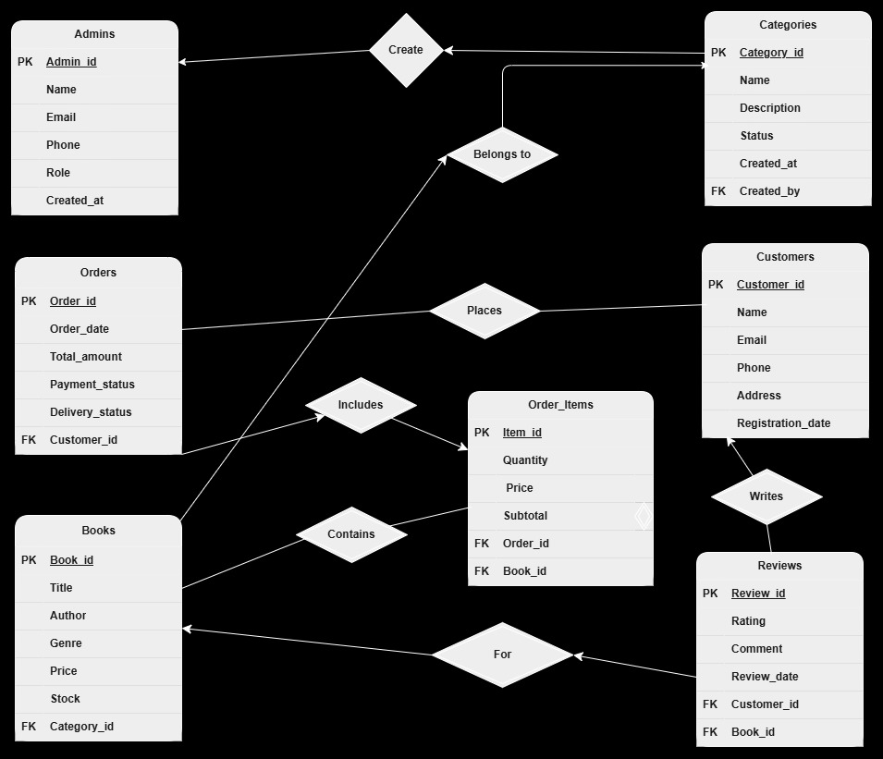

For clear understanding:

* + 1. [https://app.diagrams.net/#G1qXH6PQWHstDJHyRWhLUKhlL9g9o5K2x1#%7B%22pageId%22%3A%22bPgeqzEszBXqpjA1GqrR%22%7D](https://app.diagrams.net/#G1qXH6PQWHstDJHyRWhLUKhlL9g9o5K2x1)
    2. <https://drive.google.com/file/d/1qXH6PQWHstDJHyRWhLUKhlL9g9o5K2x1/view?usp=drive_link>

**Schema Diagram:**

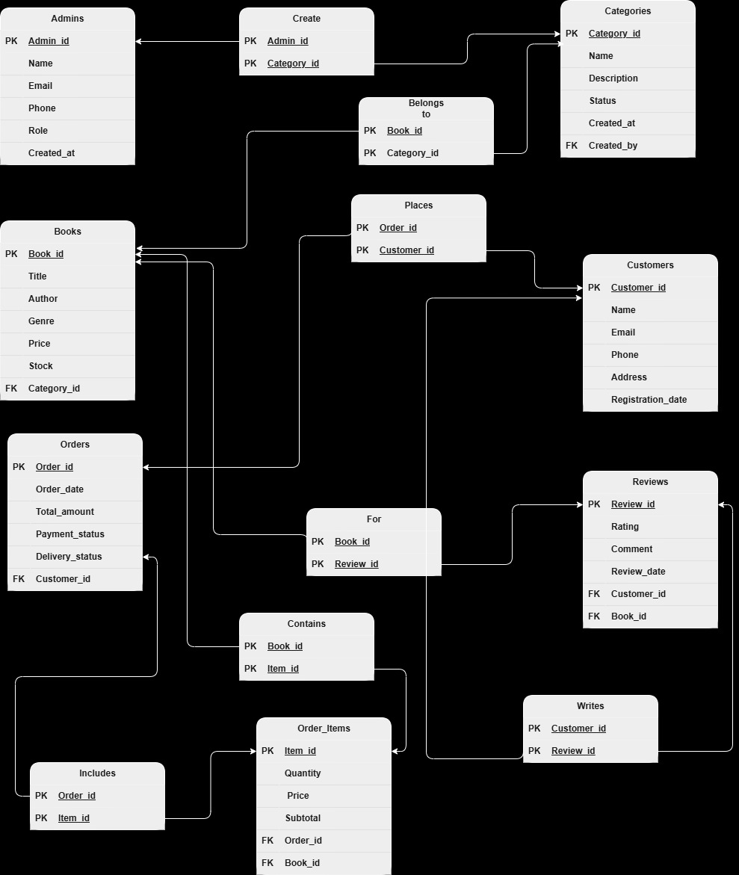

**Queries:**

1. (**Display all columns and all records from the Books table.**)

SELECT * FROM Books

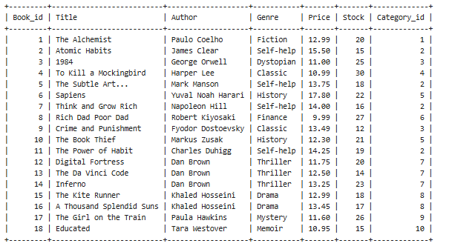

1. (**Display all columns and all records from the** Customers **table.**)

SELECT * FROM Customers

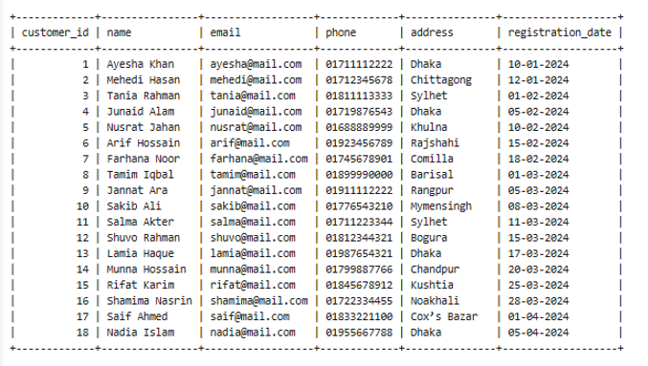

1. (**Display all columns and all records from the** Orders **table.**)

SELECT * FROM Orders

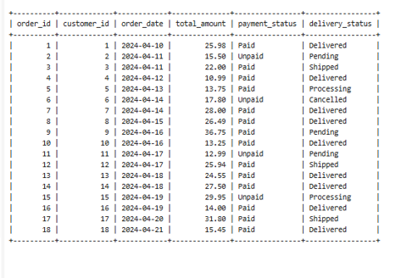

1. (**Display all columns and all records from the** Categories **table.**)

SELECT * FROM Categories

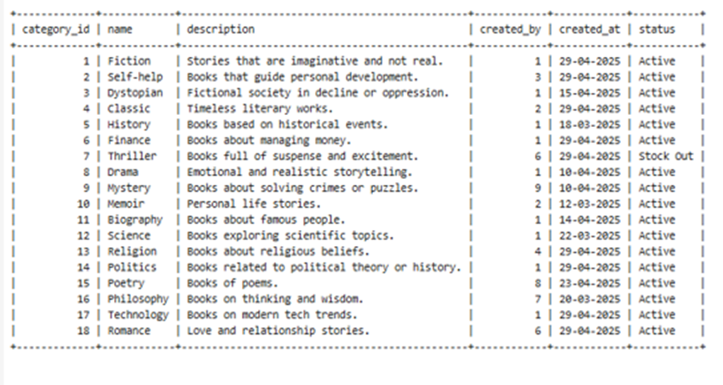

1. (**Display all columns and all records from the Admins table.**)

SELECT * FROM Admins

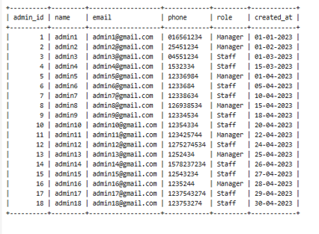

1. **(Display all columns and all records from the Reviews table.)**

SELECT * FROM Reviews

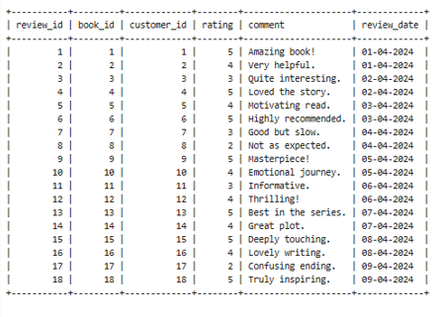

1. (**Display all columns and all records from the Order_Items table.**)

SELECT * FROM Order_Items

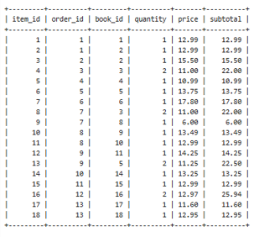

1. **(Retrieve all orders placed between April 17, 2024, and April 30, 2024.)**

SELECT * FROM Orders WHERE order_date BETWEEN '2024-04-17' AND '2024-04-30';

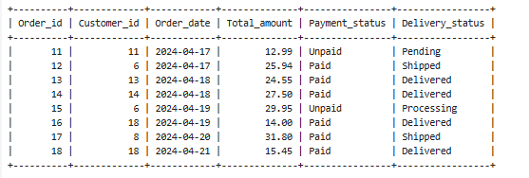

1. **(Fetche all books with stock less than 15 units.)**

SELECT * FROM Books WHERE stock < 15;

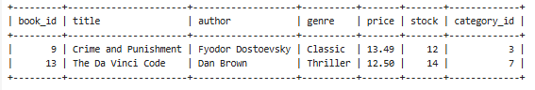

1. **(Retrieve all admin records where the role is 'Manager’)**

SELECT * FROM Admins WHERE role = 'Manager';

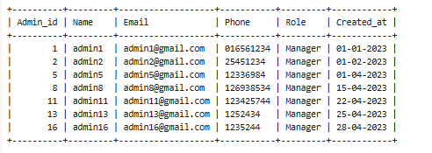

1. **(Fetche customer IDs, total amounts, and payment statuses for all orders that have been delivered.)**

SELECT customer_id,total_amount,Payment_status FROM Orders WHERE delivery_status = 'Delivered';

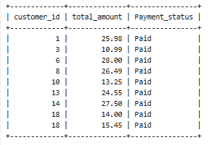

1. **(Retrieve the titles and prices of all books in the inventory.)**

SELECT title, price FROM Books;

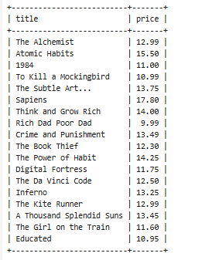

1. **(Calculate the average rating for each book based on customer reviews)**

SELECT book_id, AVG(rating) AS avg_rating FROM Reviews GROUP BY book_id;

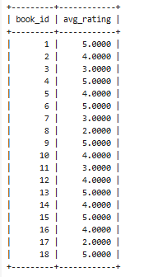

1. **(Count the total number of categories in the system.)**

SELECT COUNT(*) AS total_categories FROM Categories;

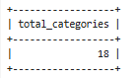

1. **(Show the total number of orders placed by each customer.)**

SELECT customer_id, COUNT(*) AS total_orders FROM Orders GROUP BY customer_id;

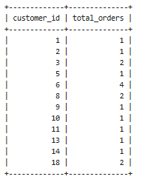

1. **(Count the number of books available in each genre)**

SELECT Genre , count(Genre) as Quantity from Books GROUP BY(Genre);

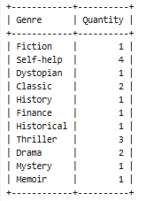

1. **(Calculate the total amount spent by each customer across all their orders.)**

SELECT customer_id, SUM(total_amount) AS total_spent FROM Orders GROUP BY customer_id ;

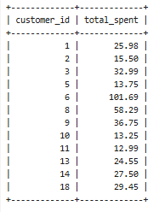

1. **(Add a new column preferred_genre to the Customers table and updates each customer with their preferred book genre, then displays their name, district, registration date, and preferred genre.)**

ALTER TABLE Customers

ADD column preferred_genre VARCHAR(50);

UPDATE Customers SET preferred_genre = 'Fiction' WHERE customer_id = 1;

UPDATE Customers SET preferred_genre = 'Self-help' WHERE customer_id = 2;

UPDATE Customers SET preferred_genre = 'Mystery' WHERE customer_id = 3;

UPDATE Customers SET preferred_genre = 'Drama' WHERE customer_id = 4;

UPDATE Customers SET preferred_genre = 'Romance' WHERE customer_id = 5;

UPDATE Customers SET preferred_genre = 'Science' WHERE customer_id = 6;

UPDATE Customers SET preferred_genre = 'Thriller' WHERE customer_id = 7;

UPDATE Customers SET preferred_genre = 'History' WHERE customer_id = 8;

UPDATE Customers SET preferred_genre = 'Classic' WHERE customer_id = 9;

UPDATE Customers SET preferred_genre = 'Poetry' WHERE customer_id = 10;

UPDATE Customers SET preferred_genre = 'Technology' WHERE customer_id = 11;

UPDATE Customers SET preferred_genre = 'Biography' WHERE customer_id = 12;

UPDATE Customers SET preferred_genre = 'Philosophy' WHERE customer_id = 13;

UPDATE Customers SET preferred_genre = 'Dystopian' WHERE customer_id = 14;

UPDATE Customers SET preferred_genre = 'Religion' WHERE customer_id = 15;

UPDATE Customers SET preferred_genre = 'Finance' WHERE customer_id = 16;

UPDATE Customers SET preferred_genre = 'Fiction' WHERE customer_id = 17;

UPDATE Customers SET preferred_genre = 'Romance' WHERE customer_id = 18;

SELECT Name, Address as District, registration_date, preferred_genre FROM Customers;

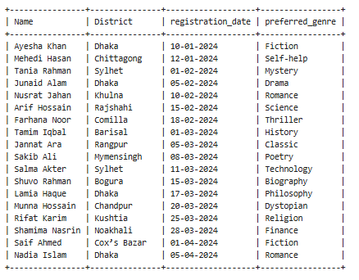

1. **(Retrieve all customers who have placed at least one order.)**

SELECT * FROM Customers WHERE customer_id IN (SELECT customer_id FROM Orders);

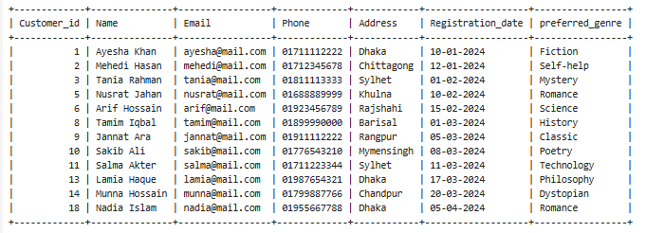

1. **(Fetche details of books that have received at least one review.)**

SELECT book_id,title,Genre FROM Books WHERE book_id IN (SELECT book_id FROM Reviews);

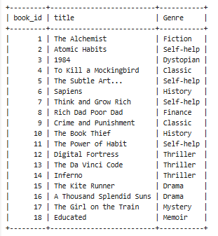

1. **(Retrieve all books priced below the average price of all books.)**

SELECT * FROM Books WHERE price < (SELECT AVG(price) FROM Books);

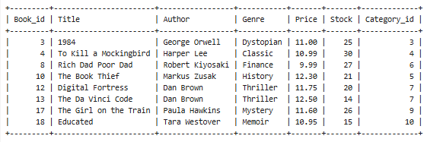

1. **(Display the top 8 highest-rated books based on average review ratings, in descending order.)**

SELECT book_id, AVG(rating) AS avg_rating

FROM Reviews

GROUP BY book_id

ORDER BY avg_rating DESC

LIMIT 8;

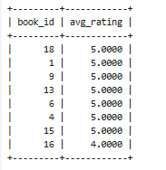

**Conclusion:**  
This report presents a comprehensive overview of the bookstore database through various SQL queries, providing insights into book inventory, customer preferences, sales performance, and administrative roles. The data retrieved supports efficient decision-making by identifying popular genres, top-rated books, customer purchase behavior, and inventory needs. These findings can help improve customer satisfaction, optimize stock management, and enhance overall business operations.