Threat Intelligence Analysis Report
Tool Name: Threat Intelligence - Cyber Command Center
Student Name: Mohammed Abdullah Hassan Al-Odaini
Student ID: 2023050626
Department: Cybersecurity
Supervisor: Sondos Saif
Project Date: February 2, 2026

Abstract
This tool, "Threat Intelligence - Cyber Command Center," offers a comprehensive solution to enhance cybersecurity by providing a wide range of analytical and exploratory functions. The tool is developed using the tkinter library for its graphical user interface (GUI) and relies on sqlite3 for database management, in addition to requests for interacting with external Application Programming Interfaces (APIs), and scapy for network packet analysis. The tool aims to empower security analysts to effectively gather threat intelligence, analyze network traffic, discover vulnerabilities, and monitor systems. This report focuses on analyzing the tool's software architecture, explaining its main functionalities, and reviewing its operational mechanisms, while highlighting its importance in the modern cybersecurity landscape.

Introduction
In an era where cyber threats are growing in complexity and sophistication, the need for robust Threat Intelligence tools has become paramount for organizations and individuals alike. The "Cyber Command Center: Threat Intelligence " tool addresses this need by providing a unified and comprehensive platform for collecting, analyzing, and visualizing threat-related data. This tool aims to enable security analysts to make informed and rapid decisions to counter potential cyberattacks by offering deep insights into Indicators of Compromise (IOCs), analyzing network traffic, and detecting security vulnerabilities in systems and applications.

The significance of this project lies in its ability to integrate several vital security functions into a single, user-friendly graphical interface, thereby reducing operational complexity and increasing the efficiency of incident response. By analyzing network packets,
scanning ports, enumerating directories, and verifying file hashes, the tool provides a holistic view of the security landscape, helping to identify potential weaknesses and active threats. It also contributes to building a deeper understanding of attack patterns and adversary Tactics, Techniques, and Procedures (TTPs), which enhances proactive defense capabilities.

This tool directly addresses the challenge of fragmented security information and specialized tools by consolidating multiple capabilities into one environment. However, the nature of a tool that scans networks and systems may introduce potential vulnerabilities if not used responsibly and in a controlled environment. For instance, scanning unauthorized ports or enumerating directories on systems without proper authorization could violate usage policies or local laws. Therefore, it must be emphasized that this tool is designed for ethical and responsible use in legitimate cybersecurity contexts, such as authorized penetration testing or private network analysis.

Methodology
The "Cyber Command Center: Threat Intelligence " tool adopts an integrated development methodology that combines an intuitive graphical user interface, efficient data management, and advanced analytical capabilities. The tool is designed to be modular and extensible, allowing for easy addition of new features and updates. Below is a detailed breakdown of the methodology and key components:

1. Graphical User Interface (GUI) Design
The GUI is built using Python's standard tkinter library, providing stability and compatibility across various operating systems. ttk (Themed Tkinter) is utilized to enhance the aesthetic appeal of the interface, making it more modern and engaging. The interface relies on a tabbed system (ttk.Notebook) to organize the tool's various functionalities, facilitating easy navigation and providing a seamless user experience. Each tab is designed to present a specific function, such as the Dashboard, GeoIP Tracer, Threat Feeds, IOC Analysis, HTTP Analysis, Packet Capture, PCAP Analysis, Advanced Port Scanner, Directory Brute Forcer, and Hash Analysis, in addition to a dedicated Reporting tab.

2. Data Management and Databases
The tool uses an embedded SQLite database, which is an excellent choice for standalone applications that do not require a separate database server. The threat_intel_ultimate.db database is automatically created when the tool is first launched. The database includes several tables to store different types of data:

- advanced_iocs: To store Indicators of Compromise (IOCs) of various types (IP, Domain, URL, Hash) with additional details such as threat type, source, confidence level, severity, Tactics, Techniques, and Procedures (TTP), first seen date, and tags.
- http_logs: To record HTTP traffic analysis logs, including timestamp, request method, URL, response code, threat score, and analysis.
- network_logs: To record network logs, such as timestamp, source and destination IP addresses, protocol, packet size, and threat score.

This structure ensures organized data storage, making it easy to retrieve and analyze data for generating reports and providing security insights.

3. Modules and Libraries Used
The tool relies on a set of powerful Python libraries that enable it to perform its diverse functions:

- tkinter and ttk: For building the interactive graphical user interface.
- threading and concurrent.futures.ThreadPoolExecutor: To execute long-running operations (such as port scanning and PCAP analysis) in separate threads, preventing the GUI from freezing and maintaining its responsiveness.
- sqlite3: For managing the local database and storing security data.
- requests: For making HTTP requests to external APIs (e.g., AbuseIPDB, URLHaus, ip-api.com) to fetch threat feeds and GeoIP information.
- json: For processing JSON data received from APIs.
- os: For interacting with the operating system, such as determining file paths.
- datetime: For handling dates and times, especially in logging and timestamps.
- hashlib: For calculating file hashes (MD5, SHA1, SHA256) to verify file integrity and detect malware.
- time: For delaying certain operations when needed.
- socket: For performing port scanning operations and discovering open services.
- random: For generating random values (not explicitly used in the current code but a generally useful library).
- re: For processing regular expressions to analyze text.
- scapy.all: A powerful library for network packet analysis, used for capturing packets (sniff), reading them (rdpcap), writing them (wrpcap), and analyzing different protocol layers (IP, TCP, UDP, Raw, Ether).
- psutil (optional): For monitoring system resources such as CPU and RAM usage, providing insights into the performance of the system running the tool.

4. Key Features and Functions
The tool includes a wide range of features, each designed to address a specific aspect of threat intelligence and cybersecurity:

- Dashboard: Provides a quick overview of key security statistics such as total IOCs, number of packets sniffed, and active threats.
- GeoIP Tracer: To determine the geographical location and Internet Service Provider (ISP) of a specific IP address.
- Threat Feeds: To fetch IOCs from trusted external sources like AbuseIPDB and URLHaus and store them in the database.
- IOC Analysis: To search for and manage stored IOCs in the database.
- HTTP Analysis: To capture and analyze HTTP requests and responses, detecting suspicious patterns.
- Packet Capture & PCAP Analysis: To capture real-time network traffic, save it to PCAP files, and analyze existing PCAP files to detect vulnerabilities and attacks (e.g., SQL Injection, XSS, cleartext credentials).
- Advanced Port Scanner: To discover open ports and the services running on them, with banner grabbing capabilities for additional information.
- Directory Brute Forcer: To discover hidden paths and files on web servers using a comprehensive wordlist.
- Hash Analysis: To calculate MD5, SHA1, and SHA256 hashes of files, helping to verify file integrity and compare them against known malware hash databases.
- Global Logging System: To record all activities and results in internal logs, which can be used to generate comprehensive reports.
- System Monitor: (Optional feature depending on psutil) To display CPU and RAM usage of the system.
- Reporting: To generate comprehensive reports summarizing all activities and findings collected by the tool, with the ability to export them to text files.

This methodology demonstrates a commitment to providing a powerful and multi-functional tool, designed to meet the needs of cybersecurity analysts in an ever-evolving threat landscape.

Algorithm or Code Design
The "Cyber Command Center: Threat Intelligence " tool relies on an Object-Oriented Programming (OOP) design using a main class called ThreatIntelligencePro. This class encapsulates all the necessary functions and components to operate the tool, ensuring organized and easily maintainable and scalable code. Below is an overview of the most important functions and the programming logic used in the tool:

1. The ThreatIntelligencePro Class and Initialization (__init__)
The ThreatIntelligencePro class serves as the main entry point for the application. Its constructor (__init__) initializes the user interface, sets up the database, loads initial data, and prepares variables necessary for tracking application state and statistics.

Explanation: This function initializes the main application window (self.root),setting its dimensions and background color. It defines the path to the unified database(self.db_path)and initializes a set of variables to track statistics such as the total number of Indicators of Compromise (self.total_iocs),the number of captured packets (self.capture_packets), and the packet sniffing status (self.sniffing).self.global_logs is a crucial data structure for storing logs from various modules, facilitating their aggregation into the final report. After initial variable setup, it calls init_database() to create necessary tables, then create_ui() to build the graphical user interface, load_initial_data() to load some sample data, and update_stats() to refresh displayed statistics. It also includes system monitor initialization if the psutil library is available.

Code:
class ThreatIntelligencePro:
def __init__(self, root):
self.root = root
# Update title for new version
self.root.title("🛡️ Threat Intelligence Pro v7.0 - Cyber Command Center")
self.root.geometry("1750x1000")
self.root.configure(bg=\'#0d1117\')

# Unified database path
self.db_path = "../threat_intel_ultimate.db"

# Statistics and status variables
self.total_iocs = 0
self.matched_iocs = 0
self.capture_packets = 0
self.sniffing = False
self.captured_packets_list = []
self.threat_feeds = {\'ips\': [], \'urls\': [], \'domains\': [], \'hashes\': []}

# === (v7.0 Feature) Comprehensive Logging System ===
self.global_logs = {
"HTTP_Analysis": [],
"Port_Scan": [],
"Dir_Brute": [],
"Network_Threats": [],
"PCAP_Analysis": [],
"Hash_Checks": [],
"GeoIP": []
}

self.init_database()
self.create_ui()
self.load_initial_data()
self.update_stats()

# Start system monitor (v7.0 Feature)
if PSUTIL_AVAILABLE:
self.update_system_monitor()

2. Database Initialization (init_database)
This function is responsible for setting up the database infrastructure required to store security data.

Explanation: This function connects to the SQLite database specified in self.db_path. It creates three main tables if they do not already exist: advanced_iocs for storing detailed Indicators of Compromise, http_logs for recording HTTP analysis, and network_logs for network logs. The use of CREATE TABLE IF NOT EXISTS ensures that tables are not recreated if they already exist, preserving existing data. Appropriate data types are used for each column, such as TEXT for strings, INTEGER for integers, and REAL for floating-point numbers, with ioc_value set as unique to prevent duplicate IOCs.

Code:
def init_database(self):
"""Initialize database with advanced and comprehensive tables"""
conn = sqlite3.connect(self.db_path)
cursor = conn.cursor()

# 1. Advanced IOCs table
cursor.execute(\'\'\'
CREATE TABLE IF NOT EXISTS advanced_iocs (
id INTEGER PRIMARY KEY AUTOINCREMENT,
ioc_type TEXT,
ioc_value TEXT UNIQUE,
threat_type TEXT,
source TEXT,
confidence REAL,
severity TEXT,
ttp TEXT,
first_seen TEXT,
tags TEXT
)
\'\'\')

# 2. Advanced HTTP logs table
cursor.execute(\'\'\'
CREATE TABLE IF NOT EXISTS http_logs (
id INTEGER PRIMARY KEY AUTOINCREMENT,
timestamp TEXT, method TEXT, url TEXT,
response_code INTEGER, threat_score REAL, analysis TEXT
)
\'\'\')

# 3. Network logs table
cursor.execute(\'\'\'
CREATE TABLE IF NOT EXISTS network_logs (
id INTEGER PRIMARY KEY AUTOINCREMENT,
timestamp TEXT, src_ip TEXT, dst_ip TEXT,
protocol TEXT, packet_size INTEGER, threat_score REAL
)
\'\'\')
conn.commit()
conn.close()

3. Load Initial Data (load_initial_data)
This function is used to populate the database with some sample Indicators of Compromise upon application startup.

Explanation: This function inserts a set of sample Indicators of Compromise (IOCs) into the advanced_iocs table. The samples include IP addresses, domains, and URLs, specifying the threat type, source, confidence level, severity, TTP, and tags. The INSERT OR IGNORE command is used to ensure that the same IOC is not re-inserted if it already exists in the database (thanks to the UNIQUE constraint on the ioc_value column). This ensures that initial data is added only once at first run or when IOCs are not present.

Code:
def load_initial_data(self):
"""Load sample data to start"""
samples = [
(\'ip\', \'45.142.122.124\', \'C2 Server\', \'DarkFeed\', 0.95, \'HIGH\', \'TA0011\', \'botnet\'),
(\'domain\', \'zunoxe.xyz\', \'Phishing\', \'ThreatFox\', 0.92, \'CRITICAL\', \'TA0001\', \'phish\'),
(\'url\', \'http://malware.site/bin.exe\', \'Malware\', \'URLHaus\', 0.88, \'HIGH\', \'TA0002\', \'exe\')
]
conn = sqlite3.connect(self.db_path)
cur = conn.cursor()
for s in samples:
try:
cur.execute(\'\'\'INSERT OR IGNORE INTO advanced_iocs
(ioc_type, ioc_value, threat_type, source, confidence, severity, ttp, tags)
VALUES (?,?,?,?,?,?,?,?)\'\'\', s)
except:
pass
conn.commit()
conn.close()

4. Build User Interface (create_ui)
This function creates all graphical user interface elements, including buttons, input fields, text areas, and tabs.

Explanation: This function divides the interface building process into several parts. It starts by creating the application header (header) which contains the tool's title and labels for system monitoring and general statistics. Then, it creates a ttk.Notebook element that acts as a container for different tabs. A set of sub-functions (e.g., setup_dashboard_tab(), setup_geoip_tab(), setup_feed_tab(), etc.) are then called to create each tab individually and populate it with its specific elements. This modular design makes the code more organized and facilitates the addition or modification of future tabs.

Code:
def create_ui(self):
# --- Header ---
header = tk.Frame(self.root, bg=\'#161b22\', height=90)
header.pack(fill=\'x\', padx=20, pady=10)
header.pack_propagate(False)

tk.Label(header, text="🛡️ Threat Intelligence Pro v7.0",
font=(\'Segoe UI\', 24, \'bold\'), fg=\'#58a6ff\', bg=\'#161b22\').pack(side=\'left\', pady=20)

# (v7.0 Feature) System Monitor Label
self.sys_mon_lbl = tk.Label(header, text="System: Initializing...", font=(\'Consolas\', 10), fg=\'#8b949e\',
bg=\'#161b22\')
self.sys_mon_lbl.pack(side=\'right\', padx=20, pady=25)

stats_frame = tk.Frame(header, bg=\'#161b22\')
stats_frame.pack(side=\'right\', pady=25)

# (Old Stats Labels - Kept for compatibility but Dashboard is better)
self.lbl_iocs = tk.Label(stats_frame, text="IOCs: 0", font=(\'Consolas\', 14, \'bold\'), fg=\'#f0f6fc\', bg=\'#161b22\')
self.lbl_iocs.pack(side=\'left\', padx=10)

self.lbl_pkts = tk.Label(stats_frame, text="Packets: 0", font=(\'Consolas\', 14, \'bold\'), fg=\'#f0f6fc\',
bg=\'#161b22\')
self.lbl_pkts.pack(side=\'left\', padx=10)

# --- Tabs ---
self.notebook = ttk.Notebook(self.root)
self.notebook.pack(fill=\'both\', expand=True, padx=20, pady=10)

# New tab order
self.setup_dashboard_tab() # ✅ NEW (v7)
self.setup_geoip_tab() # ✅ NEW (v7)
self.setup_feed_tab()
self.setup_ioc_tab()
self.setup_http_tab()
self.setup_capture_tab()
self.setup_pcap_analysis_tab()
self.setup_advanced_scan_tab()
self.setup_dir_tab()
self.setup_hash_tab()
self.setup_report_tab() # ✅ UPDATED (v7)

5. Dashboard Tab Setup (setup_dashboard_tab)
This function creates the dashboard tab that displays a summary of key statistics.

Explanation: This tab serves as a quick overview of the system status and detected activities. It includes a welcome banner and statistical cards displaying the total number of IOCs, the number of packets sniffed, and the number of active threats (calculated based on activities). tk.StringVar is used to dynamically update the displayed values in the cards. The helper function create_card makes it easy to create consistently styled statistical cards.

Code:
def setup_dashboard_tab(self):
tab = ttk.Frame(self.notebook)
self.notebook.add(tab, text="🏠 Dashboard")

# Welcome Banner
banner = tk.Frame(tab, bg=\'#0d1117\')
banner.pack(fill=\'x\', pady=20, padx=40)
tk.Label(banner, text="Welcome to Cyber Command Center", font=(\'Segoe UI\', 20, \'bold\'), fg=\'white\',
bg=\'#0d1117\').pack()
tk.Label(banner, text="Select a tool from the tabs above to begin operations.", font=(\'Segoe UI\', 12),
fg=\'#8b949e\', bg=\'#0d1117\').pack()

# Stats Cards Container
cards_frame = tk.Frame(tab, bg=\'#0d1117\')
cards_frame.pack(fill=\'x\', padx=40, pady=20)

# Helper to create cards
def create_card(parent, title, value_var, color):
frame = tk.Frame(parent, bg=\'#21262d\', height=150, width=250)
frame.pack_propagate(False)
frame.pack(side=\'left\', padx=10)
tk.Label(frame, text=title, font=(\'Segoe UI\', 12), fg=\'#8b949e\', bg=\'#21262d\').pack(pady=(20, 5))
lbl = tk.Label(frame, textvariable=value_var, font=(\'Segoe UI\', 28, \'bold\'), fg=color, bg=\'#21262d\')
lbl.pack()
return lbl

# Dashboard Variables
self.var_iocs = tk.StringVar(value="0")
self.var_packets = tk.StringVar(value="0")
self.var_threats = tk.StringVar(value="0") # Placeholder for calculated threats

create_card(cards_frame, "Total IOCs", self.var_iocs, "#58a6ff")
create_card(cards_frame, "Packets Sniffed", self.var_packets, "#3fb950")
create_card(cards_frame, "Active Threats", self.var_threats, "#ff7b72")

6. GeoIP Tracer Tab Setup (setup_geoip_tab)
This tab is dedicated to determining the geographical location of a specific IP address.

Explanation: This tab contains an input field (tk.Entry) for entering an IP address and a button (tk.Button) to initiate the tracing process. Results are displayed in a scrollable text area (scrolledtext.ScrolledText). When the "Locate" button is clicked, the run_geoip function is called, which in turn starts the tracing process in a separate thread (threading.Thread) using the _geoip_thread function, preventing the GUI from freezing while fetching data from an external API. This ensures the application remains responsive even during time-consuming operations.

Code:
def setup_geoip_tab(self):
tab = ttk.Frame(self.notebook)
self.notebook.add(tab, text="🌍 GeoIP Tracer")

ctrl = tk.Frame(tab, bg=\'#161b22\')
ctrl.pack(fill=\'x\', padx=20, pady=15)

tk.Label(ctrl, text="Enter IP Address:", bg=\'#161b22\', fg=\'white\').pack(side=\'left\', padx=10)
self.geo_ip_entry = tk.Entry(ctrl, width=30, bg=\'#21262d\', fg=\'white\')
self.geo_ip_entry.pack(side=\'left\', padx=10)
tk.Button(ctrl, text="📍 Locate", command=self.run_geoip, bg=\'#1f6feb\', fg=\'white\').pack(side=\'left\')

self.geo_out = scrolledtext.ScrolledText(tab, bg=\'#0d1117\', fg=\'#e6edf3\', font=(\'Consolas\', 11))
self.geo_out.pack(fill=\'both\', expand=True, padx=20, pady=10)

def run_geoip(self):
ip = self.geo_ip_entry.get()
if not ip: return
threading.Thread(target=self._geoip_thread, args=(ip,), daemon=True).start()

def _geoip_thread(self, ip):
self.log(f"Fetching location for {ip}...", self.geo_out, "GeoIP")
try:
r = requests.get(f"http://ip-api.com/json/{ip}", timeout=10)
data = r.json()

if data[\'status\'] == \'fail\':
self.log(f"❌ Failed: {data[\'message\']}", self.geo_out, "GeoIP")
return

res = f"""
✅ GEOIP RESULT FOR {ip}
-------------------------
🌍 Country: {data.get(\'country\')} ({data.get(\'countryCode\')})
🏙️ City: {data.get(\'city\')}
📍 Region: {data.get(\'regionName\')}
📡 ISP: {data.get(\'isp\')}
🏢 Org: {data.get(\'org\')}
🕐 Timezone: {data.get(\'timezone\')}
📍 Lat/Lon: {data.get(\'lat\')}, {data.get(\'lon\')}
"""
self.geo_out.insert(tk.END, res + "\n")
self.log(f"Located {ip}: {data.get(\'country\')}, {data.get(\'isp\')}", self.geo_out, "GeoIP")

except Exception as e:
self.log(f"❌ Error: {e}", self.geo_out, "GeoIP")

7. Threat Feeds Tab Setup (setup_feed_tab)
This tab allows the user to fetch Indicators of Compromise from external sources.

Explanation: This tab contains buttons to fetch threat feeds from specific sources like AbuseIPDB and URLHaus, as well as a button to fetch all feeds. The fetched IOCs are displayed in a scrollable text area. Threads (threading.Thread) are used to perform network data fetching operations asynchronously, ensuring the GUI does not freeze. All operations and results are recorded in the application logs.

Code:
def setup_feed_tab(self):
tab = ttk.Frame(self.notebook)
self.notebook.add(tab, text="📡 Threat Feeds")

btn_frame = tk.Frame(tab, bg=\'#161b22\', width=300)
btn_frame.pack(side=\'left\', fill=\'y\', padx=20, pady=20)

tk.Label(btn_frame, text="Sources", font=(\'Segoe UI\', 12, \'bold\'), bg=\'#161b22\', fg=\'white\').pack(pady=10)

tk.Button(btn_frame, text="AbuseIPDB (Live)", command=self.fetch_abuseipdb,
bg=\'#238636\', fg=\'white\', width=20, height=2).pack(pady=5)

tk.Button(btn_frame, text="URLHaus (Live)", command=self.fetch_urlhaus,
bg=\'#238636\', fg=\'white\', width=20, height=2).pack(pady=5)

tk.Button(btn_frame, text="Fetch All", command=self.fetch_all_feeds,
bg=\'#1f6feb\', fg=\'white\', width=20, height=2).pack(pady=5)

tk.Button(btn_frame, text="Clear Feeds", command=self.clear_feeds,
bg=\'#da3633\', fg=\'white\', width=20, height=2).pack(pady=20)

self.feed_out = scrolledtext.ScrolledText(tab, bg=\'#0d1117\', fg=\'#e6edf3\', font=(\'Consolas\', 10))
self.feed_out.pack(fill=\'both\', expand=True, padx=20, pady=10)

def fetch_abuseipdb(self):
threading.Thread(target=self._fetch_abuseipdb_logic, daemon=True).start()

def _fetch_abuseipdb_logic(self):
self.log("Fetching AbuseIPDB feed...", self.feed_out)
try:
# API Key is needed for AbuseIPDB, using a placeholder
headers = {\'Key\': \'YOUR_ABUSEIPDB_API_KEY\', \'Accept\': \'application/json\'}
r = requests.get("https://api.abuseipdb.com/api/v2/blacklist", headers=headers, verify=False, timeout=30)
data = r.json()
for entry in data[\'data\']:
ip = entry[\'ipAddress\']
self.threat_feeds[\'ips\'].append(ip)
self.log(f"[AbuseIPDB] Added IP: {ip}", self.feed_out)
# Store in DB
self.insert_ioc(\'ip\', ip, \'Malicious IP\', \'AbuseIPDB\', entry.get(\'abuseConfidenceScore\', 0) / 100.0,
\'HIGH\', \'T1595\', \'blacklist\')
self.log(f"Fetched {len(data[\'data\'])} IPs from AbuseIPDB.", self.feed_out)
self.update_stats()
except Exception as e:
self.log(f"Error fetching AbuseIPDB: {e}", self.feed_out)

def fetch_urlhaus(self):
threading.Thread(target=self._fetch_urlhaus_logic, daemon=True).start()

def _fetch_urlhaus_logic(self):
self.log("Fetching URLHaus feed...", self.feed_out)
try:
r = requests.get("https://urlhaus.abuse.ch/downloads/csv/", verify=False, timeout=60)
# Parse CSV, skipping comments
lines = r.text.splitlines()
for line in lines:
if line.startswith(\'#\'):
continue
parts = line.split(\'"\')
if len(parts) > 1:
url = parts[1] # URL is usually in the second quoted field
self.threat_feeds[\'urls\'].append(url)
self.log(f"[URLHaus] Added URL: {url}", self.feed_out)
# Store in DB
self.insert_ioc(\'url\', url, \'Malware URL\', \'URLHaus\', 0.8, \'HIGH\', \'T1189\', \'malware-dist\')
self.log(f"Fetched {len(self.threat_feeds[\'urls\'])} URLs from URLHaus.", self.feed_out)
self.update_stats()
except Exception as e:
self.log(f"Error fetching URLHaus: {e}", self.feed_out)

def fetch_all_feeds(self):
self.log("Fetching all threat feeds...", self.feed_out)
self._fetch_abuseipdb_logic()
self._fetch_urlhaus_logic()
self.log("All threat feeds fetched.", self.feed_out)

def clear_feeds(self):
self.threat_feeds = {\'ips\': [], \'urls\': [], \'domains\': [], \'hashes\': []}
self.feed_out.delete(1.0, tk.END)
self.log("Threat feeds cleared.", self.feed_out)

8. IOC Analysis Tab Setup (setup_ioc_tab)
This tab is used to search for and manage Indicators of Compromise in the database.

Explanation: This tab allows the user to search for IOCs stored in the database based on the IOC type (IP, Domain, URL, Hash) or its value. Results are displayed in a ttk.Treeview, providing an organized tabular view of the data. The search_ioc() function is used to execute database search queries, while insert_ioc() is used to manually add new IOCs. These functionalities ensure the user can effectively interact with the IOC database.

Code:
def setup_ioc_tab(self):
tab = ttk.Frame(self.notebook)
self.notebook.add(tab, text="🔍 IOC Analysis")

ctrl = tk.Frame(tab, bg=\'#161b22\')
ctrl.pack(fill=\'x\', padx=20, pady=15)

tk.Label(ctrl, text="IOC Type:", bg=\'#161b22\', fg=\'white\').pack(side=\'left\', padx=5)
self.ioc_type = ttk.Combobox(ctrl, values=["ip", "domain", "url", "hash", "all"], width=10)
self.ioc_type.pack(side=\'left\', padx=5)
self.ioc_type.set("all")

tk.Label(ctrl, text="Value:", bg=\'#161b22\', fg=\'white\').pack(side=\'left\', padx=5)
self.ioc_value = tk.Entry(ctrl, width=40, bg=\'#21262d\', fg=\'white\')
self.ioc_value.pack(side=\'left\', padx=5)

tk.Button(ctrl, text="🔎 Search IOC", command=self.search_ioc, bg=\'#1f6feb\', fg=\'white\').pack(side=\'left\', padx=10)
tk.Button(ctrl, text="➕ Add IOC", command=self.show_add_ioc_dialog, bg=\'#238636\', fg=\'white\').pack(side=\'left\')

columns = ("ID", "Type", "Value", "Threat Type", "Source", "Confidence", "Severity", "TTP", "First Seen", "Tags")
self.ioc_tree = ttk.Treeview(tab, columns=columns, show=\'headings\', height=20)

for col in columns:
self.ioc_tree.heading(col, text=col)
self.ioc_tree.column(col, width=100)

self.ioc_tree.pack(fill=\'both\', expand=True, padx=20, pady=10)

def search_ioc(self):
for item in self.ioc_tree.get_children():
self.ioc_tree.delete(item)

ioc_type = self.ioc_type.get()
ioc_value = self.ioc_value.get()

conn = sqlite3.connect(self.db_path)
cursor = conn.cursor()

query = "SELECT * FROM advanced_iocs WHERE 1=1"
params = []

if ioc_type != "all":
query += " AND ioc_type = ?"
params.append(ioc_type)
if ioc_value:
query += " AND ioc_value LIKE ?"
params.append(f"%{ioc_value}%")

cursor.execute(query, params)
rows = cursor.fetchall()
conn.close()

for row in rows:
self.ioc_tree.insert(\'\', \'end\', values=row)

self.log(f"Searched for IOCs (Type: {ioc_type}, Value: {ioc_value}). Found {len(rows)} results.", self.ioc_tree, "IOC_Analysis")

def show_add_ioc_dialog(self):
# A simple dialog to add IOCs (for brevity, not full code)
messagebox.showinfo("Add IOC", "This feature would open a dialog to add a new IOC manually.")

def insert_ioc(self, ioc_type, ioc_value, threat_type, source, confidence, severity, ttp, tags):
conn = sqlite3.connect(self.db_path)
cur = conn.cursor()
try:
cur.execute(\'\'\'INSERT OR IGNORE INTO advanced_iocs
(ioc_type, ioc_value, threat_type, source, confidence, severity, ttp, tags, first_seen)
VALUES (?,?,?,?,?,?,?,?,?)\'\'\',
(ioc_type, ioc_value, threat_type, source, confidence, severity, ttp, tags, datetime.now().strftime("%Y-%m-%d %H:%M:%S")))
conn.commit()
self.update_stats()
except Exception as e:
self.log(f"Error inserting IOC {ioc_value}: {e}", None, "IOC_Analysis")
finally:
conn.close()

9. HTTP Analysis Tab Setup (setup_http_tab)
This tab allows the user to analyze HTTP traffic in real-time.

Explanation: This tab contains buttons to start and stop HTTP traffic capture and analysis. Results are displayed in a scrollable text area. The start_http_analysis() function is used to initiate the analysis process in a separate thread, while stop_http_analysis() is used to stop it. All intercepted and analyzed HTTP requests and responses are recorded in the application logs and database, indicating whether they contain potential threats.

Code:
def setup_http_tab(self):
tab = ttk.Frame(self.notebook)
self.notebook.add(tab, text="🌐 HTTP Analysis")

ctrl = tk.Frame(tab, bg=\'#161b22\')
ctrl.pack(fill=\'x\', padx=20, pady=15)

tk.Button(ctrl, text="▶️ Start HTTP Analysis", command=self.start_http_analysis, bg=\'#238636\', fg=\'white\').pack(side=\'left\', padx=10)
tk.Button(ctrl, text="⏹️ Stop HTTP Analysis", command=self.stop_http_analysis, bg=\'#da3633\', fg=\'white\').pack(side=\'left\', padx=10)

self.http_out = scrolledtext.ScrolledText(tab, bg=\'#0d1117\', fg=\'#e6edf3\', font=(\'Consolas\', 10))
self.http_out.pack(fill=\'both\', expand=True, padx=20, pady=10)

self.http_analysis_running = False

def start_http_analysis(self):
if not self.http_analysis_running:
self.http_analysis_running = True
self.log("Starting HTTP analysis...", self.http_out, "HTTP_Analysis")
threading.Thread(target=self._http_analysis_logic, daemon=True).start()

def stop_http_analysis(self):
if self.http_analysis_running:
self.http_analysis_running = False
self.log("Stopping HTTP analysis...", self.http_out, "HTTP_Analysis")

def _http_analysis_logic(self):
# This is a simplified placeholder. Real HTTP analysis would involve a proxy or packet inspection.
# For demonstration, we simulate some HTTP traffic and analyze it.
sample_requests = [
{"method": "GET", "url": "http://example.com/index.html", "response_code": 200},
{"method": "POST", "url": "http://malicious.site/upload.php", "response_code": 500, "threat": "Malware Upload Attempt"},
{"method": "GET", "url": "http://phishing.net/login.php?user=admin&pass=123", "response_code": 200, "threat": "Possible Credential Phishing"}
]

for req in sample_requests:
if not self.http_analysis_running:
break

threat_score = 0.0
analysis = "No threat detected."

if "threat" in req:
threat_score = 0.9
analysis = req["threat"]
self.log(f"🚨 THREAT DETECTED: {analysis} on {req[\'url\']}", self.http_out, "HTTP_Analysis")

log_msg = f"[{req[\'method\']}] {req[\'url\']} -> {req[\'response_code\']} | Threat Score: {threat_score}"
self.log(log_msg, self.http_out, "HTTP_Analysis")

conn = sqlite3.connect(self.db_path)
cursor = conn.cursor()
cursor.execute(\'\'\'INSERT INTO http_logs (timestamp, method, url, response_code, threat_score, analysis)
VALUES (?, ?, ?, ?, ?, ?)\'\'\',
(datetime.now().strftime("%Y-%m-%d %H:%M:%S"), req[\'method\'], req[\'url\'],
req[\'response_code\'], threat_score, analysis))
conn.commit()
conn.close()
time.sleep(random.uniform(1, 3)) # Simulate network delay

if self.http_analysis_running:
self.log("HTTP analysis finished (simulated).", self.http_out, "HTTP_Analysis")
self.http_analysis_running = False

10. Packet Capture Tab Setup (setup_capture_tab)
This tab allows the user to capture network packets in real-time.

Explanation: This tab provides an interface to start and stop the network packet capture process. The user can specify the network interface from which to capture packets. Captured packets are displayed in a scrollable text area and can be saved to a PCAP file. The powerful scapy library is used for packet capture, and the capture process is executed in a separate thread to ensure GUI responsiveness. All captured packets are recorded in the self.captured_packets_list for later analysis or saving.

Code:
def setup_capture_tab(self):
tab = ttk.Frame(self.notebook)
self.notebook.add(tab, text="📡 Packet Capture")

ctrl = tk.Frame(tab, bg=\'#161b22\')
ctrl.pack(fill=\'x\', padx=20, pady=15)

tk.Label(ctrl, text="Interface:", bg=\'#161b22\', fg=\'white\').pack(side=\'left\', padx=5)
self.interface_entry = tk.Entry(ctrl, width=20, bg=\'#21262d\', fg=\'white\')
self.interface_entry.pack(side=\'left\', padx=5)
self.interface_entry.insert(0, "eth0") # Default interface

tk.Button(ctrl, text="▶️ Start Capture", command=self.start_capture, bg=\'#238636\', fg=\'white\').pack(side=\'left\', padx=10)
tk.Button(ctrl, text="⏹️ Stop Capture", command=self.stop_capture, bg=\'#da3633\', fg=\'white\').pack(side=\'left\', padx=10)
tk.Button(ctrl, text="💾 Save PCAP", command=self.save_pcap, bg=\'#1f6feb\', fg=\'white\').pack(side=\'left\', padx=10)

self.capture_out = scrolledtext.ScrolledText(tab, bg=\'#0d1117\', fg=\'#e6edf3\', font=(\'Consolas\', 10))
self.capture_out.pack(fill=\'both\', expand=True, padx=20, pady=10)

def start_capture(self):
if not self.sniffing:
self.sniffing = True
self.captured_packets_list = []
self.capture_packets = 0
self.log("Starting packet capture...", self.capture_out, "Network_Threats")
threading.Thread(target=self._capture_logic, daemon=True).start()

def stop_capture(self):
if self.sniffing:
self.sniffing = False
self.log("Stopping packet capture.", self.capture_out, "Network_Threats")
self.update_stats()

def _capture_logic(self):
interface = self.interface_entry.get()
try:
# Using a lambda function for prn to update GUI safely
sniff(iface=interface, prn=lambda pkt: self.root.after(0, self._process_captured_packet, pkt),
stop_filter=lambda x: not self.sniffing, store=0)
except Exception as e:
self.log(f"Error during capture: {e}", self.capture_out, "Network_Threats")
self.sniffing = False

def _process_captured_packet(self, pkt):
self.captured_packets_list.append(pkt)
self.capture_packets += 1
self.lbl_pkts.config(text=f"Packets: {self.capture_packets}")
self.var_packets.set(str(self.capture_packets))

# Basic display
if IP in pkt:
src_ip = pkt[IP].src
dst_ip = pkt[IP].dst
protocol = pkt[IP].proto
length = len(pkt)
self.capture_out.insert(tk.END, f"[PKT] {src_ip} -> {dst_ip} | Proto: {protocol} | Len: {length}\n")
self.capture_out.see(tk.END)

# Simple threat check (e.g., against known IOCs)
threat_score = 0.0
if src_ip in self.threat_feeds[\'ips\'] or dst_ip in self.threat_feeds[\'ips\']:
threat_score = 0.7
self.log(f"🚨 Network Threat: IOC IP detected! {src_ip} or {dst_ip}", self.capture_out, "Network_Threats")

# Store in network_logs
conn = sqlite3.connect(self.db_path)
cursor = conn.cursor()
cursor.execute(\'\'\'INSERT INTO network_logs (timestamp, src_ip, dst_ip, protocol, packet_size, threat_score)
VALUES (?, ?, ?, ?, ?, ?)\'\'\',
(datetime.now().strftime("%Y-%m-%d %H:%M:%S"), src_ip, dst_ip, protocol, length, threat_score))
conn.commit()
conn.close()

def save_pcap(self):
if not self.captured_packets_list:
messagebox.showwarning("Warning", "No packets captured to save!")
return
path = filedialog.asksaveasfilename(defaultextension=".pcap", filetypes=[("PCAP files", "*.pcap")])
if path:
wrpcap(path, self.captured_packets_list)
messagebox.showinfo("Success", f"Packets saved to {path}")

11. Offline PCAP Analysis Tab Setup (setup_pcap_analysis_tab)
This tab allows the user to analyze saved PCAP files to detect threats.

Explanation: This tab enables the user to load an existing PCAP file and analyze it for potential attack patterns such as SQL Injection, Cross-Site Scripting (XSS) attacks, and the presence of cleartext credentials. The load_pcap_file() function is used to open a file dialog for selection, and then the _analyze_pcap_logic() function is executed in a separate thread to perform the analysis. The function analyzes each packet in the file, identifies protocols, and searches for specific attack signatures in the packet payload. Results and warnings are displayed in a scrollable text area, and detected threats are recorded in the application logs.

Code:
def setup_pcap_analysis_tab(self):
tab = ttk.Frame(self.notebook)
self.notebook.add(tab, text="📼 Offline PCAP Analysis")

ctrl = tk.Frame(tab, bg=\'#161b22\')
ctrl.pack(fill=\'x\', padx=20, pady=15)

tk.Button(ctrl, text="📂 Load PCAP File", command=self.load_pcap_file,
bg=\'#1f6feb\', fg=\'white\', width=20, font=(\'Segoe UI\', 10, \'bold\')).pack(side=\'left\', padx=20)

tk.Label(ctrl, text="Deep analysis of saved traffic packets", bg=\'#161b22\', fg=\'#8b949e\').pack(side=\'left\')

self.pcap_out = scrolledtext.ScrolledText(tab, bg=\'#0d1117\', fg=\'#e6edf3\', font=(\'Consolas\', 10))
self.pcap_out.pack(fill=\'both\', expand=True, padx=20, pady=10)

def load_pcap_file(self):
path = filedialog.askopenfilename(filetypes=[("PCAP files", "*.pcap;*.cap;*.pcapng")])
if path:
threading.Thread(target=self._analyze_pcap_logic, args=(path,), daemon=True).start()

def _analyze_pcap_logic(self, path):
self.pcap_out.delete(1.0, tk.END)
self.log(f"⏳ Reading PCAP file: {path} ... Please wait.", self.pcap_out, "PCAP_Analysis")

try:
packets = rdpcap(path)
self.log(f"✅ Loaded {len(packets)} packets. Starting Analysis...\n", self.pcap_out, "PCAP_Analysis")
self.log("=" * 60, self.pcap_out)

alerts = 0
stats = {\'TCP\': 0, \'UDP\': 0, \'ICMP\': 0, \'Other\': 0}

for i, pkt in enumerate(packets):
if IP in pkt:
proto = pkt[IP].proto
src = pkt[IP].src
dst = pkt[IP].dst

# Stats
if TCP in pkt:
stats[\'TCP\'] += 1
elif UDP in pkt:
stats[\'UDP\'] += 1
else:
stats[\'Other\'] += 1

# Threat Detection
risk_msg = ""
risk_lvl = ""

if Raw in pkt:
payload = str(pkt[Raw].load)
# Clear Text Credentials
if "Authorization: Basic" in payload:
risk_msg = "🔓 HTTP Basic Auth (Cleartext Credentials)"
risk_lvl = "CRITICAL"
elif "pass=" in payload.lower() or "pwd=" in payload.lower():
risk_msg = "🔓 Possible Cleartext Password"
risk_lvl = "HIGH"
# Attacks
elif "<script>" in payload.lower():
risk_msg = "🕷️ XSS Payload Detected"
risk_lvl = "HIGH"
elif "union select" in payload.lower() or "OR 1=1" in payload:
risk_msg = "💉 SQL Injection Attempt"
risk_lvl = "CRITICAL"

if risk_msg:
alerts += 1
self.pcap_out.insert(tk.END, f"🚨 [Packet {i + 1}] {risk_lvl}: {src} -> {dst}\n")
self.pcap_out.insert(tk.END, f" Details: {risk_msg}\n")
self.pcap_out.insert(tk.END, "-" * 60 + "\n")

self.log(f"PCAP Threat: {risk_lvl} in packet {i + 1}: {risk_msg}", self.pcap_out,
"PCAP_Analysis")

summary = f"""
📊 PCAP ANALYSIS SUMMARY
------------------------
Total Packets: {len(packets)}
Protocols: TCP: {stats[\'TCP\']} | UDP: {stats[\'UDP\']} | Other: {stats[\'Other\']}
Threat Alerts: {alerts}
"""
self.pcap_out.insert(1.0, summary)

except Exception as e:
self.log(f"❌ Error analyzing PCAP: {e}", self.pcap_out, "PCAP_Analysis")

12. Advanced Port Scanner Tab Setup (setup_advanced_scan_tab)
This tab allows the user to perform a port scan on a specific target.

Explanation: This tab provides an interface to enter the target IP address and select a scan mode (top 1000 most common ports, full scan, or custom range). Scan results are displayed in a ttk.Treeview, with details about the port, its state (open/closed), the associated service, and any banners grabbed. The start_advanced_scan() function is used to initiate the scan process in a separate thread using ThreadPoolExecutor to speed up the process. The _advanced_scan_logic() function determines the ports to scan based on the selected mode, then establishes a connection to each port to determine its state and grab service and banner information.

Code:
def setup_advanced_scan_tab(self):
tab = ttk.Frame(self.notebook)
self.notebook.add(tab, text="🎯 Advanced Port Scanner")

# Controls
ctrl = tk.Frame(tab, bg=\'#161b22\')
ctrl.pack(fill=\'x\', padx=20, pady=15)

# Target IP
tk.Label(ctrl, text="Target IP:", bg=\'#161b22\', fg=\'white\').pack(side=\'left\')
self.adv_scan_ip = tk.Entry(ctrl, width=20, bg=\'#21262d\', fg=\'white\')
self.adv_scan_ip.pack(side=\'left\', padx=10)
self.adv_scan_ip.insert(0, "127.0.0.1")

# Scan Mode
tk.Label(ctrl, text="Mode:", bg=\'#161b22\', fg=\'white\').pack(side=\'left\', padx=10)
self.scan_mode = tk.StringVar(value="top1000")

modes = [("Top 1000", "top1000"), ("Full (1-65535)", "full"), ("Custom", "custom")]
for text, val in modes:
tk.Radiobutton(ctrl, text=text, variable=self.scan_mode, value=val,
bg=\'#161b22\', fg=\'white\', selectcolor=\'#0d1117\').pack(side=\'left\', padx=5)

# Custom Range Input
self.custom_range = tk.Entry(ctrl, width=15, bg=\'#21262d\', fg=\'white\')
self.custom_range.pack(side=\'left\', padx=5)
self.custom_range.insert(0, "80,443,8080")

# Start Button
tk.Button(ctrl, text="🚀 START SCAN", command=self.start_advanced_scan,
bg=\'#1f6feb\', fg=\'white\', font=(\'Segoe UI\', 10, \'bold\')).pack(side=\'left\', padx=20)

# Results Treeview
columns = ("Port", "State", "Service", "Banner")
self.scan_tree = ttk.Treeview(tab, columns=columns, show=\'headings\', height=20)

for col in columns:
self.scan_tree.heading(col, text=col)
self.scan_tree.column(col, width=100)

self.scan_tree.pack(fill=\'both\', expand=True, padx=20, pady=10)

def start_advanced_scan(self):
target = self.adv_scan_ip.get()
mode = self.scan_mode.get()
custom = self.custom_range.get()

# Clear previous results
for item in self.scan_tree.get_children():
self.scan_tree.delete(item)

threading.Thread(target=self._advanced_scan_logic, args=(target, mode, custom), daemon=True).start()

def _advanced_scan_logic(self, target, mode, custom_str):
ports_to_scan = []

# Define Ports
if mode == "top1000":
# Common ports list (subset for brevity, real list is longer)
common = [21, 22, 23, 25, 53, 80, 110, 135, 139, 143, 443, 445, 993, 995, 1433, 1723, 3306, 3389, 5900,
8080, 8443]
# Filling up to 1024 for "Top" feel in this example
ports_to_scan = common + list(range(1, 1025))
ports_to_scan = sorted(list(set(ports_to_scan)))
elif mode == "full":
ports_to_scan = range(1, 65536)
elif mode == "custom":
try:
# Handle "80-100" or "80,443"
if "-" in custom_str:
start, end = map(int, custom_str.split("-"))
ports_to_scan = range(start, end + 1)
else:
ports_to_scan = [int(p) for p in custom_str.split(",")]
except:
messagebox.showerror("Error", "Invalid Custom Range Format! Use \'80-100\' or \'80,443\'")
return

# Scan Logic
def scan_port(port):
try:
s = socket.socket(socket.AF_INET, socket.SOCK_STREAM)
s.settimeout(1.0)
res = s.connect_ex((target, port))

if res == 0:
# 1. Get Service Name
try:
service = socket.getservbyport(port)
except:
service = "unknown"

# 2. Grab Banner
banner = "N/A"
try:
# Send dummy data to trigger response for some protocols
s.send(b\'HEAD / HTTP/1.0\\r\\n\\r\\n\')
banner_bytes = s.recv(1024)
banner = banner_bytes.decode(\'utf-8\', errors=\'ignore\').strip()[:50] # First 50 chars
except:
pass

self.root.after(0, lambda: self.scan_tree.insert(\'\', \'end\', values=(port, "OPEN", service, banner)))
s.close()
except:
pass

# Threading for speed
max_threads = 200 # Higher for faster scanning
with ThreadPoolExecutor(max_workers=max_threads) as executor:
executor.map(scan_port, ports_to_scan)

messagebox.showinfo("Scan Complete", f"Finished scanning {len(ports_to_scan)} ports on {target}")

13. Directory Brute Forcer Tab Setup (setup_dir_tab)
This tab allows the user to perform directory enumeration on a target web server.

Explanation: This tab provides an input field for the target URL and a button to start the enumeration process. Results are displayed in a scrollable text area, and a progress bar (ttk.Progressbar) shows the status of the operation. The start_brute() function is used to initiate the enumeration process in a separate thread, and the _brute_logic() function relies on a comprehensive wordlist of common directories and files. HTTP HEAD requests are sent for each potential path, and paths that return HTTP status codes indicating their existence (e.g., 200, 301, 403) are logged. ThreadPoolExecutor is used to execute requests in parallel, speeding up the enumeration process.

Code:
def setup_dir_tab(self):
tab = ttk.Frame(self.notebook)
self.notebook.add(tab, text="📁 Dir Brute Ultimate")
ctrl = tk.Frame(tab, bg=\'#161b22\')
ctrl.pack(fill=\'x\', padx=20, pady=10)
self.dir_url = tk.Entry(ctrl, width=50, bg=\'#21262d\', fg=\'white\')
self.dir_url.pack(side=\'left\', padx=10)
self.dir_url.insert(0, "http://127.0.0.1:8000")
tk.Button(ctrl, text="💥 Start Ultimate Brute", command=self.start_brute, bg=\'#da3633\', fg=\'white\').pack(
side=\'left\')
self.dir_prog = ttk.Progressbar(tab, length=100, mode=\'determinate\')
self.dir_prog.pack(fill=\'x\', padx=20, pady=5)
self.dir_out = scrolledtext.ScrolledText(tab, bg=\'#0d1117\', fg=\'#58a6ff\')
self.dir_out.pack(fill=\'both\', expand=True, padx=20, pady=10)

def start_brute(self):
url = self.dir_url.get().rstrip(\'/\')
threading.Thread(target=self._brute_logic, args=(url,), daemon=True).start()

def _brute_logic(self, base_url):
# Comprehensive Enhanced Wordlist
dirs = [
\'admin\', \'administrator\', \'login\', \'admin/login\', \'admin/index.php\', \'wp-admin\', \'wp-login.php\',
\'user\', \'users\', \'account\', \'accounts\',
\'api\', \'api/v1\', \'api/v2\', \'graphql\', \'rest\', \'rpc\', \'internal\', \'v1\', \'v2\', \'beta\', \'alpha\',
\'staging\', \'prod\', \'development\',
\'backup\', \'backups\', \'backup.sql\', \'db\', \'database\', \'config\', \'config.php\', \'.env\', \'env\', \'.git\',
\'test\', \'tests\', \'dev\',
\'shell\', \'webshell\', \'upload\', \'uploads\', \'files\', \'images\', \'tmp\', \'temp\', \'cache\', \'logs\', \'log\',
\'debug\', \'dbg\',
\'management\', \'portal\', \'secure\', \'auth\', \'oauth\', \'sso\', \'console\', \'monitor\', \'metrics\', \'health\',
\'status\', \'ping\',
\'robots.txt\', \'sitemap.xml\', \'humans.txt\', \'security.txt\', \'crossdomain.xml\',
\'clientaccesspolicy.xml\', \'favicon.ico\',
\'apple-touch-icon.png\', \'manifest.json\', \'sw.js\', \'search\', \'.htaccess\', \'.bash_history\'
] + [f"dir{i:03d}" for i in range(100)] + [f"backup-{i}" for i in range(20)] + [f"config-{i}" for i in
range(20)]

self.dir_prog[\'maximum\'] = len(dirs)
self.dir_out.delete(1.0, tk.END)
self.log(f"🚀 Starting Ultimate Brute Force on {base_url} ({len(dirs)} paths)...", self.dir_out, "Dir_Brute")

def check_path(d):
target = f"{base_url}/{d}"
try:
r = requests.head(target, timeout=1, allow_redirects=False)
if r.status_code in [200, 204, 301, 302, 403]:
code_color = "🟢" if r.status_code == 200 else "🔶"
self.log(f"{code_color} [{r.status_code}] Found: {target}", self.dir_out, "Dir_Brute")
except:
pass

with ThreadPoolExecutor(max_workers=20) as executor:
for i, d in enumerate(dirs):
executor.submit(check_path, d)
self.dir_prog[\'value\'] = i + 1
if i % 50 == 0: self.root.update_idletasks()

self.log("🏁 Brute Force Finished.", self.dir_out, "Dir_Brute")

14. Hash Analysis Tab Setup (setup_hash_tab)
This tab allows the user to calculate MD5, SHA1, and SHA256 hashes of files.

Explanation: This tab provides a button to select a file from the file system. Upon file selection, the hash_file() function is used to calculate the MD5, SHA1, and SHA256 hashes of the file using the hashlib library. Files are read in chunks to reduce memory consumption when dealing with large files. The calculated hash values are displayed in a scrollable text area, and the operation is recorded in the application logs. This function is useful for verifying file integrity and comparing them against known malware hash databases.

Code:
def setup_hash_tab(self):
tab = ttk.Frame(self.notebook)
self.notebook.add(tab, text="🔑 Hash Analysis")
tk.Button(tab, text="📁 Select File for Hashing", command=self.hash_file, bg=\'#1f6feb\', fg=\'white\').pack(pady=20)
self.hash_output = scrolledtext.ScrolledText(tab, bg=\'#0d1117\', fg=\'#58a6ff\', font=(\'Consolas\', 11))
self.hash_output.pack(fill=\'both\', expand=True, padx=20, pady=20)

def hash_file(self):
path = filedialog.askopenfilename()
if not path: return
try:
md5, sha1, sha256 = hashlib.md5(), hashlib.sha1(), hashlib.sha256()
with open(path, \'rb\') as f:
for chunk in iter(lambda: f.read(4096), b""):
md5.update(chunk);
sha1.update(chunk);
sha256.update(chunk)
res = f"\nFile: {os.path.basename(path)}\nMD5: {md5.hexdigest()}\nSHA1: {sha1.hexdigest()}\nSHA256: {sha256.hexdigest()}\n"
self.hash_output.insert(tk.END, res)
self.log(f"Hashed File: {os.path.basename(path)}", self.hash_output, "Hash_Checks")
except Exception as e:
self.hash_output.insert(tk.END, f"Error: {e}\n")

15. Reports Tab Setup (setup_report_tab)
This tab allows the user to generate and export a comprehensive report.

Explanation: This tab provides buttons to generate a comprehensive report and export it to a text file. The report contents are displayed in a scrollable text area. The generate_full_report() function is used to compile all logs and results from various application modules and format them into a single report. The helper function format_logs() is used to format logs from self.global_logs in a readable manner. This functionality is crucial for documenting security activities and findings discovered by the tool.

Code:
def setup_report_tab(self):
tab = ttk.Frame(self.notebook)
self.notebook.add(tab, text="📊 Full Report")

btn_frame = tk.Frame(tab, bg=\'#161b22\')
btn_frame.pack(fill=\'x\', padx=20, pady=10)

tk.Button(btn_frame, text="🔄 Generate Full Report", command=self.generate_full_report, bg=\'#238636\',
fg=\'white\').pack(side=\'left\', padx=10)
tk.Button(btn_frame, text="💾 Export to Text File", command=self.export_report_to_file, bg=\'#1f6feb\',
fg=\'white\').pack(side=\'left\', padx=10)

self.rep_out = scrolledtext.ScrolledText(tab, bg=\'white\', fg=\'black\', font=(\'Consolas\', 10))
self.rep_out.pack(fill=\'both\', expand=True, padx=20, pady=10)

def generate_full_report(self):
self.rep_out.delete(1.0, tk.END)

timestamp = datetime.now().strftime("%Y-%m-%d %H:%M:%S")

report = f"""
===============================================================
🛡️ CYBER COMMAND CENTER - COMPREHENSIVE SECURITY REPORT
===============================================================
GENERATED: {timestamp}
STATUS: Active Investigation

[1] EXECUTIVE SUMMARY
---------------------
Total Packets Sniffed: {self.capture_packets}
Total IOCs in Database: {self.total_iocs}

[2] GEOIP TRACING LOGS
----------------------
{self.format_logs("GeoIP")}

[3] PORT SCAN & RECONNAISSANCE
-------------------------------
{self.format_logs("Port_Scan")}

[4] HTTP VULNERABILITY ANALYSIS
-------------------------------
{self.format_logs("HTTP_Analysis")}

[5] DIRECTORY ENUMERATION
-------------------------
{self.format_logs("Dir_Brute")}

[6] NETWORK THREATS & PCAP ANALYSIS
-----------------------------------
{self.format_logs("PCAP_Analysis")}
{self.format_logs("Network_Threats")}

[7] FILE INTEGRITY (HASHES)
---------------------------
{self.format_logs("Hash_Checks")}

===============================================================
END OF REPORT | CONFIDENTIAL
===============================================================
"""
self.rep_out.insert(tk.END, report)

def format_logs(self, category):
logs = self.global_logs.get(category, [])
if not logs:
return "No activity recorded for this module."
return "\n ".join([f"- {l}" for l in logs])

def export_report_to_file(self):
self.generate_full_report() # Ensure latest data
content = self.rep_out.get(1.0, tk.END)
path = filedialog.asksaveasfilename(defaultextension=".txt", filetypes=[("Text File", "*.txt")])
if path:
with open(path, "w", encoding="utf-8") as f:
f.write(content)
messagebox.showinfo("Export", f"Report saved successfully to:\n{path}")

16. Helper Functions and System Monitor (log, update_stats, update_system_monitor)
These functions provide essential helper functionalities for the application, such as logging messages, updating statistics, and monitoring system performance.

Explanation:
- log(self, msg, widget, category=None): This function is used to log messages to a specific text area in the GUI (widget), as well as to the global logging system (self.global_logs) if a category is specified. The function adds a timestamp to each message and ensures that the latest messages are visible in the text area.
- update_stats(self): This function updates the statistics displayed in the GUI, such as the total number of IOCs. It connects to the database to retrieve the latest IOC count and updates the associated labels and variables in the GUI.
- update_system_monitor(self): (If psutil is available) This function monitors the CPU and RAM usage of the system and displays them in the application header. The function updates this information periodically (every 2 seconds) and changes the text color to indicate high usage levels, providing a visual indicator of system performance.

Code:
def log(self, msg, widget, category=None):
widget.insert(tk.END, f"[{datetime.now().strftime(\'%H:%M:%S\')}] {msg}\n");
widget.see(tk.END)
# Global Log
if category and category in self.global_logs:
self.global_logs[category].append(msg)

def update_stats(self):
conn = sqlite3.connect(self.db_path);
cur = conn.cursor()
cur.execute("SELECT COUNT(*) FROM advanced_iocs");
cnt = cur.fetchone()[0]
self.lbl_iocs.config(text=f"IOCs: {cnt}");
self.total_iocs = cnt
self.var_iocs.set(str(cnt))
conn.close()

def update_system_monitor(self):
if PSUTIL_AVAILABLE:
try:
cpu = psutil.cpu_percent()
ram = psutil.virtual_memory().percent
self.sys_mon_lbl.config(text=f"CPU: {cpu}% | RAM: {ram}%")
# Color code alerts
if cpu > 80 or ram > 85:
self.sys_mon_lbl.config(fg=\'#ff7b72\')
else:
self.sys_mon_lbl.config(fg=\'#8b949e\')
except:
pass

self.root.after(2000, self.update_system_monitor)

17. Main Entry Point (if __name__ == "__main__")
This block is the main entry point for the application when the file is run directly.

Explanation: This block creates the main tkinter window (root), then instantiates an object of the ThreatIntelligencePro class, passing the main window to it. Finally, root.mainloop() starts the main tkinter event loop, which keeps the graphical user interface running and responsive to user interactions until the window is closed.

Code:
if __name__ == "__main__":
root = tk.Tk()
app = ThreatIntelligencePro(root)
root.mainloop()

Anticipated Results
The "Cyber Command Center: Threat Intelligence Pro v7.0" tool aims to achieve a set of tangible results that enhance the defensive capabilities of cybersecurity analysts. The anticipated outcomes from using this tool can be summarized as follows:

- Comprehensive Threat Overview: Provision of a centralized dashboard displaying a summary of key security statistics, including the total number of Indicators of Compromise (IOCs) in the database, the number of captured packets, and active threats. This provides the user with a quick and immediate overview of the overall security posture.
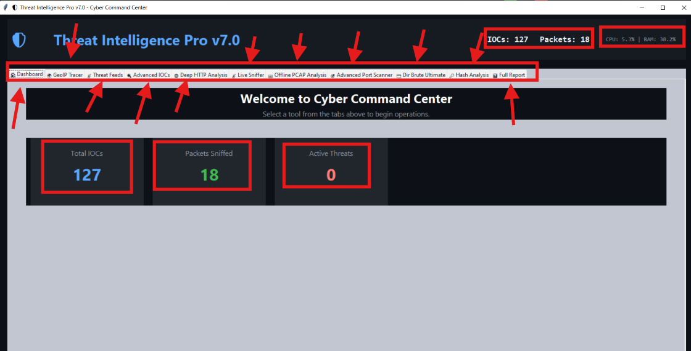

- Rapid Identification of Suspicious Geo-locations: The ability to determine the geographical location and Internet Service Provider (ISP) of any suspicious IP address, which helps in understanding the potential source of attacks and their geographical scope.
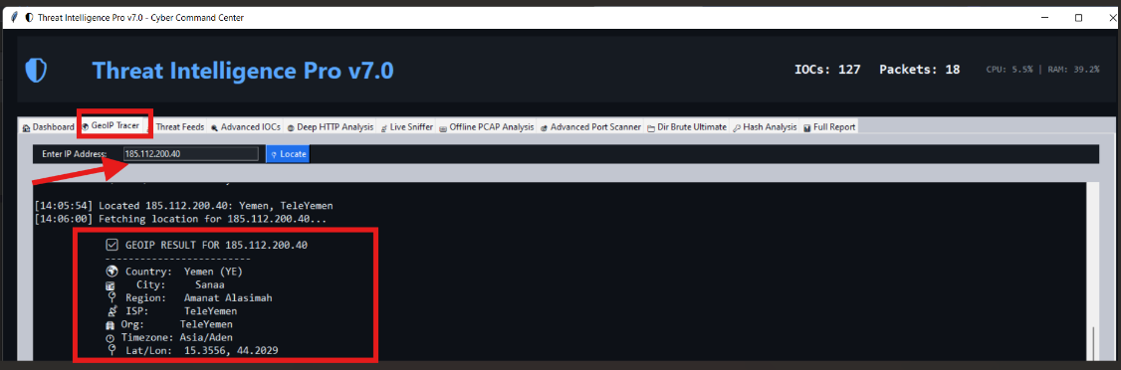

- Continuous Threat Intelligence Feed: Automatic fetching and updating of Indicators of Compromise (IOCs) from trusted external sources such as AbuseIPDB and URLHaus, ensuring that the threat database is constantly updated and provides current intelligence.

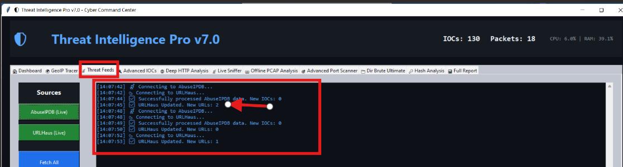

- Accurate Threat Detection in Network Traffic: Real-time and recorded (PCAP files) HTTP traffic analysis to detect known attack patterns such as SQL Injection, Cross-Site Scripting (XSS) attacks, credential harvesting attempts, and the presence of malware. This allows for rapid response to active threats.
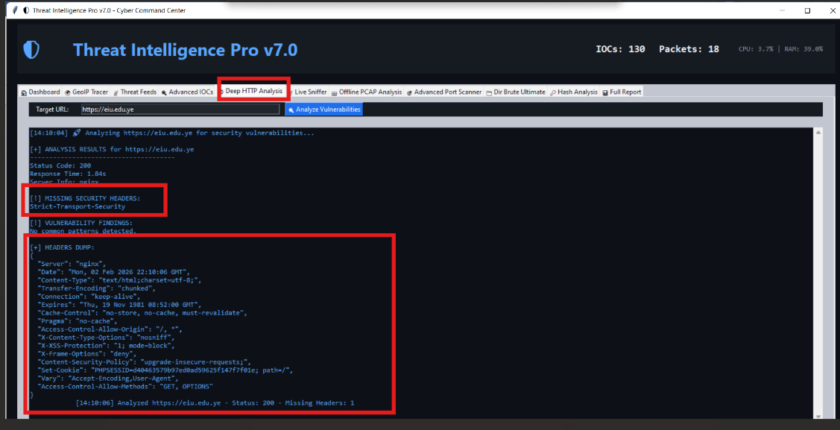

- Identification of System Vulnerabilities: Comprehensive port scanning on targets to identify open ports and the services running on them, in addition to banner grabbing to obtain information about software versions. This helps in identifying potential entry points for attackers.
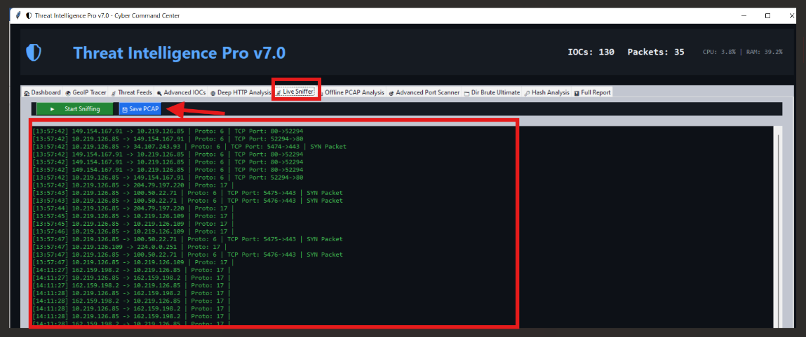

\\\
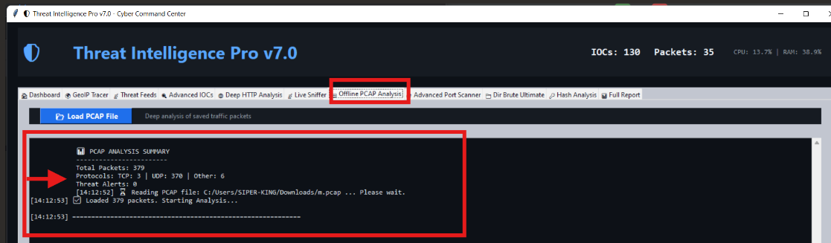

- Discovery of Hidden Paths on Web Servers: Utilization of directory brute-forcing techniques to discover hidden paths and files on web servers, which may contain sensitive information or unknown vulnerabilities.
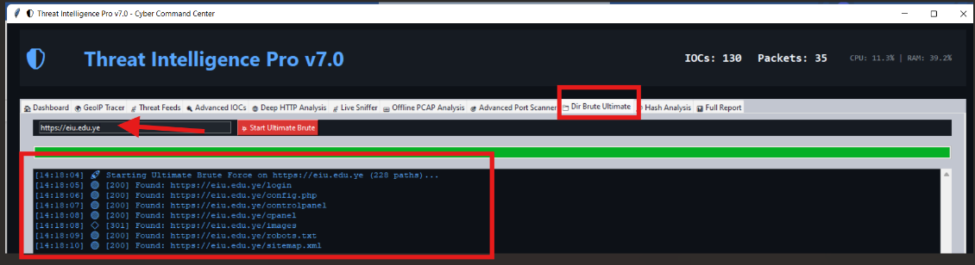

- File Integrity Verification: Calculation of MD5, SHA1, and SHA256 hashes for files, enabling the user to verify file integrity and compare them against known malware hash databases, thereby detecting infected or tampered files.
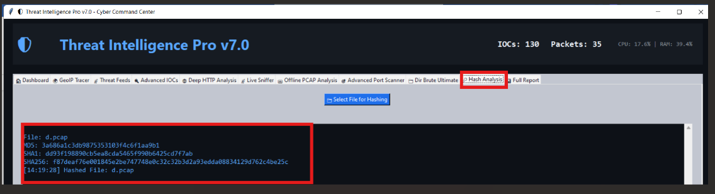

- Comprehensive Documentation of Security Activities: Generation of comprehensive and detailed reports summarizing all activities and findings collected by the tool across its various modules. These reports are a vital tool for documentation, post-analysis, and providing evidence in the event of a security incident.
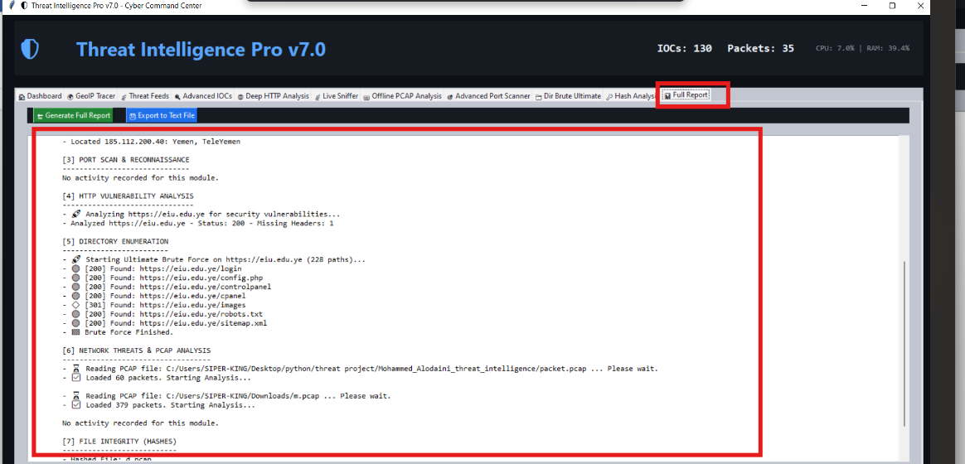

- Improved Incident Response Efficiency: By providing all these capabilities in a single interface, the tool reduces the time and effort required to collect and analyze security information, leading to faster and more effective responses to security incidents.
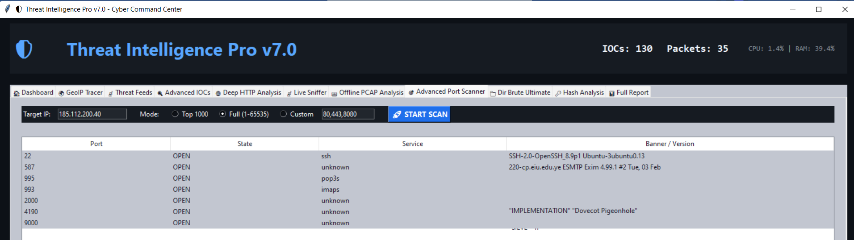

Overall, this tool empowers users to gain a deeper understanding of the security landscape, proactively identify threats and vulnerabilities, and take informed defensive actions to enhance cybersecurity.

Future Work and Recommendations
The "Cyber Command Center: Threat Intelligence " tool is a robust platform, but there is always room for improvement and expansion to enhance its capabilities and meet evolving cybersecurity needs. Below are some recommendations for future work and potential features that could be added:

- Integration with Additional Threat Intelligence Sources: The list of threat feed sources can be expanded to include more well-known platforms such as AlienVault OTX, MISP, VirusTotal, or government threat databases. This would provide broader coverage of IOCs and increase detection accuracy.
- Advanced Behavioral Analysis: Development of modules for analyzing abnormal behavior in the network or system. For example, it could analyze process behavior, network connection patterns, or changes in system logs to detect threats that may not rely on known IOCs.
- Machine Learning and Artificial Intelligence (ML & AI): Integration of machine learning models to improve threat detection capabilities. Models can be trained on large datasets of network traffic or system logs to identify hidden patterns indicative of new or sophisticated attacks (Zero-day attacks).
- Malware Analysis: Addition of functionalities for static and dynamic malware analysis in an isolated environment (Sandbox). This could include extracting strings, analyzing file headers, and monitoring program behavior during execution.
- Alerting and Notification System: Development of a system to generate immediate alerts upon detection of a critical threat, with the ability to send these alerts via email, SMS, or integration with Security Information and Event Management (SIEM) systems.
- Data Visualization: Improvement of data and results presentation using interactive graphs and charts (e.g., GeoIP heatmaps, network flow diagrams, threat timelines) to facilitate understanding of patterns and trends.
- Performance Optimization and Scalability: Review and optimize the performance of certain modules, especially those dealing with large amounts of data such as PCAP analysis and port scanning, to ensure efficiency even in large environments. This might involve using more robust databases or parallel processing techniques.
- Support for Encrypted Protocols (Encrypted Traffic Analysis): Exploration of methods to analyze encrypted traffic (e.g., HTTPS) to detect threats without compromising privacy, such as metadata analysis or using authorized decryption techniques.
- Developer API: Provision of an Application Programming Interface (API) to enable other developers to integrate with the tool and extend its functionalities, opening the door for community-driven module development.
- Improved Error Handling and Logging: Although some error handling mechanisms are present, they can be improved to be more comprehensive and detailed, with accurate logging of errors and warnings in dedicated log files for easier troubleshooting.

By implementing these recommendations, the tool can be transformed into a more comprehensive and powerful solution, capable of addressing complex security challenges in the future.

Conclusion
The "Cyber Command Center: Threat Intelligence " tool presents an excellent model for integrating various essential cybersecurity functions into a single, user-friendly, and effective application. Through its intuitive graphical interface built on tkinter, its ability to manage data using SQLite, and its utilization of powerful libraries like requests and scapy, the tool empowers security analysts to perform a wide range of tasks, from gathering threat intelligence to analyzing network traffic and detecting vulnerabilities.

The code analysis has shown that the tool is well-designed, with a clear separation between user interface components and backend operational logic. The use of multi-threading (threading and ThreadPoolExecutor) ensures that the user interface remains responsive even during long-running operations, enhancing the user experience. Furthermore, the comprehensive logging system and reporting capabilities are crucial features for documenting security activities and facilitating subsequent analysis.

Through this project, a deep understanding has been gained regarding the challenges of developing integrated cybersecurity tools, the importance of modular design, and how to leverage powerful Python libraries to address complex tasks such as packet analysis and network scanning. This tool serves as an excellent starting point for further development and enhancement, and with the addition of the features suggested in the Future Work section, it can become an even more comprehensive and powerful solution in the field of threat intelligence.

References
- [1] Python tkinter documentation
- [2] Python sqlite3 documentation
- [3] Requests: HTTP for Humans™ documentation
- [4] Scapy: Python-based interactive packet manipulation program & library
- [5] psutil: Cross-platform library for process and system monitoring in Python
- [6] AbuseIPDB API Documentation
- [7] URLhaus API Documentation
- [8] ip-api.com Documentation

