

**Faculty of engineering - Shoubra**

**Benha University**

# Research Article / Research Project / Literature Review

in fulfillment of the requirements of

|  |  |
| --- | --- |
| Department | Engineering Mathematics and physics |
| Division |  |
| Academic year | Preparatory 2019/2020 |
| Course Name | Computer |
| Course code | ECE006 |

## Title: -

**Artificial intelligence**

By:

|  |  |  |
| --- | --- | --- |
| Name | Edu mail | B. N number |
| Mohamed Abd-El-Daiem Mohamed El-Sayed | Muhammed195834@feng.bu.edu.eg | 747 |

**Approved by:**

|  |  |
| --- | --- |
| Examiners committee | Signature |
| Dr. Ahmed Bayoumi |  |
| Dr. Shady Elmashad |  |
| Dr. Abdelhamid Attaby |  |

**Name: Mohamed Abd-El-Daiem Mohamed El-Sayed**

**B.N: 747**

**Topic: Artificial intelligence**

**GitHub link:**[**https://moh827.github.io/ECE006/**](https://moh827.github.io/ECE006/)

**Main page link:**

**Artificial intelligence** (1)

Artificial intelligence (AI) is wide-ranging branch of computer science concerned with building smart machines capable of performing tasks that typically require human intelligence. AI is an interdisciplinary science with multiple approaches, but advancements in machine learning and deep learning are creating a paradigm shift in virtually every sector of the tech industry.

**HOW DOES ARTIFICIAL INTELLIGENCE WORK?**

Less than a decade after breaking the Nazi encryption machine Enigma and helping the Allied Forces win World War II, mathematician Alan Turing changed history a second time with a simple question: "Can machines think?"

Turing's paper "Computing machinery and intelligence" (1950), and its subsequent Turing Test, established the fundamental goal and vision of artificial intelligence.

At its core, AI is the branch of computer science that aims to answer Turing's question in the affirmative. It is the endeavor to replicate or simulate human intelligence in machines.

**Applications of Artificial intelligence**

1. **Artificial Intelligence in Healthcare:**Companies are applying machine learning to make better and faster diagnoses than humans. One of the best-known technologies is IBM’s Watson. It understands natural language and can respond to questions asked of it. The system mines patient data and other available data sources to form a hypothesis, which it then presents with a confidence scoring schema. AI is a study realized to emulate human intelligence into computer technology that could assist both, the doctor and the patients in the following ways:

* By providing a laboratory for the examination, representation and cataloguing medical information
* By devising novel tool to support decision making and research
* By integrating activities in medical, software and cognitive sciences
* By offering a content rich discipline for the future scientific medical communities.

1. **Artificial Intelligence in business**: Robotic process automation is being applied to highly repetitive tasks normally performed by humans. Machine learning algorithms are being integrated into analytics and CRM (Customer relationship management) platforms to uncover information on how to better serve customers. Chatbots have already been incorporated into websites and e companies to provide immediate service to customers. Automation of job positions has also become a talking point among academics and IT consultancies.
2. **AI in education:** It automates grading, giving educators more time. It can also assess students and adapt to their needs, helping them work at their own pace.
3. **AI in Autonomous vehicles:** Just like humans, self-driving cars need to have sensors to understand the world around them and a brain to collect, processes and choose specific actions based on information gathered. Autonomous vehicles are with advanced tool to gather information, including long range radar, cameras, and LIDAR. Each of the technologies are used in different capacities and each collect different information. This information is useless, unless it is processed and some form of information is taken based on the gathered information. This is where artificial intelligence comes into play and can be compared to human brain. AI has several applications for these vehicles and among them the more immediate ones are as follows:

* Directing the car to gas station or recharge station when it is running low on fuel.
* Adjust the trips directions based on known traffic conditions to find the quickest route.
* Incorporate speech recognition for advanced communication with passengers.
* Natural language interfaces and virtual assistance technologies.

1. **AI for robotics** will allow us to address the challenges in taking care of an aging population and allow much longer independence. It will drastically reduce, may be even bring down traffic accidents and researcher Shimon white stone thinks that hs, as well as enable disaster response for dangerous situations for example the nuclear meltdown at the fukushima power plant.
2. **Cyborg Technology:** One of the main limitations of being human is simply our own bodies and brains.  in the future, we will be able to augment ourselves with computers and enhance many of our own natural abilities. Though many of these possible cyborg enhancements would be added for convenience, others may serve a more practical purpose. Yoky Matsuka of Nest believes that AI will become useful for people with amputated limbs, as the brain will be able to communicate with a robotic limb to give the patient more control. This kind of cyborg technology would significantly reduce the limitations that amputees deal with dailyIn the future, predictive analytics and artificial intelligence could play an even more fundamental role in content creation and also in the software fields. Open source information and artificial intelligence collection will provide opportunities for global technological parity and the technology of artificial can become the future in all the domains of health, environment, public safety and security.

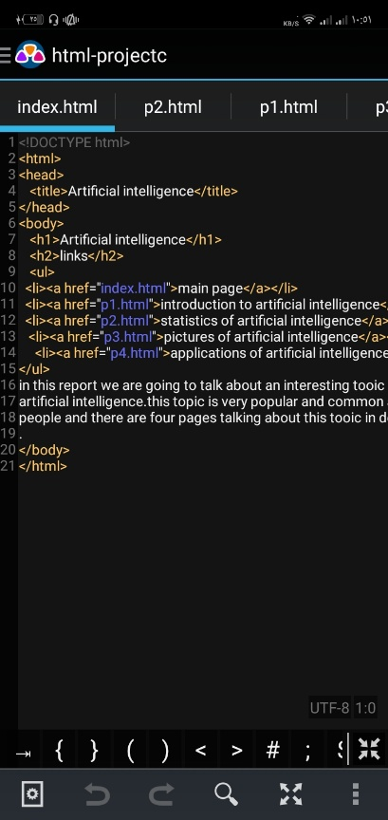**Source code**

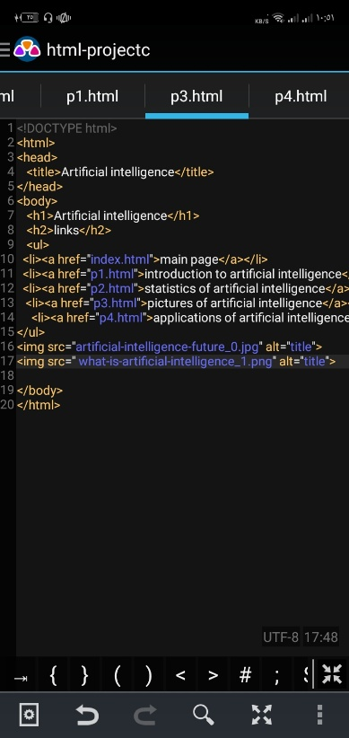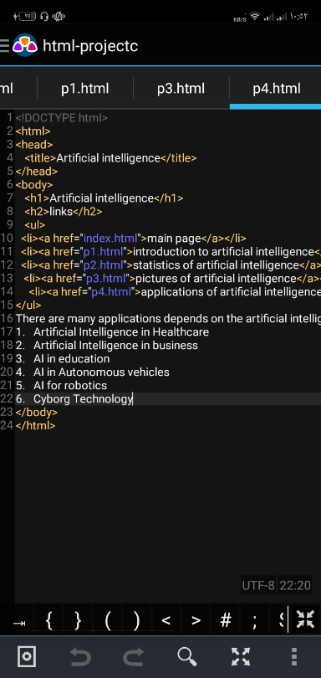

**Screenshots**

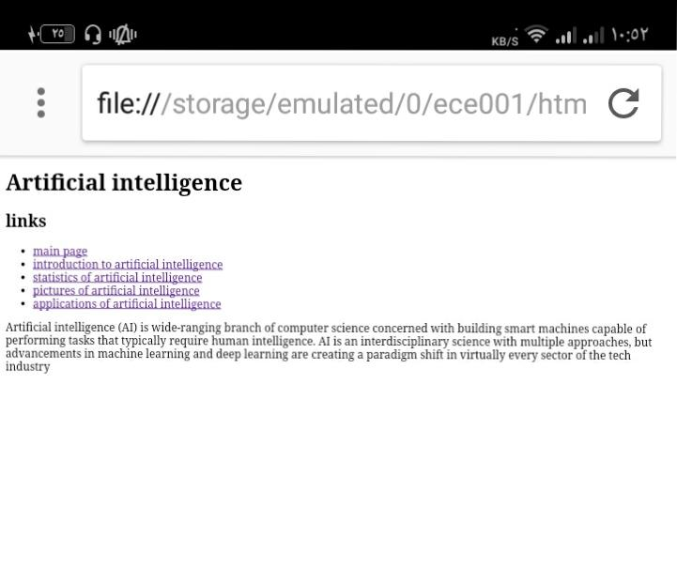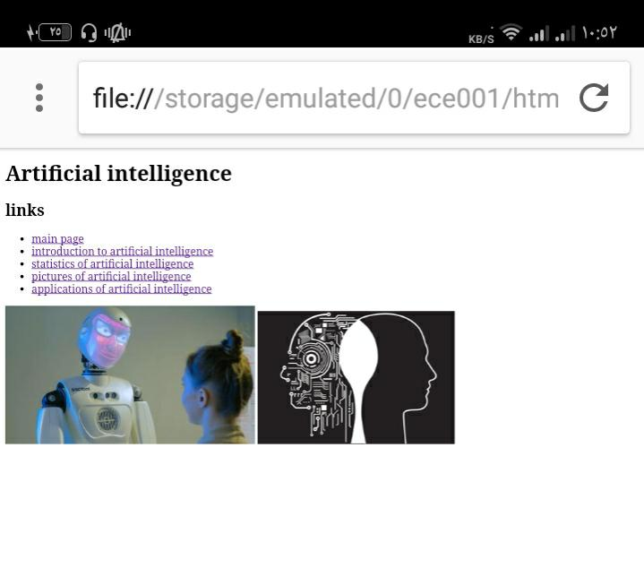

**References**

* 1. <https://www.valluriorg.com/blog/artificial-intelligence-and-its-applications/>
  2. <https://builtin.com/artificial-intelligence>